Thomas Rhys Evans

1810164

Information Engineering - ACCB4013

Table of contents
Heading | Page Number
1.Introduction | 1
2.ERD | 1
2.1 ERD Relationships | 1-2
3. Database Implementation | 2-8
4. User Documentation | 8-13
5. Reports | 13-14
6. Verifying Specification | 15

- Introduction
In order to meet the specification of the book shop, a number of separate linked tables are needed to produce the functionality required. The specifications for the database for the bookshop were defined as:
- Staff must be able to add or delete information from any table
- Staff must be able to view Book, Stock, Order and Customer Details
- View ongoing customer orders
- Query the system and produce relevant reports
An ERD has been created initially to plan the entities, attributes and relationships between the tables

- ERD
Below an initial ERD design can be seen for the book shop
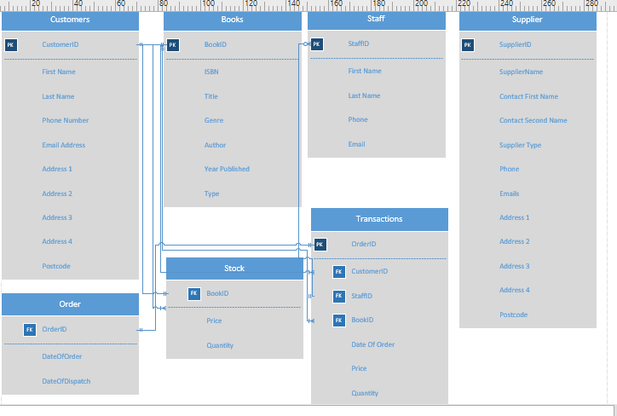
The entities include Customers, Books, Staff, Suppliers along with Stock, Orders and Transactions.
2.1 ERD Relationships
The Relationships between the entities are as follows:
- CustomerID field in Customers table relates to the CustomerID field in the Transactions table. The relationship is one-to-many, as one customer may have a number of separate transactions with the book shop
- BookID field in Books table relates to the BookID in the Stock table. This relationship is one-to-one as each book will only have one entry within the stock table
- BookID field in Books table relates to BookID in Transactions table. This is a one-to-many relationship. One book ID may appear in numerous different transactions
- OrderID field in Transactions table relates to OrderID field in Order table. This is a one-to-one relationship, as each order has a unique ID that will only appear in each table once
- StaffID field in Staff table relates to StaffID field in transaction table. This is one-to-many, as the same member of staff will be involved in numerous different transactions with customers.
The transaction table uses the OrderID as it’s primary key, but then uses the BookID, StaffID and CustomerID foreign keys to tie in the information required to create an order.

3.Database implementation
Upon opening the database, the user is welcomed by the main menu screen of the database, pictured below

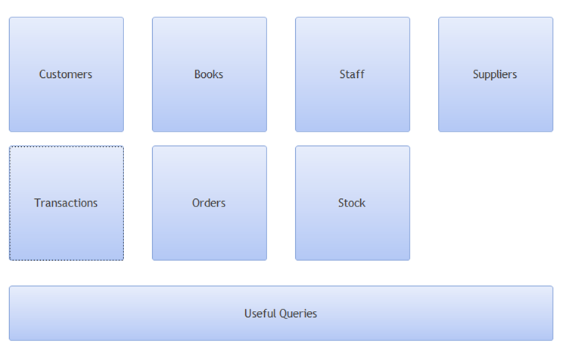
The appropriately named options make it clear to the user what each option is for. The 7 square options all open forms to allow the creation, deletion, manipulation and saving of records within their corresponding tables.

Customers
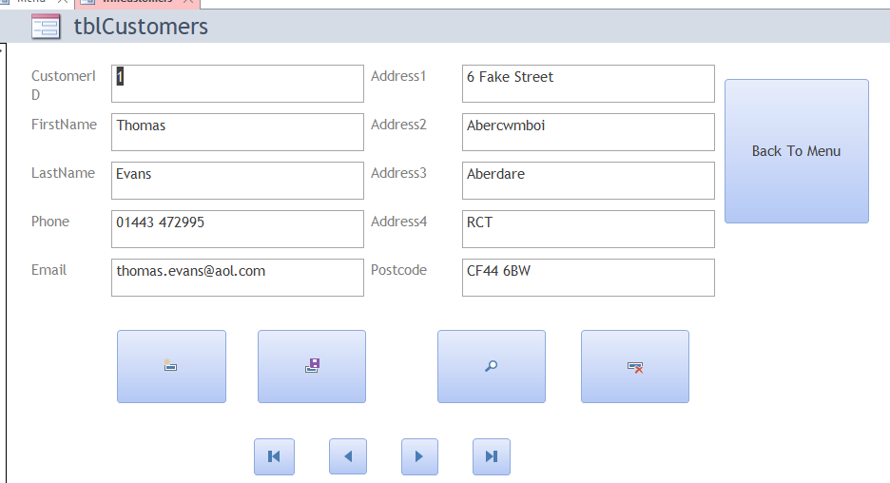
Books
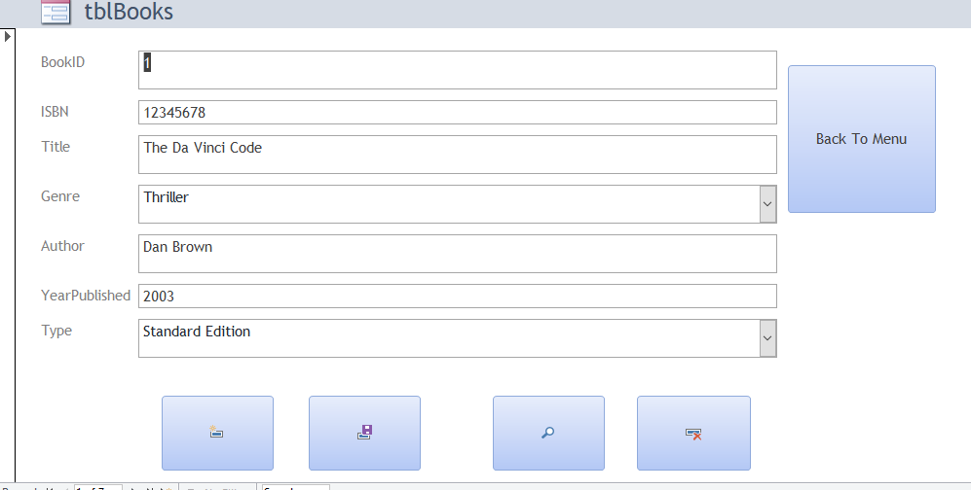
Staff
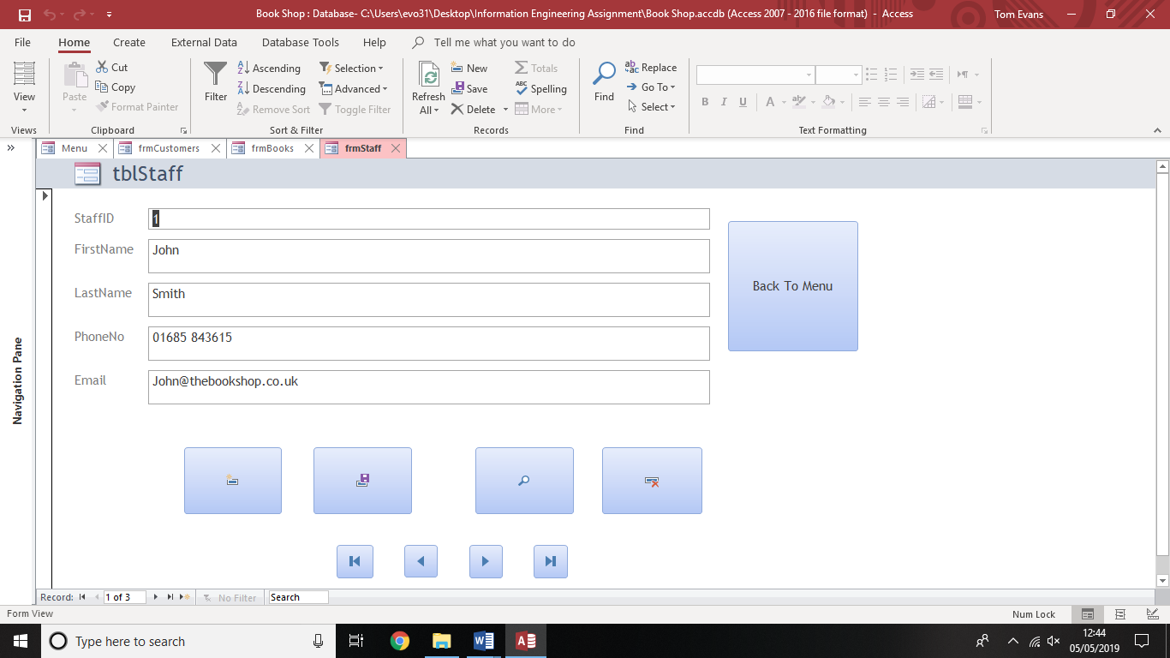
Suppliers
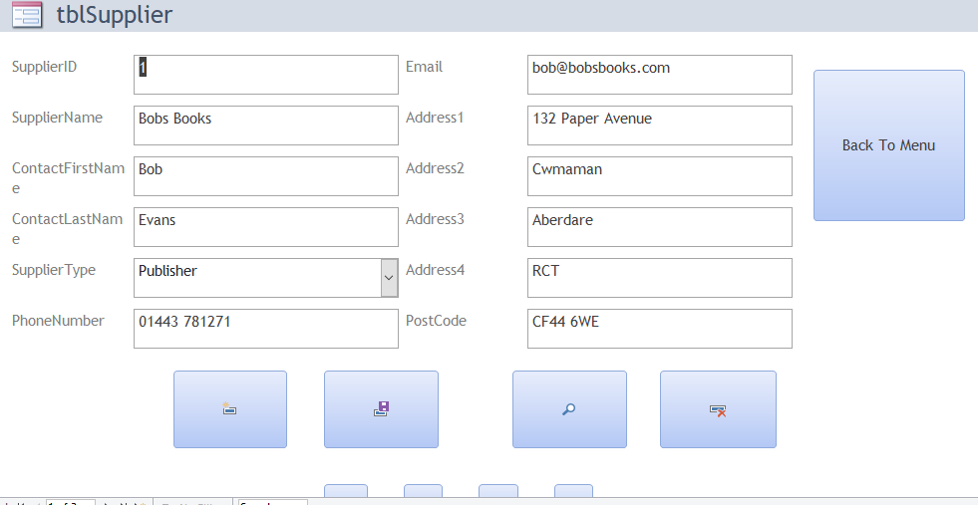
Orders
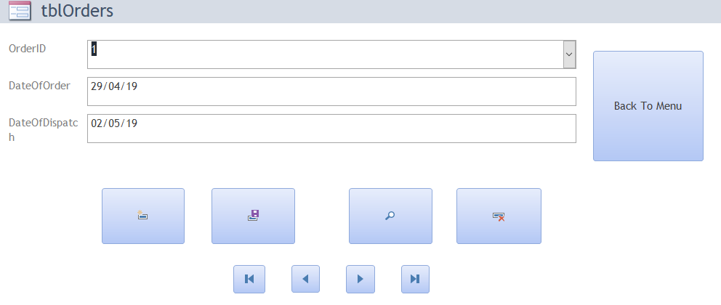
Transactions
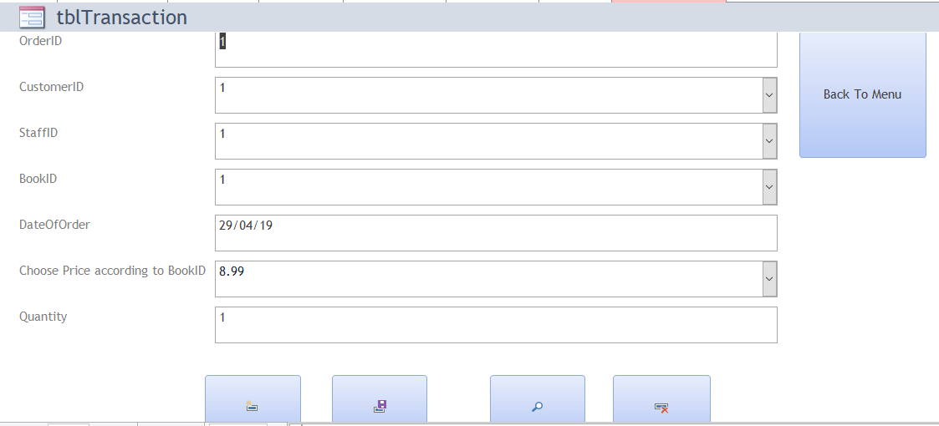
Stock
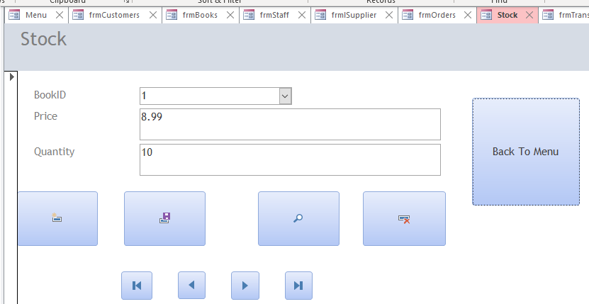

Each form has a “Back to Menu” button, which takes the user back to the opening screen. This makes sure that the user never gets stuck at a dead end and is able to navigate to all parts of the database without having to close and re-open.
The “Useful Queries” button takes the user to a sub-form containing all the pre-written queries created to provide the book shop and it’s staff the information they’ll need
Useful Queries
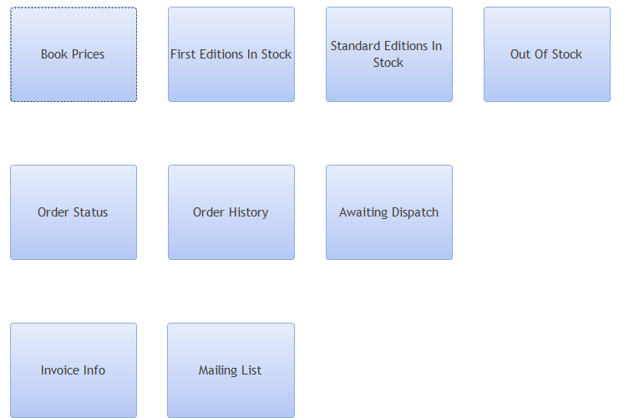

4. Query output
Below are the outputs of the queries when they are run

Book Prices
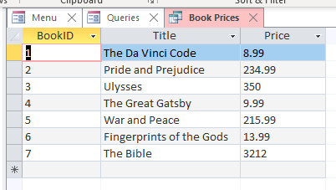
First Editions
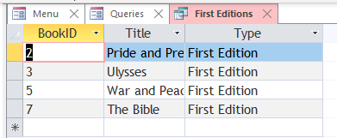
Standard Editions
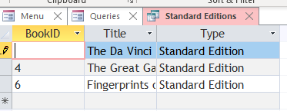
Out of Stock
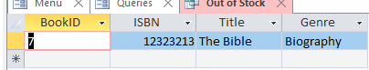
Order Status
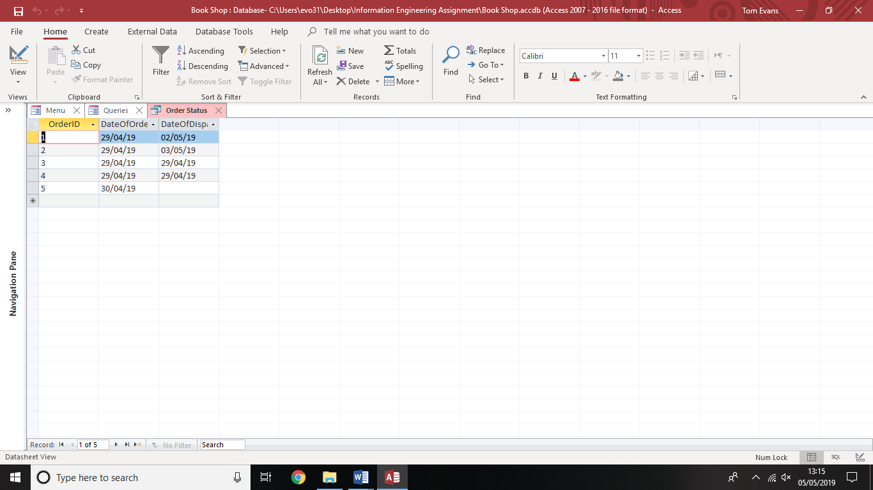

Order History
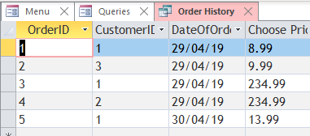
Awaiting Dispatch
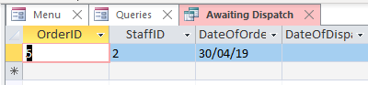
Invoice Info
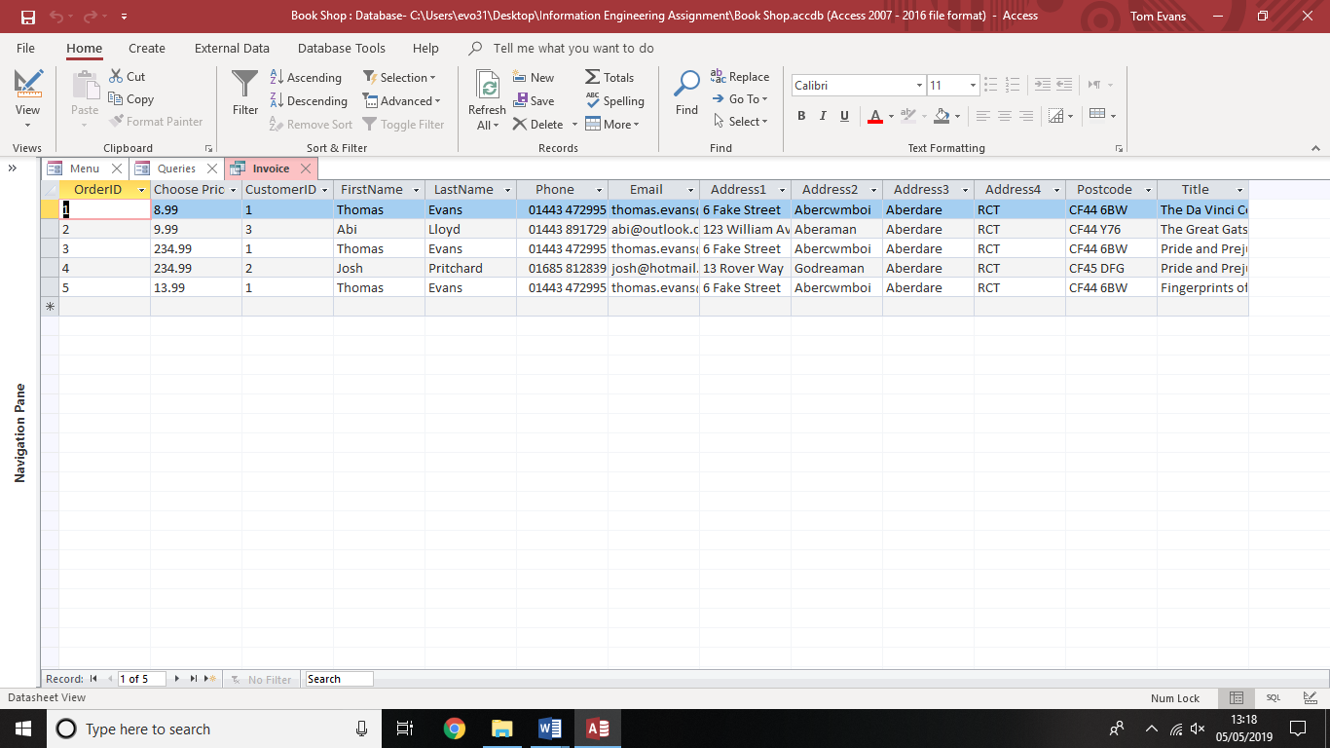
Mailing List
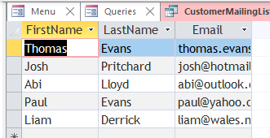

4. User Documentation
The system designed allows the user to easily search, add, amend and delete records relating to the different tables within the database.
Initially, the main menu page is displayed
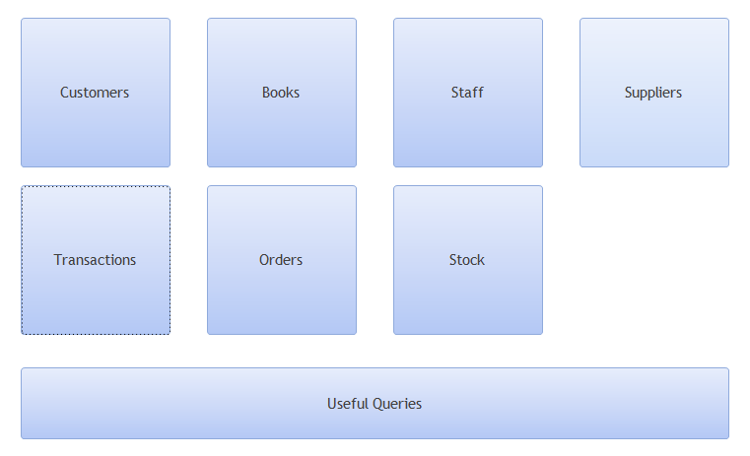
In order to place an order, information needs to be filled out on a number of forms. First, a customer record needs to be completed. The customer form needs to be opened
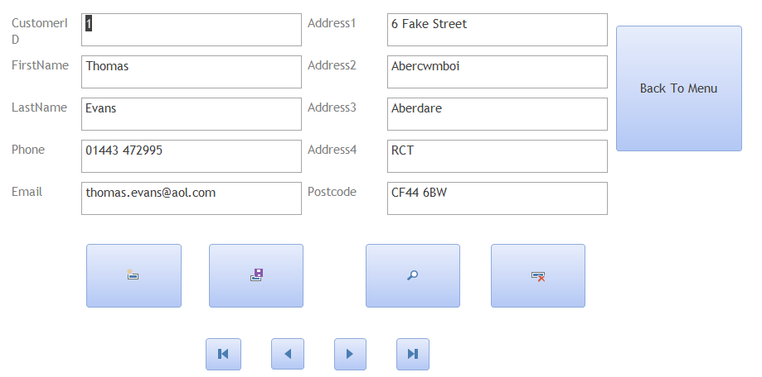
To create a new account, first navigate to the most recent record in order to find the value of the most recent customer ID number.
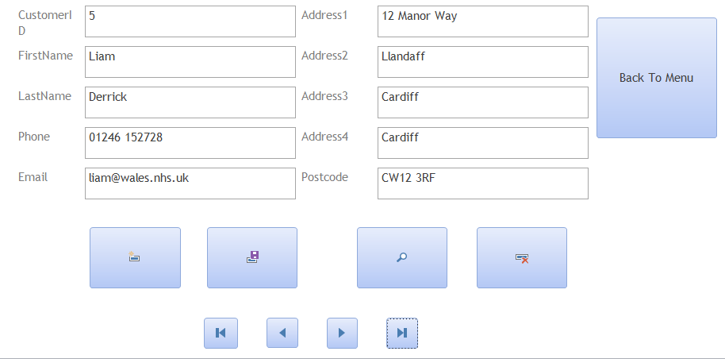
The most recent customer added is CustomerID 5. To create a new record, choose the “Add Record” option.
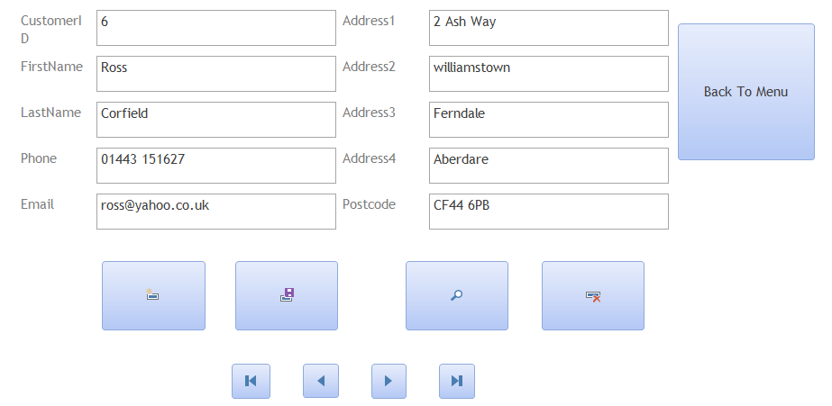
We know the next customer needs the CustomerID of 6. Once the rest of the customer information is completed, make sure to save the record. The user can then use the “Back to Menu” option to return to the main screen.
From here, a transaction can be created (Assuming that the book information and staff information have already been entered)
To create a transaction, click on the “Transaction” form option
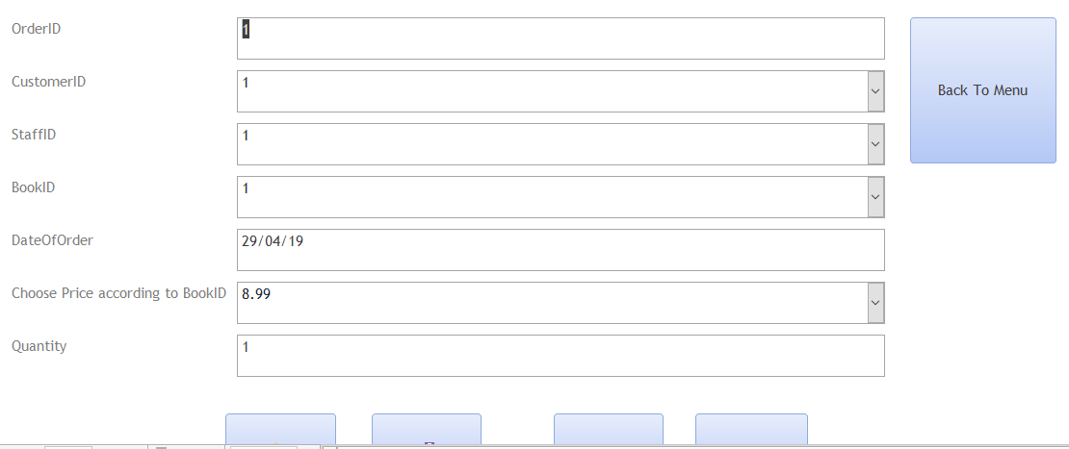
Once again, navigate to the most recent record so the correct new order number can be created. From here, click “Add record” option.
We enter the next ascending order number, then fill out the rest of the transaction using the pre-filled drop down boxes:
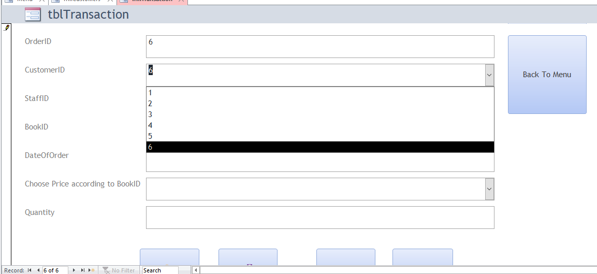
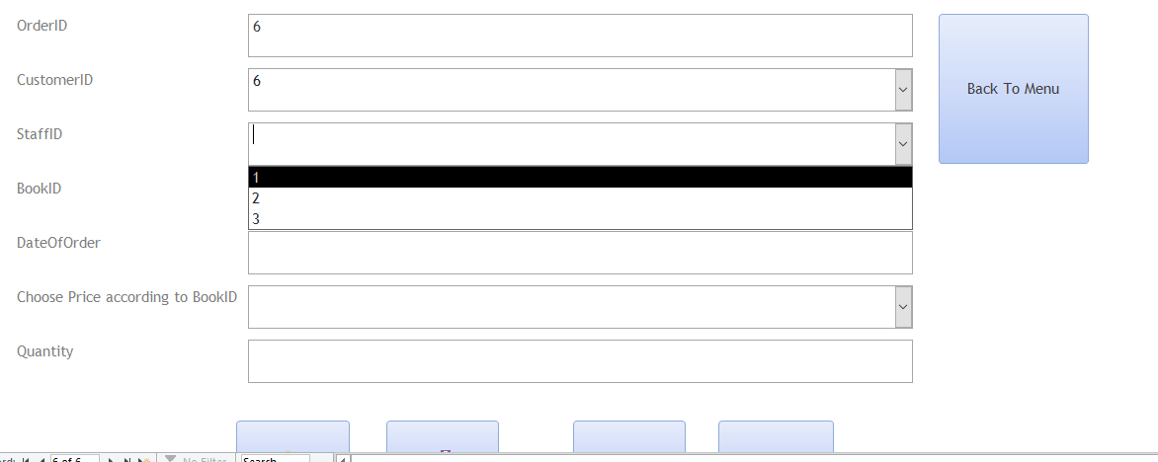
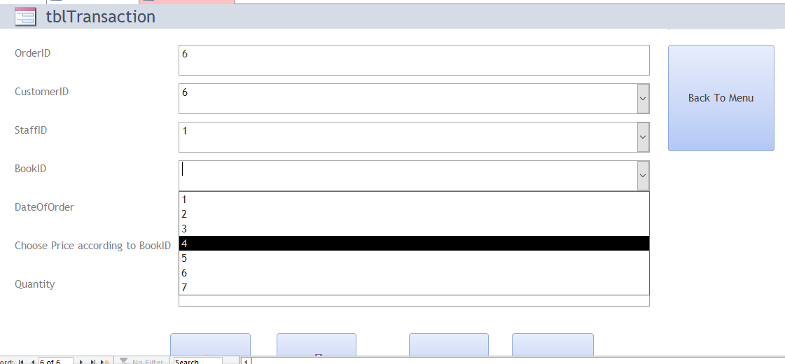
The list of prices are also provided for each book as this field is linked to the “Price” field within the “Stock” table.
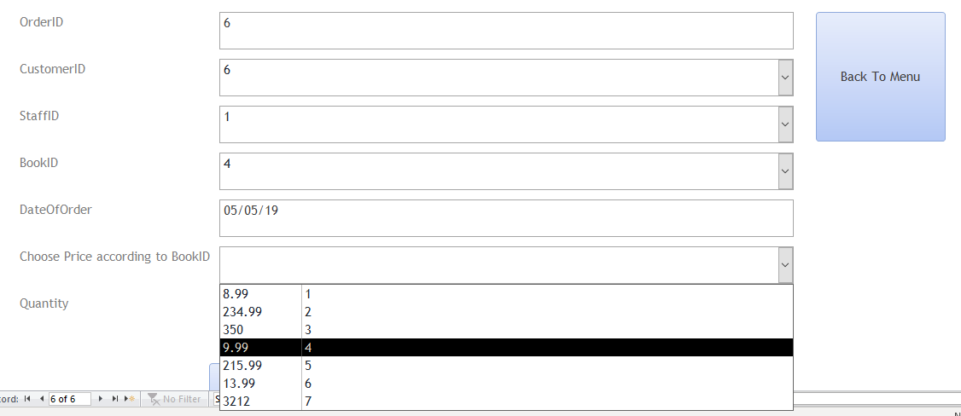
The user needs to make sure that the correct price is selected which corresponds to the correct bookID. Once the rest of the details are filled out, click on “Save Record” to complete the order.
Once the staff member has completed the order, they will need to update two forms, The first is the “Order” form. This is the table that monitors whether orders have been dispatched.
Navigate to the order form and click “Add record”. The OrderID used the OrderID values saved in the transaction table. This allows the field to be a drop down menu.
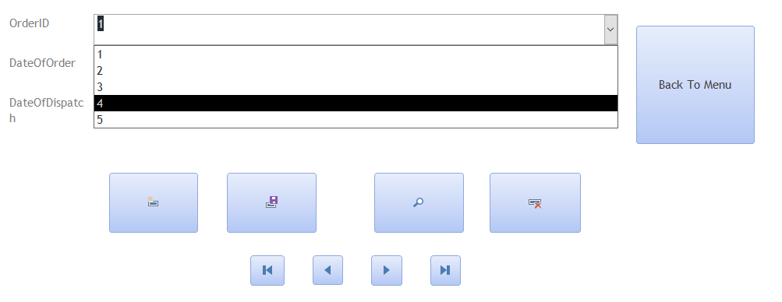
The staff member must enter the date the order was created alongside the corresponding OrderID. Once the order is dispatched, the staff member must also enter a date in the “DateOfDispatch” field
The other table that must be updated is the “Stock” table. The user must navigate to the entry that corresponds to the BookId of the book that has just been sold. The quantity needs to be reduced by one (or the number of books that were sold)
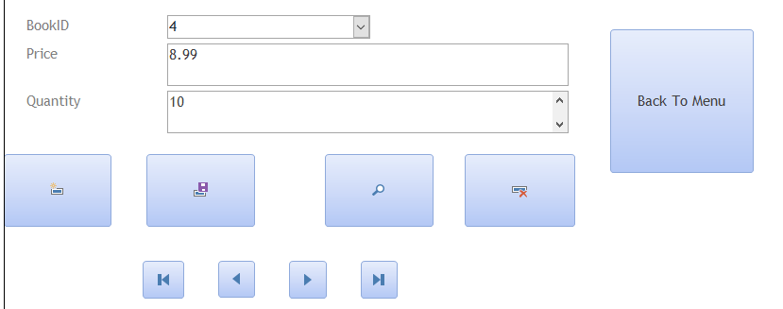
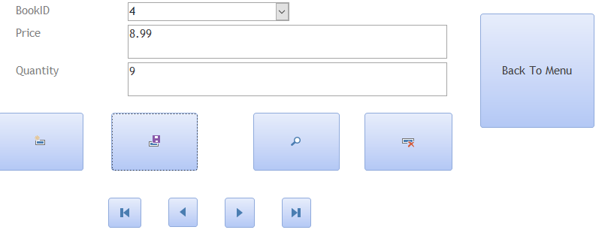
This ensures an accurate and up-to-date stock inventory is kept. To add Additional books, staff members or suppliers to the database, the same principles are applied.
5. Reports
The database can be used to create reports from queries. An example includes the invoice option. Once the invoice query has been selected and all the relevant information has been gathered, an invoice run can be completed. This provides the book shop with a list of invoices ready for printing, set out in a suitable format for customers
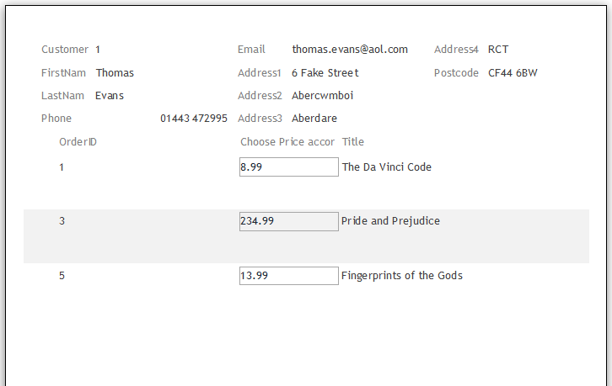
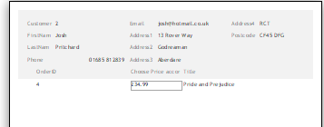
This query/report pulls in information from the customer, transaction and stock table and displays the required information in an easy to read format.
Reports can also be run on single table queries, such as the current first editions in stock
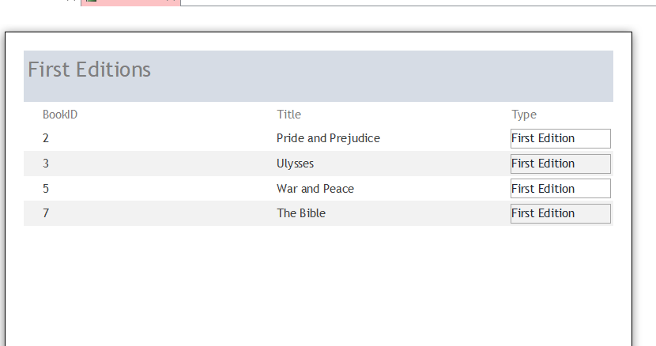
This is ideal for the book shop, for cases when they may want to send a list of previous customers their current inventory of stock in order to drum up business
6. Verifying Specifications
The specifications were set out before design of the database took place.
- Staff must be able to add or delete information from any table
- Staff must be able to view Book, Stock, Order and Customer Details
- View ongoing customer orders
- Query the system and produce relevant reports
All of the above specifications have been met. Staff can easily manoeuvre their way around the system, moving from table to table with the ability to add, delete, change and save records. They are also able to view all records within each table and can do this with ease with ease with the buttons provided. Book information is stored within its own distinct table, as is stock, order and customer information. An ongoing order table is created so staff are aware of orders that are currently awaiting dispatch.
There are also a number of pre-written queries, all tested and working to provide staff with the relevant information they need. Reports are also created from these queries in a suitable formats should they ever need to be printed for customers
Navigation between all pages work and each link on each page acts as expected. The user will never get stuck in a dead-end and have to close the database to return to the main menu

