
Skills for the Workplace
Module Assignment Submission
Student Name: | Mandy Jones
Student Number: | 1911550
Module No: | BMSK4002
Module Title: | Effective Team Working and Communication  Part 2

Statement of Confirmation of Authenticity
By the act of making this submission, the student declares that this is the work of the student named above. The work has not, in whole or in part, been knowingly presented elsewhere for assessment, or where assessment has been built on a previous assessment, this has been identified. Where materials have been used from other sources it has been properly acknowledged. If this statement is untrue, the student acknowledges that an assessment offence has been committed.
Attention is drawn to the plagiarism and unfair practice policies of both the University and of ILM.

Table of Contents
Part 2 Communication 3
1. Communication Cycle 8
2.0 9
Assessing Own Communication Skills 9
Gap Analysis 10
PDP 11
References 12
Appendix A 13
Skills You Need Communication Quiz 13
Mind Tools Communication Quiz 18

Part 2 Communication
Society not only exists by transmission, by communication, but it may fairly be said to exist in transmission, in communication.” — John Dewey
Media critic and theorist James Carey defined communication as "a symbolic process whereby reality is produced, maintained, repaired and transformed" in his 1992 book "Communication as Culture," positing that we define our reality by sharing our experience with others.
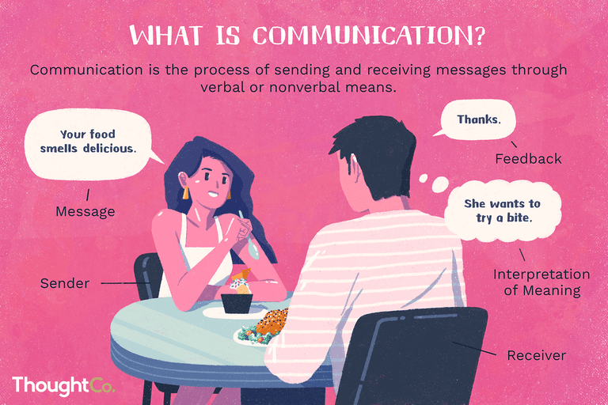

I examined all aspects of the Shannon and Weaver Model of Communication which was first written in 1948 by Claude Elwood Shannon who was an American Mathematician, Electronic Engineer and Warren Weaver who was an American Scientist who both collaborated and wrote an article in the ‘Bell System Technical Journal’ called ‘A Mathematical Theory or Communication’ also known as the ‘Shannon and Weaver Model of Communication’

When you communicate with another person you each follow the steps of the Communication Process as shown below in Figure 1:
Figure 1. The Communication Process
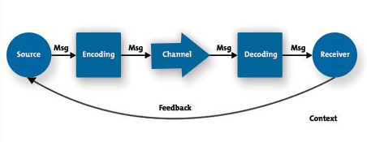
By following this process the Source is the person who encodes a message and sends it through whatever Channel they want to the Receiver who Decodes it whatever way they want and then gives feedback on their understanding or lack thereof to the Source. By understanding all the above steps of the process a person can be more aware of their role and recognise what they want to say to communicate effectively whilst anticipating any problems that may arise, hopefully before they happen and improve their overall ability to communicate more effectively.

The Source – Planning Your Message
As the Source before you start communicating take your time and figure out exactly what you want to say and why? Do not waste unnecessary time giving information that is not relevant or needed which will in effect waste the Receiver’s time.

To plan your communication understand your objectives and know why you are communicating, understand your audience and think about what exactly they need to know, plan carefully what you want to say, and how you will send the message. Always seek feedback on how well your message was received and by covering these points you will be able to put together a message that will be received positively by your audience.

Good communicators use the KISS principle of "Keep It Simple and Straightforward" and know that less is often more and that good communication should be efficient as well as effective.

Encoding – Creating a Clear, Well-Crafted Message

When you know exactly what you want to say, decide exactly how you will say it, you are responsible for sending a clear concise message and to achieve this you need to consider not only what you will say, but also think about how the recipient will perceive or interpret it.

To communicate more effectively you need to understand what you need and want to say and to anticipate the recipients reaction to your message by choosing words and body language to allow the other person to really hear and understand what you are saying or portraying.

In the case of a written communication make sure that what you write will be perceived and understood the way you intended it as written words on a page generally have no emotion in that they don’t ‘smile’ or ‘frown’ back at you while you are reading them.

When you begin writing, take your time and review your style, avoid using jargon or slang and check your grammar and punctuation, also take into account your tone, attitude, nuance, and other subtleties and whether your message may be misunderstood, it probably will so take the time to clarify it! Wherever possible use pictures, charts and diagrams because as the saying goes ‘a picture speaks a thousand words’.

Likewise, regardless of whether you speak or write your message, consider the social or cultural context. On the off chance that there is potential for miscommunication or misjudging because of social or language hindrances, address these issues ahead of time. Talk with individuals who know about these kinds of hindrances always do your research, so you are well informed before issues arise.

Choosing the Right Channel

Alongside encoding your message, you must pick the best communication channel to send it, whilst remaining productive and capitalising on your communication opportunity.

Utilising email to send basic directions is practical but if you want assign an intricate undertaking, an email will more than likely lead to more enquiries, so it might be better to organise a face to face opportunity. Also, if your correspondence has negative emotional substance, keep well away from email! Ensure that you get up close and personal or by telephone, so you can pass judgment on the effect of your words and modify your message suitably.

When choosing the right channel for your message, take into account the sensitivity and emotional content of the subject, how easy it is to communicate detail, the receiver's preferences, time constraints and the need to ask and answer questions.

Decoding – Receiving and Interpreting a Message

It is so easy to focus on speaking: we want to get our points out there, because we usually have lots to say however, to be a great communicator you also need to step back and let the other person talk and listen intently.

However, this does not mean that you have to be passive as listening is hard work, which is why effective listening is called active listening and to listen actively, give your undivided attention to the speaker by looking at the person; pay attention to his or her body language; avoid distractions; nod and smile to acknowledge pertinent points; occasionally think back on what the person has said; allow the person to speak without thinking about what you will say next and do not interrupt.

Empathetic Listening also helps you decode messages accurately and to understand a message fully, you have to understand the emotions and underlying feelings that the speaker is expressing and this is where an understanding of body language can be useful.

Feedback

Feedback is essential as without it, you cannot be sure that people have understood your message fully, sometimes feedback can be verbal and sometimes not. We have looked at the importance of asking questions and listening carefully however, feedback through body language can also help you to assess the impact of your message and by watching the facial expressions, gestures, and the posture of the person you are communicating with, you can tell confidence levels; defensiveness; agreement; comprehension (or lack of understanding); level of interest; level of engagement with the message; and finally truthfulness (or lying/dishonesty).

As a speaker, understanding your listener's body language can give you an opportunity to adjust your message and make it more understandable, appealing, or interesting and as a listener, body language can show you more about what the other person is saying. You can then ask questions to ensure that you have, indeed, understood each other and in both situations, you can better avoid miscommunication if it happens.

Feedback can also be formal and if you are communicating something really important, it can often be worth asking questions of the person you're talking to make sure that they have understood fully and if you are the one receiving this sort of communication, repeat it in your own words to check your understanding.

Key Points

It can take a lot of effort to communicate effectively however, you need to be able to communicate well if you are going to make the most of the opportunities that life has to offer. It takes a lot of effort to communicate effectively but you need to be able to communicate well if you are going to make the most of every opportunity life has to offer and by learning the additional skills you need to communicate effectively you can learn how to convey your ideas clearly and understand much more about the information that is conveyed to you.

Whether you are a speaker, a listener, a writer, or a reader, you are responsible for making sure that messages are communicated accurately and effectively by paying attention to words and actions, by asking questions and watching the other person’s body language. This will really help to ensure that you say exactly what you mean and hear precisely what is intended.

Another model which can help with effective communication is the 7 C’s of Communication which is a checklist that helps to improve your professional communication skills and increases the chance that your message will be understood in exactly the same way as it was intended.

This model is applicable to both written and verbal communication:
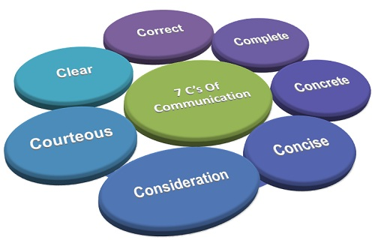

1. Communication Cycle

Perhaps you are just writing an email to a colleague, or giving a new team member instructions on training or feedback, or even giving an important presentation to your boss you must communicate in a very clear, concise and easy to understand way.
The Communication Cycle has six stages which help you to develop and refine your message and helps to ensure you do not forget anything important the first time you present and maximises its impact in the future.
By using the Six-step Communication Cycle it encourages feedback from recipients which in turn can be used positively to help in the future to improve your communication skills.
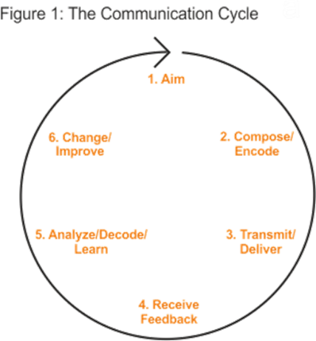

2.0

Assessing Own Communication Skills

I am currently working on providing food supplies for various Foodbanks in the Llanelli area, I have to communicate with 10 foodbanks weekly, I take their orders and process them and then send them on to our Suppliers who send me an email to say when they will be able to deliver. I then have to let each individual foodbank know and then pick up all of the delivery sheets and put them into an Excel sheet showing what has been received and then I have to check the Invoices when they arrive always ensuring that they do not go over the amount which is specified for them.
This in the past has taken me countless attempts as I message then remember something else, so by using Effective Communication Skills this will make my job so much easier in the future.

Gap Analysis

Objective | Current Position | Deficiency | Action
What do I want to do? | What can I already do? | What am I lacking? | How do I fix this?
I want to be able to write clear, concise emails. | I am a good communicator but need to plan my message before sending | Precision | By following Shannon and Weaver’s model
I want to be more assertive and be able to express myself effectively to others | By doing this course I am beginning to understand different types of theories and models | Drive | By participating in discussion more and readying articles
I would like to become a Manager as I feel if I tried hard enough I could | My writing skills are really grammatical as is my spelling | Confidence | By finishing this course and moving on to the next one.

PDP

Objectives | Tasks | Success Criteria | Time Frame | Resources
List your Goals | What do you need to do to achieve these goals? | How will you identify your success? | When do they need to be done by? | Who or what do you need to help you?
To complete this course to the best of my ability | Come to class and participate fully in discussions | By completing and passing this course | October 2020 | My tutor - Julia
I want to become fit and lose weight | Drive and commitment | By weight loss | ASAP | Me, myself and I
To make my family proud | Belief in myself | By being true to myself and achieving a Degree | The next 3 years | Tutors and UWTSD Resources

References

Blenkinsop, P. (2010) The Communication Cycle. [online] Available at: http://manyana-education.blogspot.com/2010/10/communication-cycle.html Accessed: 18.05.20
CNET (2019) Three ways to take a screenshot on a Mac. [online] Available at:
https://www.cnet.com/how-to/three-ways-to-take-a-screenshot-on-a-mac-keyboardshortcuts/ Accessed: 15.04.19
Dewey, J. “Democracy and Education” 1916, p.10, Courier Corporation

LyondellBasell (2019) Effective Communication [online] Available at:
https://www.lyondellbasell.com/en/sustainability/lifebeats/what-is-well-being/healthylife/effective-communication/ Accessed: 15.04.19

MindTools (2019) How good are your communication skills? [online] Available at: https://www.mindtools.com/pages/article/newCS_99.htm Accessed: 15.04.19

Myrick, A. (2019) How to use the new Screenshot features in macOS Mojave. [online]
Available at: https://appletoolbox.com/2018/06/how-to-screenshot-macos-mojave/ Accessed: 15.04.19

Patel, N. (2013) Communication Cycle [online] Available at:
https://nirmitpatel13es907.wordpress.com/2013/11/17/process-of-communication/ Accessed: 15.04.19

Shannon, C. and Weaver, W. (1949) The Mathematical Theory of Communication. Urbana: University of Illinois Press.

Skills You Need (2019) Interpersonal Skills Self-Assessment. [online] Available at:
https://www.skillsyouneed.com/ls/index.php/343479 Accessed: 15.04.19

Appendix A

Skills You Need Communication Quiz

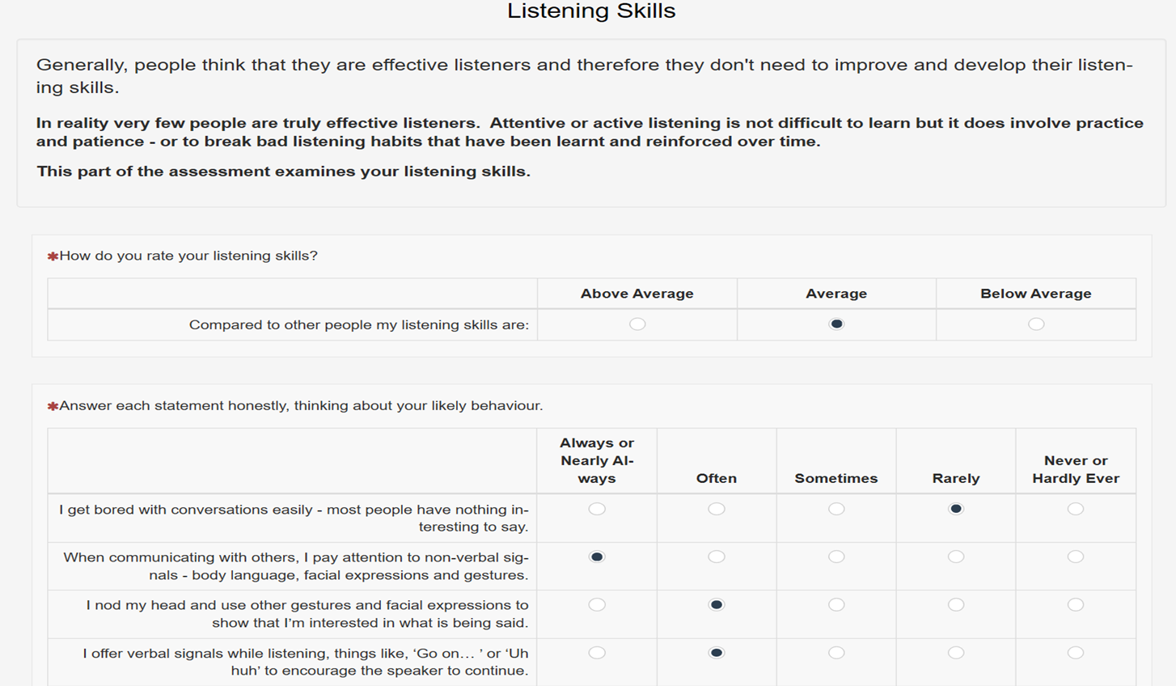
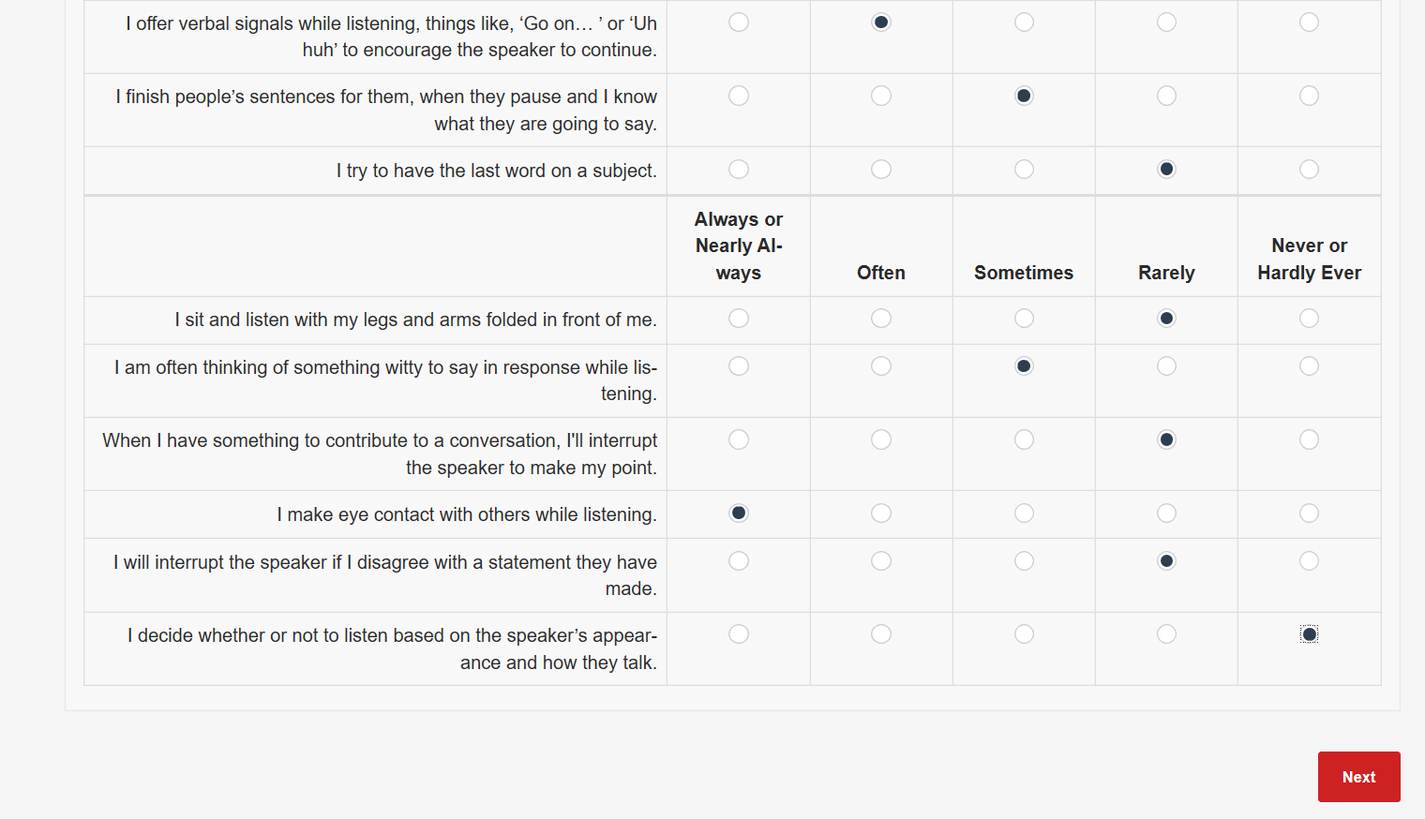
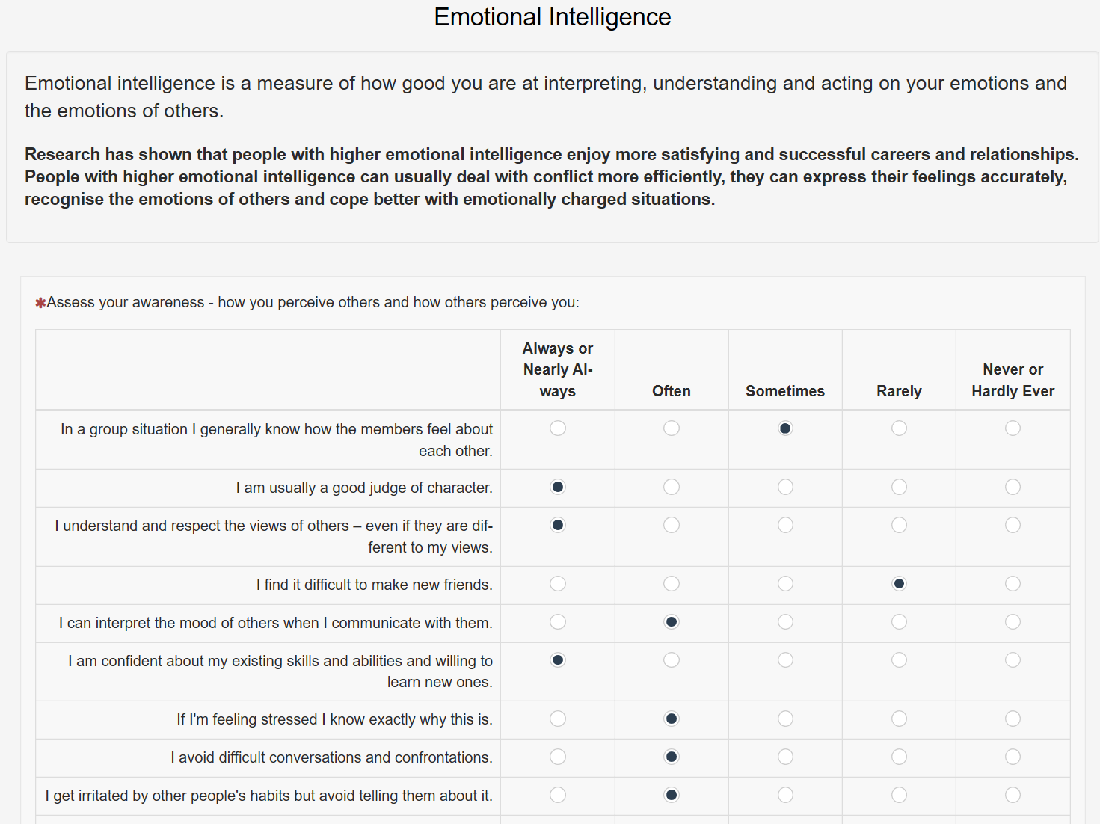
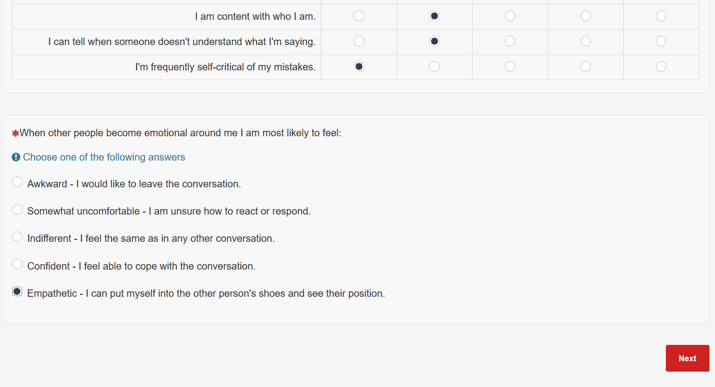
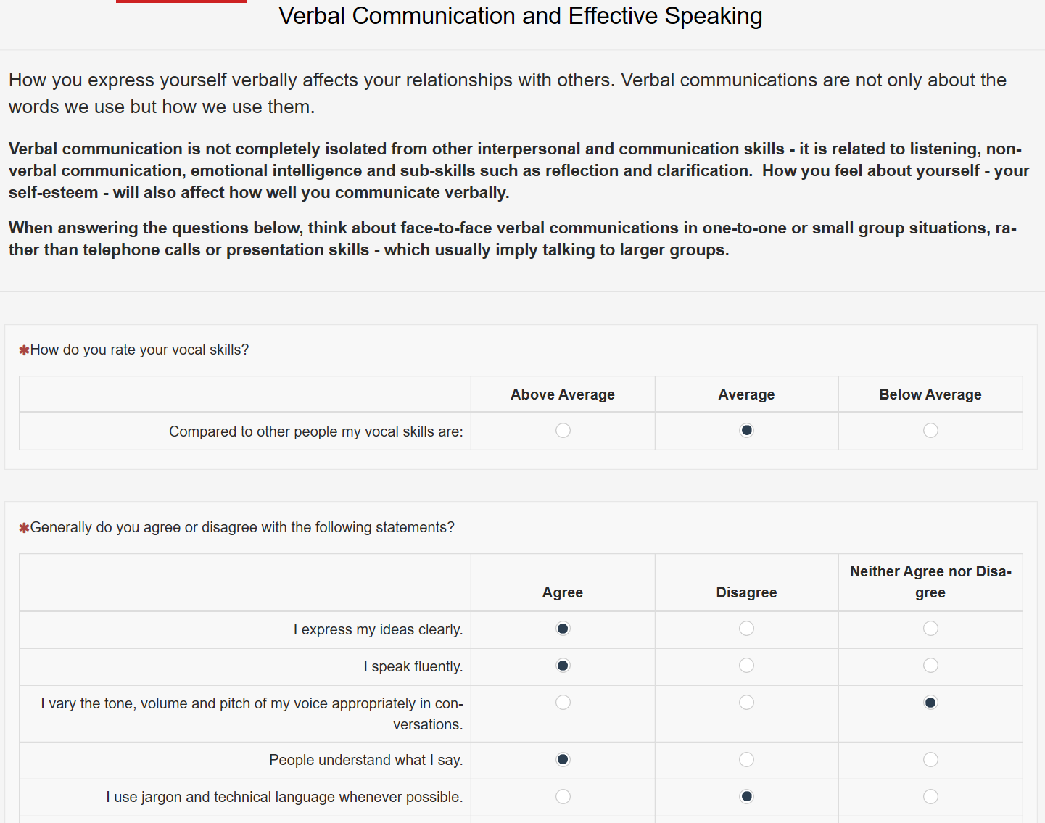
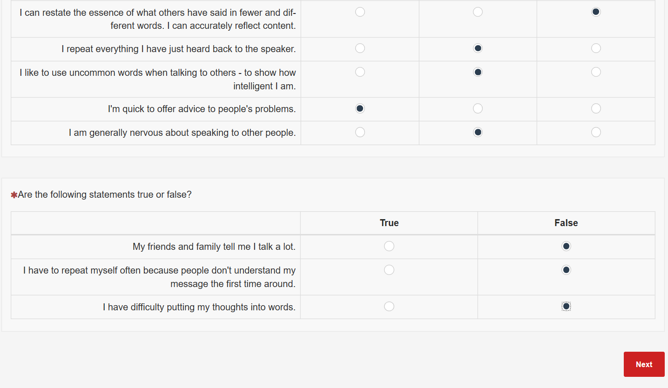
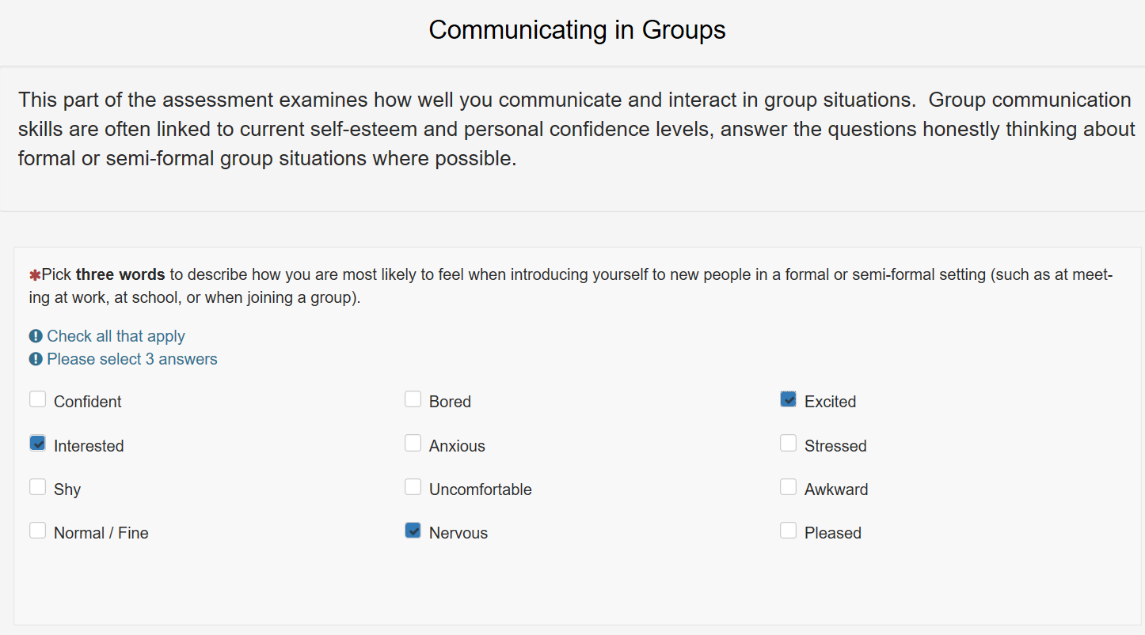
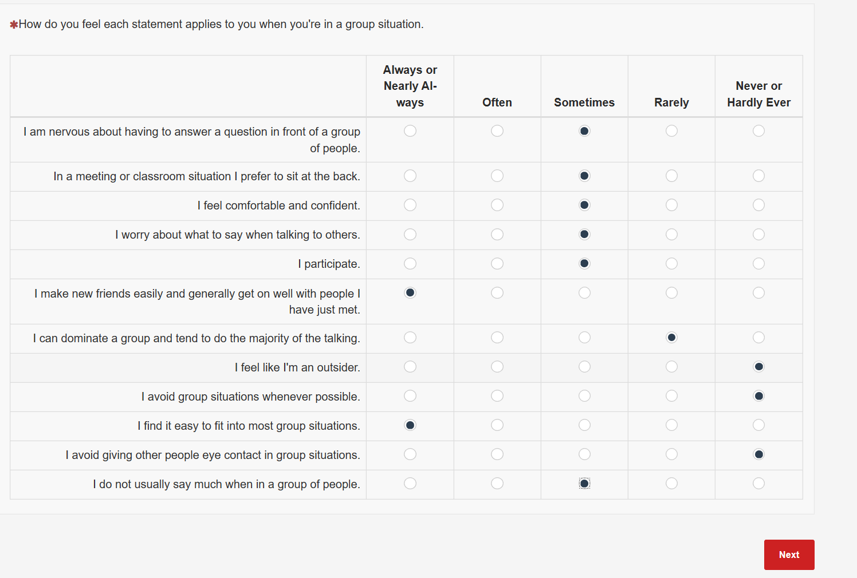
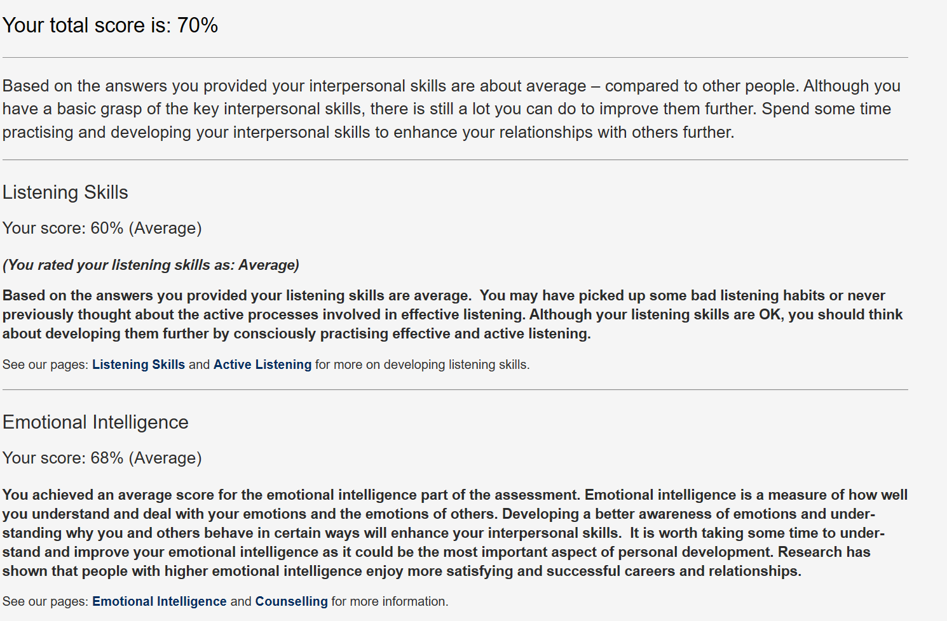
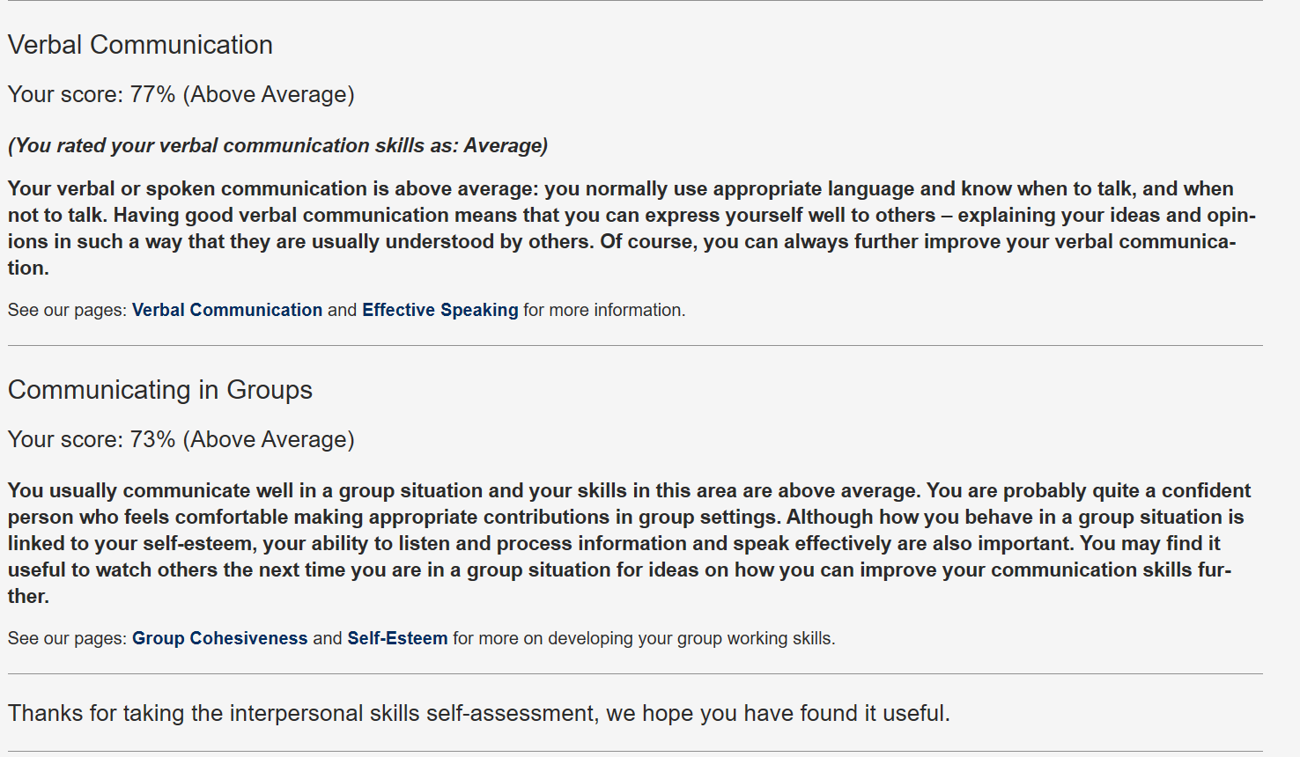

Mind Tools Communication Quiz

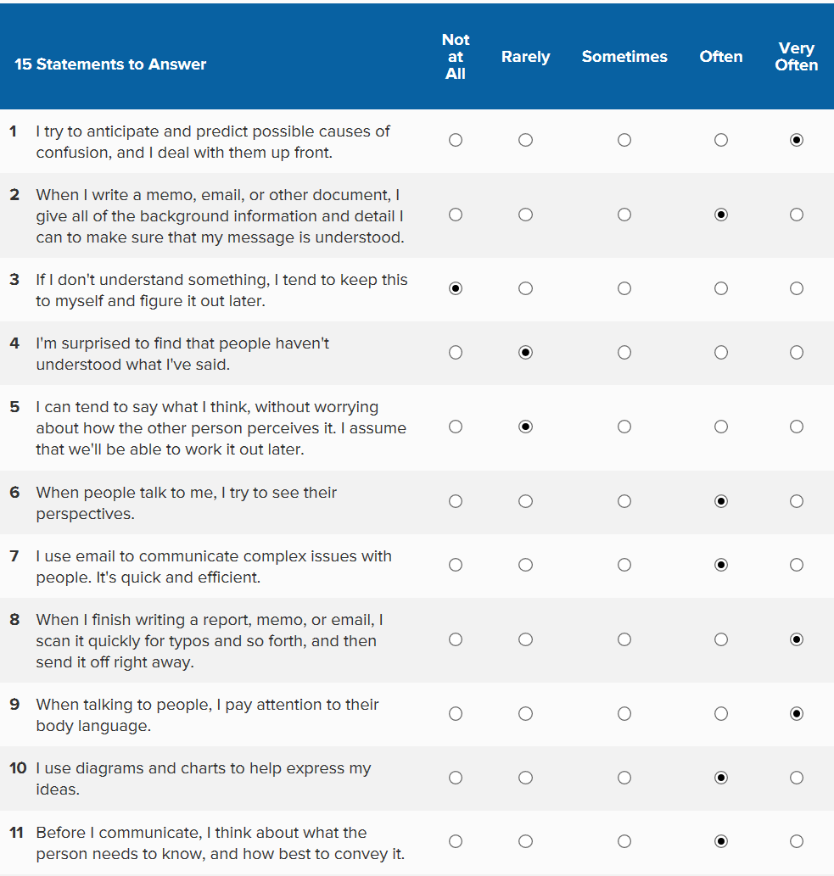
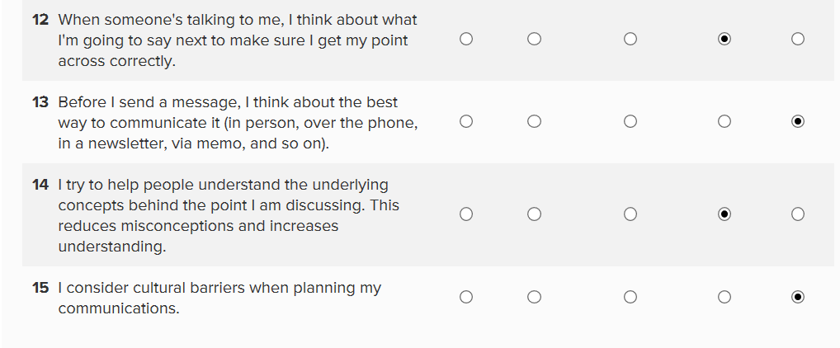
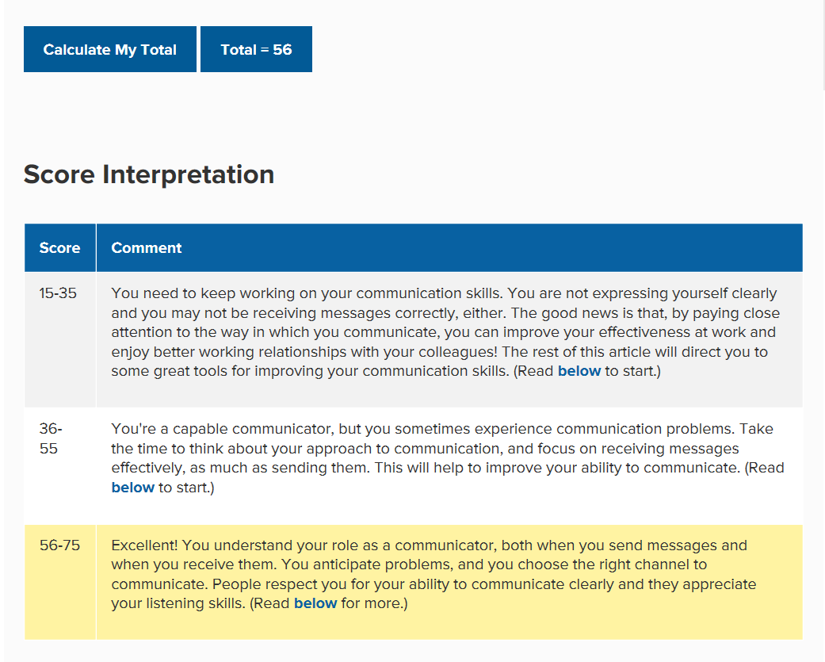
MindTools (2019) How good are your communication skills?



