Module: Corporate Governance and Social Responsibility
Module code: M6X00876
Title: CSR in the UK Water Companies
Lecturer: Manjit Biant
Student name:

Table of Contents
1.Introduction 3
2.Carroll’s pyramid of Corporate Social Responsibility 3
2.1 Economic responsibility in water companies 5
2.2 Legal responsibility in water companies 7
2.3 Ethical responsibility in water companies 8
2.4 Charitable responsibility in water companies 9
3.Sustainability issue of water provision 9
3.1 Contamination of bottled water 10
4.Conclusion 10
References 12

1.Introduction
The maximisation of enterprises' interests is the pursuit of every enterprise, especially economic interests, which can be divided into short-term interests maximisation and long-term interests maximisation. If an enterprise wants to be big, strong and long-term, it must better fulfil its corporate social responsibility. Although fulfilling corporate social responsibility may reduce short-term benefits, in the long run, fulfilling corporate social responsibility can improve the visibility of enterprises, achieve brand benefits, and thus improve the economic benefits of enterprises.
For private companies, corporate social responsibility can improve the relationship between enterprises and investment institutions, because investment institutions are more willing to cooperate with socially responsible enterprises (Brammer, Jackson and Matten, 2012). Secondly, corporate social responsibility can not only effectively prevent staff outflow, but also attract excellent employees and investment institutions. On the other hand, corporate social responsibility can improve the relationship between enterprises and employees. The image of employees is affected by corporate image and honour. Finally, fulfilling corporate social responsibility can improve the relationship between enterprises and consumers. Consumers realise their self-worth by pursuing corporate brand, thus improving their purchase intention and loyalty (Ghosh, 2015).
In this paper, private water companies to perform social responsibility analysis, using Carroll’s pyramid model analysis of corporate social responsibility of water companies. Secondly, through sustainable development and related issues, the future development direction of water enterprises is analysed. Based on the fulfilment of social responsibility by water companies, the utilisation rate of resources should be improved.

2.Carroll’s pyramid of Corporate Social Responsibility
In the past, enterprises were only responsible for the rights and interests of shareholders. Now, enterprises begin to emphasise the responsibilities of stakeholders, such as employees, consumers, government, etc. They pay more attention to the contribution of enterprises to society in the production process and the expectations of society to enterprises. In the 1970s, Carol (1979) put forward corporate social responsibility. He pointed out that in corporate social responsibility, the economic responsibility of enterprises is at the bottom and the most basic level, followed by the legal responsibility of enterprises at the second level, the ethical responsibility of enterprises at the third level and the voluntary responsibility at the highest level. Later, Carol (1991) made further amendments to the model, changed voluntary responsibility to charitable responsibility, and proposed a "pyramid" model of corporate social responsibility (Masoud, 2017). The four responsibilities in the model are not exclusive relationships, so it is only to show the order in which enterprises fulfil their social responsibilities.
ISO 26000, the guideline for social responsibility issued by the International Organization for Standardization (ISO) on November 1, 2010, has the most enormous significance in establishing a clear standard (SR) for corporate social responsibility (CSR) (Isaksson and Mitra, 2019), clarifying the meaning of corporate social responsibility worldwide, establishing the core content of corporate social responsibility, taking sustainable development of enterprises as the goal and society as the goal (Zhou and Zhang, 2002). The four words of responsibility are written into the strategic content and daily business activities of enterprises.

In 1991, Carol revised the model of corporate social responsibility. He changed conscious corporate responsibility to charity. Corporate responsibility can be divided into economic responsibility, legal responsibility, ethical responsibility and charitable responsibility (Tilt, 2016). This is the case with Carol's Pyramid Model of Corporate Social Responsibility (CSR).
The model emphasises that economic responsibility is an essential cornerstone for an enterprise to fulfil its other responsibilities. Since its inception, an enterprise has been trying to increase its economic value while fulfilling its social responsibility. The birth of the Carol Pyramid Model promotes the development of corporate social responsibility.

2.1 Economic responsibility in water companies
For the Carol Social Responsibility Model of Water Company, the specific analysis is as follows. From economic responsibility, water companies are required to safeguard their organisational interests and assume responsibility for the economic interests of shareholders. The process of privatisation reform of British water industry in the past ten years, Anglo Water Company, Southern Water Company, Thames Water Company, Southeast Water Company and Willia Water Company, which cover parts of London and most counties in southeastern and southern England, have nearly 200,000 customers (Whitehead and Read, 2013) . Among them, Thames Water is Britain's most significant water and sewage company, serving more than 15 million people, and the value of regulatory assets is close to 12 billion (Glendinning and Mitchell, 2010). Besides, bottled water consumption is increasing in the UK (Zhao, 2006). Nowadays, Nestle, Danone and Highland Springs make up the primary market of bottled water brands in the UK. For example, Nestle owns simple living and Paris water, Danone owns Fulvik and Evian.
According to the Zenith Global Water Beverage Report of 2019, UK drinking water consumption increased by 7% to 4.267 billion litres in 2018. According to the data, 87% of the market share is in ordinary bottled water, and 12% is in functional and flavour water (Zenith Global Water Beverage Report, 2019).
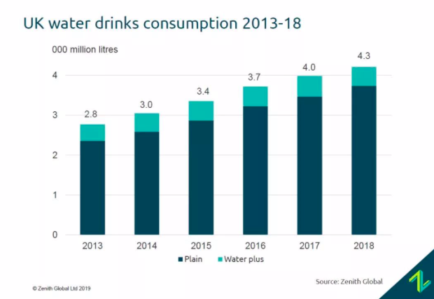
Figure 1. UK water drinks consumption 2013-2018
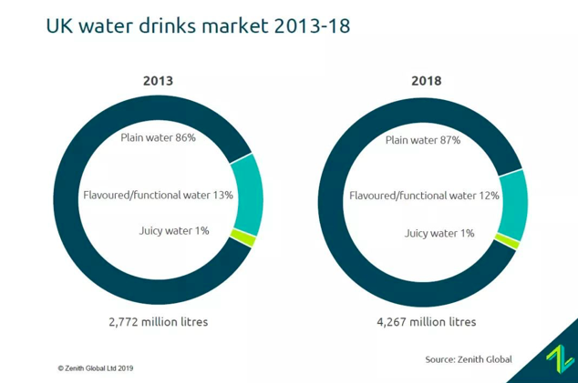
Figure 2. UK water drinks market 2013-2018
Secondly, Zenith Global expects that the drinking water market will continue to grow strongly, but at a slower rate than in recent years. Zenith Global forecasts an annual growth rate of 3-5% in 2023. So, bottled water becomes acquiring more attention in the UK (Zenith Global Water Beverage Report, 2019).

2.2 Legal responsibility in water companies
In addition to fulfilling the requirements of the Company Law and the Securities Law, the water company has established and improved the internal management and control system, formed a complete internal management system, and can provide qualified products in accordance with the law (Lombardo and Mucciarelli, 2017). In 2018, Ofwat, the UK Water Office, is investigating Southern Water's sewage treatment station performance and compliance information reports.
For example, under the combined influence of climate change and population growth, the water crisis has emerged in some parts of the UK. The UK government believes that the existing water management mechanism in the UK cannot fully adapt to this challenge (Coward, Tribe and Harvey, 2018). Therefore, the UK Department of Environmental Food Affairs has issued a white paper on water policy, Water for Life (Jin, Xia and Liu, 2015). This document provides comprehensive guidelines and measures for water intake, water industry, water environment management and water conservation.
Besides, Drinking Water Inspectorate is a public water supply company under the Department of Environment, Food and Rural Affairs of the United Kingdom responsible for providing safe and standardised drinking water for England and Wales. Headquartered in Whitehall, the agency provides annual reports on drinking water quality and related issues. The British Drinking Water Inspectorate is responsible for assessing the quality of drinking water in England and Wales. If drinking water does not meet the standard, it takes appropriate action to prevent the public from drinking water.

2.3 Ethical responsibility in water companies
In the water supervision mechanism, according to the principle of separation of powers, the supervision functions of environment, economy and drinking water quality are divided into three independent supervision departments. In order to avoid neglecting the quality of water in pursuit of interests, the Water Customer Service Commission in Britain, independent of government supervision agencies and municipal public utilities, represents the interests of consumers and supervises the operation and services of water enterprises, playing an extensive role in protecting the interests of consumers in the water industry.
For example, in order to ensure the safety of water supply, in order to ensure water quality, 476 sewage treatment plants have been built in the Thames River Basin. Sewage from the Thames River Basin must be treated before it can be discharged underground (Xu, 2013). This method effectively guarantees the ultimate pollution control of the Thames River. Finally, the relevant water sources meet quality standards. According to the report of the British Drinking Water Authority, the qualified rate of water passing through the Thames area is 99.98% after strict testing.

2.4 Charitable responsibility in water companies
British water authorities also pay attention to business openness and publicity and establish a lasting and reliable relationship of trust with the public. While striving to develop itself actively, the water company also takes into account charitable public welfare undertakings, actively participates in social public welfare activities such as science and education, health construction, community greening and beautification, donations and subsidies for needy students, and has achieved positive social effects.
Secondly, essential water companies will organize some public welfare activities of rare water resources to improve the protection of water resources and promote the sustainable development of water resources.

3.Sustainability issue of water provision
In the 15 years since the privatization of British water companies, water companies in England and Wales have compensated for past underinvestment in water infrastructure. To meet new water supply obligations and requirements, the company invested about $50 billion. Besides, the independence of regulation makes the operation of the aquaculture industry free from political interference. For the sustainable development of the aquaculture industry, privatized water companies create a stable business environment for investors. This model also provides a guarantee for the development of water and the quality of water (Tate, 2000).
For example, the quality of data acquisition has been significantly improved to make the company's operating expenses more economical. Water companies have also significantly improved the efficiency of customer service, including the quality of drinking water, river water and other daily water, and the indicators have been maintained at a high level.
Besides, Anglo Water has noticed a record drop in precipitation, with only two-thirds of the annual precipitation in 2011. Southern Water Company said that precipitation was also gradually minimal in the same period. A spokesman for Thames Water said: "We cannot control rainfall, but we can contribute to water conservation." "Closing the tap when brushing teeth can save 6 litres of water, and shortening the shower time by 1 minute can save 10 litres of water."

3.1 Contamination of bottled water
Since the first mineral water bottle appeared in 1967, it has become the world's most important beverage container because of its toughness, quality, air-tight, transparent characteristics, fast and huge glass. Now, however, these plastic bottles have also become the main culprits of environmental pollution. According to reports, by 2021, the annual consumption of mineral water bottles will reach 50 trillion bottles, which is far more than the number of recyclable bottles, and also threatens the fragile ecological environment all the time (Tukur et al., 2012). A million mineral water bottles can be sold around the world every minute. For example, the United States needs 17 million barrels of oil and 300 billion litres of water each year to produce plastic bottles. In Britain, 38.5 million mineral water bottles can be thrown away every day, but less than 14 million are recovered (Gray, 2008). Once in the ocean, it takes 450 years to decompose. In order to gradually end this pollution, the British industrial organization Water UK decided to put into free water filling stations, in addition to avoiding increasing the pollution caused by drinking mineral water bottles, but also allowing people to enjoy free drinking water.
Secondly, the natural spring brand Highland Spring will try out the new packaging of 100% rPET (Recycled Plastics) (Qi, Song and Tarverdi, 2009) bottles in the UK. This new plastic bottle aims to bring plastics into the circular economy and reduce plastic pollution. According to Zenith Global Bottled Water Report 2018, the company's performance in 2017 grew by 20.2%, ahead of Evian, which also plans to use 100% rPET packaging.

4.Conclusion
The Carol Pyramid Model has far-reaching significance to corporate social responsibility and has made outstanding contributions to the study of corporate social responsibility. The Carol Pyramid Model accurately expresses the connotation of corporate social responsibility and is widely recognized and accepted by the world. Through the above analysis, UK Water Company protects UK water development by fulfilling its social responsibility. At the same time, based on Sustainable development, Britain uses more bottled water using environmentally friendly materials to protect environmental development.

References
Brammer, S., Jackson, G., & Matten, D. (2012). Corporate social responsibility and institutional theory: new perspectives on private governance. Socio-Economic Review, volume 10(22), 3-28(26).
Carroll, A. B. (1979). A three-dimensional conceptual model of corporate performance. Academy of Management Review, 4 (4), 497-505.
Carroll, A. B. (1991). The pyramid of corporate social responsibility: toward the moral management of organisational stakeholders. Business Horizons, 34 (4), 39-48.
Coward, T., Tribe, H., & Harvey, A. P. (2018). Opportunities for process intensification in the uk water industry: a review. Journal of Water Process Engineering, 21, 116-126.

Ghosh, S. (2015). Is corporate social responsibility in india still in a confused state? — a study of the participation of the private sector companies of india in corporate social responsibility activities. Social Science Electronic Publishing, 16(1), 151-181.

Glendinning, D. J., & Mitchell, J. (2010). Uprating water-treatment works supplying the thames water ring main. Water & Environment Journal, 10(1), 17-25.

Gray, J. (2008). Water contamination events in UK drinking-water supply systems. Journal of Water & Health, 6 Suppl 1(S1), 21.

Isaksson, L. E., & Mitra, N. (2019). Iso 26000: the toyota motor corporation’s csr approaches in india.
Jin, H., Xia, P. & Liu, Q. (2015). Bright Points and Enlightenment of the Reform of British White Paper on Water Policy - Water for Life. China Water Conservancy (3), 62-64.
Lombardo, S., & Mucciarelli, F. M. (2017). Market soundings: the interaction between securities regulation and company law in the united kingdom and italy. Social Science Electronic Publishing.
Masoud, N. (2017). How to win the battle of ideas in corporate social responsibility: the international pyramid model of csr. International Journal of Corporate Social Responsibility, 2(1), 4.
Qi, K., Song, J., & Tarverdi, K. (2009). Influences of impurities in recycled plastics on properties of pim sandwich panels.
Tate, J. (2000). Water supply in the uk: towards a more sustainable future?. Sustainable Development, 8(3), 155-164.
Tilt, C. A. (2016). Corporate social responsibility research: the importance of context. International Journal of Corporate Social Responsibility, 1(1), 2.
Tukur, A., Sharp, L., Stern, B., Tizaoui, C., & Benkreira, H. (2012). Pet bottle use patterns and antimony migration into bottled water and soft drinks: the case of british and nigerian bottles. Journal of Environmental Monitoring, 14(4), 1237-1247.
Whitehead, P. G., & Read, D. S. (2013). A cost-effectiveness analysis of water security and water quality: impacts of climate and land-use change on the river thames system. Philosophical Transactions, 371(2002), 20120413.
Xu, J. (2013). Water Shortage and Water Safety Research in the UK. Water Conservancy and Hydropower Express, 34 (10), 19-21.
Zenith Global Water Beverage Report. (2019). UK Plain Bottled Water Report 2019. Retrieved from https://www.zenithglobal.com/reports_data/477/UK%20Plain%20Bottled%20Water%20Report%202019.

Zhou G.Y., & Zhang S.B. (2002). SA8000:2001 Guidelines for the Implementation of International Social Responsibility Standards. Haitian Publishing House.

Zhao, D. (2006). Consumer attitude and buying behaviour of university students toward bottled water in the UK.

