University Of Wales Trinity Saint David
School of Engineering

Engineering Project Technical Report
Workshop and Practice – ACHA4011

Student Name – Joshua Todd
Student Number – 2005986
Oct 2021

Contents
1 Introduction 1
1.1 Aims 1
2 Literature Review 2
2.1 Design 2
2.2 Marketing 2
2.3 Pre-Development planning 2
2.4 Team structure 2
2.5 The conduct of engineers 3
3 Methodology 5
3.1 Product development 5
3.2 Manufacturing process 5
4 Discussion 7
5 Conclusion 8
5.1 Product development 8
5.2 Personal career development 8
6 References 9

Figure 1 Showing the basic structure of the triad system (Jamey Austin, 2019) 3
Figure 2 Showing the differences between a Gantt chart and a PERT chart (Karlowitsch, 2018) 5

No table of figures entries found.

Introduction

Aims
This reports aim is to show understanding of the different departments that are involved in the development of a product and the department structure. This will be shown through research into the process that different departments undertake to get to the final product. The report will show how an engineering project includes much more than just a design engineer, also many other roles that an engineer may have to incorporate depending on the size of the development team.

The report will focus on the development of a ceramic mug used for the containment of hot beverages. This is a rather basic product, but it will be suitable to represent the different processes that are needed that any product will need to go through.

Literature Review

Design
One of the main areas involved in the development of any new product is the design team. The design team is important in any new development, this team is responsible for the initial use, and appearance of the product. The design team would normally either have members specialised in materials, costing and construction processes or work closely with them. The reasoning for this is that a design could be made that could be visually appeasing and could theoretically work, but the materials needed for the design could be unsuitable or wildly expensive for the intended product. The design may also not be possible due to current construction methods.

Marketing
There is also the marketing team that is equally important in the development of a new product. This team will consist of several team members such as, market research, costing, branding, sales, and personal relations. These members can have a large impact on the direction that the development will go in. this is due to if the product is going to be more expensive that the other competitors then it may not sell, same as if there is no market for the current direction of the product. This may mean that the design team need to change the intended use of the product, or to use different materials and construction processes.

Pre-Development planning
Prior to work starting on the development of any new project it is important to have pre-development planning. This part of the development is vital for the success of the overall project as a whole. When a new project is brought forward to be worked on there are members of the development team that may be looking to take the project in different directions. The most crucial part of the pre-development planning stage is to make all team members understand the overall scope of the project and the direction of approach to it. Without this understanding no matter how professional and polished the final product is, it will ultimately fail from the initial concept (Louise Møller Nielsen, 2013)

Team structure
When structuring an engineering team, it is important to understand that there is no ‘correct’ structure to the team. The team may go through many different changes from project to project, and as such need’s constant ‘tweaking’ of certain trade-offs. Although there are constant changes, most teams look to use a triad approach. Meaning that the three main areas have equal say in the development of the project. The only problem with this approach is the length of time that it takes to come to decisions. This problem is only made worse with larger teams, to combat this the basic triad model is used but inside other groups sometimes being called tribes. This has the effect of small teams being able to make decisions on their own matters quickly and then feeding this back into the larger tribe (Jamey Austin, 2019). The basic triad structure can be seen in figure 1.
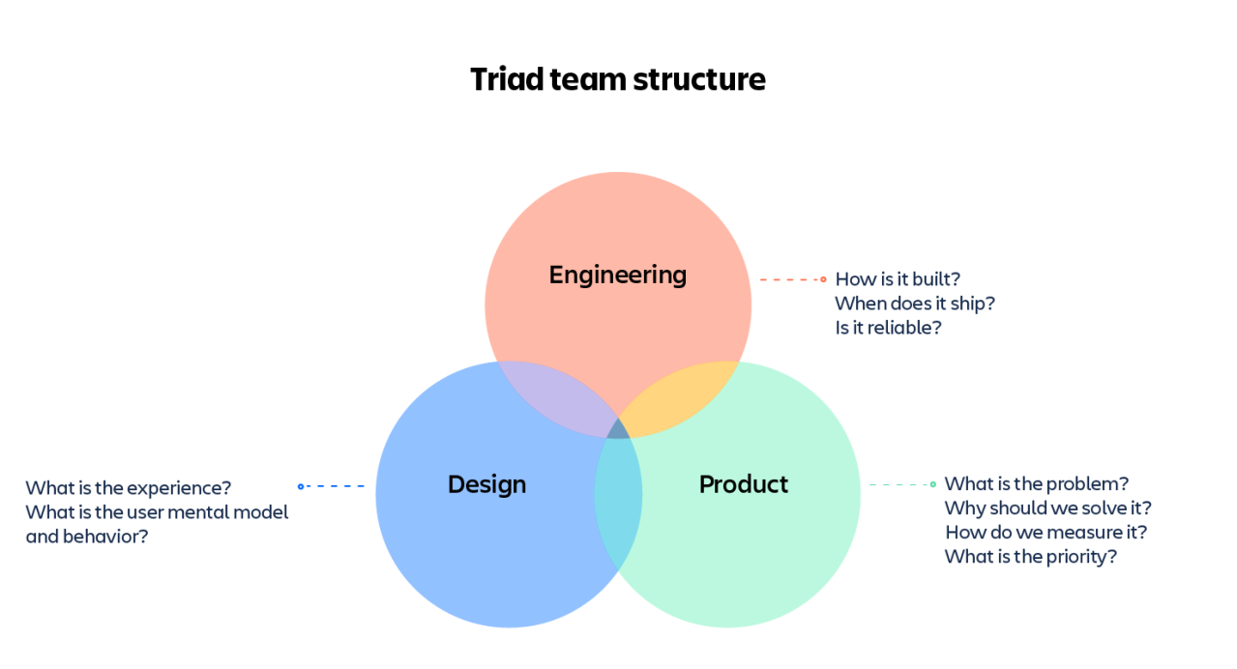
Figure 1 Showing the basic structure of the triad system (Jamey Austin, 2019)

The conduct of engineers
Due to the position that engineers are put in, development of everything from mugs to spacecraft, it is critically important that engineers have a solid code of conduct that they abide by.

The overuse of the term engineer for roles that do not require standard of educational learning has made the code of conduct hard to uphold in some circumstances. The reasoning being that every engineering qualification provided by a learning provider must be certified by an accredited body. This accredited body will make sure that any training will instil the correct code of conduct into all trainees.

There are some differences from awarding body to awarding body, but most of these differences are in the wording alone. The Royal Academy of Engineering and the Engineering Council made a joint document highlighting the code of conduct for an engineer in the current world climate. This includes honesty and integrity, respect for life, law, the environment and public good, accuracy and vigour, and leadership and communication (Engineering Council , 2017).

What this means in a brief explanation is that when engineers work, they must be as accurate as possible and always report the truth of the data, not personal or corporate opinion. Alongside this, engineers must understand the consequences of their actions, whether this means that there could be an environmental impact or ethical. As a professional, a constant learning process is required so that all the latest knowledge is known, in their field of expertise. That new improved practices are used, and not old inefficient or inaccurate ones used. Being able to successfully communicate all the above is also vital to being a professional engineer (Engineering Council , 2017).

Methodology

Product development
The first way that development would progress in is with the construction of a Gantt chart. A Gantt chart is normally use in newer practices over a PERT chart. A Gantt chart is laid out as a bar chart, this means that it is easier to break up tasks into smaller items and a more streamlined way of looking at the timeline. A PERT chart is laid out as a flow chart, this means that it is good at the initial stage of a development to show where every department should be converging at, at a set time. The team will use a Gantt chart as it is easier to show the daily passing of time in an effective way (Williams, 2021).

Figure 2 clearly shows the difference from the 2 charts, with a Gantt chart the days can be clearly ‘ticked off’. While with a PERT chart it is harder to tell at which point in time what task needs to be started or finished by.
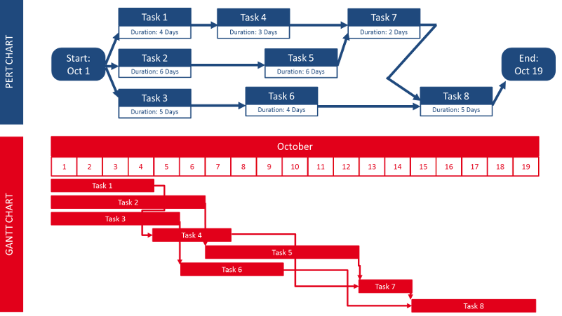
Figure 2 Showing the differences between a Gantt chart and a PERT chart (Karlowitsch, 2018)

Manufacturing process
The process that will be followed once the design of the mug has been completed is as follows. A prototype would be made from preferably plastic, as the plastic would not get damaged in the following process that follows. Next moulds would be created around the prototype, these would then be used for shaping the clay. Once in the moulds the clay would be left to harden in the moulds for a period of time. After the hardening the mug would be removed from the mould to be placed into the firing kiln to be heated till fully cured. Once this process has been completed the mug would then be coated in a glaze, after it has cooled, which would give the mug it’s finished look. The mugs would once again go through a second curing in a kiln to make sure that the glaze fully adheres to the clay (Planet Mugs, 2015).

Discussion
There are many health and safety risks related to the production of any ceramic item. Many of these risks can be reduced through responsible practices, these vary from using equipment that meets industry safety standards to having correct working procedures.

Some of the biggest concerns when working with clay on a large scale is the toxic gasses that can be released from the clay in the firing process. Due to the nature of clay, it can be mixed with a variation of different materials such as organic matter or sulphur compounds (Davis, 2021).

To ensure the smooth development of the team’s product, it would be inherit to ensure all correct procedures are followed. These would include correct ventilation to all kiln areas, with adequate PPE equipment (HSE, 03/2019). There are also several tests that would have to be taken to ensure that the product meets industry standards. These include tests to see if the ceramics ‘leak’ any of the potential harmful impurities that may still be in them after firing.

It has also been shown that clay mining can have a large impact on the local environment. This is caused by the methods of removal along with the reclaiming of the site once mining is finished. Clay mining can be harmful to surrounding waterways, with pollution of the impurities that are found in clay getting washed away into the local water sources. With the added negative affect from when clay pits are abandoned after mining, causing damage to local ecosystems (Kofi Asante-Kyei, 2016). It also poses an ethical issue as to making sure to secure a well-managed and sustainable source of clay.

Conclusion

Product development
The main issues that the team would have to face in the development of a ceramic mug would be, getting an ergonomic design for the mug, making sure that the physical construction process would meet health and safety standards, and finally securing raw materials from an environmental and ethically correct source.

Personal career development
The direction of my career that I would like to follow is as follows. Initially I would like to be lucky enough to get a graduate role in a major motorcycle manufacturer to gain valuable workplace experience and further learning in the direction of motorcycle design and manufacture. Once I have this experience, I would like to set up my own small company designing and manufacturing custom motorcycles from the ground up, such as companies like Thornton hundred motorcycles. These small companies make one of one custom motorcycles for a select client base (Thornton Hundred Motorcycles, n.d.).

References
Davis, S., 2021. Princeton University - Enviromental Health and Safety - Ceramics. [Online]
Available at: https://ehs.princeton.edu/health-safety-the-campus-community/art-theater-safety/art-safety/ceramics#sp
[Accessed 17 11 2021].
Engineering Council , 2017. Statement od Ethical Principles. [Online]
Available at: https://www.engc.org.uk/standards-guidance/guidance/statement-of-ethical-principles/
[Accessed 28 10 2021].
HSE, 03/2019. COSHH essentials in ceramics: Silica, London: Crown .
Jamey Austin, A. F., 2019. How should you structure your engineering team?. [Online]
Available at: https://www.atlassian.com/blog/technology/engineering-team-structure
[Accessed 28 10 2021].
Karlowitsch, M., 2018. What is a Gantt chart scheeduler. [Online]
Available at: https://blog.netronic.com/what-is-a-gantt-chart-scheduler
[Accessed 17 11 2021].
Kofi Asante-Kyei, A. A., 2016. The Economic and Environmental Impacts on Clay Harvesting at Abonko in the Mfantsiman West District of Central Region, Ghana. American Scientific Research Journal for Engineering, Technology, and Sciences , 18(1), p. 120.
Louise Møller Nielsen, C. T., 2013. Introduction. In: Creating Shared Understanding in Product Development Teams. 1st ed. London: Springer.
Planet Mugs, 2015. How Ceramic Mugs Are Made. [Online]
Available at: https://www.planetmugs.com.au/how-are-ceramic-mugs-made
[Accessed 17 11 2021].
Thornton Hundred Motorcycles, n.d. What We Do. [Online]
Available at: https://thorntonhundredmotorcycles.co.uk/what-we-do/
[Accessed 22 11 2021].
Williams, S., 2021. Advantages of PERT charts vs. Gantt charts. [Online]
Available at: https://www.lucidchart.com/blog/advantages-of-pert-charts-vs-gantt-charts
[Accessed 17 11 2021].

