Back Office document for trip to Finland

Trip Overview

The bespoke festival package is for a charity organisation called GirlGuiding to attend an international jamboree in Finland. The overall aim of the trip is to provide young people with the opportunity to travel together while gaining new skills and friendships in a safe environment while being exposed to cultural differences. The festival package is considered from the point of view of a guide leader taking a group of girls on the trip and also aimed for business to consumer. The goal of the package is to operate at cost on the lowest budget, due to the demographic of the consumer being parents wanting to send their children away on a trip. The trip is aimed to break-even so there will not be a profit made from this trip.

Target Market

The target market needs to be focussed on when promoting and gaining interest for the trip to ensure the tourist requirements are being meet. The demographic takes into consideration the market by dividing it into segments based on variables like age, gender, income, and generation (Kotler and Armstrong, 2016). Through using this method, it helps to identify the target market for the trip such as girls who are all in girlguides between the ages of 10 years and 18 years from the UK. The psychographic that considers the social class, lifestyle, and personality characteristics (Kotler and Armstrong, 2016) will be targeted. The type of person the trip is aimed towards is someone involved and committed to guiding, who is looking for adventure and willing to try new experience in ways that is not always comfortable to them. From considering Plogs tourist types, the type of tourist best suited to this trip is near allocentric tourist (Plog, 2001). This focus ensures the correct target market is covered and enables the trip to be best suited to the intended audience which will gain maximum interest.

Destination Safety

The destination of Finland is a safe location according to the Foreign, Commonwealth and Development Office (2022). The safety index of Finland is 86 with Helsinki ranked 9th on the list of safest cities in the world (Travel Safe Abroad, 2022). When taking young people away from their parents the safety of a country is a critical element to consider in order to put the parents’ minds at ease and feel satisfied with the risk element of their child going away.

Effects of Brexit

Another factor to consider about this location is Brexit, as this influences travel from the United Kingdom to countries in the European Union. The effect of this is communicated to the travellers to ensure there are no problems when entering the country. To travel to Finland on a UK passport a visa is not required if the stay is under 90 days (Foreign, Commonwealth and Development Office, 2022). Upon application it will be requested for the traveller to state the type of passport they have and if they have travelled to any Schengen countries in the 180 days before the assigned trip. This will help to avoid any problems that could occur at passport control and help the parents understand the process.

Covid

Covid 19 also adds another dimension to the travel industry. With the ever-changing rules and regulations, it is vital that those organising travel keep up to date and within the laws and guidelines set by the government. As 1st July 2022 those travelling from the UK will not need to present a negative covid 19 test or proof of vaccination (Foreign, Commonwealth and Development Office, 2022). As the covid 19 pandemic is an ongoing issue, the rules and guidelines can change quickly, and is unpredictable. This element would be communicated in detail to the parents if any changes were to occur before the trip so adaptions and plans could be made.

Another aspect covid has had on the travel industry is the lack of trust (Demir, Dalgic and Ergen, 2021). Through clear communication and understanding about this trip the trust needs to rebuild between the organisation and the parents. There had been lots of disruption over the past few years so confidence and trust needs to improve in the travel industry.

Health and Safety

There are health and safety considerations to make at each stage of the trip from the preplanning, start point of the trip to destination area, personal safety, and tourist health at the destination (Hunter-Jones and Hunter-Jones, 2007).

The safety when taking young people away is critical and everyone needs to obey the ratios of adults to children. Through an organisation this had to be strictly abided by a 1:10 ratio of adults to children (NSPCC, 2019). This is to help ensure that there is an appropriate number of adults to children present. For this trip there will be a maximum of 30 young people to 4 adults. In new environments it is important to have enough adults to look after the children and make sure they are always safe and do not get separated from the group while transferring on transport or on excursions. The safety precautions will be clearly communicated to the parents as they are entrusting their children to be well looked after by the organisation. Before the trip there will be a safety and expectations meeting with the children, parents and leaders going on the trip to discuss the arrangements and give every one peace of mind before the arrival at the airport.

During the registration process details will be collected from the parents about their child including a detailed medical form that will highlight any areas that might need to be addressed. This will ensure the group leaders are aware and prepared to handle any potential situation and protect the child and leaders involved. The group leaders will also have a detailed understanding of the itinerary along with the knowledge of key locations including the local pharmacies, hospitals, and supermarkets with an added understanding of how they would get to these locations should the situation arise. Along with this information the leader will have a contact back in the UK to correspond with should an emergency occur.
Planning of the tour

The trip will include arrival in Helsinki, Finland and transport to the Jamboree in Evo Hamennlinna, the ticket to the festival including all the costs involved, transport back to Helsinki, a Hotel in Helsinki and an excursion to see the sights in Helsinki before traveling back to London. All the participants will be expected to attend the excursion and any activities that take place in Helsinki.

The transport cost to and from Helsinki to the camp in Evo Hamennlinna is provided by the camp for all international participants (Kajo, 2022). The time it will take to travel between the two destinations is 2 hours.

While at the camp all costs, activities and food are all included in the price which is covered by the 320 euro camp fee. Once the group arrives at camp the leaders will be on hand to help with any issues or problems that may arise in the group, but the activities and day to day life will come under the responsibility of the camp co-ordinators. At the camp tents will be provided by GirlGuiding and the girls will be in tents of between 4 – 8 people per tent. The tents will be fully waterproof and in a good condition. The group will be put in a village with other groups from across the world but all individuals signed up to this trip will be kept together.

Itinerary

15th July
Time | Activity
5:00 am | Meet at Heathrow London Airport
7:30 am | Flight departs from Heathrow London
12:20 pm | Land in Helsinki Airport
1:15 pm | Transport from Airport to Camp
3:15 pm | Arrival at Camp

16th – 22nd July
16th – 24th | Camp activities

23rd July
Time | Activity
1:00 pm | Pick up from Camp
3:00 pm | Check into hotel
5:00 pm | River tour of Helsinki
7:30 pm | Meal out
9:00 pm | Transport back to hotel

24th July
Time | Activity
7:30 am | Breakfast
9:00 am | Leave Hotel for tour guide
1:00 pm | Tour ends
1:30 pm | Lunch
2:30-4:00 pm | Use of city bus
5:00 pm | Arrive at Airport
7:30 pm | Flight leaves Airport
8:40 pm | Flight arrives in London

Flights

There are many different flight options that could be selected. The flights chosen are with Finnair. This airline performed above average on reviews (Flight Report, 2023). This is important to investigate, especially when taking groups away. The flight times also need to be considered as the decision was made to fly in the morning on the 15th July which is the same day the camp starts. This saves on accommodation costs the night before and allows the participants to go straight to the camp. The Finnair flights matched this desired time schedule with the flight departing from London Heathrow at 7:30 am and arriving at Helsinki at 12:20 pm. The decision to depart from London Heathrow was agreed as it is a central location that can be accessed from different areas of the country. On return on the 24th July it was decided it would be a late flight to allow activities and excursions to take place in the day without occurring an additional night accommodation charge. The flight would leave at 19:30pm and return to London Heathrow at 20:40 pm. The pricing for this combination of flights also justified the timings and airline.

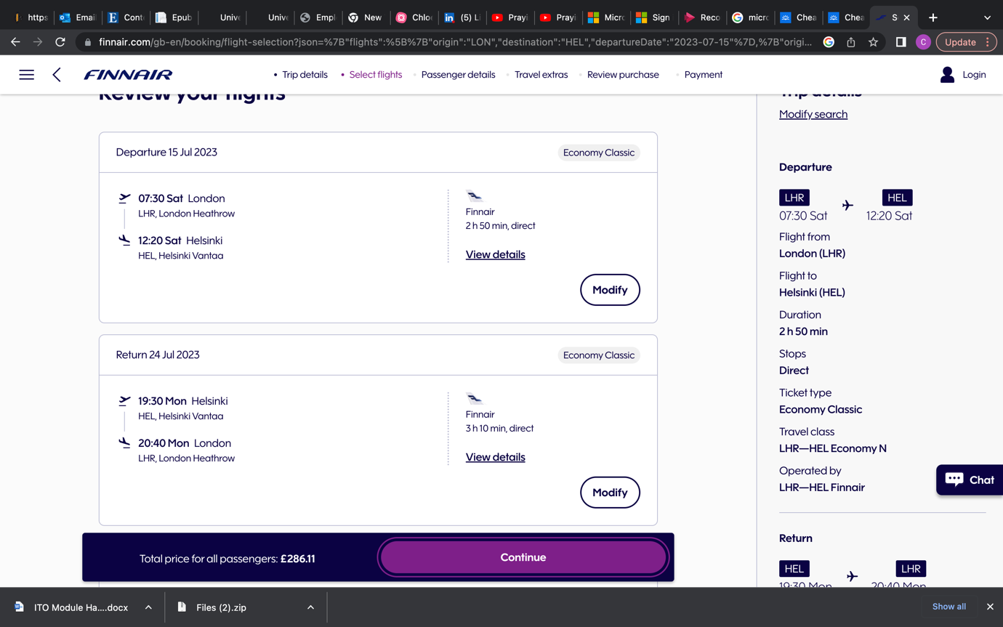

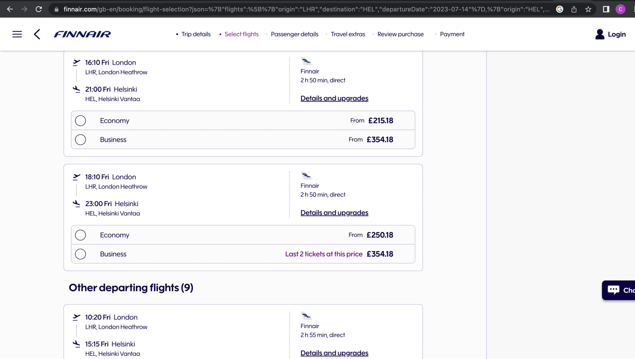

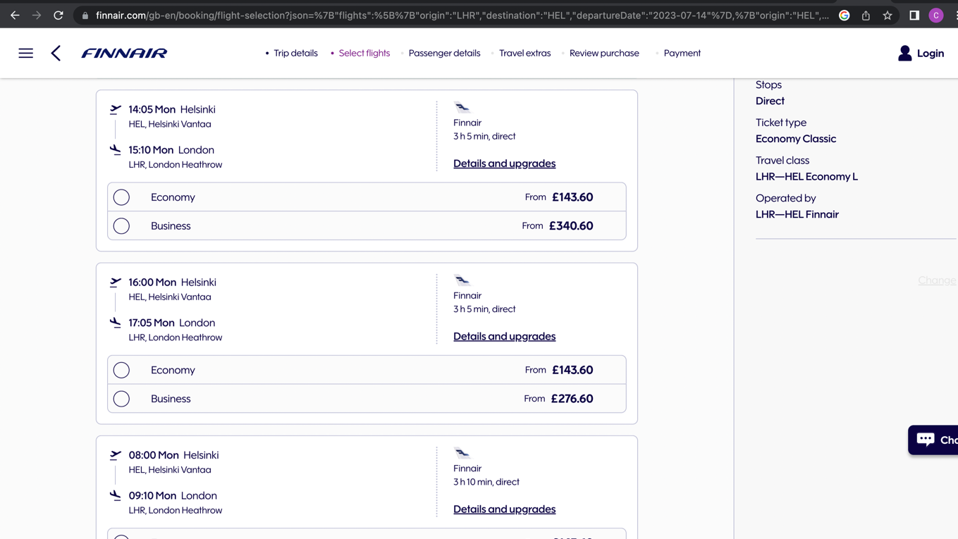
(Finnair, 2023)

The individuals will be expected to meet at London Heathrow at 4:00am on 15th July where they will be met by the leaders. Collection will be at 21:00 from Heathrow but updates will be given to those collecting their children if there are any changes.

Hotel

To add extra experiences for the group there will be a stay in the city of Helsinki after the camp. This will provide the opportunity to have a tour of the city and experience Finnish culture.

The hotel was chosen based on the cheapest price and the close proximity to the city centre of Helsinki. The reviews were also good which reflects the positive experience others have received and promoted. The chosen hotel is Omena Hotel Helsinki Lonnrotinkatu and will cost £20 for the night per person, based on 4 people sharing a family room (Hotels.com, 2023)

Other hotels were considered but the suitability was not correct for this particular group, based on different factors such as price, location and the market that the hotel was aiming to. It was also important to have a hotel where breakfast was available.

Activities in Helsinki

When considering the activities to take place in Helsinki it was important that they could fit into the tight time schedule planned. The arrival in Helsinki after the camp is 3:00pm which allows time to check into the hotel and ensure the group is settled, happy and all sorted. As it would have been a long day which including travelling and packing down from camp, the group will attend a river cruise that will show the various landmarks. Each group member will have a Helsinki by bus and boat 24 hour combo ticket that costs £41.75 (Get Your Guide, 2023). This means on the first day the boat tour will take place and on the second day the bus tour will happen which will give two different perspectives that can be observed, so getting the most out of this purchase.

Other options that were considered were the hop on hop off city tour bus that would cost £28.34 per person (City Sightseeing, 2023) or a half day walking tour that would cost £61.91 per person (Tripadvisor, 2023).

Dinner and Lunch in Helsinki

The group will be allowed to have a choice on where they would like to go for dinner and if they would like to split into two groups with the leaders. They are expected to have money to purchase their own food for these meals which will be communicated to the parents.

Finances

The total cost of this trip to the participants is £650 per person that will include the tickets to the camp, flights, travel and activities on the excursion days. The extra cost above the £637.11 shown in the table below is to account for inflation and any unexpected costs.

Camp ticket | 280 | (320 euro)
Flights | 286.11
Hotel | 20
Travel card | 9
Sight seeing | 42
Total | 637.11

The trip needs to be affordable for parents who are sending their children away, so much thought and time has been taken to focus on how the trip can be a success with limited finances in mind. The trip will aim to break-even but not make a loss. As GirlGuiding is not for profit this will be in line with their principles.

Communication

There will be open communication through the booking process and the contact methods will be easy to find and follow. There is a 48 hour response time for all enquiries aimed to be dealt with before this time. From the moment an individual enquires all the way through the process they will know there is someone dealing with their request who cares about them and their child. A profile will be kept with details of each correspondence that has taken place which all those dealing with correspondence have immediate access to. This ensures there is no crossover of information and details are kept of what has been discussed or requested. Regular emails will be sent with next steps and countdowns on the lead up to the trip. An online meeting will be held for both the parents and children before the trip to go over the details and an opportunity for the parents to ask any questions and the children to meet each other.
Packaging

The trip has two or more elements that are included in the cost such as tickets, accommodation and transport that makes it a package (Cook et al, 2014). The package aims to make the trip more affordable therefore enhancing the convenience (Getz, 2005). This trip would come under the group tour, as everyone is purchasing the same trip for the event that will be attended by all, which will form the main attraction (Getz, 2005). The trip is also protected by ABTA and ATOL. The ATOL protection is a financial protection when a package is booked which includes a flight (ATOL, 2023). This helps to give the customer peace of mind when booking, as it means there is protection from losing money or being stranded abroad should something happen to their holiday (Beaver, 2012). The ABTA element also provides another element of security and trust with the customer. ABTA provides advice, guidance and support while providing trust between the company and customer, as a code of conduct has been signed to agree to service standards, accurate advertising and fair trading (ABTA, 2023b)

Cancellation Policy

According to the company’s cancellation policy no refunds will be given once the sign up and payment process has been completed.

Insurance

The trip will be covered by group travel Insurance that will cover aspects like cancellation, accidents or injury and personal baggage. The travel insurance provides security and peace of mind to those travelling (Syratt and Archer, 2003).

Bibliography

ABTA (2023) ABTA events booking terms and conditions. Available at: https://www.abta.com/events/abta-events-booking-terms-and-conditions (Accessed: 12th January 2023)

ABTA (2023b) Who we are. Available at: https://www.abta.com/about-us/who-we-are (Accessed: 25th March 2023)

ATOL (2023) What is ATOL Protection? Available at: https://www.atol.org/about-atol/what-does-atol-protection-mean/ (Accessed: 25th March 2023)

Beaver, A. (2012) A Dictionary of Travel and Tourism. Oxford: Oxford University Press

City Sightseeing (2023) Helsinki Hop-on Hop- off Sightseeing Tours. Available at: https://city-sightseeing.com/en/40/helsinki (Accessed: 15th November 2022)

Cook, R.A. et al. (2014) Tourism The Business of Hospitality and Travel. Harlow: Pearson Education Limited

Demir, M., Dalgic, A. and Ergen, A.D. (2021) Handbook of Research on the Impacts and Implications od COVID-19 on the Tourism Industry. Pennsylvania: Business Science Reference

Finnair (2023) Finnair. Available at: https://www.finnair.com/gb-en/booking/flight-selection?json=%7B%22flights%22:%5B%7B%22origin%22:%22LHR%22,%22destination%22:%22HEL%22,%22departureDate%22:%222023-07-14%22%7D,%7B%22origin%22:%22HEL%22,%22destination%22:%22LHR%22,%22departureDate%22:%222023-07-24%22%7D%5D,%22cabin%22:%22MIXED%22,%22adults%22:1,%22c15s%22:0,%22children%22:0,%22infants%22:0,%22directFlights%22:false%7D (Accessed: 15th November 2022)

Flight Report (2023) Passenger reviews on Finnair. Available at: https://flight-report.com/en/airline/2349/finnair/#:~:text=Finnair%20is%20a%20Finnish%20carrier,average%20rating%20of%207.3%2F10. (Accessed: 3rd May 2023)

Get Your Guide (2023) Helsinki by bus and boat 24-hour combo ticket. Available at: https://www.getyourguide.com/helsinki-l13/helsinki-grand-tour-by-land-and-sea-t74941/ (Accessed: 15th November 2022)

Getz, D. (2005) Event Management & Event Tourism. 2nd edn. New York: Cognizant Communication Corporation.

Hotels.com (2023) Omena Hotel Kelsinki Lonnrotinkatu. Available at: https://uk.hotels.com/ho425175/omena-hotel-helsinki-lonnrotinkatu-helsinki-finland/?bedroom_count_gt=&chain=&chkin=23%2F7%2F2023&chkout=24%2F7%2F2023&dateSelectedByUser=false&daysInFuture=&destType=MARKET&destination=Helsinki%2C%20Uusimaa%2C%20Finland&endDate=24%2F7%2F2023&expediaPropertyId=5657252&gclid=Cj0KCQjwpPKiBhDvARIsACn-gzA8L_Ek0udp5xJwn5oTMtwnfv0m2eH6sdMeYNGGIsmgMEW3XclCkLQaAkEiEALw_wcB&group=&guestRating=&highlightedPropertyId=&hotelName=&latLong=60.169857%2C24.938379&misId=&neighborhood=&neighborhoodId=6278775&petsIncluded=false&poi=&pricing_group=&pwa_ts=1683821669593&referrerUrl=aHR0cHM6Ly91ay5ob3RlbHMuY29tL0hvdGVsLVNlYXJjaA%3D%3D&regionId=&rfrr=HSR&rm1=a2&roomIndex=&selected=5657252&selectedRatePlan=207390503&selectedRoomType=200325534&semcid=HCOM-UK.UB.GOOGLE.PT-c-EN.HOTEL&semdtl=a115310585361.b1133997136150.g1kwd-11708654320.e1c.m1Cj0KCQjwpPKiBhDvARIsACn-gzA8L_Ek0udp5xJwn5oTMtwnfv0m2eH6sdMeYNGGIsmgMEW3XclCkLQaAkEiEALw_wcB.r19208f7680dfc0210736c870f3b052946b1c2de5011c3f772a2b041dfbaad7833.c1aYdqLlU6CABWMiAWJuN4vg.j11007460.k1.d1566400442712.h1e.i1.l1.n1.o1.p1.q1.s1.t1.x1.f1.u1.v1.w1&sort=RECOMMENDED&startDate=23%2F7%2F2023&stayLength=&theme=&top_cur=GBP&us_bathroom_count_gt=&useRewards=false&userIntent=&vacationRentalsOnly=false&x_pwa=1 (Accessed 6th May 2023)

Hunter-Jones, J. and Hunter-Jones, P. (2007) ‘Managing health and safety on international school trips’, Management in education. 21(1), pp. 8 -14

Kajo (2022) For group leaders. Available at: https://kajo2022.fi/en/international-participants/for-group-leaders-individual-ists/ (Accessed: 18th November 2022)

Kotler, P. and Armstrong, G. (2016) Principles of marketing. 16th edn. Harlow: Pearson Education Limited

NSPCC (2019) Recommended adult to child ratios for working with children. Available at: https://learning.nspcc.org.uk/research-resources/briefings/recommended-adult-child-ratios-working-with-children#article-top (Accessed: 27th November 2022)

Plog, S. 2001 Why destinations areas rise and fall in popularity. Cornell Hotel and Restaurant Administration Quarterly , 42(3) pp.13-24

Syratt, G. and Archer, J. (2003) Manual of travel agency practice. Oxford: Elsevier Butterworth – Heinemann.

Travel Safe Abroad (2022) Finland. Available at: https://www.travelsafe-abroad.com/finland/ (Accessed: 27th November 2022)

Tripadvisor (2023) Private Walking Tour: Helsinki in Half a Day. Available at: https://www.tripadvisor.co.uk/AttractionProductReview-g189934-d11991365-Private_Walking_Tour_Helsinki_in_Half_a_Day-Helsinki_Uusimaa.html (Accessed: 23rd November 2022)

Picture List

ABTA (2023) ABTA Travel with Confidence. Available at: https://www.abta.com/ (Accessed: 12th May 2023)

Ahlers, K. (2023) Teenagers jumping off a dock at Lake Ranuanjarvi in Finland. Avaliable at: https://www.dreamstime.com/teenagers-jumping-off-dock-lake-ranuanjarvi-finland-two-teenagers-boy-girl-jumping-off-wooden-pier-lake-image164676311 (Accessed: 8th May 2023)

Black, C. (2023) Outdoor. Available at: https://unsplash.com/s/photos/outdoor (Accessed: 8th May 2023)

CAA (2023) Civil Aviation Authority. Available at: https://www.caa.co.uk/ (Accessed: 13th May 2023)

Datalignum (2020) Available at: https://www.datalignum.com/content/31/6227/the-prince-of-wales_uk:-interest-in-forest-bioeconomy-initiated-a-plan-to-invest.html (Accessed: 24th April 2023)

Eller, F. (2018) Join the adventure. Available at: https://scouts.fi/join/ (Accessed: 3rd May 2023)

GirlGuiding (2023) Girlguiding. Available at: https://www.girlguiding.org.uk/ (Accessed: 12th May 2023)

Hodgson, R. (2017) Adventure: The Best Way to Learn. Available at: https://ryanintheus.com/adventure-quote/ (Accessed: 12th May 2023)

Oksanen, S. and Pakarine, S. (2016) Campers innovate new products from UPM materials at the Roihu 2016 jamboree. Available at: https://www.upmtimber.com/whats-new/2016/campers-innovate-new-products-from-upm-materials-at-the-roihu-2016-jamboree/ (Accessed: 14th May 2023)

