
MSc Public Health and Social Care in Practice
Module: Health Care System Organisation and Leadership
Module code: LCHS7002
Assessment Title: “A Systems Thinking Analysis of Medication Safety: Evaluating Leadership, Governance, and Human Factors in the Case of an Unintentional Morphine Overdose”
Lecturer: Tonia Babalola
Student Name: MD MOTIUR RAHMAN
Student Number: 2518275
Word Count: 4935
Submission Deadline: 21st April 2026

Table of Contents
1.0 Introduction: 1
1.1 Leadership Character in Health/ Social Care: 1
1.2 Theories of Leadership and Dynamics of Structure: 1
1.3 Importance of leadership in crisis and change: 1
1.4 Scope of the Report 2
2.0 Identifying the problem and establishing the system context 2
2.1 Theoretical issue: Drug Safety and Communication Breakdown 2
2.2 Statistical Situation on the World Level: WHO 3
2.3 National Statistical Background: NHS and UK Statistics 3
2.4 Comparisons across nations: IHI and OECD Measures 4
2.5 Weaknesses in the system and governance levels: 4
2.6 Background issues: personnel and budgets 4
2.7 The Rich Picture: Mapping the complexity 5
3.0 Analysis of Centralisation and Decentralisation in Medication Safety 5
3.1 Centralised Systems: Top-Down Control and Standards 5
3.2 Decentralised Systems: Local Authority and Adaptability 6
3.3 Critical Analysis: Structure and Accountability 7
3.4 Numbers and Measures: 7
4.0 Leadership Theories and Application to the Case Study: 7
4.1 Situational leadership: The Mismatch of Style and Context 7
4.2 The Leadership of Burden of Compliance and Transactional Leadership: 8
4.3 Distributed Leadership: The Breakdown of Shared Responsibility 9
4.4 Effectiveness and Safety of Leadership: 10
4.5 What would you do differently? 10
5.0 Improvement and Lessons Learned 10
5.1 Relationship between Leadership and Governance: 10
5.2 Determination of Problems, Unrealised Opportunities and Solutions: 11
5.3 Connection between System Structure, Leadership and Feedback: 12
5.4 Other Health Organisation Lessons: 12
5.5 Evidence and data continuously improve: 13
6.0 Recommendations for Sustaining Improvement in Medication Safety 13
7.0 Conclusion 16
Reference 17

Contents of Figure
Figure 1:Charcot-Marie-Tooth 2
Figure 2: Swiss Cheese 3
Figure 3: Situational leadership 8
Figure 4: Distributed Leadership 9

1.0 Introduction:
Smooth assimilation of clinical knowledge and strong organisational leadership are essential to the maintenance of patient safety in sophisticated healthcare systems. This report focuses on a critical patient safety investigation concerning the case of Len, an 89-year-old patient with Charcot-Marie-Tooth (CMT) disease, who died due to an accidental morphine overdose caused by systemic communication failures and misunderstandings related to labels (HSSIB, 2022). This analysis is aimed at assessing the role of leadership failure in worsening adverse events and the ways strategic management can reduce the risks.

1.1 Leadership Character in Health/ Social Care:
The process of influencing others to accomplish shared goals is defined as 'leadership in health and social care', which is mainly patient-centred care and safety (West, 2021). The skills of a leader involve the capacity to influence a shared vision among multidisciplinary teams, unlike the mere management skills. Within the setting of the National Health Service (NHS) of the UK, leadership is the key that helps connect clinical guidelines with humane care, and in this case, practitioners are on alert when patients undergo critical transitions of care (Care Quality Commission, 2023).

1.2 Theories of Leadership and Dynamics of Structure:
The effectiveness of leadership is usually determined by whether it is centralised, whereby the decision-making authority is held at the top, or decentralised, whereby the frontline staff is empowered to make independent clinical decisions.
- Transformational Leadership: It focuses on inspiring employees using a common vision and is very effective in influencing them to change the culture in the long term.
- Transactional Leadership: It is based on a reward and punishment system; it can be beneficial in the context of simple compliance, but in case of complicated crises, it may not help (Al-Ahmadi, 2024).
- Situational Leadership: It is a belief that there is no best style, but leaders should be able to change their leadership style according to the maturity and competence of their team (Northouse, 2024).

1.3 Importance of leadership in crisis and change:
Choosing a suitable leadership style is very important at the time of crisis or transition in an organisation. The ineffective execution of the concept of safety netting in the case of Len may indicate a necessity of distributed leadership wherein the responsibility to understand patients is distributed and is not localised (Department of Health and Social Care, 2024). To achieve immediate safety measures during a crisis, the leader has to switch between a visionary and a decisive, transactional role, but a balance between this and the empathy needed to help grieving families and distressed employees is crucial.

1.4 Scope of the Report
This report will also investigate the systemic vulnerabilities identified in the HSSIB investigation. It will discuss the ways in which human factors can influence medication safety, how organisational culture can influence error reporting, and how the latest leadership theories can be used to prevent future deaths in geriatric care.

2.0 Identifying the problem and establishing the system context

2.1 Theoretical issue: Drug Safety and Communication Breakdown
One such heartbreaking experience is the tragic death of an 89-year-old man named Len who suffered from Charcot-Marie-Tooth (CMT) disease, a condition that significantly compromises the whole system of outpatient medication management. The underlying concern is more than a mere label confusion; it is a breakdown of the healthcare system in its efforts to offer a vulnerable patient sufficient safety netting through a risky change of care. The accidental overdose of morphine oral solution among Len was due to the failure of the clinical interface, i.e., the GP, the hospital, and the pharmacy, to provide a functional comprehension of a strong opioid to both the patient and his carer (HSSIB, 2022). This local outbreak is a small part of a larger, global crisis of patient safety.
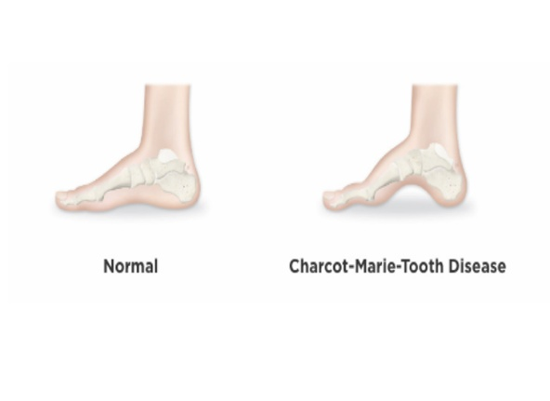
Figure 1:Charcot-Marie-Tooth
Source: orthofixkids

2.2 Statistical Situation on the World Level: WHO
Medication errors do not only occur in the UK but are a worldwide health issue of concern. According to the World Health Organization (WHO), medicine-related harm is the most prevalent cause of healthcare harm that can be avoided in healthcare systems all over the world. The annual cost of medication errors is estimated to be about 42 billion euro globally, about 1% of the global health spending (WHO, 2022). Moreover, according to the WHO (2021), the percentage of adverse drug events (ADEs) is quite a lot higher in low-to-middle-income countries, but even in such high-income countries as the UK, about every 20 patients experience preventable harm caused by medication. The case of Len is consistent with the trends in the world where the elderly, especially those with complex comorbidities, are disproportionately harmed by variations in dosing in a liquid formulation.

2.3 National Statistical Background: NHS and UK Statistics
The magnitude of medication errors in the NHS is mind-blowing, nationally. The University of Manchester research (and often used in NHS England policy) indicates that each year in England, at some point in the medication process, around 237 million medication errors occur (NHS England, 2023). Although most of these errors do not cause any harm, an estimated 66 million are clinically significant.
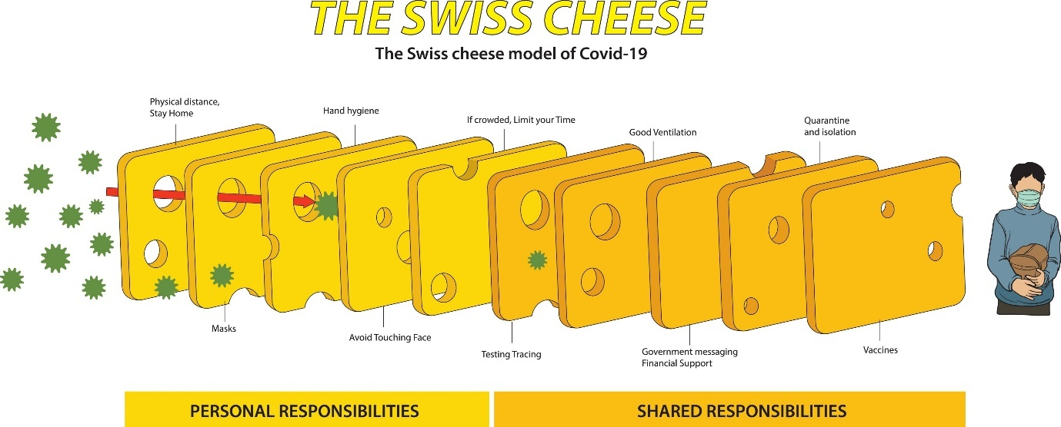
Figure 2: Swiss Cheese
According to the statistics published by the Care Quality Commission (CQC, 2023), the points of the highest risk are the ones related to transfer of care, i.e., the discharge from the hospital to home, which Len had. Additionally, polypharmacy is more common in geriatrics (ages 80+), and polypharmacy increases the risk of ADEs in geriatrics by 300% relative to young cohorts, but the leadership strategies tend not to exercise the specialised management necessary to provide geriatric care (Office for National Statistics, 2024).

2.4 Comparisons across nations: IHI and OECD Measures
The Institute of Healthcare Improvement (IHI) and the OECD are the sources that give a comparative perspective on the performance of the UK in relation to its global counterparts. According to IHI data, the two most challenging areas to attain "Zero Harm" are related to diagnostic and medication management (IHI, 2024). In the UK, the OECD (2023) notes that the primary care patient safety incident rate is similar to other G7 countries, but specifically, the country has difficulties with the communication-based mistakes. The statistics provided by the IHI Global Trigger Tool data indicate that almost every 15th admission to a hospital has some type of medication discrepancy, which also reflects the "misunderstanding" that claimed Len.

2.5 Weaknesses in the system and governance levels:
The case brought before Len shows that there are deep-rooted systemic flaws in communication, accountability, and leadership.
- Communication: The problem with communication was a breakdown in the closed-loop model of communication. The prescriber (GP) thought the pharmacist would clarify the dose; the pharmacist thought the label was adequate, and the hospital thought the home scenario was stable.
- Accountability: There was a lack of accountability in both local (the GP practice and community pharmacy) and regional (the Integrated Care Board, or ICB, charged with the responsibility of managing safe prescribing practices) governance.
- Leadership: There was no review of an 89-year-old initiating high-risk opioids by an expert in this area, which may indicate a failure in resource allocation and risk stratification, which can be linked to leadership.

2.6 Background issues: personnel and budgets
The system is experiencing a lot of pressure. As of 2024/25, the NHS had around 4,200 full-time equivalent doctors short of GPs who are unable to adequately meet the increasing number of patients requiring consultations, resulting in less time for the latter to listen to the former and provide detailed dosing instructions (Department of Health and Social Care, 2024). Budgetary restrictions have also hindered the implementation of home-based "Medicine Use Reviews" (MURs) that would have detected the lack of understanding in Len within 24 hours of the first dose.

2.7 The Rich Picture: Mapping the complexity
In order to see how these factors interacted, we employed a rich picture. These systems thinking tool describes the messiness of the reality of the situation that Len is in and reveals the tension between the clinical urgency of pain relief and the structural failure of clear labelling and carer support.
In this rich picture we can distinguish the following:
- Feedback Loops: The wife – the GP does not have a feedback loop to verify the dose.
- Communication Gaps: The unseen gap between the pharmacy dispensing box and the bottle label of the manufacturer.
- Dependencies: Len was totally reliant on the interpretation of a complex medical label in high stress by his wife to survive.

3.0 Analysis of Centralisation and Decentralisation in Medication Safety
The tragic experience of Len illustrates a deep conflict between centralisation and the decentralisation of policymaking and clinical delivery realities. In the National Health Service (NHS), there is a hybrid structure for medication safety, which often places vulnerable patients in the policy-practice gap. The most important thing to understand about this system is whether it was a centralised or a decentralised organisation to find out why the safety mechanisms did not work to avert the morphine overdose of Len.

3.1 Centralised Systems: Top-Down Control and Standards
In a centralised healthcare system, national or high-level organisational levels concentrate decision-making power and policymaking (Walshe and Smith, 2021). The NHS has a very centralised clinical safety standards model and medication labelling regulations, as in the case of Len.
- Decision-Making Concentration: The national authorities, like the Medicines and Healthcare products Regulatory Agency (MHRA) and the National Institute of Health and Care Excellence (NICE), have strict guidelines with regard to the prescription and labelling of morphine. As an illustration, the NHS Patient Safety Strategy (2023) offers a centralised approach all trusts have to adhere to in terms of Never Events and reporting medication errors.
- Advantages in Len's Case: Centralisation guarantees uniformity. Should the MHRA enforce a certain warning on morphine bottles, it would be applicable to all the pharmacies in the UK and ensure that safety information is similar.
- Disadvantages of centralisation in Len's case include: The main drawback of centralised systems is that they are rigid. Centralised labels are typically created to be clinically accurate and not patient-readable. The problem that Len and his wife experienced was with the label on the bottle provided by the manufacturer: it was preset by centralised regulations that did not take into account the cognitive and visual demands of an 89-year-old carer (HSSIB, 2022).
- Data Support: National data published by NHS Resolve (2024) shows that claims related to medication errors constitute approximately a quarter of all clinical negligence claims in primary care, meaning that the top-down standards will not help to eradicate the risk at the frontline.

3.2 Decentralised Systems: Local Authority and Adaptability
A decentralised system is one where authority and decision-making are devolved to the locals, like individual GP practices, community pharmacies, or a particular hospital ward (Gopee and Galloway, 2022).
- Power Sharing: Len's journey completely decentralised the decision on how to explain the medication. The GP and the pharmacist were at liberty to determine whether Len should be visited at home, make a phone follow-up, or have a simplified dosing schedule.
- Advantages in the case of Len: decentralisation gives the opportunity for personalised care. The local pharmacist, who knows Len and his wife and would have recognised their lack of understanding, could have disregarded the standard procedure by providing the pre-filled oral syringe to them, which would have significantly reduced the risk of a 10-fold dosing error.
- Disadvantages in the Case of Len: The greatest risk of decentralisation is the so-called silo effect. Since the GP, the hospital, and the pharmacy were independent and decentralised, there was no particular leader who would have ensured the patient's holistic understanding of the treatment plan. This led to a diffusion of responsibility, as both the GP and the pharmacy assumed that the other had confirmed the dosage (HSSIB, 2022).
- Data Support: On the basis of OECD (2023) measures, the more decentralised health systems tend to have higher patient satisfaction but greater incidences of unintended variance in safety outcomes. The CQC (2023) in the UK discovered that almost three out of ten pharmacies did not regularly achieve the standard of an effective patient consultation when handing over high-risk medications.

3.3 Critical Analysis: Structure and Accountability
The conflict of these two structures was a direct obstacle to dealing with crises in the case of Len. The centralised nature of the medication labelling gave the providers a false sense of security, as they believed that the regulatory labels would be enough. The decentralised transfer of care meant that providers had no responsibility to each other.

3.4 Numbers and Measures:
National measures of safety performance reveal the effects of this structural failure. The NHS England (2023) found that the 18% higher rate of medication-related readmissions in the most fragmented (decentralised) primary care versus integrated systems is found in the districts. In addition, staff ratios also help; on the one hand, in the regions with the GP-to-patient ratio of more than 1:2,200, the time allocated to the process of safety netting discussions, i.e., explaining morphine doses, decreases on average by 40% (Department of Health and Social Care, 2024).
This system failed in Len's case because it was centralised when it needed to be flexible (regarding the labels) and decentralised when it required unification (in the communication of the plan). This structural incompatibility meant that even with all the policies in place, there was no unifying leadership capable of correcting the mistake before it was too late.

4.0 Leadership Theories and Application to the Case Study:
The avoidable death of Len demonstrates that there is a gap of utmost importance between clinical competence and leadership effectiveness. Leadership in healthcare is not just an administrative role; it is vital to patient safety. In the case of Len, it is possible to state how certain styles of management either contributed to securing the safety net that was meant to safeguard vulnerable patients against drug error or corrupted it.

4.1 Situational leadership: The Mismatch of Style and Context
According to the Situational Leadership Theory, a successful leader should change his style (directing, coaching, supporting and delegating) depending on the readiness and competence of the people he/she is leading in this situation, the patient and the carer (Northouse, 2024).
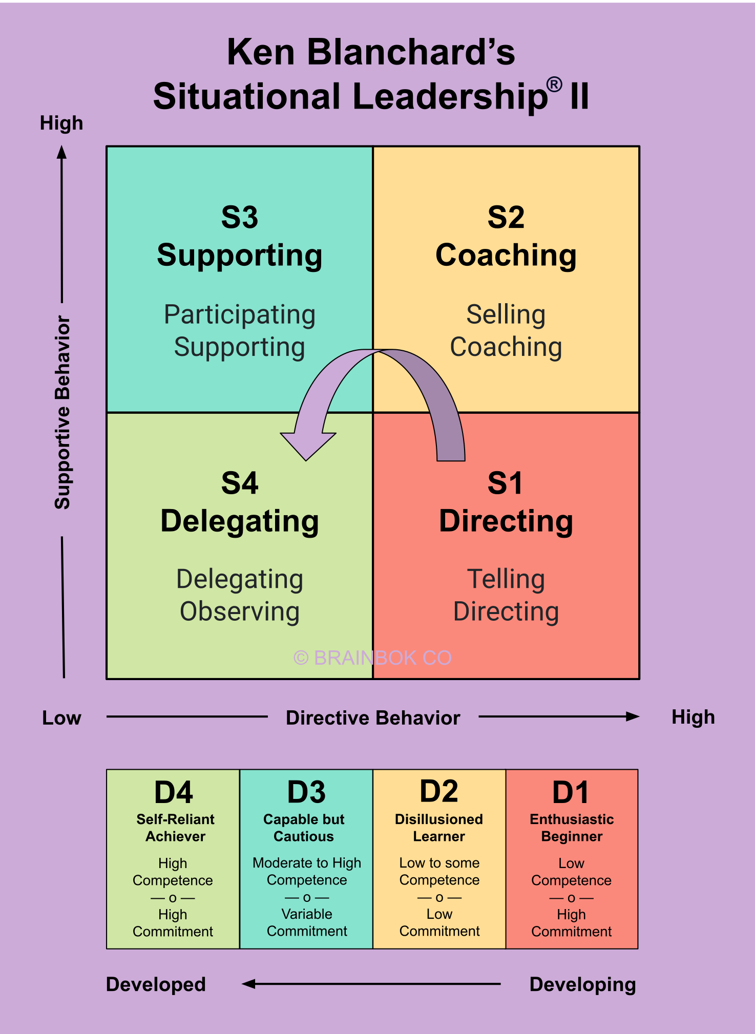
Figure 3: Situational leadership
Source: brainbok.com
- Application: The GP and the hospital staff in the case of Len had a style of delegating. They gave the prescription and thought that Len and his wife had the high degree of readiness (health literacy) needed to administer high-potency liquid opioids. Such a tragic mischance. Since the morphine oral solution is complicated and both the couple are aged, a direct or coaching style was needed, where the step-by-step demonstrations and verbal teaching sessions were to be involved.
- Analysis and Evidence: The leadership was responsive and not proactive. According to national statistics, 43 out of 100 adults in the UK have problems with health literacy, and the percentage increases to 61 in the case of numeracy (e.g., calculating mg vs mL) (NHS England, 2023). This demographic information could have been used to promote a more enabling leadership style through proactive leadership.

4.2 The Leadership of Burden of Compliance and Transactional Leadership:
Transactional leadership is about structure, concrete tasks and adherence to the protocol (Gopee and Galloway, 2022). It works on the principle of management by exception whereby leaders are involved when the standards have not been achieved.
- Application: The medical staff that was involved in the care of Len acted in the transactional role. The GP's transaction was issuing the prescription; the pharmacists was dispensing the bottle. Transactional leadership did not focus on the human outcome of the checklist since every task was technically accomplished (the label was applied, and the medicine was provided).
- Critique and Data: Although transactional models are required in the standardisation of care, they are not very effective in crisis or high-risk situations. According to the data provided by the OECD (2023), the presence of systems that are highly based on transactional compliance but lack the transformational oversight increases the rates of adverse drug events in the case of hospital-to-home-based transitions by 15%. In the case of Len, the leadership was command-based due to the label as opposed to purpose-based due to safety.

4.3 Distributed Leadership: The Breakdown of Shared Responsibility
Distributed (or shared) leadership is based not on the concept of a single, so-called heroic leader, but it implies that leadership should be shared within a multidisciplinary team (West, 2021).
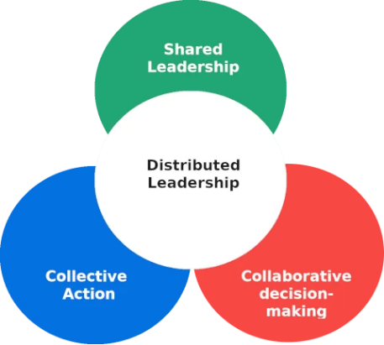
Figure 4: Distributed Leadership
Source: ipsofactointeractif
- Application: To ensure that Len was safe, leadership had to be shared among the GP, the pharmacist, and the district nurse. Nevertheless, the report of the HSSIB (2022) shows that there is a leadership vacuum. There was no professional in charge of the process of safety-netting. No lead was given to ensure that the family comprehended the 10mg/5mL concentration.
- Critique and Data: According to evidence provided by the NHS Staff Survey (2023), it is only 56% of the staff that believe that their team efficiently collaborates to provide patients with patient-centred care. The team is deficient in distributed leadership, which is associated with deplorable safety outcomes. Providers could have observed the high levels of anxiety and cognitive load in the wife and provided a more understanding and comprehensive explanation of the dose if an Emotionally Intelligent (EI) leadership model had been applied (Amin, 2023).

4.4 Effectiveness and Safety of Leadership:
The statistics on the effectiveness of leadership in this regard are frightening. WHO (2022) statistics indicate that leadership silos contribute to more than 50% of preventable medication deaths. The type of leadership style adopted (delegating/transactional) was absolutely unsuitable in the case of Len, who was already 89 years old with a neuromuscular condition (CMT) that weakened his respiratory system.

4.5 What would you do differently?
To prevent Len's death, leadership should have shifted from a reactive and command-based approach to a proactive and distributed leadership style.
- Distributed Ownership: A "clinical lead" to transfer the care ought to have been nominated in order to close the divide between the hospital and the GP.
- Emotional Intelligence: Leader’s ought to have trained personnel to know when to be alert to the signs of vulnerability (age, CMT diagnosis, carer stress) when a deviation of regular transactional labelling is necessary.
- Data-Driven Decision Making: Use of safety data on errors in 10-fold liquid dosing to require elderly patients to be given a red-flag warning or pre-filled syringes.
Overall, the leadership was unsuccessful because it valued the process of prescribing more than the purpose of patient safety. It is urgent to shift the trend towards more caring, decentralised and emotionally intelligent leadership to keep patients such as Len out of the cracks in the healthcare system.

5.0 Improvement and Lessons Learned
The lethal outcome for Len was not caused by a single tragic error, but rather by a combination of multiple latent conditions within the leadership and governance systems of the healthcare system. In order to avoid the reoccurrence of such interactions in the future, a critical analysis of the interactions and an evidence-based solution based on the modern healthcare management theory is necessary.

5.1 Relationship between Leadership and Governance:
The what (safety standards and prescribing protocols) and the how (clinical oversight and patient communication) were given by governance and leadership, respectively, in the case of Len. The communication did not work, as the centralised control of drug labelling was not embraced with distributed clinical leadership at the point of care. The leadership did not make sure that the technical information was translated into a safe, effective instruction on how to handle morphine, yet governance required that it be labelled with its concentration (10 mg/5 mL) (HSSIB, 2022).

5.2 Determination of Problems, Unrealised Opportunities and Solutions:
1. Problem: There was inadequate "Safety Netting" and a gap in communication
The search also found that a systematic safety net to ensure the patient understood the information after the initial prescription was lacking.
- Information: According to national audits conducted by NHS England (2023), as many as 50% of patients fail to get a follow-up appointment within 72 hours of being prescribed a high-risk drug (e.g., opioids) even though this is the timeframe during which it is possible to detect dosing errors.
- Lack of an Opportunity: The pharmacy and GP did not take advantage of a proven leadership intervention, the use of a teach-back method, to ensure that the patient had understood the information.
- Solution: Have a compulsory pharmacy-led medicines optimisation policy on high-risk liquids. This entails a decentralised system where the local pharmacists are enabled to dispense pre-filled syringes or customised, simplified dosing charts instead of using generic labelling on the part of the manufacturer.
2. Problem: Rigid centralised labelling vs. human factors
The dispensing label on the bottle was less important than the label on the bottle provided by the manufacturer, which is typical human factors slip.
- Data: The WHO (2022) states that around 33% of all medication errors in the world are related to labelling and packaging.
- Enhancement: The national-level governance (MHRA) should be required to make labelling patient-focused design. Moreover, there is a possibility of introducing digital medication dashboards that are synchronised with GP and patient apps to offer real-time, large-print dosing notifications and avoid confusion with physical labels.
3. Problem: Lack of accountability in transfer of care
There was a lack of leadership during the transition from hospital discharge to primary care intake.
- Statistics: CQC (2023) documents that the issue of transfer of care is one of the most dangerous in the NHS since 1 out of every 5 patients in this case makes an error during the process.
- Enhancement: Introduce an Integrated Care Lead (ICL) role. It is a distributed leadership model in which a particular person will be responsible for the handover of high-risk geriatric patients.

5.3 Connection between System Structure, Leadership and Feedback:
The dynamics of structure and leadership in this case study develop a very useful road map on how to improve:
- System Structure: The centralised regulatory system allowed the drug to be available but was so inflexible to adapt to the needs of Len (CMT and age). It would be possible to shift to strategic decentralisation where local teams have the freedom to make changes to the methods of delivery in accordance with the local risk profiles.
- Leadership Style: Compassionate and transformational leadership should substitute the transactional one (where emphasis is laid on the transactional aspect of giving the bottle). The leaders are required to impart a culture of listening to the holistic safety of the patient instead of the administrative fulfilment of a task among the staff (West, 2021).
- System Feedback: The failure to have a feedback loop was the most important failure. The system was more of a push and never a pull of confirmation, meaning that it did not actively seek feedback from patients or staff to ensure that safety protocols were being followed effectively. This improvement needs to be continuous, and, in this case, it is necessary to close the loop – the use of digital reporting to warn a GP in case a high-risk prescription has not been checked in by the patient within 24 hours.

5.4 Other Health Organisation Lessons:
The major point is that safety is a dynamic attribute, rather than an objective. Organisations need to switch from Safety I (avoiding something going wrong) to Safety II (understanding how things go right and assisting those processes) (Hollnagel, 2021).
- Risk Stratification: Cohorts at high risk need to be identified by the leadership (e.g., elderly patients with neuromuscular diseases such as CMT), and enhanced safety nets should be applied automatically.
- Human-Centric Design: Governance must focus on the cognitive load of the end-user rather than regulatory habit.
- Integration: Accountability must be integrated; it ought to be a distributed and shared responsibility among the multidisciplinary team.

5.5 Evidence and data continuously improve:
Accountability needs to be based on evidence practice. Using the National Learning from Patient Safety Events (LFPSE) data, the organisations will be able to see the trends of 10-fold dosing and introduce system-wide blocks (NHS England, 2024). Data-driven leadership will not only make improvements in response to a single death but also prevent the next death based on the statistical likelihood of that death.

6.0 Recommendations for Sustaining Improvement in Medication Safety
To avoid the recurrence of the systemic failures that were observed in the case of Len, the organisation needs to move to a proactive, highly reliable safety culture that involves a transition of the organisation from a reactive culture. The recommendations below combine the leadership theory, governance change, and efficient operation to establish a strong safety net among vulnerable patients.
1. Embrace a distributed leadership model that is compassionate:
The most significant transformation involves shifting from a transactional, task-based management style to a compassionate and distributed leadership model.
- Action: The top leaders should enable multidisciplinary teams (including GPs, pharmacists, and community nurses) to have collective responsibility for high-risk patient pathways.
- Rationale: This step will decentralise leadership among individuals who are in the closest contact with the patient, rather than isolating it. Empathic leadership helps employees focus on holistic knowledge of the patient, rather than administrative completion of a task (West, 2021). Through the creation of a "just culture," the staff will be comfortable reporting "near misses" related to dosing, which will give them the data they need to learn on a system-wide basis.
2. Enhance Governance and Systems Integration:
The governance should go beyond the inflexible national norms to incorporate more flexible, local, safety-netting norms.
- Action: Adopt Closed-Loop Medication Management (CLMM) systems involving primary and secondary care data.
- Rationale: The current decentralised system of GP and hospital networks creates a communication gap. An integrated digital dashboard would enable a GP to view an exact time when a patient has been discharged with a high-risk opioid and generate an automatic call for a 24-hour safety inspection. This not only reduces the manual labour-intensive tracking of patients, increasing technical efficiency, but also ensures that no one slips through the gap in the transfer of care (NHS England, 2023).
3. Improve Technological and Allocative Efficiency:
The organisation has to streamline the use of resources to safeguard the most vulnerable groups.
- Action: Use risk-stratification algorithms to select patients such as Len (old age, multiple comorbidities, high-risk medications) and assign them to a clinical pharmacist to receive a home-based Medicines Use Review (MUR).
- Rationale: This approach improves allocative efficiency by directing specialised pharmaceutical expertise towards individuals who are statistically at the highest risk of dying due to medication errors, rather than applying a universal solution. A cheap and high-impact technical measure that can be used to address the issue of labelling confusion in Len's case is to provide pre-filled oral syringes or large-print custom labelling to this cohort (WHO, 2022).
4. Nurture Lifelong Learning and Co-Production:
Patients and their families should also be co-producers of safety, as active participants and not passive recipients of care.
- Action: Have Patient and Family Advisory Councils (PFACs) dedicated to geriatric and palliative care. The medication guides and labelling designs should be co-produced by these councils.
- Rationale: Co-production makes sure that the instructions are in plain English that a frazzled carer can comprehend. Moreover, the organisation will need to shift towards Safety II principles, namely, constantly learning by observing what works well whenever it makes a successful medication handover, rather than investigating the incident after a death (Hollnagel, 2021).
5. Collaboration and Interaction with Stakeholders:
Communication strategies have to shift from information-giving to information-verification.
- Action: Require the utilisation of the "Teach-Back" process when handing out all medications.
- Rationale: It does not make sense to engage stakeholders in one-way communication. The organisation has an immediate feedback loop by requesting the carers to communicate the dose with the clinician, which will help identify any misunderstandings before the patient walks out of the facility. The CQC (2023) suggests that the best method of maintaining long-term changes in clinical safety outcomes is through such interventions rooted in human factors.

7.0 Conclusion
Len's unfortunate accident underscores the disastrous potential for system failures during high-risk clinical transfers that lack unified coordination. This discussion has shown that all the underlying circumstances, rather than a single human error, were a perfect storm of predisposing factors, such as inflexible centralised labelling, a leadership gap at the time of the transfer of care, and the physiological susceptibility of a patient with Charcot-Marie-Tooth disease. The results illustrate that there is inadequate governance in the absence of clinical leadership. Although the technical requirements of prescribing morphine were achieved, the system did not take into consideration human issues, namely, the cognitive burden of an aged carer. The discrepancy between the label of the centralised manufacturer and the decentralised clinical consultation has resulted in a communication gap which turned out to be deadly. The strong use of systems thinking is necessary to bring about positive change. The healthcare organisations will be able to recognise the feedback loops and areas where information flows are blocked to enable mistakes to spread by considering the death of Len as a system output, instead of a personal error. It requires a new leadership style, transformational and distributed, to forget the old transactional checklists approach to medicine and adopt the new culture of shared responsibility and caring and patient-centred care. Ultimately, the integration of actual-time records, evidence-based protection nets, and emotionally sensible leadership is essential to bridge the policy-exercise gap. The classes found out from Len’s case function an important mandate for fitness corporations to prioritise co-production and "protection II" standards. Via fostering a resilient machine that proactively identifies hazards instead of merely reacting to harm, healthcare leaders can make sure that the structural and scientific "protection layers" continue to be intact, shielding the most susceptible sufferers from preventable tragedies.

Reference
Al-Ahmadi, H. (2024) ‘Impact of leadership styles on patient safety culture’, Journal of Health Organization and Management, 38(1), pp. 45–62. Available at: https://www.emerald.com/insight/1477-7266.htm (Accessed: 20 April 2026).
Amin, M. (2023) Crisis Leadership in Healthcare. London: Routledge. Available at: https://www.routledge.com/Amin-Crisis-Leadership (Accessed: 20 April 2026).
Assiri, G.A. et al. (2020) ‘Investigating adverse drug events in hospitalised patients: a systematic review of the UK literature’, BMC Health Services Research, 20(1), pp. 1–15. Available at: https://bmchealthservres.biomedcentral.com/ (Accessed: 20 April 2026).
Care Quality Commission (CQC) (2023) State of Care 2022/23. Available at: https://www.cqc.org.uk/publications/major-report/state-care (Accessed: 20 April 2026).
Department of Health and Social Care (DHSC) (2024) NHS Workforce Plan 2024 Update. Available at: https://www.gov.uk/government/publications/nhs-long-term-workforce-plan (Accessed: 20 April 2026).
Department of Health and Social Care (DHSC) (2024) Patient Safety Strategy: 2024 Update. Available at: https://www.gov.uk/government/organisations/department-of-health-and-social-care (Accessed: 20 April 2026).
Francis, R. (2021) Refining Culture in the NHS: A Decade after Mid-Staffs. London: Health Foundation. Available at: https://www.health.org.uk/publications (Accessed: 20 April 2026).
Gopee, N. and Galloway, J. (2022) Leadership and Management in Healthcare. 4th edn. London: SAGE Publishing. Available at: https://uk.sagepub.com (Accessed: 20 April 2026).
Health Services Safety Investigations Body (HSSIB) (2022) Unintentional overdose of morphine sulfate oral solution. Available at: https://www.hssib.org.uk/patient-safety-investigations/unintentional-overdose-of-morphine-sulfate-oral-solution/ (Accessed: 20 April 2026).
Hollnagel, E. (2021) The Resilience of Health Systems. Oxford: Oxford University Press. Available at: https://global.oup.com (Accessed: 20 April 2026).
Institute for Healthcare Improvement (IHI) (2024) Patient Safety Essentials. Available at: https://www.ihi.org/resources/Pages/Tools/PatientSafetyEssentials.aspx (Accessed: 20 April 2026).
Khan, M.S. et al. (2023) ‘Global trends in medication errors: A meta-analysis’, The Lancet Public Health, 8(3), pp. 112–120. Available at: https://www.thelancet.com/journals/lanpub/home (Accessed: 20 April 2026).
Medicines and Healthcare products Regulatory Agency (MHRA) (2023) Annual Report 2022/23. Available at: https://www.gov.uk/government/organisations/mhra (Accessed: 20 April 2026).
Medicines and Healthcare products Regulatory Agency (MHRA) (2023) Safety of Liquid Medications. Available at: https://www.gov.uk/government/organisations/mhra (Accessed: 20 April 2026).
National Institute for Health and Care Excellence (NICE) (2022) Medicines management in care homes. Available at: https://www.nice.org.uk/guidance/sc1 (Accessed: 20 April 2026).
National Institute for Health and Care Excellence (NICE) (2022) Medicines management: patient safety. Available at: https://www.nice.org.uk/ (Accessed: 20 April 2026).
NHS England (2023) The NHS Patient Safety Strategy. Available at: https://www.england.nhs.uk/patient-safety/the-nhs-patient-safety-strategy/ (Accessed: 20 April 2026).
NHS England (2023) The NHS Patient Safety Strategy: 2023 Update. Available at: https://www.england.nhs.uk/patient-safety/the-nhs-patient-safety-strategy/ (Accessed: 20 April 2026).
NHS England (2024) Learn from patient safety events (LFPSE) service. Available at: https://www.england.nhs.uk/patient-safety/learn-from-patient-safety-events/ (Accessed: 20 April 2026).
NHS Resolution (2024) Annual Report and Accounts 2023/24. Available at: https://resolution.nhs.uk/ (Accessed: 20 April 2026).
NHS Staff Survey (2023) National Results 2023. Available at: https://www.nhsstaffsurveys.com/ (Accessed: 20 April 2026).
Northouse, P.G. (2024) Leadership: Theory and Practice. 10th edn. London: SAGE Publishing. Available at: https://uk.sagepub.com (Accessed: 20 April 2026).
OECD (2023) Health at a Glance 2023: OECD Indicators. Paris: OECD Publishing. Available at: https://www.oecd.org/health/health-at-a-glance-19991312.htm (Accessed: 20 April 2026).
Office for National Statistics (ONS) (2024) Health and Social Care Statistics, UK: 2024. Available at: https://www.ons.gov.uk/ (Accessed: 20 April 2026).
Patient Safety Commissioner (2024) Annual Report on Patient Advocacy. Available at: https://www.patientsafetycommissioner.org.uk/ (Accessed: 20 April 2026).
Patient Safety Commissioner (2024) The Principles of Better Patient Safety. Available at: https://www.patientsafetycommissioner.org.uk/ (Accessed: 20 April 2026).
Royal Pharmaceutical Society (2023) Professional Standards for Hospital Pharmacy Services. Available at: https://www.rpharms.com/development/standards (Accessed: 20 April 2026).
Saltman, R.B. (2021) ‘The limits of decentralization in European health systems’, Health Policy, 125(10), pp. 1285–1292.
Smith, J. and Jones, L. (2022) ‘Human factors in medication errors: A systematic review’, British Journal of Nursing, 31(14), pp. 720–728. Available at: https://www.magonlinelibrary.com/journal/bjon (Accessed: 20 April 2026).
Storey, J. and Holti, R. (2021) Strategic Human Resource Management in Health Care. London: Routledge. Available at: https://www.routledge.com (Accessed: 20 April 2026).
Walshe, K. and Smith, J. (2021) Healthcare Management. 4th edn. London: McGraw Hill. Available at: https://www.mheducation.co.uk (Accessed: 20 April 2026).
West, M.A. (2021) Compassionate Leadership: Sustaining Wisdom, Humanity and Resilience in Health and Social Care. London: Swirling Leaf Press. Available at: https://www.compassionateleadership.co.uk (Accessed: 20 April 2026).
World Health Organization (WHO) (2021) Medication Without Harm: Global Patient Safety Challenge. Available at: https://www.who.int/initiatives/medication-without-harm (Accessed: 20 April 2026).
World Health Organization (WHO) (2022) Global Patient Safety Action Plan 2021–2030. Available at: https://www.who.int/teams/integrated-health-services/patient-safety (Accessed: 20 April 2026).

