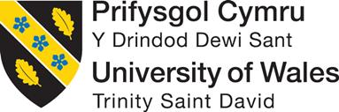

Programme Name: Master of Business Administration

Module Name: International Business Concepts
Module Code: LCMB7034

Assignment Title: Report on UNIQLO

Student name: Patel Shubham Rakeshkumar
Student ID: 2531460
Word Count: 5006

Executive Summary
This report showcases the current global market presence of the Japanese fashion brand known as Uniqlo towards establishing brand presence in the European, Asian and US marketplaces. The economic instability in the Brazilian marketplace has also been showcased here, caused by rising fuel prices because of the war in West Asia. The report also suggests the development of mutual business partnerships with Brazilian clothing brands with Uniqlo that can help manifest localised clothing production for the Japanese firm.
Table of Contents
Section 1: 4
1. Organisational Classification and Global Strategy 4
1.1 Introduction 4
1.2 Strategic Categorisation 4
1.3 Global Configuration 5
2. Macro-Environmental Appraisal and Market Attractiveness 6
2.1 Host Country Analysis 6
2.2 Market Entry for UNIQLO 14
3. Entry Mode Strategy and Strategic Synthesis 16
3.1 Historical Pattern Recognition 16
3.2 Strategic Fit & Justification for UNIQLO’s expansion 17
3.2 Conclusion & Recommendation 19
Section 2: 21
Reflective account using Kolb’s reflective cycle 21
Reference List 25

Section 1:

1. Organisational Classification and Global Strategy

1.1 Introduction
The commercial marketing activities performed by multinational corporations for operating in foreign continents can be referred to as international business that empowers corporate officials to improve brand value among customers (Collinson et al. 2019; Daniels et al. 2020). This report is regarding the Japanese multinational fashion corporation known as Uniqlo and its expansion operations into the prominent South American country of Brazil to improve global brand reputation. The current political, economic, and cultural conditions of Brazil are going to be discussed here that can help Uniqlo and its Japanese officials to devise a suitable expansion policy for attracting new Brazilian customers. The report is going to evaluate the potential differences in the social culture between the Japanese and Brazilian markets that can directly influence customer buying behaviour. Multiple recommendations are going to be made in this report that can help the Uniqlo officials to implement uninterrupted clothing sales operations in Brazil despite international uncertainties.

1.2 Strategic Categorisation
The current international expansion policies of Uniqlo are going to be described here using the Bartlett and Ghoshal’s model (BGM) for understanding the global market operations of the Japanese brand. Since 2019, Uniqlo has slowly expanded its brand operations in 25 separate global nations through almost 2250 offline clothing retail stores selling organisational clothing to global clients (Martin Roll, 2021). On the other hand, the retail market capitalisation for Uniqlo is around 49.2 billion US dollars, with a global employee base of 56,000 employees working tirelessly to deliver personalised client services (Martin Roll, 2021). According to the BGM approach, the unique brand message of Uniqlo and delivery system support have proven to be an international strategy choice for establishing clothing sales operations in major cities of the US and Europe. Hence, the reliable delivery system and diverse workforce can help Uniqlo officials to establish balanced priorities of the Japanese firm based on the BGM technique for easily acclimating to Brazilian fashion industry culture.
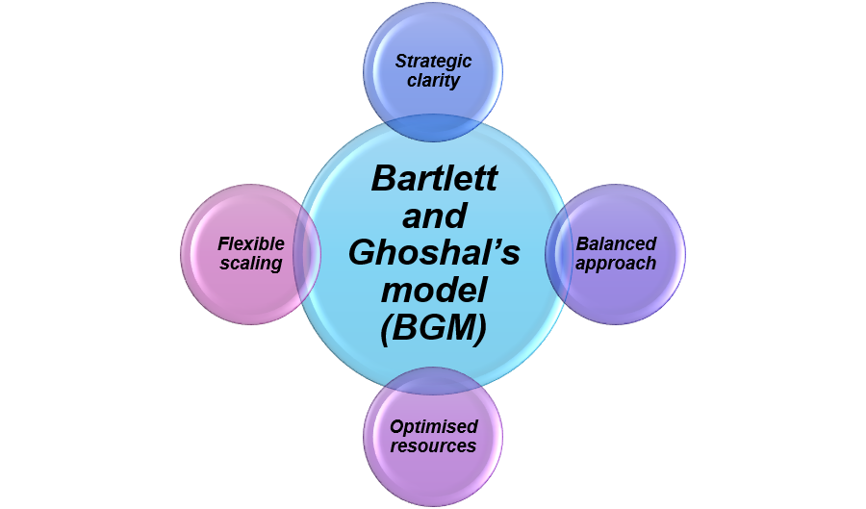
Figure 1: Different features involved with the BGM approach
(Source: Self-developed)

1.3 Global Configuration
In the Europe and North American markets, Uniqlo has encountered steady growth in revenue in the financial year of 2026, which further showcases the geographical footprint of the Japanese clothing retailer. For instance, almost a 35.1% and 23.7% increase in yearly income levels have been witnessed by Uniqlo in both North American and the European continent in the last calendar year (Stambor, 2025). Apart from that, the Chinese market has been considered the major overseas clothing operation for Uniqlo with 900 offline stores, which showcases the Japanese organisational dominance in the diverse Asian nations (Stambor, 2025). It can be mentioned that Uniqlo officials have employed tailored product sizing and visual merchandising to improve brand value for customers residing in North American, European and Asian nations. Hence, the current clothing operations of Uniqlo in North America, Asia and Europe have been indicative of the international clothing operations of the Japanese firm to maintain clothing market competitiveness with H&M and Zara.

2. Macro-Environmental Appraisal and Market Attractiveness

2.1 Host Country Analysis
The legal, political, cultural and economic conditions of Brazil have been examined here that can help Uniqlo officials identify positive and negative market elements that can help with South American expansion.
Critical evaluation of external factors in Brazil
Political Factors
The South American nation known as Brazil has been operating under a parliamentary democracy system with the President recognised as the head of state elected by the local population. The federal republic of Brazil includes 26 independent states and a federal state that have sent their regional leaders to represent them in the national parliament assembly of Brazil (US State Department, 2026). On the other hand, the Brazilian political system also includes almost 81 senatorial candidates representing each federal district and 513 separate deputies responsible for daily governance operations (US State Department, 2026). The president of Brazil has a 4-year reigning period after being elected to their respective federal office, with an additional 4-year tenure upon re-election (US State Department, 2026). As a result, the current democratic system of Brazil has provided adequate stability to the local marketplace, which can be exploited by the Uniqlo officials towards establishing its clothing brand footprint.
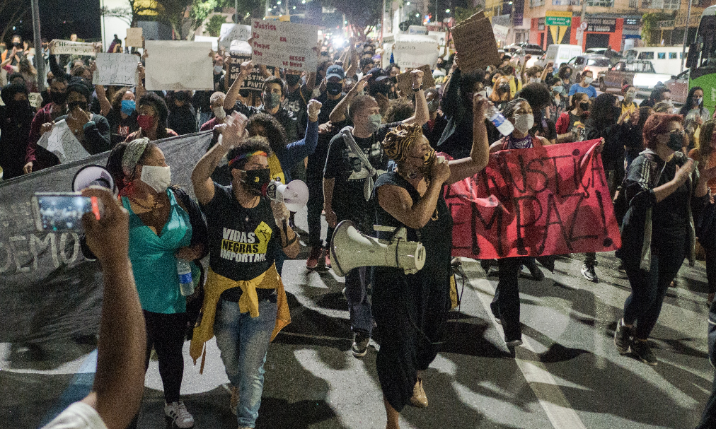
Figure 2: Political Unrest in different segments of Brazil
(Source: INT, 2025)
The Republic of Brazil has also scored a high position in the global index of democratic performance, which has further highlighted the democratic working environment of the nation. As per civil rights and an impartial legal system, Brazil has procured a global score of 50 and 51 out of 175 recognised democracies around the world (INT, 2025). However, the recent police operations launched by President Lula da Silva against the criminal group ‘Comando Vermelho’ have led to the death of almost 120 civilians, with 100 detained for criminal association (INT, 2025). On the other hand, the failed political coup organised by the former Brazilian president, and his closest allies has resulted in 27 years and 3 months conviction for the former head of state (INT, 2025). It can be mentioned that Brazilian police crackdowns and political dissonance have negatively impacted the political stability within the South American nation. Therefore, the current leadership of Uniqlo needs to carefully navigate through the current political fragility of Brazil to maintain undisrupted expansion operations in the Brazilian clothing industry.
Economic Factors
In the last decade, Brazilian national inflation has experienced major fluctuations instigated by the COVID-19 pandemic and ongoing war in West Asia and Ukraine. In the fiscal year of 2022, the inflation level of Brazil had reached its peak with 12.13% recorded by the central bank, which negatively influenced customers' buying capabilities (Scholle, 2026). However, Brazilian inflation has encountered a gradual decline since then based on the positive actions taken by the Central Bank officials through managing the national interest rate. In 2026, Brazilian inflation has been recorded to be around 4.52 which has encountered a major decline powered by the consecutive interest cuts instigated by the Central Bank of Brazil Araujo, 2026). It can be mentioned that the positive actions taken by the Brazilian government and central banks have stabilised the national economy and gradually improved civilian living standards. Hence, the high purchasing power for the Brazilian public and low inflation can prove to be a suitable market condition for Uniqlo to develop a premium client base through selling quality clothing materials.
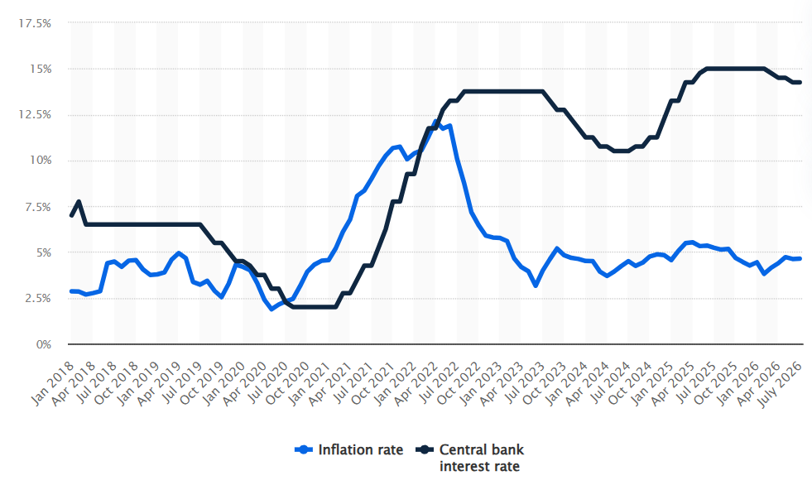
Figure 3: Inflation rate of Brazil for the last financial decade
(Source: Araujo, 2026)
The ongoing war in West Asia between Iran and the US has major negative implications for the economic conditions of Brazil through increasing fuel prices across different sectors throughout the nation. For instance, the 3 major airlines in Brazil have paid almost 1 billion US dollars of additional financial revenue towards purchasing aviation fuel, which signifies the drastic increase in oil prices in the international market (Silva, 2026). On the other hand, the current military blockade in the Strait of Hormuz has also introduced major volatility in the international fuel market. It has also been estimated that aviation fuel costs are going to reach almost 170 US dollars per barrel within the next financial quarter (Silva, 2026). Uniqlo needs to focus on retrieving locally sourced raw materials from the Brazilian market instead of relying on exported clothing goods, which is bound to increase the financial burden during local market expansion. Hence, supply line diversification and premium product sales are major economic factors that can dictate the future expansion operations for Uniqlo in the clothing industry of Brazil while managing global market volatility.
The Brazil economy has been categorised as the second largest in the Western hemisphere after the United States, which further signifies the local market suitability towards acquiring quality FDI investments. In the fiscal year of 2022, the annual FDI inflow in the Brazilian marketplace was recorded to be around 86 billion US dollars, which has experienced an almost 68% increase from pre-pandemic levels (US State Department, 2024). Apart from that, in 2021, the overall FDI stock from the US was mentioned to be around 29.3%, based on Brazilian central bank reports, which showcases North America as a major foreign investment market (US State Department, 2024). It can be noted that Uniqlo from Japan is going to greatly benefit from the high FDI stock in the US market for streamlining foreign market capital in clothing operations development. Hence, despite the global market uncertainties, the strong FDI level in Brazil has been a critical element that can help solidify Uniqlo's expansion into the local fashion retail sector.
Legal Factors
The Federal Constitution of Brazil was officially formulated in 1988 for dictating local civil laws and its subsequent legislative systems for managing labour, federal and state courts. In 1943, the Consolidation of Labour Laws (CLT) was implemented by the Brazilian government for safeguarding local workforce rights in terms of work hours, minimum wage and termination guidelines. For example, the contemporary working period in Brazil has been categorised to be around 8 hours every day while not exceeding the weekly restriction of 44 hours (L&E Global, 2026). Apart from that, Brazilian employees partaking in overtime responsibilities for their respective firms are obligated to procure almost a 50% increase in their hourly rates depending on regular compensation (L&E Global, 2026). It can be signified that the Uniqlo officials ought to abide by the CLT and other federal regulations implemented by the Brazilian government to move forward with smooth local expansion. Hence, the CLT and federal laws of Brazil are major legal elements involved that directly influence Uniqlo’s organisational regulation development to ensure optimal employee engagement during fashion product creation.
Cultural Factors
The 21st-century fashion industry of Brazil is composed of diverse ethnic cultures from around the world, which include African heritage, local indigenous roots and European traditional clothing options. In the Southern regions of Brazil, the use of Bombacha pants and baggy trousers has become the latest fashion statement among the local population based on social standards (Fashington Post, 2026). The Brazilian clothing item called Canga has also been considered an attractive clothing option in the coastal regions, which generally includes printed and colourful fabrics worn by the female population (Fashington Post, 2026). In 2026, the different clothing retailers operating in the Brazilian marketplace generated almost 10.26 billion US Dollars of market revenue, which further showcases the local customer engagement levels (Statista, 2025). As a result, the diverse fashion culture within different parts of Brazil has been a major cultural factor for Uniqlo leadership to come up with the latest product line that can peak local population interest.
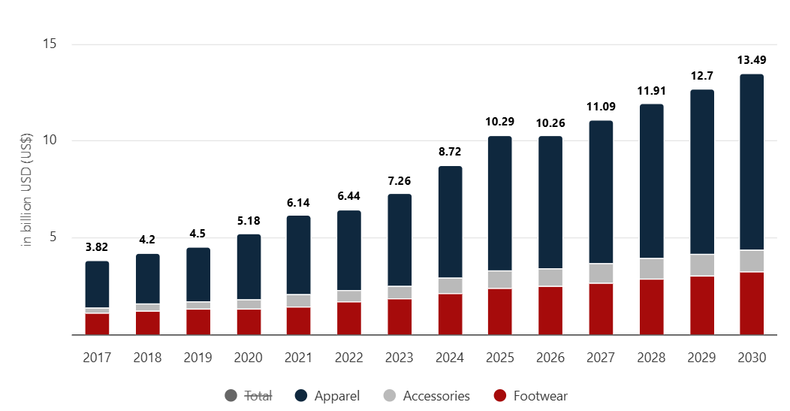
Figure 4: Gradual increase in revenue generation by the Brazilian fashion industry
(Source: Statista, 2025)
The Brazilian city of São Paulo has been recognised as the fashion capital of the nation, with major clothing brands operating their local headquarters throughout different major city corners. The fashion sector of Brazil is estimated to reach a revenue production of around 13.49 billion US dollars by 2030, with an annual growth of 7.07% (Statista, 2025). It can be showcased that the usage of digital shopping platforms is slowly becoming popular among Brazilian customers, with the local e-commerce sector showcasing the highest growth resilience. In 2026, almost 33.2% of Brazilians utilised various online fashion platforms towards locating suitable clothing materials without going to physical shops owned by major retail brands (Statista, 2025). Hence, the reliance on e-commerce platforms and online shopping is becoming a crucial cultural trend in Brazil that needs to be recognised by Uniqlo for expanding the fashion brand operation through developing an online customer base.
Firm’s industry and strategy analysis using Porter’s Diamond model
The national elements of Brazil have been clearly depicted by Porter’s Diamond model for maintaining brand relevance for Uniqlo in the local fashion industry.
Factor Conditions
The national employment index of Brazil has been examined to be around 58.6% in May of 2026, which is expected to reach almost 58.8% in June of the same financial year (Trading Economics, 2026). However, the youth unemployment rate among the female residents of Brazil has been significantly high at around 20.86% (World Bank, 2026). It can be showcased that the high female employment level of the nation can greatly lower the capability of recruiting a diverse employee base in localised fashion retail operations. On the other hand, in 2024, the Brazilian government implemented the National Plan for AI, investing around 4 billion US dollars of financial revenue towards developing smart infrastructure for local enterprises (ITA, 2025). Therefore, despite the low female employee base of Brazil, the latest AI investment plan at the national level can empower Uniqlo officials to develop an AI-based fashion retail platform for delivering a personalised shopping experience.
Demand Conditions
The urban and higher-income Brazilian citizens living in São Paulo and Rio de Janeiro have showcased increased demand towards procuring sustainable clothing options that can positively influence the surrounding environment. For example, almost 78% of Brazilian customers mentioned having a positive impression towards local fast fashion companies that implemented sustainable manufacturing practices on a daily basis (de Oliveira et al. 2022). On the other hand, nearly 91% of fashion consumers from Brazil have also developed a positive attitude towards local slow fashion brands that successfully adopted eco-friendly manufacturing habits (de Oliveira et al. 2022). Hence, the current administration of Uniqlo needs to recognise the current demand condition of Brazilian citizens to incorporate sustainable development policies in their localised clothing manufacturing functions.
Related and Supporting Industries
The local textile suppliers in Brazil can prove to be a major supporting industry for Uniqlo towards maintaining an undisrupted supply of quality raw materials for developing designer clothing options. For example, almost 9.7% of industrial manufacturing operations in Brazil have been performed by the local textile suppliers and their subsequent companies for cultivating a robust supply line (Delta, 2026). Hence, the increased reliance on the Brazilian textile and supply industry can be established by the Uniqlo leadership for creating quality fashion items without overbloating the international expenses through export options.
Firm Strategy, Structure, and Rivalry
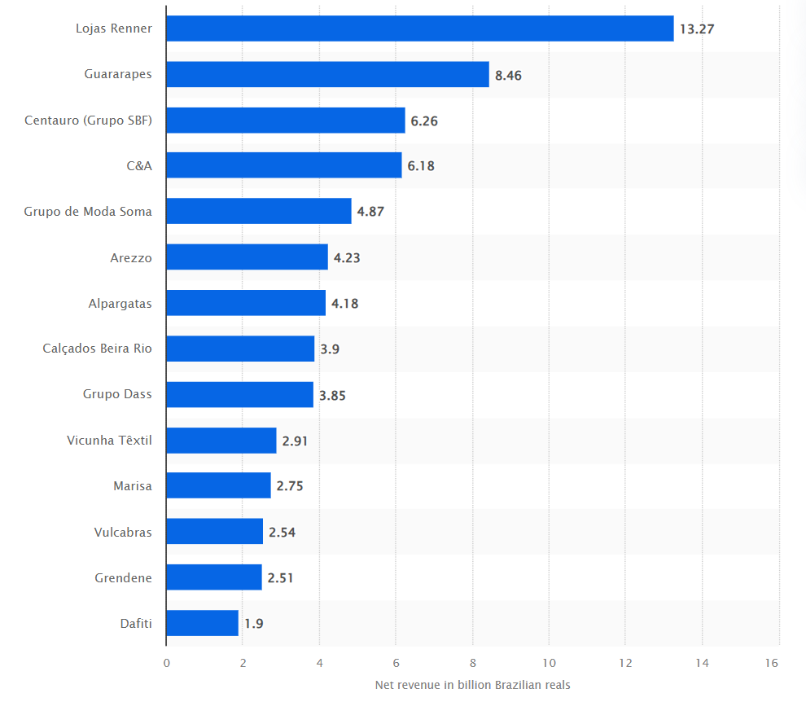
Figure 5: Major fashion brands in the Brazilian marketplace
(Source: Rocco, 2026)
In the Brazilian fashion sector, Lojas Renner, Guararapes and C&A can be considered as major fashion retail brands that have developed a faithful customer base in the nation through delivering quality products. For instance, Lojas Renner and its fashion outlets in Brazil have generated almost 13.27 billion Brazilian reals from the local market to ensure a dominating market presence (Rocco, 2026). As a result, different Brazilian fashion corporations such as Lojas Renner and Guararapes can provide major competition to the up-and-coming Uniqlo clothing products during the initial years of expansion.

2.2 Market Entry for UNIQLO
OLI framework
The current leadership of Uniqlo can employ the different factors involved with the OLI framework towards identifying potential advantages in the Brazilian marketplace for continued expansion operations.
Ownership Advantage
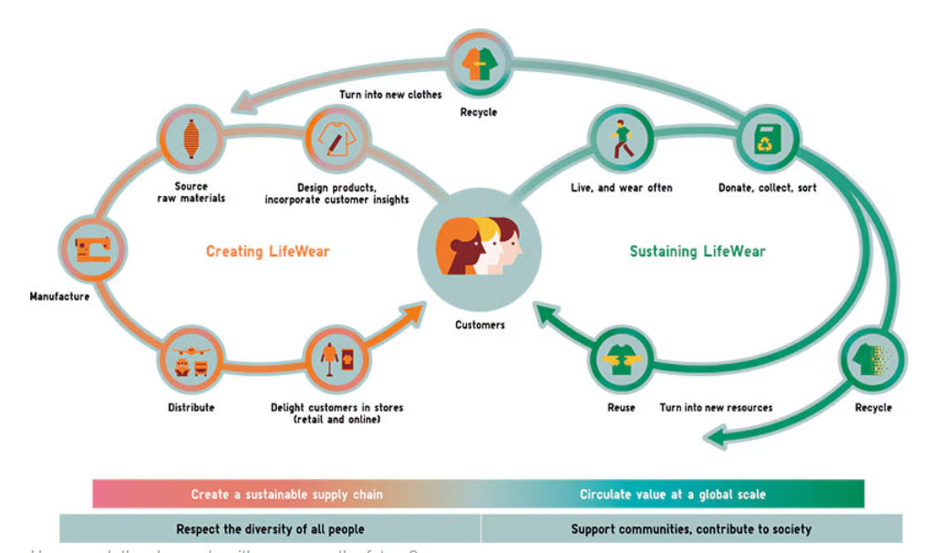
Figure 6: Lifeware operations by Uniqlo
(Source: Uniqlo, 2025)
The Fast-Retailing Group is the parent company of Uniqlo, which can prove to be a massive ownership advantage for the Japanese firm for easily moving into the fragmented clothing industry of Brazil. The use of a Speciality Store Retailer has allowed Uniqlo administration towards instigating localised manufacturing endeavours for producing private apparel labels based on the Brazilian public's expectations. It also enabled the Uniqlo leadership to come up with the LifeWear brand in Scandinavia, which has been categorised as the Power of Clothing issue No.25 in the local media to peak customer interest. For instance, UNIQLO Sweden has also participated in social activities such as developing low-cost hockey and skiing sports attire for 42,200 local children from 600 schools for improving social engagement levels (Uniqlo, 2025). It can be mentioned that the Speciality Store Retailer technique and Uniqlo Dream Project are major ownership activities undertaken by the Japanese firm for improving brand value internationally. Therefore, the Japanese leadership of Uniqlo can also employ similar social activities in the Brazilian marketplace for increasing engagement levels of local fashion enthusiasts for elevating market penetration levels.
Location Advantage
In terms of locational edge, the Brazilian government has provided adequate tax reliefs and R&D initiatives for multinational brands for performing manufacturing endeavours within the national marketplace. The Lula administration has initiated the "Mover" program for 721.34 million US dollars of financial incentives to local corporations for expanding business and manufacturing operations locally (Reuters, 2023). On the other hand, the lower income tax benefits provided by the Brazilian government have been aimed towards increasing the Industrial output of the nation towards 18%, similar to the pre-pandemic levels (Reuters, 2023). It can be mentioned that the delivery of financial revenue by the Brazilian government is going to incentivise Uniqlo towards moving forward with localised clothing manufacturing during the initial years of expansion. As a result, the delivery of low-income tax and financial incentives on R&D projects are major localised factors that can inspire the Japanese leadership of Uniqlo to successfully enter the Brazilian marketplace.
Internalisation Advantage
The implementation of In-house operations has also been employed by Uniqlo for developing designer clothing to meet the expectations of the target audience in the global fashion landscape. For example, in the Shinonome area of Tokyo, Uniqlo leadership have created a manufacturing hub for locally producing limited edition capsule collections (Suen, 2021). Apart from that, the 3-D knit technique has also been cultivated by the Uniqlo designers in collaboration with Shima Seiki Manufacturing for performing both offline and online retail operations simultaneously (Suen, 2021). In the Brazilian marketplace, Uniqlo can develop mutually beneficial business partnerships with local manufacturing powerhouses for generating quality garments based on South American culture.

3. Entry Mode Strategy and Strategic Synthesis

3.1 Historical Pattern Recognition
The administrative body of Uniqlo has employed foreign direct investment (FDI) and wholly owned subsidiaries in foreign markets for proceeding with entry operations in the US, Europe and Asian marketplaces. The material innovation strategy implemented by Uniqlo in collaboration with manufacturing giant Toray Industries has allowed the fashion retailer to come up with the HEATTECH for developing a temperature-regulating clothing system. By the fiscal year of 2012, almost 130 million units of HEATTECH products were sold by Uniqlo, which allowed the organisational customer base to remain warm during cold weather situations (GLOBIS News, 2025). In 2024, the annual closing revenue for Uniqlo was recorded to be around 20 billion US dollars, which has empowered the Japanese firm towards becoming one of the top global retailers (GLOBIS News, 2025). Hence, the cultivation of wholly owned subsidiaries and business partnerships has been recognised as a major historical entry mode policy employed by Uniqlo towards sustaining a global foothold in the fashion industry.
The utilisation of FDI sales channels has also been done by Uniqlo for gradually developing a brand footprint in the Asian fashion industry in recent years. For example, in 2019, Uniqlo leadership launched operations in the South Asian market of India by instigating their e-commerce operations, as mentioned by the organisational chief executive officer. The Japanese fashion retailer is offering 360-degree e-commerce fashion solutions such as "Shop-from-Home" for showcasing the positive effects of their Lifewear brand (Blue Horse, 2025). According to Uniqlo leadership, both the online clothing platform and physical shops are offering almost 11,000 items with a variety of size ranges that can help attract the attention of Indian consumers (Blue Horse, 2025). It can be mentioned that the e-commerce and physical shop operations are the backbone of Uniqlo operations in various global market segments for delivering a personalised shopping experience to fashion enthusiasts. As a result, the FDI-based sales channels and whole-owned subsidiaries are past entry mode policies employed by the Uniqlo administration for proceeding with internationalisation plans.

3.2 Strategic Fit & Justification for UNIQLO’s expansion
Suitability of Uniqlo’s historical mode
The FDI-based sales channels and Wholly owned subsidiaries have proven to be effective international entry mode policies for Uniqlo for maintaining greater control over clothing production and delivery operations. For example, the multinational enterprises have mentioned that product feature adaptation by around 25% enabled their manufacturing department to create personalised goods based on the taste and preferences of local clients (Lubis and Muniapan, 2024). On the other hand, in 20% of instances, the use of local packaging features has helped proceed with foreign market expansion through catering to the needs of local consumers (Lubis and Muniapan, 2024). It can be mentioned that Uniqlo officials ought to incorporate local clothing features and packaging characteristics before proceeding with successful entry operations in the Brazilian marketplace. Therefore, greater control over the clothing supply line has proven to be useful for Uniqlo towards performing greater clothing modification based on local customer preferences instead of regular entry modes such as licensing and joint ventures.
Evidence-based justification of Uniqlo’s entry mode based on risks
Factors | Issue identification | Risk Level | Impact | Strategies
Political risk | Ongoing war between Iran and the United States | High | High | Playing an intermediary role to bring in regional stability in the Middle East
Operational Risk | Disruption in Aviation fuel Supply increasing clothing export costs | Medium | Medium | Diversifying airline fuel SCM among South American nations
Financial risk | Heightened inflation rate lowering the purchasing capabilities of Brazilian fashion enthusiasts | High | High | Adjust fuel price to control heightened costs of daily items
Table 1: Different risk factors involved with Uniqlo’s Brazil market expansion
(Source: Self-developed)
The above Table 1 clearly showcases the current political, financial and operational risks involved with Brazilian market entry that might increase the annual expenses of Uniqlo. The rising aviation fuel expenses in Brazil have been a major risk during the Iran war that can disrupt Uniqlo’s expansion into the local fashion market. For instance, between 2017 and 2021, the European nation of Poland encountered almost a 69.9% increase in global energy prices that have threatened to destabilise the national economic elements (Milewska and Milewski, 2023). Therefore, the procurement of wholly-owned subsidiaries and local manufacturing collaboration are justifiable market entry modes for Uniqlo towards reducing the annual exporting costs through localised clothing development.

3.2 Conclusion & Recommendation
Conclusion
Based on the above findings, it can be concluded that Brazil has an appealing possibility for Uniqlo’s global growth given its population-driven economy, fashion-sensitive consumer attitudes, well-established textile-related economy and growth in eco-friendly choices. However, the entry would involve various hurdles, namely political instability, inflation, the erratic expense of energy and differing Brazilian law, along with severe competition from incumbent domestic retailers. According to the diverse cultural dimensions of Brazil, adjustments to Uniqlo’s products, promotional messages, and the brand’s communication with its target Brazilian consumers and the fashion-conscious population need to be implemented.
The report also shows the use of the OLI framework to locate considerable ownership opportunities for Uniqlo along with location-specific benefits and internal ownership. Uniqlo’s historical practice of using FDI and completely owning operations makes local strategic agreements with the current sector promising. Brazil as a marketplace is favourable for the Uniqlo brand by having local product adjustments, modern retail outlets, along with eco-friendly processes to enable operational safety alongside supply chain support.
Recommendation: Development of local business partnerships with popular Brazilian brands for market expansion of Uniqlo
The Japanese leadership of Uniqlo needs to consider developing financially lucrative business partnerships with popular Brazilian fashion brands such as Lojas Renner for creating a local manufacturing factory. For example, in 2025, Lojas Renner and its administrative body have reported 539 resale clothing suppliers around different corners of the world (Lojas Renner SA, 2025). Apart from that, almost 25.1 million of employees have also been operational for Lojas Renner from diverse global continents to create quality fashionware (Lojas Renner SA, 2025). As a result, the development of business collaboration can help Uniqlo towards producing local market knowledge from Lojas Renner officials before developing internal manufacturing operations within Brazil.

Section 2:

Reflective account using Kolb’s reflective cycle
During the university task, I have decided to utilise Kolb’s cycle that can help me towards examining the learning process for Brazilian fashion industry elements which are suitable for Uniqlo’s expansion processes.
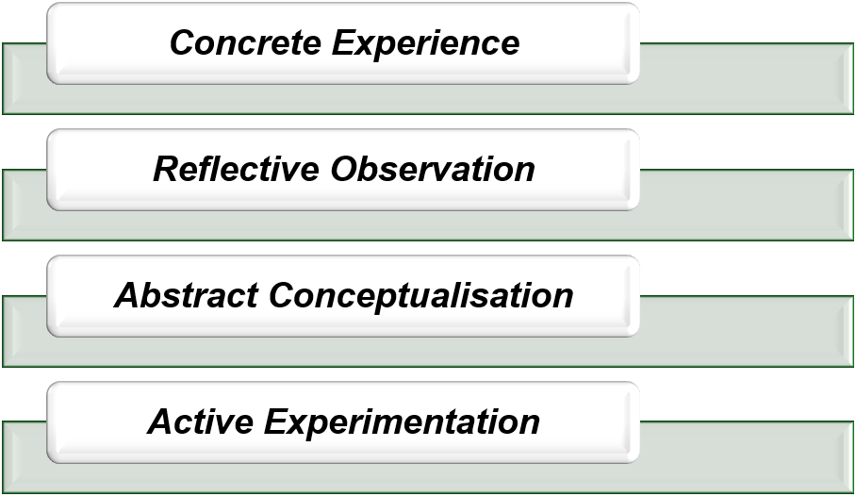
Figure 7: Different elements involved with Kolb’s reflective cycle
(Source: Self-developed, idea taken from Kolb, 1984)
Concrete Experience
In the beginning, I utilised the BGM model that has allowed me to examine the current global market position of Uniqlo in different parts of the US, Europe and Asia. I feel very surprised to know about the brand popularity of Uniqlo in prominent Asian markets such as China and India, which have further validated the FDI sales channel approach of the Japanese clothing brand. I have also developed adequate researching skills during the business task to learn about the Brazilian market, which includes its socio-economic vulnerabilities and local fashion culture. For instance, in higher education, almost 539 students have mentioned the positive implications of researching skills to be highly impactful for developing personal competency levels (Cutillas et al. 2023). I also utilised my researching abilities towards locating the adverse effects that the Middle East war between the US and Iran had on increasing fuel change in the Brazilian Airline sector.
The evaluation of Brazilian economic, political and cultural factors has improved my understanding of global SCM processes, including the potential vulnerabilities such as the Strait of Hormuz that can cause a potential fuel crisis. In my opinion, modern AI tools such as ChatGPT and Gemini have also helped towards locating relevant online information regarding the Brazilian fashion industry based on newspaper articles and journals. For example, almost 25% of modern teaching professionals have been utilising AI tools such as Dall-E and ChatGPT for delivering a personalised learning experience (Monib et al. 2025). Based on my Brazilian market research, I have come to the conclusion that the Uniqlo officials need to focus more on localised clothing production to avoid increased organisational expenses from fuel price surges.
Reflective Observation
While conducting the Brazilian market examination, I have employed my critical thinking skills, for that empowered me towards gathering relevant fashion industry information to propose suitable entry modes for Uniqlo. I have come to recognise the diverse fashion culture of the Brazilian city of Sao Paulo that can prove to be useful for the Japanese leadership of Uniqlo towards choosing prime fashion store locations. According to 21st-century students, the delivery of proper teaching lessons to academic peers has helped them towards assimilating necessary information on different topics by around 90% (Blyznyuk and Kachak, 2024). In my opinion, the deployment of critical thinking abilities has allowed me to assimilate the total FDI outflow into the Brazilian marketplace, which is strictly governed by the Lula government. I genuinely believe that the current FDI sales channel development can prove to be a vital market entry policy for Uniqlo towards developing mutually beneficial business collaboration with popular Brazilian fashion brands.
My communication skills have also proven to be useful towards locating relevant information regarding historical market entry policies employed by Uniqlo officials with the help of university peers. I have come to appreciate the dominating market presence that Uniqlo has developed in both the Chinese and Indian fashion industry, which demonstrates the effectiveness of organisational expansion policies.
Abstract Conceptualisation
During the module task on Uniqlo’s expansion into the Brazilian market, I have come to recognise my lack of time management abilities that caused major distractions during the international fashion market evaluation. I also experienced an increased workload because of a lack of time management skills that usually allow me to perform multiple tasks at the same time without being distracted from my research into Uniqlo’s fashion operations. For instance, during COVID-19, almost 60% of students have mentioned the usefulness of online classes that have permitted them towards developing self-decipline and self-learning abilities simultaneously (Li, 2022). I am also working towards developing my self-decipline skills that can help me avoid being distracted while harnessing time management capabilities.
Currently, I am working towards developing a digital task manager using my smart devices such as a laptop and phone for keeping a 1-month log for university tasks. I think that the utilisation of task manager tools can help me towards submitting academic assignments within the deadline without incurring heavy penalties. It is my responsibility towards checking the digital task manager 2 times every week for mitigating the possibility of missing out on an active deadline that can jeopardise my academic performance.
Active Experimentation
In the assignment, I have also employed my communication skills for reaching out to my classmates and module leaders concerning any queries regarding the expansion policies of Uniqlo. I have also recommended the development of a mutual business partnership with Brazilian fashion brands such as Lojas Renner that can aid the Uniqlo officials towards recognising the modern dressing sense of the Brazilian population. For instance, almost 71.4% of students have highlighted the usefulness of collaborative learning that helped towards strengthening personal communication abilities (Kausar, 2025). On the other hand, almost 37% of students have showcased the positive effects of collaborative learning that slowly improved individual reasoning abilities to gain better academic knowledge and understanding (Kausar, 2025). In my opinion, the cooperation between Lojas Renner and Uniqlo can assist the latter towards developing international clothing manufacturing factories to create personalised fashion items that meet the Brazilian population's expectations.
While performing the Brazilian market examination, I have utilised Porter’s diamond model for understanding the current Brazilian labour industry and the technological conditions of the South American nation. I am glad to see that the Brazilian government has facilitated major financial investment towards incorporating Industry 4.0 tools such as artificial intelligence within the present digital infrastructure for local firms. In my opinion, the enhancement of digital skills can also help me towards using modern tools such as Microsoft Excel and PowerPoint to improve personal presentation abilities in academia. For example, almost 46% of students have mentioned using digital tools such as Google during the collaborative learning process, which further exemplifies their personal digital competency levels (Kwiatkowska and Wisniewska-Nogaj, 2022). I am thinking about participating in online courses for the next 6 months that can help improve my digital competency level in operating complex systems on a daily basis to maximise personal productivity levels.

Reference List
Essential Readings
Collinson, S., Narula, R., Qamar, A. and Rugman, A.M., (2020). International business. Pearson UK.
Daniels, J.D., Radebaugh, L.H. and Sullivan, D.P., (2019). International business: Environments and operations. Pearson.
Web Articles
Araujo, G. (2026) Brazil inflation nears target band, supporting more monetary easing, Available at: https://www.reuters.com/world/americas/brazil-mid-july-inflation-slows-more-than-expected-annual-rate-nears-target-band-2026-07-28/ [Accessed: 7th Aug 2026]
Blue Horse (2025) Uniqlo Launches eCommerce Operations in India, Available at: https://bluehorse.in/uniqlo-launches-ecommerce-operations-india [Accessed: 8th Aug 2026]
Delta (2026) Textile industry in Brazil: discover the panorama, Available at: https://deltatextilesolutions.com/textile-industry-in-brazil-discover-the-panorama/ [Accessed: 7th Aug 2026]
Fashiongton Post (2026) Complete Guide to Brazilian Clothing, Available at: https://fashiongtonpost.com/brazilian-traditional-clothing/ [Accessed: 7th Aug 2026]
GLOBIS News (2025) The Quiet Revolution: How UNIQLO Engineered Fashion’s Most Unconventional Success Story, Available at: https://globis.eu/uniqlos-unconventional-success-story/ [Accessed: 8th Aug 2026]
INT (2025) Brazil, Available at: https://www.idea.int/democracytracker/country/brazil [Accessed: 7th Aug 2026]
ITA (2025) Brazil Country Commercial Guide, Available at: https://www.trade.gov/country-commercial-guides/brazil-digital-economy [Accessed: 7th Aug 2026]
L&E Global (2026) Working conditions in Brazil, Available at: https://leglobal.law/countries/brazil/employment-law/employment-law-overview-brazil/03-working-conditions/ [Accessed: 7th Aug 2026]
Lojas Renner SA (2025) Annual Report 2024, Available at: https://www.lojasrennersa.com.br/en/wp-content/uploads/2025/05/250425_LojasRenner_RA24_V3A-compactado.pdf [Accessed: 8th Aug 2026]
Martin Roll (2021) Uniqlo: The Strategy Behind The Global Japanese Fast Fashion Retail Brand, Available at: https://martinroll.com/resources/articles/strategy/uniqlo-the-strategy-behind-the-global-japanese-fast-fashion-retail-brand/ [Accessed: 7th Aug 2026]
Reuters (2023) Brazil unveils tax benefits for firms to boost investments, Available at: https://www.reuters.com/world/americas/brazil-unveils-tax-benefits-firms-boost-investments-2023-12-31/ [Accessed: 8th Aug 2026]
Rocco, D. (2026) Leading fashion retail companies in Brazil in 2022, based on net revenue, Available at: https://www.statista.com/statistics/956883/brazil-fashion-retailers-net-revenue/?srsltid=AfmBOoooOckTAQiAzDdvHephjq2VTSNyNMK5jBy4w9bmFu0n0z4XdykJ [Accessed: 7th Aug 2026]
Scholle, K. (2026) Monthly inflation rate and central bank interest rate in Brazil from January 2018 to July 2026, Available at: https://www.statista.com/statistics/1312454/brazil-inflation-rate-central-bank-interest-rate-monthly/?srsltid=AfmBOopqpcUBtoAF-MGTQKPiQbJ-nDqvXlckRin6vEXUfM4QQOC5kOBU [Accessed: 7th Aug 2026]
Silva, C. (2026) Iran War Cost Brazil’s Airlines US$1 Billion in Extra Fuel, Available at: https://www.riotimesonline.com/iran-war-brazil-airlines-fuel-cost-2026/ [Accessed: 7th Aug 2026]
Stambor, Z. (2025) Uniqlo parent Fast Retailing looks to the US and Europe for growth, Available at: https://www.emarketer.com/content/uniqlo-parent-fast-retailing-looks-us-europe-growth [Accessed: 7th Aug 2026]
Statista (2025) Fashion, Available at: https://www.statista.com/outlook/emo/fashion/brazil/?srsltid=AfmBOor12AnBsOOthvOouroA1vJtgWs2HP9lH4Mx34RnBkAM2G109pKe#revenue [Accessed: 7th Aug 2026]
Suen, Z. (2021) Uniqlo Experiments With In-House Manufacturing, Available at: https://www.businessoffashion.com/news/global-markets/uniqlo-experiments-with-in-house-manufacturing/ [Accessed: 8th Aug 2026]
Trading Economics (2026) Brazil Employment Rate, Available at: https://tradingeconomics.com/brazil/employment-rate [Accessed: 7th Aug 2026]
Uniqlo (2025) The Most Beloved Brand in Scandinavian~ The Power of Clothing No.25, Available at: https://www.uniqlo.com/in/en/news/topics/2025080402/?srsltid=AfmBOorCJo993p0C0jO1wln9iC6rxRqpOc0KDTYa_4UPBqJFUy670noU [Accessed: 8th Aug 2026]
US State Department (2024) 2024 Investment Climate Statements: Brazil, Available at: https://www.state.gov/reports/2024-investment-climate-statements/brazil [Accessed: 7th Aug 2026]
US State Department (2026) Brazil (07/02), Available at: https://2009-2017.state.gov/outofdate/bgn/brazil/21162.htm [Accessed: 7th Aug 2026]
World Bank (2026) Brazil, Available at: https://humancapital.worldbank.org/en/economy/BRA [Accessed: 7th Aug 2026]
Academic Articles
Blyznyuk, T. and Kachak, T., (2024). Benefits of interactive learning for students' critical thinking skills improvement. Journal of Vasyl Stefanyk Precarpathian National University, 11(1), pp.94-102. https://journals.pnu.edu.ua/index.php/jpnu/article/download/7840/8050
Cutillas, A., Benolirao, E., Camasura, J., Golbin Jr, R., Yamagishi, K. and Ocampo, L., (2023). Does mentoring directly improve students’ research skills? Examining the role of information literacy and competency development. Education Sciences, 13(7), p.694. https://www.mdpi.com/2227-7102/13/7/694
de Oliveira, L.G., Miranda, F.G. and de Paula Dias, M.A., (2022). Sustainable practices in slow and fast fashion stores: What does the customer perceive?. Cleaner Engineering and Technology, 6, p.100413. https://www.sciencedirect.com/science/article/pii/S2666790822000180
Kausar, F.N., (2025). Effect of collaborative learning on students’ communication skills and reasoning skills. Social Science Review Archives, 3(3), pp.2228-2244. https://policyjournalofms.com/index.php/6/article/download/1065/1073
Kolb, D.A. (1984) Experiential Learning: Experience as the Source of Learning and Development. Englewood Cliffs, NJ: Prentice-Hall.
Kwiatkowska, W. and Wisniewska-Nogaj, L., (2022). Digital Skills and Online Collaborative Learning: The Study Report. Electronic Journal of e-learning, 20(5), pp.510-522. https://files.eric.ed.gov/fulltext/EJ1372850.pdf
Li, D., (2022). The Shift to Online Classes during the COVID-19 Pandemic: Benefits, Challenges, and Required Improvements from the Students' Perspective. Electronic Journal of E-Learning, 20(1), pp.1-18. https://files.eric.ed.gov/fulltext/EJ1333732.pdf
Lubis, M. and Muniapan, B., (2024). International market development strategies for enhancing global expansion in the export industry. Involvement International Journal of Business, 1(1), pp.14-28. https://ejournal.agungmediapublisher.com/index.php/iijb/article/download/3/6
Milewska, B. and Milewski, D., (2023). The impact of energy consumption costs on the profitability of production companies in Poland in the context of the energy crisis. Energies, 16(18), p.6519. https://www.mdpi.com/1996-1073/16/18/6519
Monib, W.K., Qazi, A. and Mahmud, M.M., (2025). Exploring learners’ experiences and perceptions of ChatGPT as a learning tool in higher education. Education and information technologies, 30(1), pp.917-939. https://www.researchgate.net/profile/Wali-Khan-Monib/publication/385106588_Exploring_learners'_experiences_and_perceptions_of_ChatGPT_as_a_learning_tool_in_higher_education/links/679844cf645ef274a44c16cb/Exploring-learners-experiences-and-perceptions-of-ChatGPT-as-a-learning-tool-in-higher-education.pdf

