BA (Hons) Leadership and Management Skills in the Workplace

Project Management
Module Code:LCLM5003

Meeting the Sustainability Needs of Tomorrow, Today: Sustainable Redevelopment of a Metropolitan Transport Hub

Student name:Desislava Yovcheva
Student ID:2321718
Table of Contents
Poster 3
Reflection 4
Learning from the Project 4
Skills and Knowledge Developed during the Poster Preparation 4
Challenges during the Project 5
Future Improvements 5
Conclusion 5
Project Report 7
Executive Summary 7
Introduction 8
Project Overview 9
Project Background 9
Project Aim and Objectives 10
Strategic Value 11
Project Scope 12
Project Scope 12
Project Deliverables 13
Project Constraints and Assumptions 14
Work Breakdown Structure (WBS) 15
Quad Chart 16
Gantt Chart 17
Stakeholder Management 18
Resource Allocation 19
Risk Management 20
Conclusion 22
References 23

Poster
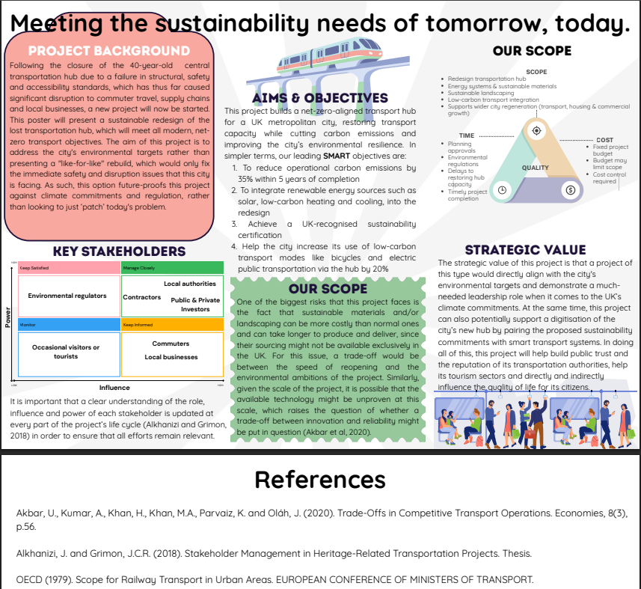

Reflection

Learning from the Project
Making this project poster helped me understand how project management principles can be used in a real infrastructure project. The chosen project concentrates on re-creating a metropolitan transport hub and ensuring that the UK's net-zero objectives are met. It also will help the city improve environmental sustainability. In the planning stage, I understood that project management is way more than providing a ready-to-use product. Moreover, it focuses on creating balance between stakeholder expectations, project limitations, environmental responsibilities, and long-term strategic value. I was motivated to sort out the information for the poster and present its purpose in a professional way.

Skills and Knowledge Developed during the Poster Preparation
One of the most important sides of this project was noticing clear project objectives through the SMART approach. The analysis of the quantifiable targets such as reduction in operational carbon emissions and increase in low carbon transport helped me understand the way to make realistic and achievable project outcomes. Moreover, I understood that scope definition is crucial for doing successful projects. Also, it helps individuals avoid extra work and manage project expenses. Defining the project scope helped separate different activities regarding the improvements and limitations that can impact project delivery. The Association for Project Management (2023) indicates that efficient scope management is crucial for keeping project control during the project life cycle.
Also, I experienced analysis of stakeholders and saw that different groups require different impact and interest. Making the stakeholder mix showed me that local authorities, contractors, and investors need closer management. However, local companies and commuters need consistent communication throughout the project. Recognising stakeholders’ expectations improved my focus on communication and engagement during the delivery of the project. PMI (2021) shows that proper stakeholder management helps companies in achieving success through better cooperation and less conflict.

Challenges during the Project
During the initial stages of the project, I saw many risks related to sustainable infrastructure projects. Such risks include supply chain limitations, high construction costs, and insecurity about innovative technologies. In addition, these can impact project performance. Focusing on these risks I was better able to balance environmental motivators against project time, cost and quality. In addition, the observation of these risks made me think critically about possible mitigation strategies prior to the implementation of the project. Currently, project management suggests constant risk monitoring as risks may change during the project lifecycle (Kerzner, 2022).

Future Improvements
If I am given this project again, I will use more detailed costs prediction analyses, sustainability performance measures, and a staged implementation plan. Also, I will create a more complex risk management schedule and use other stakeholder engagement activities during the project. Therefore, I will improve project planning and ensure more efficient decision-making during the preparation and implementation.

Conclusion
The assessment helped me understand that sustainable project management and environmental objectives can be integrated into key infrastructure developments. This task helped me increase my confidence in implementing different project management concepts. These skills will be very important in my future academic work and professional practice, especially when I should manage more comprehensive infrastructure and environmental projects (Turner, 2023).

Project Report

Executive Summary
This report evaluates a proposal for the sustainable redevelopment of a metropolitan transport hub to be undertaken on the closure of the existing facility due to structural, safety and accessibility issues. The project will provide a state-of-the-art transport hub incorporating renewable energy systems, sustainable construction and low carbon transport infrastructure in support of the UK’s Net Zero Strategy. The report addresses project background, objectives, scope and strategic value using recognised project management principles. It also introduces key project management tools such as a work breakdown structure (WBS), quad chart, Gantt chart, stakeholder management plan, resource allocation strategy and risk management approach. These tools enable effective planning, communication, tracking and decision making of the project during its life cycle. The analysis shows that the success of the project depends on the continuous management of risks, the engagement of stakeholders and the careful planning of the project. The proposed redevelopment is generally expected to improve the passenger experience, promote environmental sustainability, foster local economic development and establish a resilient transport hub providing long-term social, environmental and operational benefits to the city and its communities.

Introduction
The re-creation of transport infrastructure has been a key priority for several UK cities because they should provide solutions to high environmental challenges, population growth, and different transport demands. Sustainable transport hubs increase passenger mobility while also dedicating themselves to decreasing carbon emissions. Moreover, it motivates companies to focus on low-carbon travel and support long-term economic development of cities. Local authorities and governments invest in projects, which focus on environmental sustainability and modern transport technologies in order to achieve national climate objectives (Department for Transport, 2023).
This report analyses the suggested sustainable re-creation of a metropolitan transport hub after the closure of the current facility because of structural, safety, and accessibility issues. Moreover, the suggested projects’ key aim is to build a contemporary transport hub, which ensures the achievement of the UK's net-zero ambitions by using renewable energy systems, sustainable construction materials, and better public transport infrastructure. As a support to restoring transport capacity, the renovation will increase environmental resilience, provide better passenger experience, and guarantee the long-term economic growth of the city. The Association for Project Management (2023) also focuses on the essence of risk management, good stakeholder engagement, and strategic planning during a project life cycle.
Also this report discusses the stakeholder requirements, project’s scope, possible risks and strategic value also using the common project management principles. Furthermore it explains how sustainability issues can be integrated into the infrastructure development to deliver long-term environmental, social and economic benefits. Recommendations are made to ensure successful delivery of the project and to maximise the value gained for the local community and the wider transport network (PMI, 2021).
Figure 1. Sustainable Transport Hub Redevelopment Overview
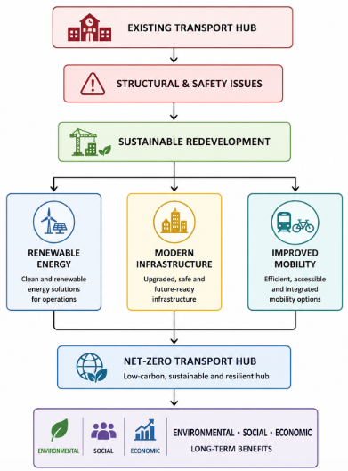

Project Overview

Project Background
After the closure of a 40-year-old metropolitan transport hub, this project was suggested in order to satisfy the modern structural, safety, and accessibility standards. Also, the old infrastructure exposed passengers, freight operators, and local businesses to issues and decreased the efficiency of the city's transport network. Being a major connection point for commercial transport and commuters, the transport hub’s closure increased traffic and influenced local economic activities. The Department for Transport (2023) indicates that reliable transport infrastructure is important for better accessibility to ensure economic growth and create sustainable communities.
The project suggests a sustainable redesign with modern transport infrastructure and environmental responsibility. Moreover, it consists of sustainable construction materials, renewable energy systems, low-carbon transport facilities, and green landscaping. This project focuses on the UK's Net Zero Strategy and improves the resilience and long-term performance of the transport network in the city. Economic and durable environmental benefits will be gained when sustainability is connected to the planning stage of this project (Institution of Civil Engineers, 2023; IPCC, 2023).
Figure 2. Project Overview
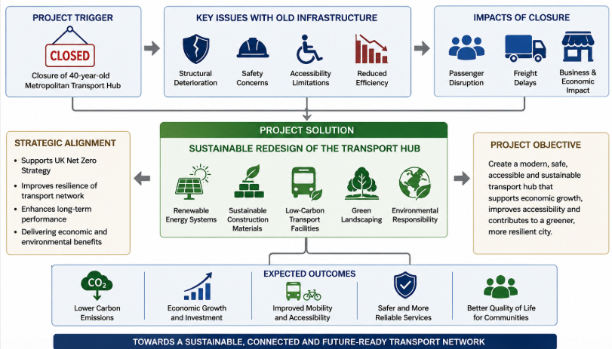

Project Aim and Objectives
The main aim of the project is to redesign the metropolitan transport hub into a safe, modern, and environmentally sustainable facility. It will also improve transport services and contribute to the UK's Net Zero Strategy. Efficient planning will guarantee the achievement of environmental objectives, maintaining higher project quality, low cost, and better performance (Association for Project Management, 2023).
The project has settled four SMART objectives. The first is to decrease operational carbon emissions by 35% in 5 years after completion. The second objective is to integrate renewable energy technologies like solar power and energy-efficient systems into the transport hub. In addition, the third objective is to gain a UK sustainability certification. The last objective is to raise the use of low-carbon transport like cycling and electric public transport by 20%. Well-defined objectives will provide measurable targets that focus on efficient project monitoring during the project lifecycle (PMI, 2021).
Figure 3. Project Aim and Objectives
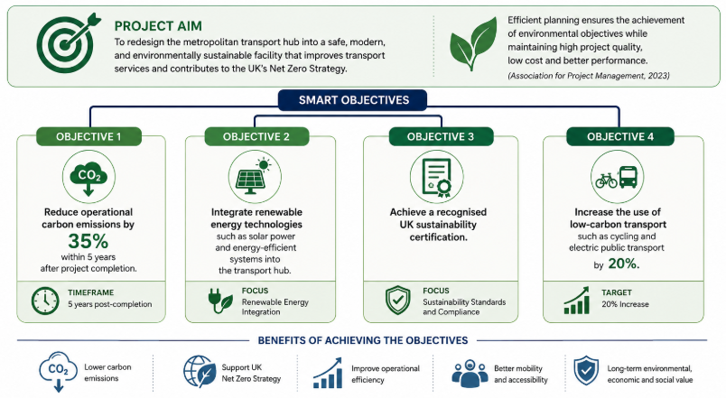

Strategic Value
The suggested redevelopment offers long-term strategic value by improving environmental sustainability, economic development, and public transport services. Also, the project improves national climate objectives as it decreases carbon emissions, motivates sustainable mobility, and endorses cleaner transport infrastructure. According to HM Government (2021), such improvements support broader government strategies for resilient and environmentally responsible transport systems (HM Government, 2021).
Also, this project will provide a better passenger experience, support local businesses, and motivate future investments by better transport connectivity. Moreover, the combination of sustainable infrastructure and modern technologies will increase operational resilience and ensure city development. The World Green Building Council (2023) states that long-term investment in sustainable transport infrastructure improves quality of life, increases public confidence, and improves the city's long-term competitive advantage.
Figure 4. Strategic Value of the Project
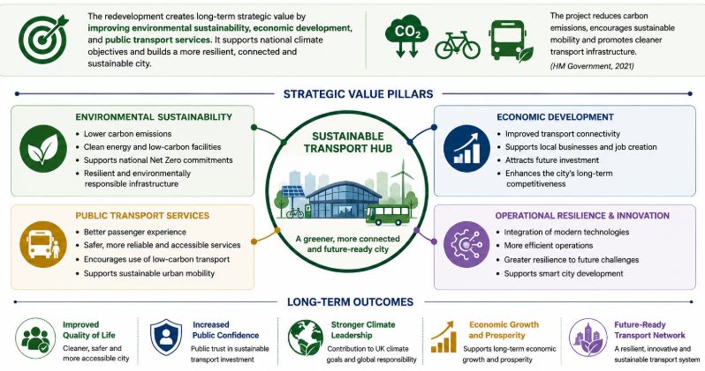

Project Scope

Project Scope
The project scope examines the practices demanded to provide the sustainable redevelopment of the metropolitan transport hub. A scope, which is properly defined, will help the project team realise that some work is included and other work is excluded. This will decrease uncertainty and avoid instant changes during the execution. In addition, project scope helps resource allocation, better planning, and project management control during the project lifecycle (Chartered Institute of Logistics and Transport, 2022).
The recreation of a transport hub through sustainable construction methods, renewable energy systems, green landscaping, and low-carbon transport infrastructure is the major aim of this initiative. Such improvements will create a more accessible, safer, and eco-friendly transport facility, which will help the city reach its long-term sustainability objectives. Also, the redevelopment will enhance transport connectivity and ensure better infrastructure to future urban generations.
On the other hand, the project avoids commercial property development, residential housing, and major road construction outside the transport hub. Understanding these limitations will help direct resources to the agreed objectives. According to the Office for National Statistics (2023), sustainable transport infrastructure improves local economic development and community wellbeing.

Project Deliverables
The successful implementation of this project will create key deliverables that will help the recreation of the transport hub. In addition, the primary deliverable is a modern transport facility that focuses on fulfilling structural, safety, and accessibility requirements. It will also focus on supporting sustainable urban mobility. Other deliverables are energy-efficient public facilities, renewable energy installations, improved pedestrian and green landscaping, cycling infrastructure, and better public transport services.
This project will also provide operational improvements as it ensures better passenger accessibility, lower carbon emissions, and high use of environmentally friendly transport. Focusing on the achievement of these deliverables will comply with the UK's sustainability objectives and offer measurable environmental, economic, and social benefits. According to ISO (2021), deliverables should be properly examined as they indicate measurable results showing successful project completion.

Project Constraints and Assumptions
The project encounters many constraints like limited budgets, planning approvals, environmental regulations, and strict deadlines. The access to sustainable materials and experienced contractors can also impact implementation and construction practices. Kerzner (2022) states that infrastructure projects that are successful demand efficient time control, considered costs, and better quality during the execution. Planning permission, project funding, and stakeholders’ engagement will help this project succeed by obtaining sustainable technologies. Good assumptions can help a project manager decrease uncertainty and enhance project planning (Axelos, 2020).
Figure 5. Project Scope, Deliverables, and Constraints
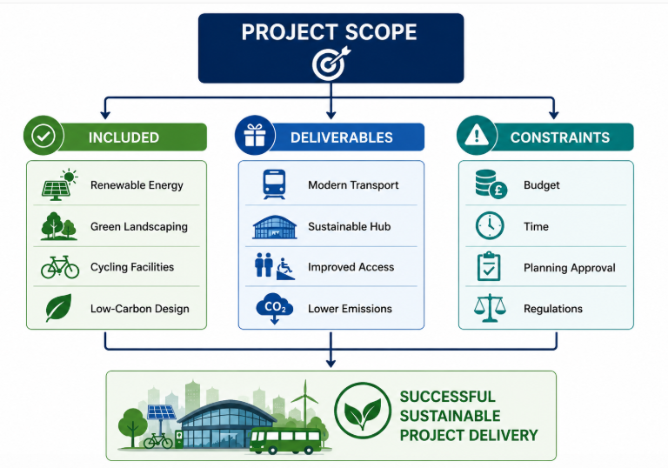

Work Breakdown Structure (WBS)
The Work Breakdown Structure (WBS) is considered a crucial project management tool that helps separate a project into smaller and manageable activities. Moreover, it offers a proper structure for organising, planning, managing, and controlling the work that should be done in order to execute the project successfully. A WBS, which is well-created, helps improve communication, clarify responsibility, and monitor progress more effectively during the project implementation. Lock (2020) states that dividing a project into logical work packages improves planning and project control.
The WBS of the sustainable redevelopment of the metropolitan transport hub is organised into four main phases – project planning, design and procurement, construction and installation, and testing with final handover. Every stage includes particular tasks that help achieve the project's sustainability and operational objectives. Such an organised approach helps managers with resource allocation, progress monitoring, and delay identification in advance. ISO (2020) also indicates that international project management guidance suggests the application of structured work breakdown approaches in order to enhance coordination and increase the possibility of delivering a successful project.

Figure 6. WBS of the Project
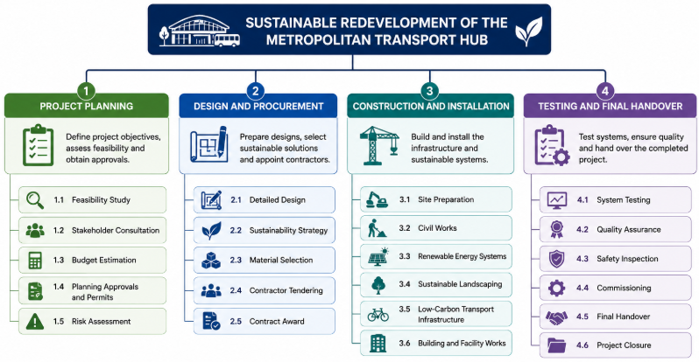

Quad Chart
The Quad Chart is a useful tool employed in project management that provides a brief visual synopsis of the most important information of the project on a single page. It also is a way of communicating deliverables, schedule, goals and significant risks to stakeholders without revealing detailed project documentation. In addition, the charts improve decision-making and communication, which helps project teams manage the project progress more effectively. Nicholas and Steyn (2020) state that visual project planning tools help stakeholder involvement and improve project control.
The sustainable redevelopment of the metropolitan transport hub will use the Quad Chart to summarise SMART objectives, expected deliverables, the implementation timeline and the key project risks. It also focuses on the redevelopment activities, sustainability targets and the major milestones and highlights issues such as planning approvals, budget limitations and supply chain concerns. The information is provided in a summarised format to improve collaboration between the project stakeholders and facilitate regular reviews of the project progress. Maylor (2021) states that visual reporting helps project managers identify problems more quickly and show project performance to main shareholders.
Figure 7. QUAD Chart of the Project
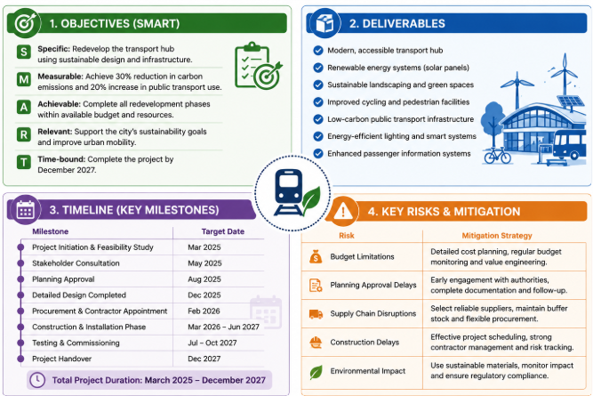

Gantt Chart
The Gantt Chart is a very important project scheduling tool that shows project activities over a specified timeline. It allows project managers to monitor progress, plan tasks, and see dependencies between the different stages of the project. In the case of the sustainable redevelopment of the metropolitan transport hub, the Gantt Chart shows the sequence of main activities like project planning, design, procurement, construction, testing, and final handover. Moreover, it illustrates major milestones that guarantee the completion of the project activities in the specified timeframe. A good project schedule helps managers improve coordination between stakeholders and ensures better use of resources during the implementation. According to Burke (2023), Gantt Charts focus on improving project scheduling by offering a visual summary of task durations and dependencies. Also, Schwalbe (2022) indicates that project scheduling tools ensure efficient monitoring, proper decision-making, and successful provision of comprehensive infrastructure projects.
Figure 8. Gantt Chart of the Project
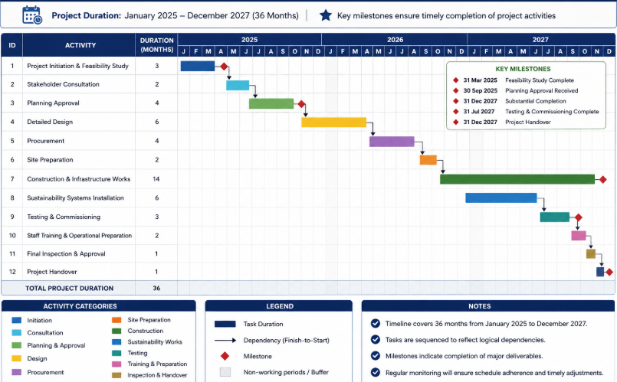

Stakeholder Management
Stakeholder management is important for the successful delivery of the sustainable redevelopment project as there are many groups with different interests and influence. Key stakeholders are local authorities, environmental regulators, contractors, investors, commuters and local business. Good communication and regular consultation enable an understanding of the expectations of the stakeholders and early resolution of potential conflicts. In addition, a stakeholder engagement strategy encourages greater collaboration and improved decision making across the project lifecycle. Effective stakeholder management requires good communication and good relationships with all relevant stakeholders (Bourne, 2020). Stakeholder influence should also be continuously monitored as priorities may change during the course of the project. A structured communication plan, including meetings, progress reports and public consultations will ensure transparency and improve stakeholders’ confidence. Walker (2021) further explains that continuous stakeholder engagement improves project performance; provides risk mitigation and increases the likelihood of successful project outcomes.
Figure 9. Stakeholder Management of the Project
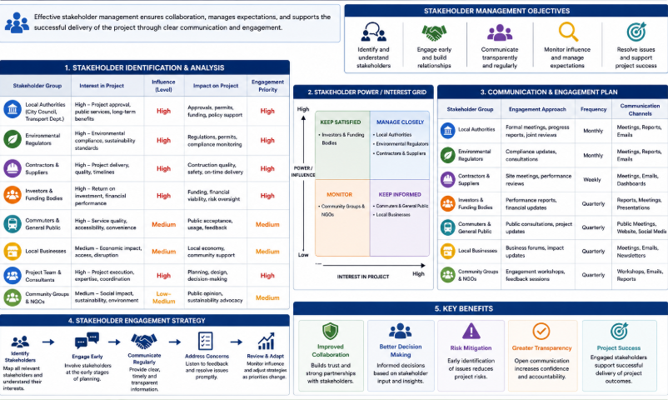

Resource Allocation
Effective resource allocation is critical for the sustainable redevelopment project to be delivered on time, on budget and to the required quality standards. Implementation of the project at each stage requires proper coordination of human resources, financial investment, construction materials, special equipment and modern technologies. Project managers have to distribute resources considering the priorities of the project. But all activities must be sufficiently supported in order to avoid delays and unnecessary costs. Appropriate resource planning also improves productivity and keeps project performance during construction (Heagney, 2022).
Engineers, architects, environmental consultants, construction contractors and project management professionals will collaborate on the project. Necessary sustainable construction materials, renewable energy technologies and specialized transport infrastructure equipment must be available, to avoid interruptions to the construction schedule when needed. Financial resources should be monitored continuously to ensure that expenditure does not exceed the approved budget and that the required quality standards are met. Digital project management systems can also help you track resource availability and identify potential shortages before they affect your project’s progress. The use of resources effectively leads to good decision making, operational efficiency and successful delivery of sustainable infrastructure projects (Heldman, 2021).

Risk Management
Risk management is crucial during project implementation because it helps managers see possible risks before they impact overall performance. For the successful implementation of the redevelopment of the metropolitan transport hub, many risks are involved, like budget overruns, unsuccessful delivery, approval delays, supply chain disruptions, labour shortages, and unexpected construction problems. Moreover, environmental regulation and different sustainability requirements can also impact project practices when not carefully supervised. Recognising risks in advance helps project managers create mitigation strategies and decrease their influence on project objectives. Cooper, Grey, Raymond and Walker (2022) also state that systematic risk management helps decision-making and ensures achieving successful outcomes.
All risks should be evaluated by probability and possible impact. For example, high-priority risks should be often monitored and improved with response plans like contingency budgets, alternative suppliers, and consistent communication with regulatory authorities. Moreover, risk review should be implemented during the project in order to see new threats and examine the efficiency of current mitigation measures. Following a project risk register and regular updates will help management make better decisions and enhance project resilience. In addition, good risk management ensures better project control, protects stakeholder interests, and guarantees that the project of the redevelopment will be implemented successfully (Hillson and Simon, 2020).
Figure 10. Risk Management of Metropolitan Transport Hub Development
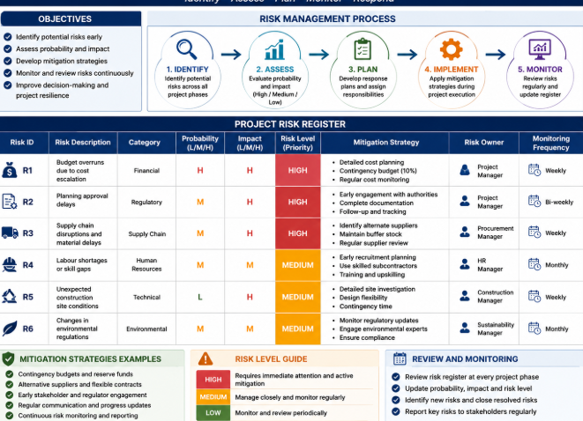

Conclusion
The suggested sustainable redevelopment of the metropolitan transport hub is a great example of showing a practical solution to the issues posed by the old transport infrastructure and the improvement of the city’s future transport. Also, this project uses modern transport design and environmental responsibility in order to create a safer, more accessible, and more effective transport hub for passengers, companies, and the local community. Applying renewable energy systems, sustainable construction methods, and low-carbon transport facilities will improve the redevelopment’s long-term environmental and economic growth and ensure a contribution to the UK's Net Zero ambitions.
This report showed that implementing well-known project management tools during the project lifecycle is crucial. Analysing the project scope, creating a Work Breakdown Structure (WBS), preparing a Quad Chart and Gantt Chart, allocating resources effectively, and managing project risks ensure that the project will be successfully implemented. Moreover, stakeholder management will help the project’s communication, improve collaboration, and ensure better decision-making processes throughout each stage of the project.
In general, the proposed redevelopment is a sustainable investment that will provide long-term benefits for the transport network and the broader community of the city. This project will also provide a better passenger experience, raise operational effectiveness, ensure operational performance, and provide consistent monitoring. Therefore, the redevelopment can achieve its objectives and build a resilient transport hub that satisfies the current needs of the city.

References
Association for Project Management (2023) APM Body of Knowledge. 8th edn. Princes Risborough: Association for Project Management.
Axelos (2020) Managing Successful Projects with PRINCE2. 7th edn. London: TSO (The Stationery Office).
Bourne, L. (2020) Stakeholder Relationship Management: A Maturity Model for Organisational Implementation. London: Routledge.
Burke, R. (2023) Project Management: Planning and Control Techniques. 7th edn. Chichester: John Wiley & Sons.
Chartered Institute of Logistics and Transport (2022) The Value of Sustainable Transport Infrastructure. Corby: CILT(UK).
Cooper, D., Grey, S., Raymond, G. and Walker, P. (2022) Project Risk Management Guidelines: Managing Risk in Large Projects and Complex Procurements. 3rd edn. Chichester: John Wiley & Sons.
Department for Transport (2023) Transport Data Strategy 2023. London: Department for Transport.
Heagney, J. (2022) Fundamentals of Project Management. 6th edn. New York: AMACOM.
Heldman, K. (2021) Project Management JumpStart. 4th edn. Indianapolis, IN: Sybex.
Hillson, D. and Simon, P. (2020) Practical Project Risk Management: The ATOM Methodology. 3rd edn. Vienna, VA: Management Concepts.
HM Government (2021) Net Zero Strategy: Build Back Greener. London: HM Government.
Institution of Civil Engineers (2023) State of the Nation 2023: Infrastructure and Net Zero. London: Institution of Civil Engineers.
Intergovernmental Panel on Climate Change (IPCC) (2023) Climate Change 2023: Synthesis Report. Geneva: IPCC.
ISO (2020) ISO 21502:2020 Project, Programme and Portfolio Management – Guidance on Project Management. Geneva: International Organization for Standardization.
ISO (2021) ISO 21500:2021 Project, Programme and Portfolio Management – Context and Concepts. Geneva: International Organization for Standardization.
Kerzner, H. (2022) Project Management: A Systems Approach to Planning, Scheduling, and Controlling. 13th edn. Hoboken, NJ: John Wiley & Sons.
Lock, D. (2020) Project Management. 11th edn. London: Routledge.
Maylor, H. (2021) Project Management. 5th edn. Harlow: Pearson.
Nicholas, J.M. and Steyn, H. (2020) Project Management for Engineering, Business and Technology. 6th edn. New York: Routledge.
Office for National Statistics (2023) Transport and the Economy, UK: 2023. Newport: Office for National Statistics.
Project Management Institute (2021) A Guide to the Project Management Body of Knowledge (PMBOK® Guide). 7th edn. Newtown Square, PA: Project Management Institute.
Schwalbe, K. (2022) Information Technology Project Management. 10th edn. Boston, MA: Cengage Learning.
Turner, J.R. (2023) Handbook of Project-Based Management. 5th edn. New York: McGraw-Hill Education.
Walker, D.H.T. (2021) Project Management in Construction. 7th edn. Hoboken, NJ: John Wiley & Sons.
World Green Building Council (2023) The Business Case for Sustainable Infrastructure. London: World Green Building Council.

