

Module Code: ECEY4001
Assignment title: Portfolio of three parts
Student Number: 2501895
AI Acknowledgement: I confirm that I gave not used any AI tools in the research and creation of this assignment. I confirm that I have not presented any AI generated materials as my own work. I confirm I have copies of my drafts, notes and other resources I used, which I may be asked to provide in evidence.

Part 1:
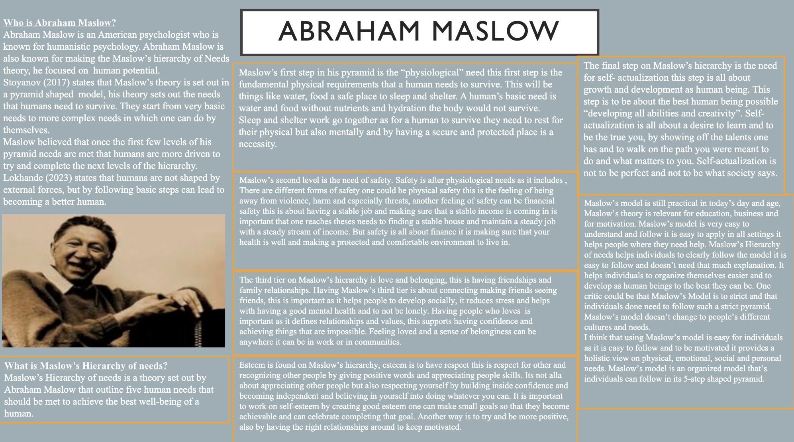
MASLOW INFORGRAPHIC.pptx

Part 2:
The concept of holistic child development comes from an educator called Friedric Frobel he believed that children grow through a combination of the child’s health, physical development the environment they grow up in and their social development. Hallow (2024) states that learning about children is not all about how well they can count or make sentences but how well they develop physically, emotionally and their social skills. Tovey (2016) states that Frobel’s ideas were an approach and wasn’t a method he wanted children to go and explore and have an active learning to be able to critically think. Froebel’s approach to early years links to Abrham Maslow’s hierarchy of needs. Buckler (2009) says that Maslow recognises all points of a child’s growth from cognitive, social, emotional to physical. A holistic approach helps children to overall wellbeing and their potential for growth in later life as it fosters many traits that are beneficial in gaining confidence and this can all be promoted in early years. A holistic approach lines up with Maslow’s hierarchy of needs as Maslow adopted a holistic approach in his pyramid as Maslow’s needs provides the basic needs a human needs to do. Abraham Maslow’s developed a model called Maslow’s Hierarchy of Needs, this model is set out into 5-steps.
The first step of Abraham Maslow’s pyramid is the physical development. Physical development forms foundations for a child to develop, it helps the child to widen their brain development their motor skills and their growth and general health. Maslow’s first step in his hierarchy of needs is Physiological needs for children it is important that they have accurate nutrition and access to clean water they have sleep, this is important for a child to develop healthy. Without such basic needs children will not be able to function properly their “emotional” wellbeing will not work and that they children may feel all over the place. Cowley (2021) states that if a child has poor nutrition and aren’t being fed nutrient rich food this can also effect a child’s memory and as well as their behavioural issues and the child’s attention span. By following Maslow’s model it helps and supports physical growth as a necessary step in developing as a child, by providing them with the main parts to develop properly as a child.
Maslow’s second and third level in his hierarchy of needs is for love and belonging this aligns with the emotional development of a child. For a child a routine is key in their development, and having a stable connection and feeling safe to a parent or a caregiver is a main benefit as when a child is supported they are more willing to express themselves and engage with others. Having a strong attachment to parents and caregivers, it helps children to grow emotionally and to build on self-esteem. According to Brummelman (2024) it is vital that a child has that feeling of being loved by a parent for their health and wellbeing, children need to feel loved and accepted before they can grow. Without having the support from a trusted adult children will struggle later on in life with anxiety and behavioural difficulties. Maslow’s holistic approach on emotional wellbeing interlinks with social skills and building and moral understandings.
The cognitive development area of Maslow’s pyramid refers to the growth of thinking and the problem-solving aspect. Maslow’s cognitive level shows that children need to be encouraged to try their best and to be challenged but also to be praised for their effort of trying rather than the outcome that has happened. Holistic development believes that the cognitive development is important, as a child who is unsafe or not loved will have lower self-esteem rather than a child who’s needs are met are much more rounded and confident and fulfilled. When a child’s needs are met they are more willing to think outside of the box and being confident and take on difficult tasks. It is important that a child learns through play and also are given open ended questions as this helps a chid lead by doing this it develops that child’s cognitive skills.

For a child it is vital that their social and moral development are learnt as social norms and empathy is learnt and not taught. Maslow’s highest level of the hierarchy believes that it is important that children develop personal values and independence and that they have a sense of purpose. Environments are important for children as children pick up behaviours quickly as behaviours are learnt not necessarily taught. Having self-actualization is important for children to learn as it allows children to experiment and be creative and to re-think and imagine independently without having an adult tell them what to do. Children who reach Maslow’s last stage are the children who are more willing to try new things this helps them feel fulfilled and be motivated to do more. Having the last tier helps children to become independent, confident and creative and to be pushed to all limits.
Having holistic child development works closely to Maslow’s Hierarchy of Needs, making sure that children work well and are happy and their well-being is supported is the main goal. Making sure that safety and physiological needs are stable is adamant for learning, where relationships is important for building a security to keep them safe and loved. Making sure that children are given every opportunity is key as it strengthens self-esteem and self-actualization.

Part 3:
Abraham Maslow’s hierarchy is a pyramid shaped like grid that has every basic need which every child and adult needs to live a happy comfortable life. Maslow’s hierarchy is a five step with the first step being physiological needs the second step in Maslow’s hierarchy is safety. Maslow’s third step on the pyramid is the sense of love and belonging, the fourth step in the pyramid is esteem and the final step of Maslow’s hierarchy of needs is the tier of self-actualization.
Maslow’s first step is meeting basic needs on his hierarchy is physiological Pichere (2015) explains that physiological needs are the vital need for any human to function, this may be from eating, drinking to even breathing. In this part of the assignment I am going to be writing about things that have happened in my early years setting. My first example is of a child who’s diet wasn’t the best in fact it was very unhealthy and was full of the wrong things. Child A was an overweight child, and he was very conscious of being the biggest child in the class. Child A’s lunch box consisted of lots of full fat food and high sugary foods he would have sandwiches filled with chocolate spread he would have a full-size chocolate bar and crisps child A would always have a sugary sports drink. Lissner (2015) sets that children who are overweight when they are in their early years are more likely be overweight when they are older, being overweight as a child can lead to many health problems such as asthma and type 2 diabetes. Not only can being overweight lead to health issues but they can lead to mental issues such as low self-esteem and also lead to anxiety. Child A was very insecure in himself he would always wear a jumper and would never take it off, on hot days we would have to remind him that it would be better to take it off as we didn’t want him overheating. Child A would get conscious as when he had forgotten his jumper at home time a child had read out it was 10-11 jumper, child A got very embarrassed. Child A had been picked up as overweight on a screening the parents were informed but never changed child A's diet. As an early year team, we took it as a whole class approach we made sure we did lots of sporting activities we did a task called “daily Puff’ the children would do a run or a walk around their school yard, child A would always take part in this. As a class we also learnt about the eat well poster we did tasks on the eat well plate for every child in the class, we asked the children to make their own eat well plate. Child A made his own plate, and it had all the protein and vegetables needed. The example I have given links with Maslow’s first tier on his hierarchy of needs which is the physiological need that is the need for basic food and water, and in the case of child A that was to have a healthy balanced diet which he wasn’t given by his guardians.
Th second example that has happened is from an early year setting where Child B was a very emotional child and this stemmed from his social background. Child B parents separated when child B was born, there would be numerous times where child B would come in very upset saying he missed his father. Child B would also be doing a work and be playing with fiends and then would get very upset all of a sudden. Child B would always come to myself for reassurance, he would open up to me and explain why he felt sad, his reasoning was that he missed his dad and that his dad lived to far away. As an early year’s team this was a struggle as we have no powers to move the dad back or for him to see child B more. What I did do was make sure that child B felt happier was to know it is normal to feel this way and to have all these emotions and that lots of people feel this way he wasn’t the only one who felt alone. I always made sure that child B could feel open to talk to me and my other colleagues, we also offered child B that whenever he felt that it was to much he could come and get a member of staff and go off in a quiet corner and have a break and to be able to speak privately. As an early year team we did speak to child Bs mother, and she explained that he was like this at home and that his father would speak to him a lot. Child B was missing from school for a few days, when he came back he was like a new child, Child B had gone on holiday to Disneyland with his mother and that there would be a surprise when he was there, when we asked child B what was the surprise was it Mickey Mouse or another character child B excitedly said that it was his dad. After coming back from his holiday child B was more open to talk about his emotions, this fits in with Maslow’s third level of his hierarchy of needs and the sense of belonging and the connection to his family. As a team we worked together to support child’s B needs and to make sure he had a sense of belonginess, and that he did have a connection to his father even if he did live far away.
In my school we give our children lots of different roles so that they build self-esteem, every child in the class has a role that may be changing the day and date of the week or it could to make sure that the art area is reset neatly. By giving the children roles it builds their strength, it also helps us as an early year’s group give children extra praises which build their confidence. When we give the children their roles and tasks, we make sure that they can complete these task and they aren’t set out to hard and we make sure they will be fulfilled, as making sure the child can complete the role builds self-worth. It also helps those children who may struggle academically succeeded in smaller jobs. This links into Maslow’s fourth step which is all about self-respect and believing in yourself. As an early year group it is important to believe in our children and to make them feel confident in school, by praised for amazing work and the jobs they do. Building esteem also helps the children be independent and sets the children up for later in life to be confident in themselves.

Reference List

Buckler, S. (2025) ‘Maslow’s greatest critic was… Maslow’, The psychology of education review (Online), 49(1), pp. 30–33. Available at: https://doi.org/10.53841/bpsper.2025.49.1.30.

Hallow School. (2024). WHAT IS HOLISTIC DEVELOPMENT IN EARLY YEARS? UNDERSTANDING COMPREHENSIVE CHILD EDUCATION. [Online]. All Hallow School. Last Updated: 22 September 2024. Available at: https://allhallowsschool.co.uk/all-hallows-blog/what-is-holistic-development-in-early-years-understanding-comprehensive-child-education

Tovey, H. (2016). Bringing the Froebel Approach to your Early Years Practice (2nd ed.). Routledge. https://doi.org/10.4324/9781315617190

Noltemeyer, A. et al. (2020) ‘The Relationship between Deficiency Needs and Growth Needs: The Continuing Investigation of Maslow’s Theory’, Child & Youth Services, 42(1), pp. 24–42. doi: 10.1080/0145935X.2020.1818558.

Qutishat, M. (2025) ‘Challenges in the application of Maslow’s hierarchy of needs for children living in Gaza amid ongoing conflict started in October 2023’, Middle East current psychiatry (Cairo), 32(1). Available at: https://doi.org/10.1186/s43045-025-00506-0.

Cowley, A. (2021) The wellbeing curriculum : embedding children’s wellbeing in primary schools. London, England: Bloomsbury Education.
Brummelman, E. et al. (2024) ‘Reciprocal self‐disclosure makes children feel more loved by their parents in the moment: A proof‐of‐concept experiment’, Developmental science, 27(6), pp. e13516-n/a. Available at: https://doi.org/10.1111/desc.13516.
Pichère, P. and Cadiat, A.-C. (2015) Maslow’s hierarchy of needs. Translated by C. Probert. Namur: Lemaitre Publishing.
Lissner, L. et al. (2015) ‘Differential outcome of the IDEFICS intervention in overweight versus non‐overweight children: did we achieve “primary” or “secondary” prevention?’, Obesity reviews, 16(S2), pp. 119–126. Available at: https://doi.org/10.1111/obr.12326.
Stoi͡anov, S. (2017) An analysis of Abraham Maslow’s A theory of human motivation. London, [England: Routledge.

Sanket Lokhande. (2023). How is human nature shaped, and who are we as individuals?. [Online]. Medium. Last Updated: 30th March 2023. Available at: https://medium.com/@lokhandesanket/how-is-human-nature-shaped-and-who-are-we-as-individuals-f5d4ec6849a1

