
Exploring Self-managed Logistics: Reducing Dependency on Third-Party Logistics in Retail using Milk Run Logistics
Huy (Kieran) Tran
Doctor of Business Administration

April 28, 2026
University of Wales Trinity saint david

Abstract

Introduction
In today’s volatile business environment, firms are facing intense competition caused by unpredictable demand, increasing customer expectation, and ever-rising operational costs. Given this situation, logistics and supply chain emerged as a crucial determinant of financial and operational success. A good supply chain process must be able to deliver consistent quality, low cost, high service level and high sustainability. In response to all those requirements, supply chain managers are seeking for more optimised and practical delivery strategy, capable of managing all those competing demands. This paper will focus on Milk Run, a delivery method where a single vehicle can pick up or drop off goods to multiple destinations thanks to a predetermined route making process (Chopra and Meindl, 2016).

Problem Identification
Specifically in the retail sector, the pressure on the supply chain and logistics department to perform well has intensified significantly. Customers now are expecting faster delivery and greater responsiveness, forcing retailers to in turn demand higher delivery frequency and greater reliability from their suppliers. This chain of pressure again moves upstream, when suppliers are forced to place heavy demands on their third-party logistics (3PL) providers to handle the deliveries. As a result, a recurring cycle of increasing service level expectations appears across the supply chain, essentially creating a bullwhip effect, where small demands fluctuate into major operational instability (Sarac et al., 2010). Furthermore, the growth of e-commerce post Covid-19 further heightened the problem. With a common expectation of next-day delivery thanks to one mouse click, the traditional cargo and bulk-delivery method are expected to struggle to keep up with the pace. This has altered the complexion of supply chain and logistics by emphasising on flexibility and dynamic change, as the procedure for planning predetermined routes is now not possible if the consumers require express next day delivery (Zahra et al., 2022).
In response, many suppliers and manufacturers turn to 3PL as they have the capabilities and expertise on handling complex frequent deliveries. While the benefits of 3PLs can’t be denied, the long-term challenges also appear. As 3PL slowly taking over the supply chain, the owner’s visibility over the distribution process is reduced, the operational control is lost, and the long-term operational cost is not optimal. And most importantly, there is another factor that suppliers/manufacturer sometimes overlook. Looking at the Resource Dependence Theory (RDT), it suggests that stakeholders should work together to obtain long-term performance, rather than seeking short-term benefits at the costs of others (Jiang et al., 2023). However, Sarkis et al. (2011) added an interesting point that when relying on other parties, firms must be able to manage the relationship carefully to sustain its development. This sentence was further explored, which led to the identification of a concept known as Dependence Asymmetry. This is a situation in a relationship where one party relies heavily on the other for resources but not the reverse, creating power imbalances. In a supply chain perspective, usually between a small business with limited capitals and a fully developed 3PL, there could be a situation where a stronger firm might take advantage of the other to extract value (Paulraj et al., 2025) (Hofer, 2015) (Kim and Fortado, 2021) (Rodrigues and Martins, 2022). Many scholars have raised this problem of joint dependence and logistics outsourcing relationships, but there are lacks empirical evidence whether this happens in real-life business or not. Therefore, this paper will not only look into a promising alternative solution that can internalise the supply chain process without needing the helps from any external parties; but in later research stages, it will also try to survey the market to investigate this dependence asymmetry issue further. By using Milk Run logistics as a main delivery process, manufacturers can self-manage their logistics network with greater opportunity in gaining competitive advantage.

Research Gap and Problematisation
An in-depth examination of the Milk Run literature reveals a significant gap and a clear bias within the research: Milk Run Logistics has predominately been recorded and applied within an industrial manufacturing environment (for example, aeroplane, electronics and automobile) where predictable production schedules and a stable demand pattern allow for a recurring routing process. In contrast, in the retail environment that this paper focuses on, the supply chain and distribution process is entirely different. For example, in the cosmetic industry, demand is highly volatile because of promotion, seasonality and store location. Cosmetic retailers have to place small orders across a wide variety of product range (different lipstick and hair dye colour) in a tight schedule for daily replenishment. This is complete contrast compared to the Industrial setting, where delivery orders are almost the same every week, thanks to a strict manufacturing plan. Furthermore, with Toyota’s just-in-time production system that popularised the concept in the 2000s (Nemoto et al., 2010), it received greater attention from scholars globally, further cemented the assumption that Milk Run can only work in an Industrial process and limited its adaptation within retail.
Given the lack attention and a dedicated framework for Milk Run implementation in a retail setting, this study will challenge the current assumption and address this conceptual blind spot by developing a practical order consolidation and route planning process for retail using heuristic methods. By doing so, the research will try to offer a theoretical repositioning of Milk Run: transforming it from a static and unresponsive distribution tool into a flexible and dynamic logistics capability. By utilising this logistics concept, suppliers can have the opportunity to internalise the supply chain process in-house, which ultimately reduce the reliance on 3PLs providers.

1.3 Research Objectives
The final aim of this paper is to propose an alternative solution that can reduce dependency on 3PLs in retail; to achieve this aim, the objectives of the research will be:
-Understand the reason why Milk Run is only popular in an Industrial setting, not Retail.
-Evaluate Milk Run effectiveness for cost reduction and efficiency improvement of palletised goods distribution in retail.
-Choose and analyse the most appropriate algorithm to design a Milk Run for daily use.
-Formulate a conclusion to see if Milk Run Logistics is viable enough to replace the traditional 3PL delivery process.

1.4 Research Questions
The CIMO framework (Context, Intervention, Mechanism, and Outcome) is used to create the research question for this research. It is said that this framework is useful for supply chain and logistics research as it focuses on the pragmatic nature of logistics and can be used to identify problems that lead to actionable solutions (Tanskanen et al., 2017). Table <> will illustrate CIMO’s application for Milk Run
Context | Demands in the retail industry are unpredictable and unstable, complicated the delivery process. This forces suppliers to turn to 3PL to handle the delivery process
Intervention | An algorithm using heuristics methods to group orders and plan routes for daily use.
Mechanism | Self-managed route planning process, better order consolidation, greater visibility and control of the supply chain network.
Outcome | Reduce dependency on 3PL.  Insourcing the delivery process to improve vehicle usage efficiency, reduce delivery costs and inventory holding cost, and enable greater service level
Table <>. CIMO Framework
Research question: “Is Milk Run Logistics a cost-effective method that can improve operational efficiency and cost for palletised goods distribution in retail to replace the traditional 3PL delivery model?”
Additionally, these sub-questions will be used to split the main research question into smaller chunks to ensure a complete study:
-Why was Milk Run more popular in an Industrial setting instead of Retail?
-What are the key opportunities and risks of using Milk Run Logistics as a baseline for a self-managed supply chain network?
-Which is the best algorithm to make Milk Run an optimal solution for Retail palletised distribution?
-Is Milk Run efficient enough to change the current dominate trend of Third-party Logistics delivering?

1.5 Contribution to Knowledge
This study will focus on developing a conceptual framework for creating Milk Run deliveries for palletised good distribution in the retail sector. The research will act as a guide for daily distribution operations, using simple Heuristic approach. To design a Milk Run route, the research will specifically examine three core parameters: Volume (truck capacity), distance travel, and time windows. It is worth noticing that this framework will be human-centred, meaning that human’s expertise and judgement is still required, rather than autonomising the process by using AI.
With the hope to reduce dependency on 3PL and promote in-house supply chain process, the study will also look into different theories that can provide practical guidance and theoretical grounding:
- Resource Dependence Theory (RDT)
Previously mentioned above, this theory suggests that if firms want to self-sustain and survive through the volatile market, they must collaborate with different parties to increase long-term benefits (Jiang et al., 2023). This theory is suitable and frequently applied to supply chain management, where the many parties are involved and collaborate to maintain in the “chain”.
- Dynamic Capabilities Theory (DCT) and Resource-based View (RBV)
These two theories, in this case, can be combined because they complement each other. The DCT explains how firm can gain competitive advantage in a dynamic and volatile market (in retail) by adapting and capitalising internal and external resources (Siems et al., 2021). The RBV theory emphasise the importance of using in-house capability and internal resources to gain competitive advantage (Cuervo-Cazurra et al., 2021). In this case, firm can use internal resources (Like logistics infrastructure, vehicles, ERP systems…) to capitalise the volatile market of retail and transform those opportunities into competitive advantages.

Literature Review
As the contemporary business environment evolves, so does the supply chain industry. For manufacturers, their success no longer solely depends on core production activities such as material conversion or scheduling, the supply chain activities like procurement or inventory management also have to perform excellently. For that reason, in order to achieve sustainable competitive advantage, there has to be a balance between cost control and process efficiency. To consistently deliver products at a low price, supply chain managers have to look into reducing smaller expenses like inventory holding cost, ordering cost and transportation cost (Minh et al., 2020). With that being said, this paper will now introduce a promising approach: Milk Run Logistics, an effective delivery option that has been extensively explored by Minh et al. (2020) and Chopra and Meindl (2016).

2.1 Milk Run Logistics
“Milk Run” was the term used to describe milk delivery men in the 20th century, who followed a fixed daily route to pick up empty bottles from the previous delivery and drop off fresh bottle (Minh et al., 2020). This regular, daily service was popular as it ensured the freshness of the product while still avoid overstocking. In a modern logistics point of view, Chopra and Meindl (2016) described this concept as a pre-planned delivery process that allows a single vehicle to follow a predetermined set of routes to service multiple delivery points. There are many advantages that comes with this approach, with the primary reason being its ability to consolidate multiple orders from different customers onto one vehicle, thus reducing the number of trucks and trips required to process daily deliveries. By combining many less-than-truckload shipments onto one cargo, users can utilise their fleets accordingly and are able to lower associated costs like maintenance, fuel, and CO2 emissions. These advantages are particularly useful for organisations who want to transition from 3PL dependence to building their own supply chain network, as it allows higher resource utilisation with fewer vehicles and lower logistics costs.
It is important to distinguish between an Inbound and Outbound logistics process. The inbound logistics process manages the movement of goods from the suppliers into the business, while the outbound process focuses on distributing finished goods to the end customers (Minh et al., 2020). Regarding inbound, nowadays, manufacturers who have a dedicated fleet offer to pick up their orders at the seller’s location using Milk Run, rather than receiving multiple deliveries at their production site. This helps by reducing traffic within the manufacturing site as well as reducing the workloads for warehouse workers as they now must unload only 1 truck. Furthermore, Milk Run can also help separate transportation cost from purchasing cost. Normally when procuring goods, the transportation costs are automatically added to the price of each order, with some sellers refuse to deliver if the order is too small. But now since the buyers offer to pick up the cargo, they can control both the quantity and the transportation cost. As for the Outbound process, it is considered simpler than the Inbound, as suppliers now only have to deliver the finished goods to their customers. However, the complexity now lies in the logistics activities like storing, packing, labelling… From a personal perspective, Milk Run works better in the Outbound process, because when it comes down to the supply chain process between retail and industrial, there are many physical characteristics that favours retail. The next chapter will further explore these factors.

2.2 Comparison: Retail vs Industrial Supply Chain
As mentioned above, the implication of Milk Run in industrial manufacturing received much attention from scholars around the world, while retail is the opposite. This chapter will take a closer look into three important factors of logistics: Order frequency, Physical Characteristics and Volume, and Route Planning to find the difference between the two industries.

Order Frequency
Minh et al. (2020) stated that a Milk Run system would thrive in an industrial setting because it has a consistent ordering frequency and stable demand. Toyota’s Just-in-time manufacturing system is a prime example of Milk Run application. They rely on small batches of delivery everyday that aligns with their predictable assembly needs (Nemoto et al., 2010). In such situation, Toyota was able to receive precise and repetitive deliveries with high reliability that enables them to maintain low inventory levels.
On the other hand, the order frequency of the retail industry is highly varied. Because of many different factors like store locations, demographic information, product types, and even trends and social media that define the dynamic, unpredictable characteristic of retail. This variability disrupts the repetitive rhythm that Milk Run thrive on, creating a dominant assumption that Milk Run only works fine in a stable demand environment. Hence, despite the needs for a high-frequency and responsive order replenishment process, firms choose to rely heavily on 3PL to handle the complexity. The persistent reliance without any effort of changing deepens the dependence, locking them from any alternative supply chain options.

Physical Characteristics and Volume
Regarding physical characteristics, Minh et al. (2020) provided a clear distinction between retail and industrial supply chain. Industrial components like engines, windshields, tyres… are often bulky and would require special handling equipment to unload. The bulky size is an important factor when it comes to transportation, as additional activities like unloading, packaging, or stacking of cargo would add up to the cost. However, in retail, the finished goods normally come in pallets, meaning that they have a uniformed size with much easier method of transporting.
When it comes to volume, there is also major different between the two. In an industrial context, the truckloads are always expected to be full thanks to the strict production schedule and stable demand. In contrast, goods distribution in retail is characterised with low volume orders of a mixed variety of product types that rarely fill up a truck. While historically being viewed as a barrier for traditional transportation method; it presents as a valuable opportunity for Milk Run, as a good order consolidation process can combine small volume orders together to fill a truck and serve multiple locations.

Route Planning
Routing is an aspect that heavily support Milk Run within an industrial context. In manufacturing, the delivery points are typically recurring and predetermined, allowing for repetitive routes that require low complexity and adjustment. In retail, not only the volume, but the location could change frequently from day to day. Far more flexibility is required to support the dynamic nature of retail. However, this is precisely the objective of this study of creating a flexible Milk Run framework for daily use, which will be discussed in later chapters.
Furthermore, with retail deliveries often occur in urban areas, more complexities are introduced to the transportation process like traffic, last-mile deliveries, congestion charges… Nemoto et al. (2010) also added that with retailer’s warehouse located in urban areas to support e-commerce and last-mile deliveries, they need to have a precise procurement process to overcome the space constraint of urban locations. These factors combined further increased the reliance on 3PLs, who possess great expertise in managing complex urban distribution network.

A critical review of this chapter saw a large gap in the literature for a manual and dynamic order consolidation procedure. Although there is strong evidence that supports the application of Milk Run in industrial manufacturing like the stable order frequency and fixed route planning, there is also small factor that can potentially support the effort of using Milk Run for retail distribution, for example: the needs for small volume orders consolidation and the uniformed pallet size. From a theoretical perspective, these positive factors strengthen Milk Run’s application in retail from a Resource-Based View. Unlike the bulky shape of industrial cargo that often require specialised handling, the small volume per order and uniformed pallet size of retail simplifies the order consolidation and vehicle loading processes, creating valuable operational capabilities that are easier to develop and manage internally. This is one of many factors that support the internalisation process of building an in-house distribution process that ultimately reduce dependency on 3PLs.

2.3 Vehicle Routing Problem (VRP)
The VRP was generalised by Ramser and Dantzig in 1959, it is an optimisation challenge that aims to determine the most efficient and optimal set of routes to serve many customers while still minimise the total cost and distance travelled (Gora et al., 2020). In the modern days, it is now being used to solve supply chain issues like fuel cost calculation, transport planning, vehicle requirement calculation, and most importantly, Milk Run logistics (Braeker et al., 2016).
Mei et al. (2017), You and Jiao (2014), Minh et al. (2020), Eroglu and Hofer (2011), etc., have produced studies that try to solve VRP, and all of their methods use these three criteria: Distance, Volume (vehicle capacity), and Time Window. These parameters were chosen randomly; they were chosen because they defined the fundamental service trade-offs and operational requirement for any multi-stop distribution system. Therefore, they will be used as a foundation to build this proposed Milk Run framework.
- Volume is the first and most important component as it keeps the orders within the vehicle’s carry limit. As Milk Run’s main trait is the ability to combine multiple orders together onto one truck, it is most efficient to keep the volume of each truck as high as possible to spread the transportation cost across every orders.
- Distance is the main cost contributor. The higher the distance travelled, the higher the cost for vehicle maintenance, driver’s wage, fuel, and emissions. Without saying, the distance needs to be as low as possible.
- Time Window is the most difficult to track, as they involve external factors that cannot be anticipated beforehand, such as traffic accidents that affect travel times, or last-minute bookings that disrupt the route planning.
These three parameters must be balanced and well-considered. However, in practise, it is not possible to optimise all three factors simultaneously without any trade-offs. But which parameters should be prioritised? The choice should be pragmatic and aligned with the company’s big picture objective. For instance, a firm should focus on low distance if they want to reduce cost, maximise vehicle capacity for operational efficiency, and time window for greater customer service. Importantly, the framework is designed to be adaptable and tailored, without imposing any rigid or static solution. Whether it is cost-focused, distance-conscious, or customer-oriented, flexibility and practicality of the framework are the main concerns.

2.4 Optimisation Technique
Optimisation techniques are used to find the most viable solution for a complex problem (Ahmed et al., 2020). There are 2 types of technique: Heuristic and Meta-heuristics. Heuristic methods are simple and fast approach that are used to find a near-correct answer (Salleh et al., 2023), while Meta-heuristics are higher-level methods that can solve scientific mathematical problems with large domain space (Gil-Rios et al., 2021).
A near-correct answer isn’t necessary a wrong answer, it is a realistic approximation to a problem that is useful when a precise solution can’t be found (Salleh et al., 2023). Furthermore, they are easy to understand, transparent and don’t need much investment in technology, which is particularly useful for daily operation. Therefore, this Milk Run framework will only use Heuristic methods rather than Meta-heuristics that require much calculation time and computational investment. Additionally, the near-optimal answer that heuristic methods obtain require human’s involvement to make a decision without reliance on automation system or AI, which is particularly practical in the supply chain industry where sometimes customers require specifications that need human judgment.
The Dynamic Capabilities Theory (DCT) said that in a highly volatile retail environment, the adaptation and reconfiguration of resources are vital in creating competitive advantage. Thus, a heuristic method that can quickly generate daily routes is more practical than pursuing marginal efficiency gains through intense computational methods. Although the chosen algorithm for the Milk Run route design hasn’t been finalised in this pilot study stage yet, a provisional design of combining the Clustering Algorithm and Greedy Grouping will be used to simulate a problem; they will be further explained in later chapters.

Methodology
This chapter will outline the approach used to evaluate the effectiveness of Milk Run Logistics in a Retail context. The study will use Saunder’s Research Onion as a guideline to ensure that every aspect aligns logically with the research’s aim and objective. However, before going through the Onion layers, the chapter will first start with the research paradigm, which includes the Ontology, Epistemology, and Methodology. The research paradigm will build the foundation and will help set in motion the development of the research philosophy (Saunders et al., 2023, pp. 132).

Research Paradigm

Ontology
Ontology explains the nature of reality and existence (Saunders et al., pp. 134). The research examines and evaluates the Milk Run Logistics effectiveness as a potential alternative to the 3PLs models in retail. The aim is to see if the framework would improve key performance indicators like cost reduction, operational performance, and vehicle utilisation. The paper acknowledges that in a dynamic and complex environment of retail, factors such as demand volatile or geographic and time window difficulty are constraints that affect the routing planning and network design process. These constraints influence the performance of any different distribution strategies, meaning that the effectiveness of 3PL or Milk Run can vary across different retail settings and operational conditions.
Saunders et al. (2023, pp. 653) said that from a realist perspective, reality helps to shape the participants’ interpretations rather than being constructed by them. Some logistics managers might prioritise these outcomes differently. For example, some might value the reduced operational burden of supply chain tasks through outsourcing to 3PL even if it is more expensive, this preference doesn’t alter the actual performance generated by the logistics system. Meaning that, whether Milk Run or 3PL is being used, the improvement of KPI is still a real and tangible outcomes of the logistics structure, independent of the managerial preference or perception. For this reason, the study will follow a realist ontology approach, as it assumes that logistics performance outcomes are objective realities that can be viewed through concrete data. This realism is suitable for this research as it ensures the comparison between the two methods are real and measurable, while still acknowledging that the results might vary depend on which context being used.

Epistemology
Epistemology refers to assumptions about knowledge, how knowledge is generated and communicated to others, and what is considered valid in a study (Saunders et al., 2023, pp. 134). In later stages of the research, knowledge can be generated through the analysis of measurable logistics data from a simulation to see if Milk Run or 3PL perform better.
This study will adopt the positivist epistemology approach, as Saunders et al. (2023, pp. 146) said that this approach focuses on generating observable and measurable evidence. Logistics performance generated from quantitative analysis is measurable, and qualitative data collected from logistics and supply chain professionals on their perspectives on the topic is observable. While the quantitative data is the core of the study to compare between the two distribution methods, and the qualitative data are used to support the findings rather than replace them. This ensure that the outcome of the study is more comprehensive in terms of operational performance and real-work practical decision-making.

Axiology
Axiology considers the role of values and ethics in a research process (Saunder et al., pp. 135). The study does not seek to promote any particular logistics approach but instead focus on making a comparison between the two approaches for their performance. By adopting a neutral stance, the research focuses on creating a practical framework to improve long-term performance.
However, the study acknowledges that by collecting qualitative data from logistics professionals on their opinion of the topic, such as their preference on any particular distribution method might introduces bias into the study. Therefore, to address this, the collected qualitative data should be interpreted carefully to ensure that the findings are not influenced by subjective opinion but are supportive evidence to maintain the reliability of the research.

Saunder’s Research Onion
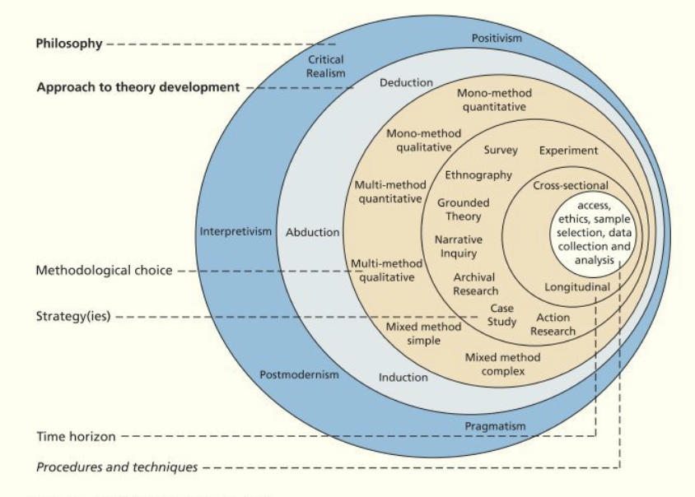
Figure <>. Saunders’ Research Onion, from Saunders et al. (2022, pp. 131)

Philosophy
Described as “school of thoughts” by Saunders et al. (2022, pp. 144), research philosophy is a system of beliefs and assumptions on how knowledge is developed. This study follows a critical realism philosophy that believe an objective reality exists independently of knowledge, theories, and human perceptions (Saunders et al., 2022, pp. 148). This approach aligns with the realist ontology and positivism epistemology by viewing logistics KPI as measurable and objective factors.
Furthermore, Saunders et al. (2022, pp. 149) added that “critical realism recognise the underlying structure of reality that shape the observable events”, in this case is the volatile demands of retail supply chain and the complexity of building an in-house distribution network. This allows the study to conduct an objective comparison between the two distribution approaches while still acknowledge the challenges of a real-life logistics environment.

Approach to Theory Development
This study used a deductive approach as it starts with an existing logistics concept. Furthermore, Saunders added that a deduction approach is subjected to rigorous tests to develop a theory, which is what this study is trying to achieve. The Milk Run delivery strategy was used as a theoretical foundation for developing a self-managed supply chain network. Using quantitative data, the concept will be tested to see whether it’s effective enough to replace the traditional 3PL delivery method.

Methodological Choice
Qualitative research includes descriptive data, narrative, and experience, while quantitative research uses statistical analysis and mathematical operations (Melnikovas, 2018). In this research, the mixed method is needed to strengthen the research and comprehensively answer the research question.
If the data collection process goes positively, quantitative data like stock reports or transport volume data can be used to test the Milk Run framework using different heuristic algorithm, and qualitative data collected from supply chain or logistics professionals is used to understand their perspective on the use of 3PL.
Additionally, Saunders et al. (2022, pp. 188) noted that there are two types of mixed method research: “Concurrent” and “Sequential Explanatory”. Concurrent research involves collecting both types of data at the same time, sequential explanatory research collects data in different stages throughout the research. This study will follow the concurrent approach to save time and enable a cross-validating process of analysing the data at the same time.

Strategies
In this early stage of pilot research, the intended data collecting strategies are Case Study, Narrative Inquiry, and Survey. The combined strategies can help levelling up the study by providing comprehensive insights and validity.
Case study is an effective method of conducting research, as each company has its own logistics challenges, allowing for a more in-depth examination of a real-world retail distribution environment. Additionally, a survey conducted through selective supply chain managers on LinkedIn will provide valuable context on decision-making processes and industry perspectives that are not captured through quantitative analysis alone. Lastly, narrative inquiry conducted through interviews with logistics experts can add further integrity into the research by providing more detail and discovering nuances of the research topic.

Time Horizon
Aligning with the concurrent research approach of collecting both quantitative and qualitative data at the same time, this research will also do a cross-sectional study of analysing the data at one specific point in time (Saunders et al., 2022, pp. 212). A Longitudinal approach of tracking data points over a prolonged period of time is not achievable or realistic.
By analysing data through a snapshot comparison, a clear before and after assessment can be made to evaluate the impact of Milk Run logistics

Procedures and Technique
- Data Collection Method
The study will collect both primary and secondary data. Secondary data has already been collected throughout the duration of the pilot study, such as literature review on Milk Run logistics, the difference between retail and industrial environments, different types of algorithms… However, the primary data hasn’t been collected yet and is currently the limitation of this pilot study. Due to the short timeframe and the fact that this research hasn’t been finalised yet, primary data will be collected in later stages.
Using case study method to collect quantitative data, a questionnaire will be sent out to obtain supply chain and general information like the number of trucks in a fleet, how much cargo can the truck carries, location of distribution centre, customer types… (included in the Appendix).
Similarly, for survey and narrative inquiry, a set of questions will be sent out to a list of selective professionals to obtain qualitative data. Questions will be designed around the key themes, including the current method of distribution, performance evaluation, knowledge on Milk Run logistics, and barriers to changes (included in the Appendix)
- Sampling Size
Saunders et al. (2023) suggested that the sampling size for a specialised topic (Milk run) should be small to ensure correct and valid information is gathered. The intended sampling size is 30 participants, ranging from logistics professionals to academic expertise in supply chain management. This size is sufficient enough to generate meaningful qualitative insights while manageable for an in-depth analysis. Rather than random sampling or focusing on the quantity of data, the focus is placed on the relevance and quality of data being collected.
- Ethics
The research will follow the university’s guidelines for data gathering. As primary data being involved, participation is fully voluntary and withdrawal at any stage is permitted. Furthermore, sensitive information like company and customer name is only disclosed with permission from the providers.
- Data Analysis Technique
Quantitative data like Stock Reports will be analysed in an Excel worksheet. The dataset will be processed using basic sorting technique, formatting and simple equations to simulate a daily task that a supply chain manager encounter.
Qualitative data from survey and interviews will be analysed differently. They will be illustrated using pie charts and graphs; furthermore, techniques like SWOT analysis, the 5 Whys, or the Fishbone diagram are tools that can be used to identify strengths, weaknesses, and the root cause of the specific issue.

Design and Analysis
With the literature review and research methodology out of the way, this chapter will explain further in-depth the design of the Milk Run framework: how it works and what is the reasonings behind it. As primary data hasn’t been collected yet, a simple simulation will be conducted to give a taste on how quantitative data will be analysed in later stage of the research.

Reasonings
Drawing on the author’s previous working experience in the retail supply chain sector, particularly a fast-moving consumer goods (FMCG) environment, it became understandable that supply chain managers nowadays require a quick, practical and easy to use routing planning system for daily usage. In such competitive, trendy and fast-paced environment, managers must be able to combine the planning system with quick decision-making to ensure no backlogs or disruptions within the supply chain. As a result, the proposed Milk Run framework is designed to be human-centred, straightforward, transparent and easy to understand so that anyone within supply chain process can be involved.
Furthermore, it has been mentioned that customisability is also an important feature. The framework will allow managers or leaderships to prioritise different objectives, it could be cost saving, customer service, sustainability, or space optimisation by adjusting the three core parameters: Volume, Distance, and Time Window during the route design. This flexibility ensures that the Milk Run is adaptable and suitable for any retailers who want to adopt the model, from small to medium-sized organisations.

Framework Design
The framework will use two heuristics approach rather than advanced meta-heuristic ones to avoid complexity, hardware requirements, and quick calculation time. The design process will be divided into 2 steps: order grouping and route designing. The Clustering Algorithm is used in the first step to group orders based on proximity while still kept volume and time window in consideration. Next, the Greedy Grouping method is used to sequence the deliveries according to the organisation’s chosen priority.

Order Grouping
To effectively manage a large set of data, the proposed framework begins by breaking the problem into smaller, more manageable sub-problems. This is called Dividing Strategy by Butta et al. (2022), a strategy that divide the original problem into sub-problems to individually solve them and later combined to solve the original problem. Therefore, the first step starts with the Clustering Algorithm, a process that organise data into groups based on similarities (De et al., 2022). The aim is to analyse the three parameters respectively and ensure that each order must exclusively be assigned to a single Milk Run without overlapping with other runs; and each milk run is a separate group.
As mentioned above; to explain the framework easily, the study will create a simulation with 5 shipping points (Figure <>) and information like volume and time window included in Table <>.
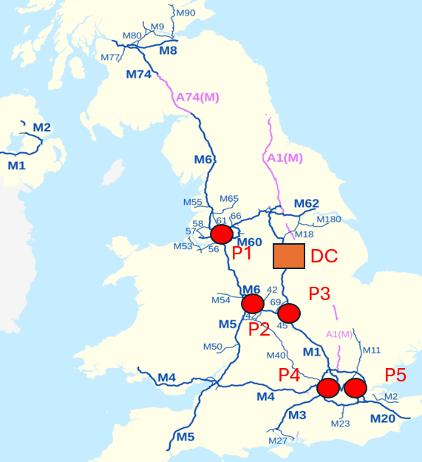
Figure <> Milk Run simulation map 1
Shipping Point | Address | Volume | Time Window
P1 | Liverpool | 5 pallets | 9:00 to 11:00
P2 | Birmingham | 6 pallets | 11:00 to 13:00
P3 | Coventry | 5 pallets | 11:00 to 13:00
P4 | London | 3 pallets | 15:00 to 17:00
P5 | London | 4 pallets | 12:00 to 14:00
Table <>. Milk Run Simulation information
In this example, the central distribution centre is the orange square in the middle of the map, and the truck carry capacity is 10 pallets.
First, the five orders should be clustered into three different groups that are close to each other: Point 1 in Group 1; Point 2 and Point 3 in Group 2; Point 4 and Point 5 in Group 3 (shown in Figure <>)
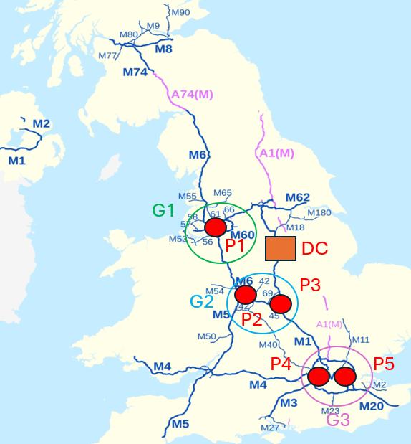
Figure <>. Simulation map 2
Shipping Point | Address | Volume | Time Window
P1 | Liverpool | 5 pallets | 9:00 to 11:00
P2 | Birmingham | 6 pallets | 11:00 to 13:00
P3 | Coventry | 5 pallets | 11:00 to 13:00
P4 | London | 3 pallets | 15:00 to 17:00
P5 | London | 4 pallets | 12:00 to 14:00

However, moving next to volume, Point 2 and Point 3 cannot be in the same group as their combined capacity of 5 and 6 exceed the carry limit of 10. But Point 1 and Point 3 can be clustered as their combined volume are exactly 10 pallets, so the new clusters are as followed: Point 1 and Point 3 in Group 1; Point 2 in Group 2; Point 4 and Point 5 in Group 3 (Shown in Figure <>).
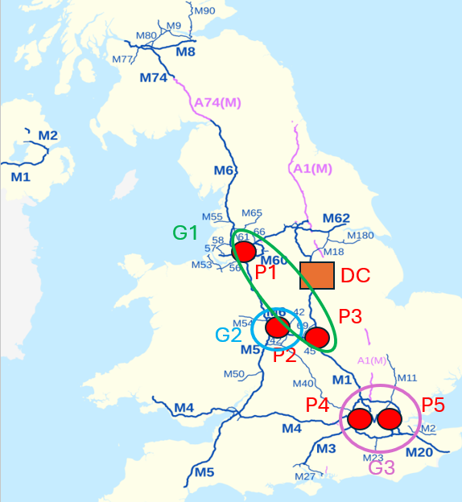
Figure <>. Simulation map 3
Shipping Point | Address | Volume | Time Window
P1 | Liverpool | 5 pallets | 9:00 to 11:00
P2 | Birmingham | 6 pallets | 11:00 to 13:00
P3 | Coventry | 5 pallets | 11:00 to 13:00
P4 | London | 3 pallets | 15:00 to 17:00
P5 | London | 4 pallets | 12:00 to 14:00
Lastly, the time window should be analysed. There is a mismatch between the time window of Point 4 (15:00 to 17:00) and Point 5 (12:00 to 14:00). If the delivery starts at Point 5, the truck has to stand and wait until 15:00 for Point 4, which is not optimal. While Point 2’s time window fits better with Point 5; therefore, a new set of clusters is created: Point 1 and Point 3 in Group 1; Point 2 and Point 5 in Group 2; Point 4 in Group 3 (Shown in Figure <>).
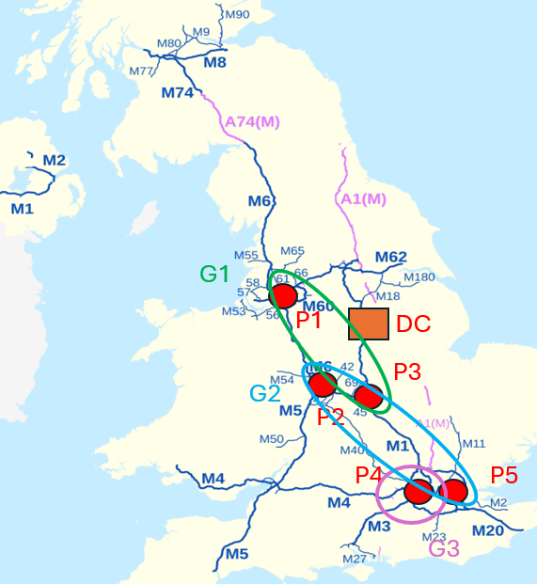
Figure <>. Simulation Map 4

Route Designing
The second step is to design the routes so that the sequence of stops is operationally feasible. The Greedy Grouping algorithm is applied to selecting the most appropriate next delivery point based on the current situation (Alidaee et al., 2001). Importantly, it is worth noticing that the “next best” destination choice might not necessarily be the nearest in geographical proximity; instead, the next choice should be based on the firm’s operational objective. This means that sometime firms must disregard the most straightforward, nearby location if it clashes with the firm’s time window focused objective.
In this simulation example, the objective is to travel the least amount of mileage. The route design for Group 1 is as follows: the run begins at the main distribution centre and make it first drop at Liverpool; it continues to Coventry and returns to the distribution centre to end the run (Shown in Figure <>).

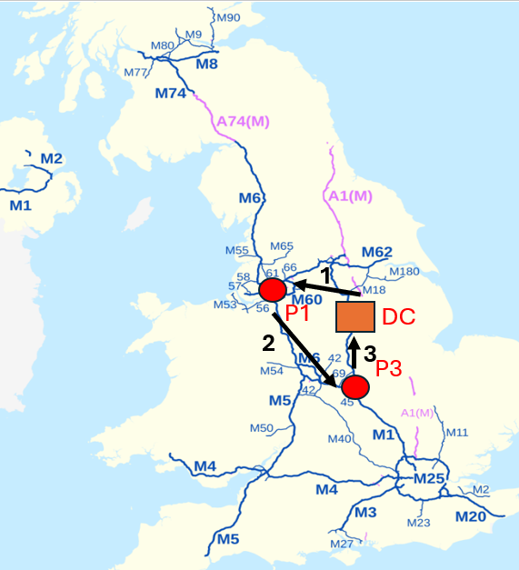
Figure <>. Simulation map 5
There are many possibilities for adjusting the delivery routes depending on the firm’s objective. For example, the choice of stopping at Liverpool first aligns better with the time window constraints. Furthermore, choosing to avoid the M6 Midland Toll also directly reduce transportation costs. Similarly, firms can also choose to operate outside of London’s congestion charge by delivering at off peak hours. These example shows that the nearest geographical proximity should not be the only consideration but instead should be a combination of time constraints and cost optimisation.

Conclusion

Appendix
Questionnaire for Quantitative Data:
1/ Daily Operation
How many deliveries completed per day? How many pallets on each delivery on average?
What is the truck fill rate? What is the pallet fill rate
2/ Fleet Information
How many trucks are there in the current fleet?
What model? How much weight it can carry?
3/ Customer Information
Where is the main central warehouse located?
What is your current type of customers? (high-street retailers, supermarket, discount store…)
What are the main KPI used to assess your logistics network’s efficiency? (cost, on-time delivery, quality-focused – missed delivery, damaged products, inaccuracy…)
4/ General Information
What is the current distribution model?
Is the delivery managed in-house or outsourced?
What is the current logistics problem that the firm is facing?
What is the biggest challenge to implement changes on the logistics operation?

Questionnaire for Qualitative Data:
1/ Current Use of 3PL
What role does 3PL currently play in your logistics operation?
What are the pros and cons of using a 3PL?
What are the reasons your firm relies on a 3PL?
2/ Performance
What are the main KPI used to assess your 3PL?
How many customers do your 3PL currently serve at the moment?
Are you currently happy with your 3PL performance? Why or why not?
3/ Perception on Milk Run Logistics
Are you familiar with the Milk Run delivery approach? (Brief explanation)
In your opinion, what advantages could a Milk Run approach offer to your organisation?
What concerns would you have in this Milk Run system?
4/ Barriers to changes
What challenges would arise if your supply chain were managed in-house?
Is your current workload manageable enough for additional order consolidation and route design tasks?
What internal capability (capital, fleet, expertise, IT…) would limit the adoption of an in-house supply chain network?
5/ Final Evaluation
Do you believe an in-house distribution network using Milk Run could replace a 3PL model?
Do you think it is realistic and beneficial to insource your logistics process?
Do you think 3PL is a sustainable method in the long-term?
What is your thoughts on the topic?

Reference
Ahmed, Z. E., Saeed, R. A., Mukherjee, A., Ghorpade, S. N. (2020) ‘10 - Energy optimization in low-power wide area networks by using heuristic techniques’, LPWAN Technologies for IoT and M2M Applications, pp. 199-223. Available at: https://www.sciencedirect.com/science/article/pii/B9780128188804000119
Alidaee, B., Kochenberger, G. A., Amini, M. M. (2001). Greedy solutions of selection and ordering problems. European Journal of Operational Research, 134(1), 203-215. https://www.sciencedirect.com/science/article/pii/S0377221700002526#:~:text=The%20greedy%20method%20is%20a%20well%2Dknown%20approach%20to%20problems,are%20simple%20implementation%20and%20efficiency
Braekers, K., Ramaekers, K. and Van Nieuwenhuyse, I. (2016) 'The vehicle routing problem: State of the art classification and review', Computers & Industrial Engineering, 99, pp. 300–313. Available at: https://doi.org/10.1016/j.cie.2015.12.007.
Butta, R., Kamaraju, M., Sumalatha, V. (2022). 4 - Heuristic methods for data clustering. Artificial Intelligence in Data Mining, 65-86. https://www.sciencedirect.com/science/article/pii/B9780128206010000033

Chopra, S., Meindl, P., Kalra, D. V. (2019) ‘Supply Chain Management: Strategy, Planning, and Operation’ (7th ed.). Pearson Education.
Cuervo-Cazurra, A., Dieleman, M., Hirsch, P., Rodrigues, S.B. and Zyglidopoulos, S. (2021) 'Multinationals’ misbehavior', Journal of World Business: JWB, 56(5), pp. 101244. Available at: https://doi.org/10.1016/j.jwb.2021.101244.
De, S., Dey, S., Bhatia, S., Bhattacharyya, S. (2022). Chapter 1 - An introduction to data mining in social networks. Advanced Data Mining Tools and Methods for Social Computing, 1-25. https://www.sciencedirect.com/science/article/pii/B9780323857086000084

Eroglu, C. and Hofer, C. (2011) 'Lean, leaner, too lean? the inventory-performance link revisited', Journal of Operations Management, 29(4), pp. 356–369. Available at: https://doi.org/10.1016/j.jom.2010.05.002.
Gil-Rios, M., Cruz-Aceves, I., Cervantes-Sanchez, F., Guryev, I. and Lopez-Hernandez, J. (2021) ‘Chapter 8 - Automatic enhancement of coronary arteries using convolutional gray-level templates and path-based metaheuristics’ Recent Trends in Computational Intelligence Enabled Research, pp. 129-153. Available at: https://www.sciencedirect.com/science/chapter/edited-volume/abs/pii/B9780128228449000050

Gora, P., Bankiewicz, D., Karnas, K., Kazmierczak, W., Kutwin, M., Perkowski, P., Plotka, S., Szczurek, A. and Zieba, D. (2020) ‘Chapter 2 - On a road to optimal fleet routing algorithms: a gentle introduction to the state-of-the-art’ Smart Delivery Systems, pp. 37-92. Available at: https://www.sciencedirect.com/science/article/abs/pii/B9780128157152000142
Hofer, A.R. (2015) ‘Are We in This Together? The Dynamics and Performance Implications of Dependence Asymmetry and Joint Dependence in Logistics Outsourcing Relationships’ Transportation Journal, 54, pp. 438-472. Available at: https://doi.org/10.5325/transportationj.54.4.0438 (13/04)
Jiang, H., Luo, Y., Xia, J., Hitt, M. and Shen, J. (2023) 'Resource dependence theory in international business: Progress and prospects', Global Strategy Journal, 13(1), pp. 3–57. Available at: https://doi.org/10.1002/gsj.1467 (13/04)
Kim, D. Y., and Fortado, B. (2021) ‘Outcomes of supply chain dependence asymmetry: a systematic review of the statistical evidence’, International Journal of Production Research, 59(19), pp. 5844–5866. Available at: https://doi.org/10.1080/00207543.2020.1791999 (13/04)
Mei, H., Jingshuai, Y., Teng, M.A., Xiuli, L.I. and Ting, W. (2017) 'The modeling of milk-run vehicle routing problem based on improved C-W algorithm that joined time window', Transportation Research Procedia (Online), 25, pp. 716–728. Available at: https://doi.org/10.1016/j.trpro.2017.05.453.
Melnikovas, A. (2018). Towards an Explicit Research Methodology: Adapting Research Onion Model for Futures Studies. Journal of Futures Studies, 23(2), 29-44. https://jfsdigital.org/wp-content/uploads/2019/01/03-Melnikovas-Onion-Research-Model.pdf (20.04)
Minh, N.D., Kien, D.T. and Hau, P.K. (2020) 'Applying milk-run method to optimize cost of transport: An empirical evidence', International Journal of Supply and Operations Management, 7(2), pp. 178–188. Available at: https://doi.org/10.22034/IJSOM.2020.2.6.
Nemoto, T., Hayashi, K. and Hashimoto, M. (2010) 'Milk-run logistics by Japanese automobile manufacturers in Thailand', Procedia - Social and Behavioral Sciences, 2(3), pp. 5980–5989. Available at: https://doi.org/10.1016/j.sbspro.2010.04.012 (14.04)
Paulraj, A., Subramanian, N., Jayaram, J., and Blome, C. (2025) ‘The dark and bright sides of dependence relationships and their effect on buyer-supplier unethical behaviour’, International Journal of Production Research, 63(20), pp. 7637–7658. Available at: https://doi.org/10.1080/00207543.2025.2504157 (13/04)
Rodrigues, A. C. and Martins, R. S. (2022) ‘The Effects of Dependence on Brazilian Third-Party Logistics Satisfaction’, Journal of Contemporary Administration, 26(1). Available at: https://www.redalyc.org/journal/840/84068347006/84068347006.pdf (13/04)
Salleh, N.A.M., Ahmad, S.F., Shaharudin, M.R. and Rahim, S.A. (2023) 'Evaluation of transportation distance optimization route for milk run logistics system', International Journal of Supply and Operations Management, 10(3), pp. 295–318. Available at: https://doi.org/10.22034/IJSOM.2022.109361.2347.

Sarac, A., Absi, N. and Dauzère-Pérès, S. (2010) 'A literature review on the impact of RFID technologies on supply chain management', International Journal of Production Economics, 128(1), pp. 77–95. Available at: https://doi.org/10.1016/j.ijpe.2010.07.039 (7/04)
Sarkis, J., Zhu, Q. and Lai, K. (2011) 'An organizational theoretic review of green supply chain management literature', International Journal of Production Economics, 130(1), pp. 1–15. Available at: https://doi.org/10.1016/j.ijpe.2010.11.010. (07/04)
Siems, E., Land, A. and Seuring, S. (2021) 'Dynamic capabilities in sustainable supply chain management: An inter-temporal comparison of the food and automotive industries', International Journal of Production Economics, 236, pp. 108128. Available at: https://doi.org/10.1016/j.ijpe.2021.108128.
You, Z., Jiao, Y. and Wu, H. (2014) 'Development and application of milk-run distribution systems in the express industry based on saving algorithm', Mathematical Problems in Engineering, 2014(1) Available at: https://doi.org/10.1155/2014/536459.
Zahra, S.A., Petricevic, O. and Luo, Y. (2022) ‘Toward an action-based view of dynamic capabilities for international business’, J Int Bus Stud ,53, pp. 583–600. Available at https://doi.org/10.1057/s41267-021-00487-2

