

Assessment component: Financial performance and management of Tesla
Student ID: 2532584
Student Name: Krishna oghad modhavadiya
Course Name:Financial Management
Lecturer Name:Shengfeng Mai
Term:February 2026
Word Count: 5015
Submission Deadline: 24th April 2026

Table of Contents
1. Financial health check 4
1.1 Analysis of Tesla’s past 5 years’ financial condition 4
1.2 Evaluation of Tesla’s financial ratios 5
1.2.1 Profitability ratio 5
1.2.2 Liquidity ratio 6
1.2.3 Efficiency ratio 7
1.2.4 Gearing ratio 8
1.2.5 Investment ratio 8
1.2.6 Cash flow 9
2. Working capital management analysis 10
2.1 Discussion of cash operating cycle 10
2.2 Strategies to improve the liquidity situation of Tesla 11
2.3 Comparison of short-term and long-term financing options 12
3. Strategic financial restructuring plan 13
3.1 Recommendation of financial restructuring plan 13
3.2 Impact of shareholders' value, debt structure, and operational flexibility 14
3.3 Impact of international and ethical considerations 15
4. Investment appraisal and Capital budgeting 16
4.1 PBP 16
4.2 ARR 16
4.3 NPV 17
4.4 PI 17
4.5 IRR 17
4.6 Recommendation with reference to the company’s financial performance and non-financial risks 18
4.7 Recommendation with reference to capital rationing 19
Conclusion 20
References 21
Appendices (ratios and NPVs) 24
Appendix 1: Ratio Analysis 24
Appendix 2: Cash operating Cycle 25
Appendix 3: Investment Appraisal and Capital Budgeting 26

Introduction
Tesla is an American MNC that provides automobiles and clean energy across the globe. The company is involved with the manufacturing, designing, and selling of battery electric vehicles (EVs) along with energy storage devices.It is going to discuss the financial health of the company over the 5 years with the help of financial ratios. Utilization of the cash operating cycle is also going to help determine if the company's liquidity proportion is in a beneficial position or not. There are various financial restructuring options,which are expected to help the company improve its current situation, considering the financial and non-financial risks. The company is required to choose between 3 projects for investment, which are going to provide the company the highest return with the minimum financial resources and have the lowest risk.

1. Financial health check

1.1 Analysis of Tesla’s past 5 years’ financial condition
Based on the 5-year financial analysis of the company Tesla,it has been found that the company has increased revenue prospects from 2021 to 2024 (ir.tesla.com, 2026). In recent times, the company has faced declining revenue growth. Chinese automaker BYD overtook Tesla in total EV sales, while other manufacturers introduced lower-cost, competitive alternatives. This shift has eroded Tesla’s market dominance and intensified pressure across the global EV landscape. This is the actual cause of the declining revenue of the company in 2025.

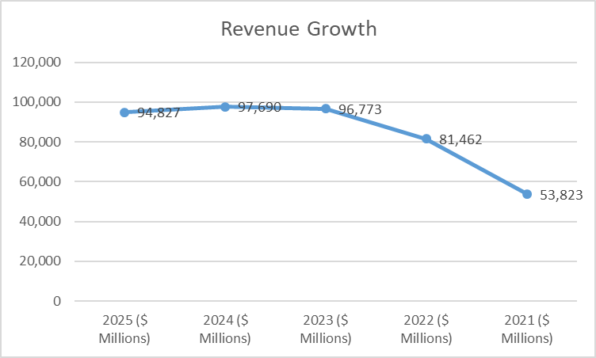
Figure 1: Revenue Growth
(Source: Excel)
After analysing the profit prospects of the company,it has been stated that Tesla achieved the highest profit growth in 2023. Also, the lowest profit was achieved in 2025, due to leadership issues,rising inventories, and a lack of demand for highly innovative models (ir.tesla.com, 2026).It has also affected the brand value of the company, which is the main reason for having the lowest profit prospect in the last 5 years.
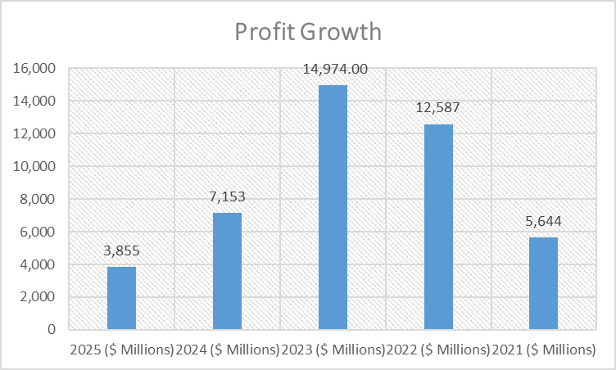
Figure 2: Profit Growth
(Source: Excel)

1.2 Evaluation of Tesla’s financial ratios

1.2.1 Profitability ratio
Trend
The company has lower profitability in 2025, with respect to the previous four years. Tesla earned3,855 million dollars of profit and 98,427 million dollars in revenue in 2025; based on that, the net profit ratio for that year is 4.06% (ir.tesla.com, 2026).On the other hand,the profitability ratio was much higher,7.32% in 2024,15.47% in 2023, which is the highest among all five years, 15.45% in 2022, and 10.48% in 2021. The highest revenue earned by the company is in 2024, amounting to 97,690 million dollars; however, the highest profit margin was earned in 2023, with the amount of 14,974 million dollars (ir.tesla.com, 2026).
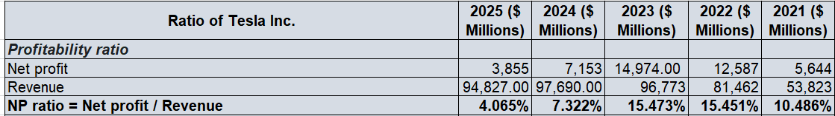
Table 1: Profitability ratio
(Source: Excel)
Based on the net profit ratio,the company needs to improve its profit margin to overcome the lower profit in respect to the past years.
Strength
The company includes a direct-to-customer sales model,which has helped to improve brand control and profit margin.
Threats
There are various new arrivals in the market, which have been the reason for lower profitability and declining revenue growth of the company (Avi, 2023). Also, the company has not implemented any innovative models,due to which it has faced lower business growth in recent years.

1.2.2 Liquidity ratio
Trend
Tesla's liquidity proportion is good in 2023,as the company has proportionate current liabilities and increased current assets. The liquidity ratio of the company is 2.16 in 2025,2.02 in 2024,1.73 in 2023,1.53 in 2022, and 1.38 in 2021 (ir.tesla.com, 2026). A good liquidity ratio is when the company is decreasing current liabilities with increasing current assets (Blessing and Sakouvogui, 2023). The financial trend of Tesla shows that there is an increasing current liability aspect, and there are also increasing current assets in recent years. This signifies that the company faced financial risk in 2025, and it has the ability to recover from significant risk.
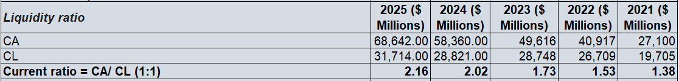
Table 2: Liquidity ratio
(Source: Excel)
Strength
The company has an increasing trend of current assets, which is going to help to recover future financial risks. There are certain situations of having an increasing trend of liabilities that are going to impact the financial condition of the company (ir.tesla.com, 2026).
Threats
Tesla has a lack of rapid model innovation and dependency on subsidies, which has impacted its financial strength. Also, there are situations like increasing inventory with less demand for the product due to new competition in the market.

1.2.3 Efficiency ratio
Trend
The efficiency of the company has been calculated by using the inventory turnover ratio, which includes the cost of goods sold and the average inventory of the company. The company has an increasing revenue trend till 2024, and after that, there is a declining growth in 2025. Based on that, the cost of goods sold has the same trend as revenue, as it includes gross profit deducted from sales (Hasidi et al., 2024). On the other hand,there is an increasing growth of average inventory noticed in recent years,which implies that the company's stock turnover proportion is high (ir.tesla.com, 2026).
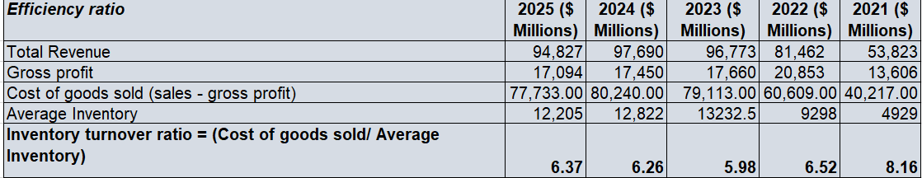
Table 3: Efficiency ratio
(Source: Excel)
Strength
The company is a fast-growing segment, and it has an increasing asset proportion, which is going to help the company recover its financial gaps.
Threats
Based on the recent trends, Tesla has declining total automobile revenue in 2025 and has increased expenses. Due to that, the company has had an insignificant efficiency proportion in recent years.

1.2.4 Gearing ratio
Trend
The gearing ratio has been calculated by including the total debt of the company and the total equity. As per the view of Purnaningtyas (2023),a sufficient gearing ratio signifies the company's depth of recoverable condition. The good gearing ratio also indicates the company's financial strength. Tesla has a trend of increasing total debt in the last 5 years, along with having an increasing equity proportion. The gearing ratio of the company is 0.67 in 2025,0.66 in 2024,0.69 in 2023,0.82 in 2022, and1.01 in 2021 (ir.tesla.com, 2026).
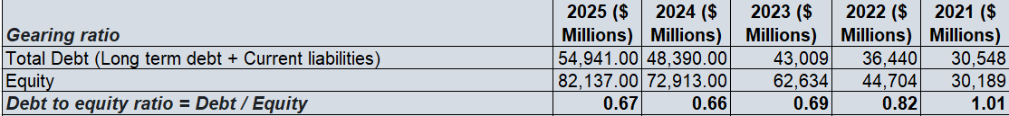
Table 4: Gearing ratio
(Source: Excel)
Based on the debt to equity ratio,the company has an optimal range of gearing ratio, which signifies that it has a healthy balance between shareholders' equity and company total debt.
Strength
Tesla has the proportion and balanced mix of debt and equity, which is going to help the company maintain financial stability while facing increased risk and economic downturns. Moreover,the company is in a moderate position of financial strength in the automobile industry.
Threats
As the company has an increasing trend of total debt,it will impact its future financial strength. Additionally, there are issues with the leadership that also impact the company’s brand valuation.

1.2.5 Investment ratio
Trend
The investment ratio includes the proportion of net income and shareholders' equity. As per the view of Indah (2024), return on equity is the best investment evaluation ratio to justify a company's earnings based on its equity availability. The company has declining net income in the automobile industry due to new competition; however, it has increased income growth till 2023. On the shareholders' equity prospect, the company has an increasing trend. Based on that,the return on equity of the company is 0.05 in 2025,0.1 0 in 2024,0.24 in 2023,0.28 in 2022, and 0.19 in 2021. The good return on equity implies between15% to 20%,mainly above 10% rate, which shows that the company has a good capital-intensive situation (ir.tesla.com, 2026). Tesla has a 5% return on equity in recent times, which suggests that the company has a weak financial situation. It has a considerably good financial condition till 2024 from 2012, but due to high debt, it faces a declining financial situation (ir.tesla.com, 2026).

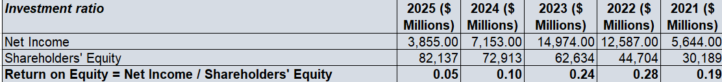
Table 5: Investment ratio
(Source: Excel)
Strength
In the consideration of the return on equity aspect,the company has a good proportion of shareholders' equity, which is going to help the company improve its financial weaknesses.
Threats
The evaluation of return on equity provides that the company has a moderate financial condition, which occurs when the company has higher expenses and lower stock returns.

1.2.6 Cashflow
Trend
The cash flow trend of the company has been helping to identify the company’s sufficient inflow and outflow. It has been noticed that the operating activity of the company has an increasing growth till 2024, after that, in 2025, the declining operating activity rates have been visible (ir.tesla.com, 2026). In terms of cash flow from investing activities and financing activities, there is also lower growth noticed. At the beginning of the period cash inflows are less in recent time in respect of the past few years. Additionally, at the end of the period, cash proportions are higher than in the previous years.

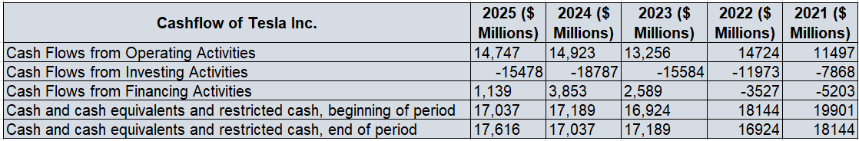
Table 6: Cashflow
(Source: Excel)
Strength
The company has moderate liquidity, but it has good inflow conditions, which are going to help it recover from future financial distress.
Threats
The lower cash flow situation of the company indicated that the company has 4 cash management issues, and has low customer payments and issues with inventory build-up.

2. Working capital management analysis

2.1 Discussion of cash operating cycle
The cash operating cycle includes Inventory turnover and receivable turnover ratio proportion. It has played a major role in determining the efficiency of the business.The cash operating cycle formula includes the inventory period, adding up with the accounts receivable period, and deducting the accounts payable period. As per the view of Ruguru (2023), the cash operating cycle is going to help the company to speed up the sales of its inventory and reduce the time in terms of collecting the amount receivable. For the company Tesla, inventory turnover is 6.36 in 2025, and receivable turnover is 20.72. However, the inventory Period of the company is 57 days, and the accounts receivable period is 17.61 days. On the other hand, accounts payable turnover is 11.22, and the payable period is 32.50 days. The total cash operating cycle of the company Tesla is 42.41 days in 2025, and in 2024 it was 13.63 days (ir.tesla.com, 2026).
Tracking down the cash operating cycle of the company helps to improve the operational efficiency in future aspects. The lower cash operating cycle means improved operational efficiency and better liquidity. The cash operating cycle also helps to assess the liquidity risk of the company's operations. The operating cycle mostly involves the short-term assets and liabilities. Mostly, a shorter cash operating cycle has shown better efficiency, and it indicates good financial health of the company. Tesla's cash operating cycle shows that in 2024, the company has better financial health as its cash operating cycle is indicated as 13.63 days, which is lower than in 2025 (ir.tesla.com, 2026).

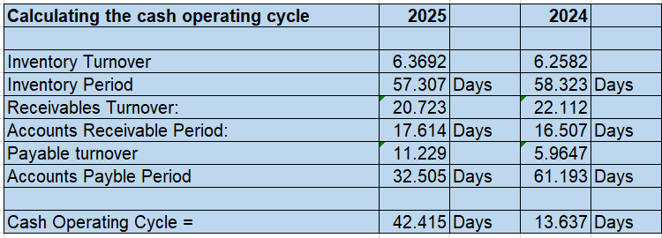
Table 7: Cash Operating Cycle
(Source: Excel)

2.2 Strategies to improve the liquidity situation of Tesla
The financial analysis of the company shows that there is a liquidity gap, and the company's efficiency proportion is also not in a good position. The company has increased liability and expenses, which result in financial risk in the future. In order to modify the financial strength of Tesla, the company needed to implement a capital expenditure and asset management strategy. Capital expenditure and Asset management include rolling of the capex strategy and inventory optimization. The company is required to increase its fake inventory to improve the efficiency of the supply chain and turn the available inventory within the company into liquid cash (Akpadaka and Edeh, 2024). Tesla needs to increase its operational efficiency by minimizing resource waste and maximizing output.
The company is also required to take some Strategic financial moves to control the debt equity management and regional financing. Tesla needs to stabilize its liquidity position by reducing the logistics costs and import duties. Moreover, by using vertical integration, such as manufacturing of own batteries and development of the in-house software, it has been possible to reduce the dependency on the external vendors for production (Figlioli et al., 2024). This has been going to help to protect the profit margins and volatile the community in the automobile market. Implementation of these strategies has been going to improve the liquidity condition of Tesla, along with helping the declining cash operational cycle in the future.

2.3 Comparison of short-term and long-term financing options
The short-term financing defines less than 1year financing terms, and the long-term financing defines more than one-year financing terms. Short-term financing options are for inventory, payroll, operational emergencies, and working capital, and also have the benefit of easier access with high flexibility. On the other hand, long-term financing options generally start from3 years, and it has a tenure of 10+ years. As per the view of Yusan and Handoyo (2024), long-term financing includes the acquisition of fixed assets, debt refinancing, and business expansion. It has been providing a lower interest rate with a monthly payment. Long-term financing helps to improve the cash flow of the company.
Trade credit, short-term bank loans,commercial papers, and overdrafts are examples of short-term financing; on the other hand, equity financing, such as long-term bank loans and debenture bonds, is an example of long-term financing.
Cost: In comparison to short-term and long-term financing aspects,if the company uses short-term financing, it will provide higher interest rates with a higher risk. On the other hand, if the company implies long-term financing,the company gets the benefit of a lower interest rate, which is often fixed and spread over a long financial term, and it has a lower liquidity risk (Ogbuigwe et al., 2025).
Collateral: Short-term financing provides quicker access to smaller amounts; on the other hand, long-term financing provides the structured payment of the amount with the larger value.
Purpose: Short-term financing is mostly utilised for covering emergency expenses, inventory purchases, to recover the temporary cash flow gaps, and working capital. On the other hand, for large investments, long-term financing has been used, such as for business expansion.
Repayment: In short-term financing, a lump sum amount is required to be paid within a year in instalments. Whereas for the long term,instalments have been scheduled for several years based on the selected financial terms chosen by the business.
Flexibility: Short-term financing is very flexible, and it requires minimal collateral with quick approvals. Similarly, long run financing is left flexible; it requires detailed documentation and collateral.
Cash flow: Short-term financing has an immediate impact on cash flow as an immediate effect of the liquidity.On the other hand, long-run financing is more predictable, and over time, it helps to mobilize the financials.
Based on the comparison, Tesla is required to take into consideration the long-term financing for their business improvement.

3. Strategic financial restructuring plan

3.1 Recommendation of financial restructuring plan
Financial restrictions in providing better solvency, liquidity, and profitability for the company. It will help to resolve the short-term cash flow issues and long-term structural challenges. As per the view of Colliard and Gromb (2025), there are various restructuring options,such as equity restructuring, debt restructuring, divestiture, and operational restructuring. Tesla has a moderate liquidity, solvency, and profitability financial situation. Due to that, the company requires financial restructuring to improve its current financial health. Among those various restricting options, equity restructuring is the best financial restricting plan that is going to help to enhance the current financial loss condition, and lower solvency growth. Also, it has been going to help the company increase its financial efficiency in the future.
Equity restructuring: The equity restructuring involves converting the debt/preference shares into buyback shares or equity, and it also requires the issuance of new shares. It refers to the company’s equity capital and strong financial position. This restructuring plan also helps to improve the market perceptions and helps to meet the long-term goals. The benefits of an equity restructuring plan are that it improves the solvency by reducing debt financing.Bonus issues and stock splits increase the outstanding shares, which boosts the liquidity condition of the company (Shem and Mupa, 2024). Additionally, this equity restructuring plan helps optimize the capital structure by balancing the debt and equity proportions of the company to achieve sustainable business growth.However, this plan might have some risks, such as market volatility. A stock split or share buyback can affect the short-term financial fluctuation in the company’s share price. Additionally, issuing rights and debt to equity proportion can reduce the current shareholders’ stake.
However, implementation of the equity restructuring plan is expected to help by retaining the financing control and enhancing the confidence of the investors for future aspects.

3.2 Impact of shareholders' value, debt structure, and operational flexibility
Shareholders' Value: The positive impact of the equity restructure plan in shareholders' value is to boost the liquidity, increasing the investor's confidence. Moreover, it helps to improve the solvency proportion and reassure the shareholders regarding the long-term stability of the company (Lin et al., 2024).It has also helped to reduce the outstanding shares and support the share prices by increasing the earnings per share (EPS). There are some negative effects of equity restructuring on shareholders' value, such as diluting the existing ownership after the debt conversion or rights share issues. Equity restructuring impacts on the market perception, such as it might reduce the valuation over the time.
Debt structure: The equity restructuring plan mostly reduces the interest rate to improve the proportion of debt and equity. It also impacts by balancing the capital structure, and it makes the company's finances more attractive to the grantor. As per the view of Shem and Mupa (2024), the new equity structure might increase the expectation of the dividend pay-out, which might impact on the company in a negative way. Lowering the debt and expenses deduction causes the tax liability.
Operational flexibility: Equity restructure in the plan reduces the debt pressure and improves the investor relations. This restructuring plan is going to strengthen the balance sheet of the company with easier access to the new financing for business expansion. However, it has some negative impact, such as the new equity investor has been influencing the business strategy. Also, the recapitalization might shift the corporate priorities such as, such as it might affect the employee morale.
The equator restructuring plan has the power to strengthen the operational freedom and improve the solvency of the company. As it provides the long-term effect for the sustainable business growth and operation, and flexible movement, the equity restructuring plan is a suitable plan to address the financial shortcomings of Tesla.

3.3 Impact of international and ethical considerations
Taxation:
The equity restructuring provides debt-to-equity conversion, rights issues, and buybacks,which can trigger different taxes across the jurisdictions. It might have cross-border investors to face double taxation on dividends. It increases the tax liability by reducing the debt to a lower interest rate.
Inflation:
The equator restructuring in the plan has been impacted by inflation, as inflation affected the valuation model, and the making of equity restructuring is not very predictable.
Currency Risk:
The equity restructuring plan created currency risk, as if there is a high rise of equity in the foreign market, exchange rate fluctuation impacted the shareholders' return, and capital inflows.
CSR:
Corporate social responsibility alliance with the equity restructuring plan to provide the CSR commitments regarding business improvements. This has involved fundraising through the rights issues regarding sustainable projects. In this aspect, transparency has been maintained in the communication to avoid the perceptions of inside favouritism and also create and maintain trust among the shareholders. In the implementation of the equity restructuring plan, the night impact on the existence of the existing shareholders, but also stabilizes the operations, improves the ethical responsibilities towards the community and employees.
Below are the discussions involving the dimensions of shareholders' value, operational flexibility, and debt structure, along with taxation, CSR, currency risk, and inflation.
Dimension | Shareholders' Value | Debt Structure | Operational Flexibility
Taxation | It may reduce the overall return in order to have a higher tax burden. | The lower debt reduces the tax structure. | It is less tax efficient, but it has more predictability in terms of cash flows.
Currency risk | For international investors, it provides a volatile return. | Foreign currency debt can be replaced with equity. | It has flexibility in hedging strategies.
Inflation | It endorses the actual shareholders' value. | Create posts to rely on equity over debt. | It reduces the flexibility and increases the operational cost.
CSR | It enhances the reputation by aligning with the business sustainability. | It stabilizes the finances by implementing an ethical debt to equity conversion. | It has built a long run trust and created a limit on aggressive cost-cutting.
Table 8: Dimension wise discussion
(Source: Created by author)

4. Investment appraisal and Capital budgeting

4.1 PBP
Simply put, the payback period is the amount that has been recovered from the cost of the investment. The formula of the payback period helps to signify the time period to recover the initial cost associated with the project's investment. PBP includes the Time value of money, and it is the most useful method of capital budgeting. Repayment of the project investment is required to recover as quickly as possible; however, a shorter time period is the best PBP (Usodan et al., 2025). As per the calculation of PBP, projects A and B have a time period of 11 months, and project C has a 1-year and 1-month time period. Based on this aspect, the investor should invest in project B as it has the shortest time period and is going to provide a high return.

4.2 ARR
Accounting rate of Return provides the predictability of a higher return to the investors. A good accounting rate of return should be within the 40% to 60%. Accounting rate of return has the benefit of easy comparison among the various projects. It has been focused on profitability based on the project's life. It has also helped to evaluate the early return and provide a clear picture of the project's future performance. It is a very good capital budgeting tool for quick screening of new projects, and it provides a fast evaluation of a project's profit earnings over time. Project A has an ARR of 43%, Project B has 44%, and Project C has 34%. Based on the accounting rate of return, the prospects, the project has the best return rather than the other two projects.

4.3 NPV
The proposed three investment projects have different net present values due to having different cash flows. Project ABC has the same discounting rate of 10% and initial investment of £ 50 million. Project A has £ 54 million in total cash flows, Project B has £ 55 million, and Project C has £ 42 million in total cash flows. Based on the calculation of Net present value,Project A has an NPV of £ -8.68 million, Project B has £ -8.30 million, and Project C has £ -17.69 million. The good fit of net present valuation is when a project has a higher positive net present valuation. It signifies that the project has the greater value creation and it has subtracted the initial investment cost at a specific rate. Among the projects, A, B, and C, Project B has the highest NPV valuation rather than the other two.

4.4 PI
A good profitability index should be greater than 1.0, which signifies a better investment plan and helps to show more value generation cost per unit. As per the view of Ogbulu et al. (2025), the profitability index is an essential tool for ranking the projects when there are limited funds, and investors need to earn the maximum return. It helps to select the project to maximize the shareholders' stake. Project A and B have a PI of0.83, and project C has a PI of 0.65. Based on the contacts, projects A and B both have a good profitability index situation. However, it has been recommended to invest in Project B as it will provide more return than Project A.

4.5 IRR
Internal rate of return depends on the risk; however, the internal rate of return should be within the 10%. The range of 7% to 20% is the higher return leveraged internal rate of return of a project. IRR mostly indicates profitability for short-term projects. Project A has an internal rate of return of 2.7%, Project B has 3.3%, and Project C has -5.9%. In respect of that project, we have the best IRR,as it will provide the investors with a higher return. It has been considered the time value of money, which helps to calculate the annualised return percentage, and this has made it easy to calculate the project's profitability (Purnamasari and Adriza, 2024). IRR simplified the investor's decision-making process, and it includes the asset comparison and profit interpretation for the investors.

The investor should invest in Project B as it has the chance of getting a better return than the other two projects with lower risk. Project Bequally distributed its cash flow for the 5 years, which has helped to recover the higher initial cost of investment for the investors.

4.6 Recommendation with reference to the company’s financial performance and non-financial risks
The company, Tesla, has had declining profitability growth and moderate liquidity proportion in recent years. Due to that, the company should invest in a project which has the highest return with the lowest risk over the year. Project B has the highest efficiency in terms of the highest recovery of the initial cost of investment. The company has issues with the Increased debt, which impacted the investment proportion also. Tesla achieved higher revenue growth till 2024 due to new Market competition, and leadership issues faced lower revenue and income growth, which not only impacted its profitability but also impacted on the financial health. Project B has the highest return with respect to the other two projects in consideration of capital budgeting.
Based on the company's financial performance, there are chances of ESC failure, which can impact the investors and customers, creating cultural and reputational risk after investment. A company's database can also reduce the sales of the company due to the impact of poor service's impact on the customers' trust. Instability of the Government and political change is going to disrupt the supply chain management,market axis, and operations of the company (Décaire, 2024). There are other environmental and social risks involved, but impacts on the investor disbursement, and it reduces the market access. This political and environmental risk has directly reduced the company's revenue, and it has directly increased the cost of the company.
Considering the financial risk and non-financial risk of the company,investing in project Bis better than investing in projects A and C. Also, investing in Project B is going to provide future financial support to improve the financial condition of Tesla.

4.7 Recommendation with reference to capital rationing
The concept of capital rationing is a process that helps to find the best investment project that will provide the maximum net present value of the fund. The hard capital rationing is when there is limited borrowing capacity of the company and high interest rates, which also includes external constraints. On the other hand, Soft Capital rationing includes management proposing a budget capital to control the risk. Involving the capital rationing concept is to maximize the overall return after investment when there are not enough financial resources, but the company requires to earn maximum profitability. As per the view of Yin et al. (2024), the best method of capital rationing to find the best fit for investment among the available projects is using the profitability index, the net present valuation method.
In this context, project A has an NPV of £ -58.68 million, project B has £ -58.30 million, and project C has £ -67.69 million, while having a fixed investment valuation of £ 100 million. As per the net present valuation method whichever project has the lowest and positive valuation of NPV,will be the best fit for the investment to invest in that project. As it is going to provide the investor with a higher return than the other two projects. Here, Project B has the efficiency to provide the investor with a good amount of return. In the other context, the profitability index is going to help the investor to find out which project is going to provide a higher return while there are limited funds. However, Project A has a PI of 0.41, Project B has a PI of 0.42, and Project C has a PI of 0.32. Based on that project, B has the closest PI value,as the value should be approximately 1.00. It has been recommended that the company should invest in Project B rather than the other two projects. It has been going to provide the company with a sufficient amount of profitability with the minimum investment fund and limited financial resources. Investing in the project is also going to provide lower financial and non-financial risk to the company in the future. Due to that, investing in project B is a good fit for the company, considering the financial condition in recent times. Additionally, it has also been going to help the company expand its business and resolve its issues related to efficiency and profitability.

Conclusion
Tesla is the renowned automobile company that has extended its business of automobiles and clean energy across the globe. It has been found that in recent times the company has lower financial strength due to declining profitability and revenue. On the other hand, it has increased debt validation, which has impacted its efficiency and liquidity factors.It has been found that the company's financial health is moderate with the help of financial ratios. In terms of improving the solvency situation,it has been recommended to implement an equity restructuring plan. On the other hand,by performing a cash operating cycle, it has been found that the company's financial recoverable strength is declining as its pay off days increased in2025 rather than 2024. Lastly,it has been suggested to invest in project B among the other two projects, as it will provide financial support to the company in the future with the help of capital budgeting.

References
Journal and Books:
Akpadaka, O. and Edeh, P.O., (2024). Impact of Cash Conversion Cycle and Financial Stability on Firm Value. Journal of Accounting and Financial Management, 10, pp.123-141.https://www.researchgate.net/profile/Ovbe-Akpadaka/publication/383262033_Impact_of_Cash_Conversion_Cycle_and_Financial_Stability_on_Firm_Value/links/66c4c856ccd355055fe1342b/Impact-of-Cash-Conversion-Cycle-and-Financial-Stability-on-Firm-Value.pdf
Avi, M.S., (2023). Financial Ratios: Considerations of Their Relevance to Corporate Financial Analysis andan In-Depth Look at The Major Errors Often Mar These Ratios. International Journal of Business & Management Studies, 4(4), pp.27-60.https://iris.unive.it/bitstream/10278/5018541/1/article%20Avi.pdf
Blessing, H. and Sakouvogui, G., (2023). Impact of liquidity and solvency ratios on financial performance: a comprehensive analysis. Indonesia Auditing Research Journal, 12(3), pp.102-115.http://journals.iarn.or.id/index.php/ARJ/article/download/208/141
Colliard, J.E. and Gromb, D., (2025). Financial restructuring and resolution of banks. The Review of Financial Studies, p.hhaf113.https://papers.ssrn.com/sol3/Delivery.cfm?abstractid=3183777
Décaire, P., (2024). Capital budgeting and idiosyncratic risk. Available at SSRN 3480884.https://papers.ssrn.com/sol3/Delivery.cfm?abstractid=3480884
Figlioli, B., Antônio, R.M., Gatsios, R.C. and Lima, F.G., (2024). Influence of the cash conversion cycle on firm's financial performance: Evidence from publicly traded firms in the Latin American context. Accounting & Finance, 64(3), pp.2375-2401.https://onlinelibrary.wiley.com/doi/abs/10.1111/acfi.13220
Hasidi, M.H., Baheri, J. and Hajar, K.I., (2024). Financial performance evaluation using profitability and liquidity ratio analysis. Jurnal Ilmiah Manajemen Kesatuan, 12(4), pp.1347-1358.https://jurnal.ibik.ac.id/index.php/jimkes/article/download/2742/1966
Indah, S., Lestari, E., Sasono, A.D. and Indrihastuti, P., (2024). Liquidity, solvency, and profitability ratio analysis as a financial performance measurement tool at PT Telkom Indonesia (Persero) Tbk for the period 2020-2022 (Case study of companies listed on the Indonesia Stock Exchange). Journal of Economics and Business Letters, 4(2), pp.63-77.https://www.journal.privietlab.org/index.php/JEBL/article/download/308/183
Lin, S.J., Xu, K., Wang, K., Huang, Y., Yang, Y. and Liao, H., (2024). The Intervention and Impact of Digital Society on the Governance of Dual Equity Structure in Enterprises. Revista de Cercetare si Interventie Sociala, 86, pp.34-45.https://www.rcis.ro/images/documente/rcis86_03.pdf
Ogbuigwe, M., Aluya, S. and John, E., (2025). Effect of cash conversion cycle on financial performance of listed consumer goods firms in Nigeria.https://mpra.ub.uni-muenchen.de/126477/1/MPRA_paper_126477.pdf
Ogbulu, O.M., Udensi, C.E., Okanta, S.U., Uruakpa, P.C. and Ndubuisi, P., (2025). Appraisal Techniques and Socio-Economic Factors in Real Assets Investment: Critical Study of Micro, Small, and Medium Scale Enterprises in Nigeria. IIARD Journals. https://www.researchgate.net/profile/John-Onoh/publication/393122271_Appraisal_Techniques_and_Socio-Economic_Factors_in_Real_Assets_Investment_Critical_Study_of_Micro_Small_and_Medium_Scale_Enterprises_in_Nigeria/links/685feadd39c3583512054ccb/Appraisal-Techniques-and-Socio-Economic-Factors-in-Real-Assets-Investment-Critical-Study-of-Micro-Small-and-Medium-Scale-Enterprises-in-Nigeria.pdf
Purnamasari, P. and Adriza, (2024). Capital budgeting techniques and financial performance: a comparison between SMEs and large listed firms. Cogent Economics & Finance, 12(1), p.2404707.https://www.tandfonline.com/doi/pdf/10.1080/23322039.2024.2404707
Purnaningtyas, K.C., (2023). Analysis of Liquidity, Solvency, and Profitability Ratio to Assess the Financial Performance of PT Hamparan Estate Management in 2018-2020. JOBS (Jurnal Of Business Studies), 9(1), pp.11-22.https://jurnal.polines.ac.id/index.php/jobs/article/download/4817/108805
Ruguru, A.N., (2023). Effect of cash conversion cycle on profitability: A case study of binathman household supermarkets in Kenya. South Sahara Multidisciplinary Journal, 1(1), pp.8-16.https://ssapub.com/index.php/ssmj/article/download/2/2
Shem, A.M. and Mupa, M.N., (2024). Turnaround Financing: Legal and Financial Considerations for Distressed Companies. Iconic Research and Engineering Journals, 8(4), pp.19-37.https://www.researchgate.net/profile/Munashe-Naphtali-Mupa/publication/384735379_Turnaround_Financing_Legal_and_Financial_Considerations_for_Distressed_Companies/links/6705d4e34cb01e6ec78177c2/Turnaround-Financing-Legal-and-Financial-Considerations-for-Distressed-Companies.pdf
Usodan, A.K.M., Jalal, F.D.H., Bandera, A.D. and Usman-Macadaag, O.M., (2025). Making the Right Choice: A Literature-Based Analysis on Investment Appraisal. International Research Journal of Economics and Management Studies IRJEMS, 4(11).https://irjems.org/Volume-4-Issue-11/IRJEMS-V4I11P113.pdf
Yin, Z., Caldas, C. and de Oliveira, D., (2024). Identification of business-project management processes that improve capital efficiency of downstream and chemical projects. International Journal of Construction Management, 24(1), pp.1-9.https://www.researchgate.net/profile/Zhe-Yin-4/publication/364323954_Identification_of_business-project_management_processes_that_improve_capital_efficiency_of_downstream_and_chemical_projects/links/643df0e1e881690c4bdec703/Identification-of-business-project-management-processes-that-improve-capital-efficiency-of-downstream-and-chemical-projects.pdf
Yusan, B.O. and Handoyo, S.E., (2024). The effect of cash conversion cycle on company profitability: a study on Indonesian food and beverage listed companies. International Journal of Management Science and Application, 3(1), pp.24-42.https://ejournal.sultanpublisher.com/index.php/ijmsa/article/download/146/104
Website:
ir.tesla.com (2026).Home page.Available at: https://ir.tesla.com/sec-filings

Appendices (ratios and NPVs)

Appendix 1: Ratio Analysis
Table 1: Financial Ratio Analysis of Tesla
(Source: Excel)

Appendix 2: Cash operating Cycle
Table 2: Cash Operating Cycle
(Source: Excel)

Appendix 3: Investment Appraisal and Capital Budgeting
Table 3: Project A
(Source: Excel)
Table 4: Project B
(Source: Excel)
Table 5: Project C
(Source: Excel)

