Name: Noah John________________________________

Student Number: 2502346________________________
__________________________________________________________

WORKSHEET 1 – TESTING (Using Variables)

- Original code:
[Copy and paste your original code from Moodle into this box. Do not change it.]

"""alphabet = ["A","B","C","D","E","F","G","H","I","J","K","L","M","N","O","P","Q","R","S","T","U","V","W","X","Y","Z"]"""
userSurname = input("Please input your Surname:")
userNINumber = input("Please enter your National Insurance Number:").upper()
userAge = int(input("Please enter your Age:"))
userWorkHoursPerWeek = float(input("Enter the number of hours you work per week:"))

while userAge < 16:
print("You're not old enough to have received a NI number.")
userAge = int(input("Are you sure this is your age? If not please enter your real age:"))

while userAge > 110:
print("You should retire.")
userAge = input("Or, enter a valid age.")

while userWorkHoursPerWeek <= 0:
print("This is not a valid amount of hours.")
userWorkHoursPerWeek = float(input("Please enter the amount of hours you work per week:"))

while userWorkHoursPerWeek >= 100:
print("You're working too many hours a week.")
userWorkHoursPerWeek = float(input("Please enter the amount of hours you actually work per week:"))

"""while userNINumber not in alphabet:
print("NI number must include letters")
userNINumber = input("Please enter valid NI Number:")"""

while len(userNINumber) != 9:
print("This is not a valid National Insurance Number.")
userNINumber = input("Please enter a valid National Insurance Number (9 characters:")

while len(userSurname) <= 0:
print("Surname is not valid.")
userSurname = input("Enter a valid Surname:")

while len(userSurname) > 35:
print("Surname is not valid.")
userSurname = input("Enter a valid Surname:")

"""while userNINumber not in alphabet:
print("NI number must include letters")
userNINumber = input("Please enter valid NI Number:")"""

print("Surname: {}".format(userSurname))
print("NI Number: {}".format(userNINumber))
print("Age: {}".format(userAge))
print("Number of Working Hours Per Week: {}".format(userWorkHoursPerWeek))

- Code Testing

For each test below, run your code and enter the values provided. Present a screenshot of the programme running. Did the programme behave correctly or did it do something unexpected, and if so, why?

Surname:
- Enter JONES
- Leave blank
- Enter A
- Enter 123

National Insurance Number:
- Enter PE534121B
- Leave blank
- Enter AB11223344556677 (ie too long for National Insurance number format)
- Enter 22PE4088A (ie wrong format)

Age
- Enter 34
- Enter 150
- Enter -4
- Enter a letter

Number of working hours per week:
- Enter 37.5
- Enter 150
- Enter 0
- Enter -2

Fill in a box for each test above. You should present 16 separate boxes, 1 for each test. (Note: the first two boxes are provided as a template)

Test:
Surname i. Enter JONES

Screenshot(s) of output:
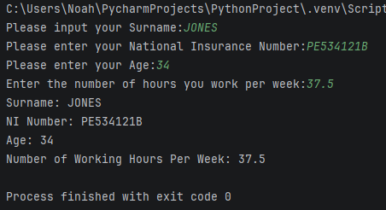
Result: Did the programme behave as expected ie syntactically and logically correct?
YES
If NO, what went wrong?
If YES, comment on what happened

User was not prompted to re-enter any inputs as no while loops were triggered meaning entries where valid in this context.

Test:
Surname ii Leave blank

Screenshot(s) of output:
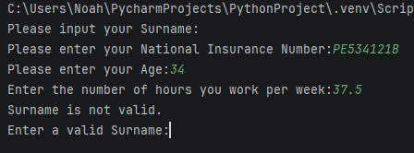
Result: Did the programme behave as expected ie syntactically and logically correct?
YES
If NO, what went wrong?
If YES, comment on what happened

The user is prompted to re-enter the Surname input, as the input was empty and the error detection while loop was triggered. The while loop in question:

while len(userSurname) <= 0:
print("Surname is not valid.")
userSurname = input("Enter a valid Surname:")

Test:
Surname iii Enter A

Screenshot(s) of output:
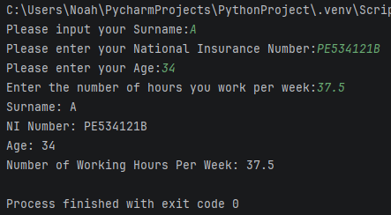
Result: Did the programme behave as expected ie syntactically and logically correct?
NO
If NO, what went wrong?
If YES, comment on what happened

The error detection while loop is not triggered due to the input not matching the criteria to enter the loop. This would cause problems in a real-world scenario as one letter Surnames do not exist and therefore are not valid. To amend this error the while loop will need to be triggered when any input below or equal to one character is entered. The while loop in question:

while len(userSurname) <= 0:
print("Surname is not valid.")
userSurname = input("Enter a valid Surname:")

Test:
Surname iv Enter 123

Screenshot(s) of output:
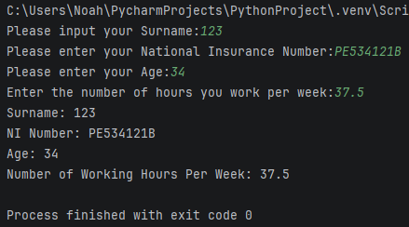
Result: Did the programme behave as expected ie syntactically and logically correct?
NO (delete as appropriate)
If NO, what went wrong?
If YES, comment on what happened

User can enter numeric values as their Surname; this is not valid in the context of this program. Means of mitigation should be added to ensure the program runs as intended.

Test:
National Insurance Number i Enter PE534121B
Screenshot(s) of output:
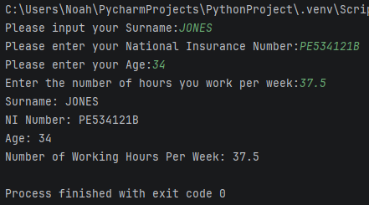
Result: Did the programme behave as expected ie syntactically and logically correct?
YES
If NO, what went wrong?
If YES, comment on what happened

User was not prompted to re-enter any inputs as no while loops were triggered meaning entries where valid in this context.

Test:
National Insurance Number ii Leave blank
Screenshot(s) of output:
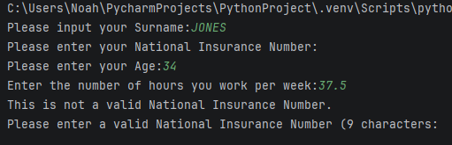
Result: Did the programme behave as expected ie syntactically and logically correct?
YES
If NO, what went wrong?
If YES, comment on what happened

The user is prompted to re-enter their National Insurance Number as the input was blank triggering this validation while loop:

while len(userNINumber) != 9:
print("This is not a valid National Insurance Number.")
userNINumber = input("Please enter a valid National Insurance Number (9 characters:")

Test:
National Insurance Number iii Enter AB11223344556677
Screenshot(s) of output:
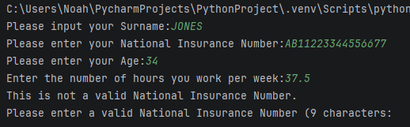
Result: Did the programme behave as expected ie syntactically and logically correct?
YES
If NO, what went wrong?
If YES, comment on what happened

The user is prompted to re-enter their National Insurance Number as the input exceeds the 9-character length which triggers this validation while loop:

while len(userNINumber) != 9:
print("This is not a valid National Insurance Number.")
userNINumber = input("Please enter a valid National Insurance Number (9 characters:")

Test:
National Insurance Number iv Enter 22PE4088A
Screenshot(s) of output:
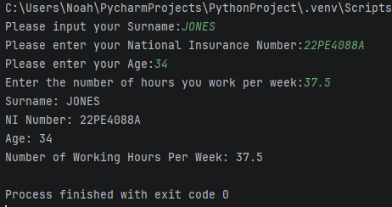
Result: Did the programme behave as expected ie syntactically and logically correct?
NO
If NO, what went wrong?
If YES, comment on what happened

User can enter an incorrect formatted National Insurance Number; this is not valid in the context of this program. Means of mitigation should be added to ensure the program runs as intended.

Test:
Age i Enter 34
Screenshot(s) of output:
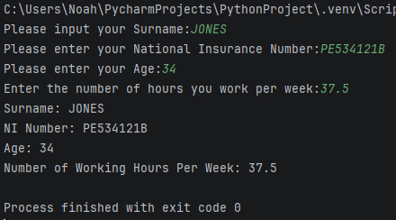
Result: Did the programme behave as expected ie syntactically and logically correct?
YES
If NO, what went wrong?
If YES, comment on what happened

User was not prompted to re-enter any inputs as no while loops were triggered meaning entries where valid in this context.

Test:
Age ii Enter 150
Screenshot(s) of output:
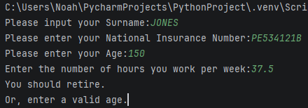
Result: Did the programme behave as expected ie syntactically and logically correct?
YES
If NO, what went wrong?
If YES, comment on what happened

The user is prompted to re-enter the Age input, as the input meets the criteria to enter the error detection while loop. The while loop in question:

while userAge > 110:
print("You should retire.")
userAge = int(input("Or, enter a valid age.")

Test:
Age iii Enter -4
Screenshot(s) of output:
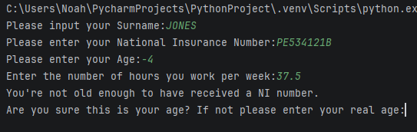
Result: Did the programme behave as expected ie syntactically and logically correct?
YES
If NO, what went wrong?
If YES, comment on what happened

The user is prompted to re-enter the Age input, as the input meets the criteria to enter the error detection while loop. The while loop in question:

while userAge < 16:
print("You're not old enough to have received a NI number.")
userAge = int(input("Are you sure this is your age? If not please enter your real age:"))

Test:
Age iv Enter a letter
Screenshot(s) of output:
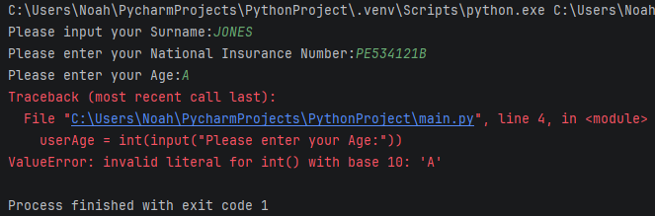
Result: Did the programme behave as expected ie syntactically and logically correct?
YES
If NO, what went wrong?
If YES, comment on what happened

The program stops as the “userAge” input is cast as an integer meaning string type inputs are invalid for entry.

Test:
Number of working hours per week i Enter 37.5

Screenshot(s) of output:
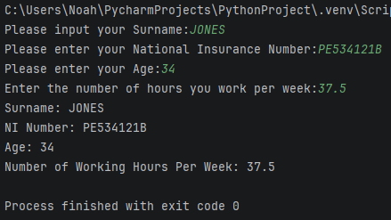
Result: Did the programme behave as expected ie syntactically and logically correct?
YES
If NO, what went wrong?
If YES, comment on what happened
User was not prompted to re-enter any inputs as no while loops were triggered meaning entries where valid in this context.

Test:
Number of working hours per week ii Enter 150

Screenshot(s) of output:
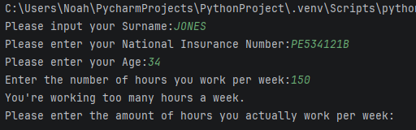
Result: Did the programme behave as expected ie syntactically and logically correct?
YES
If NO, what went wrong?
If YES, comment on what happened

The user is prompted to re-enter the Number of Working Hours Per Week input, as the input meets the criteria to enter the error detection while loop. The while loop in question:
while userWorkHoursPerWeek >= 100:
print("You're working too many hours a week.")
userWorkHoursPerWeek = float(input("Please enter the amount of hours you actually work per week:"))

Test:
Number of working hours per week iii Enter 0

Screenshot(s) of output:
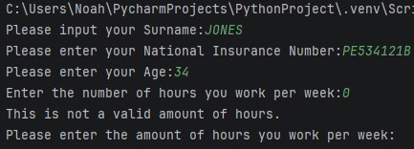
Result: Did the programme behave as expected ie syntactically and logically correct?
YES
If NO, what went wrong?
If YES, comment on what happened

The user is prompted to re-enter the Number of Working Hours Per Week input, as the input meets the criteria to enter the error detection while loop. The while loop in question:

while userWorkHoursPerWeek <= 0:
print("This is not a valid amount of hours.")
userWorkHoursPerWeek = float(input("Please enter the amount of hours you work per week:"))

Test:
Number of working hours per week iv Enter -2

Screenshot(s) of output:
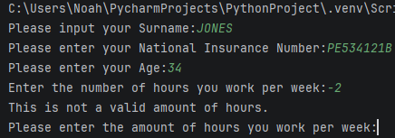
Result: Did the programme behave as expected ie syntactically and logically correct?
YES
If NO, what went wrong?
If YES, comment on what happened

The user is prompted to re-enter the Number of Working Hours Per Week input, as the input meets the criteria to enter the error detection while loop. The while loop in question:

while userWorkHoursPerWeek <= 0:
print("This is not a valid amount of hours.")
userWorkHoursPerWeek = float(input("Please enter the amount of hours you work per week:"))

- Consider the results of the above tests and revisit your code in order to solve the problems. (Note: you may not be able to solve all of them, but solve as many as you can.)

Paste your revised code here:
P.s Couldn’t find a way to completely verify the NI number with tools I’ve learnt in class.
while True:
userSurname = input("Please input your Surname: ").lower().strip()

try:
float(userSurname) #converts the userSurname input to a float
print("Numbers are not allowed.") #if succesfully converted into a float then the program knows the input is incorrect and returns this message
except ValueError: #if the input does not convert into a float then it returns ValueError, usually this would crash the program but "except" tells it to run the following code instead
if len(userSurname) <= 1:
print("Surname is not valid.")
elif len(userSurname) > 35:
print("Surname is not valid.")
elif not userSurname.isalpha(): #ensures that the string only includes letters, as at this point inputs such as "jones123" can slip through, the try section only works for only number inputs
print("Surname must contain letters only.")
else:
break #exits the loop if everything is valid

userNINumber = input("Please enter your National Insurance Number:").upper()
userAge = int(input("Please enter your Age:"))
userWorkHoursPerWeek = float(input("Enter the number of hours you work per week:"))

while userAge < 16:
print("You're not old enough to have received a NI number.")
userAge = int(input("Are you sure this is your age? If not please enter your real age:"))

while userAge > 110:
print("You should retire.")
userAge = int(input("Or, enter a valid age:"))

while userWorkHoursPerWeek <= 0:
print("This is not a valid amount of hours.")
userWorkHoursPerWeek = float(input("Please enter the amount of hours you work per week:"))

while userWorkHoursPerWeek >= 100:
print("You're working too many hours a week.")
userWorkHoursPerWeek = float(input("Please enter the amount of hours you actually work per week:"))

while len(userNINumber) != 9:
print("This is not a valid National Insurance Number.")
userNINumber = input("Please enter a valid National Insurance Number (9 characters):")

print("Surname: {}".format(userSurname))
print("NI Number: {}".format(userNINumber))
print("Age: {}".format(userAge))
print("Number of Working Hours Per Week: {}".format(userWorkHoursPerWeek))

