ACADEMIC AND EMPLOYABILITY SKILLS
Student Name: MRS RUMA ANOWAR
Student ID : 1817892
Lecturer Name : ALLEN PETER
UNIVERSITY NAME : UNIVERSITY OF WALES TRINITY SAINT DAVID
SUBMISSION DAEDLINE: 05/05/2020

Table of Contents
Introduction 3
SWOT analysis 3
Time management practices 5
PDP............................................................................................................................................5
Analysis and reflection on the progress.................................................................................................6
Conclusion..............................................................................................................................................6
Reference...............................................................................................................................................8
Appendix....................................................................................................................................9

Introduction
The world is currently changing rapidly and every sector and industry is undergoing severe structural changes which is also forcing the business owners to alternate their methods and operations in order to stay in the competition and continue to operate in the industry so that they can generate revenues through their operations and activities. This has also made it necessary for the employees to adapt new measures and ways to operate so that they can become efficient and contribute to the growth and expansion of the organisation through their individual skills. However, the modern world and business operations have become more integrated which means that employees must also be able to function as a part of a team for overall progress and attainment of the organisational goals and objectives (Gould, 2017). The following report will try to evaluate my own skills and capabilities to find employment through the analysis of my skill set. Thus, the report aims to provide better understanding of the skills that I possess and my knowledge base so that my employability can be assessed effectively.

SWOT analysis
The SWOT analysis is a tool that provides comprehensive understanding of the various aspects of the advantages that an individual or a business entity possesses. The SWOT analysis will be beneficial in assessing the employability of a person based on the observation of the strengths and weaknesses that a person possesses. A comprehensive SWOT analysis on self is provided below for a better understanding of the capabilities that I possess.
(appendix)

Time management practices
The term time management basically refers to the ability of an individual person to effectively use that specific amount of time towards creative output. In order to enhance the creative skills which will help one particular person to enhance academic and employability skills it is important that the person understands the value of time and learns different time management skills. I believe the time management is another aspect which I have learnt consciously by approaching time as an important tool for my creative development. Time management is effective for employability skills as it helps one individual person to progress with work within the associated circumstances in relation to the allocated time. Time is an important aspect for the academic development as well as it is considered important in different institutions for creative output. According to my opinion I have learnt to use time as an important technique for enhancing my individual skills and learning how different activities can be progressed within a short span of time by learning proper time management through the help of efficient practises or effective time management tools (Zeijen, Peeters & Hakanen, 2018). It is generally seen that when a person is appointed as an employee in any academic institution or organisation that he or she is capable to understand the importance of time and is able to deliver a particular task meeting that allocated time to enhance the sustainability and profitability of the institution or organisation in general.
It basically provides the idea of prioritising time as an important tool for creative development which I have practised as an attribute to enhance my employability skills and my academic skills as a person. I have also understood that time management is deeply associated with two other important aspects which are project management and attention management. These two important aspects require serious attention to develop the employability skills according to my opinion and I have learnt that through the effective practices of time management initiated by different tools and techniques provided for the people. One effective time management tool according to my understanding is the calendar or me more which is easily found into the different smartphones or computers used by most of the users. It basically provides the ability to the user to create different reminders according to the priorities of different work and allocate it within specific dates to understand the amount of work one person request to provide in order to initiate that particular reminder as a part of time management.
To-do list according to me is another useful tool which I vastly use to create an account of the different activities in relation to the associated time required for me to complete that specific task. It helps me to have a proper understanding of the required time and manage the time slots according to the work priority so that I can fulfil different tasks without wasting much time through learning the efficient practices of time management tools. Gantt chart is another important time management tool used by most of the organisations and according to me it can be an important time management tool to successfully conduct different projects in relation to the different activities of the employees associated with the task for maintaining a timeline. Nowadays the importance of time management tools have increased so much that most of the organisations are opting for such techniques and tools to help the candidates and employs to have a proper understanding of time management. These time management software is which are easily accessible and affordable for the general mass helps individual persons liking me to initiate my objectives for creating a dimension of efficiency. On the other hand it is also important the time management tools helps candidates or employees to become multitasking by being able to perform different set of activities within one specific time slot.

PDP
(appendix)
Personal development plan is more like an action plan initiated by a person with the incorporation of values and different objectives planned according to a specific timeline to complete the activities for achieving the desired goal. Personal development plan is another aspect of understanding individual values and objectives and visions. This is so that all of the activities can be performed properly to achieve the objectives .I have understood that in order to develop my skills related to academics and employability requires a proper personal development plan through which I can understand my basic objectives and values. This will help me to initiate different set of activities and prioritise them within a specific time slot so that my basic objective can be earned by my own efficiency (Filelis-Papadopoulos et al., 2017). Personal development plan is used by most of the organisations and academic institutions to enhance the creative ability of a person by understanding the requirements themselves and initiate self-efficiency through continuous practice. The long terms and the short terms goals that we will develop will help in personal development. Moreover in this context it needs to be stated that goal would be to improve and gather experiences for business management Moreover it has been evident that skill development on my part would be important which includes business management digital knowledge management and others . devoting more time for study would be an essential factor here . For the mid terms time frame improving the research skills would be important. Finishing my degree is also an important part of my personal development schedule attending the university and gathering the knowledge would help in the accomplishment of the goal. In this context developing the digital skills would help me in achieving competitive advantage over others. In the final stages the development of the business would and essential achievement and working hard to achieve it would be important.
Organisations basically use personal development plan as a tool for enhancing the overall efficiency of human resource department and it in for sizes on the importance of personal development plan for understanding the employability skills and academic skills of an individual person. The use of properly designed personal development plan according to my understanding can help my objectives to get successfully established through the help of different activities which I can choose according to my priority. According to my understanding the basic importance of personal development plan is to check the consciousness of an individual candidate regarding his or her qualities and abilities before performing a task (Lejeune,Beausaert & Raemdonck, 2018). That is why in most of the academic institutions and organisations candidates are generally requested to come up with their own personal development plan so that the organisation of the academic institution can also understand the confidence level and the experience of the employees. Personal development plan has not only helped me to understand how my objectives can be achieved through the help of different activities but also helped me to synchronise those activities properly towards my values.

Analysis and reflection on the progress
In the course of working for this term provided me with a number of different insights regarding my personal capabilities. It also gave me the opportunity to work on my own drawbacks so that I can develop these aspects and make myself become more efficient. At the beginning of the module I was fairly confident of my own capabilities and thought that I possessed all the necessary skills and abilities that are required in an efficient and performing employee. However, during the course of the module I understood that I lacked on many different aspects which were previously unknown to me. Thus, the module provided me with the opportunity to re-assess my own capabilities. This aspect of introspection has been of high benefit for myself and I have learned to assess a situation carefully before initiating the process with limited understanding. Limited knowledge can lead to faulty finished work which may cause dismay to all the involved parties in the project (Rimmer, 2018). Thus, this new aspect of assessing a project and evaluating the available resources and designing the project plan based on these factors have been understood by me as to why is it important for the attainment of the organisational goals. I have also understood how professional growth can also benefit personal development through better efficiency on each aspect.

Conclusion
It can be concluded from the above assessment that even though I possess a number of considerable strengths on many aspects as compared to many other employees like myself, I also have severe drawbacks where I will be outdone by my peers. These drawbacks have been identified with accuracy so that I can work to develop my skills and knowledge base. Through proper introspection I have understood that I need to work on many levels so that I can match the industry requirements properly and provide the best quality of work for my employers so that the performance of the overall organisation can be enhanced through my increased efficiency. Through the module the connection between personal and professional dimensions have been understood which I can also focus upon for complete and aggregate development rather than being concerned with only one aspect of my growth.

Reference List
Filelis-Papadopoulos, C., Xiong, H., Spătaru, A., Castañé, G. G., Dong, D., Gravvanis, G. A., and Morrison, J. P. 2017. A generic framework supporting self-organisation and self-management in hierarchical systems. In 2017 16th International Symposium on Parallel and Distributed Computing (ISPDC) (pp. 149-156). IEEE.
Gould, J. 2017. Career development: A plan for action. Nature, 548(7668), 489-490.
Honicke, T., and Broadbent, J. 2016. The influence of academic self-efficacy on academic performance: A systematic review. Educational Research Review, 17, 63-84.
Lejeune, C., Beausaert, S., and Raemdonck, I. 2018. The impact on employees’ job performance of exercising self-directed learning within personal development plan practice. The International Journal of Human Resource Management, 1-27.
Panadero, E., Jonsson, A., & Botella, J. (2017). Effects of self-assessment on self-regulated learning and self-efficacy: Four meta-analyses. Educational Research Review, 22, 74-98.
Rimmer, A. (2018). How do I prepare a personal development plan?. Bmj, 363, k4725.
Zeijen, M. E., Peeters, M. C., & Hakanen, J. J. 2018. Workaholism versus work engagement and job crafting: What is the role of self‐management strategies?. Human Resource Management Journal, 28(2), 357-373.

APPENDIX
Personal SWOT Analysis
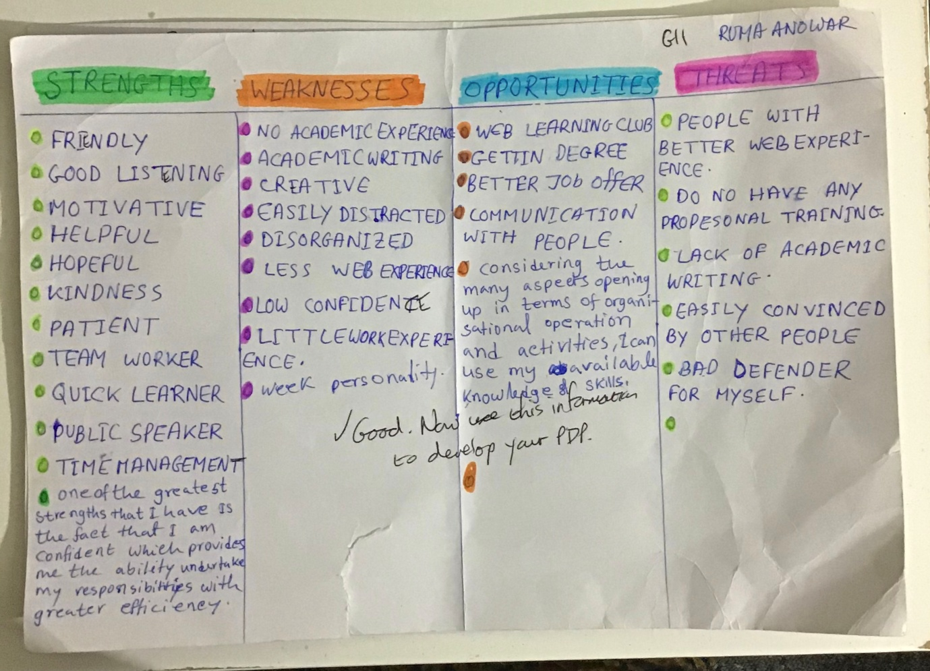

PDP


