Organisational Performance and Culture in Practice (BMPD5016)

Evaluate the advantages and disadvantages of the organisation structure in your organisation (or an organisation with which you are familiar) and evaluate the advantages and disadvantages of one other organisation structure. Within the evaluation, you should include the reasons underpinning the structure. (AC 1.1)

Amcor Flexibles Swansea-

The organisational structure of this business consists of a leadership team which includes the plant manager who leads the business and is responsible for capital improvements and the physical upkeep of the plant they work closely with the production team and the operations manager to increase profitability and production in the manufacturing plant, overall, the PGM is responsible for the plant in its entirety.

The other main pillars within the leadership team who report the PGM include the OHSE manager, the human resources manager, finance controller, operations manager. All play a part in the management on the day today business decisions. Leading the plant as a team and working together collaboratively together. The advantages of having an experienced leadership team is that each brings their experience and knowledge to the table in order for to deliver of the business objectives set by the senior leadership team who are based outside of the plant.

The leadership team includes the plant General manager who oversees and is responsible for the plant and its entirety. The following roles direct directly to the plant general manager. Operations manager who is responsible for the day-to-day activities within the plant.

Prior to weighing the benefits and drawbacks of different organisational structures, it is critical to comprehend the concept and how it is used inside the organisation. Structure of organisations Organisational structure, in the words of Maduenyi et al. (2015), is the way in which different organisational tasks are carried out in order to accomplish the firm's aims and objectives. The regulations and personal accountability may be a part of these actions. Information flow between different organisational levels is another aspect of organisational structure. There are two typical structures: hierarchical and flat.

Amcor flexibles use the below Hierarchical structure.

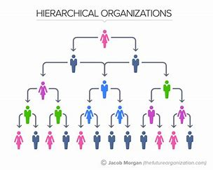
Analyse connections between your organisation’s strategy (or an organisation with
which you are familiar) and its products or services, and customers. (AC 1.2)

At Amcor flexibles we have a well-defined plan and method to achieving our main goals and objectives is known as its organisational strategy. It includes a number of things, such as the goal, vision, basic principles, and strategic plans of the company. There are three tiers of organisational strategies: corporate, business, and functional. (Katuse, 2021).

Organisational Strategy and Revenue
The way a corporation adjusts to changes and establishes objectives and orientations is at the heart of the relationship between strategy and income. A key component of organisational strategy is defining the company direction. This guarantees that the business fulfils its goals and maintains its competitiveness, which is demonstrated by its high revenue. Additionally, an organisational strategy makes sure that the company's methods and offerings match the demands of its clients. As a result, the market share grows and the company's revenue rises. (F.Dieffenbacher, 2023)

Organisational Strategy and Products, Services, and Outcomes
Creating an organisational strategy entail creating a plan that guarantees the company adjusts to the dynamics and trends of the market today. The shifting wants and preferences of customers is one of these trends. This suggests that a variety of goods and services are required, ones that satisfy consumers' demands while also keeping up with emerging trends. For example, as the banking industry demonstrates, most businesses are currently concentrating on integrating information and communication technology (ICT) to improve service delivery. The achievement of the business outcomes is based on these strategies. Simplifying and streamlining the decision-making process is another component of organizational strategy, and it is essential to boosting revenues and accomplishing the goal and vision of the company. (university of Lincoln, 2021)

Analyse three external factors or trends currently impacting your organisation (or one with which you are familiar). The impact of these factors or trends could be positive, neutral or negative, some are short-lived whilst others are long-lasting. Identify organisational priorities arising from the factors or trends analysed. (AC 1.3)

Tesla has released an article stipulating the external impacts on the automotive industry. As a result, the organisation may be impacted by the numerous external elements that influence the industry.
Conducting a Pestle Analysis outlines the impacts -

Political –
One of the primary sociocultural forces influencing businesses and industries is the government. Trade regulations, for instance, may restrict the performance of the industry and the earnings of the business. The following political considerations are important to Tesla and the automobile and energy solutions industries in this external analysis case. With government subsidies, Tesla has the chance to improve its financial performance. This external element has a direct bearing on the business's efforts to limit carbon emissions from its operations and goods. (Kissinger,2023)

Economic –
This section of the PESTEL analysis of Tesla, Inc. takes into account the influence of economic conditions on the remote or macroenvironment. These circumstances include growth in the market, trade volumes, exchange rates, and other elements that affect the automotive industry. For instance, the company's solar panel business's growth prospects are determined by the rate of growth in the solar energy industry. (Kissinger, 2023)

Social-cultural –
Global consumer preferences are changing significantly at the moment, which has an impact on businesses' efforts to innovate and diversify in order to create goods and services that meet both customer demands and business goals. Diversity among employees is one of the social-cultural features of the employment sector that is important to recognize.

Conducting an environmental scan is one of the most important tasks in modern organisations. According to Yu et al. (2019), scanning enables the business to recognize the internal and external factors that have an impact on the organisation. Developing an organisational strategy to achieve the goals and objectives requires these insights. SWOT, PESTEL, and Porter's Five Forces are just a few of the methods and models that must be used to evaluate the internal and external aspects. As seen below, PESTEL analysis is the most appropriate and thorough method for assessing the external factors.

Another external factor is the advancement of technology and digitization. This inclination has both beneficial and harmful effects on us. Positively, technological advancements may streamline business processes, raise productivity, and improve customer happiness. If we adapt and use technology successfully, we may enjoy growth and innovation in many ways—new booking systems, for example (McGregor, 2017). However, digitalization may also cause issues for us since some of our employees have trouble adjusting to new technologies or fail to see how our clients are evolving. Additionally, as most of our customers are older, these changes may be difficult for them to accept, which might
result in a decline in sales.

When setting out its view on automation, AI and technology, the CIPD states, ‘Automation, artificial intelligence (AI) and other workplace technologies are bringing major changes to work and employment.’ Assess the scale of technology within organisations and how it impacts work. (AC 1.4)

Automation, artificial intelligence (AI), and other workplace technologies, according to the Chartered Institute of Personnel and Development (CIPD), are causing profound changes in the nature of work and employment in organisations. The degree of technological integration is significant; according to a 2021 Gartner estimate, artificial intelligence (AI) would impact 85% of organisational decision-making processes by 2024. (CIPD, 2020)
The effects of technology on the workplace are evident in many different ways. First off, by automating monotonous jobs, it increases efficiency and production and frees up staff members to concentrate on more difficult problems to solve. For example, robotics has been used into industrial industries to eliminate human error and expedite production processes. In a similar vein, customer support teams employ chatbots to respond to standard inquiries, freeing up human representatives to work on trickier problems. (CIPD)

Second, with the help of technologies like project management platforms and video conferencing software, remote work and flexible scheduling are made possible. Employees' work-life balance is enhanced, and companies may recruit people from anywhere in the world, expanding their talent pool. Thirdly, because to its powerful analytics and machine learning capabilities, technology encourages creativity and innovation. AI systems, for instance, are capable of analysing enormous volumes of data to spot patterns and trends that people would overlook. The creation of new goods or services, as well as the enhancement of current ones, may be done using this knowledge.(CIPD)

In conclusion, because technology significantly alters work processes and job prospects, its function inside organisations is becoming more and more important. While there are many advantages, such higher output, flexibility, and creativity, there are drawbacks as well, like employment displacement and moral dilemmas.

Explain Edgar Schein’s model of organisational culture and explain one theory or model which examines human behaviour. (AC 2.1)

Edgar Schein (2010) proposed that organisational culture can be divided into three layers, and it is from this theory that the now-famous pyramid or iceberg explanation of organizational culture originated. These include endorsed beliefs, fundamental underlying presumptions, and objects and behaviours. This paradigm is depicted as an iceberg in Figure 1 below, which symbolizes both the visible and invisible facets of culture.

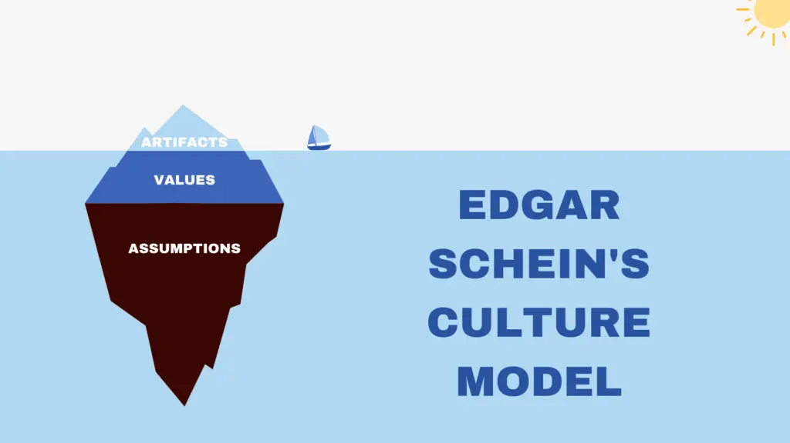

According to Schein, physical manifestations of organisational culture include things like employee uniforms, interior design of buildings, branding of equipment or products, and any other tangible elements like an organisation's pride in displaying its affiliation with a certain cause. People outside the organisation can easily identify and at least partially understand these artifacts. The next layer consists of declared organizational aim and intended behaviour, or espoused ideals. These could include any declared goals or mission statements, as well as any organizational mottos, like "creativity" or "family firm."(Cuofano, 2024)

Edgar Schein, a renowned organisational psychologist, developed a model to explain organizational culture. According to Schein, organizational culture is formed through three levels:

Artifacts: This is the visible level of culture and includes the physical environment, dress code, symbols, rituals, and language used within an organisation. To learn more about the underlying cultural beliefs and presumptions, these manifestations may be watched and examined.

Espoused Values: These are the beliefs, philosophies, and norms that members of an organisation claim to follow. They are often expressed in the organisation’s mission statement or official documents.

Basic Assumptions: The third stratum explores fundamental underlying presumptions. These are the fundamental convictions and underlying ideas that direct behaviour in a company. They may not always be obvious since they are deeply rooted, but they have a big impact on how people see, think, and behave in the workplace.

Assess how people practices in your organisation (or one with which you are familiar) impact both on organisational culture and behaviour, drawing on examples to support your arguments. (AC 2.2)

Processes including performance management, recruiting and selection, and training and development influence employee behaviour, engagement, and relationships in the workplace. By implementing successful people practices, organisations may cultivate a positive culture that boosts employee happiness, productivity, and overall performance (Vulpen)
People practices at Amcor Flexibles have a big influence on employee behaviour and our company culture. People practices have been shown to influence how coworkers interact with one another, how engaged they are, and how satisfied they are with their jobs overall.

People Practice role involves communicating with employees, Effective internal communication creates trust within a company and impacts employee engagement and productivity. Clarifying problems direct with employees showing them the problem and objective so they understand the issue and can implement the change within the company.
Showing respect for colleagues with a professional and ethical approach, if stakeholders are engaged it boosts moral and helps a company succeed in their goals and better working environment. (Opex, no date)

Recruitment and Selection –

Our hiring and selection processes for new employees have the power to influence our culture. We've found that hiring individuals with a range of experiences, skills, and perspectives fosters a creative and welcoming work environment. On the other hand, a culture that lacks diversity and discourages creativity may be fostered if the recruiting process only employs traditional methods or favours a specific type of candidate (Cancialosi, 2016).

The employment process at Amcor Flexibles is a drawn-out process that includes thorough screenings and many interviews with a diverse panel of interviewers. By doing this, we promote an inclusive environment where employees feel valued for their unique contributions, which promotes increased cooperation and teamwork.

Training and Development-

When we provide chances for continuous learning and development, our staff members feel inspired and supported. People who work in positive environments are more likely to be creative, flexible, and accountable for their work. Regular training sessions are very important to us at Amcor Flexibles as it keeps staff skilled and updated with all the recent changes.

According to Deer (2020) Within HR it is important to respect opinions and different views that employees have. explain when an idea may not be appropriate and give an explanation. Encourage ideas and suggestions so that staff feel valued and engaged and feel like they are part of the change.

‘’Poor communication between different departments leads to poor culture, significantly hindering workplace happiness’’ (Lockley, no date)

Peter Cheese, current CEO of CIPD asserts, ‘People professionals are a vital function in supporting businesses to adapt to rapidly changing circumstances’ Explain two different models or theories to managing change. (AC 2.3)

Lewins Change Management Model-

Unfreeze This is the preparatory stage. Analyze how things are currently working so you can understand exactly what needs to change to achieve the desired results. At this stage, you will also present your case to staff and tell them what to expect so that everyone affected is prepared. (Roberts, 2023)

Change This is the implementation phase. Put the change into practice and keep communicating and providing support for all employees involved. (Roberts, 2023)

Refreeze To avoid reverting to old ways of doing things, develop an enrolment strategy and make sure the change sticks. Check how the new processes are working and measure how well you have achieved your goals. (Roberts, 2023)

By putting the necessary change into effect by being aware of these three different phases of transformation. To begin, you must first build confidence In others to be onboard (unfreeze). Encouraging good communication and giving individuals the confidence to accept new working practices are two approaches to advance through the change process. The process comes to an end when you refreeze the organisation, which is crucial for building the trust needed to take on the next, inevitable change. (Roberts,2023)

Kotter’s 8-step change Model (MSG, NO DATE)
This model, which was created by Harvard Business School professor John Kotter, offers a thorough method for handling change in businesses.
- Create a sense of Urgency - Convincing important stakeholders of the need for change and instilling a feeling of urgency to rally their support.
- Form a powerful coalition - Assembling a group of powerful people who can spearhead and steer the transformation project.
- Create a Vision for Change - This vision ought to explain the intended results of the modification and encourage others to accept it.
- Communicate the Vision - Addressing issues, gaining support, and ensuring that everyone understands the goals of the change are all facilitated by open and honest communication.
- Empowers Action - Giving workers the freedom to act, try new things, and make choices consistent with the change's goals.
- Generate Short-Term Wins - Early victories should be recognised and celebrated since they provide the change momentum, raise spirits, and inspire people to support it further.
- Consolidate gains and produce more change - implementing more significant adjustments to alter systems, structures, or processes.
- Anchor the change in the organisations culture - educating staff, rewarding supportive behaviour, and ensuring the change is in line with the organisation's values

A variety of models have been developed to explain how change is experienced. Discuss one model that explains how change is experienced. (AC 2.4)

According to the Kubler-Ross Five Stage model, an organisation may need to go through five stages in order to undergo a total organisational makeover, whether they are seeking change or are faced with an unavoidable shift. The model makes use of psychological ideas to note that an organisation that has to change could at first be in a self-denial state (Amin and Mohamad, 2017).

Kuler-ross was developed in 1969 by American-Swiss psychiatrist Elisabeth Kübler-Ross. This model illustrates the five phases of normal emotional reactions that people experience in the event of major loss or change. Denial, Anger, Bargaining, Depression, and Acceptance are the phases.

An important illustration to emphasize this point is the situation of organisations that had a financial crisis as a result of senior executives' deception. These facilities are shown to start at the very point of utterly rejecting such facts. The organisation may enter the second stage of rage if stakeholders, the general public, and authorities persistently press for the truth. Thirdly, the organisation might enter the negotiation stage in an attempt to control the situation, depending on the accumulation of potentially damaging evidence. Should things continue this way, the organisation might descend into a depression-like condition of inaction. The last level of acceptance is made possible by this stage. It is anticipated that the organisation will implement adjustments during acceptance, including disciplining offenders. The Kubler-Ross model does outline how most businesses encounter changes in crises (Morris, 2023)

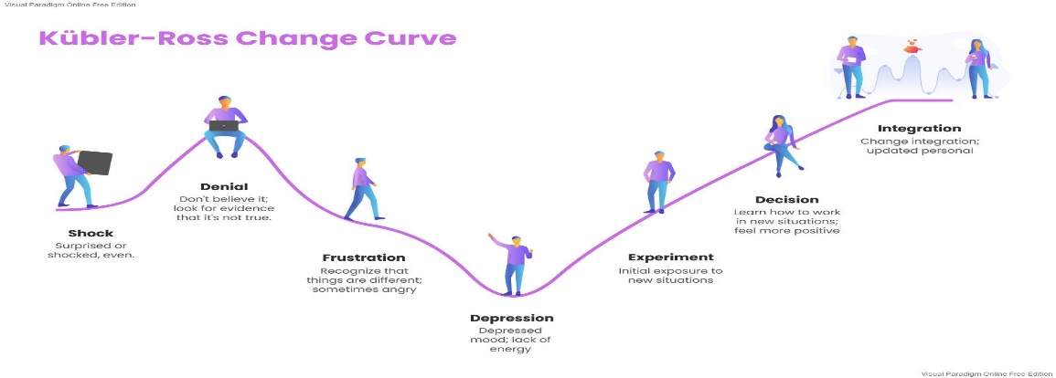
The Kübler Ross Change Curve Model Has Five Stages:

Denial: People respond to the shift in this early stage with shock or denial. They may employ coping strategies to keep from acknowledging the truth of the circumstance, which would reduce their output and cause them to become detached from reality.
Anger: People may become fearful or angry when the reality of the shift sinks in. If this phase is not handled well, it may lead to resistance and even the failure of change projects.
Bargaining: Following their emotional outburst, people could attempt to resolve the conflict through compromise or negotiation. During this phase, finding alternate ways to deal with the transition is necessary.
Depression: As people process the effects, they may go through periods of intense melancholy, remorse, and demotivation.(Tahir, 2019)

The CIPD’s Health and wellbeing at work survey 2022 found, ‘There is less management focus on health and wellbeing compared with the first year of the pandemic’, and goes on to remark that this is disappointing. Assess the importance of wellbeing at work and factors which impact wellbeing. (AC 2.5)

The World Health Organisation consider wellbeing at work “a state of complete physical, mental, and social wellbeing”. Encouraging employees' well-being at work can contribute to a productive workplace by lowering stress levels, raising engagement and satisfaction levels, and ultimately enabling your staff to flourish there. We think that creating a successful company requires a contented and healthy team. While supporting this can require a lot of work, the rewards can be long-lasting, and not all firms can afford the high premiums associated with private health insurance (World Health Organization, 2022)

Wellbeing -
The word "employee wellbeing" describes how well an employee is doing in terms of their work, relationships with others, financial security, physical health, and community participation. Organisations may enhance this quantifiable idea by implementing diverse initiatives and methods. Five essential components of wellbeing are identified by Gallup: career, social, financial, physical, and community. Tracking emotional experiences and assessing a person's view of their present and future lives using indices such as the Life Evaluation Index are key components of measuring wellbeing.(Bhatt, 2023)

Employers and workers both gain from investments made in employee welfare. Prioritising staff health and wellness benefits an organization's productivity, profitability, retention rate, number of safety incidents, and level of customer involvement. In order to create a comprehensive strategy for employee wellbeing, it is necessary to address issues related to physical safety at work, allow workers to get enough sleep, normalise mental health support, operationalize DEIA policies and programmes, foster a sense of community and social connections at work, develop trusted relationships between leaders and employees, encourage teamwork, and promote open communication (Mcintyre, 2021)

Work-Life Harmony-
A fair and balanced work-life balance is necessary for maximum wellness. Prolonged workdays or excessive work-related stress can lead to burnout, which can negatively impact overall health and wellness (Wood, 2018). People who are given adequate time and support for their personal and professional life report being happier. They can spend more time taking care of their physical and mental health. Better relationships with their employers and coworkers as well as higher performance and productivity follow from this (Bierdron, 2022).

The CIPD Profession Map states ‘People practices are the processes and approaches that we use across the employee lifecycle’. Discuss the links between the employee lifecycle and different people practice roles. (AC 3.1)

The employee lifecycle is a comprehensive framework that illustrates the various stages that an employee experiences while working for a company. Professionals in people practice play a critical role at every stage of the employee lifecycle:

Attraction
Human resource specialists work in tandem with hiring managers to pinpoint staffing shortages and create job specifications. They create advertising campaigns as one of their recruitment techniques (Afzal,2023)

Recruitment
They also handle recruiting, screening, interviewing, and evaluating candidates. They negotiate contracts, extend employment offers, and supervise the hiring process (Verlinden, no date) Additionally, they oversee the onboarding procedure, making certain that new hires have the required paperwork, orientation, and training. They make it easier to join the group.

Development
Establishing performance standards and goals that are in accordance with the aims of the business is made easier by people professional practice. They communicate performance standards and metrics to staff members. HR is in charge of organising procedures for performance reviews and making sure that assessments and feedback are given on a regular basis (verlinden,no date) They support supervisors in carrying out fair and helpful performance reviews. They also participate in training and development during the development stage. Human Resources determines the needs for training and development and provides chances to advance one's skills. They support continuous learning and help staff members create development plans.

Retention
Professionals in people practice play a crucial role in mediating and settling conflicts at work throughout this stage. They ensure that labor regulations are followed and improve communication between management and employees. They also assist staff members who encounter hurdles in their personal or professional lives. They could offer guidance, recommendations for resources, and help striking a balance between work and life (Verlinden, no date) Those who work in practice are responsible for managing benefit plans, compensation schedules, and wage structures. In order to make sure that their pay is competitive, they carry out market research.

As part of succession planning, HR finds and nurtures future leaders within the company at this point. They provide development plans and talent pipelines for aspiring leaders. HR helps staff members determine their career goals and routes inside the company.

Analyse and supports wider people and organisational strategies. (AC 3.2)

People practices are vital in determining the overall culture, performance, and success of any firm. Wider organisational and people strategies can be supported by the implementation and management of people practices, which can have a substantial impact on a number of organisational areas.

Recruitment and Selection: HR specialists work with hiring managers during the recruitment and selection process to make sure the best candidates are chosen for positions based on their qualifications, abilities, and cultural fit. HR assists in bringing in people that can help the business achieve its goals by coordinating recruiting procedures with organisational objectives (CIPD, 2023)

Learning and Development: HR collaborates closely with department heads to pinpoint workers' skill shortages and offer training courses to fill them in. By ensuring that workers have the skills needed to support organisational initiatives, this alignment promotes better performance and talent retention (Brassey, 2019)

Performance Management: HR establishes objectives, targets, and routinely gives staff members feedback through performance management procedures. HR promotes excellent performance by tying individual performance to organisational goals (Tardy, 2023)

Ultimately, broader organisational and people strategies depend on the interdependence of people practices with other organisational components. Professionals may promote talent development, performance improvement, employee engagement, and overall business success by skillfully coordinating HR procedures with organisational goals.

Discuss processes you have, or could use, for consulting and engaging with internal customers of the people function in order to understand their needs. (AC 3.3)

Establishing strong processes for consulting and interacting with internal consumers is essential to understanding their requirements inside the people function. By doing this, HR professionals may obtain insightful knowledge that will help them with strategic choices and activities meant to improve organisational performance and the work experience of employees.

1. Surveys and feedback mechanisms: Among the most popular ways to consult internal consumers are feedback mechanisms and surveys. HR teams may collect both quantitative and qualitative data using these tools on a range of aspects of the employee experience, including levels of satisfaction, areas for development, and particular requirements or preferences. Surveys may be used to get timely employee input either on a regular basis or in real time (Edgecumbe, ND)

2. Focus Groups and Interviews: Holding focus groups or one-on-one interviews with people from various organisational departments or levels is another successful strategy. HR practitioners may learn more about certain problems, acquire detailed insights, and comprehend the underlying causes of certain patterns or difficulties that have been discovered through surveys or other forms of feedback by using this qualitative technique.

3. Cross-Functional Collaboration: Working together with various organisational departments and functions can yield insightful insights into the requirements of internal consumers. HR may obtain a comprehensive awareness of how many activities intersect with the people function and spot possibilities for alignment and cooperation by collaborating closely with key stakeholders from a variety of fields, including operations, finance, IT, and marketing (CIPD, 2022)

4. Data Analytics: HR managers may find patterns, trends, and correlations in employee data that may point to particular needs or areas that require attention by using data analytics tools and methodologies. HR may find possible areas for improvement in serving the demands of internal customers by examining data on employee engagement, turnover rates, performance reviews, training results, etc.(HR Tutorial, ND)

In summary, HR professionals can effectively engage and consult with internal customers of the people function to obtain important insights that propel significant change within the organisation by utilising a variety of techniques such as surveys, focus groups, cross-functional collaboration, data analytics, and continuous improvement processes.

Bhatt (2023) The workforce wellbeing . Available at:https://www2.deloitte.com/us/en/insights/topics/talent/employee-wellbeing.html (Accessed: 7th May 2024)

Brassey (2019) the successful components of L&D. Available at:https://www.mckinsey.com/capabilities/people-and-organizational-performance/our-insights/the-essential-components-of-a-successful-l-and-d-strategy (Accesseed:5th May 2023)

CIPD, (2023) effective cross functional collaboration. Available at:https://www.cipd.org/uk/knowledge/reports/cross-functional-collaboration/ (Accessed: 4th May 2024)

CIPD, 2020. Organisation design. CIPD Factsheet. Available [online] at: https://www.cipd.co.uk/knowledge/strategy/organisational-development/design-factsheet# [Accessed December 26, 2021].
Cuofano (2024) what is sheins model of organisational culture. Available at: https://fourweekmba.com/scheins-model-of-organizational/ (Accessed:09th May 2024)

Dieffenbacher (2023) Leadership . Available at: https://digitalleadership.com/blog/organizational-strategy/ (Accessed: 18th January 2024)

Dwyer, J. (2012) - This source offers information on communication strategies for business success which is relevant in the context of connecting people practices with wider organizational strategies.

Deer (2020) The importance of respect in the workplace. Available at: https://cpdonline.co.uk/knowledge-base/business/importance-respect-workplace/#:~:text=A%20respectful%20working%20environment%20can%20offer%20more%20opportunities,creative%20solutions%2C%20benefiting%20the%20business%20as%20a%20whole (Accessed: 14th Sept 2022)

Edgecumbe (ND) benefits of qualitative data. Available at: https://www.edgecumbe.co.uk/benefits-of-using-qualitative-research-within-your-employee-engagement-surveys/ (Accessed: 02nd May 2024)

HR Tutorial (ND), The roles of data in HR. Available at: https://hrtutorial.com/hr-transformation/digital-hr-transformation/key-components/role-data-hr/ (Accessed: 02nd May 2024)

Katuse, P., 2021. Employee Perceptions on Organisational Strategy Implementation in Covid 19 Era. Indian Journal of Economics and Business, 20(3).

Kissinger (2023) Tesla pestle/Pesel. Available at:https://panmore.com/tesla-motors-inc-pestel-pestle-analysis-recommendations (Accessed: 3rd May 2024)

Maduenyi, S., Oke, A.O., Fadeyi, O. and Ajagbe, A.M., 2015. Impact of organisational structure on organisational performance.
Management study guide,(no date). Kotters 8 step guide. Available at: https://www.managementstudyguide.com/kotters-8-step-model-of-change.htm (Accessed: 7th May 2024)

Morris (2023), Change management. Available at: https://www.paulmorris.org.uk/mastering-business-change-management-with-the-kubler-ross-change-curve (Accessed: 7th May 2024)

Mcintyre (2021) Why wellbeing in the workplace is so important, Available at: https://www.peoplemanagement.co.uk/article/1744109/why-wellbeing-workplace-important (Accessed: 6th May 2024)
Opex (no date) Examples of showing respect. Available at: https://opexmanagers.com/examples-of-showing-respect/ (Accessed: 10th Sept 2022)

Roberts (2023) Change Management. Available at: https://www.cipd.org/en/knowledge/guides/change-management/#models-for-change (Accessed: 19th January 2024)

Taylor, S. & Woodhams, C. (2022) - The source provides insights into human resource management practices that align with organiz(ational goals.

Tahir (2019), cubler ross change curve. Available at: https://changemanagementinsight.com/kubler-ross-change-curve-model/ (Accessed: 7th May 2024)

Tardy (2023) Performance management. Available at: https://www.investopedia.com/terms/p/performance-management.asp (Accessed: 4th May 2024)

University of Lincoln (2021) What is organisational stratehy and why does it matter? Available at: https://online.lincoln.ac.uk/what-is-organisational-strategy-and-why-does-it-matter/ (Accessed: 18th January 2024)

Vulpen (no date) what is performance management. Available at: https://www.aihr.com/blog/what-is-performance-management/ (Accessed:7th May 2024)

Verlinden (no date) employee life cycle. Available at: https://www.aihr.com/blog/employee-life-cycle/ (Accessed: 6th May 2024)

World health organisation (2022), Mental health at work. Available at: https://www.who.int/news-room/fact-sheets/detail/mental-health-at-work (Accessed:5th May 2024)

Yu, W., Chavez, R., Jacobs, M., Wong, C.Y. and Yuan, C., 2019. Environmental scanning, supply chain integration, responsiveness, and operational performance: An integrative framework from an organizational information processing theory perspective. International Journal of Operations & Production Management.

