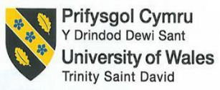

BA International Hotel Management
BMIH5003: Cultural Awareness
Student Name: Irina Dode
Student ID: 2123684
University Name: UWTSD
Lecturer: Giulia Chifari
Executive Summary
Diversity Hotel & Spa has launched its outlets in France and it will be opened after a few days. Hence, the general manager of this organisation will visit this country to train new employees. It will be effective if the training programme is suitable to the culture of this country. This strategy will assist the employees to adapt the contents of training easily. Hence, the GLOBE Project has been highlighted to execute country analysis. Finally, a few recommendations have been focused on based on the identified challenges in detail.

Table of Contents
1. Introduction 4
2. Description 4
2.1 Cultural overview of France 4
2.2 GLOBE Project 5
2.3 Identification of most relevant practices 7
3. Conclusion 7
4. Recommendations 7
References 9

1. Introduction
Different countries have different cultures and their daily lifestyle may be different from the UK. The behaviour, communication processes and way of talking of different countries can also totally be opposite of other regions. New companies need to adapt and respect the cultural characteristics of the specific region if they want to run a business for a long time. Diversity Hotel & Spa opened its outlets in France a few days ago. This organisation also hired efficient staff to execute its organisational activities properly. This organisation needs to develop training programmes for its staff by focusing on the culture of France. This report will analyse the GLOBE Project Culture and Leadership of France to gain detailed knowledge about the culture of this country. This study will also identify the most relevant practices for the culture of this country. This report will also provide a few recommendations to the general manager of Diversity Hotel & Spa for resolving the challenges properly.

2. Description

2.1 Cultural overview of France
French values their families highly and they execute all their activities by involving family members (Fougières. 2021). French people take common meals with their family every weekend and several times, they organise family gatherings (Gordon and Zimmermann, 2022). The main motto in France is “Liberty, Equality, and Fraternity” which focuses on the values of French society (Kaplan, 2018). Citizens in France love the artistry and beauty of their country. French gastronomy is also a popular culture in the world and it enrolled its name in the List of the Intangible Cultural Heritage of Humanity by UNESCO in 2010 (Coulangeon, 2017). Cheese, wine, bread and sauces are some traditional foods in France. People in this country love to execute activities unitedly (Sowerwine, 2018). French fashion started to become popular globally from the era of Louis XIV. This country has popular fashion brands like Louis Vuitton and Chanel (Austin, 2019). People in this country mainly wear suits or dresses with long coats and scarves. Arts, literature and cinemas are also appreciated in French tradition intensely (Bourg, 2017).

2.2 GLOBE Project
The effectiveness of leadership, culture and organisational behaviour can be identified with the help of the GLOBE Project.
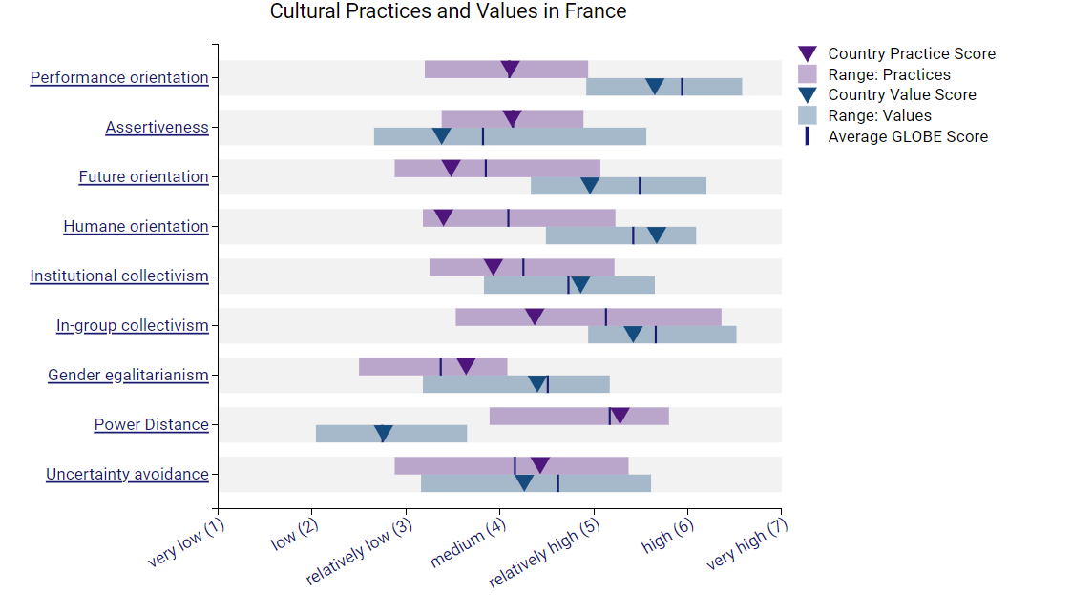
Figure 1: Cultural practices and values in France
(Source: GLOBE Project, 2023)
Performance orientation is about 4.11 and assertiveness is about 4.13 in France in recent years. Ure orientation, humane orientation, institutional collectivism, in-group collectivism and gender egalitarianism are 3.48, 3.4, 3.93, 4.37 as well as 3.64 respectively. Power distance and uncertainty avoidance are 2.76 as well as 4.43 respectively. All the numbers are a little different from the figures of the UK (GLOBE Project, 2023). As an example, the excessive power distance in France is about 5.28 which is near to relatively high. It refers to the higher degree of inequality among the people in this country. Medium institutional collectivism refers to people who love to work in groups and get rewarded. Future orientation is quite low in France and it makes this country weak in planning the future (Bresinsky and von Reusner, 2018). The people of this country do not focus on the future consequences of any action. Hence, the tendency to recover damages and execute future development is not good enough. The main challenge for this business will be the lack of a future-focused mindset of employees (Ozgen, 2012). Gender egalitarianism is near to medium in France and it shows moderate gender inequality. As an example, only about 34.6% of senior managerial posts in France are dominated by female employees (GLOBE Project, 2023).
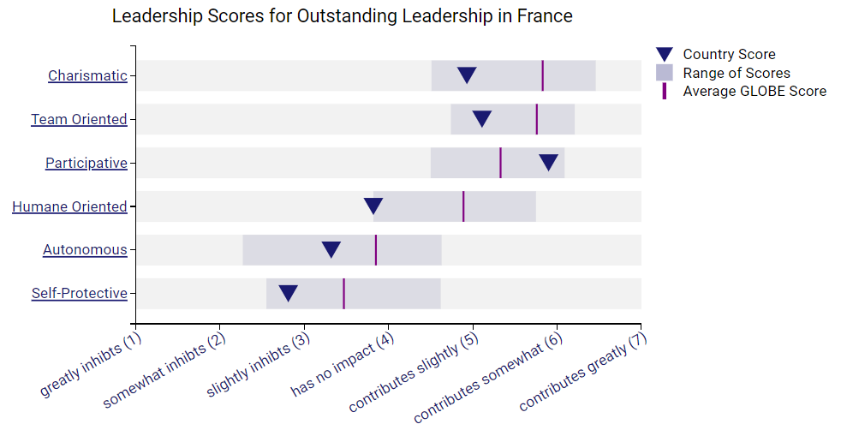
Figure 2: Leadership Visualisation
(Source: GLOBE Project, 2023)
According to Figure 2, charismatic, team-oriented, humane-oriented, autonomous and self-protective leadership style scores are under the average number in the GLOBE Project (Bresinsky and von Reusner, 2018). Only participative leadership can gain a total score of about 5.9 where the average mark is about 5.33. According to the above analysis, the general manager of Diversity Hotel & Spa will be able to lead the employees of its French outlets by following participative leadership styles. However, all the training-related decisions are required to be made by management after including employees. It will make the situation more collaborative and engaged for both management as well as staff (GLOBE Project, 2023).

2.3 Identification of most relevant practices
Moderate female inequality is a main cultural practice in France and females get their rights more or less all the time. The general manager of Diversity Hotel & Spa may also host training programmes for any female (Bourg, 2017). It will encourage other women to join this organisation for work. Additionally, the degree of inequality is higher in this country and future-focused activities are also less in number. According to the GLOBE Project, the participative leadership style is highly followed in France as a major practice in companies (Kaplan, 2018).

3. Conclusion
Cultural components like lifestyles, communication style and ethics in society influence the behaviour of people in any country. France and the UK are two culturally different countries in Europe. Diversity Hotel & Spa may face several challenges after and before opening its outlets. Hence, this report has assessed a detailed country analysis with the help of the GLOBE Project. It assisted in identifying the possible challenges for this organisation. This company can implement suitable solutions by focusing on the identified issues properly. Finally, this report has provided a few recommendations to the general manager of this organisation briefly.

4. Recommendations
Recommendation 1: Execution of proper analysis: It is recommended that the general manager of Diversity Hotel & Spa needs to analyse the culture of this country before teaching there to provide training to employees. It will assist the general manager in implementing suitable strategies to communicate with employees easily and execute further actions.
Recommendation 2: Hiring of consultants: It is suggested to the general manager of this organisation to hire consultants for planning training properly before its grand opening. This activity can assist this organisation to start its business activities in larger numbers after first opening.
Recommendation 3: Implementation of participative leadership styles: It is recommended to the general manager of Diversity Hotel & Spa for implementing participative leadership styles. It will enhance the engagement and productivity of the employees significantly.

References
Austin, G., (2019). Contemporary French cinema: an introduction. In Contemporary French cinema. Manchester University Press.
Bourg, J., (2017). From revolution to ethics: May 1968 and contemporary French thought. McGill-Queen's Press-MQUP.
Bresinsky, M. and von Reusner, F., (2018). GLOBE–Learn and innovate digitization by a virtual collaboration exercise and living lab. In Interactivity, Game Creation, Design, Learning, and Innovation: 6th International Conference, ArtsIT 2017, and Second International Conference, DLI 2017, Heraklion, Crete, Greece, October 30–31, 2017, Proceedings 6 (pp. 273-281). Springer International Publishing.
Coulangeon, P., (2017). Cultural openness as an emerging form of cultural capital in contemporary France. Cultural Sociology, 11(2), pp.145-164.
Fougières. D. M., (2021). The French Brief - The Road to Gender Equality in France’s Labor Market. Available at https://www.institutmontaigne.org/en/expressions/french-brief-road-gender-equality-frances-labor-market#:~:text=In%20France%2C%20women%20only%20hold,higher%20than%20Germany%20(29%25). [Accessed 11 October 2023]
GLOBE Project, (2023). France. Available at https://globeproject.com/results/countries/FRA?menu=country#country [Accessed 11 October 2023]
Gordon. J and Zimmermann. A. K., (2022). French culture: Customs & traditions. Available at https://www.livescience.com/39149-french-culture.html [Accessed 11 October 2023]
Kaplan, A., (2018). French lessons: A memoir. University of Chicago Press.
Ozgen, E., (2012). The effect of the national culture on female entrepreneurial activities in emerging countries: An application of the GLOBE project cultural dimensions. International Journal of Entrepreneurship, 16, p.69.
Sowerwine, C., (2018). France since 1870: culture, politics and society. Bloomsbury Publishing.

