LEGAL RISKS WITHIN THE HOSPITALITY INDUSTRY
Name: Ionela Vlad
Student id: 1905718
Module Code: M4X01017
Lecturer: Dale Clarke

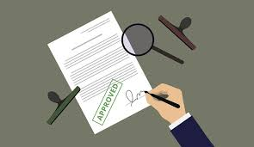

Coming in the assignment
Introduction
- Health and safety……………………………………….
- Data Protection………………………………………….
- Licensing………………………………………………..
- Food hygiene…………………………………………….
- Risk management……………………………………………..
- The hotel proprietors act………………………………………
Conclusion……………………………………………………………..
References……………………………………………………………..



Introduction
Within the assignment, the task is to use knowledge and analyse legislative risks that the members of staff must think about in the hospitality and tourism industry. The legislative risks that will be mentioned within the report are health and safety, data protection, licensing, food hygiene, risk management, the hotel proprietors’ act 1956.
Risks within the hotel industry started to be more important aspects and this because the hotel industry became one of the most important businesses that are working a lot in the economy regarding to the high number of people going to them and supporting them within profits. As mentioned by Guzelian and Whalley (2016), “legal risks are the ones that can be seen as risks of economic or reputational injury that can have in the end a result of absence of understanding, confusion or the way law and techniques applied to your organisation, its products, services or actions”
- Health and safety
Health and safety are more than important in the hospitality industry and regarding to this, hotel owners and people in charge of the hotel management as well as employers must follow so many legislative procedures to ensure that the services provided are under health and safety criteria. As mentioned on the Health and Safety Act (2015), “its goal is to provide a well-adjusted framework to provide the health and safety of employers and companies through caring employers and any other individuals beside injury to their health, safety and wellbeing by removing or minimising dangers at the workplace” therefore such aspects must be risk assessed in order to maintain a safety background to make the workers feel safe and protected. Health and safety is maintained even through the protection of food and the cleanliness of the hotel itself. In addition, the managers should have in their mind the health and safety of floors as they could be slippery sometimes and many people could have major injuries regarding to that
. 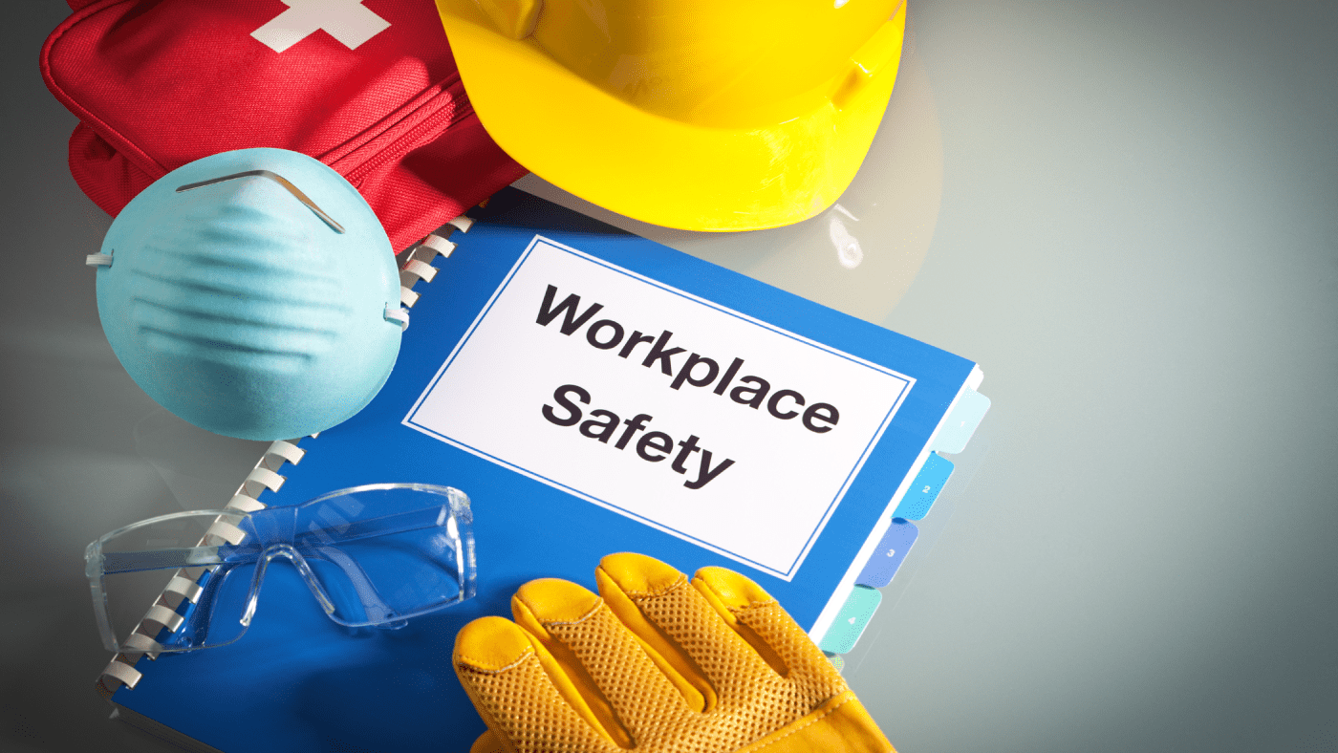
- Data Protection Data protection is another important thing when managing a business especially one in the hospitality industry because, the hotels are dealing with so many people and therefore the members in charge of collecting data must register people’s o information. As mentioned in the GDPR (General data protection regulation) “data protection is highly important in businesses because it means that the is collection, sorting, analysing of data which means that workers are collecting data about policies and next to that about employees and guests” this meaning that the people in charge of data protection have a massive responsibility when it comes to keeping the data and information safe and up to date. There are internal systems on each department that are helping in keeping the data organised depending on the department the specific information is about. In addition, when employing people, the managers must be very careful at their experience for the role to make sure that they are able to work within the data protection systems.
- Licensing A license is an approval of doing something in a business and if the specific license is not approved then the selling of doing the wanted thing is not able to take place. In the hospitality industry, there are many kinds of licences and this because the hospitality industry is an industry that is working with a variety of people offering multiple products and multiple service/ facilities. According to (Newton and Hirschfield) The UK GOV offers different kind of licenses to people and organisations to fund them permission for the conduct of the performing related activities, supply and sale of alcohol and provisions of food and drink past midnight” this quote showing the importance of licenses in the hotel industry. Some kinds of the needed licenses are the following:
Premise License: is the kind of permission that is based on the approval supplying and selling of alcohol. In addition, this license allows the hotel/ restaurant to sell hot food, made in the hotel between specific intervals of hours. Personal License: Is the license that has, as a base the permission of selling or supplying alcohol and this is a permit is usable in authorising the sale or supply of alcohol. Club premise license: is a license that is needed for the ones that are presenting sports/ specific performances.

- Food hygiene
Hospitality companies that are preparing food for guests need to be governed by legislation to show that the food handling and preparation processes are safe and that the members of staff working with food are following the rules and regulations mentioned in the law. In order to prevent food contamination, the members of staff need to be aware of all the rules because food in general in such businesses includes handling, preparation, storage, transporting etc. and in each of these, hygiene is very important.
Anyway, for the members of staff that are directly working of food, there are few necessary things for them to know. Before they start working within the food, they must:
- Wash their hands correctly
- Wear clean uniform
- Wear an apron when working with unwrapped food
- Communicate with the line manager when having critical condition in a day (vomiting/ diarrhoea)
- Take off such accessories (watch, bracelets...)
- Wear something on your head to prevent hair falling.
The mentioned aspects are helping in preventing such contaminations from happening. According to Hazard Analysis and Critical Control Point (HACCP), there are three types of contaminations and it is very important to prevent them. The three types of contamination are the following:
- Microbiological- including bacteria, viruses, tapeworms, fungi and bacteria from unwashed hands or from the incorrect storage in critical conditions.
- Chemical- may contaminate food when cleaning fluids are getting into contact with the food
- Physical- When elements such as pieces of a bracelet/ glass are getting into the food and then in contact with the person eating the food.

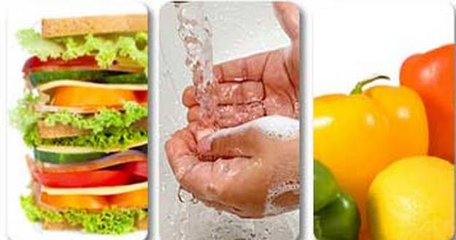

- Risk management
The risk management is an aspect that pushes employees to identify, analyse, test and hopefully avoid or mitigate risks that can be results of a variety of situations. As mentioned by Williams and Heins,” risk observation is the procedure by which a company recognizes land, responsibility and employees’ exposures as soon as or before they develop” (1989). This quote shows the difficulties that are faced by people in charge of risk management. When managing risks, people in charge should use different resources and checklists to observe what is creating risks and how they can be minimised. Anyway, after the risks are identified, the risk manager is requested to evaluate their level of gravity and to create a measurement data, which represents the actual probability of chance for risk to occur in the specific hotel. Therefore, risks assessments are needed to show clearer exactly how serious a hazard is. As Fischhoff said in 1981, “the suitability of a risk is a comparative concept rather than an pure one and therefore, there can be no single, all-purpose number that conveys the acceptable risk for a group or a society.”

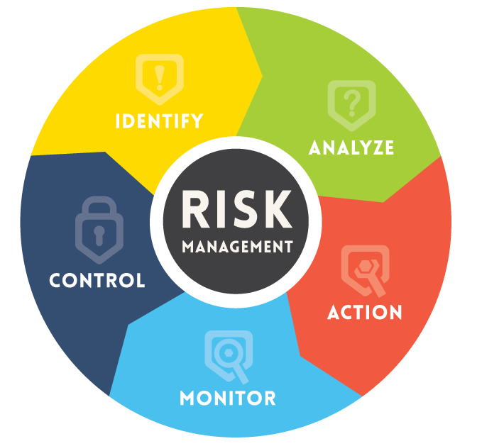

- The Hotel Proprietors Act 1956
The hotel proprietor’s act is an act that mentions that a hotel administrator may in certain conditions be legally responsible to make good any loss of or injury to a guest’s property even though it was due to any error of the proprietor or staff of the hotel” this meaning that the proprietors must response for the guest’s goods
Conclusion
As a conclusion, the most important thing to speak about is that within the assignment all the asked risks mentioned in the introduction were discussed and analysed linking each of them within the hospitality industry and as a result, each aspect plays an important role in the hotel as a business. 

References

Lichtenstein, S., Fischhoff, B. Slovic, P., Derby S.L., and R.L. Keeney, Acceptable Risk, Cambridge University Press, 1981
Food-safety-hazard-analysis, Hazard analysis and Critical Point (HACCP). [Available on: https://www.rentokil.co.uk/hospitality-pubs-bars-restaurants-and-cafes/hospitality-food-safety/]
http://www.hse.gov.uk/pubns/cais25.pdf
The regulation (EU) 2016/679 of the European Parliament and of the Council [online] available on: http://uk.milliman.com/uploadedFiles/insight/2018/Data=protection-GDPR-world.pdf
Legislation.gov.uk. Health and Safety act 2015. [Online] available at: http://www.legislation.govt.nz/act/public/2015/0070/latest/DLM5976667.html
Whalley, M. and Guzelian, C. (2016). The legal risk management handbook
Williams C. Arthur and R.M. Heins, Risk Management and Insurance, New
York: McGraw-Hill Book Co., 6th ed., 1989, Chap 1, 2 & 3.
.

