BMIH5003
RESIT C2
Foreign Languages and Cultural Awareness
LEVEL 5
Intercultural Competence Report

Constantin Bogdan Rusu

Word count: 1,017

Executive summary

In the current context of the hospitality market, business leaders must recognise their community’s culture and be aware of cultural differences and their consequences for management effectiveness and organisational performance. The purpose of this report is to outline a culture overview to the General Manager of the Inclusivity Hotel & Spa in London regarding the key cultural differences between England and Germany, where the headquarters of the parent company is located. The goal of the report is to enhance awareness of international cultures and customs, which impact the quality of the touristic customer experience. The objectives of the report include discussing the main cultural differences between the countries mentioned above, based on the GLOBE Project’s study, and analysing the challenging aspects of intercultural leadership in the tourism industry, followed by recommendations to address them.
The analysis found that there are potential areas of conflict related to assertiveness, humane orientation, institutional and in-group collectivism, power distance, and uncertainty avoidance between English and German employee groups. The management team of the Inclusivity Hotel & Spa in London can overcome these challenges by increasing awareness of cultural differences between the two groups and their consequences on organisational performance, reducing the cultural shock experienced by the German employees that will join the London hotel, using training programmes for all employees, and providing organisational support for individual integration in a multicultural environment. The HR department must devise and implement a training programme and an individual employee support programme to overcome the challenges and increase the individual and group contribution to organisational performance.

Table of Contents
Executive summary 2
Introduction 4
Culture overview 4
GLOBE Project/country analysis 5
Conclusion and recommendations 9
References 10

Figure 1. Cultural practices and values in England 7
Figure 2. Cultural practices and values in East Germany 8
Figure 3. Cultural practices and values in West Germany 8

Table 1. Cultural practices and values in England and Germany 7

Introduction

According to Christiansen, Branch, and Karmowska (2020), business leaders must recognise their community’s culture and be aware of cultural differences and their consequences on management effectiveness and organisational performance. The purpose of this report is to outline a culture overview to the General Manager of the Inclusivity Hotel & Spa in London regarding the key cultural differences between England and Germany, where the headquarters of the parent company is located. The goal of the report is to enhance awareness of international cultures and customs, which impact the quality of the touristic customer experience. The objectives of the report include discussing the main cultural differences between the countries mentioned above, based on the GLOBE Project’s study, and analysing the challenging aspects of intercultural leadership in the tourism industry, followed by recommendations to address them.

Culture overview

The literature review shows that employee performance and professional behaviour in the tourism industry are influenced by the level of cultural intelligence and intercultural skills (Alshaibani and Bakir, 2017). Culture is a concept with different meanings that refers to a set of basic assumptions, values, life perspectives, beliefs, policies, actions, and behaviours shared by specific groups of people that influence the behaviours and understanding of other individuals’ behaviours (Spencer-Oatey, 2012). According to Reisinger and Turner (2012), given the current global circumstances, the influence of culture must be considered in all of its forms and dimensions since it significantly affects tourism policy, planning, development, management, and marketing. Cultural elements include entertainment, cuisine, drink, employment, attire, media, architecture, handicrafts, history, language, religion, education, customs, humour, art, music, dance, hospitality, and all the other aspects of a country's way of life.
England is the predominant constituent unit of the United Kingdom; it occupies more than half of Great Britain, where more than 53 million people live (Kellner and Thomas, 2024). The UK is a homogeneous nation with well-developed traditions, considering that, as the British Empire grew and the nation began to absorb people from all over the world, Afro-Caribbeans, Asians, Muslims, and other immigrant groups made diverse contributions to English culture (Kellner and Thomas, 2024). Moreover, England maintained its own specific customs, traditions, cuisine, and festivals. From a religious perspective, the Church of England is predominant. According to Gov.uk (2022), more than four fifths of the population is white, followed by Asians at 9.3%, blacks at almost 3%, and mixed and other ethnic backgrounds at 5%.
Germany is situated in north-central Europe; it is a federal multiparty republic; and it has a population of 86,3 million (Britannica, 2024). German tourism attracts many travellers due to its natural beauty, history, culture, cuisine, and drinks such as famous wines and beers (Dugan, Turner, and Leyser, 2024). From an ethnic perspective, Germany is a very homogenous nation, with over 85% Germans, almost 2% Turkish, and 12% other ethnic groups (CIA, 2024). The official language is German, whereas from a religious perspective, there are almost one fourth of Roman Catholics, Protestants at 22.6%, none at 43.8%, Muslims at 3.7%, etc. (CIA, 2024).

GLOBE Project/country analysis

The GLOBE (Global Leadership and Organisational Behaviour Effectiveness) project observed the connections between culture, leadership, and business practices (GLOBE, 2020a).
According to this project, there are very small cultural differences between England and Germany regarding performance orientation, assertiveness, future orientation, humane orientation, institutional collectivism, in-group collectivism, gender egalitarianism, power distance, and uncertainty avoidance.
Both Germans and English have very similar performance orientations, which are close to the Average Globe Score. Thus, both nations culturally encourage and reward performance improvement and excellence within groups and organisations.
Germans have slightly higher assertiveness cultural practices, meaning that they are more convincing, challenging, and aggressive, as opposed to collaborative and compassionate, while English people have slightly higher assertiveness values.
Moreover, humane orientation practices are slightly higher in England, considering the focus on increasing individual well-being.
Institutional collectivism is higher in English practices but smaller in values compared to Germany, meaning that English businesses and societal institutions tend to encourage people to be team players.
In-group collectivism practices are higher in Germany, where individuals have a higher tendency to show pride, loyalty, and cohesion within workplaces or families, increasing their sense of duty and obligations towards organisations and family.
The power distance is slightly higher in Germany, both from the perspective of practices and values, meaning that Germans accept less of an uneven division of power and class privileges, and they have a higher tendency to obey rules and tolerate concentrated power than in England.
Uncertainty avoidance practices are slightly higher in Germany, while uncertainty avoidance values are slightly smaller than in England. Hence, Germans are more reliant on cultural practices based on rules and norms to address the unpredictability of future events.
Considering the analysis above, there are potential areas of conflict related to assertiveness, humane orientation, institutional and in-group collectivism, power distance, and uncertainty avoidance. German hospitality employees could be more direct in their communication, while English employees are more polite, collaborative, and compassionate. Germans could also be less humane-oriented and more individualistic, while English tend to be better team players. The sense of duty and obligation is higher for German employees, and they would obey rules and tolerate concentrated power better than their English colleagues.
Please see Table No. 1, which synthesises the findings of the project related to cultural practices and values in England and Germany.

Dimension | England | Germany (East/West) | Average Globe Score
Performance orientation | Practice: 4.08  Values: 5.9 | Practice: 4.09/4.25  Values: 6.09/6.01 | Practice: 4.1  Values: 5.94
Assertiveness | Practice: 4.15  Values: 3.7 | Practice: 4.73/4.55  Values: 3.23/3.09 | Practice: 4.14  Values: 3.82
Future orientation | Practice: 4.28  Values: 5.06 | Practice: 3.95/4.27  Values: 5.23/4.85 | Practice: 3.85  Values: 5.49
Humane orientation | Practice: 3.72  Values: 5.43 | Practice: 3.4/3.18  Values: 5.44/5.46 | Practice: 4.09  Values: 5.42
Institutional collectivism | Practice: 4.27  Values: 4.31 | Practice: 3.56/3.79  Values: 4.68/4.82 | Practice: 4.25  Values: 4.73
In-group collectivism | Practice: 4.08  Values: 5.55 | Practice: 4.52/4.02  Values: 5.22/5.18 | Practice: 5.13  Values: 5.66
Gender egalitarianism | Practice: 3.67  Values: 5.17 | Practice: 3.06/3.1  Values: 4.9/4.89 | Practice: 3.37  Values: 4.51
Power Distance | Practice: 5.15  Values: 2.8 | Practice: 5.54/5.25  Values: 2.69/2.54 | Practice: 5.17  Values: 2.75
Uncertainty avoidance | Practice: 4.65  Values: 4.11 | Practice: 5.16/5.22  Values: 3.94/3.32 | Practice: 4.16  Values: 4.62
Table 1. Cultural practices and values in England and Germany
Sources: Globe, 2020b; Globe, 2020c

Please see the next three figures that illustrate the cultural practices and values in England, in East Germany, and in West Germany.

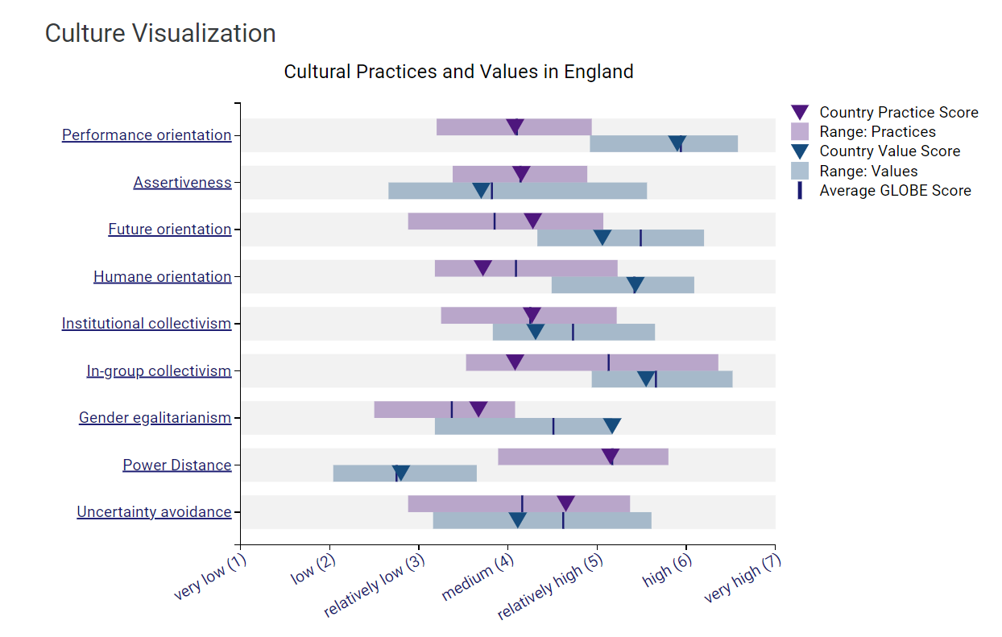
Figure 1. Cultural practices and values in England
Source: Sources: Globe, 2020b

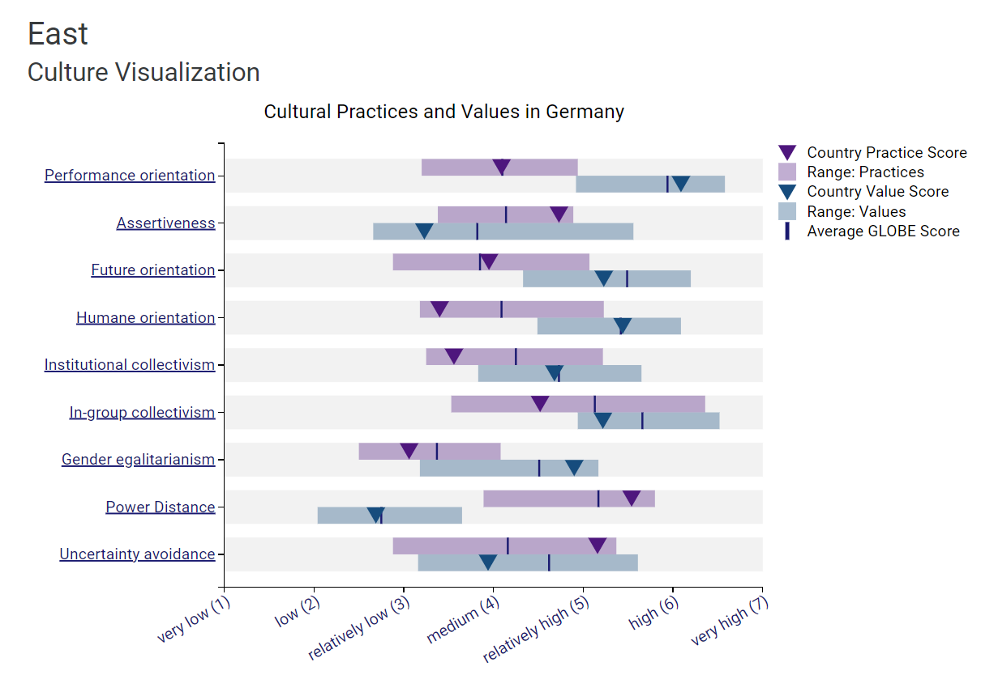
Figure 2. Cultural practices and values in East Germany
Sources: Globe, 2020c

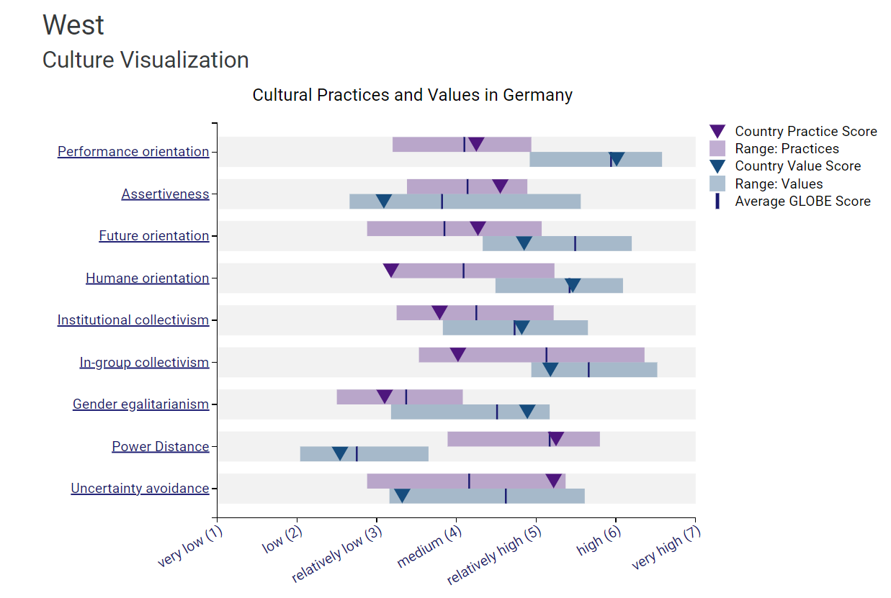
Figure 3. Cultural practices and values in West Germany
Sources: Globe, 2020c

Conclusion and recommendations
The report outlined a cultural overview, including the key cultural differences between England and Germany.
There are potential areas of conflict related to assertiveness, humane orientation, institutional and in-group collectivism, power distance, and uncertainty avoidance between English and German employee groups.
The hotel’s management team can overcome these challenges by increasing awareness of cultural differences between the two groups and their consequences on organisational performance, reducing the cultural shock experienced by the German employees, using training programmes and providing organisational support for individual integration in a multicultural environment, devised and implemented by the HR department, to increase the employee contribution to organisational performance.

References

Alshaibani, E. and Bakir, A. (2017) ‘A reading in cross-cultural service encounter: Exploring the relationship between cultural intelligence, employee performance and service quality’. Tourism and Hospitality Research, 17(3), pp. 249-263. Available at: https://doi.org/10.1177/1467358416651474

Britannica (2024) Germany. Available at: https://www.britannica.com/facts/Germany (Accessed: 20 February 2024)

Christiansen, B., Branch, J.D. and Karmowska, J. (2020) Cultural Factors and Performance in 21st Century Businesses. Hershey : IGI Global.

CIA (2024) Germany – Country Summary. Available at: https://www.cia.gov/the-world-factbook/countries/germany/summaries/ (Accessed: 20 February 2024)

Dugan, L.G., Turner, H.A., and Leyser, K.J. (2024) Germany. Available at: https://www.britannica.com/place/Germany (Accessed: 20 February 2024)

GLOBE (2020a) About. Available at: https://globeproject.com/about%3Fpage_id=intro.html#globe2020_intro (Accessed: 21 February 2024)

GLOBE (2020b) England. Available at: https://globeproject.com/results/countries/GBR%3Fmenu=list.html#list (Accessed: 28 February 2024)

GLOBE (2020c) Germany. Available at: https://globeproject.com/results/countries/DEU%3Fmenu=list.html#list (Accessed: 28 February 2024)

Globe Project (2020a) GLOBE 2020 – Global Leadership and Organizational Behaviour Effectiveness. Available at: https://globeproject.com/ (Accessed: 14 February 2024)
Gov.uk (2022) Population of England and Wales. Available at: https://www.ethnicity-facts-figures.service.gov.uk/uk-population-by-ethnicity/national-and-regional-populations/population-of-england-and-wales/latest/ (Accessed: 20 February 2024)

Kellner, P, and Thomas, W.H. (2024) England. Available at: https://www.britannica.com/place/England (Accessed: 15 February 2024)

Reisinger, Y. and Turner, L. (2012) Cross-cultural behaviour in tourism. London: Routledge
Spencer-Oatey, H. (2012) ‘What is culture. A compilation of quotations’. GlobalPAD Core Concepts. Available at: http://go.warwick.ac.uk/globalpadintercultural (Accessed: 14 February 2024)

