

ASSESSEMENT COMPONENT 2
SUPPORTING PAPER

NAME: Massangbe Saran SY SAVANE

STUDENT ID: 1807717

MODULE: Living With Care: Older Person (BMHP6009)

LECTURER: Diola Bijlhout

Table of content
Cover page……………………………………………………………………………..1
Table of Content……………………………………………………………………….2
Debate and the Supporting Paper……………………………………………………3
- What are the older people’s contributions in the UK Economy……….3
- Elderly the hidden workforce………………………………………………….3
- What are the others arguments in the debate…………………………..4
- Elderly resource for the new generations……………………………………4
- What are the impacts of the pandemic Covid-19 on older person…….4
- Recommendations …………………………………………………………5
- Conclusion …………………………………………………………………..5
References list…………………………………………………………………………..6

Debate and the Supporting Paper

This paper is to support the standpoint during the debate around the topic two, stated as following: Does population ageing pose challenges for Health and Social Care Systems? By a negative affirmation to this statement overall as a group. Moreover, the personal standpoint was defending to see the elderly as the hidden workforce in society.
It is well noticeable that the ageing population in the United Kingdom is growing than ever, and people are living longer than before. Now we count 15.5 million people aged sixty five and over, so the ageing population is making up 23% of UK population (MHA, 2022).
Relating to this situation, there is a growing view that the elderly is a drain on our society, especially on Health and social care systems.

- What are the elderly’s contributions to the UK Economy?

- Elderly the hidden workforce

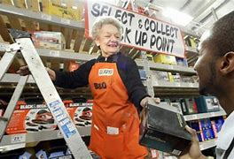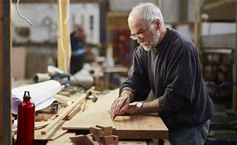
Elderly the Hidden Workforce
The concept of ageing is not Universal concept. Being old does not necessary mean incapability. Now the technology and advance improvement in Medicine and Public Health have positively impacted the aging process. Also, increases the life expectancy. So, 81.52 years is the current life expectancy in the UK, rise 0.15% from 2020. Therefore, more and more old people still work contribute a lot to the economy formally and informally (Macrotrends, 2022).
According to a study conducted by the Royal Voluntary Services (2021), which is first to demonstrate the economic value of elderly. Taking together caring responsibilities and volunteering effort of people aged 65 and over, the tax payments, spending power, it estimates their contribution almost £40bn more to the UK economy than elderly receive in welfare, in state pensions and health services (the Guardian, 2011).
Also, according to Office for National Statistics, Data from Census 2021; exposes some facts which demonstrate the impact of old people on the UK workplace:
- 1st fact, part-time Self-employed workers have a tendency to be older than part-time employees in the UK.
- 2nd fact, the Economy might be depend on increasingly on Older worker by 2039.
- 3rd fact, the working world for people aged 65 and over is similar to those aged 16 to 64.
In 2013 elderly contribute £61 billion to the UK economy through informal volunteering, caring, and employment, to this report from Age UK. Corresponding to 4.6 per cent of gross value added and 6 times more than the money spent on social care by local authorities in England (AgeUK, 2014).

- Others arguments in the debate?

- Elderly resource for the new generations.
We cannot afford to take for granted the huge contribution older women and men are making to the care of family and friends. People aged 65 and over bring a huge contribution informally to the community wellbeing such as working in charities sectors, taking care of grandchildren (allow children parents to go to work), and disseminate their wisdom to the new generations.
For instance, ageing population loves sharing stories based on their own experiences. One story can change one whole life. According to a study from Exploring Your Mind, the wisdom of the elderly is infinite. Life’s full of nuances, things are not just black or white. This is something you realize when you pay attention to their stories (Exploring Your Mind, 2020).
For illustration, according to Laura Carstensen a Stanford Psychology Professor reported that the great benefit of connecting old people with the young generations through intergeneration relationship is to share skills such as Critical Thinking, problem solving and Social interaction, so these skills are key to succeed at school and work, and also enable people to contribute meaningfully to society ( Carstensen, 2016).
Creating the mentoring/teaching learning model lets elderly to be prompted and appreciate the life experiences challenges and the skills they learned from it in order to help serve as a guide to the coming generations.
Thus, the other group argued that with the growing of aging population causes a serious challenge in terms of taking in charge chronic illness, falls, long stay in hospitals. As a response to this growing view of seeing old people as a drain on society, beside of financial contribution of elderly to UK’s economy, we can also add that all is not about money. Build a society on values is better than money, as these values and wisdom provided by the elderly contribute to build a solid foundation for our new generations.
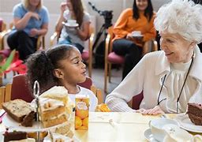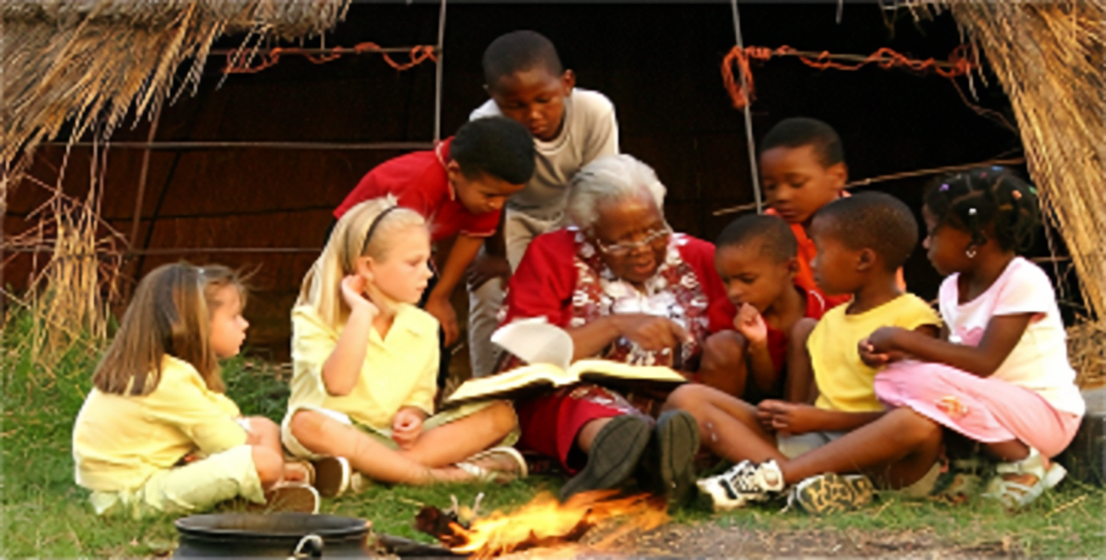
Intergeneration relationships

- What are the impacts of the pandemic Covid-19 on Older person?
The pandemic of Covid-19 has had a huge impact worldwide on every age group, mostly in terms of social connections and mental wellbeing. Though, we all know that the major concerns with elderly even before the pandemic are isolation, loneliness and treatment for the long-term conditions. Therefore, the advent of the pandemic with lockdowns affected significantly elderly lives, such as their daily routines, the support and care they receive, the lack of physical activities, the increase of mental illness, the lack of social connections with friends and family (WHO,2022).
Studies showed that the inequality in access and the use of technology had made elderly more affected than the younger generations (Van Jaarsveld, 2020).

- Recommendations
Promoting heath throughout lifecycle is paramount, as aging is part of life. It also can help elderly to improve their health and wellbeing. As a result, healthier aging may lower health expenditure and the possibility for elderly to make a longer and more valuable role in society.
Policy makers through organisations governmental or non-governmental in the United Kingdom must support service providers for elderly such as AgeUK, LinkAge Southwark, Alzheimer Association and others to empower elderly for active ageing, also to promote age-friendly cities, this could help to reduce the charge of Healthcare Systems.

Conclusion
Finally, Gold from Oldies: The UK’s elderly are a benefit for the Economy rather than a burden, they contribute billions to the United Kingdom’s Wealth. We must see them as an asset not a drain, their value contribution to society is underestimated, they constitute the hidden workforce in society.

References:

Brindle. D. (2011). Older people are an asset not a drain. Available at https://www.theguardian.com/ {Accessed 08-11-22}
Carstensen. L, and Parker. C (2016). Older people offer resources that children need. Available at https://www.news.stanford.edu/ {Accessed 14-11-22}
Explore Your Mind (2020). The wisdom of the Elderly. Available: https://www.exploringyourmind.com/ {Accessed 08-11-22}
Maheshwari. K. (2021). How do Older Adults contribute to society? Health Journal. Available at https://www.health-journal.karewise.com/ {Accessed 11-11-22}
Macrotrends (2022). U. K. Life Expectancy 1950-2022. Available at https://www.macrotrends.net/ {Accessed 08-11-22}
Methodist Homes (2022). How many older people are there in the UK? Available: https://wwwmha.org.uk/ {Accessed 07-11-22}
Office for National Statistics (2016). Five facts about older people at work. Available: https://www.ons.gov.uk/ {Accessed 13-11-22}
Van Jaarsveld. M. (2020). The Effects of Covid-19 among the Elderly population: A case for closing the Digital divide. Frontiers In Psychiatry. Volume: 11. Issue: 577427.
World Health Organisation (2022). Older people and Covid-19. Available: https://www.who.int/ {Accessed 21-11-22}

