

UNIVERSITY OF WALES TRINITY SAINT DAVID

MODULE : COMMUNITY ENGAGEMENT
MODULE CODE : SBUS4102
ASSIGNMENT : 1
NAME : NAGMA S. VAHORA (1604520)
TUTOR NAME : MUSHFIQUR RAHMAN

RESEARCH AND REPORT ON BURGER KING

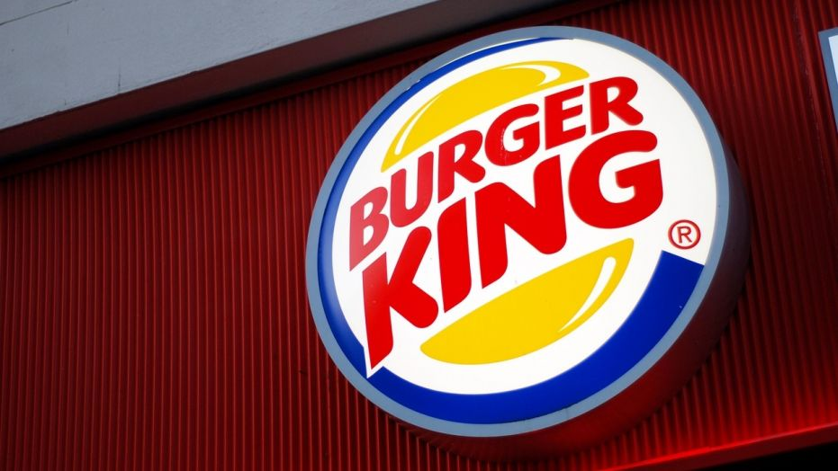

Introduction
In this task the researcher selected fast food industry and the selected organization is Burger king, this company is included in this task because the researcher has some working experience in this organization. The company’s mission statement is to offer reasonably priced quality food, served quickly, in attractive, clean surroundings. The company pays more than enough attention on these attributes, rational prices, high quality food, faster service and clean surroundings. Whereas the vision statement of the company is to be the most profitable QSR business, through a strong franchise system and great people, serving the best burgers in the world? The company considers four main areas in its vision statement such as most profitable QSR business, franchise system, great people and best burgers in the world. Because in this assignment the researcher worked in a burger king franchise in London, that is why she presented organizational structure of the company in that franchisee. Diagram 1
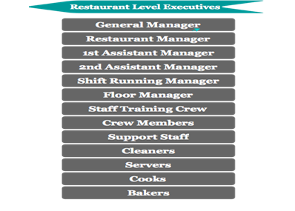
Main customers of the company are fast food lovers, they usually have age range from 9 years to thirty five years, the burger of the company is equally famous in kids, youths, adults, customers of the company expect quality burger in cheaper prices as compare to other fast food restaurants like McDonalds, KFC and Subway, and also customers of the company expect faster delivery of products both at the restaurant and also through delivery staff (if ordered online).
In this section the researcher of the task presented SWOT and PESTLE analysis of the case organization, having detailed understanding about these two areas is essential for designing and modifying corporate strategy with the purpose of attaining set targets in as efficient style as possible.
Discussion
SWOT analysis of Burger Kind
Table 1
Strengths  - A famous fast food brand  - Strong financial position  - High market penetration  - reasonable differentiation of products  - Present of huge loyal workers | Weaknesses  - Easily imitable business  - Limited product mix  - Limited options of food  - Lower control on franchise model
Opportunities  - The company can increase its kinds of burgers for attracting more a more customers. . . . . .  - Diversification/product mix widening  - Market development  - Service quality can be improved  - Special discount on buying more burgers | Threats  - Rising level of competition due to opening of more and more fast food restaurants  - Risks of economic down turn (recession)  - Change in eating habits  - Healthy lifestyles trend: Rising level of awareness in people about negative effect so fast food.
Pestle Analysis: PESTLE stands for (political, economical, social, Technologic; m legal and environmental factors),

Diagram 2
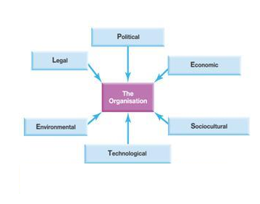
All these factors are directly connected with growth and development of the company. From political perspective the UK market is in stable condition, Burger King Type companies are forced for reducing obesity, and also to reduce level of salt in burger with the purpose of securing interest of customers from heart related diseases (Mathew & Sheldon, 2011). Fast food restaurants like burger king are also demanded by the government to provide full details such as sugar levels, calorie content, saturated and unsaturated fat levels to their customers. From economic perspective UK can said to be in critical situations especially after BREXIT (Schein, 2017). BREXIT decision increased level of inflation three in 2017 and it is expected to go up nearly five percent in 2018, all these signs are showing that several fast food customers may switch to home cooked food, and also rising level of interest rate and relatively decreasing buying power of fast food customers may influenced sales of Burger King. From social factors perspective main points are changes in eating habits of customers, because level of awareness in fast food customers has started increase about side effects of junk food on their health, and rising trend of eating out in fine dining restaurants due to cost reduction of such restaurants in UK. Technological advancement also implements effects on the company, rising level of advancement in IT made companies to be present online, this also made customers to go online, search, and compare prices and products of different burger providing organizations like Burger King. And environmental factors include inclusion of CSR in corporate strategy of the company, this terms demands companies like Burger King to secure interest of their stakeholders by fulfilling their ethical obligations, paying attention on this area demands relatively enough resources and time of management initially , but benefits companies a lot after while. . . . . . . . . . . . . . . . . . . . . . . . . . . . . . . . . . . . . . . . . . . . . . . . . . . . . . . . . . . . . . . . . . . . . . . . . . . . . . . . . . . . . . . . . . . . . . . . . . . . . . . . . . . . . . . . . . . . . . . . . . . . . . . . . . . . . . . . . . . . . . . . . . . . . . . . . . . . . . . . . . . . . . . . . . . . . . . . .
Analysis
There is no doubt that presence of skilled, talented and committed workforce is essential not only for survival of the company but also for attaining leading position over rival, the company can said to be in good position in terms of having loyal , talented and capable workers which is essential for attaining short and long term goals, capable and talented employees of the restaurant play a vital role in serving the customers in as efficient way as possible, the company has adopted policy of serving the customers in professional manner without any kind of discrimination, and also excellent services being provided by the staff of the restaurant made customer to revisit the restaurant again and again .
Training & development: According to Nasyira M &Ghazali H. (2014) in fact employees training and development can said to be a wider term that covers numerous types of personnel learning in a working environment. in the view of Kar &Misra (2013) training cab be defined like a precise program which supports workers learning definite knowledge or skills with the purpose of improving performance in their current roles. Whereas by Dirani (2012) development is more expansive and pays attention on worker’s level of growth and prospect performance, rather than an instant job role. It is quite probable to state that good training and development programs supports companies like Burger King in retaining the most suitable and committed employees and increase degree of profitability. Rising level of competition in companies in almost every business segment made organizations to pay more than enough attention on training and development related perspectives, because process to hire new workers is more expensive then keeping existing ones loyal. In the view of Lahoti (2014) effective training programs offer major opportunities for expanding the knowledge base of personnel in companies. A variety of scholars such as Ralph & Birks (2014) identified quite a few reasons which make training and development an important area in companies such as effective training and development programs supports a lot in addressing weaknesses of workers in the working place, training programs permit companies like Burger King for strengthening those skills which every workers needs to enhance , a development program has capability of bringing every single workers to a higher level so they all have similar skills and knowledge. Whereas by Hong & Kumar (2012) a worker who gets the crucial training is superb capable for performing his or her job, it also enhances his or her level of awareness about safety practices and proper procedures in their organization. according to Wang (2012) in present dynamic business it is essential for companies to assure that level of motivation, commitment and loyalty of their employees is higher, and all these factors can be attained in presence of higher degree of confidence, and this confidence can be produce in employees through increasing their skills to perform their assignment task in as efficient way as possible and role of training is hard to dent in increasing level of skills and capabilities of employees. . . . . . . . . . . . . . . . . . . . . . . . . . . . . . . . . . . . . . . . . . . . . . . . . . . . . . . . . . . . . . . . . . . . . . . . . . . . . . . . . . . . . . . . . . . . . . . . . . . . . . . . . . . . . . . . . . . . . . . . . . . . . . . . . . . . . . . . . . . . . . . . . . . . . . . . . . . . . . . . . . . . . . . . . . . . . . . . .
Selected role: Till operator (Cashier)
Every role in the organization is crucial and success of the company is heavily rely on capability’s of employees to perform their role in as efficient way as possible, in this task I selected role of Till operator which is also known as Cashier in the company, the chosen Burger king restaurant is the franchisee and the restaurant made some changes in the organizational structure with the purpose of saving the customers in as professional way as possible, though concept of cashier in bank is different as compared to this role in the selected organization (burger king ), usually cashiers in the company are the first individuals who have first and direct interaction with customers of the burger king who come to the restaurant for having burger(s), cashiers in the selected burger kind franchisee are responsible of taking order and collecting cash before delivery of burger , the company uses an electronic cash machine that opens with special pin code and only cashiers known that code. Process to perform duty of the cashiers demands presence of precise knowledge and some essential skills in cashiers in order to perform their responsibilities effectively , some essential skills to perform this role are (Active Listening, pay full attention on demand and order of customers, talking softly and professionally with customers, service orientation skills, capable of calculating prices of products altogether, social perceptiveness, critical thinker – utilizing reason in order to recognize the strengths and weaknesses of alternative solutions, faster Judgment and decision making to tackle any uncertain situation , persuasion and coordination .
Whereas essential knowledge with the purpose of becoming an effective cashier in the restaurant are customer & personal service (must known standards and processes to provide customer and personal services, it takes in customer needs evaluation, meeting quality standards for services, and assessment of customer satisfaction , knowledge of multiple cultures and habits of people, capability to speak multiple language, according to Mannay (2013) a key attribute of a structured training and development program is ensuring that workers posses a reliable experience and background knowledge, the consistency is chiefly relevant for the organization 's fundamental policies and procedures, effective training and development programs boost level of awareness of employees regarding expectations of their organization from them and also such programs increase level of awareness of employees in learning culture perspectives of other employees and this also make them more capable to serve their customers in as efficient way as possible. Process to design effective training and development programs demand companies like Burger King to take into account current situations of their employees, management must know what factors motivate their co workers and what kind of skills they need with the purpose of performing their job in sophisticated style. . . . . . . . . . . . . . . . . . . . . . . . . . . . . . . . . . . . . . . . . . . . . . . . . . . . . . . . . . . . . . . . . . . . . . . . . . . . . . . . . . . . . . . . . . . . . . . . . . . . . . . . . . . . . . . . . . . . . . . . . . . . . . . . . . . . . . . . . . . . . . . . . . . . . . . . . . . . . . . . . . . . . . . . . . . . . . . . .
Conclusions:
In fact success of the company depends upon a variety of factors including presence of talented, committed and motivated workforce with the purpose of serving the customers in as efficient and professional way as possible, the company has much better code of conduct and also tried to link its procedures and functions with corporate strategy with the purpose of attaining set targets both from customers satisfaction and staff retention perspectives, the company has also designed and implemented much better training and development programs and these programs also made the company capable to sustain its position in competitive fast food industry in UK where McDonalds, subway and KFC are in much stable position, though the company (Burger King) still needs to do a lot in terms of enhancing its procuress and policies with the purpose of increasing level of knowledge and skills of its employees in order to serve the customers in as efficient way as possible, in fact the researcher of this task could not find element of empowerment and job rotations in training and development programs of the company, these areas are least discussed in their training related perspectives, in present dynamic business situation these area need more than enough attend managers. . . . . . . . . . . . . . . . . . . . . . . . . . . . . . . . . .. . . . . . . . . . . . . . . . . . .

References

- Ashar M &Munir, E (2013). The impact of perceptions of training on employee commitment and turnover intention: Evidence from Pakistan. International Journal of Human Resource Studies, 3(1), 74.
- Dirani K. (2012). Professional training as a strategy for staff development: A study in training transfer in the Lebanese context. European Journal of Training and Development, 36(2/3)
- Hong E & Kumar R. (2012). An effectiveness of human resource management practices on employee retention in institute of higher learning: A regression analysis. International Journal of Business Research and Management, 3(2), 60-79.
- Joarder M &Ahmmed K. (2011). Mediating role of affective commitment in HRM practices
- Kar S &Misra C. (2013). Nexus between Work Life Balance Practices and Employee Retention–The Mediating Effect of a Supportive Culture. Asian Social Science, 9(11), 63.
- Khalid M & Rehman S (2014), “HRM Practices and Employee Performance in Public Sector Organizations in Pakistan: An Empirical study” “International Journal of Management Sciences and Business Research”. Vol 3
- Lahoti H (2014)– “Role, Scope & challenges of HR in retail sector” Role, Scope & challenges of HR in retail sector” Indian Journal of Applied Research Vol 4,isue 8 ISSN -2249-research methods5X
- Mannay D. (2013). ‘Who put that on there... why why why?’ Power games and participatory techniquestionnaire of visual data production. Visual Studies, 28 (2), pp.136-146 Mannay, D. 2013. ‘Who put that on there... why why why?’ Power games and participatory techniquestionnaire of visual data production. Visual Studies, 28 (2), pp.136-146 Jump up
- Mathew S & Sheldon P (2011). Toward an understanding of achievement-related conflicts in women.
- Mehmood Z & Arif M. (2011). Leadership and HRM: Evaluating new leadership styles for effective human resource management. International Journal of Business and Social Science,
- Nasyira M &Ghazali H. (2014). Predictors of intention to stay for employees of casual dining restaurant in Klang Valley area. International Food Research Journal, 21(3).
- Ralph, N & Birks M (2014). "Contextual Positioning: Using Documents as Extant Data in Grounded Theory Research". SAGE Open 4 (3). Doi: 10.1177/2158244014552425.
- Saladana J (2012). The coding manual for qualitative researchers. Sage. ISBN 1446247376.
- Salleh R &Harun H. (2012). Job Satisfaction, Organizational Commitment, and Turnover
- Schein H. (2017) Organizational Culture and Leadership West Sussex : John Wiley & Sons
- Wang Y. (2012). Recruitment and Retention of Knowledge Workers in Taiwan’s High Technology Industry. Doctoral dissertation, Section of Cardiff Business School, Cardiff University.

