
DIGITAL SURVEYING
Kai Llewelyn - 2408796


- Contents

- Introduction
2a. Overview Of Building Surveying.
2b. Digital Technologies Role Within Surveying.
2c. Assignment Purpose & What It Aims To Achieve.

- Surveying Scope & Objectives
3a. Building Survey Objectives
3b. Scope Of Survey, Building Type. Location & Key Areas.

- Digital Tools & Technologies
4a. Technology / Tools Selection.
4b. Justification Of Each Selection.

- Planning The Surveys
5a. Plan For Conducting The Survey.
5b. Methodology.

- Challenges & Solutions
6a. Potential Problems / Issues.
6b. Solutions / Mitigation Of The Issues.

- Conclusion & Recommendations
7a. Summary.

- References.

2. Introduction.
2a. The Importance Of Building Surveys.
Building surveys are extremely important as they are used to identify and defects or concerns that may be present on the building. These problems can be identified, and a maintenance plan can be put in place in order to make good of the existing. These surveys are extremely accurate, and therefore a budget cost can be identified following completion of the survey.
Building Surveys can also identify the materials used within the framework and external layers of the buildings. Building surveys also outline whether there is need for any further specific surveys or investigations.

2b. The Role Of Digital Technologies Within Building Surveying.
As time progresses, similarly to lots of methods within the construction industry, digital tools and technologies are being heavily relied on. These tools are advancing day-by-day, becoming more efficient and self-explanatory to use.
Many tools like theodolites and total stations are used by the surveyors when carrying out heir surveys. These are expensive pieces of equipment therefore the users must be training and competent in handling the equipment.
Traditional surveying techniques are only used in instances where they must be, for example the digital tools are unable to be used due to space etc.
Using the digital tools, it ensures the chances of human error is minimalised, while speeding up the process also.
Text 1 (Programme, 2023)
2c. Assignment Purpose.
In this assignment I will be identifying the benefits of building surveying, using the relevant and up-to-date digital tools.
I will be identifying the scope of the survey to be carried out on the Dylan Thomas Centre, outlining the requirements of care and precision due to the building being Grade II listed.

3. Surveying Scope & Objectives.
3a. Building Survey Objectives.
Due to the age and historical value of the property, this survey is required in order to assess the property’s condition structurally. Upon a quick site visit, there are a number of minor defects to the outer shell of the building and therefore the scope and severity of these issues needs to be outlined.
Following identification and surveying of these defects, such as cracks etc. A plan will need to be put in place in order to permanently amend and make good, preventing the problems from worsening and worst-case causing collapse.
The identification and in detail survey of these defects will ensure the buildings safety, as the building is still in use. This is extremely important in relation to all Health and Safety acts throughout Wales and the United Kingdom.
Similarly to Health and Safety, there are numerous building regulations that must be met for all buildings, and a detailed survey will ensure that the building complies and is in line with all up-to-date regulations.
Text 2 (Trowler, 2022)
3b. Building Information.
The Dylan Thomas Centre is a cultural and literary venue located in Swansea’s Maritime Quarter at Somerset Place. Housed in the former Guildhall, the neo-classical building was originally constructed between 1825 and 1829 and is now Grade II* listed. Renovated in 1995, it features exhibitions on Dylan Thomas, hosts literary events, and is home to the annual Dylan Thomas Festival.

4. Digital Tools & Technologies.
4a&4b. Tools & Technologies Selections & Justifications.
There are a number of both digital tools and technological surveying tools used throughout the construction industry in the UK:
There are hundreds of digital tools such as Revit and SketchUp, these tools are used to create a Building Information Model (BIM), which is a 3D building replica digital model of the building, scaled to size on your computer or device.
It enables surveyors to collect accurate information about the materials, systems, and structure of the building. The program facilitates teamwork, which makes it simpler for different project stakeholders to handle and exchange data.
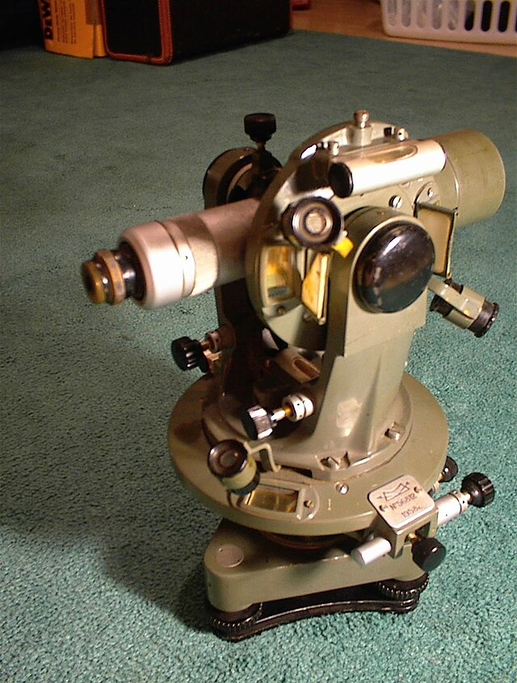
Similarly, there is lots of surveying equipment used throughout the industry, such as Total Station, Laser Scanners, Digital Levels, GPS Receivers, Vibration, Sound & Tilting Monitors. The list could go on forever, however in this instance, I feel the most beneficial for the Dylan Thomas Centre are:
Due to the building not being that big, I believe a total station isn’t required and a theodolite will be most sufficient. A theodolite is a precise laser tool used to measure angles both vertically and horizontally. Surveyors can measure angles precisely, frequently to seconds of an arc, using this device, which is made up of a revolving telescope fixed on a base.
Figure 1 (Paiva, 2015)
Both manual and digital theodolites are available; more recent models come with digital readouts for convenience. They are frequently employed in topographical surveys and jobs like setting out, where exact alignment of buildings or structures is crucial. High accuracy, adaptability, and affordability are the key advantages.
Theodolites provide accuracy and dependability in a variety of construction and building surveying tasks, making them a vital instrument for basic angle measurement and alignment.
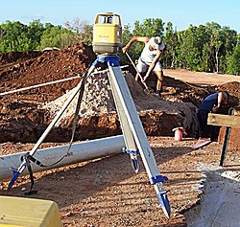
I also believe a 3D Laser Scanner will be extremely beneficial as A 3D laser level is a surveying tool that projects a laser beam in multiple planes, creating a three-dimensional reference grid for precise alignment and levelling. It is commonly used for tasks like building alignment, setting out construction projects, and ensuring horizontal and vertical accuracy. The laser emits lines or points in 360 degrees, allowing for comprehensive measurements across a large area.
Benefits include high accuracy, efficiency, and the ability to cover large spaces without repositioning the device. It simplifies tasks like checking plumb and level across complex surfaces, enhancing productivity and reducing errors during construction.
Figure 2 (Blake, 2013)
A 3D laser level is beneficial for identifying cracks in a building by providing precise, real-time measurements of surfaces, helping to detect any displacement or misalignment caused by crack expansion over time.
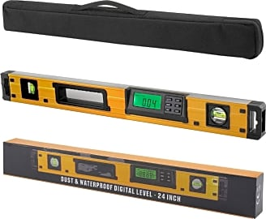
Also, a digital level, which compared to traditional spirit levels, a digital level is a more sophisticated surveying tool that can measure height differences and create specific elevations with more accuracy. It provides quick, accurate measurements using electronic sensors and a digital display; it is frequently used in conjunction with a barcode staff to calculate height automatically. Because of their precision, usability, and capacity to record data, digital levels are frequently utilized in building surveying and construction.
Digital levels are very helpful for inspecting building fractures since they can identify vertical displacement, subsidence, or uneven settlement surrounding the damaged location. Surveyors can assess structural risk and direct necessary repairs or monitoring efforts by routinely monitoring these elevation changes and determining if a crack is stable or getting worse.
Figure 3 (Rennie, 2018)
These tools are essential to building surveying because they enable surveyors to deliver precise measurements, assessments, and solutions for building inspections and construction projects. Due to the previous identification of cracks to the building, all of the previous tools and techniques will be extremely effective in ensuring these defects are solved and made safe.
Text 3 (Toolbox, 2001)
5. Survey Planning.
5a. Plan For Carrying Out The Survey & Methodology.
Having already outlined numerous issues, such as, the cracks to the external face of the entrance elevation and slight subsidence with the brickwork. It is important we have a step-by-step methodology in order to carry out the survey, in a safe and professional manner:
To begin, an initial site inspection would need to take place. Both the external faces and internal, look for all possible defects that can be seen by the human eye, and record their location, size and danger level.
Make sure to photograph all defects or potential future defects before the survey takes place, just in case they worsen as the survey is being carried out. Keeping a track record of the scale of each defect is extremely important, especially when trying to be as safe as possible.
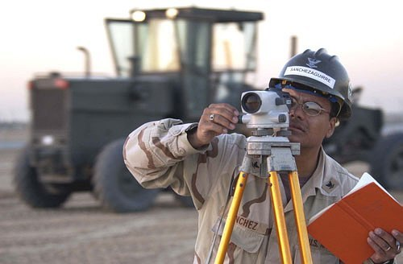
Once photographed, ensure all defects are measures, whether they are cracks, subsidence or even efflorescence of sulphur on the brick / blockwork. Anything that could deprive over time will need to be recorded.
Once happy, ensure crack and movement monitors are places around the area which is being surveyed, to ensure there is no further movement during the survey being done.
Figure 4 (J, 2000)
Finally, determine the reason behind the fractures or subsidence by analysing all the data gathered, then create a thorough report with suggestions for maintenance, repair, or additional research (such as a structural engineer evaluation or ground investigation).
By using advanced technology, some equipment can automatically produce this report for you, therefore speeding up the process and increasing efficiency.
Text 4 (Trowler, 2022)

6. Challenges & Solutions.
6a&6b. Challenges That May Become Present & How To Overcome Each Challenge.
Limited access to the roof of the Dylan Thomas Centre, therefore the use of drones to check for initial signs of any defects would be needed. If sighted, either scaffolding or fixed ladders would need to be implemented to ensure safety.
Due to the Centre also being currently occupied, if the survey was carried out in the day, users could get in the way and prevent accurate results. Therefore, the surveys would need to be scheduled around the opening times, e.g. late at night or early in the morning before they open.
Having already identified cracks, the severity of these cracks will be unknown, the cracks could be active and prone to increase in both length and width. Therefore, crack and tilt monitors will be required to ensure no further worsening becomes present during or as a result of the survey.
Due to the wet weather in Swansea, where the Dylan Thomas Centre is located, any external surveys will need to be planned in advance around the wet weather, to ensure no stops are needed and the survey can flow accordingly. Also, preventing unreliable results.

7. Summary.
To conclude, the Dylan Thomas Centre is an extremely historical and old building, that preserves a lot of Swansea’s Heritage. It is vitally important the building survey is carried out with the upmost of precision and care, ensuring the defects are limited to their current state.
Early identification of the problems will turn out to be crucial, as some cracks are fairly large. Upon completion of the report post survey, the maintenance works will need to take place very soon after to prevent worsening and in the worst case, collapse.
The use of a Theodolite, Digital Level and 3D Scanner will collate accurate information, providing they all run smoothly and are carried out by professionals. Following this, the production of a Revit model may need to take place and be reviewed by a Structural engineer, in case any temporary works are required to hold the wall in place while works take place on it.

- References

Bibliography
Blake, L. S. (2013, 10 22). Laser Level. Retrieved 07 15, 2025, from Wikipedia: https://en.wikipedia.org/wiki/Laser_level
J, K. (2000, 01 01). Surveying . Retrieved 07 15, 2025, from Wikipedia: https://simple.wikipedia.org/wiki/Surveying
Paiva, J. V. (2015, 10 20). Theodolite. Retrieved 07 15, 2025, from Wikipedia: https://en.wikipedia.org/wiki/Theodolite
Programme, T. P. (2023, 08 31). What impact will artificial intelligence have on building surveying? Retrieved 07 14, 2025, from RICS: https://www.rics.org/news-insights/what-impact-will-artificial-intelligence-have-on-building-surveying
Rennie, A. (2018, 02 18). Wiki Ezvid. Retrieved 07 15, 2025, from The 10 Best Digital Levels: https://wiki.ezvid.com/best-digital-levels#gsc.tab=0
Toolbox, E. (2001, 01 01). Retrieved 07 15, 2025, from Engineering Toolbox : https://www.engineeringtoolbox.com/
Trowler, J. (2022, 11 28). Building Survey. Retrieved 07 14, 2025, from Designing Buildings: https://www.designingbuildings.co.uk/wiki/Building_survey

