

Module: - LCLM 5001 Understanding and Engaging Stakeholders

Academic report of using stakeholder engagement mechanisms.

BA (Hons) Leadership and Management Skills for the Workplace

Student Name: Maryna Zhzhonykh

Student Number: 2411439

Lecturer’s Name: Dr Eric Osei

Ex Summary
This report explores Huma's interactions with stakeholders before a new wearable health monitoring gadget enters the market. With the help of strategic tools (SWOT, PESTEL, stakeholder matrix), the influence of different groups on operational efficiency, innovative potential and compliance with the company's ethical norms is analysed.
The analysis identifies key stakeholder groups—clinicians, patients, regulators, investors, and internal departments—and assesses their roles, interests, and impact. The stakeholder engagement process, despite increased product confidence and regulatory preparedness, has also revealed a key challenge: a significant divergence in priorities in the transatlantic business landscape. European stakeholders insist on rigorous ethical standards and data protection, while their American counterparts prioritize accelerated expansion and profitability. This opposition raises a number of problems, such as: uneven distribution of influence, conflicting interests, emotional exhaustion of employees and differences in the long-term goals of the company.
Ethical and flexible management of stakeholders can be based on the relationship proximity model (Ashcroft et al., 2017) and collaborative creativity methods (Lindgreen et al., 2019). The report argues for the integration of interaction with influence groups into strategic planning — not as a formal requirement, but through resource investment, ethics training, and goal alignment. Such a strategy turns interaction with stakeholders into a key factor of competitiveness.
The report emphasizes that effective interaction with stakeholders should be adaptive, based on ethical principles and be an integral part of the strategy to ensure stable innovation. For Huma, technological excellence is only one component of success; equally important is the ability to build human relationships under different cultural and regulatory requirements.

Table of Contents
Introduction to Huma and product overview – wearable health device 3
HUMA SWOT analysis, PESTLE with SMART objectives 4
SWOT 4
✓ Strengths 4
✓ Weaknesses 4
✓ Opportunities 4
✓ Threats 4
SWOT Analysis Table 5
PESTEL analysis 5
PESTEL Table. 6
HUMA SMART objectives 6
Identifying key HUMA internal and external stakeholders 6
Stakeholder identification 7
Identified stakeholders list 7
The Stakeholders map. 7
The roles, responsibilities, benefits, and challenges of key HUMA stakeholders 8
The roles and responsibilities of key stakeholder 8
Benefits 9
Challenges 9
HUMA engaging stakeholders: frameworks, models, and tools 10
HUMA Stakeholder Matrix 10
HUMA Stakeholder Engagement Plan 11
HUMA Communication Plan 12
HUMA RACI Matrix 13
Stakeholder engagement and conflict resolution in Huma’s launch. 14
Strategic stakeholder engagement: mapping, prioritising, and evaluating 14
Role and responsibilities of the Project Manager. Manage conflict 4C’s model. 15
The impact of stakeholders’ engagement on HUMA business performance and recommendations for future practice. 16
Impact of stakeholders’ engagement on HUMA business performance 16
Recommendations for future practice 17
Conclusion 18
Reference: 20

Introduction to Huma and product overview – wearable health device
The British company Huma specializes in the development of digital solutions for health care aimed at remote monitoring of patients and optimization of diagnosis and treatment. The company's technology enables virtual hospitals, home «hospital models, and certified software that is a medical device (SaMD) that serves Huma 's goal of helping people live longer and better (Huma, 2024). In order to improve a personalized approach to health and expand its own digital infrastructure, Huma is preparing to enter the market with a wearable device for tracking heart rate, oxygen saturation and sleep patterns.
This wearable device monitors key health indicators — pulse, blood oxygenation and sleep — for early detection of disorders and personalized recommendations. By integrating with the Huma platform, the device develops the company's digital infrastructure and works to achieve its main goal of — increasing healthy life expectancy. This system provides patients with the ability to effectively manage their condition and contact doctors instantly, which promotes the development of preventive medicine and expands the possibilities of long-distance diagnosis. The equipment provides continuous monitoring of key indicators, automatic synchronization of information in cloud storage and generates intelligent notifications about dangerous abnormalities, in particular heart rhythm disorders or sleep apnoea.

HUMA SWOT analysis, PESTLE with SMART objectives
A SWOT analysis validated by the study (Namugenyi et al, 2019) identifies key innovation factors for Huma by structuring the strengths, risks and alignment of stakeholders for a successful launch.

SWOT
As a UK digital health company, Huma's new vital signs monitor requires strategic planning. A SWOT analysis effectively evaluates its internal capabilities and external market dynamics to inform strategy (Belton and Stewart, 2002).

Strengths
Huma's market position is strengthened by already available resources: professional knowledge in the field of telemedicine, cooperation with NHS and pharmaceutical corporations, experienced specialists and a stable digital platform. This creates a solid foundation for launching a new portable device (NHSX and Kent Surrey Sussex AHSN, 2020). (See figure 1).

Weaknesses
Huma faces several challenges: investor pressure requires quick commercial returns, integration with existing medical systems is resource-intensive, and scaling services makes quality control and regulatory compliance difficult (UK Tech Investment News, 2024; Office for Life Sciences, 2024). (See figure 1).

Opportunities
Personalized telemedicine is showing growing demand (Khan and Duncan, 2025), and Huma's $80 million funding (Prosser, 2024) is scaling artificial intelligence for digital health care. (See figure 1).

Threats
Despite market prospects, Huma faces serious challenges: strong competition, regulatory uncertainty and privacy risks. Jawad (2024) estimates that this could result in delays, rising costs and loss of customer confidence. (See figure 1).

SWOT Analysis Table

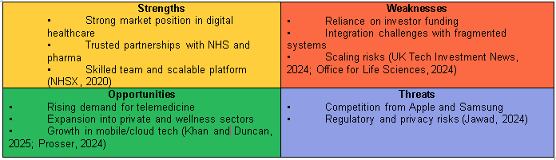
Figure 1: Summary of SWOT Analysis

PESTEL analysis
PESTEL analysis is a key strategic planning tool for digital health care, as it allows identifying external risks and reconciling stakeholder positions (Pan et al., 2018).
The macro environment for the development of the Huma wearable device is shaped by state programs of digitalization of medicine, demographic changes and regulatory requirements. According to NHS England (2023), the policy aims to stimulate innovation (NHS Plan), but at the same time strengthens controls on data protection. In the economic sphere, there is a contradiction: the market has the potential for growth, but financial instability can limit consumer demand. A powerful stimulus for telemedicine is the aging of Europe's population, which will reach 150 million people by 2050 (Eurostat, 2022). However, technological challenges such as cyber hazards (34% of all data breaches occur in healthcare) and mandatory legal requirements are key barriers (Verizon, 2023). The environmental aspect requires eco-hereditary solutions in response to 57.4 million tons of global electronic waste (UN Global E-waste Monitor, 2021). (See figure 2 ).

PESTEL Table.
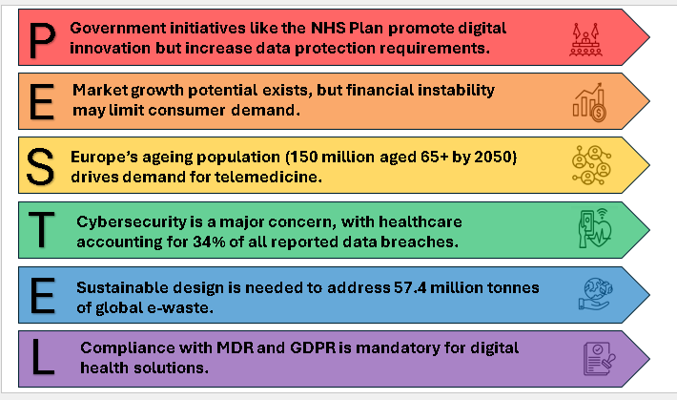
Figure 2. PESTEL Analysis

HUMA SMART objectives
The HUMA SMART objectives set by:
- To generate £2M in online sales in year one,
- reduce supply risk by securing a backup sensor supplier by Q4 2026,
- outperform rivals with 10% longer battery life, and
- deliver five top user-requested app features within one year.
A comprehensive assessment of Huma's strengths and weaknesses and the market situation creates a strategic foundation. This approach helps to avoid threats, find a common language with partners and launch the product in time thanks to a well-thought-out decision-making process.

Identifying key HUMA internal and external stakeholders
Cooper (2019) emphasizes that the conception and rollout of a new device involves a wide range of stakeholders, each with distinct roles, interests, and influence over the project’s success.

Stakeholder identification
Effective management of stakeholders in the Huma project on digital health care is based on systematic identification of key groups and analysis of their relationships with the initiative. The effectiveness of Huma is based on a framework that includes inter-departmental interaction (Huma, 2023b) and the implementation of anticipatory compliance (Huma, 2023a). Stratified stakeholder mapping (Huma, 2023c) serves as a prioritization tool consistent with the scientific concept of key impact determination through interdependence and participation parameters in project outcomes (Bourne and Walker, 2005). This methodology ensures optimization of communication flows and reduction of project uncertainties.

Identified stakeholders list
Stakeholder identification applies influence, legitimacy, and participation principles (Mitchell et al., 1997); using a map helps prioritise key groups and optimise communication for effective project engagement.

Internal Stakeholders
- Project Manager
- Executive Leadership
- Product and Engineering Department
- Regulatory and Clinical Affairs Department
- Marketing and Sales Department
- Legal, Compliance and Data Security
- Customer Support and Success
External Stakeholders
  - End-Users: Patients and Customers
  - Healthcare Professionals (HCPs)
  - Hospitals and Clinics
  - Government Agencies
  - Investors and Shareholders
  - Retail and Distribution Partners
  - Supply and Manufacturing Partners
  - Patient Advocacy Groups
  - Industry Media and Analysts

The Stakeholders map.
Huma's performance is based on organizational architecture that integrates cross-functional collaboration (Huma, 2023b) and proactive regulatory compliance (Huma, 2023a). A critical factor in the success of the project is the external environment formed by external stakeholders: end users, medical professionals, regulatory bodies and partners. Their interaction, implemented through financial flows, fulfilment of legal requirements and exchange of information, directly affects the public perception of the product, forming the third level of influence in the general structure. Below is the stakeholder map illustrating their relationships, proximity, and influence across Huma’s wearable device development and launch.
The application of structured methods of identification and visual mapping of stakeholders allows Huma to provide targeted interaction, which facilitates collective decision-making, minimizes resistance and guarantees the successful development and implementation of a wearable medical device. (See figure 3).
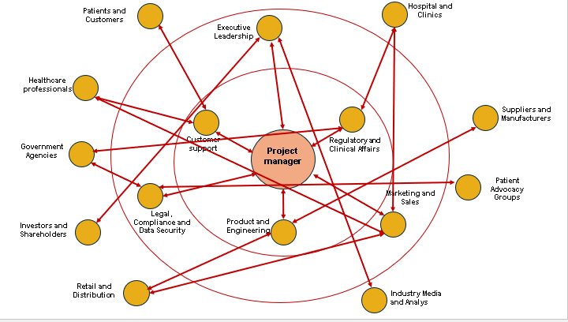
Figure 3. Stakeholders map.

The roles, responsibilities, benefits, and challenges of key HUMA stakeholders

Strategic management of stakeholders determines the success of the development of the Huma medical wearable device, because, according to Freeman's (1984) theory, these groups directly affect and depend on the results of the project. Differentiated roles, powers and levels of influence of each participant form a unique contribution to the product life cycle – from concept to commercial launch.

The roles and responsibilities of key stakeholder
Internal Stakeholders
At the centre of Huma’s product development, the Project Manager ensures the wearable device is delivered on time, within budget, and to specification. The first level of operational interaction brings together engineering teams responsible for hardware and software development, regulatory affairs that ensure compliance with standards, and a support service that deals with feedback and customer retention (Huma, 2023a). The second level of strategic management covers executive management responsible for financing and external relations, marketing departments with a commercialization strategy, as well as legal-compliance services that ensure intellectual property protection and data security (Jawad, 2024). These structural units are coordinated with the project manager to solve complex issues and maintain strategic integrity. Strategic coordination of these units with the project manager ensures the solution of complex tasks and maintenance of development integrity. The joint work of these departments allows you to turn the idea into a quality product that meets standards, withstands competition and inspires customer trust.
External Stakeholders
Feedback from end users (patients and health monitors) on usability is key to implementing the device (Huma, 2025). Medical personnel, for their part, certify the value of the device, participate in shaping its prescribing practices, and provide regulatory authorities with data on its safety and efficacy (Khan and Duncan, 2025). Hospitals can implement the device in remote patient monitoring programs, organizing cooperation between IT and procurement departments. Regulatory bodies grant market access by evaluating safety and efficacy. Investors fund development and expect ROI. Stores and sales partners ensure the device is affordable for consumers, and component manufacturers work closely with engineers on technical specifications. Patient organisations represent user interests and raise product awareness, while scientific centres conduct clinical studies to confirm efficacy. mass media and experts, in turn, shape public opinion and the level of trust in technology.

Benefits
The development of the Huma medical device depends on the joint efforts of all involved: engineering and regulatory teams ensure quality and safety, management - funding, doctors and patients - medical value, and manufacturers - stable production of the product. Each stage of the product life cycle — from development to implementation — depends on the collective contribution of all participants. Patient organizations raise awareness and shape policies, building trust. Academic partners provide clinical evidence and media — public visibility. All of them together provide the key resources, expertise and support needed to succeed.

Challenges
In the Huma project, conflicts may arise between different groups, which affects joint work. As noted by Ashcroft et al. (2017), different expectations often lead to a loss of trust and make decision-making difficult. As noted by Rajhans (2018), the difference in — priorities, such as technical improvement in engineers and financial results in — management, is exacerbated by ineffective communication, especially when clinical needs conflict with commercial deadlines. Such contradictions arising from different value systems and motivations need to be resolved through open dialogue to preserve product integrity and develop ethical and sustainable innovations in the field of digital health care.

HUMA engaging stakeholders: frameworks, models, and tools

The importance of a structured development methodology Ashcroft et al. (2017) prove that participatory matrices and coordination strategies ensure coherence of actions and ethical collaboration at all steps of the product life cycle.

HUMA Stakeholder Matrix
As Mendelow (1991) outlines in his constituency theory, organisations can tailor involvement by participants across the industry landscape according to their power and interest. In Huma’s case, those with high power and high interest—such as regulators, executives, financiers, and the project manager—require active collaboration. Lindgreen et al. (2019) argue that interaction between parties builds trust and promotes moral innovation in health care. As a result, doctors, marketers and patients benefit from open contact, while regular users and media with little reach are regulated to protect public trust and a positive image. (See Figure 4).
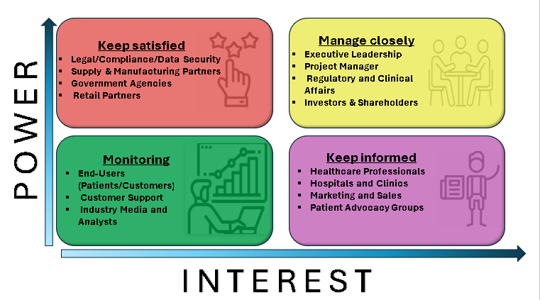
Figure 4. Stakeholders Matrix.

HUMA Stakeholder Engagement Plan
The success of projects in complex, highly regulated industries directly depends on the presence of a strategic plan for stakeholder relations. This is confirmed by the research of Prebanić and Vukomanović (2023) in the infrastructure field, where such plans structuring the process of definition, prioritization and cooperation are crucial. Launching Huma in digital medicine requires a differentiated approach to key groups. Investors and government regulators receive focused reports, and doctors and patient organizations are involved in product testing and development. At all stages, this ensures the creation of honest and convenient technologies, as well as promotes openness and helps to prevents possible problems. (See Table 1).

Table 1. Stakeholder Engagement Plan
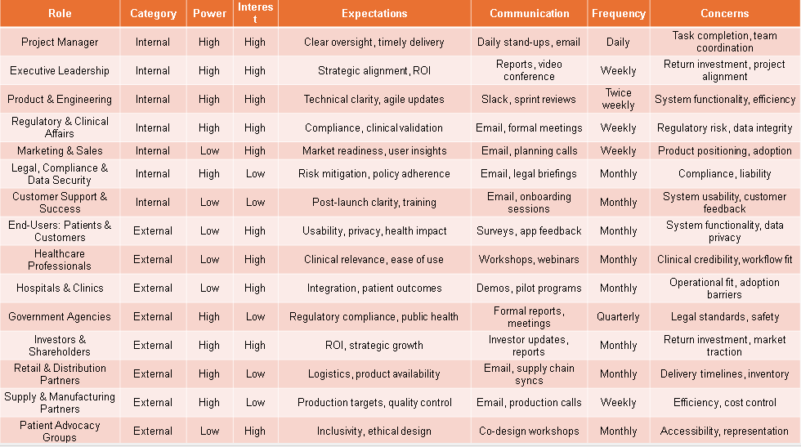

HUMA Communication Plan
The task of the communication plan is to structure details flows among all project participants to maintain mutual agreement, reliability and synchronization of actions. According to Rajhans (2018), coherent interaction is considered critical to preventing project disruptions and disagreements. As Ashcroft (2017) notes, constant personalized interaction forms sustainable connections that directly increases trust among stakeholders. For Huma, this plan supports ethical modernization by coordinating outreach with stakeholder power, interest, and role It includes structures, summaries, responsible potential buyers and a feedback system to ensure clarity and responsiveness throughout the product's life. (See Table 2).

Table 2. Communication Plan
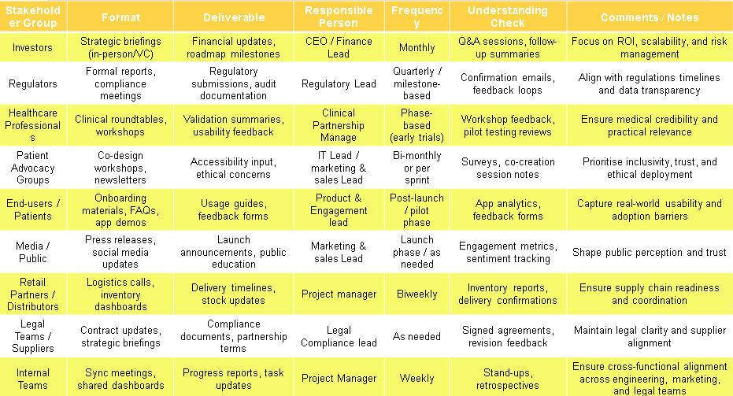

HUMA RACI Matrix
The RACI matrix allocates the roles of: executor, approver, participant of consultations and persons informed, ensuring clarity and consistency of actions between all project participants. To ensure structured interaction during the launch of Huma, this tool coordinates the work of internal departments with external partners on specific goals, including clinical verification, regulatory compliance and the co-design process. According to Ashcroft (2017), the value derived from stakeholder partnerships depends on the clarity of roles and the quality of communication. Lindgreen et al. (2019) add that transparent delineation of responsibilities is a prerequisite for conducting reliable business that meets the expectations of all stakeholders. By applying the RACI framework, Huma fosters ethical innovation, reduces ambiguity, and ensures that strategic decisions are executed with shared accountability. (See Table 3).

Table 3. RACI Matrix
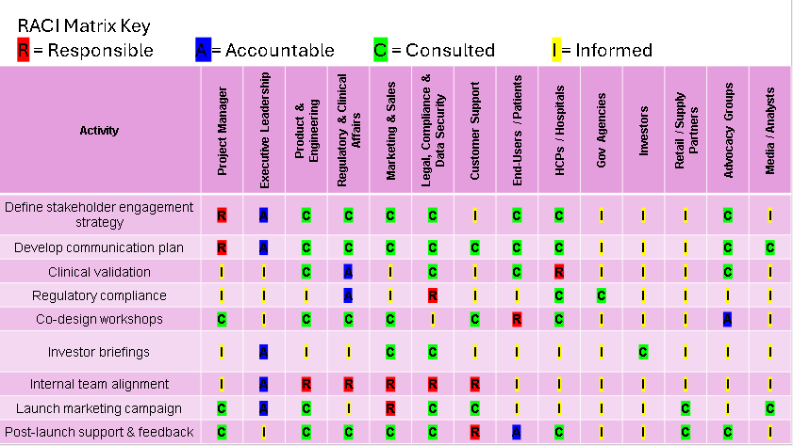
The implementation of Huma is based on a thorough approach to working via collaborative initiatives with participant groups drawing up matrices of their influence, forming a coordinating policy, implementing interaction programs and establishing the distribution allocation of duties based on the RACI method. Such a methodology provides a basis for openness, adherence to ethical norms and increased mutual trust between different units and groups. Inclusivity, technical compatibility and strategic compliance with stakeholders' expectations of the Huma digital solution in health care are founded on two key principles. If Ashcroft (2017) considers building close relationships a necessary condition for successful cooperation, then Lindgren et al. (2019) call transparency the main criterion of socially responsible business.

Stakeholder engagement and conflict resolution in Huma’s launch.

Strategic stakeholder engagement: mapping, prioritising, and evaluating
Stakeholder engagement in Huma’s wearable launch must be structured, ethical, and responsive. Stakeholder analysis is initiated using the Mendelow matrix (Mendelow, 1991), which makes it possible to rank them by level of impact and interest. To compensate for the disadvantage of the Mendelow matrix, which is manifested in the inability to flexibly manage interaction processes, its combination with the Belbin model is proposed (Belbin, 2010). This will allow taking into account changes in operational tasks and ethical aspects, since the static approach of the matrix is not sufficient for dynamic digital projects. This allows the manager to build communication taking into account both the position of influence and the peculiarities of work practices.
Despite RACI's effectiveness in assigning responsibilities, its rigid design can make adaptation in stressful environments difficult (Griffith and Dunham, 2015). In line with the approach of Quintanilla and Waal (2020), the solution is to combine this framework with flexible coordination that takes into account the expectations of all participants in the process.
Involvement should not be seen as an operational process, but as a form of relationship. Cameron (2013) notes that it is trust and the ability to interact that shape value for stakeholders. In the context of Huma, this is implemented through joint planning, iterative consultations and collective discussion of ethical aspects. The task of the manager is to integrate these approaches to achieve synergy that combines strategic orientations and the interests of all participants.

Role and responsibilities of the Project Manager. Manage conflict 4C’s model.
In managing stakeholder conflict during the launch of Huma’s wearable health device, the project manager must apply structured frameworks that support both operational clarity and relational trust. To manage group activities, in particular in distributed collectives, the 4C model can be used, which is based on four elements: communication, coordination, cooperation and collaboration (Ellis et al., 1991). Despite this, the use of this model in conditions of high responsibility with the participation of numerous stakeholders requires careful analysis and strategic adaptation.
In the view of Duck and McMahan (2021), effective communication should consider audiences and adhere to ethical norms. In contrast, the 4C model, focused only on clarity, ignores power disparities and emotional factors important for overcoming ambiguities. According to Shaw et al. (2009) it is inclusiveness and empathy that are key in such settings. The solution to this problem is to incorporate the principles of emotional intelligence and flexible approaches to message construction.
A clear definition of responsibilities through tools such as the RACI matrix helps align participants' actions with project goals but can increase hierarchy and reduce flexibility. The effectiveness of teamwork, as noted by Whelan (2009), directly depends on the stage of its formation and the consent of the participants to joint actions. That is why tools such as iterative techniques and public digital panels act as optimal solutions for organizing interaction (Griffith and Dunham, 2015).
The model organizes joint work well, but ignores hidden conflicts and informal connections. However, real cooperation is only possible if the restrictions are mutually respected and observed together.
The effectiveness of means such as anonymous feedback mechanisms to detect implicit tension (Shaw et al., 2009) remains low without providing psychological security, which Edmondson (1999) identifies as critical to collective learning and cooperation. The creation of an enabling environment is facilitated by the practices proposed by West (2012): cyclical change of presenters and conducting internal reviews of activities that reduce the benefits of influence and activate group responsibility.
Successful cooperation requires joint creation and collective responsibility, but this process often requires a lot of effort and can cause fatigue from constantly reaching an agreement. According to a study by Christopher et al. (2013), it is trusting and transparent relationships that form value for stakeholders. Simultaneously, Ellis et al. (1991) warn of the risk of collective projects ceasing in the absence of proper organization of interaction. The proposed Griffith and Dunham (2015) timelines during workshops help balance effectiveness and broad engagement.
The 4C model is evaluated as a fundamental but incomplete approach to conflict resolution. The analysis carried out integrates behavioural models, flexible tools and inclusive approaches to address existing gaps. The key priorities are the development of emotional intelligence, building trust and joint planning, where the manager acts as a facilitator, combining the structuring of approaches with emotional sensitivity to generate common value.

The impact of stakeholders’ engagement on HUMA business performance and recommendations for future practice.

Impact of stakeholders’ engagement on HUMA business performance
For Huma, which is developing a portable medical gadget for monitoring heart rhythm, blood oxygenation and sleep, effective interaction with all influential groups is a priority. This process, which according to Ashcroft et al. (2017) covers the identification, analysis and integration of those who influence or depend on a business project, is crucial for achieving ethical legitimacy, market relevance and commercial success of the product. Such involvement provides strategic certainty, regulatory harmonisation and opportunities for innovation. At the same time, it creates certain challenges: contradictions of interests, psychological exhaustion and uneven distribution of influence. This section analyses the impact of interaction with stakeholders on the effectiveness of Huma, and provides well-founded recommendations for further activities.
The inclusion of clinicians and patients during the design phase strengthened the legitimacy and market relevance of the Huma product (Hristov and Appolloni, 2022). The consequence was a conflict of interest: on the one hand, medical stakeholders demanded thorough testing, on the other - the business side preferred accelerated entry into the market. As evidenced by Ashcroft et al. (2017), such a disparity in interaction creates conditions for an uneven distribution of influence and a departure from the main strategic guidelines. The consequence of this inconvenience for Huma was delays in the execution of regulatory documents and a decrease in the efficiency of internal coordination. The need for structured management became apparent as the impact of involvement on innovation proved heterogeneous and needed to curb the dominance of powerful parties.
Conflicts of interest, where the same professionals are both developers and business owners, create ethical uncertainty as a separate problem. Habsa et al. (2022) note that uncontrolled conflicts of interest can undermine transparency and objectivity in decision-making. Huma's practice demonstrated that the lack of formalized risk control mechanisms led to distortion of results and unclear division of responsibility. An excessive amount of discussion led to mental exhaustion, which is consistent with a study by Haring et al. (2023) on the harmful health effects of over cooperation. Thus, the stakeholder engagement process requires clear ethical frameworks and structural limits to maintain effectiveness.
Adapting the strategy of working with stakeholders is a key factor for overcoming regulatory and cultural differences between the European and American markets. According to the data (Ashcroft et al, 2017), the contradiction between European information protection requirements and the American orientation towards expansion formed significant obstacles for Huma. That communication had to be adapted to regional conditions was a direct consequence of the risks that created the lack of a differentiated approach and the difficulty of combining operational efficiency with ethical principles –, namely the risks of moral violations and the breakdown of partnerships.

Recommendations for future practice
Proposed by Ashcroft et al. (2017), the Relational Proximity framework, which measures the quality of relationships through criteria of sustainability, parity and common benchmarks, could be a tool for Huma in identifying imbalances. This will allow for a context and relationship-based adjustment of the engagement strategy, optimizing interaction with impact groups and protecting operational effectiveness.
In the field of digital health, the blurring between innovation and financial interests poses a threat to public trust, so Huma must clearly separate expert functions from investment functions, particularly in clinical alliances. The Huma strategy must integrate two components: internal control mechanisms and external communication. According to Khabsa et al. (2022), the former include transparent declaration, ethics commissions, and stratification of stakeholders to address conflicts of interest. The second pillar, should take into account regional specificities: European partners expect to be involved in data management and protection, while American partners expect business flexibility and financial results. This two-pronged strategy calls for communication, policies and initiatives to be adapted to the regional context.
According to Lindgreen et al. (2019), the implementation of structured co-creation processes with clear time frames and feedback monitoring helps overcome psychological stress and complexity in decision-making. Thanks to the functionality of non-synchronous communication, open monitoring of decisions made and individual dashboards for stakeholders, modern digital platforms provide Huma with the opportunity to monitor the effectiveness of communication and quickly update approaches.
Integrating stakeholder work into strategic planning — not as a formal requirement, but through resource allocation, team training in relationship ethics, and the inclusion of appropriate criteria in KPI — will allow Huma to transform this process from a risk factor into a competitive advantage (Lindgreen et al., 2019; Ashcroft et al., 2017). This alignment of ethical management with a relational approach will enhance innovation, trust and stability in the European and American markets.
.

Conclusion
As the study found, interaction with all — exposure groups from medical professionals and patients to regulators and — investors constitute a strategic basis for Huma's activities, not a secondary function. Despite the significant advantages of — strengthening the market value, ethical legitimacy and practical availability of the product —, the comprehensive involvement of stakeholders has also revealed critical problems. Threats to productivity in the form of conflicts of interest, power disparities, psychological exhaustion and interregional regulatory differences need to be systematically addressed. As demonstrated by the data, achieving sustainable innovation is only possible through structured engagement frameworks, ethical oversight and a quality-oriented relationship. Adaptive management and strong relationships of trust are necessary to overcome reputational risks, regulatory obstacles and loss of support of participants, as even advanced technologies do not guarantee success. The practical guide here is the structured joint design models and the Relational Proximity approach, which make it possible to effectively coordinate interests, manage multi-level complexity and increase the openness of interaction in international markets.
For Huma and the entire digital health industry, a key challenge in the face of accelerated technological change and increased regulatory control is finding a balance between innovation and moral responsibility. The conclusions obtained are of fundamental importance here. The effective performance of industry leaders, including Huma, depends on the integration of stakeholder management into the core strategy as an important component of productivity, rather than formal compliance.
The ability to transform work with all participants from a source of risk to a decisive advantage depends on combining ethical management with the entire Huma strategy. In the current conditions, which require ethical responsibility, leadership will be determined by the ability to build complex interpersonal connections. Because of this, managers need to direct resources not only to technological development, but also to the formation of a relationship infrastructure that will ensure stable trust, innovative potential and competitiveness on the world stage.

Reference:
- Ashcroft, J., Atkins, P., Noble, D. and Robertson, R. (2017). The relational lens: understanding, measuring and managing stakeholder relationships. Cambridge: Cambridge University Press.
- Belbin, R.M. (2010). Team roles at work. 2nd ed. Oxford: Butterworth-Heinemann.
- Belton, V. and Stewart, T. (2002). Multiple Criteria Decision Analysis: An Integrated Approach. 1st ed. New York: Springer. Available at: https://link.springer.com [Accessed 1 November 2025].
- Bourne, L. and Walker, D.H.T. (2005). Visualising and mapping stakeholder influence. Management Decision, 43(5), pp.649–660. https://doi.org/10.1108/00251740510597680
- Cameron, S. (2013). The business student's handbook: skills for study and employment. Harlow: Financial Times Prentice Hall.
- Christopher, M., Payne, A. and Ballantyne, D. (2013). Relationship marketing: creating stakeholder value. Saint Louis: Taylor and Francis.
- Cooper, R.G. (2019). The drivers of success in new-product development. Industrial Marketing Management, 76, pp.36–47. https://doi.org/10.1016/j.indmarman.2018.07.005 [Accessed 5 November 2025].
- Duck, S. and McMahan, D.T. (2021). Communication in everyday life: a survey of communication. 4th ed. Los Angeles: SAGE. Chapter 12.
- Edmondson, A. (1999). Psychological safety and learning behaviour in work teams. Administrative Science Quarterly, 44(2), pp.350–383. https://doi.org/10.2307/2666999
- Ellis, C.A., Gibbs, S.J. and Rein, G.L. (1991). Groupware: Some issues and experiences. Communications of the ACM, 34(1), pp.38–58. https://doi.org/10.1145/99977.99987
- Eurostat (2022) Ageing Europe – Looking at the lives of older people in the EU. Available at: https://ec.europa.eu/eurostat (Accessed: 07 November 2025).
- Freeman, R.E. (1984) Strategic Management: A Stakeholder Approach. Boston: Pitman.
- Griffith, B.A. and Dunham, E.B. (2015). Working in teams: moving from high potential to high performance. Los Angeles: SAGE.
- Haring, M. et al. (2023). Tensions in collaborative innovation in healthcare. BMC Health Services Research, 23(1292). https://doi.org/10.1186/s12913-023-09876-2

- Hristov, I. and Appolloni, A. (2022). Stakeholders' engagement in the business strategy as a key driver to increase companies' performance. Business Strategy and the Environment, 31(4), 1488–1503. https://doi.org/10.1002/bse.2964
- Huma (2025) Longer, fuller lives. Available at: https://huma.com/ (Accessed: 21 October 2025).
- Huma, (2023a). Quality & Regulatory. Available at: https://huma.com/footer/quality-regulatory [Accessed 5 November 2025].
- Huma, (2023b). Documentation Portal: Workspace Overview. Available at: https://docs.huma.com/workspace/ [Accessed 5 November 2025].
- Huma, (2023c). Software as a Medical Device (SaMD) – Pharma Solutions. Available at: https://huma.com/solutions/software-medical-device-samd-pharma [Accessed 5 November 2025].
- Jawad, L. (2024). Security and Privacy in Digital Healthcare Systems: Challenges and Mitigation Strategies. Abhigyan, 42(1), pp.23–31. Available at: https://doi.org/10.1177/09702385241233073 [Accessed 1 November 2025].
- Khan, A. and Duncan, D. (2025). Remote Patient Monitoring Applications in Healthcare: Lessons from COVID-19 and Beyond. Electronics, 14(15), p.3084. Available at: https://doi.org/10.3390/electronics14153084 [Accessed 1 November 2025].
- Khabsa, J. et al. (2022). Conflict of interest issues when engaging stakeholders in health and healthcare guideline development: a systematic review. Campbell Systematic Reviews. https://doi.org/10.1002/cl2.1232
- Lindgreen, A. (ed.) (2019). Engaging with stakeholders: a relational perspective on responsible business. Abingdon, Oxon: Routledge, Taylor & Francis Group.
- Mendelow, A.L. (1991). Environmental scanning: the impact of the stakeholder concept. In: Proceedings of the International Conference on Information Systems. New York: ICIS, pp. 407–417.
- Mitchell, R.K., Agle, B.R. and Wood, D.J. (1997). Toward a theory of stakeholder identification and salience: Defining the principle of who and what really counts. Academy of Management Review, 22(4), pp.853–886. https://doi.org/10.5465/amr.1997.9711022105
- Namugenyia, C., Nimmagadda, S.L. and Reiners, T. (2019) ‘Design of a SWOT analysis model and its evaluation in diverse digital business ecosystem contexts’, 23rd International Conference on Knowledge-Based and Intelligent Information & Engineering Systems, Procedia Computer Science, 159, pp. 1145–1154. https://doi.org/10.1016/j.procs.2019.09.283
- NHS England (2023) The NHS Long Term Plan. Available at: https://www.longtermplan.nhs.uk (Accessed: 07 November 2025).
- NHSX and Kent Surrey Sussex AHSN. (2020). Huma: Medopad, evaluation of the remote digital care platform. NHS Transformation Directorate. Available at: https://transform.england.nhs.uk/covid-19-response/technology-nhs/huma-medopad-evaluation-remote-digital-care-platform/ [Accessed 1 November 2025].
- Office for Life Sciences. (2024) Unlocking the potential of UK HealthTech. GOV.UK. Available at: https://www.gov.uk/government/publications/unlocking-the-potential-of-uk-healthtech (Accessed: 25 October 2025).
- Pan, W., Chen, L. and Zhan, W. (2018). PESTEL Analysis of Construction Productivity Enhancement Strategies: A Case Study of Three Economies. Journal of Management in Engineering, 35(1). Available at: https://doi.org/10.1061/(ASCE)ME.1943-5479.0000662 [Accessed 3 November 2025].
- Prebanić, K.R. and Vukomanović, M. (2023). Exploring Stakeholder Engagement Process as the Success Factor for Infrastructure Projects. Buildings (Basel), 13(7), p.1785.
- Prosser, D. (2024). Huma Raises $80 Million As It Opens Up Its Digital Healthcare Platform. Forbes. Available at: https://www.forbes.com/sites/davidprosser/2024/07/16/huma-raises-80-million-as-it-opens-up-its-digital-healthcare-platform/ [Accessed 1 November 2025].
- Quintanilla, K.M. and Wahl, S.T. (2020). Business and professional communication: KEYS for workplace excellence. 4th ed. Los Angeles: SAGE.
- Rajhans, K. (2018). Effective communication management: a key to stakeholder relationship management in project-based organizations. The ICFAI Journal of Soft Skills, 12(4), pp.47–66.
- Shaw, A., Elliott, B. and Dunhill, A. (2009). Effective communication and engagement with children and young people, their families and carers. Exeter: Learning Matters.
- UK Tech Investment News. (2024) Huma secures £61.7 million Series D Investment from investors including AstraZeneca. Available at: https://www.uktechnews.info/2024/07/16/huma-secures-61-7-million-series-d-investment-from-investors-including-astrazeneca (Accessed: 25 October 2025).
- Forti, V., Baldé, C.P., Kuehr, R. and Bel, G. (2020). The Global E-waste Monitor 2020: Quantities, flows and the circular economy potential. Bonn/Geneva/Rotterdam: United Nations University (UNU), United Nations Institute for Training and Research (UNITAR), International Telecommunication Union (ITU) and International Solid Waste Association (ISWA). Available at: https://ewastemonitor.info/gem-2020/ (Accessed: 25 October 2025).

