Name:

Email address:

Contact number: Home
Contact Number: Mobile

Type of stall you would like (see below):

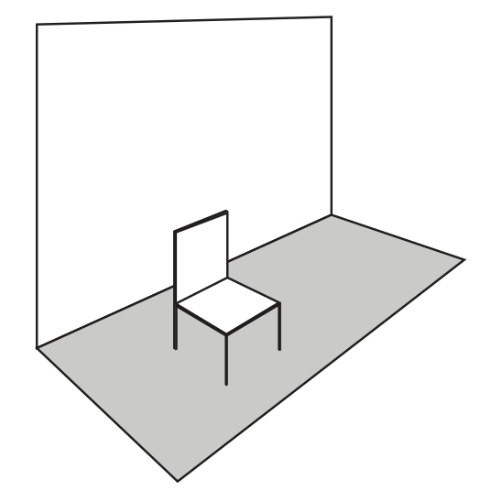 | 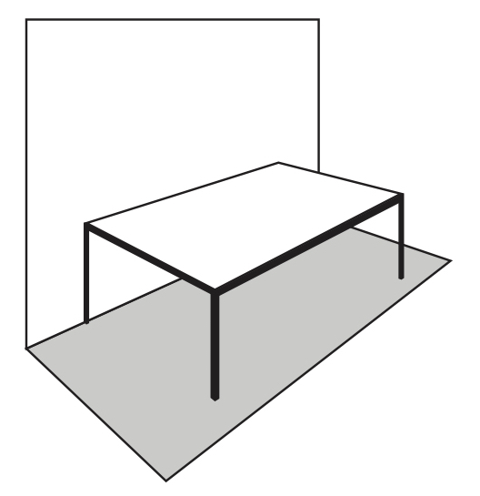 | 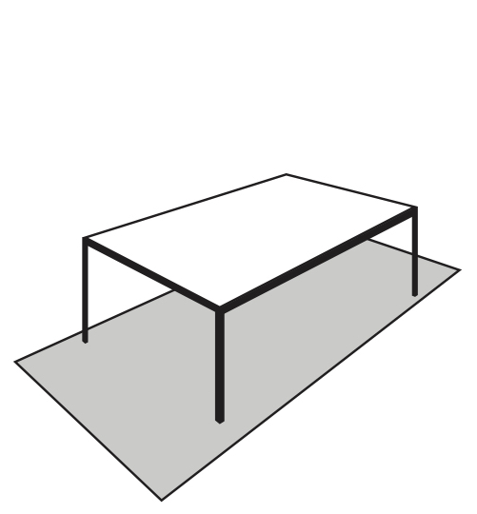
Wall only - £30 | Wall and table - £35 | Table only - £30

Description of work you will be selling e.g. photographs, paintings ceramics, performances, prints, jewellery etc.

If you are selling performances or experiences, please give further details.

Are you happy for us to use your images for promotion?

Please send this completed form along with six images to aafswansea@gmail.com. The deadline for applications is 30th September.

By submitting this application form you are confirming that you have read the requirements below and agree to abide by them. Anyone breaking the rules will be seen as not taking part in the spirit of the event and will not be considered for future initiatives.

- Swansea Affordable Art Fair will be held from Friday 15th-17th November at Elysium, High Street.
- The event is open to all artists, designers and makers living or working in Wales.
- There will be a maximum of 50 spaces available.
- In line with other events run by Elysium, there will be no application fee. Only successful applicants will be charged (see below).
- All applications must be received by 30th September 2019 via email.
- Your application must be accompanied by no more than six images representative of the work you would like to sell.
- For those selling performances or experiences please provide details on the application form.
- There will be a selection process to ensure there is a balanced portfolio of exhibitors.
- All successful applicants will be notified by 12th October and will be required to pay for their space by 30th October. If payment is not received your space will be forfeited and given to another applicant on the waiting list.
- Each exhibitor will be allocated a wall space no smaller than 6 foot wide and 8 foot high with space for an adjoining table.
- Wall only and table only spaces are available. Please indicate your requirements on the application form.
- Exhibitors will be required to set up their work between midday and 6.30pm on Friday 15th November in readiness for the private view.
- A private view will be held from 7pm-9pm on Friday 15th November.
- In keeping with the ‘affordable’ art fair theme, there should be a maximum price of £300 on any individual work.
- The art fair will be open on Saturday and Sunday from 11-5pm.
- All exhibitors will be required to take down their work and remove it by 7pm on the Sunday.
- You will need to ensure that your stand is manned throughout the duration of the event.
- At the end of the event, exhibitors should ensure their spaces are free of litter and returned to their original condition.
- Elysium Gallery will provide public/employers liability insurance.
- Artists are advised to insure their work for the duration of the Affordable Art Fair against theft, loss or damage.



