Changemakers:

Creativity and Value Creation

Task 3 & 4

(BMHP5014_BIRM)

STUDENT- SALEMA ALIM 1913900
TUTOR- DR AZORA HURD

2 minute elevator pitch with flyer/ leaflet and poster.
Task-3
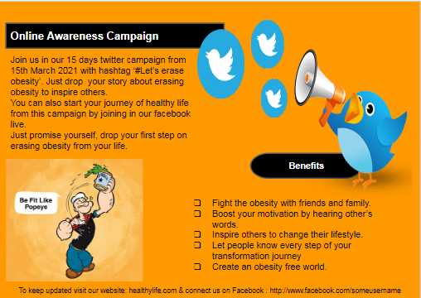

Pitch
Obesity is a complex disease that indicates excessive amount of fat in the human body. According to statistics, 28% adults and 9.9% children in England are suffering from obesity (Woodman, 2017).
This online campaign’s objective is to motivate all people, dealing with obesity especially young people, to practice a healthy life. In this online campaign we will bring some fighters who have already overcome their fight against obesity. As our target people is the young generation, we will try to engage them in the healthy lifestyle in a fun eagerly style. Instead of giving lectures or statistics only, we will provide them with some inspiring tried and tested stories, of combatants through twitter and Facebook live sessions. This will help them to find their own way to deal with the problem and to understand the severity of their disease. This story sharing session will help them to think positively and work as a Pygmalion effect. As through this campaign all storytellers will state their positive outcome, and will leave an expectation from others so listeners and participants of this campaign will be able to show positive impact by leaving their bad lifestyle.
To create a comfortable environment this campaign also includes online twitter campaign. In this section, people who are dealing with obesity will share their steps in their healthy life journey. This can be photos of their healthy food, video of exercising or plan of focusing to their determination. All contents of this campaign will be posted by them with a hash tag; tagline will be ‘Let’s erase obesity’. As young people prefer networking on social media so we chose this platform. Besides this kind of campaign needs less financial support to continue.
Using social media will help us to spread the news to mass number of people. So, for this campaign both obese and their relatives, content creators on social media regarding healthy lifestyles, previous sufferers and viewers are included in our stakeholder map.

Task-4
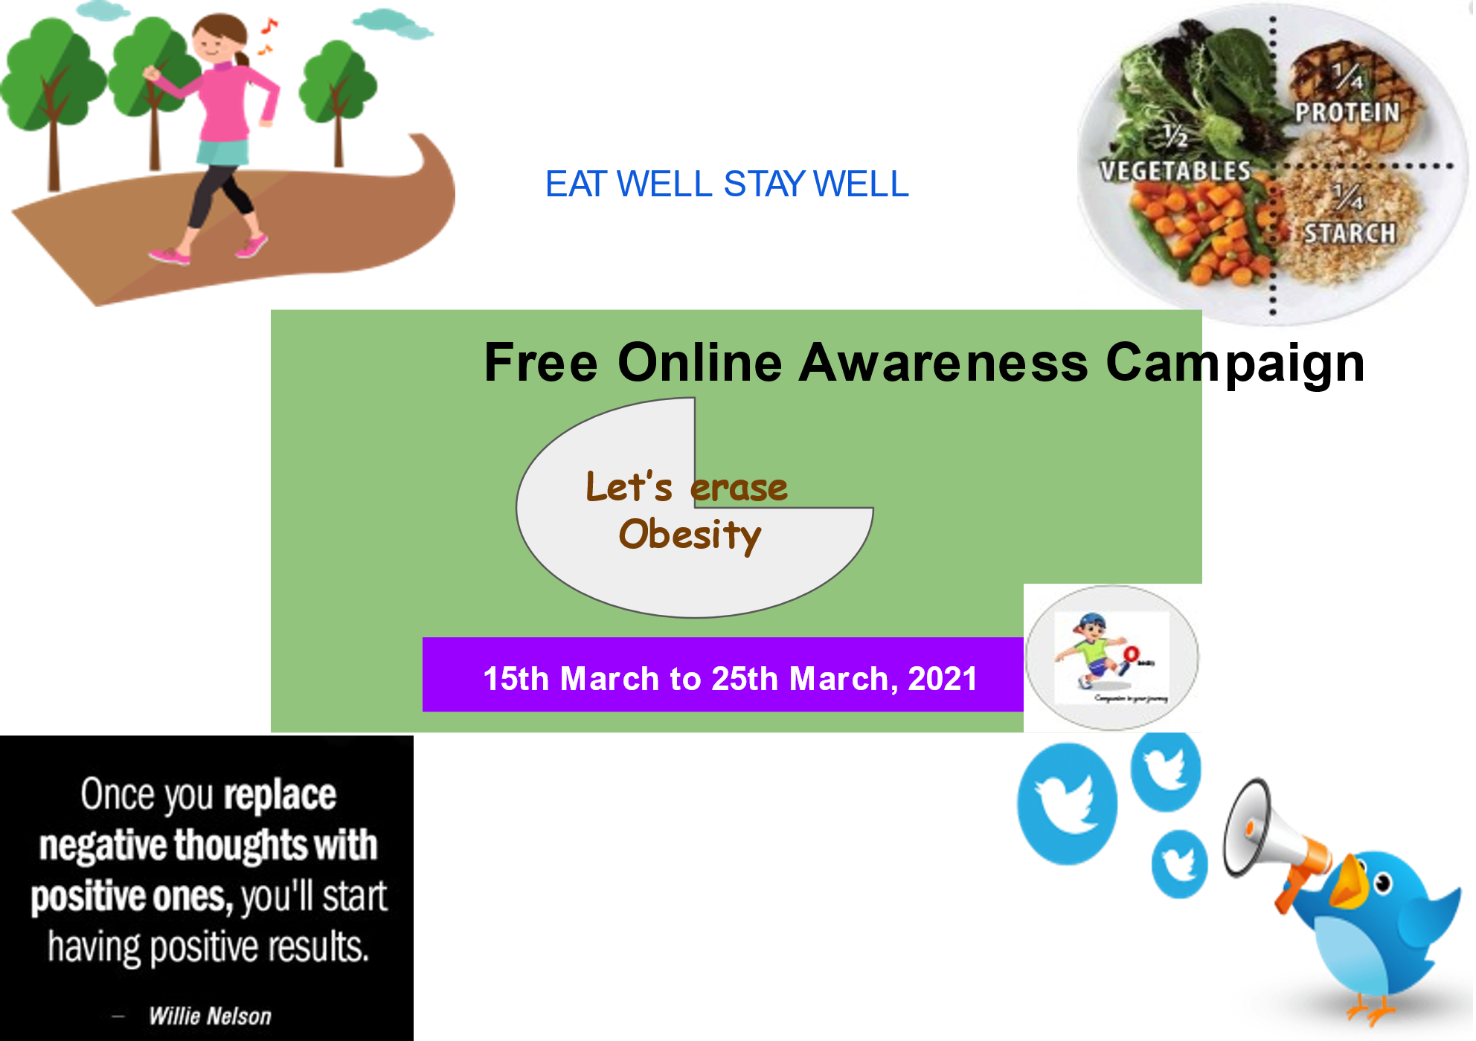
http:www.facebook.com/someusername

REFERENCES
Woodman,R.,2017. WHO launches initiative against obesity. The Lancet, 347(9003),p.751.

