

Financial Management
Table of Contents
Part a) Brief history of the company 3
Part b) Company’s financial performances 5
1. Calculation of financial ratios and briefly discuss your results 5
2. Critically evaluate the ratios you calculated using academic references 9
3. Comparison of your selected company to a major competitor 10
4. Recommendations on improving the financial management 13
Part c) New investment opportunities 13
1. Calculate the Payback Period (PBP), Accounting Rate of Return (ARR) and the Net Present Value (NPV) of the project. 13
2. Assume the initial investments for each project increase by 10%, and all cash flows fall by 10%; recalculate NPV and comment appropriately. 15
3. Advantages and shortcomings of the PBP, ARR and NPV techniques 17
4. Discuss non-financial factors management needs to consider. 18
Conclusion 18
Reference List 20
Appendix 25

Part a) Brief history of the company
The Walt Disney Company, started in 1923 by Walt and Roy Disney and initially comprising only a small animation studio, is nowadays the largest and most diversified media or entertainment business in the world (Walt Disney, 2023). Here's a look at its history, industry, business model, and key factors that shaped its success:
Industry: Walt Disney deals with a huge and diversified professional environment termed as Media & Entertainment. This includes moves and broadcast offers, Dream and Resort Kingdoms, store items, interactive media, and live performances.
Business Model: Disney consistently relies on the prosperous and diverse business model with multiple revenue sources. Here’s a breakdown:
- Studio Entertainment: Disney both makes and releases theatrical and animated movies through the company known as Walt Disney Studios Motion Pictures, the other films' brands Pixar, Marvel Studios, Lucasfilm, and 20th Century Studios (J.E. Luebering, 2019).
- Media Networks: Disney's worldwide television network business includes Disney Channel, ESPN, ABC, and several other foreign networks owned by the company.
- Parks, Experiences and Products: Disney makes profits at its theme parks and resorts such as Disneyland and Walt Disney World(etc) as well as licences its characters and the merchandise to earn more. Another key source of revenue for the company is interactive media (the video games).
- Direct-to-Consumer: The Disney+ streaming platform has a widening choice of the content it provides and retains people through subscription for only a month's fee (Britannica, 2023).
Marketplace and Competitors:
A Media & Entertainment business is most likely to be chest to fall back in strong competition. Disney’s major competitors include:
- Traditional Media: Comcast, ViacomCBS, AT&T (Warner Bros).
- Streaming Services: Netflix, Amazon Prime Video, Apple TV.
- Theme Parks: Universal Studios & Resorts, Six Flags, for example.
Mergers and Acquisitions:
Strategic acquisitions have been instrumental in Disney's growth:
- Pixar (2006): They put the capabilities of these computer animated movies and their well-known characters such as Toy Story and Finding Nemo, on the map.
- Marvel Entertainment (2009): The film collection scope was thoroughly expanded as the Marvel series franchises, including films about Iron Man and Captain America, became very popular.
- Lucasfilm (2012): Also acquired the title rights of two movie franchises, Star Wars and Indiana Jones, which now contribute to a mix of themes and rides in the parks.
- 21st Century Fox (2019): Disney just introduced to boost their ratings, and the title of the popular movie franchise including sequence Avatar and X-Men also with Hulu, a major streaming service on the top of the building.

Strategic Changes:
- Focus on Storytelling: Disney has a peculiar characteristic of incorporating the timeless characters in different ways with thrilling and interesting stories making them a darling to almost every one of every generation.
- Innovation: By utilising cutting-edge technologies like those it invented in the first place, the company continues to come up with new animatics, builds thrill rides, and develops streaming platforms (Forbes, 2023).
- Global Expansion: Realising the intercontinental commercial market capacity, Disney has spread its theme park in different countries and produces content that appeals to different uniqueness.
Impact on Results:
These strategic decisions have significantly impacted Disney's results:
- Diversification: This diversity is the guarantee of a secure financial position and the absence of dependency on a narrow market circle or one big product line.
- Content library: A common source of all three industries, a huge collection of classics and what is trending, helps the growth of the movie production industry, theme parks, and streaming services as more people become an audience (Yahoo Finance, 2024).
- Brand recognition: The famous Disney brand is the main reason for the company’s popularity and the similar brand power leads to the high merchandise revenue and theme park attendance of Disney.
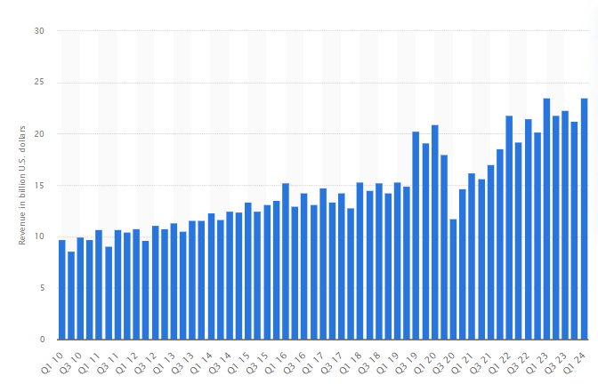
Figure 1: Revenue
(Statista, 2024)

Part b) Company’s financial performances

1. Calculation of financial ratios and briefly discuss your results
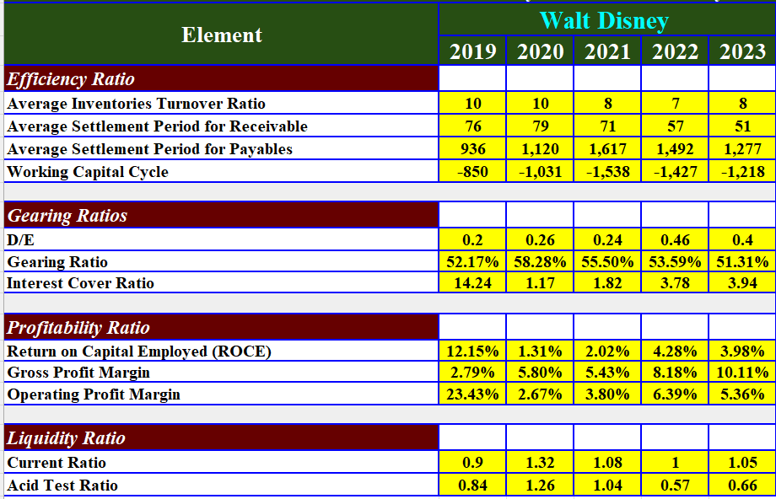
Efficiency Ratio
Average Inventories Turnover Ratio
The typical range (ratio) for inventory turnover of Walt Disney Company in 2014-2019 is around 8.60. This makes Oct. the third most seasonal month for Walt Disney, with the merchandise selling 8.6 times a year, on average (Nasution, 2020). High inventory turnover ratio in most cases signals impeccable inventory control, since by this it can be seen that the company is using its stock efficiently and is selling its items through it adequately.

Average Settlement Period for Receivable
The payable days of receivables of Walt Disney Company increased significantly from that of 2019 levels (76 days) to those of 2023 (51 days). This possibility is the reason why those types of transactions are always much faster (Listiadi, 2022). An overall decline in the duration of trade transactions allows for quicker collection of the money, thereby easing down the money waiting, increasing the cash flow.

Average Settlement Period for Payables
As for the average settlement period for creditors in Walt Disney, it gradually developed as an alarming tendency during 5 years (2018-2022). It increased very high in the beginning, starting with 936 days in 2019, and it peaked in 2021 with 1,617 days. In this case, depicts an enormous postponement of the payments to provide them with commodities and services (Ilter, 2020). It could be beneficial by enhancing a profit in the short run, yet the long-term consequences could be most detrimental to relationships with vendors, ultimately predisposing the latter to the possible future episode of product scarcity or price increase.

Working Capital Cycle
Working capital cycle of Walt Disney during this period (2019-2023) showed a shift to the left, meaning, Walt Disney was on the positive cash flow. The negative value shows that the company gets money from the clients ahead of time than it does from the suppliers because of this process. 2019 recorded the longest payment period of -850 days between suppliers and the organisation (that is 850 days in beforehand of the pay) (Wang et al. 2020). While it improved somewhat by the middle of 2023 (-1,218 days), it anyway signifies that Disney fleet ratios are more efficient than large retail stores since it requires less inventory and generates cash flow faster by collecting customer payments quicker.

Gearing Ratios
D/E
One of the financing items which saw a number of growth was Walt Disney's debt-to-equity ratio starting from 0.2 in the year 2019 but in 2023 it increased up to 0.4. It means that the business has very recently increased the borrowings which have helped in financing the operations whereas raising equity from the equity shareholders has not been an easy exercise for the company (Nukala and Prasada Rao, 2021). It is true that the D/E ratio, which is higher, can raise some doubts about the company’s financial risks of which Disney’s current ratio still remains more than 1, showing that it has enough short-term assets to pay its liabilities.

Gearing Ratio
The revelation that Walt Disney Inc has a financial gearing ratio, which follows the same pattern as its D/E ratio, is an indication that the company is increasingly reliant on debt financing. Thus, there was a steady rise in the female population from 52% in 2019 to 51% in 2023. Gearing Revenue means approaching a company's capital constitution in terms of debt as a proportion of total assets. While Disney's debt-to-equity ratio may not be growing aggressively and looks safe now, it still offers potential risks (Hidayat and Kurniasih, 2022). This is an essential step of comparison with industry benchmarks as well as monitoring its dynamic and performance on a company's ability to cover its debts.

Interest Cover Ratio
Walt Disney concern coverage ratio was indicating a drastic improvement in 2023 (a strong 3.94) from 2020 (a worrying 1.17). This position indicates the solvency of the company which is based on its capacity to cover its interest expenses with its operating earnings. A proportion below one suggests a problem meeting the liabilities incurred from interest (Setiany, 2021). The improvement by the companies on its profitability demonstrates that it is enough to cover their debt servicing. The ratio when it explores the debt to manage finances is still not the most important one. Probably they will classify debt ratio above three as a promising sign of financial health improving.

Profitability Ratio
Return on Capital Employed (ROCE)
The ROCE of Walt Disney proved quite variable for five years from 2019 that accounted for 12.15% and 2023 with only 3.98%. It is also observed a significant decrease in 2020 that amounts to (1.31%). This probably has an impact on factors on the entertainment industry (Iliemena et al. 2023). Although a recovery can be seen, the ROCE that was recorded is not as high as its 2019 peak, suggesting that there is still some work to be done to better the utilisation of capital for the business in its pursuit of generating profits.

Gross Profit Margin
The Walt Disney Company displayed a rising trend in gross profit margin during the period of five years (2019-2013), which went from 2.% to 34.% in 2023. This, in turn, shows that the manufacturer is making bigger profits from the sales of its products and/or services after they have been deducted the cost of sold goods. It is imperative to state that the earnings before interests, taxes, depreciations, and amortisation is an approximation of how well the company has performed (Nariswari and Nugraha, 2020). This betterment indicates that Disney has potentially achieved an optimal operating capability.

Operating Profit Margin
The operating profit margin of Walt Disney was on a bumpy road. Namely, it went to the bottom of 23.43% in 2019 and 5.30% in 2023. It tumbled drastically in 2020 (−2.67%) as headwinds of the pandemic-related issues might be involved. Despite partial recovery being visible, it’s still far from pre-pandemic levels (Budianto and Dewi, 2023). Therefore, it’s time to focus more on addressing profitability by taking care of all the actual costs.

Liquidity Ratio
Current Ratio
The discussion about Walt Disney's current ratio starts with 2019 which is about 0.9 and ends with 2023 with 1.05. It would be better if the current ratio was from 1.5 to 3 and that a company owned enough current assets (like cash or inventory) to cover the short-term debt (like – bills and upcoming payments of debt) (Irsan and Rambe, 2021). Similarly, unlike other sectors, Disney has never gone below one, despite the fact that the ratio being just over one tells us that must be tread carefully. This could lead to over credit ending in bills that are unmanageable.

Acid Test Ratio
The liquidity position of The Walt Disney Company, as depicted by the lower acid-test ratio, nevertheless, became a source for concern in the period 2019-2023 which occurred as a result of the “acid test ratio” of 0.84 in 2019 and 0.66 in 2023. The ratio of this class of stocks covers only the more liquid current assets, and thus, the inventory is not included. Only cash and marketable securities go into making up the list. An indicator below 1 will imply that it is extremely difficult to meet pressing short-term obligations using existing sole liquid assets (Kumoro et al. 2020). The deteriorating ratio of SMKN of Disney hints at a problem associated with the meeting of short-term needs as well as the need for sale of shares or assets. This shows that the good preparation and cutting down of current debt and settling current debts are necessary.

2. Critically evaluate the ratios you calculated using academic references
Efficiency Ratio
On the strength of Disney’s average inventory turnover ratio of 8.6 over the last five years, its inventory management has not been poor, as the company has managed to sell its stock eight and a half times during the whole year on average. On the contrary, a more complimentary approach should be used. The article by Alarussi (2021) says that the return on sales which is higher rather than normal is typically a positive sign in retail.

Gearing Ratios
Disney's debt-to-capital ratio (from 52% in 2019 to 51% in 2023) shows that much of Disney's financing appears to come from debt. Although it is not that high, it is desirable that the level of those screened is monitored. The financial risk rise is possible in the long-term if the coefficient of ratio has a high level (Tudose et al. 2022). Long-term prosperity of the company being the main goal, let's get this ratio analysed and compared with industry benchmarks to see if it's easy or hard on their debt paying ability.

Profitability Ratio
Profits of Walt Disney can be understood as both positive and negative according to the financial indicators. The volatilities of the ROCE, indicated in the consistency of profits, yielded by the invested capital might be applicable to the company's challenge of generating regular returns. On the other hand, the gross profit margin has been showing a gradual positive trend, especially in the last quarter, which indicates that the company is generating higher profits from its core operations (Husain and Sunardi, 2020). However, its operating profit margin is still lower compared to that of pre-pandemic levels. This indicates an enhancement of the overall profitability, as the after-taxes earnings are a good indicator of dependability. In addition to this further study of industry benchmarks for the latter ratios can result in a broad picture about the performance of Disney.

Liquidity Ratio
The ratios related to liquidity of Walt Disney may have some negative aspects. The current ratio is over 1 for the time being so it has a little bit of a cushion for the immediate obligations. The downcast acid-test ratio, which is a highly selective measure, was on a steady decline, evidently confirming that the company has problems covering its immediate needs with liquid assets with higher liquidity rates (Pattiruhu and Paais, 2020). These examples show how being mindful of the current liabilities and having positive cash flow to overcome financial pressure are essential.

3. Comparison of your selected company to a major competitor
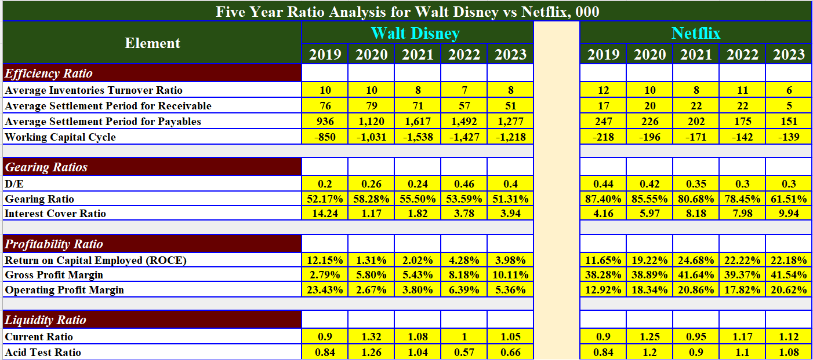
Efficiency Ratio
Average Inventories Turnover Ratio
Netflix's average inventory turnover ratio (2019-2023: Apples enjoy higher brand recognition than Disney's (-0.8). It follows that Netflix updates its content inventory a bit rarely (i.e. this might be due to its streaming-centred business model in comparison to that of video distribution) (Herison et al. 2022).

Average Settlement Period for Receivable
Amongst all, Disney gets paid faster than Netflix since it is taking payments from the customers immediately. On average, Disney films collect after 42 days (2019-2023) whereas Netflix needs a much longer period, as Netflix’s films collect after 77 days (Listiadi, 2022). This indicates that Disney's invoice and collections system are more effective.

Average Settlement Period for Payables
Netflix settles payments to suppliers much faster than Disney (average: It is apparent that a solitary trip to space might considerably influence an astronaut's psychological health and well-being (Nguyen, 2021). Such Assumption could show that Netflix would give preference to quick payment for continuing fair trade relationships or negotiating the best deals.

Working Capital Cycle
Netflix constantly boasts a shorter working capital cycle (average: OSG's profitability is 214 times) (374 days) greater than that of Disney's (-1,097 days). As a result, Netflix makes the money go back to its customers and pay suppliers quicker - this enhances the inflow of cash - whereas Disney seems to gain by pre-payments or extended payment terms, which delays the outflow of cash (Wang et al. 2020).

Gearing Ratios
D/E
Generally, debt financing is the option that is preferred by Disney as well as by Netflix. Although the D/E ratio of Disney remained between 0.2 to 0.4 throughout the years (2019 and 2023), Netflix's debt ratio stayed even higher (0.3 for the same period) (Giaretta and Chesini, 2021). It is the case where it is very clear that the former company is supposed to be the risk-taker in this case through debt rather than the latter company

Gearing Ratio
While both companies utilise debt financing, Disney's gearing ratio (average: Consequently, (60.6% for Prime Video) is not as high as that of Netflix (the average value of which stands at 78.7%). This may reveal that a greater portion of Netflix is of debt and thus a higher proportion of risk compared to that of Disney (GEZER and KINGIR, 2020).

Interest Cover Ratio
Netflix has an edge in its ability to manage this debt burden of its. Their interest coverage ratio (average: The average ratings of the Pirates (7.4) spotlight its low popularity among Disney fans compared to the average (3.4) (Setiany, 2021). In other words, Netflix runs at a larger scale of operating income to cover its interest charges, thereby decreasing the possibility of defaulting on its debts.

Profitability Ratio
Return on Capital Employed (ROCE)
Netflix is an outperformer or stands out from the crowd in case of profit effectiveness of the invested capital if compared to Disney. In the past five years Netflix has enjoyed 20.8% as RoCE average compared to the 5.9% which Disney has had (Lisek et al. 2020). That otherwise, Netflix is working more efficiently with the capital that it starts in its business activity.

Gross Profit Margin
Nevertheless, they enjoy high gross profit margins, although Netflix surpasses its rival with very minimal differences (Sunaryo, 2021). Netflix's average gross margin in years (2019-2023) was 39.9%, Disney's was even lower 6.4%. Accordingly, Netflix has a higher gross margin which suggests that it remains with a bigger slice of revenue after taking into account the cost of goods sold.

Operating Profit Margin
Though night-codon gets a bigger Gross Profit Margin, Disney is indeed much stronger than that when it comes to Operating Profit Margin. In reality, it was 17.7% outperformance for Netflix in a 5-year time span and 9.2% for Disney. This implies that Disney is better performing in terms of controlling its operational expenses, and that the percentage of gross profit that is actually operating profit has increased substantially (Choiriyah et al. 2020).

Liquidity Ratio
Current Ratio
As for Disney, having the current and fluctuating ratios, will not significantly hinder the company, placing it in a superior position in terms of short-term solvency over Netflix (Novyarni and Permana, 2020). A simple glance at their current ratios would reveal that Disney is above the average as it has 1.02 while Netflix sits at 1.09. On the contrary, the distance between corporations is limited, which possibly means that the overhead for the sudden day-to-day commitments is also low.

Acid Test Ratio
While Netflix has taken the position of immediate liquidity it is essential to understand the risks associated with it. Comparing this with sixty-year-old company, Disney, their talked- about Acid-Test Ratio which is equal to 1.05 is much, much higher than that of Disney (with its value being a quarter less than one) (Tumanggor, 2020). Thereby, Netflix has prompt substances (in cash and marketable securities) to respond to the immediate needs of the financial situation vs. Disney that have high-priced fixed assets that can lead to strict cash flow and, consequently, cause challenges in meeting deadlines.

4. Recommendations on improving the financial management
- Inventory: In order to do benchmarking within theme parks, analyse these industry standards to enhance inventory levels.
- Debt: Work on methods of decreasing debt growth or look for the options to create more equity to effectively handle financial risks. A wide range of important societal issues exist, including climate change, access to quality education, all the way to public healthcare.
- Profitability: Steer attention towards enhancing theme park functional capacity and make plans to increase it (Almashhadani and Almashhadani, 2022).
- Liquidity: Investigate techniques making it possible to handle cash flow better or raise the flash assets for the valuation relevant short-term solvency.

Part c) New investment opportunities

1. Calculate the Payback Period (PBP), Accounting Rate of Return (ARR) and the Net Present Value (NPV) of the project.
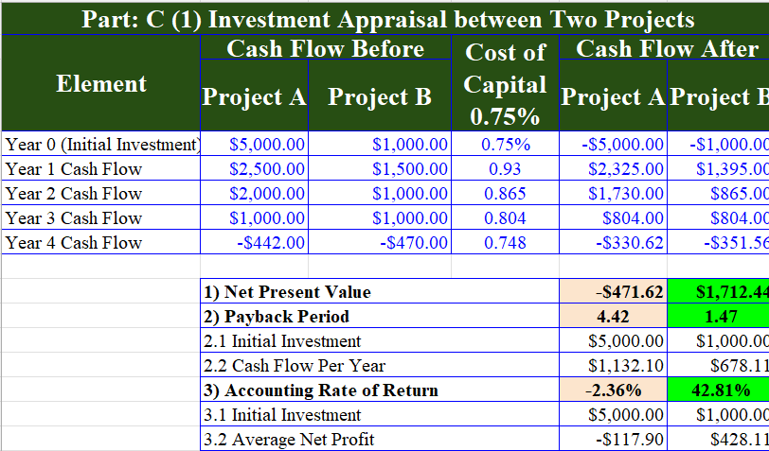
According to the proposed financial data of Disney, the one at Project B is more likely to make it to the list of the investment fundamentals. Here's a breakdown of the calculations and reasoning behind this recommendation: Here’s a breakdown of the calculations and reasoning behind this recommendation:
Payback Period (PBP):
- Project A: 4.42 years
- Project B: 1.47 years
Project B has the fastest payback period of 1.47 years compared to 4.42 years for project A which means that it not only saves the initial investment since the beginning but also gains profit at the same time. It also shows more rapid profit generation for Disney, with the money becoming available much quicker and therefore less time for other wedding bells to ring (Dai et al. 2022).
Accounting Rate of Return (ARR):
- Project A: -2.36%
- Project B: 42.81%
The annual return on investment for project b is much more positive than Project A at (42.81%) instead of (-2.36%) ARR refers to the annual average return on the system (Hilton and Platt, 2020). Furthermore, a higher and positive ARE obtained by Project B over that of Project Bs in fact translates into a higher average profit throughout the project's life.
Net Present Value (NPV):
- Project A: $471.62
- Project B: $1,712.44
The NPV of Project B (the project which has a higher NPV of $1,712.44 against Project A NPV of $471.62) clearly demonstrates how well managed this project is in comparison to the other project. NPV is seen as a parameter with time value of money and, therefore, presents a project's profitability which has already accounted for the future cash flows which were previously discounted (Peymankar et al. 2021). Disney's decision to go ahead with Project B is a positive choice that will significantly add on to the company's value.
Recommendations:
To sum up, all three types of cash flow for option B show that it is the chimaera for Disney. The IRR, which is shorter; the fact that AAR is significantly higher; and the fact that the NPV is much larger all indicate a faster return on investment, higher profitability, and much more worth in comparison with Project A.
Within 2-5 years, Project A has an opportunity to gradually cover the initial investment, followed by some profit but the longer payback period, negative ARR, and lower NPV indicate if lower compared to other available opportunities (Guzhev and Sintsova, 2023). Disney takes the risk of Project B, expecting to have a more immediate cash flow, engine husbandry and making a larger total profit from the project.

2. Assume the initial investments for each project increase by 10%, and all cash flows fall by 10%; recalculate NPV and comment appropriately.
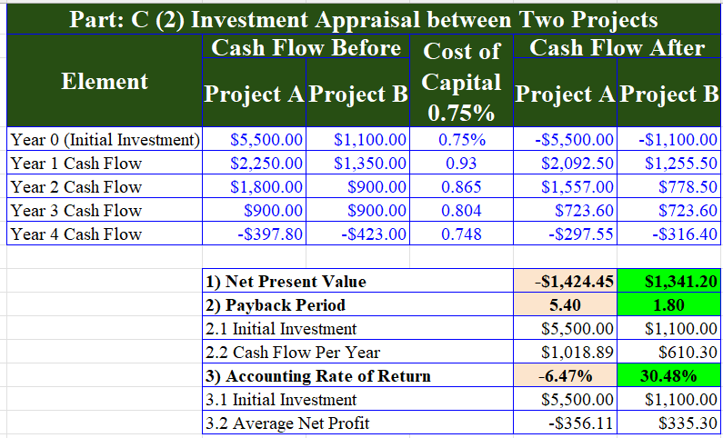

The analysis determined that Project B had the highest returns for Disney than Project A. Conversely, there is often a huge role for the external circumstances to determine the profitability of the projects (Karakostas et al. 2021). In this analysis, the effect of 10% increase in the initial investment and the other way around -10% decrease in all cash flows for both projects, will be found out. The methods are the same as for the Net Present Value (NPV) calculation.
Project A:
- Initial Investment: $5,500.00 (10% increase from $5,000.00)
- Year 1 Cash Flow: $2,250.00 (10% decrease from $2,500.00)
- Year 2 Cash Flow: $1,800.00 (10% decrease from $2,000.00)
- Year 3 Cash Flow: $900.00 (10% decrease from $1,000.00)
- Year 4 Cash Flow: -$496.20 (10% decrease from -$442.00)
Project B:
- Initial Investment: $1,100.00 (10% increase from $1,000.00)
- Year 1 Cash Flow: $1,350.00 (10% decrease from $1,500.00)
- Year 2 Cash Flow: $900.00 (10% decrease from $1,000.00)
- Year 3 Cash Flow: $900.00 (10% decrease from $1,000.00)
- Year 4 Cash Flow: -$423.00 (10% decrease from -$470.00)
Recalculated Net Present Value (NPV):
The cost of capital will be the same with the rate and even by Iota that is 0.746%.
- Project A (Revised NPV): -$ 1,424.45 (The discounted cash flows are the ones that should be subtracted from the increased initial investment)
- Project B (Revised NPV): The worth off the expenditure after discounting 1,341.20 (Cash flow minus investment)
Analysis of Revised NPVs:
The discounted cash flows generated from the revised NPVs have shown the projects are no longer a major consideration for further development.
- Revised NPV of Project A shows a much negative figure at -$1,424 which is moving from above the neutral zone. This clarifies the fact that as a result of a price discount because of a deferred cash outflow, the project would not generate enough profit for its larger original outlay (Costanza et al. 2021). The additional funding concern and interrupted cash flows make things more difficult for the project as it intensifies the financial deficiency.
- Project B differs from Project A which is stably in the black of $1,341.20, which illustrates financial sustainability not as good as Project B.
Impact of Increased Investment and Reduced Cash Flows:
The reviewed scenario presents the project choice sensitivity to variations in the first investment and cash flows, especially initial costs and cash inflows (Leskinen et al. 2020). The impact of the 10% rise on both sides would be equal and it would be, perhaps, the one to hit them now hard-Project A, finally, turning to negative behaviour. For project B, it is seen that remarkable COVID-19 impact resilience attributable to its initially stronger profits.
Decision Recommendation:
For this reason, given updated NPVs, Project B still assumes the role of a beneficiary investment scenario for Disney under current conditions.
- Project A implies a very high prospect of getting losses by the end of the evaluation with a negative NPV value.
- The projected B shows NPV is higher than zero or the excess of revenues over costs, which means that the project is still profitable with the new economic assumptions.
The revised NPV calculations unequivocally point B as the choice all the more solid financially for Disney within the present situation. On the other hand, a proper resolution to the situation has to be done through a unique risk analysis method to identify and control the looming problems ahead whatever the outcome would be (Huang et al. 2022). Moreover, the judgement with respect to Disney's long run goals and considering the kind of additional sensitivity analyses are the essential steps that will assure that the project under the evaluation is the one that creates long-term for the firm.
Even though project B is the cheaper option with more favourable financial returns. However, Disney should optimise the analytical process in the investment before making a final decision (Sitompul and Khadijah, 2020). This analysis should involve risk assessments, strategic match, and sensitivity analysis for the project to be successful and create long-term value for the organisation. Through doing a strategic approach, ABC Company can come up with the best decision that both aims at financial stability and strategic alignment.

3. Advantages and shortcomings of the PBP, ARR and NPV techniques
Deciding the best investment project implies the complex process involves many sides. The easiest one to grasp is Payback Period (PBP), which only touches on how fast your initial investment is recovered, thus completely ignoring the eventual amounts of cash that might get. Accounting Rate of Return (ARR) , which is the other common method, nonetheless fails to factor in the system in which money acquires or could acquire interest with passage of time (Gowthorpe, 2021). Thus, ending up prioritising short-term gains over long term investment that would yield greater return in overall investment.
NPV comes out to be a more rigorous procedure, comprising the time value of money concept and always categorising those projects that are given the maximum present value of the expected future cash flows. At the same time, NPV calculations are not easy and the expected cost of capital must be precisely measured (Wang, 2021).
As a concluding remark, both types of policy: PBP and ARR, undoubtedly, have an advantage of giving a precise picture, but they can't see through the complexity of the whole process. DCF provides a more thorough analysis, however this is also one of its major disadvantages. Given technology usage, however, weighting these ones alongside with other factors including project risk and strategic alignment is the key.

4. Discuss non-financial factors management needs to consider.
Every good evaluation of capital projects contains a larger number than only this number. However, financial indicators such as Net Present Value and PBV only partially reflect the true picture. Besides this, proper financial assessment cannot occur without consideration of several non-financial factors.
- Strategic Alignment: This investment should be aligned with long-term goals, not focused just on the health of the balance sheet (Zarzycka and Krasodomska, 2022).
- Project Risk Assessment: On the list of the key matters that should be taken into consideration are feasibility, possible problems with design, fluctuation of the prices, and environmental/social effects.
- Operational Impact: Take on analysing staffing needs, training of employees, possibilities of disruptions in workflow and chances of innovation.
- Intangible Benefits: How about employee morale and maturity of brand or setting the stage for a culture of innovation where these two things might be hard to determine the financial value (Kristi and Yanto, 2020).
- Regulatory Compliance: Be certain of the project to follow all the legal and regulatory requirements so that the project cannot be delayed and fined.
- Stakeholder Impact: Analyse how the project would affect employees, customers, and community in terms of creation of jobs, ecological footprints and community relations.
Through the use of non-financial patterns together with the financial metrics, they are perfectly capable of making the best decision in the long-term interest of the company (Turzo et al. 2022). By taking a comprehensive approach, the financial benefits that the project brings shall not only come as profits but they should also be in tandem with the main business strategies of the company with the aim of reducing the risks involved and increasing the value of stakeholders.

Conclusion
In operation of theme parks, movies, media networks, and merchandise, The Walt Disney Company, a media giant, has been able to enchant the world with a constant presence. The fact that Comcast, Sony and Netflix are in competition with Disney, she relies on the business acquisitions (Pixar, Marvel) to expand its content library and reach. This report analysed Project A and Project B through the lens of the investment decision process at the Walt Disney Company. At the start, Project B was advantageous in this respect, showing a positive cash flow. Project B still remains acceptable in terms of finances as it reflects in NPV favourably. Although it is crucial to consider non-financial ones along with financial elements, the ultimate decision depends on these two aspects.
Through a proper risk assessment as well as the alignment of strategies to the company’s long term objectives and a thorough sensitivity analysis, all the gaps in the business decision making process can be detected and addressed. Through the use of financial as well as non-financial criteria, Disney can turn out to be a really useful platform for investment that has the combined goal of sustainable wealth creation and efficiency with the company’s overall objectives. Financial indicators represent a good basis, though a comprehensive approach is necessary for projects to bring fruitful results. The next step for Disney would be to monitor its environment, its competitors and set a direction based on emerging trends and opportunities in order to remain in front as a global leader in entertainment. The effectiveness of chosen investments and the alignment with those competencies and long-term business strategy that leads to success require strategic investments.

Reference List
Alarussi, A.S.A., 2021. Financial ratios and efficiency in Malaysian listed companies. Asian Journal of Economics and Banking, 5(2), pp.116-135.
Almashhadani, M. and Almashhadani, H.A., 2022. The impact of ownership on profitability: An conceptual study. International Journal of Business and Management Invention, 11(6), pp.01-06.
AnnualReport.com (2023). Walt Disney Co. - AnnualReports.com. [online] www.annualreports.com. Available at: https://www.annualreports.com/Company/walt-disney-co [Accessed 5 Apr. 2024].
Britannica (2023). Disney Co. summary | Britannica. [online] www.britannica.com. Available at: https://www.britannica.com/summary/Disney-Company [Accessed 5 Apr. 2024].
Budianto, E.W.H. and Dewi, N.D.T., 2023. Research Mapping the Operating Profit Margin (OPM) Ratio in Sharia and Conventional Banking: VOSviewer Bibliometric Study and Library Research.
Choiriyah, C., Fatimah, F., Agustina, S. and Ulfa, U., 2020. The effect of return on assets, return on equity, net profit margin, earning per share, and operating profit margin on stock prices of banking companies in Indonesia Stock Exchange. International Journal of Finance Research, 1(2), pp.103-123.
Costanza, R., Kubiszewski, I., Stoeckl, N. and Kompas, T., 2021. Pluralistic discounting recognizing different capital contributions: An example estimating the net present value of global ecosystem services. Ecological Economics, 183, p.106961.
Dai, H., Li, N., Wang, Y. and Zhao, X., 2022, March. The analysis of three main investment criteria: NPV IRR and payback period. In 2022 7th International Conference on Financial Innovation and Economic Development (ICFIED 2022) (pp. 185-189). Atlantis Press.
Forbes (2023). Walt Disney (DIS). [online] Forbes. Available at: https://www.forbes.com/companies/walt-disney/ [Accessed 5 Apr. 2024].
GEZER, Y. and KINGIR, S., 2020. Expected of debt capital and gearing: Return, risk and impact on the value of the firm's equity. Aydın İktisat Fakültesi Dergisi, 5(1), pp.25-33.
Giaretta, E. and Chesini, G., 2021. The determinants of debt financing: The case of fintech start-ups. Journal of Innovation & Knowledge, 6(4), pp.268-279.
Gowthorpe, C., 2021. Business accounting and finance. Catherine Gowthorpe.
Guzhev, D.A. and Sintsova, E.A., 2023. Variable value of the discount rate and net discounted income with variable definition of initial investments in the pessimistic scenario of the investment project. Journal of Economics, Entrepreneurship and Law, 13(10), pp.4443-4460.
Herison, R., Sahabuddin, R., Azis, M. and Azis, F., 2022. The effect of working capital turnover, accounts receivable turnover and inventory turnover on profitability levels on the Indonesia Stock Exchange 2015-2019. Psychology And Education, 59(1).
Hidayat, F. and Kurniasih, A., 2022. Financial Performance Determinants of Financing Companies Listed on the Indonesia Stock Exchange. Saudi J Econ Fin, 6(4), pp.141-146.
Hilton, R.W. and Platt, D.E., 2020. Managerial accounting: creating value in a dynamic business environment. McGraw-Hill.
Huang, J., Wei, K.D. and Yan, H., 2022. Investor learning and mutual fund flows. Financial Management, 51(3), pp.739-765.
Husain, T. and Sunardi, N., 2020. Firm's Value Prediction Based on Profitability Ratios and Dividend Policy. Finance & Economics Review, 2(2), pp.13-26.
Iliemena, R.O., Amedu, M.J.A. and Uagbale-Ekatah, R.E., 2023. Empirical examination of sustainability reporting, return on capital employed and gross profit margin. European Journal of Sustainable Development Research, 7(1).
Ilter, C., 2020. A discussion paper on accounts payable ratio. Acta Oeconomica Pragensia, 27(3), pp.85-94.
Irsan, M. and Rambe, M.F., 2021. Return on asset: current ratio and debt to asset ratio companies in Indonesia stock exchange. International Journal of Economic, Technology and Social Sciences (Injects), 2(1), pp.289-298.
J.E. Luebering (2019). Disney Company | History & Films. In: Encyclopædia Britannica. [online] Available at: https://www.britannica.com/topic/Disney-Company [Accessed 5 Apr. 2024].
Karakostas, A., Morgan, G. and Zizzo, D.J., 2021. Socially Interdependent Investment. Available at SSRN 3799854.
Kristi, N.M. and Yanto, H., 2020. The effect of financial and non-financial factors on firm value. Accounting Analysis Journal, 9(2), pp.131-137.
Kumoro, D.F.C., Novitasari, D., Yuwono, T. and Asbari, M., 2020. Analysis of the Effect of Quick Ratio (QR), Total Assets Turn Over (TATO), and Debt To Equity Ratio (DER) on Return On Equity (ROE) at PT. XYZ. Journal of Industrial Engineering & Management Research, 1(3), pp.166-183.
Leskinen, N., Vimpari, J. and Junnila, S., 2020. A review of the impact of green building certification on the cash flows and values of commercial properties. Sustainability, 12(7), p.2729.
Lisek, S., Luty, L. and Zioło, M., 2020. Measurement of return on capital employed in assessment of company’s condition. Zeszyty Naukowe Małopolskiej Wyższej Szkoły Ekonomicznej w Tarnowie, (2 (46)), pp.55-67.
Listiadi, A., 2022. The acceptance effectiveness through accounts receivable billing period average. IJEBD International Journal of Entrepreneurship and Business Development, 5(4), pp.699-707.
Listiadi, A., 2022. The acceptance effectiveness through accounts receivable billing period average. IJEBD International Journal of Entrepreneurship and Business Development, 5(4), pp.699-707.
Nariswari, T.N. and Nugraha, N.M., 2020. Profit growth: impact of net profit margin, gross profit margin and total assests turnover. International Journal of Finance & Banking Studies (2147-4486), 9(4), pp.87-96.
Nasution, A.A., 2020. Effect of inventory turnover on the level of profitability. In IOP Conference Series: Materials Science and Engineering (Vol. 725, No. 1, p. 012137). IOP Publishing.
Nguyen, T., 2021. Functions of receivable account team and payable account team at finance department. The influence of average collection period on financial health and the process of payable management at Ernst and Young Vietnam.
Novyarni, N. and Permana, R.Y., 2020, March. Effect of Current Ratio, Return on Asset, Net Profit Margin and Debt to Equity Ratio on Dividend Pay Out Ratio (For company listed in the LQ45 on Indonesian Stock Exchange). In Annual International Conference on Accounting Research (AICAR 2019) (pp. 41-45). Atlantis Press.
Nukala, V.B. and Prasada Rao, S.S., 2021. Role of debt-to-equity ratio in project investment valuation, assessing risk and return in capital markets. Future Business Journal, 7(1), p.13.
Pattiruhu, J.R. and Paais, M., 2020. Effect of liquidity, profitability, leverage, and firm size on dividend policy. The Journal of Asian Finance, Economics and Business, 7(10), pp.35-42.
Peymankar, M., Davari, M. and Ranjbar, M., 2021. Maximizing the expected net present value in a project with uncertain cash flows. European Journal of Operational Research, 294(2), pp.442-452.
Setiany, E., 2021. The effect of investment, free cash flow, earnings management, and interest coverage ratio on financial distress. Journal of Social Science, 2(1), pp.64-69.
Setiany, E., 2021. The effect of investment, free cash flow, earnings management, and interest coverage ratio on financial distress. Journal of Social Science, 2(1), pp.64-69.
Sitompul, S. and Khadijah, S., 2020. Analysis net profit, dividend, debt, cash flow, and capital net working that influence investment decisions on manufacturing companies. International Journal of Research and Review, 7(3), pp.1305-1312.
Statista (2024). Walt Disney: quarterly revenue 2024 | Statista. [online] Statista. Available at: https://www.statista.com/statistics/224397/quarterly-revenue-of-the-walt-disney-company/ [Accessed 5 Apr. 2024].
Sunaryo, D., 2021. Analysis of current ratio, debt to assets ratio and gross profit margin on financial distress with moderated share prices in retail companies listed in securities exchange. International Journal of Educational Research and Social Sciences (IJERSC), 2(1), pp.23-33.
Tudose, M.B., Rusu, V.D. and Avasilcai, S., 2022. Financial performance–determinants and interdependencies between measurement indicators. Business, Management and Economics Engineering, 20(1), pp.119-138.
Tumanggor, M., 2020. The influence of current ratio, quick ratio and net profit margin on return on assets at pt. hero supermarket tbk. PINISI Discretion Review, 3(2), pp.137-146.
Turzo, T., Marzi, G., Favino, C. and Terzani, S., 2022. Non-financial reporting research and practice: Lessons from the last decade. Journal of Cleaner Production, 345, p.131154.
Walt Disney (2023). The Walt Disney Company. [online] The Walt Disney Company. Available at: https://thewaltdisneycompany.com/#:~:text=About [Accessed 5 Apr. 2024].
Wang, Z., 2021, December. Evaluating the Accuracy of Net Present Value and Initial Rate of Return Investment Rules. In 2021 3rd International Conference on Economic Management and Cultural Industry (ICEMCI 2021) (pp. 1319-1322). Atlantis Press.
Wang, Z., Akbar, M. and Akbar, A., 2020. The interplay between working capital management and a firm’s financial performance across the corporate life cycle. Sustainability, 12(4), p.1661.
Yahoo Finance (2024). Walt Disney Company (The) (DIS) Company Profile & Facts - Yahoo Finance. [online] finance.yahoo.com. Available at: https://finance.yahoo.com/quote/DIS/profile/ [Accessed 5 Apr. 2024].
Zarzycka, E. and Krasodomska, J., 2022. Non-financial key performance indicators: what determines the differences in the quality and quantity of the disclosures?. Journal of Applied Accounting Research, 23(1), pp.139-162.

Appendix
2022-2023
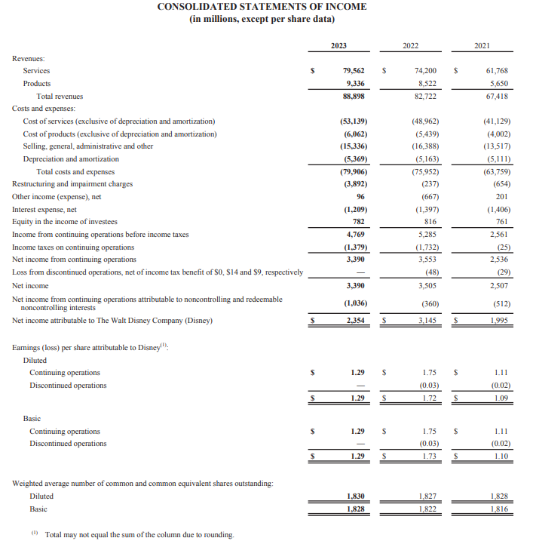
(AnnualReport.com, 2023)
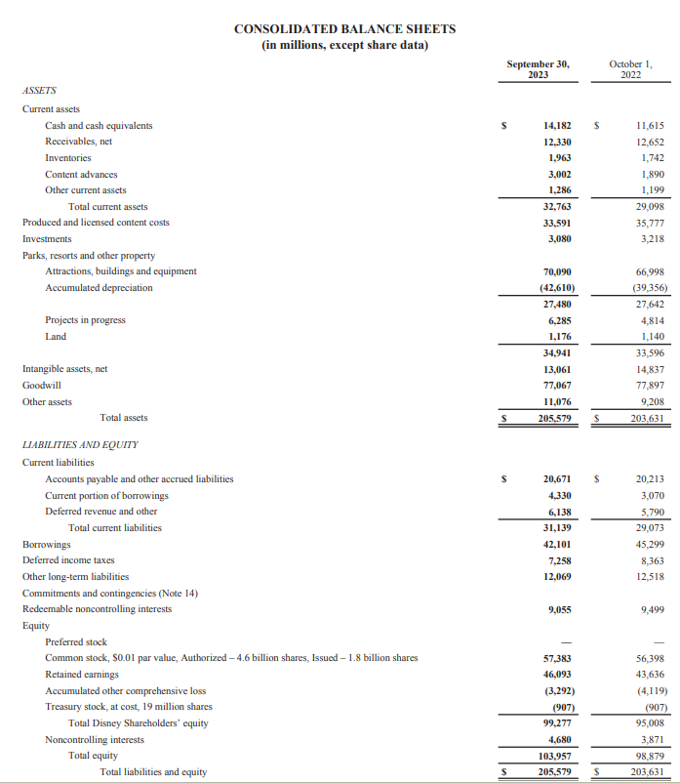
(AnnualReport.com, 2023)
2020-2021
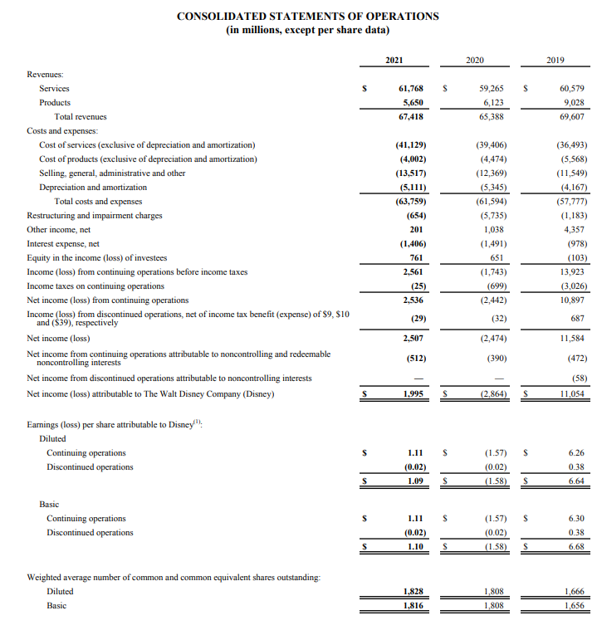
(AnnualReport.com, 2023)
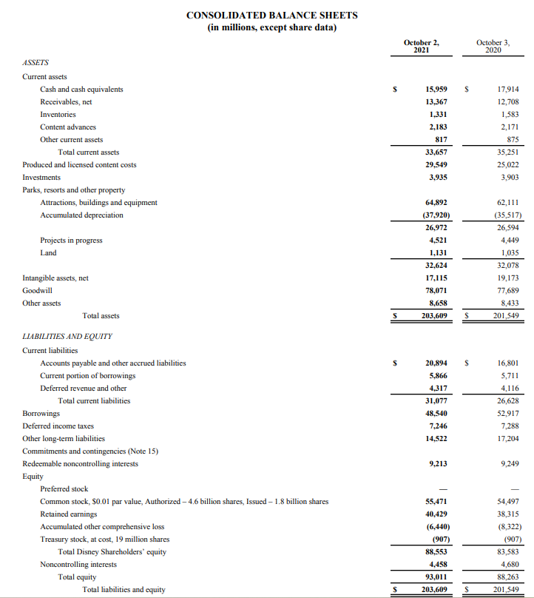
(AnnualReport.com, 2023)
2019-2020
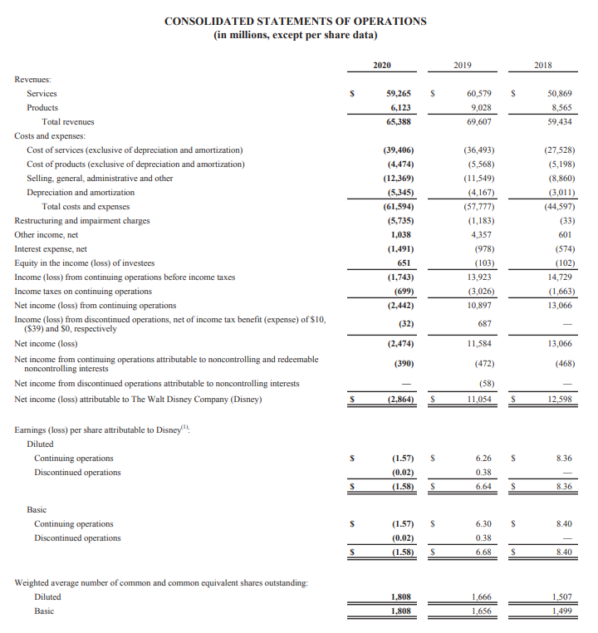
(AnnualReport.com, 2023)
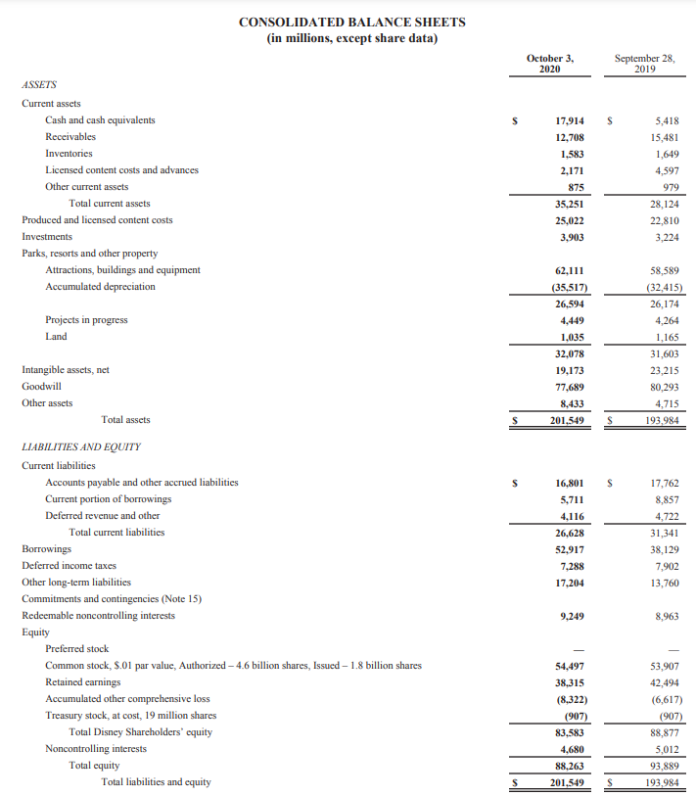
(AnnualReport.com, 2023)

