

PROGRAMME: MASTER OF BUSINESS ADMINISTRATION
MODULE: STRATEGIC MANAGEMENT
MODULE CODE: LCMB7003
Report on Tesla Inc.

LECTURER: Dr Hoang Dang Nguyen
Student Name:Hersh Deep Singh
Student ID: 2436567

TABLE OF CONTENTS
SECTION 1 3
1. Introduction 3
2. Organisational Context & Overview 3
2.1 Company Background 3
2.2 Business Model 4
2.3 Industry & Market Position 5
3. External & Internal Environment Analysis 6
3.1 PESTEL Analysis 6
3.2 Industry Analysis (Porter’s Five Forces) 7
3.3 Critical Success Factors (CSFs) 9
3.4 Internal Analysis 9
3.5 VRIO Framework 10
3.6 Critical Evaluation 11
4. CSR & Sustainability 12
5. Balanced Scorecard 13
6. Strategic Choices & Implementation 14
6.1 Business-Level Strategy 14
6.2 Corporate-Level Strategy 15
6.3 Recommendation 15
6.4 Change Management Analysis 15
7. Strategic Evaluation & Recommendations 16
7.1 SWOT Analysis 16
7.2 Ansoff Matrix 17
7.3 Final Recommendations 18
SECTION 2 – Reflective Report (Kolb’s Reflective Cycle) 19
1. Concrete Experience 19
2. Reflective Observation 20
3. Abstract Conceptualisation 20
4. Active Experimentation 21
Reference List 22

SECTION 1

1. Introduction
This report examines Tesla Inc.'s strategic management strategies and how it gains and maintains a competitive advantage in the global electric vehicle and clean energy market. The research assesses Tesla's internal and external environments through traditional strategic management concepts such as PESTEL, Porter's Five Forces, and VRIO. It also examines the company's performance using the Balanced Scorecard financial and non-financial measures. Tesla's strategy, implementation, and sustainability strategy is also assessed in the report. Through a combination of theory and empirical analysis, the report seeks to offer insights into Tesla's future strategic direction.

2. Organisational Context & Overview

2.1 Company Background
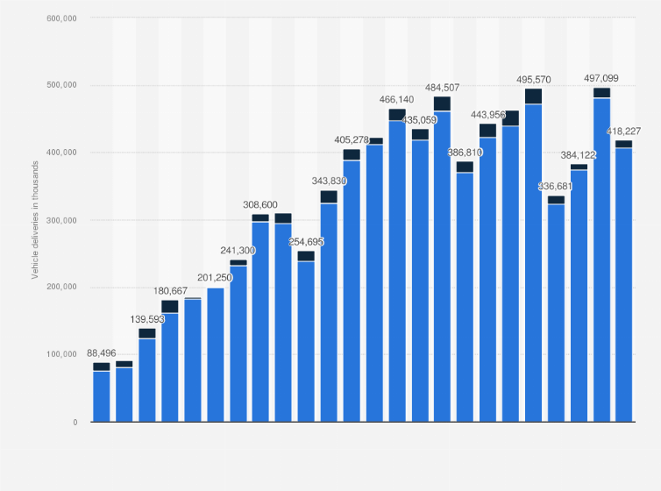
Figure 1: Tesla's vehicles delivered
(Source: Statista, 2025)
Tesla Inc. is an American producer of electric vehicles (EVs), energy storage and AI software, founded in 2003 by CEO Elon Musk and headquartered in Palo Alto, California. It is engaged in electric vehicle (EV) manufacturing, energy storage and artificial intelligence (AI). The accompanying chart illustrates Tesla's impressive growth in operations, driven by quarterly vehicle deliveries from roughly 88,496 in early 2020 to a peak of 497,099 in 2023, but slowing to about 418,227 vehicles in a recent quarter. This is a result of both strong market demand and market dynamics. Tesla’s 2023 report states that it sold more than 1.8 million vehicles, cementing its position as a global EV leader (Tesla, 2024). Tesla's size, innovation and vertical integration drive its competitive advantage.

2.2 Business Model
Tesla's business model is based on direct-to-consumer (DTC) sales, vertical integration, and an integrated software-hardware stack. Tesla sells directly to consumers, allowing for direct engagement, pricing and feedback loops, enhancing cost reduction and branding . Vertical integration is a key element of the model, with estimates indicating Tesla owns 80% of its supply chain, which includes battery manufacturing, assembly, and charging networks (TSI, 2025). This approach has led to a 15% reduction in production costs, improving profits and efficiency (Eightception, 2024). Moreover, Tesla's platform seamlessly links vehicles with its proprietary software, allowing over-the-air upgrades and autonomous driving features, further enhancing differentiation. This approach enabled revenue growth from $24.6 billion in 2019 to more than $96 billion in 2025, showcasing its success in attaining competitive advantage(Hieu and Duyen, 2025).Moreover, this approach allows Tesla greater control over the entire customer journey, from sales to post-sale support, minimising the need for distributors. Software integration also allows for ongoing product enhancements without hardware replacements, enhancing lifetime value. As a result, Tesla increases both operating efficiency and customer loyalty and long-term revenue streams.

2.3 Industry & Market Position
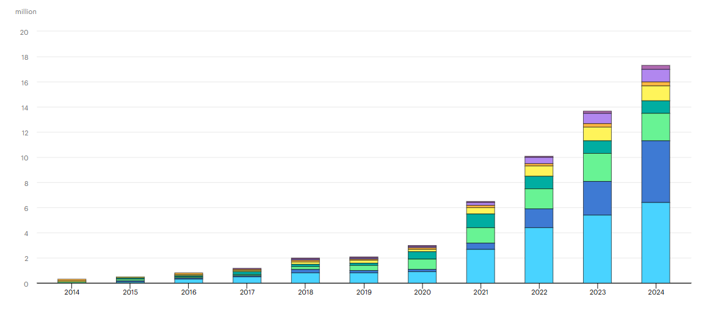
Figure 2: Global electric car sales, 2014-2024
(Source: IEA, 2025)
Tesla is in the fast-growing global electric vehicle (EV) and renewable energy sectors, with rapid growth and intense competition from companies including BYD, Volkswagen, Ford and Rivian. In 2024, more than 17 million electric vehicles were sold worldwide, with an increase of over 25%, and are expected to grow at 32.5% CAGR by 2030 (IEA, 2025).
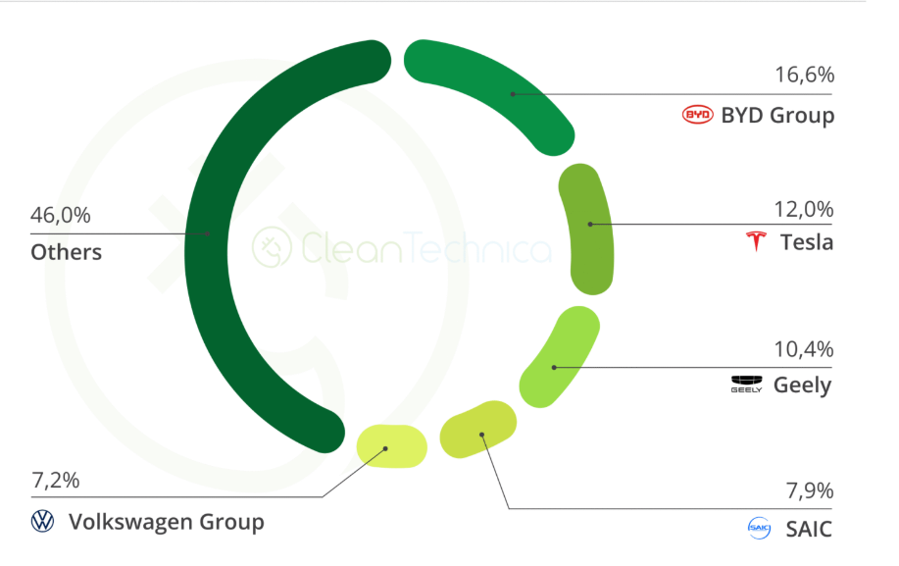
Figure 3: Global Electric Vehicle Market Share by Manufacturer (2024)
(Source: IEA, 2025)
This expansion has spurred competition, with BYD currently dominating the market with a share of about 19-20%, while Tesla remains a prominent player with a share of 7-12% in the global market, as a leading pure battery-electric vehicle (BEV) manufacturer (Pontes, 2026). While under pressure from other manufacturers, Tesla's competitive advantage is grounded in innovation, brand differentiation, and technological advancement, especially in autonomous driving and software integration. This allows Tesla to maintain a competitive advantage, while flexibly responding to market changes and global industry trends.

3. External & Internal Environment Analysis

3.1 PESTEL Analysis
Factor | Key Insight (with Data) | Strategic Impact | Opportunity / Threat
Political | Governments around the world offer EV subsidies and incentives; e.g., tax credits drove EV uptake in the US, China and EU (M, 2025). | Tesla profits from lower price and higher demand but risks subsidy phase-out and regulatory changes. | Opportunity
Economic | In 2023, EV battery demand was over 750 GWh (+40%), with cost and supply pressures,inflation and interest rates limit consumer spending (IEA, 2024). | Tesla's margins are impacted by cost volatility and price sensitivity of luxury vehicles. | Threat
Social | Demand for electric cars driven by environmental concerns; 20% of global car sales in 2024 were electric (Wang and Witlox, 2025). | Positive consumer shift supports Tesla's vision; drives loyalty and sales. | Opportunity
Technological | Accelerating technological advancements in AI, automation, battery technology; Tesla heavily invests in autopilot and software platforms (Kissinger, 2024). | Drives competitive advantage and sustainability but needs to invest heavily in R&D. | Opportunity
Environmental | International movement towards net-zero carbon emissions; 17 million EV sales in 2024 (+25%) (IEA, 2024). | Tesla's business model is in line with environmental and sustainability trends. | Opportunity
Legal | Growing focus on safety like, Autopilot recalls and privacy regulations with fines up to 4% of global turnover under GDPR (Buckley, 2015). | Regulatory compliance affects product rollout, costs, and reputation | Threat
Table 1: PESTEL Analysis
(Source: Self-Created)
Critical Evaluation
Tesla's operating environment seems to be mostly opportunity-based; however, this is contingent rather than sustainable. Government incentives like subsidies increase demand, but reliance on these policies creates risk (M, 2025). Likewise, favourable social and environmental factors facilitate EV uptake, but these benefits are industry-wide, not unique to Tesla. Innovation allows differentiation, but it also demands significant ongoing investment, raising risk (Kissinger, 2024). Economic factors, such as increasing battery and inflation costs, directly impact Tesla's profitability and pricing powers. Regulation also adds complexities (Buckley, 2025). Crucially, Tesla's profitability relies on its ability to consistently transform these opportunities into firm-specific advantages, while counteracting these threats.

3.2 Industry Analysis (Porter’s Five Forces)
Factor | Key Insight (with Data) | Strategic Impact | Outcome
Competitive Rivalry | More than 17 million EVs were sold worldwide in 2024, increasing competition among the global players like BYD, Volkswagen and Ford (IEA, 2025a). | Increasing competition forces Tesla to reduce prices and continuously innovate, placing pressure on margins | Threat
Threat of New Entrants | EV manufacturing and R&D is capital-intensive, often costing more than billions of dollars, posing a barrier (Yang and Fulton, 2023). | High barriers protect Tesla, but new technologically advanced entrants still challenge long-term market share | Threat
Buyer Power | There is a wider range of EV products for consumers, with more than 500 EV models globally in 2024, providing more choice (IEA, 2024a). | Greater choice increases price sensitivity and forces Tesla to improve value proposition and pricing strategies | Threat
Supplier Power | Battery expenses represent almost 30-40% of EV manufacturing cost and lithium-based batteries are expected to see a five-fold increase in demand by 2030 (IEA, 2024) | Dependence on critical raw materials increases cost volatility and supply chain risk | Threat
Threat of Substitutes | ICE vehicles still dominate global car sales (>70%), and public transport in urban areas. | Availability of cheaper alternatives limits EV adoption, particularly in developing markets | Threat
Table 2: Porter’s Five Forces
(Source: Self-Created)
Critical Evaluation
The EV industry structure is generally hostile, with most factors negatively impacting Tesla's profitability. Intense rivalry due to rapid growth leads to price and innovation pressures (IEA, 2025a). Growing buyer power also limits pricing power as customers are offered a wider range of EV options (IEA, 2024a). Suppliers retain power due to material constraints, affecting Tesla's production costs (IEA, 2024). While entry barriers are high, they do not preclude competition from technologically advanced and well-capitalised competitors (Yang and Fulton, 2023). Further, substitutes such as combustion vehicles still restrict industry transition. Critically, Tesla is in a "tough" industry, meaning that its competitive advantage is largely a function of its own efforts.

3.3 Critical Success Factors (CSFs)
Tesla's competitive advantage is based on a number of critical factors that impact its strategy. Battery technology plays a pivotal role since batteries account for 30-40% of total cost to produce EVs, and improving efficiency is vital for cost reductions, profitability and scalability (IEA, 2024). This allows Tesla to decrease costs and increase range, which enhances its competitive position. Efficiency is achieved through vertical integration and economies of scale, enabling Tesla to keep its prices up, relatively speaking. Thus, economies of scale and process optimisation are critical factors for success. Brand reputation is also a success driver, with high customer loyalty and technological innovation. Tesla's brand strength around innovation adds value, affecting consumer choices in a crowded marketplace. The charging ecosystem is important. In 2025, Tesla has more than 8,100 Supercharger stations globally with over 80,000 connectors, ensuring widespread availability (PTI, 2026) . This alleviates range anxiety and enables EV uptake as research shows charging infrastructure is a critical factor in EV uptake . In sum, these factors allow Tesla to maintain a competitive advantage by meeting market needs with technology.

3.4 Internal Analysis
Tesla's internal setting is characterised by a unique blend of tangible, intangible and human resources that collectively support the company's competitive advantage. Tesla’s tangible resources are exemplified by the company's global Gigafactories that allow for economies of scale. These enable vertical integration and have allowed production to scale up, helping Tesla to produce more than 1.8 million vehicles in 2023 (Tesla, 2024). Tesla's intangible resources are its key strengths. Tesla's brand is synonymous with innovation and sustainability, enhancing brand loyalty and ability to charge a premium. Moreover, Tesla's software and artificial intelligence (AI) technologies, especially in autonomous driving and over-the-air updates, enable ongoing product innovation and differentiation. Studies emphasise the importance of software integration in the EV industry (Chauhan and Rani, 2024). Employee skills, particularly in advanced engineering, are a key source of Tesla's innovation. High-tech talent enables Tesla to develop innovative AI, battery technologies and manufacturing techniques. In summary, Tesla's bundled resources support efficient operations, innovation and growth, the basis of its competitive advantage.The extensive use of technology and innovation makes operations more complex and demands ongoing investment, which could impact profits. Moreover, Tesla's strong brand is exposed to potential reputational risks from product problems or corporate governance challenges. Tesla's reliance on its engineers also presents human resource challenges in a tight labour market. So, while Tesla has many resources, they provide a source of advantage that needs to be managed effectively, through ongoing innovation and risk mitigation in a dynamic environment.

3.5 VRIO Framework
Resource / Capability | Valuable | Rare | Inimitable | Organised | Competitive Implication
Brand Reputation | Yes | Yes | Yes | Yes | Sustained Competitive Advantage
Autonomous Driving & AI Software | Yes | Yes | Yes | Yes | Sustained Competitive Advantage
Gigafactories (Manufacturing Scale) | Yes | No | No | Yes | Temporary Competitive Advantage
Supercharger Network | Yes | Yes | Yes | Yes | Sustained Competitive Advantage
Engineering Talent | Yes | No | No | Yes | Temporary Competitive Advantage
Table 3: VRIO Analysis
(Source: Self-Created)
Tesla's VRIO analysis shows that its long-term competitive advantages lie in intangible rather than tangible resources. Its brand is globally recognised for innovation and sustainability, driving customer retention and ability to charge a premium (Farooqui and Mehmood, 2026). Likewise, Tesla’s self-driving capabilities and artificial intelligence are valuable, rare and inimitable due to ongoing software updates and data collection, and will be a future competitive advantage. The Supercharger network, comprising more than 80,000 connectors worldwide, also adds to Tesla's ecosystem, by improving customer convenience and eliminating range anxiety, further helping with customer retention and competitive advantage. By comparison, physical assets like Gigafactories offer economies of scale and efficiency, but are increasingly mimicked by other firms heavily investing in EV manufacturing. Engineering talent is critical but not scarce in a global market where industry leaders compete for the same talent. Ultimately, Tesla's long-term advantage is the result of creating fit between its brand, software and infrastructure to provide a competitive advantage.

3.6 Critical Evaluation
Tesla's competitive advantage can be seen as a product of fit between its internal and external environment. Tesla does not just react to the market, it strategically fits its competencies (particularly its technology ecosystem, branding and innovation) to external factors such as sustainability concerns, technological changes and government policies (Jinshuo, 2024). In particular, Tesla's vertical integration and software-centricity enable it to harness external factors, such as sustainability and electrification of the industry, to gain competitive advantage (Nezhadkian and Zho, 2024). This allows it to grow and stand out. Indeed, the high-tech nature and high-end positioning makes Tesla potentially cost-pressured and easily imitated as competitors accelerate their innovation, and match Tesla's technological advances. And Tesla's innovative strategy is not flexible: its competitive advantage may wane if it cannot sustain its technological lead. Finally, Tesla exhibits a high level of strategic fit, but it is dynamic as the company needs to adapt to the changing environment and capabilities and therefore needs a high degree of strategic integration to gain competitive advantage.Furthermore, Tesla's ability to maintain this strategic fit is dependent on its dynamic capabilities, particularly its sensing, seizing and reconfiguring of resources to changing factors. In a dynamic environment, learning and flexibility are important for fit. Further, environmental uncertainties such as regulatory changes and supply chain disruptions may undermine this fit. So, Tesla will need to play to its existing strengths but also evolve its strategy.

4. CSR & Sustainability
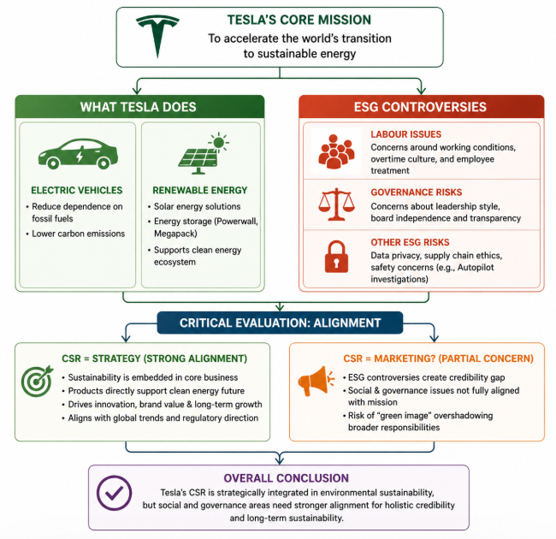
Figure 4: CSR & Sustainability
(Source: Zhang, 2025)
Tesla's business model is based on its commitment to the world's sustainable energy future; here, sustainability is not an add-on but part of the business. Tesla's business operations - electric vehicles, energy storage and solar power - are associated with decarbonisation and renewable energy generation . This implies that Tesla's CSR is embedded within its value creation process. At the strategic level, Tesla demonstrates a high level of environmental goal congruence with its strategy. Its focus on electric vehicles and energy storage enables both market and regulatory fit, enabling it to ride the global sustainability wave. This is an example of a proactive CSR strategy, in which sustainability supports long-term performance and innovation. Tesla has faced ESG concerns over labour issues, employment practices and transparency. This is a disconnect between its environmental success and social and governance CSR (Zhang, 2025). So, is Tesla's CSR holistic or strategically positioned to achieve competitive advantage? In conclusion, Tesla's CSR is a strategy and selectivity. While it is serious about incorporating environmental sustainability into its strategy, it doesn't have social and governance aspects, which demonstrates strategy. Therefore, Tesla's CSR can be considered as integrated, but not necessarily holistic, with environmental sustainability as a competitive advantage and other aspects of ESG to be enhanced for sustainability.

5. Balanced Scorecard
Perspective | Objective | KPI | Initiative | Strategic Link
Financial | Revenue growth and profitability | Revenue growth rate, operating margin | Cost reduction through economies of scale and vertical integration | Supports Tesla’s strategy of scaling EV production while maintaining margins through efficiency and cost leadership elements
Customer | Enhance brand loyalty and customer experience | Customer satisfaction scores, repeat purchases | Expansion of Supercharger network and software updates | Strengthens Tesla’s differentiation strategy through superior user experience and ecosystem integration
Internal Processes | Improve production efficiency and operational excellence | Vehicle output, production cycle time | Expansion of Gigafactories and automation | Aligns with Tesla’s strategy of vertical integration and large-scale manufacturing efficiency
Learning & Growth | Drive innovation and technological leadership | R&D expenditure, AI development progress | Investment in AI, autonomous driving, and software development | Supports long-term differentiation and sustained competitive advantage through innovation
Table: Balanced Scorecard
(Source: Self-Created)
Tesla's Balanced Scorecard is a highly integrated model, in which financial and non-financial metrics support its competitive strategy. The financial perspective emphasises revenue and profit growth, tied to Tesla’s capacity to expand production and control costs (Patel, 2025). By integrating aspects of production and achieving economies of scale, Tesla can minimise costs and offer competitive pricing with healthy margins. This is a hybrid strategy that includes elements of cost leadership and differentiation.
From the customer viewpoint, Tesla focuses on customer retention through brand loyalty and improved customer experience. Tesla fosters long-term relationships through its ecosystem, such as Supercharger and over-the-air software upgrades (Li, 2023). This offers greater convenience, lowers churn and increases retention. In turn, Tesla’s customer strategy underpins its luxury brand and technological innovation strategies. The internal process perspective is crucial to Tesla's strategy. Gigafactories allow for economies of scale, simplification and efficiency in manufacturing. This is consistent with Tesla's vertically integrated approach, enabling them to control quality, cost and supply chain. Streamlined processes are essential to meet global demand, as well as ensuring quality and speed in production.
Tesla's long-term strategy is rooted in the learning and growth perspective. Investment in research and development in areas such as artificial intelligence and autonomous driving, ensures Tesla continues to lead the industry in technological development (Miao, 2025). This enables Tesla to continually enhance its products via software upgrades, further supporting its differentiation strategy. Importantly, Tesla's Balanced Scorecard reflects effective alignment, with each view contributing both to operational efficiency and ensuring long-term advantage. But the emphasis on innovation and technological leadership carries risk, as this approach demands ongoing investment and evolution. In summary, the Balanced Scorecard demonstrates Tesla's ability to link efficiency, customer satisfaction and innovation for strategic alignment and market dominance.

6. Strategic Choices & Implementation

6.1 Business-Level Strategy
Tesla primarily employs a differentiation strategy through technological innovation, brand positioning and software integration. It markets its cars as high-end, high-performing, high-tech products, and provides capabilities like self-driving and software updating. This allows Tesla to build brand loyalty and value. A similar approach is pursued by Apple through differentiation via design, ecosystem and innovation. This has allowed Apple to command higher prices and maintain customer loyalty, showcasing how differentiation through technology can drive long-term success (Siahaan, 2023) But Tesla's differentiation is under threat due to competition copying EV technology and bridging performance gaps. This reduces uniqueness and intensifies competition. Consequently, differentiation has been successful in the past, but is only sustainable through innovation. Tesla needs to maintain its technological advantage to retain its strategic edge.

6.2 Corporate-Level Strategy
Tesla's corporate strategy includes vertical integration, globalisation, and diversification in energy. Tesla's vertical integration enables it to manage manufacturing, sourcing and distribution, thereby enhancing efficiency and decreasing supplier risk.
The outcome of vertical integration is similar to those achieved by Amazon in logistics and distribution, which have improved efficiency and customer satisfaction (Vidani, 2024). Likewise, Tesla's Gigafactories and direct-to-consumer sales allow for cost and quality control. Internationalisation is also a critical strategy, with Tesla setting up plants in various locations to tap into new markets and cut transport costs. Offering energy products (battery and solar) supports Tesla's role as an energy company. These approaches improve scalability and growth, but also add to complexity and capital needs, so execution is key to future success.

6.3 Recommendation
Tesla should adopt a hybrid strategy combining cost leadership and differentiation. Tesla should continue to position itself as a high-tech luxury brand while also emphasising cost efficiency to reach mainstream markets. This dual strategy enables it to target both premium and low-price segments.
This approach has been successful for Toyota, which operates with cost efficiency and quality differentiation, allowing it to lead the global auto industry. This cost-quality balance has allowed Toyota to scale and prosper (Takeuchi, 2023). This would involve Tesla streamlining costs by leveraging scale while also investing in artificial intelligence (AI), battery technology and software. This balanced strategy would fortify Tesla’s market position, increasing its market share while retaining its technological edge. This approach is crucial to avoid over-dependence on a premium segment and build resilience in a competitive market.

6.4 Change Management Analysis
Tesla faces substantial change management issues as it seeks to expand production, globalise its operations and uphold quality standards. The company's management structure is highly centralised, allowing for rapid decision-making, but also creating a reliance on management. For example, Netflix has successfully adapted to large-scale change from DVD sales to digital streaming through organisational flexibility and innovation (Kapadia et al., 2025). This highlights the need for flexibility in the fast-paced environment. Tesla has made significant strides in scaling and innovating; however, issues like production delays, quality control and human resources issues point to execution issues. Centralised decision-making, effective for fast pace, may reduce adaptability and risk-taking. Crucially, Tesla's change management is successful in responding to innovation but needs to be complemented with better operational control and decentralisation to facilitate long-term execution and organisational performance.

7. Strategic Evaluation & Recommendations

7.1 SWOT Analysis
Strengths | Weaknesses
Strong innovation capability in EVs, AI, and software integration, enabling continuous product differentiation. | High production and operational costs, particularly in battery technology and global expansion.
Globally recognised brand associated with sustainability and advanced technology, supporting premium positioning (Nascimento and Maria, 2024). | Overdependence on premium pricing strategy, limiting accessibility to mass-market segments.
Vertical integration and control over supply chain improve efficiency and quality management. | Centralised leadership structure may create decision-making bottlenecks and operational risks (Pacheco-Cubillos, Boria-Reverter and Gil-Lafuente, 2024).
Opportunities | Threats
Rapid growth in global EV demand driven by sustainability trends and regulatory support. | Intensifying competition from established automakers and new EV entrants.
Expansion into emerging markets and diversification into renewable energy solutions (Nibedita and Irfan, 2024). | Price wars and technological imitation reducing differentiation advantage (Lok, Lee and Lei, 2025).
Advancements in AI and battery innovation enabling long-term competitive advantage. | Supply chain disruptions and raw material dependency increasing cost volatility.
Table 4: SWOT Analysis
(Source: Self-Created)

7.2 Ansoff Matrix
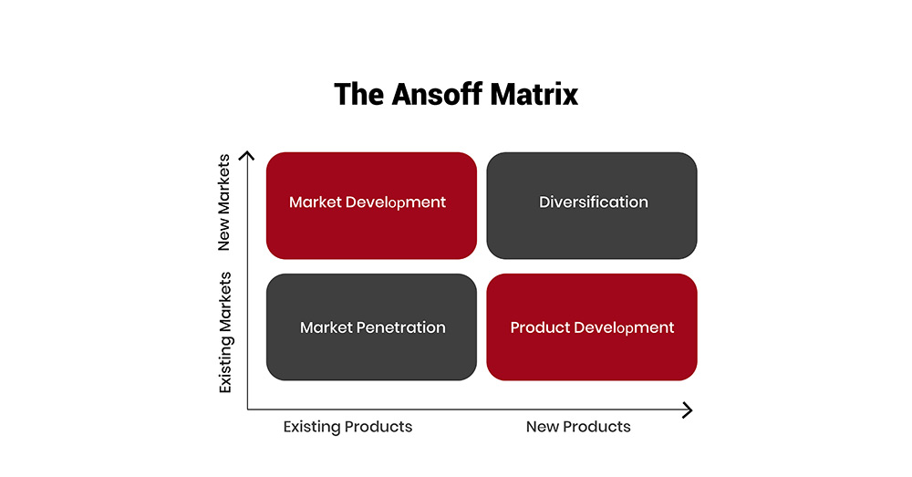
Figure 5: Ansoff Matrix
(Source: Lei, 2025)
Tesla's growth strategy can be categorised into the Ansoff Matrix, which is balanced with all four strategies. Market penetration is evident in the success of the Model 3, which enables Tesla to penetrate existing markets by increasing its market share in those markets (Lei, 2025). Tesla's market share in the highly competitive EV industry grew as the Model 3 was less expensive than the earlier models. Market development is seen in Tesla's attempt to expand into new markets, such as the new markets in India. This allows Tesla to enter new markets, but it has to adapt to the market in terms of pricing and infrastructure. Product development is evident in the development of new products, such as the Cybertruck, which expands Tesla's product portfolio, and serves new segments in existing markets (Micucci, 2025). This helps Tesla differentiate and its business model that focuses on innovation. Finally, diversification is evident as Tesla moves into energy storage and solar with batteries. This adds another revenue stream and positions Tesla as a green energy company. Overall, Tesla's use of all four of the strategies is a comprehensive approach to growth, and managing the risks and rewards of markets and products.

7.3 Final Recommendations
Tesla should consider a strategy to enhance competitive advantage through a theory-driven approach. First, Tesla should move into new markets (India and Africa) as suggested by the Ansoff Matrix (market development) helping Tesla access new markets and diversify risk (Tarhan, 2016). These are potential markets for future growth; but it requires pricing and infrastructure re-adaptation. This aids revenue growth and provides diversification. Second, cost optimisation is key to support business competitiveness, particularly under the threat of industry competition (Porter's Five Forces). Strong buyer power and price sensitivity require cost reduction from Tesla in the form of economies of scale and efficiency gains (Bendegúz, 2025). It also enables a hybrid strategy by enabling Tesla to offer products to the mass market while remaining profitable. Third, improvements in governance address the SWOT analysis weakness and align with CSR and stakeholder theory. Better governance increases investor confidence and minimises legal and reputational risk, improving sustainability. This is crucial amid increasing external pressures (Farag, 2025). Lastly, battery research and development enhances Tesla's capability (VRIO model). Battery technology is valuable, rare and costly to imitate, providing a competitive advantage. Increased efficiency and performance will also differentiate Tesla and lower its costs. By simultaneously addressing market expansion, cost, company governance and innovation, Tesla will improve its competitive performance and stay ahead in a very competitive future electric vehicle industry.

SECTION 2 – Reflective Report (Kolb’s Reflective Cycle)
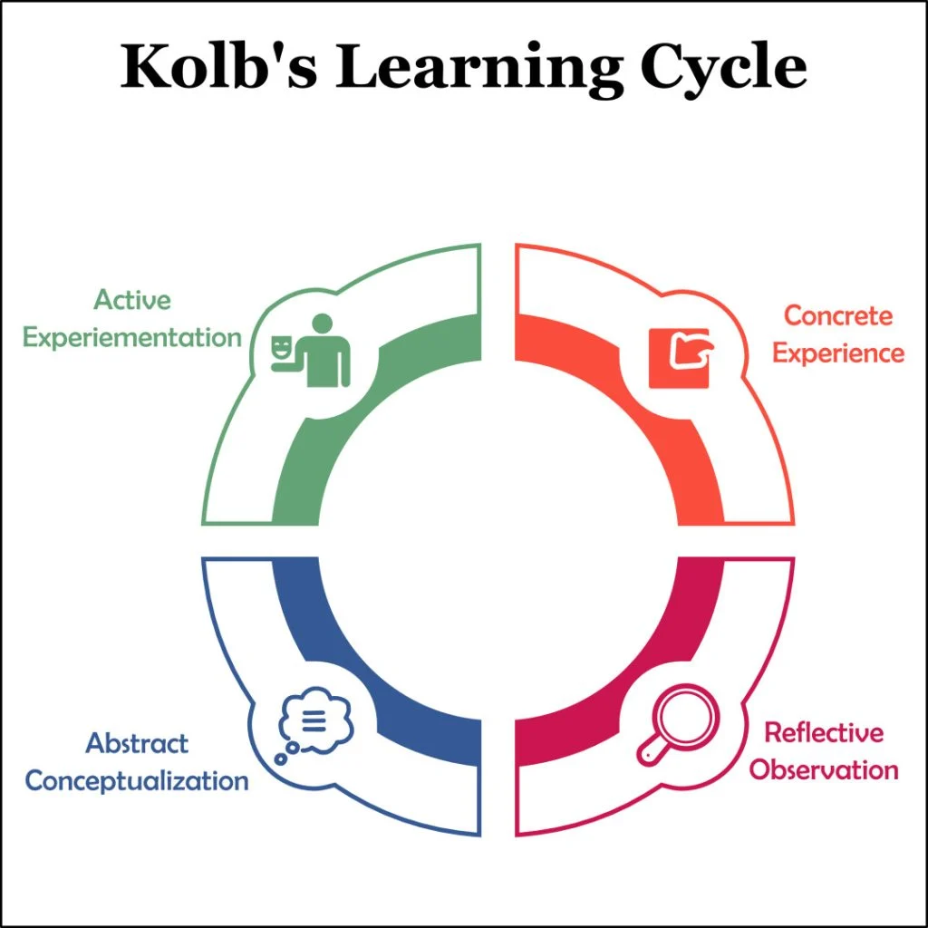
Figure 6: Kolb’s Reflective Cycle
(Source: Vince, 2022)

1. Concrete Experience
The research, analysis and preparation of the strategic management report on Tesla involved the synthesis of different theories, reports and data. The difficulty was in the selection of an appropriate organisation and its analysis of strategic management in a dynamic industry. This organisation was chosen because of its popularity in the electric vehicle and renewable energy industry and its link to today's strategic management issues such as sustainability and disruptive technology (Kleinheksel et al., 2023). During the research, I sourced information from journals, industry reports and corporate documents. I applied a number of strategic management analysis and tools such as PESTEL, Porter's Five Forces, VRIO, Balanced Scorecard and the Ansoff Matrix to understand Tesla's external and internal environments. I also analysed statistical data, trends and related theory to practice. The report was structured according to the task requirements and academic conventions (such as referencing and academic writing) were followed.Additionally, the process involved continuous refinement of ideas as ideas needed to be revised in the light of new information. I also re-read and reviewed sections to enhance clarity and cohesiveness. This process highlighted the importance of connecting theory and practice, and logical reporting.

2. Reflective Observation
On reflection, I discovered that the early stages of research were complex as there was a large volume of information. Selecting relevant and reliable sources was essential, and involved discerning between academic and less rigorous articles online. I also realised that while collecting data was relatively simple, critically analysing and connecting data to strategic approaches required a greater understanding. Finding the right balance between description and analysis was also a challenge. I sometimes become overly descriptive, rather than critical and analytical. Also, it was difficult to synthesise different frameworks to build a cohesive argument as each model offered a different view of Tesla's strategic approach (Barbierato and Gatti, 2024). But as time went on, I felt more comfortable in connecting these models to create a coherent analysis.I realised that in my approach, there was no prioritisation and hence time was wasted. Some of my time was wasted gathering information rather than assessing its pertinence. This process allowed me to recognise the need for prioritising quality over quantity. Further, self-review feedback allowed me to identify areas where arguments may have been improved through better justification and connecting the theory with practice.

3. Abstract Conceptualisation
This process enhanced my knowledge of strategic management concepts and their application. Models like PESTEL and Porter’s Five Forces improved my external environment analysis skills, whereas the VRIO model and Resource-Based View (RBV) showed me how internal resources can be used to gain competitive advantage.
Kolb's learning cycle highlights the importance of converting experience to knowledge, which I did in progressing from understanding to evaluation (Meijer et al., 2022). I discovered that strategic analysis is not solely focused on using models but also understanding the interaction between internal and external conditions. Strategic fit was a critical concept as it explains how organisations match resources with the environment to maintain competitive advantage.
What's more, I learned that critical thinking and substantiated arguments are vital in academic work. Readings of current research helped me to understand current issues in industry, and better apply the theories. It also highlighted the importance of structured and systematic reasoning in solving business challenges.Furthermore, I became more aware of the interconnected nature of strategic models, and how they interact. This blending of approaches improved my capabilities to develop more holistic and sophisticated arguments, demonstrating greater analytical sophistication.

4. Active Experimentation
This learning experience would help me to do future assignments more tactically and critically. Firstly, I would look for appropriate academic references at the beginning of the research process, to enhance the validity of the analysis. I would also ensure that in each section of the assignment I can answer "how" and "why" rather than just "what". I would also need to develop research skills in using multiple frameworks and think of the relationships, instead of the frameworks individually. It will improve the rigour and integration of the analysis. I would also be more efficient with my time, by allocating time for reviewing and editing the assignment, to improve clarity and quality. The skills that I learned from this assignment can be applied to practice in the form of strategic management (Vázquez-Calatayud et al., 2024). The ability to analyse complex systems, organisational strengths and weaknesses, and to offer recommendations are important skills for managers. Overall, this assignment has enhanced my analytical, research and critical thinking skills, which will assist me in future studies and in practice.For the future I would also try to improve my writing skills, to write more iteratively, to get feedback and revise work as you go, rather than just after it has been written. This may improve the quality of the analysis. Additionally, I would like to improve my communication skills to be able to better convey complex issues more effectively, with the same level of critical analysis.

Reference List
Barbierato, E. and Gatti, A. (2024) ‘The Challenges of Machine Learning: A Critical Review’, Electronics, 13(2), pp. 416–416. Available at: https://doi.org/10.3390/electronics13020416.
Bendegúz, M.V. (2025) ‘Teslas pricing strategy and its economic impact on market demand - Dolgozattár’, Uni-bge.hu [Preprint]. Available at: http://dolgozattar.uni-bge.hu/58720/1/Teslas%20pricing%20strategy%20and%20its%20economic%20impact%20on%20market%20demand-CJWDM5.pdf.
Buckley, G. (2025) ‘Privacy at the intersection of technology, business and regulation: A case study of the GDPR - UCL Discovery’, Ucl.ac.uk [Preprint]. Available at: https://discovery.ucl.ac.uk/id/eprint/10205245/2/GBThesis_Final.pdf.
Chauhan, A. and Rani, M.V. (2024) ‘Comparative Insights: Untangling IoT Success Factors in Traditional vs. Electric Vehicle Manufacturers’, IEEE Transactions on Engineering Management, pp. 1–15. Available at: https://doi.org/10.1109/tem.2024.3415496.
Eightception (2024) Why Vertical Integration Worked for Tesla (And Why It Might Not Work for You), Eightception. Available at: https://eightception.com/tesla-vertical-integration-strategy/ (Accessed: 1 May 2026).
Farag, M.I.H. (2025) ‘The Role of SWOT Analysis in Enhancing Business Growth and Long-Term Management Sustainability’, Management Science Advances, 2(1), pp. 304–329. Available at: https://doi.org/10.31181/msa21202528.
Farooqui, M. and Mehmood, S. (2026) ‘STRATEGIC RESOURCES AND SUSTAINABLE COMPETITIVE ADVANTAGE:AN EMPIRICAL EXAMINATION THROUGH THE RESOURCE-BASED VIEW’, Advance Journal of Econometrics and Finance, 4(1), pp. 1796–1806. Available at: https://doi.org/10.63075/tqpg0861.
Hieu, N.H.T. and Duyen, P.T.M. (2025) ‘INNOVATION IN THE EV INDUSTRY: CASE STUDY OF TESLA 2019 – 2025’, Zenodo (CERN European Organization for Nuclear Research) [Preprint]. Available at: https://doi.org/10.5281/zenodo.17588714.
IEA (2024a) Outlook for battery and energy demand – Global EV Outlook 2024 – Analysis, IEA. Available at: https://www.iea.org/reports/global-ev-outlook-2024/outlook-for-battery-and-energy-demand (Accessed: 1 May 2026).
IEA (2024b) Trends in Electric Cars, IEA. Available at: https://www.iea.org/reports/global-ev-outlook-2024/trends-in-electric-cars (Accessed: 1 May 2026).
IEA (2024c) Trends in electric vehicle batteries – Global EV Outlook 2024 – Analysis - IEA, IEA. Available at: https://www.iea.org/reports/global-ev-outlook-2024/trends-in-electric-vehicle-batteries (Accessed: 1 May 2026).
IEA (2025a) Executive summary – Global EV Outlook 2025 – Analysis - IEA, IEA. Available at: https://www.iea.org/reports/global-ev-outlook-2025/executive-summary (Accessed: 1 May 2026).
IEA (2025b) Trends in electric car markets – Global EV Outlook 2025 – Analysis - IEA, IEA. Available at: https://www.iea.org/reports/global-ev-outlook-2025/trends-in-electric-car-markets-2 (Accessed: 1 May 2026).
Jinshuo, L. (2024) A STUDY OF THE FACTORS INFLUENCING CORPORATE PERFORMANCE FROM AN ENVIRONMENTAL PERSPECTIVE: A CASE STUDY OF TESLA, INC. LI JINSHUO 6517195811 AN INDEPENDENT STUDY SUBMITTED IN PARTIAL FULFILLMENT OF THE REQUIREMENTS FOR THE DEGREE OF MASTER OF BUSINESS ADMINISTRATION GRADUATE SCHOOL OF BUSINESS. Available at: https://e-research.siam.edu/wp-content/uploads/2025/03/MBA-2024-IS-Li-Jinshuo-6517195811-A-Study-of-the-Factors-Influencing.pdf (Accessed: 1 May 2026).
Kapadia, P., Patel, B., Makadia, J., Vasa, J. and Shaikh, N. (2025) ‘Agile-Driven Innovation in Streaming Services: Netflix’s Strategic Benefits from Agile Amalgamation’, Lecture Notes in Networks and Systems, pp. 237–247. Available at: https://doi.org/10.1007/978-981-96-4142-0_20.
Kissinger, D. (2024) Tesla PESTEL/PESTLE Analysis & Recommendations - Panmore Institute, Panmore Institute. Available at: https://panmore.com/tesla-motors-inc-pestel-pestle-analysis-recommendations (Accessed: 1 May 2026).
Kleinheksel, A.J., Chen, W., Rudd, M.J., Drowos, J., Gupta, S., Minor, S. and Bailey, J.M. (2023) ‘Putting reflection back into practice: Kolb’s theory of experiential learning as a theoretical framework for just-in-time faculty development’, SN Social Sciences, 3(3). Available at: https://doi.org/10.1007/s43545-023-00649-z.
Lei, C. (2025) ‘Analysis of Tesla International Strategies’, Studies in big data, pp. 237–246. Available at: https://doi.org/10.1007/978-3-031-83911-5_21.
Li, Y. (2023) ‘Analysis of Tesla’s Marketing Strategy Model’, Advances in Economics Management and Political Sciences, 54(1), pp. 33–39. Available at: https://doi.org/10.54254/2754-1169/54/20230873.
Lok, C.K., Lee, B.P. and Lei, U.M. (2025) ‘Enhancing Guest Experiences Through Smart Hotel Systems in the Hotel Industry in China: A System Integration Approach’, Proceedings of the World Congress on Electrical Engineering and Computer Systems and Science [Preprint]. Available at: https://doi.org/10.11159/cist25.143.
M, M. (2025) Tesla PESTEL Analysis: The Electric Car Revolution, Project Templates. Available at: https://www.projectmanagertemplate.com/post/tesla-pestel-analysis-the-electric-car-revolution (Accessed: 1 May 2026).
Meijer, M.W., Brandhuber, T., Schneider, A. and Berberat, P.O. (2022) ‘Implementing Kolb´s Experiential Learning Cycle by Linking Real Experience, Case-Based Discussion and Simulation’, Journal of Medical Education and Curricular Development, 9(2), pp. 1–5. Available at: https://journals.sagepub.com/doi/full/10.1177/23821205221091511 (Accessed: 1 May 2026).
Miao, D. (2025) ‘Tesla’s Innovation Management Strategy and Market Strategy Optimization Analysis’, pp. 224–229. Available at: https://doi.org/10.5220/0013988900004916.
Micucci, L. (2025) ‘Electric vehicles: Actual market and future prospects , with a focus on battery technology - Webthesis’, Polito.it [Preprint]. Available at: https://webthesis.biblio.polito.it/35717/ (Accessed: 1 May 2026).
Nascimento, J. and Maria, S. (2024) ‘Mapping the sustainability branding field: emerging trends and future directions’, Journal of Product & Brand Management, 33(2). Available at: https://doi.org/10.1108/jpbm-02-2023-4349.
Nezhadkian, M. and Zho, W. (2024) Leveraging AI and IoT for Industry Transformation: A Case Study of Tesla’s Technological Integration and Strategic Innovation, Information Sciences and Technological Innovations. Available at: https://isti.reapress.com/journal/article/view/29 (Accessed: 1 May 2026).
Nibedita, B. and Irfan, M. (2024) ‘Energy mix diversification in emerging economies: An econometric analysis of determinants’, Renewable and Sustainable Energy Reviews, 189, p. 114043. Available at: https://doi.org/10.1016/j.rser.2023.114043.
Pacheco-Cubillos, D.B., Boria-Reverter, J. and Gil-Lafuente, J. (2024) ‘Transitioning to Agile Organizational Structures: A Contingency Theory Approach in the Financial Sector’, Systems, 12(4), p. 142. Available at: https://doi.org/10.3390/systems12040142.
Patel, J. (2025) ‘Financial Performance in Manufacturing: Analyzing Cost Structures and Profitability Metrics’, IJAIDR - Journal of Advances in Developmental Research, 12(1). Available at: https://doi.org/10.5281/zenodo.15104218.
Pontes, J. (2026) Global EV Sales Leaders — Top Selling Brands & OEMs in 2025 - CleanTechnica, CleanTechnica. Available at: https://cleantechnica.com/2026/02/03/global-ev-sales-leaders-top-selling-brands-and-oems/ (Accessed: 1 May 2026).
PTI (2026) Electric carmaker Tesla to expand supercharging network in India, The Hindu. Available at: https://www.thehindu.com/business/Industry/electric-carmaker-tesla-to-expand-supercharging-network-in-india/article70901082.ece (Accessed: 1 May 2026).
Siahaan, M. (2023) ‘Analysis and Evaluation of the Business Innovation Strategy: a Case Study of Apple Inc.’, Enigma in Economics, 1(2), pp. 42–48. Available at: https://doi.org/10.61996/economy.v1i2.30.
Statista (2025) Tesla vehicle deliveries by main model series 2025| Statista, Statista. Available at: https://www.statista.com/statistics/801157/tesla-quarterly-vehicle-deliveries-by-model/?srsltid=AfmBOoqtObHczibPVNwW562fkdDMWIUjy3IWS-Y9b1Wb-jSXKtMAIYlT (Accessed: 1 May 2026).
Takeuchi, I. (2023) ‘Navigating Competition through Alliances: An Analysis of Toyota’s Strategy in the Japanese Auto Industry’, Journal of strategic management, 7(6), pp. 1–12. Available at: https://doi.org/10.53819/81018102t4188.
Tarhan, H. (2026) ‘Corporate Strategy in a Complex World’, Bridging Traditional Theory and Emerging Corporate Strategies, pp. 27–66. Available at: https://doi.org/10.4018/979-8-3373-6466-7.ch002.
Tesla (2024) Tesla Vehicle Production & Deliveries and Date for Financial Results & Webcast for Fourth Quarter 2023 | Tesla Investor Relations, Tesla. Available at: https://ir.tesla.com/press-release/tesla-vehicle-production-deliveries-and-date-financial-results-webcast-fourth-quarter-2023 (Accessed: 1 May 2026).
TSI (2025) Inside Tesla’s Blueprint: Strategy, Sustainability, and Competitive Edge, Thestrategyinstitute.org. Available at: https://www.thestrategyinstitute.org/insights/inside-teslas-blueprint-strategy-sustainability-and-competitive-edge (Accessed: 1 May 2026).
Vázquez-Calatayud, M., García-García, R., Regaira-Martínez, E. and José Gómez-Urquiza (2024) ‘Real-world and game-based learning to enhance decision-making’, Nurse Education Today, 140, pp. 106276–106276. Available at: https://doi.org/10.1016/j.nedt.2024.106276.
Vidani, J. (2024) ‘E-Commerce Supply Chain Efficiency: A Case Study of Amazon E-Commerce Company’, Social Science Research Network, 7(1). Available at: https://doi.org/10.2139/ssrn.4849852.
Vince, R. (2022) ‘Reflections on “Behind and Beyond Kolb’s Learning Cycle”’, Journal of Management Education, 46(6), pp. 983–989. Available at: https://doi.org/10.1177/10525629221114040.
Wang, Y. and Witlox, F. (2025) ‘Global trends in electric vehicle adoption and the impact of environmental awareness, user attributes, and barriers’, Energy Reports, 13, pp. 1125–1137. Available at: https://doi.org/10.1016/j.egyr.2024.12.054.
Yang, H. and Fulton, L. (2023) ‘Decoding US investments for future battery and electric vehicle production’, Transportation Research Part D: Transport and Environment, 118, p. 103693. Available at: https://doi.org/10.1016/j.trd.2023.103693.
Zhang, L. (2025) ‘Business Practice and Green Finance’, pp. 415–431. Available at: https://doi.org/10.1007/978-3-031-87829-9_19.

