Module Title: Problem Solving and Decision Making

Module Code: LCLM 4004

Assessment: Component 2 Report – Basil’s Bakery

Student Name: Rachelle Morada

Student Number: 2531934

Lecturer’s Name: Charles Obinwa

Table of Contents

Overview of Case Study 3
Two Proposed Solutions 3
Evaluation Results & Justification 4
Justification of Risk Analysis 4
Justification of Implementation Plan 5
Justification for the KPI and SMART Objectives 6
Key Findings 6

References 7

APPENDICES

PMI Evaluation Table 9
Risk Analysis 10
Implementation Plan 11
Key Performance Indicator 12

Overview of Case-study

In the previous weeks we have been discussing Basil’s Bakery, an Artisan Bakery located in Coventry Retail Park. The bakery was established in 2015 and has experienced good sales growth year on year until after COVID-19. After the pandemic, the bakery has experienced sales growth of 25% and has not grown since. The stagnation in sales was mainly caused by low footfall within the retail park as a result of shop closures and the introduction of hybrid working. Additionally, the bakery is unable to accommodate changing customer preferences of Online delivery and Pre-ordering options further contributing to the decline in the income turnover of the bakery. In this report, we will be covering the proposed solutions and the overall recommendation that is backed by PMI and Risk Analysis and SMART Objectives.

Two Proposed Solutions

Based on the problem stated as stagnated sales since 2020, we can introduce 2 solutions to improve the sales performance of the business they are as follows:

- Introduce Online ordering and delivery systems –According to the Office for National Statistics (Office for National Statistics, 2025) with the current change in the customer preferences to shop online due to hybrid working, partnering with services such as UberEats, Deliveroo and JustEats will allow the business to expand its service and market reach. Basil’s Bakery heavily relied on customer footfall to achieve its sales targets. With the help of this new service feature, the bakery’s sales numbers will no longer heavily rely on customers physically purchasing baked products in the shop. An expected outcome is that the bakery will be able to increase sales volume because of the service.

- Digital Marketing. In the current day and age of Social Media, Digital Marketing has now become an essential growth strategy for any business operation. The cost to start an online marketing campaign is significantly small. However, the time needed to create effective and eye-catching content can take time and effort. This still proves one of the best current marketing strategies used by any business wishing to increase their sales. This strategy expands the customer reach and opens the business to new customers and different kinds of partnerships from influencer based tie up to corporate catering partnerships. This fits perfectly with the online delivery solution proposed earlier.

Evaluation Results and Justifications

Based on the PMI Evaluation, Online Ordering and Delivery is the preferred solution for Basil’s Bakery. The criteria used were based on sales potential, customer reach and ease of implementation, cost and customer convenience as these all relates to the stagnant sales and reliance of customer footfall.
PMI Analysis was used in this case study as this is an effective thinking tool developed by Edward de Bono that allows people to weigh the advantages and disadvantages of an idea before reaching an objective decision.

The results of the PMI Analysis as seen in Appendix 1; shows that Platform cost and potential product quality issues during delivery shows to be disadvantages, the solution still gives an opportunity for the business to grow and expand market reach without simply relying on physical customer visits. However, if we look at Sales potential and Customer reach this is given greater weightings because increasing the sales and expanding customer reach outside of the retail park are the primary objectives of the proposed solution. Ease of implementation and cost were also considered as criteria due to ensure the solution is realistic for a small business such as Basil’s Bakery that has limited resources. Customer convenience was included because this addresses the changing customer preferences and gives customer more accessibility on the products of the bakery.

Furthermore, even though Digital Marketing scored positively in the PMI analysis, it was not selected as the primary solution because increased online visibility does not guarantee increased sales. Online ordering and delivery however, addresses both accessibility and reduced footfall by allowing customers to purchase without visiting the retail park. Digital marketing could instead support the chosen solution by promoting the new service and encouraging customer uptake.

Justifications for the Risk Analysis

Project Risk is an uncertain event or condition that may have a positive or negative effect on project objectives (Project Management Institute, 2009 (a))The risk assessment identified three high risks, each scoring 15 points they are as identified as delivery platform costs, staff lack of training and low customer uptake. However, project risk management involves identifying, analysing and responding to risks throughout the project lifecycle. (Project Management Institute, 2009 (b)). These risks can therefore be managed through comparing providers, training employees and promoting the online service. The risks do not make the solution unfeasible because appropriate mitigation and contingency measures are available and can be easily executed or remedied as shown in Appendix 2.

Conducting the risk analysis also supports better decision-making by allowing Basil’s Bakery to consider potential problems before committing its resources. This is particularly important for a small business where unexpected costs or operational issues may have a significant impact. Identifying these risks in advance allows management to prepare appropriate responses and make a more informed implementation decision. Online ordering remains a feasible and strong solution for expanding customer reach and supporting Basil’s Bakery’s sales growth.

Justifications for the Implementation Plan

The implementation plan as illustrated in Appendix 3 is structured in stages to ensure Basil’s Bakery can introduce online ordering and delivery with minimal disruption to its existing operations. The first stage involves market research to compare available delivery platforms, their costs and services, followed by selecting the most suitable provider and developing an online menu. This allows the bakery to assess different alternatives before committing its resources and supports effective implementation (Kotter, 1996)

Integration with the bakery’s existing operations is followed by staff training to ensure employees understand the new ordering process, system and their individual responsibilities. A soft launch then provides an opportunity to test the service before the full launch. During this stage, operational issues such as order preparation, delivery times and staff performance can be identified and corrected, reducing the potential impact on customer service.

Following the full launch, management will monitor sales and operational performance to determine whether the solution is achieving the expected results. Monitoring supports the achievement of measurable objectives and enables corrective action where necessary (Doran, 1981 a). It also allows Basil’s Bakery to control its resources and costs by identifying whether further investment or adjustments are required.

Overall, the staged approach provides clear responsibilities and realistic scheduling while supporting the objective of increasing monthly sales by 15% by March 2027. Performance results can then inform future business decisions, including whether to continue with the existing provider, make improvements to the service or consider alternative solutions.

Justifications for the KPI and SMART Objectives

The proposed Key Performance Indicator (KPI) is to increase Basil’s Bakery’s monthly sales by 15% by March 2027. The KPI used SMART Objectives as shown on Appendix 4. This directly measures whether the online ordering solution is addressing the bakery’s problem of stagnating sales. KPIs provide measurable indicators that can help organisations monitor performance and identify areas requiring improvement (Parmenter, 2015)

The objective is Specific because it focuses on increasing monthly sales through the implementation of online ordering. It is Measurable because the bakery can compare monthly sales against the 15% target. It is Attainable because the solution uses established online ordering and delivery platforms rather than requiring the bakery to develop its own system. It is Relevant because increasing sales directly addresses the bakery’s main business problem and reduces its reliance on physical customer footfall. Finally, it is Time-bound because the target has a clear deadline of March 2027. Setting objectives using these five SMART characteristics provides greater clarity and enables progress to be evaluated against defined outcomes (Doran, 1981 (b))

Regular monitoring of the KPI will also allow management to identify whether further changes are required to improve performance. This provides management with evidence to evaluate whether the implemented solution is delivering sustainable improvements in sales performance and supporting the bakery’s longer-term business objectives.

Key Findings

- Basil’s Bakery’s sales have stagnated due to reduced customer footfall and changing customer preference following COVID-19.
- Online ordering and delivery was identified as the most suitable solution because it can increase the customer reach and improve customer convenience and ultimately reduce reliance on physical visits.
- The main risks identified were delivery platform costs, staff training and low customer uptake. These can be reduced through a good provider comparison, staff training and promotional activities.
- A staged action plan that includes research, integration, training, soft launch and close monitoring can minimise disruption.
- The proposed KPI is a 15% increase in monthly sales by March 2027, providing a sustainable and measurable target for evaluating the success of the solution.

Reference List

Davey, J., 2025. Reuters. [Online]
Available at: https://www.reuters.com/business/retail-consumer/uk-baker-greggs-reports-further-slowdown-sales-growth-2025-03-04/?utm_source=chatgpt.com
[Accessed 2 August 2026].
De Bono, E., 1982. De Bono's thinking course. London: BBC Books.
Doran, G. T. (., 1981 a. There’s a S.M.A.R.T. way to write management’s goals and objectives. Management Review, 70(11), p. 35.
Doran, G. T., 1981 (b). There’s a S.M.A.R.T. way to write management’s goals and objectives’. Management Review, 70(11), p. 35.
Kotter, J. P., 1996. Leading Change, Boston: MA: Harvard Business School Press.
Office for National Statistics, 2025. Office for National Statistics. [Online]
Available at: https://www.ons.gov.uk/employmentandlabourmarket/peopleinwork/employmentandemployeetypes/articles/whohasaccesstohybridworkingreatbritain/2025-06-11
[Accessed 26 July 2026].
Parmenter, D., 2015. Key Performance Indicators: Developing, Implementing, and Using Winning KPIs. 3 ed. Chichester: John Wiley & Sons.
Project Management Institute, 2009 (a). Practice Standard for Project Risk Management.. Pennsylvania: Project Management Institute.
Project Management Institute, 2009 (b). Practice Standard for Project Risk Management. Pennsylvania: Project Management Institute.

Appendices

Appendix 1

PMI Evaluation Table
(De Bono, 1982)

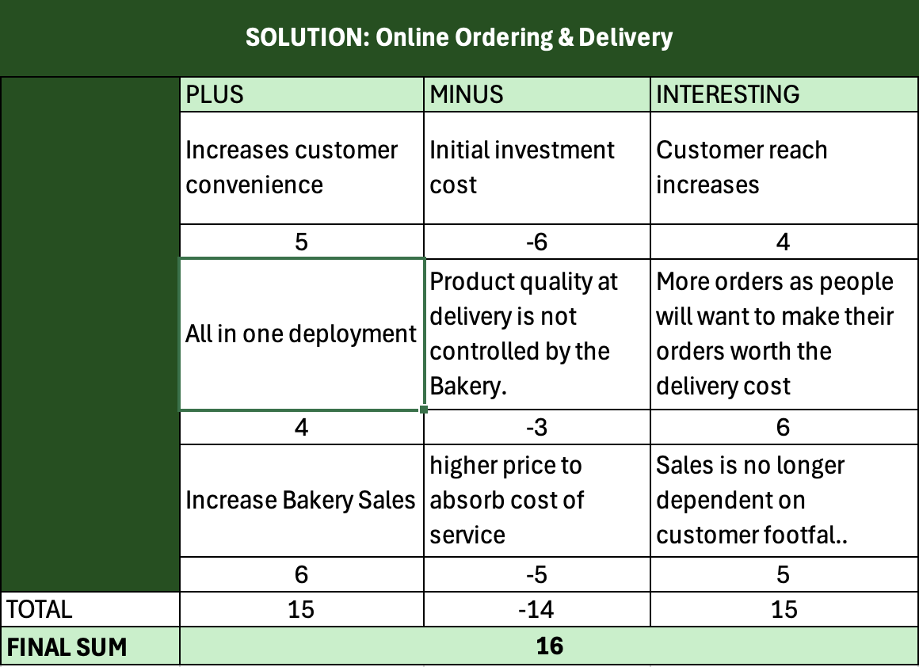

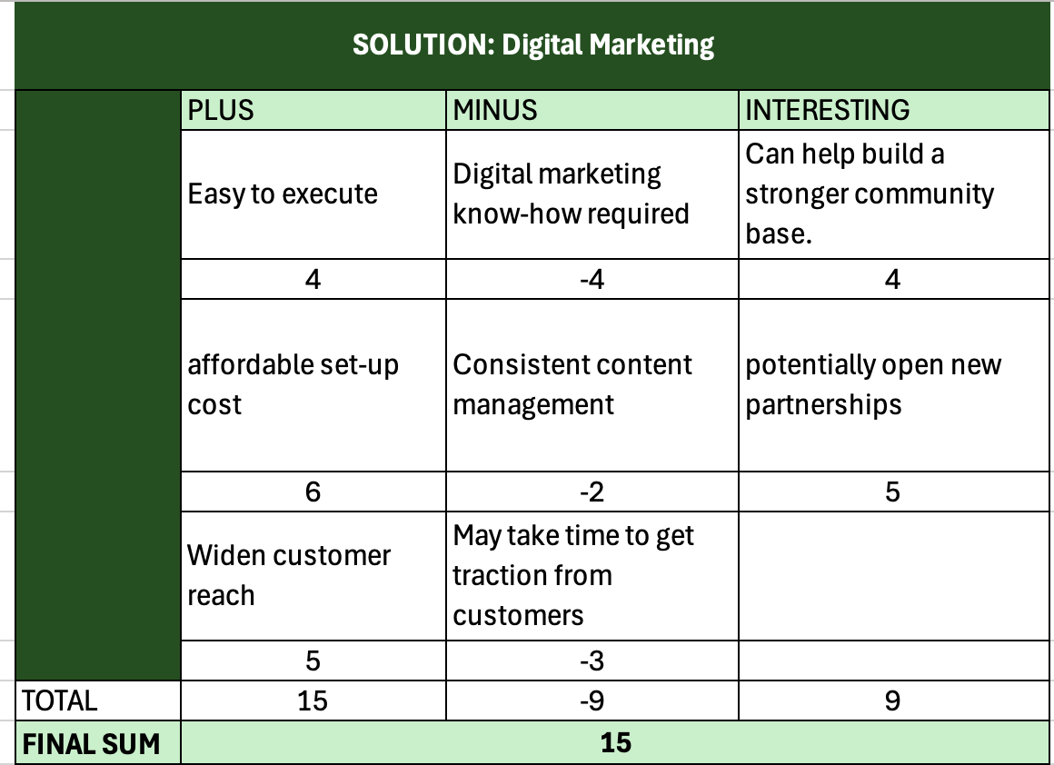

Appendix 2

Risk Analysis

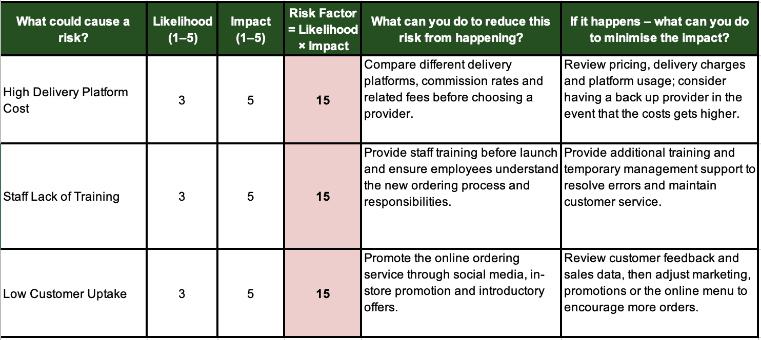

Appendix 3

Implementation Plan

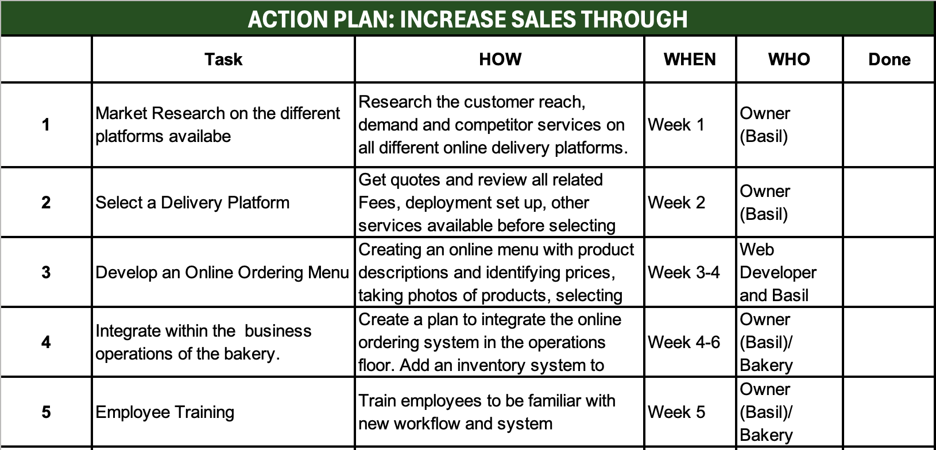
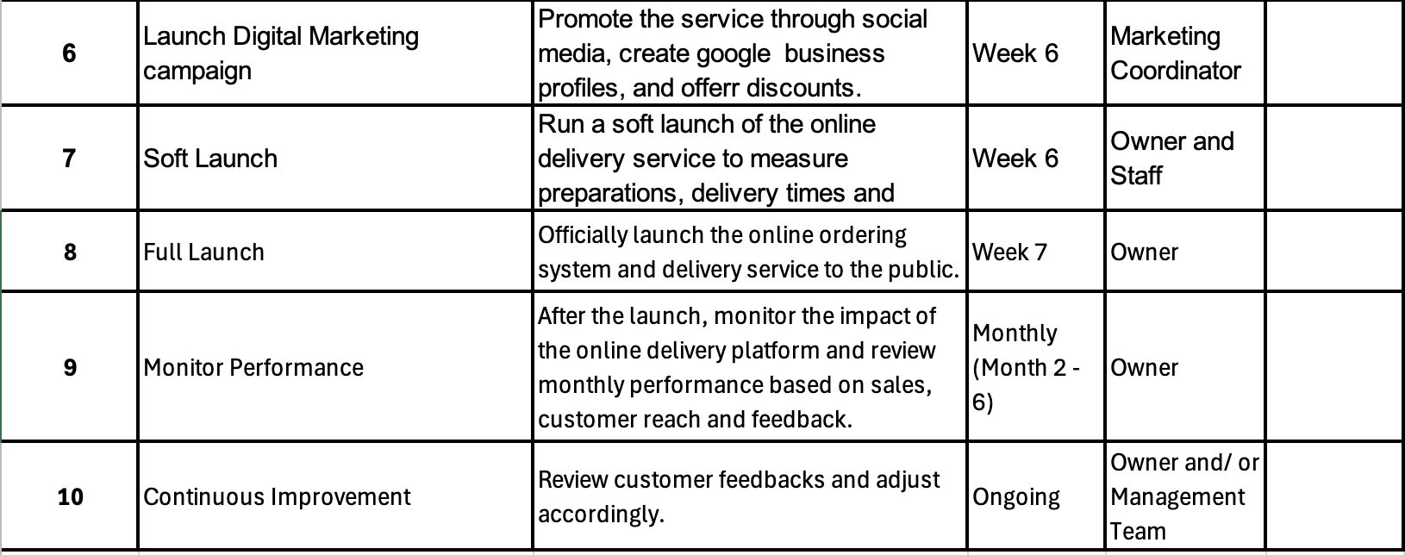

Appendix 4

Key Performance Indicator



