Remote Sensing & Imaging

Notes Obtained During Data Acquisition Practical

Student:
Creighton Rees
1910564
Lecturer:
Dr Nik Whitehead & Beverley Holland
Course:
Ordinance Munitions and Explosives: M6X00 945: Remote Sensing & Imaging

Notes
Practical Scenario
- To investigate the suitability of remote sensing and imagery for use in locating and identifying land mines during or after conflict, 12 Inert Representative Land Mines (IRLM) have been hidden in various locations at a waste ground near the University of Wales Trinty St. David (UWTSD), IQ Building, Swansea Marina.
- Currently in the Ukraine conflict, drones with IR imaging are being used to identify land mines by passing over the survey area at very low altitudes at dusk, the mines retain residual heat from the sun which is clearly discernible from the surrounding ground when viewed using Thermal Imagery (TI) at that specific time of day.
- Using the resources provided efficiently and effectively locate and identify the hidden IRLMs. Identify the possible methods of data acquisition, observe the methods in use to determine the suitability of their application in a real-world scenario.
General Information
Location:
SA1 8AH - UWTSD IQ Building – Marina Waste ground
Survey Area - 100 meters by 150 meters
Date & Time of Acquisition:
16th November 2023 14:00-16:00
Meteorological Data (@10:14 16/11/23)*:
Cloudy with 10% chance of precipitation
Temperature – 9°C
Dew Point – 6°C
Sunrise – 07:52 Sunset – 16:25
Wind Speed & Direction – 5-6 mph West
Wind Gusts – 8-10 mph
Visibility – Good – 46.5 miles
Humidity – 83%
UV Level – 1 Low
*Information obtained from Metoffice.gov.uk @10:14 16/11/23 which use ESRIs ARCGIS HUB software and network for its data acquisition and analysis.

Terrain & Ground Type
The local terrain is an urban waste land setting which included, concrete, gravel, rubble, large bushes, small bushes, foliage, grass verges and one fairly-large body of water, approximately 25% of the total survey area up to 0.75 meters deep in places.
Equipment Used During Data Acquisition
Ground Based
Spot - Boston Dynamics Mk 4 with CAM payload fitted.
Spot is a quadruped (four-legged) robot capable of mobility on a variety of terrains. Spot uses multiple sensors and three motors in each leg to navigate indoor and outdoor environments, maintain balance, and attain postures.
Spot can be operated manually by remote control, or automatically using its perception and guidance systems to follow predefined routes. It can be equipped with a variety of sensors and other payloads to tailor Spot for specific applications such as thermal sensing, site inspections, and more.
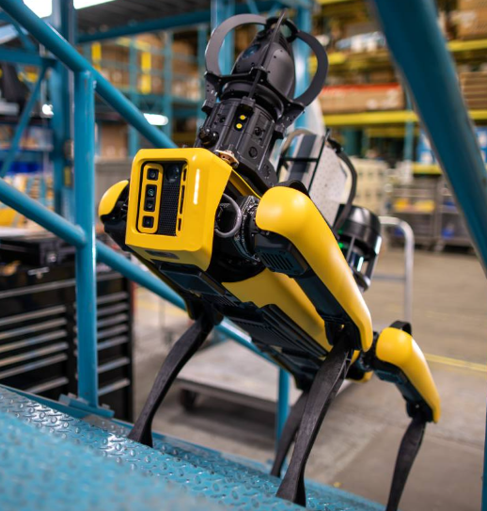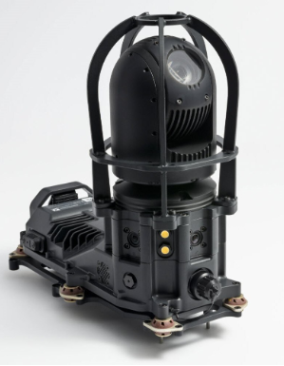
Spot CAM features include:
- Spherical camera that creates 360° panoramas.
- PTZ camera with 30x optical zoom.
- Radiometric thermal camera (if using the Spot CAM+IR)
- Sennheiser MKE-600 shotgun microphone (if using the Spot CAM+IR)
- Four pairs of LED lights.
- Two speakers for broadcasting audio.
- Two microphones for receiving audio.
- A USB port for inserting a USB stick to save panorama or PTZ image data.
90 minute battery life, life dependant on work rate and terrain type, one additional battery pack was available for the survey. 40Kg Mass without payload.
Field of view - 2.1 meters – Upper Limit

Smartphone for Manual Image Capture
iPhone 13 – Camera features:
- Dual 12MP camera system: Main and Ultra Wide cameras
- Main: ƒ/1.6 aperture
- Ultra Wide: ƒ/2.4 aperture and 120° field of view
- 2x optical zoom out
- Digital zoom up to 5x
- Sensor-shift optical image stabilisation (Main)
- True Tone flash
- Panorama (up to 63MP)
- Sapphire crystal lens cover
- 100% Focus Pixels (Main)
- Night mode
- Smart HDR 4
- Wide colour capture for photos and Live Photos
- Lens correction (Ultra Wide)
- Auto image stabilisation
- Photo geotagging
- Image formats captured: HEIF and JPEG
Air Based
DJI Mavic 2 Pro Drone fitted with 4k camera and IR imaging capability.
The DJI Mavic is a series of teleoperated compact quadcopter drones for personal and commercial aerial photography and videography use, released by the Chinese technology company DJI.
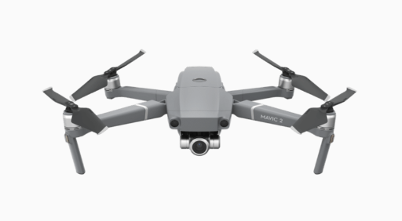
20-30 minute battery pack life, life dependant on output levels. One additional battery pack available for the survey.
Field of view – Determined by altitude, to ensure high quality images are captured an altitude of 30 meters was maintained throughout the survey area – survey was then repeated at 50 meters to compare the images quality.
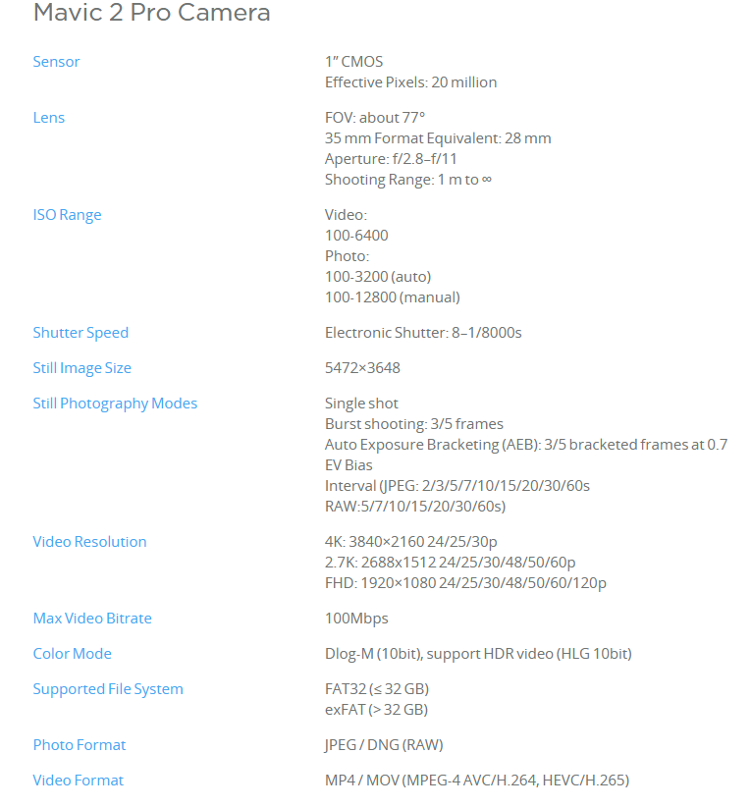
Software Used for Analysis of Data
The resulting data will be input into GQIS software package to allow for visualisation of data with geographical alignment of the findings.
QGIS is a user-friendly Open-Source Geographic Information System (GIS) licensed under the GNU General Public License. QGIS is an official project of the Open-Source Geospatial Foundation (OSGeo). It runs on Linux, Unix, Mac OSX, Windows and Android and supports numerous vector, raster, and database formats and functionalities.
A geographic information system (GIS) is a computer system for capturing, storing, checking, and displaying data related to positions on Earth’s surface.

Raw Data
Data ID | Photo ID | Longitude | Latitude | Time | Ground Type | Found By
1 | IMG_0695 | 51.61626 | 3.9278 | 15:13 | Rubble/Grass | SPOT
2 | IMG_0696 | 51.61621 | 3.92753 | 15:26 | Shallow Water/Grass | Drone
3 | IMG_0697 | 51.61631 | 3.92751 | 15:29 | Gravel/Grass | SPOT
4 | IMG_0698 | 51.61638 | 3.92756 | 15:39 | Foliage | Drone
5 | IMG_0699 | 51.61638 | 3.9275 | 15:45 | Foliage | Drone
6 | IMG_0700 | 51.61639 | 3.92747 | 15:58 | Foliage | Drone
7 | IMG_0701 | 51.61641 | 3.92744 | 16:20 | Long Grass | Drone
8 | IMG_0702 | 51.61628 | 3.92734 | 16:27 | Shallow Water/Grass | SPOT
9 | IMG_0703 | 51.61617 | 3.92724 | 16:40 | Long Grass/Gravel | Drone
10 | IMG_0704 | 51.61634 | 3.92723 | 16:44 | Foliage | Drone
11 | IMG_0705 | 51.61624 | 3.92712 | 16:49 | Foliage | Drone
12 | IMG_0706 | 51.61601 | 3.92692 | 16:57 | Grass verge/edge of water | Drone
Table 1 – Raw Data Gathered on the 16/11/23
Equipment Suitability and Observations
SPOT
The approach to surveying with SPOT was to split the area into lanes, 2.1 meters wide (SPOTs field of view) so that it could travers the whole area in a methodical manor ensuring that the entire surface was surveyed.
Before completing one length of the survey area using SPOT it became evident that it was not fit for this application. It could not manage the terrain alterations, which resulted in it falling over and needing to recalibrate itself.
Due to the 90-minute battery life, and the speed at which it surveyed, meant that the spare battery would be required to complete the whole area.
The biggest limitation was its inability to survey the body of water, SPOT is water resistant but due to the automatic sit-down function of the device if a signal drop occurs, if any issues were found whilst in the water it would fully submerge itself rendering it unserviceable. As a result, 25% of the survey area was inaccessible to SPOT.
For the reasons outlined above SPOT would not be a suitable method of data gathering in this scenario. Additionally, if this was a real-world scenario using Live mines, the operator would be at substantial risk to injury due to the 20 meter maximum range from SPOT to controller.
DJI Mavic 2 Pro Drone
A substantial benefit to using the drone was the speed at which the area was surveyed. The approach was the same as with SPOT, to split the area into lanes, although the field of view of the drone is governed by its altitude. To ensure a clear image was obtained during the data capture, two sweeps of the survey area was conducted at different altitudes, one at 30 meters and one at 50 meters. Both surveys were completed before SPOT had made one sweep. Both altitudes produced high resolution images with clear thermal imaging.
Another benefit of using the drone was that there was more control to the survey lanes, in that the ability to overlap lanes was easily achieved, giving a high degree of confidence no areas were missed.
The expectation when reviewing the thermal imaging was that the IRLM would indicate as a thermal hot spot when compared to the surrounding ground. This was not the case, the IRLMs appeared as black bodies, this is believed to be from the emissivity of the IRLM material combined with the rapid heat loss of the IRLMs, due to security reasons they were not buried as the scenario intended.
The application of a drone in this scenario was extremely beneficial, quality of data and speed at which it was obtained was impressive. Additionally, if this was a real-world scenario with Live Mines the risk to the operator when locating and identifying the mines would be non-existent.
Recommend to repeat the practical in an area where the IRLMs can be buried over a 24 hour period to reflect the heat gain and loss seen in the ground, as found in a real world scenario.

