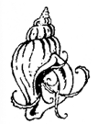  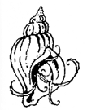  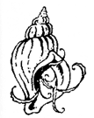  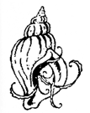 | Whelk Walking  this is my story  it is not the one I planned  but life can be a bitch  get over it  these are my words committed to paper  by the scribe chosen for the task  their digits can still caress  to comprehend read below  then choose your appellation  so you can understand the narrative  Whelk shell  Dog whelk shell  Nucella lapillus shell  Cragen gwichiaid cŵn  Atlantic dog winkle shell  Predatory sea snail shell  Carnivorous gastropod shell  Species – nucella lapillus  Genus – nucella  Family – muricidae  Such beauty has the power to transform and deliver miracles | 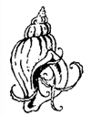  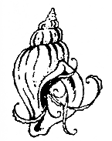  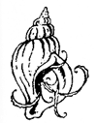  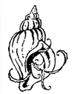  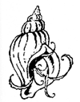  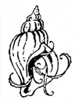
Lying on this state of the art
cutting edge choose your cliché bed
my tetrapack body sanctions only
movement of the head
and the satisfaction of speech

So today I choose to define myself as a character
from a Greek classical tale
these four these tetra limbs are plegic
paralysed
sounds so sophisticated in the vernacular doesn’t it?

T e t r a p l e g i c

I prefer to roll the words nucella lapillus around my mouth
the vowels and consonants
give something substantial to bite down on
when the pain is too much to bear

This is no ordinary whelk shell
this is a Pendine whelk shell
an end of the dunes
Pentywyn cragen gwichiaid cŵn
my liberty my chalky organic cariad bach
Three shells sit  on the fugly institutional wipe clean bedside table  there is no pretence no symmetry nor charm  this is what you have become I heard in my head  Said to a woman who never wore black  or took a straight line when a curved one would do  I weep for the before life  But there are still a few choices not denied  I chose the three that are set in a row  a triptych the holy trinity  religion fuck no  sand sun and sea is and always was my theology  A sisterhood the three and me  I determined their gender to suit my needs  to conform to my world of dependency  Although they are literally empty shells devoid of life  their sex obliterated by bleaching in the sink  after crabs and ravenous seabirds devoured their soft flesh  they are my kind of shell  a cross-layered hard outer protective husk  that once cradled the nucleus of a life inside  Did you know they are pseudohermaphroditic?  neither did I but hey what a word  for now just admire their beauty and form  for they have a greater part to play on pages to come | 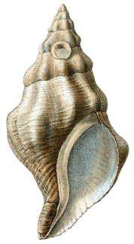  Fig. 1

