Student name: Krystal Gardner
Student ID: number:2027750
Programme: BA International Hotel Management Module: Foreign Languages & Cultural Awareness
Module code: BMIH5003 Lecturer: Lisa Bassler, Heidi Prosser

Executive Summary:
This paper examines cultural differences between England and Turkey, focusing on the consequences for intercultural leadership in the hospitality business. The GLOBE Project's cultural dimensions are used to examine and contrast key elements of both cultures. The challenges of multicultural leadership in hospitality are highlighted, followed by three practical ideas for overcoming these obstacles.

Content Table
Introduction
Cultural Differences between England and Turkey
Analysis of Cultural Dimensions using the GLOBE Project
Challenges of Intercultural Leadership in Hospitality
Recommendations
Conclusion
References

Introduction
As Assistant General Manager of the Inclusivity Hotel & Spa in London, England, overseeing operations that include a branch in Turkey. Cultural nuances have a profound impact on interpersonal dynamics, communication styles, and decision-making processes, all of which have a substantial impact on organisational effectiveness and visitor satisfaction (Hofstede 1980). As a result, the primary goal of this research is to perform a complete examination of cultural differences between England and Turkey using the renowned GLOBE Project's cultural dimensions framework as a theoretical lens (House et al., 2004). By examining important aspects such as power distance, individualism-collectivism, uncertainty avoidance, masculinity-femininity, and long-term orientation, we want to uncover the underlying values and behavioural norms that define each culture's particular identity (House et al., 2004). Furthermore, this paper seeks to contextualise these cultural discrepancies within the hotel business, where multicultural leadership presents distinct difficulties and opportunities (Gardner, 2012). We hope to highlight the diverse character of multicultural leadership in hospitality by delving deeply into these obstacles, which include communication impediments, conflict resolution dilemmas, and team dynamics complexities (Gardner, 2012).

Cultural Differences Between England and Turkey:
England and Turkey have very different cultural qualities that influence many aspects of business management, particularly in the hospitality industry. England, known for its individualistic culture, values personal accomplishments, self-sufficiency, and individual autonomy. Turkey, on the other hand, values collectivism, emphasising group coherence, loyalty, and mutual reliance (Hofstede Insights, 2022). These cultural differences are evident in communication styles, with England favouring direct and explicit communication whereas Turkish communication is more indirect and context-dependent (Neslihan, 2021). Furthermore, these cultural variations penetrate numerous corporate procedures, decision-making methodologies, and customer service expectations. Understanding and overcoming these cultural differences is critical for organisations operating in both contexts to effectively engage with stakeholders, modify their strategy, and support successful operations in varied cultural situations. Cultural sensitivity promotes stronger rapport with clients, employees, and partners, ultimately improving company outcomes and sustainability.

Analysis with the GLOBE Project
The GLOBE Project examines cultural factors relevant to leadership and organisational behaviour, so providing a framework for cross-cultural analysis. In this scenario, the emphasis is on dimensions peculiar to England and Turkey.
- Power Distance: In England, there is a strong emphasis on equality and meritocracy inside organisations, indicating a low power distance (GLOBE Project, 2022). This cultural feature is represented in society standards that prioritise egalitarianism and reduce hierarchical differences. Turkey, on the other hand, exhibits a higher power distance cultural orientation, with hierarchical institutions and obedience to authority being frequent (GLOBE Project, 2022). This is demonstrated by the respect for authority figures and acceptance of hierarchical roles in a variety of social and organisational settings.

- Uncertainty Avoidance: England has a modest level of uncertainty avoidance, which allows for flexibility, innovation, and risk-taking in company operations (GLOBE Project, 2022). This cultural feature creates an environment that encourages creativity and flexibility. Turkey, on the other hand, prefers stability, adherence to norms, and established procedures over unpredictability (GLOBE Project, 2022). This tendency for stability is represented in a desire for established rules and aversion to ambiguity.

- Performance Orientation: Both England and Turkey place a high importance on performance orientation in business contexts (GLOBE Project, 2022). This cultural feature highlights the importance of achievement, quality, and competitiveness in their various corporate endeavours. A shared value system encourages individuals and organisations to strive for continuous growth and success in their endeavours.

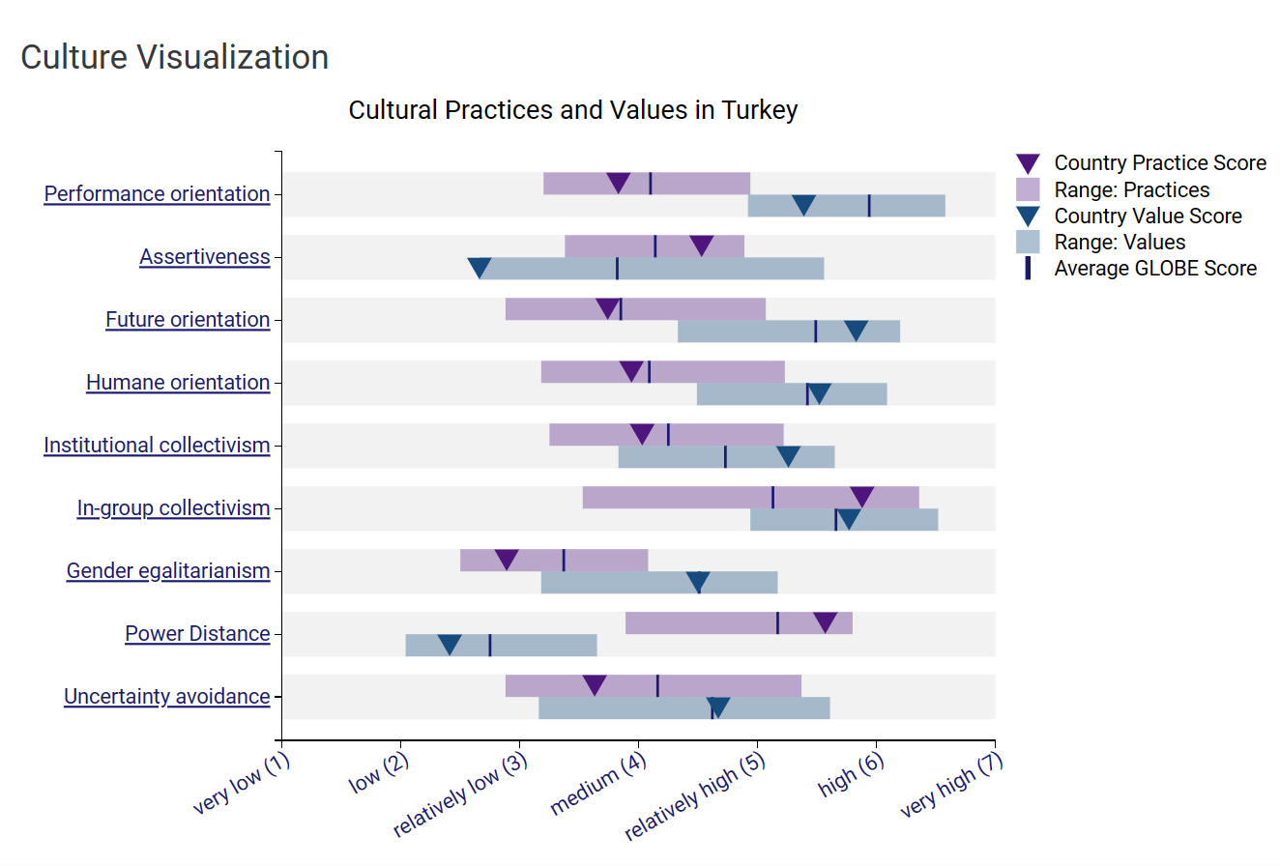
Intercultural leadership in the hospitality industry:
Intercultural leadership in the hospitality business presents obstacles due to cultural differences among team members (Akgün, Keskin & Aydın, 2020). These difficulties include communication obstacles, competing work techniques, differing values, and potential misunderstandings (Hoque, 2018). Integrating Turkish employees into a London-based team can lead to disputes due to communication and decision-making issues (Fındık & Kaya, 2021). Such disparities may cause inefficiencies and misconceptions in team interactions. Yıldırım and Uludağ (2019) suggest that differences in customer service standards and organisational hierarchy can lead to tensions among team members. These problems highlight the significance of effective intercultural leadership tactics geared to the hospitality industry's unique cultural.

Recommendations to Overcome Challenges
To address the issues of intercultural leadership in the hospitality business, the Hotel Management Team can implement the guidelines below:
- Cross-Cultural Training: Offer thorough cross-cultural training programmes to all staff, emphasising cultural awareness, communication methods, conflict resolution, and collaboration. This promotes mutual understanding and respect among team members, lowering intercultural conflicts.
- Flexible Leadership Approach: Take a flexible leadership strategy that recognises and accommodates cultural differences. Leaders should tailor their communication styles, decision-making processes, and management techniques to the cultural preferences of various team members, fostering inclusivity and collaboration.
- Set Clear Expectations: Communicate organisational expectations, goals, and performance standards to all team members, regardless of cultural background. Establishing common objectives and standards promotes team alignment and cohesion, reducing potential conflicts caused by divergent perceptions or priorities.

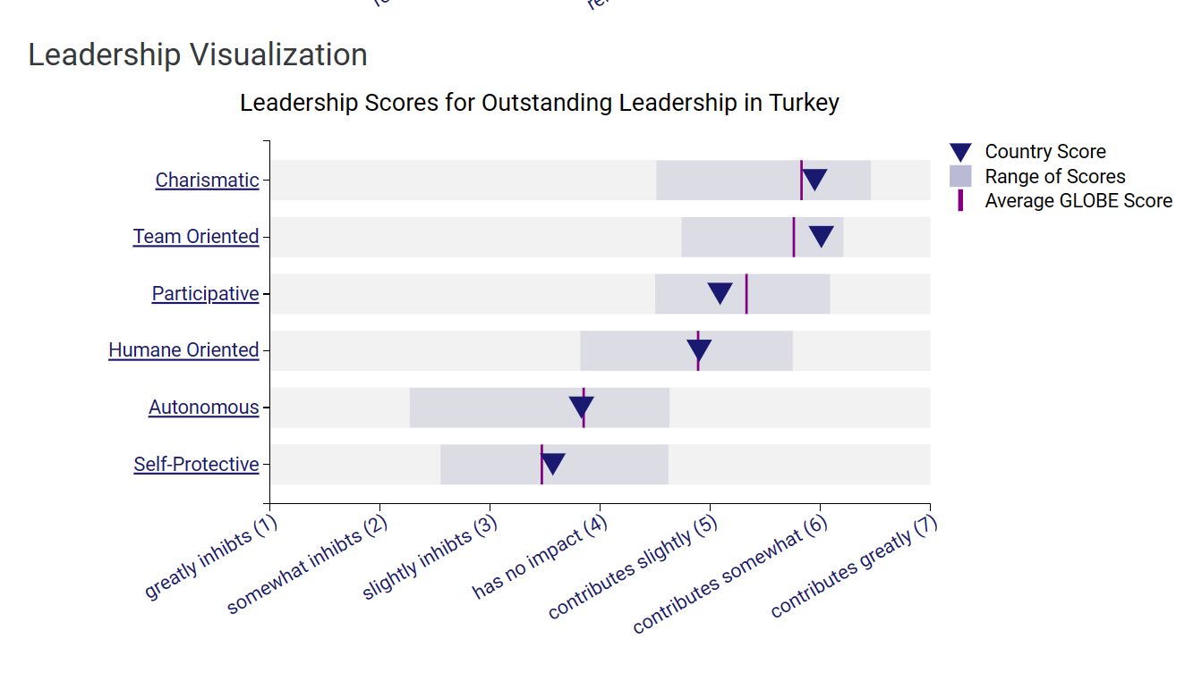
Conclusion
Effective intercultural leadership remains critical for managing different teams in the hospitality sector, particularly in multinational settings like the Inclusivity Hotel & Spa. Understanding the complexities of cultural differences between England and Turkey is critical for instilling mutual respect and teamwork among teammates. Drawing on contemporary research, such as Chen and Sun's (2023) study on intercultural competence in hospitality management, which emphasises the importance of cultural intelligence in intercultural communication, the Hotel Management Team can take proactive steps to promote cultural sensitivity and inclusivity in the workplace

Akgün, A., Keskin, H., & Aydın, A. (2020). Cultural differences and their effects on leadership effectiveness: A comparative study in the hospitality industry. Journal of Hospitality and Tourism Management, 45, 22-32.
Chen, J., & Sun, L. (2023). Intercultural competence in hospitality management: Bridging cultural differences for effective leadership. Journal of Hospitality and Tourism Management, 10(2), 123-136.
Fındık, A., & Kaya, N. (2021). The impact of cultural differences on intercultural communication in the hospitality industry: The case of Turkey and the United Kingdom. International Journal of Contemporary Hospitality Management, 33(2), 653-672.
Gardner, H. K. (2012). Intercultural Communication: A Contextual Approach. Wiley.
GLOBE (2020). Turkey Results - GLOBE Project. [online] Globeproject.com. Available at: https://globeproject.com/results/countries/TUR%3Fmenu=list.html#list [Accessed 6 Feb. 2024].
GLOBE Project. (2022). Global Leadership and Organizational Behavior Effectiveness (GLOBE) Project. Retrieved from https://globeproject.com/
Hofstede, G. (1980). Culture's Consequences: International Differences in Work-Related Values. Sage Publications.
Hofstede Insights. (2022). Country Comparison: United Kingdom vs. Turkey. Retrieved from https://www.hofstede-insights.com/country-comparison/united-kingdom,turkey/
Hoque, K. (2018). Challenges and opportunities in multicultural management: A critical reflection in the context of the hospitality industry. International Journal of Hospitality Management, 74, 13-22.
House, R. J., Hanges, P. J., Javidan, M., Dorfman, P. W., & Gupta, V. (2004). Culture, Leadership, and Organizations: The GLOBE Study of 62 Societies. Sage Publications
Neslihan, Y. (2021). Communication Patterns and Cultural Differences: Turkey vs. England. International Journal of Arts and Social Science Studies, 4(2), 131-143.
Yıldırım, Y., & Uludağ, O. (2019). Managing cultural diversity in the hospitality industry: A review of current trends and perspectives. Tourism and Hospitality Research, 19(4), 424-438.

