
Student Name: Mohammed Azharuddin
Student Id: 2105239

Research topic: Identifying the impacts of e-vehicles on business sustainability of the automobile industry in India

Abstract
The following study is based on the identification of the role of Electric Vehicles on business sustainability practices in the automobile industry in India. It has been identified in the study that the role of E-Vehicle on business sustainability enhancement in the Indian automobile industry has been described through the analysis of several authentic journals and articles. Additionally, the researcher has developed a specific aim, objectives and research question, which has been addressed in the data analysis and findings section with consideration to the subject matter. Moreover, the study has developed an effective literature review section, which would help to compare the findings and thereby make the study effective.
Additionally, the below research has depicted the influence of business sustainability in the context of Indian automobile companies. Moreover, this study has mentioned the significance of business sustainability for developing the organisational volume and organisational image. In addition, the production and selling of EVs have become a major factor for organisational sustainability. Along with this, several challenges have been outlined and measures justified for developing this research topic. Additionally, this research has included conclusive evidence with future scope, linking with objectives and Limitations. However, the researcher has given some recommendations to develop the EV market in India. Lastly, this study has reflected the personal reflection of the author based on the learning outcomes from this topic.
Key words: Electric Vehicles, EVs, Sustainable Business, Indian Automobile Sector/Industry
Table of Contents
Chapter 1: Introduction 6
1.1 Research background 6
1.2 Problem statement 7
1.3 Rationale of the research 9
1.4 Aim and objectives 9
1.5 Research questions 10
1.6 Significance of the research 10
1.7 Dissertation structure 11
Chapter 2: Literature review 12
2.1 Introduction 12
2.2 Analysing the rising popularity of E-Vehicle in global context and in India 12
2.3 Importance of business sustainability for automobile companies in India 16
2.4 Role of government initiatives for supporting the development of E-Vehicles in India 19
2.5 Influence of E-Vehicles on business sustainability of automobile sector in India 23
2.6 Major challenges faced by Indian automobile companies regarding popularity of EV and sustainable business practice 25
2.7 Conceptual framework 30
2.8 Literature gap and summary 30
Chapter 3: Research methodology 32
3.1 Research onion 32
3.2 Research design 33
3.3 Research philosophy 34
3.4 Research approach 35
3.5 Research Strategy 36
3.6 Data collection method 36
3.7 Data analysis technique 37
3.8 Ethical consideration 38
3.9 Limitation of the chosen method 39
3.10 Research timeline 39
Chapter 4: Findings and discussion 41
4.1 Findings 41
4.1.1 Increasing demand among consumers for E-Vehicles in India 41
4.1.2 Sustainable business practice has become a major factor in the Indian automobile sector 43
4.1.3 E-Vehicle practice increases the business sustainability in the automobile industry in India 46
4.1.4 Challenges faced by E-Vehicle affect the business sustainability practice in the Indian automobile industry 49
4.2 Discussion 52
Chapter 5: Conclusion and recommendation 57
5.1 Conclusion and Summary of the findings 57
5.2 Linking with objectives 58
5.3 Future scope 59
5.4 Research limitation 60
5.5 Recommendation 60
Reflection 62
References 64

Table of Figures
Figure 1: Market share of EVs in India 6
Figure 2: Sales of Electronic vehicles in India 8
Figure 3: Structure of the dissertation 11
Figure 4: Importance of E-vehicles 13
Figure 5: Sales growth of E- vehicles 14
Figure 6: EV volumes 15
Figure 7: Reduction of carbon emission by E-vehicles 17
Figure 8: Number of Vehicles in operation 18
Figure 9: Roadmap of Indian policy for electronic Vehicle 20
Figure 10: Government policy for the electronic vehicle 21
Figure 11: Sales of automobiles in India from 2011 to 2022, by type 24
Figure 12: Challenges of the automobile companies for launching EVs in India 26
Figure 13: Problems faced by electric vehicle owners 27
Figure 14: Conceptual Framework 30
Figure 15: Research onion model 33
Figure 16: Gantt chart 40
Figure 17: Company shares in Automobile sector of India by their percentage 42
Figure 18: Growth of sustainable practices by the automobile sectors 44
Figure 19: Transition of E-vehicles in India 47
Figure 20: Beta version of batteries in the EVs 50
Figure 21: Challenges faced by Indian EV companies 51
Figure 22: Service cost of EVs in India 52
Figure 23: Increase in the demand for the electronic vehicle in India 55

Chapter 1: Introduction

1.1 Research background
The below research is focusing on the impacts of e-vehicles on the business sustainability of the automobile industry in India. According to Pb, Rayudu Thunga and Raju (2021), the pandemic has changed the automobile industry's operation dynamically and the Electric Vehicles placed a dynamic situation for the automobile industry in the context of India. Moreover, Deb et al. (2019) depicted that the charging station in India especially for Electronic vehicles has developed the functions of the automobile industry and enhanced business sustainability rapidly. As per the news report of Business-standard (2022), the automobile industry in India is expected to revenue growth around 9%-11% within 2027 and this implies a significant growth level for the Indian manufacturers of automotive parts. Moreover, growing carbon emission and the pandemic has shifted the business model of the automobile industry in India massively. Tarei, Chand and Gupta (2021) opined that business sustainability in India would be possible if the market of EVs in India accelerate.
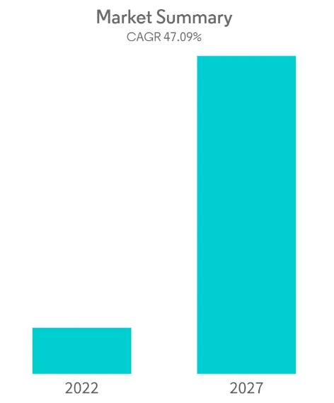
Figure 1: Market share of EVs in India
(Source: Mordorintelligence, 2022)
As per the report of Mordorintelligence (2022), the growth rate of the EV market showing a growth rate of around 47.9 % by 2027 and that indicates the functions of Electric Vehicles in the Indian context are rapidly increasing and motivate the operational style of the automobile companies rapidly. Moreover, the implementation of advanced technology in the EV manufacturing units in India has dynamically increased the functions of automobile companies and provided a concrete solution to their business sustainability. According to Ecer (2021), the functions of the management and marketing departments of automobile companies are operating very flexibly and applying various methods to deal with critical challenges in the future. Moreover, the rapid development of demand for manufacturing EVs not only determines the functionality of the organisation but also influences their identification of the aspects for a better future in the automobile sector.
According to Sun (2022), around 231.34 thousand EV sales have been incurred in India as of 2022 and that are mainly two-wheelers. Hence, it can be said that through the application of electric and advanced technology, Indian automobile companies can develop EV production, which would expand their business sustainability flexibly. According to Patil and Majumdar (2022), the maximum EV sales in India incurred as Two-wheelers in urban areas, where peoples are very rich and wealthy. As the EV market in India is not well developed hence, the companies need to develop modern strategies for a better position in the future and to run their business flexibly.

1.2 Problem statement
According to Mishra (2021), in India, around 8% of cars will be electric and the rest of the world will carry 28% by 2030, which significantly tells that the lack of innovation and poor government support hindered the actions of the Indian automobile companies massively. Moreover, the fall in the financial condition of the Indian automobile companies due to the pandemic has disrupted to make of cheap EVs for car lovers. As per the opinion of Radhakrishnan and Rose Varghese (2022), around 27.81 crores registered non-electric vehicles present in India, whereas around 13.34 lacks are electric vehicles, which shows a decreasing level of electronic vehicle use in the context of India. Hence, it can be said that in order to meet sustainability automobile companies need to develop their actions and make pricing decisions effective.
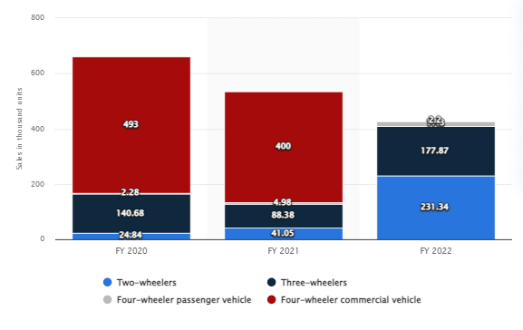
Figure 2: Sales of Electronic vehicles in India
(Source: Sun, 2022)
As per the opinion of Sun (2022), around 177.87 thousand e-vehicles have been sold out in 2022 and most of them are three-wheelers. Moreover, due to the pandemic and financial distress Indian automobile companies faced a rapid decline in EVs from 2020 to 2021. Hence, it can be said that as the pandemic has minimised EV sales, organisations looking for sustainability for their future business running. As per the report by A Khan (2022), India’s automobile sales in the domestic market nosedived to 17.51 million in 2021-22 compared with 2012-13 due to high fuel prices and poor financial services. Considering this, it can be said that the Indian automobile companies shifted to produce EVs for their business sustainability and the researcher took this issue to prepare the project effectively.

1.3 Rationale of the research
The researcher has analysed the factors for determining the significance of the topic with the justified example for the research value. Moreover, the researcher has taken the business sustainability topic for elaborating on the concept of EV manufacturing to gain this sustainability in the future. As per the report of Mordorintelligence (2022), the growth rate of the EV market showing a growth rate of around 47.9 % by 2027 and that indicates the functions of EVs in the Indian context are rapidly increasing and motivate the operational style of the automobile companies rapidly. Moreover, the implementation of advanced technology in the EV manufacturing units in India has dynamically increased the functions of automobile companies and provided a concrete solution to their business sustainability.
Moreover, Kaur et al. (2021) depicted that electronic vehicle production in India is increasing after the pandemic and most of the largest cities have already developed charging stations in India for developing automobile companies’ sustainability. Hence, it can be said that the increasing trend and growing fuel prices have increased the production of electronic vehicles massively in the context of India and it will expand the business sustainability level massively.

1.4 Aim and objectives
1.4.1 Aim: The following study aims to investigate the impacts of the E-Vehicles on business sustainability of the automobile industry in India and considering this, several objectives could have been developed respectively. The following aim has been derived from the key problem statement and rationale of the study, which has been described in the earlier section as well.
1.4.2 Objectives:
The previous aim has helped to develop key study objectives and thereby help to make the study effective as well. Research objectives help to identify the key variables of the study, which have to be addressed by the researcher and thus, the objectives of the following study, have been developed as below.
- To investigate the importance of sustainability practice in the Indian automobile industry
- To identify the importance of e-vehicle in the business sustainability practice in India
- To analyse the challenges faced by the e-vehicle of automobile industry of India regarding sustainability practice
- To evaluate the suggestive measures for further development of e-vehicle for future business sustainability practices in India

1.5 Research questions
Considering the problem statement, research rationale, aim and objectives of the study, the research question for the following study are as follows, which will help the researcher for addressing the problem statement of the study and thereby make it effective.
- What is the importance of sustainable business practice in the Indian automobile sector?
- How E-Vehicle could increase business sustainability in the automobile industry in India?
- What are the challenges faced by the E-vehicle of the Indian automobile industry regarding sustainability practice?
- How E-Vehicle practice in the Indian Automobile industry can be improved for future sustainable business practice?

1.6 Significance of the research
The following study is based on the impact of the E-Vehicle on business sustainability in the automobile industry in India and considering this, the researcher has developed a specific aim, objectives, research questions and problem statement, which would make the study effective. Moreover, the researcher has provided a significant background of the research study, which has addressed specific information regarding the importance of sustainable business practice in the automobile industry in developing countries such as India and thereby making the study significant. Additionally, by supporting the problem statement of the study, the researcher has justified the overall statement with the help of research rationale respectively. Furthermore, the study will consider the secondary methodological process by collecting several online publications related to the subject matter, which ensures the significance of the study respectively.

1.7 Dissertation structure

Figure 3: Structure of the dissertation
(Source: Self-created)
In the first chapter, the introductory part of the dissertation of the study would be generated while the second chapter will review several publications and articles for an effective understanding of the study. Additionally, the third chapter consists of the methodological selection while the fourth chapter considers the analysis and discussion of collected data relevant to the study. Lastly, the fifth chapter of the study will focus on the conclusion and development of recommendations for the study to make it effective.

Chapter 2: Literature review

2.1 Introduction
The study will illustrate the literature review, based on the various literature articles and journals that will provide authentic data to make the research effective. The study will delve into the rising popularity of E-vehicle in the global as well as Indian context by analysing the importance of business sustainability for automobile companies in India, and the role of government initiatives to support the development of E-vehicles in India. Furthermore, the study will investigate the role of Indian government initiatives to support the development of E-vehicles and the influence of E-vehicles on the business sustainability of the automobile sectors in India will be discussed in this section. Apart from these, the major challenges faced by automobile companies of India regarding the popularity of electronic vehicles and sustainable business practices and lastly, it will briefly present the major obstacles faced at the time of proceeding with the research.

2.2 Analysing the rising popularity of E-Vehicle in global context and in India
According to E-Amrit (2022), Electric vehicles or E-vehicles are the advanced technological output that uses electricity for charging the batteries instead of petrol and diesel. Electric vehicles are more efficient compared to traditional vehicles and have been combined with the cost of electricity, which indicates that charging an electric vehicle is much cheaper than petrol and diesel and for this reason, e vehicles have gained popularity in the global context. As opined by Karmaker et al. (2020), the use of renewable sources makes electric vehicles eco-friendly and the electricity costs are reduced by charging with the help of renewable sources of energy such as solar panels. As per Jeon, Cho and Lee (2020), electric vehicles offer low maintenance costs because of having less number of moving parts than internal combustion vehicles. According to the report published by E-Amrit (2022), electronic vehicles help in reducing carbon emissions as there will be zero tailpipe emissions and can convert around 60% of electrical energy from the grid to power, while petrol and diesel convert only 17% of the stored energy in the fuel.

Figure 4: Importance of E-vehicles
(Source: Self-created)
According to Jeon, Cho and Lee (2020), the global market share of electronic vehicles has achieved a tremendous leap in the last decade and this following trend will accelerate exponentially. Karmaker et al. (2020) further stated that low maintenance has accelerated the sales growth in 2020 for new electronic vehicles and the outlook for the global sales of EVs was unpredictable during the time of the pandemic situation.
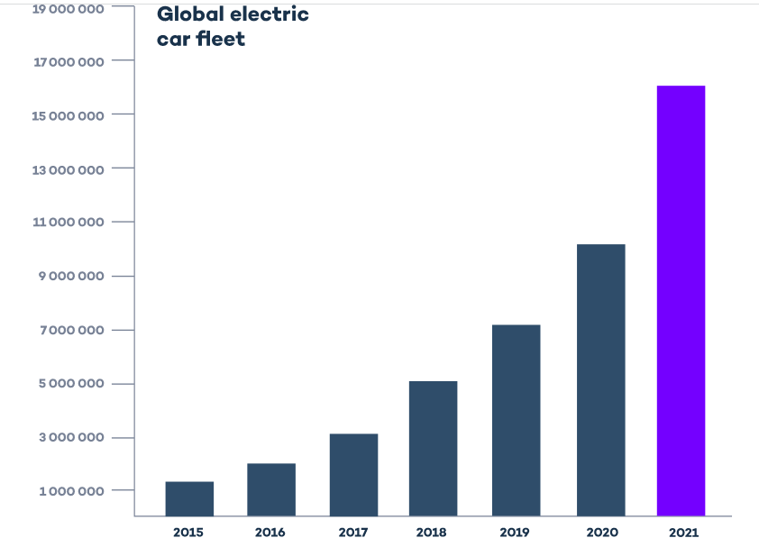
Figure 5: Sales growth of E- vehicles
(Source: Virtaglobal, 2022)
According to Virtaglobal (2020), the year 2020 was a positive year that witnessed a global sales growth of EVs by 43% and the global market share rose by 4.6% in 2020. Arfeen (2020) further stated that the sales growth of electronic vehicles doubled in 2021 to about 6.74 million and the amount of EVs sold in the year 2021 was higher than the total number of EVs sold in the year 2012. As opined by Naumov, Keith and Sterman (2022), it is due to the zero-emission targets, the global sales of EVs keep accelerating in 2022 and the sales of the new plug-in cars have reached 3.2 million within the first five months of this year.
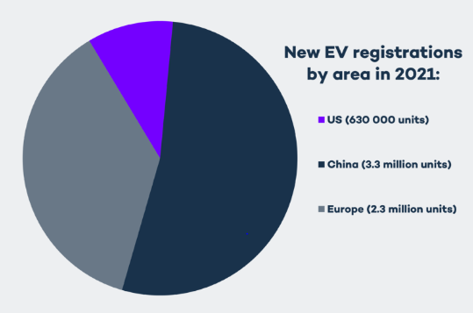
Figure 6: EV volumes
(Source: Virtaglobal, 2022)
According to Arfeen (2020), the year 2020 was a positive year that witnessed a global sales growth of EVs by 43% and the global market share rose by 4.6% 2020. Arfeen (2020) stated that the sales growth of electronic vehicles doubled in 2021 to about 6.74 million and the amount of EVs sold in the year 2021 was higher than the total number of EVs sold in the year 2012. According to Naumov, Keith and Sterman (2022), it is due to the zero-emission targets, the global sales of EVs keep accelerating in 2022 and the sales of the new plug-in cars have reached 3.2 million within the first five months of this year.
As per Pelletier et al. (2019), .Europe witnesses an increased number of electric car registrations compared to 2019, which can be attributed to the measures of stimulus by the European Government and the major markets have introduced certain revenue benefits as well as subsidies that help in contributing to the overall sales growth. According to Salikhov and Tulaganov (2022), the Global electronic vehicle outlook, the largest European markets have been contributed by Germany, Iceland and Sweden in 2022. Yankevich and Yankevich (2022) have stated that electric buses have gained popularity since 2020 and the global stock of electric buses has reached 670000 in 2021. As per Virtaglobal (2022), the number of rapid and ultra chargers increased in 2021, which were replaced by the slow chargers and that was up by more than 30% reaching almost 50000 units. Salikhov and Tulaganov (2022) have stated that the innovations of the smart charging system ensure to increase in the EV space especially for the business owners to have greater convenience over the consumption of electricity.
Electronic cars have expanded the growth in the Indian market, which ensures the sustainable growth of automobile industries. As per Goel, Sharma and Rathore (2021), the government of Delhi has recently introduced an innovative policy for electric cars, which provides additional benefits up to 1.5 lacks, and developing countries like India, are moving towards renewable sources of energy to meet the sustainable goals. According to the report stated by Autocarpro, (2022), the sales growth of EVs in India has been attributed to the increase of available products in the Indian market and it helps in developing the customer-awareness regarding the use of eco-friendly transport.
As per Goel, Sharma and Rathore (2021), the retail sales of electronic cars have reached about 429217 units in 2022 and Tata Motors, an Indian automobile company has witnessed the rise of demand for EV reached about 7000 units in 2022. . According to the report stated by Autocarpro, (2022), the high price range of petrol and diesel in India is responsible for the increased number of electric car owners as they can save Rs 2000 for each 5000 km and electrification has reduced the vehicular emissions, which has been regarded as the key contributor for air pollutants.

2.3 Importance of business sustainability for automobile companies in India
According to Llopis-Albert, Rubio and Valero (2021), automobile industries have a tremendous effect on the planet and considering this, the innovations in electronic vehicles ensure long-lasting sustainability in India. Jiang et al. (2018) further stated that electronic vehicles reduce the emissions of greenhouse gases and thereby prevent air pollution, which helps in the transition into green practices of business by choosing fuel alternatives to make the company more reliable as well as eco-friendlier. As per Llopis-Albert, Rubio and Valero (2021), electric vehicles enhance sustainability by improving air quality and reducing the consequences of global warming.
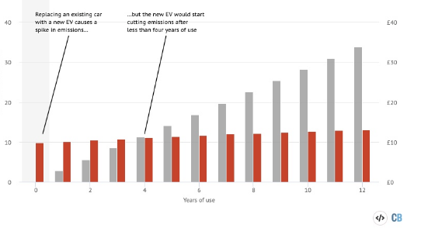
Figure 7: Reduction of carbon emission by E-vehicles
(Source: Googleusercontent, 2022)
According to Pielecha, Skobiej and Kurtyka (2020), it has been observed that electric vehicles have reduced the emission of carbon with the help of zero tailpipe emission and thereby, securing the environmental balance. The innovation of electric vehicles has altered chargeable batteries, which helps in reducing energy consumption and provides certain financial benefits by eliminating the costs required for purchasing petrol and diesel. As opined by Kiesecker et al. (2019), India aims to accomplish about 40% of the cumulative electrical power installed capacity from the non–fossil resources that can ensure sustainable growth of the automobile industry.
According to Abdi et al. (2018), business sustainability is the crucial element for developing the organisational tendency to become famous in the modern competitive world. Business sustainability proves the capacity of the business to deal with critical challenges very carefully and enhances its integrity and power for a dynamic future. Stoycheva et al. (2018) depicted that the manufacturing of automobiles is very crucial for sustainability in the recent world. As the pandemic has reduced the business operation of the automobile industry in India hence, it is needed to establish the business operation through innovative actions and motivate others for their business retention patiently. Reinhardt et al. (2019) mentioned that the production of batteries is of the most significant importance for establishing the automobile sector's sustainability. Along with this, the functions of the Indian automobile sector can be extended through innovative and creative thought for the betterment of business sustainability. Hence, it can be said that through sustainable business operations Indian automobile companies can expand their outcome dynamically.
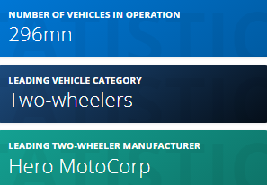
Figure 8: Number of Vehicles in operation
(Source: Sun, 2022)
According to Sun (2022), around 296 million vehicles are operating on the roads and two-wheelers are the main vehicles in the Indian market, which helps to retain the business operation even in the pandemic. Along with this, the growing vehicle production and selling of vehicles positively boost business sustainability in the context of India. As per the opinion of Sun (2022), around 177.87 thousand e-vehicles have been sold out in 2022 and most of them are three-wheelers. Moreover, due to the pandemic and financial distress Indian automobile companies faced a rapid decline in EVs from 2020 to 2021. Hence, it can be said that massive sales and the pandemic helped automobile companies to influence their business sustainability massively.
As per the news of Economic Times (2020), due to the pandemic, Indian carmakers faced huge losses and that massively hindered their financial performance to run their business properly. Moreover, the functions of automobile companies have disrupted and reduced their manufacturing units to reach the targeted revenue effectively. In addition, the systems of manufacturing must be improved to meet the goals faster. According to Llopis-Albert, Rubio and Valero (2021), digital transformation helps automobile companies to build their strategies innovative and reach their goals faster. Moreover, due to the pandemic people of India shifted to the digitalisation process and that helps to increase business sustainability. As per the report by A Khan (2022), India's automobile sales in the domestic market nosedived to 17.51 million in 2021-22 compared with 2012-13 due to high fuel prices and poor financial services. Hence, it can be said that in order to meet the favourable goal, automobile industries must focus on sustainable strategies for future betterment.
As per the news of Economic Times (2021), due to the rising temperature in the world, automobile companies decided to increase EV production rather than produce general cars. Moreover, the pandemic has reduced the functions of automobile companies and reduced their financial condition rapidly. Hence, it can be said that in order to establish their car market, they have chosen an EV manufacturing approach initially as two-wheelers. As per the report of Mordorintelligence (2022), the growth rate of the EV market showing a growth rate of around 47.9 % by 2027 and that indicates the functions of EVs in the Indian context are rapidly increasing and motivate the operational style of the automobile companies rapidly. Hence, it can be said that through proper identification of the futuristic aspects, automobile companies can expand their business sustainability.

2.4 Role of government initiatives for supporting the development of E-Vehicles in India
Singh (2021) reviewed that, as per the “National Electric Mission Plan” (NEMMP), the mission of the government of India is to prepare a quick roadmap for the adaptation of electric vehicles in the nation and the manufacturing of electronic cars within the country to mitigate pollution problems. Jacob (2021) deducted that this project was launched in 2013 and planned to save more than 9500 million litres of fuel annually. Patyal (2021) said that with the investment of 14000 crores to the R&D effort and advanced technologies of kick and start, the main objective s of the NEMMP was to take proper initiatives the develop the technologies and infrastructure through the investment of public and private companies. By understanding the necessity of the electric cars, the organisation further focused on the detailed discussion in groups, taking experts’ opinions, developing ideas from the existing literature, studying international opinions and developing primary research on the reflectivity of electronic cars.
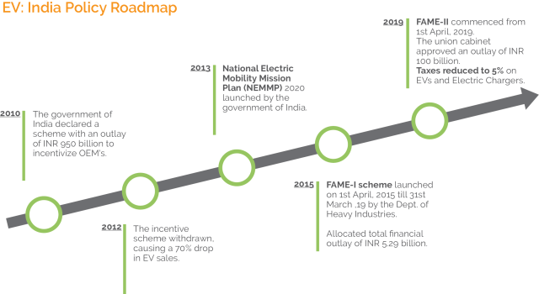
Figure 9: Roadmap of Indian policy for electronic Vehicle
(Source: Singh, 2021)
Chhikara (2021) identified that National Electric Mobility Mission Plan (NEMMP) further focuses on segmenting the period for developing electronic cars in India. From 2012 to 2015, they took important initiatives for the plan for the faster adoption and scheme for manufacturing electronic vehicles in India. Tarei (2021) deducted that from 2013 to 2020, they further developed programmes for achieving more than 5% to 10% electronic mobility in India.
Benefits of the initiative of e-vehicles in India
Mishra (2021) identified that NEMMP developed a different scheme for controlling the strategies for the implementation of electronic automobile products in India. The electronic vehicle will effectively decrease fuel consumption by using other components. As the increase in pollution has created problems for the environment in India, the increase in the use of electronic cars will be very helpful for removing the threats of pollution. Dua (2021) reflected that the promotion of advanced technology and development in battery technology would be very effective for managing power consumption in automobile products. The developed infrastructure of the products easily attracts ordinary people. Promoting the charging infrastructure will change users' perception of the decrease in fuel consumption. This will be very effective for the Indian economy. The increase in the acceptability of customers will create awareness for a better-quality environment and encourage local manufacturing capabilities. James (2022) concludes that the considerable investments in the manufacturing of the original equipment of electronic automobile products will be helpful for the increase in the demand for electronic automobile products in India.
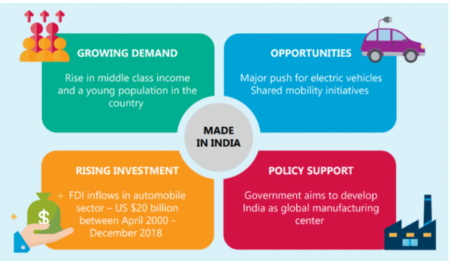
Figure 10: Government policy for the electronic vehicle
(Source: Mishra, 2021)
Subha (2021) identified that the Government of India further developed a practical scheme for launching automobile products in India. Kumar (2021) deducted that the “Faster Adoption and Manufacturing of Hybrid and electronic Vehicles” (FAME) is additionally very helpful for the manufacturers of electronic automobile products in India by providing subsidies and incentives for promoting electronic vehicles. Lamba (2022) said that The FAME further focused on the significant areas of launching electronic automobile products in India, like development in technology, creation of demand, pilot projects, and bringing a change in the infrastructure.
Government Policy for the electronic vehicle
India's government further changed their mobility policy and developed their role for the sustainability of electronic vehicles. Chaturvedi (2022) reflected that more than 50% of states in India further changed their policy for cars and vehicles. The policy of the government, including subsidies in investment in the particular sector, created enormous opportunities for the electronic vehicle companies and the support for purchasing. Exemption of the road tax, registration fees for vehicles, and lower interest for loans create enormous opportunities for developing electronic cars in India. Goel (2021) identified that the Government of India’s further initiatives for launching electronic vehicles for public transport, decrease in the delivery cost and massive investment in the charging infrastructure in larger quantities further enouncing the automobile companies to launch electronic cars in the Indian market.
As the fourth largest automobile market, India is creating a huge opportunity for a massive change in the ecosystem. Kaur (2021) reviewed that more than 170 active investors in this particular sector are developing this specific sector in India. The Government of India brings an enormous investment in this particular sector. Kumar (2022) deducted that with the change in a new system of GST, the reduction of GST for an electronic vehicle from 12% to 5% increase the interest for investment in this particular sector. Juyal (2022) identified that the FAME one and two of the Indian government developed different programs for manufacturing electronic vehicles. The incentive scheme for this sector boosts the performance of electronic automobile companies. Bhakar (2021) reflected that with the Budgetary support of 10000 crores, the government further planned to launch more than 62000 electronic buses all over India.
The manufacturing companies of electronic vehicles are taking initiatives to promote electronic cars to increase the demand in the market. Raman (2021) identified that by increasing production, they are planning to launch more than 40% by 2030 and convert ICE vehicles to electronic vehicles. This can be very effective for decreasing the rate of pollution from India and replace of fuel cars, further developing the quality of air in different cities in India, which is the main priority for the Government of India. Chaturvedi (2022) concludes that innovations are required to bring a positive change in automobile products for developing the particular sector. By changing the policies, the Indian Government further encourages customers to access modern technologies. which can quickly establish the performance of the automobile sector in India.

2.5 Influence of E-Vehicles on business sustainability of automobile sector in India
The main purpose of introduction of the e-vehicles in India is to check the environmental pollution as well as reduce the rapid depletion of natural resources such as natural gas, CNG and petroleum. As pointed by Munjal (2022), not only do e-vehicles help in saving the environment and its natural resources, furthermore, it bolsters the sustainability practices by being comparably much cheaper than all the other sources of energy. The E-Vehicles not only will make the future more sustainable and greener, it will immensely contribute towards numerous other industries related to automobile sectors directly as well as indirectly. Business sustainability in the automobile sector already has been in under quite a threat in India, especially after the rising issues with climate and environmental sustainability.
According to Patel (2022), the global data shows that it is not only in India but all the automobile business firms entire the globe that have been quite concerned with the public's shift in preference towards E-Vehicles over new models of traditionally fuelled cars. As estimated, by the end of the year 2025, about one-third of the whole chain of automobile manufacturers will completely stop using the old internal combustion engine models as their first step towards attempting to go fully electric. Furthermore, it has been estimated that the percentage of completely E-Vehicles manufacturing companies will be rising to at least 40 per cent by the year 2040. Specific to the Indian market the rate of increase in its preference and popularity of the E-Vehicles is quite unpredictable. Consumers are continually seeking the E-Vehicles because of the numerous advantages it offers. In the view of Mishra and Malhotra (2019), people are not even quite bothered about the supporting technologies required for enabling the E-Vehicles to function, such as stable renewable energy production as well as essential charging facilities.
The automobile industry in India has already witnessed and been helped by the people's shift of preference toward the E-Vehicles. The sustainability exhibited by the E-Vehicles companies that have catered charging facility vehicles in India is unbelievably high. According to Navalagund, Mahantshetti and Nulkar (2020), though four-wheelers running on sustainable energy in India are still a very rare picture, yet two-wheelers, three-wheelers and other categories of public transport running on electricity have shown a remarkable amount of growth in India in the past 5 years.
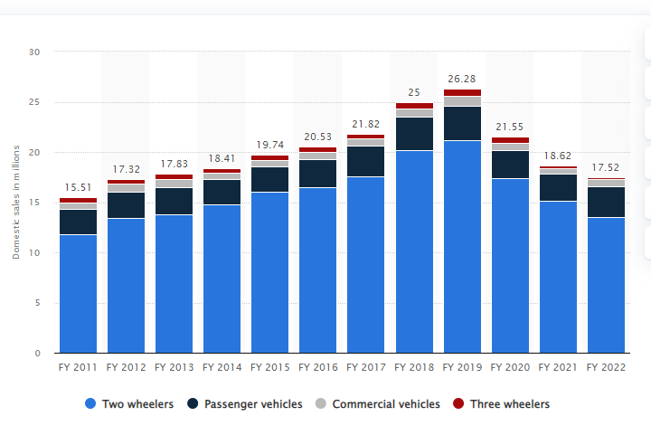
Figure 11: Sales of automobiles in India from 2011 to 2022, by type
(Source: Sun, 2022)
The public has stated their unanimous preference for the E-Vehicles due to many reasons, especially, due to being cheap, having no noise and emitting no harmful gases in the air. As noted by Kurien, Srivastava and Molere (2020), there has been a great demand among the different transport business owners as well as the occupational drivers for the E-Vehicles because the net expenditure is reduced by more than 50 per cent for them to operate in comparison to traditional automobiles. As opined by Sun (2022) the Indian companies have experienced their highest sales of E-Vehicles in the two-wheeler type, followed by passenger vehicles, commercial vehicles and finally three-wheeler vehicles.
According to Pandey and Das (2020), the business plans and the permissions of the government until now, the charging stations would be mostly set up in the shopping malls due to high-energy demands, which are bound to bring them more customers and earn extra revenue from the rents. Recently, as par the Delhi government's plan, the Delhi Electric Vehicle Plan, the government has aimed to set up more than 200 charging stations in a year so that there would definitely be a charging station within every 3 km by the year of 2024 (Patel, 2022). Projects of such a huge scale will certainly require many workforces to engage many different industries and deploy many experts to succeed; all these would not only increase future sustainability but as well help to reduce the present situations of unemployment and stagnancy in various organisations all over India.
In the opinions of Pandey and Das (2020), if compared to the internal combustion engine vehicles, the E-Vehicles have a very significant upper hand, as the developments in the battery technologies are much faster than the internal combustion models or the gasoline-based models. The E-Vehicles are a ray of hope for a sustainable future for the automobile industries in India as they eliminate the tailpipe emissions, decrease the dependence on fossil fuels, boost the community health standards, protect the energy security and enhance the prospects of employment and up-skilling. As noted by Kurien, Srivastava and Molere (2020), the fusion of the electric technology developments along with the mobility targets using the renewable energy sources will further help in decarbonising the transport sector, increasing its marking appreciation and thus making the automobile sector one of the most sustainable one in the future.

2.6 Major challenges faced by Indian automobile companies regarding popularity of EV and sustainable business practice
Tiwari (2022) reviewed that Indian automobile companies are planning to launch electronic vehicles as commercial vehicles, and in the year 2019, the companies found RV400 in India, which was most preferred among Indian people. Navalagund Mahantshetti and Nulkar (2020) reflected that Tata further launched Nexon EV, the most super hit product in the Indian market, and planning to launch an electronic vehicle as a public transport within a few years. Kurien, Srivastava and Molere (2020) said that more than 1.8% of the population prefers electrical in India, and more than 30% of public transport will convert into electronic ones within a few years. Though there is a massive opportunity for electronic vehicles, different problems have arisen for automobile companies in India.
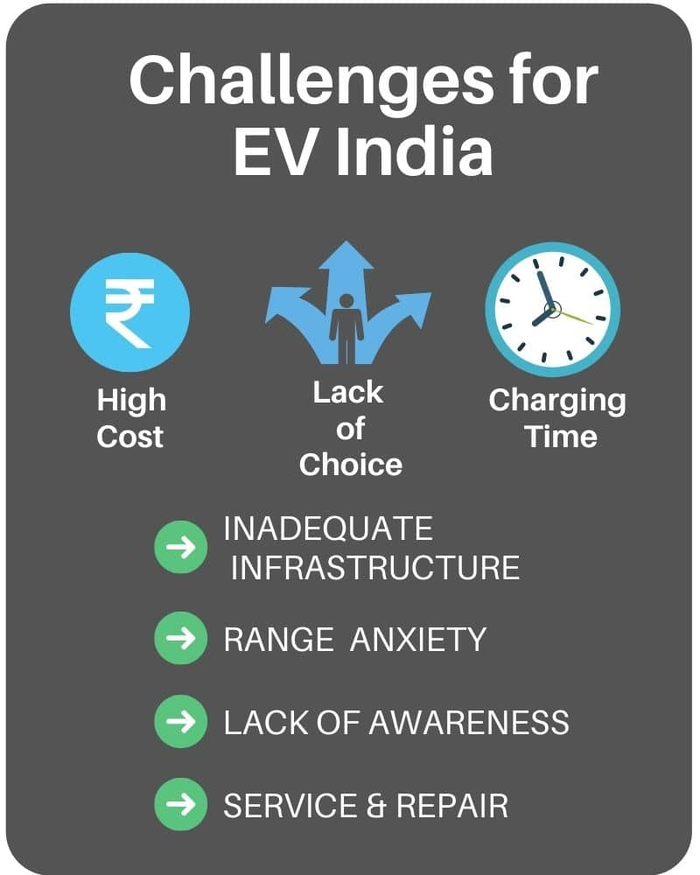
Figure 12: Challenges of the automobile companies for launching EVs in India
(Source: Tiwari, 2022)
High price margin
Hans (2020) reflected that the initial cost of production of electronics is relatively higher than ICE vehicles, and massive dependency on foreign companies for different parts created problems for the customers; due to the high price margin, the Indian customers faced problems regarding affordability and lack of demand in the market further began a problem for the automobile companies. Deepak (2020) identified that more than 10 to 14% of parts of electronic vehicles are not available in the Indian market, which creates limitations for the companies.
Cost of Battery
Shanmugavel (2022) identified that due to the advanced technology, automobile companies are looking for advanced technology for the battery for the electronic vehicle. Lithium-ion batteries are essential for electronic cars, and the product price is relatively high in the market. Vijayakumar (2021) said that the lasting period of a flurry of an electronic vehicle is six to seven years, and after that owner of the electronic vehicle has to change the battery, which is quite costly, near 75% of the total cost of an electronic vehicle, which is a big challenge for the Indian automobile companies. Although the government of India is proving to subsist in purchasing batteries for electronic cars, customers do not prefer electronic vehicles due to the high cost of batteries.
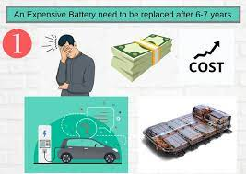
Figure 13: Problems faced by electric vehicle owners
(Source: Bindhu, 2020)
Beta version of the electronic vehicle
Bindhu (2020) identified that the technology and the electronic vehicle producing companies are new in the market, which created a genuine concern for these companies. As they are facing real customers for the first time, due to the lack of planning and customer attraction strategies, they are facing huge problems creating a positive impact on customers. The product is new in the market, and the buyers face different issues with the complex program. Morankar (2020) deducted those other electronic vehicles, like RV400, and EPluto 7G, further need updates to make more customer-friendly functions of their car. The vast number of feedback and negative reviews on social media created a problem for those companies. The electronic vehicle's software, policies, and hardware created difficulties for the companies. Tata Motors plans to upgrade its electronic vehicle, which further creates problems for the company.
Poor infrastructure
As the production of electronic vehicle needs advanced infrastructure, the company are facing huge problem regarding the fund. The high range of anxiety creates problems among the customers, and presently lack of proper set-up for charging creates issues for the customers. Garg (2020) deducted that a significant problem was charging heavier electronic vehicles, which needed a good set-up, like power MCB, earthing and wire. The poor infrastructure is creating issues for the companies as customers face huge problems regarding charging. Bhardwaj (2019) said that, however, many companies offer a middle-range category of driving, like 200 or 180, but cannot satisfy Indian customers looking for a 100km range of driving.
Lack of universal charger
The automobile companies are producing different charging ports for the other vehicles, which further create a massive problem for the customers as there is no set-up for the various charging points, and the electronic vehicle’s owner is also facing difficulties. Prasad (2022) reflected that the users of the electronic vehicle are complaining to the companies about the huge trouble regarding charging, which further hampered the growth of the electronic vehicle industry. The lack of standard infrastructure is a barrier to the Indian electronic vehicle industry for further development. The different charging point in the other vehicle creates a problem for adopting an electronic car.
Lack of awareness
The purchasing of electronic cars needs lots of awareness among local people in India, and the government’s support is necessary for creating awareness among the ordinary people. Skills and understanding are essential for the development of the environment. Yosef (2021) deduced that due to the lack of skills and knowledge, the customers prefer ICE vehicles other than electronic vehicles and lack customer support; the automobile companies face a huge problem. The customers are further facing another issue regarding the temperature. Due to the cold environment, like Uttarakhand and Meghalaya, the electronic vehicle battery is inappropriate, and the high temperature like Rajasthan etc., further creates confusion among Indian customers.
Poor servicing
As the original parts of the electronic vehicles are pretty costly and unavailable in the Indian market, consumers do not prefer electronic cars for that. The quality of the material of the new-age vehicles is relatively high, and the substitutes are not available in the market. Venugopal (2021) said that high-tech functions, like GPS, Touch screen panels, need high-quality skills for operating and repairing. As the choice of replacing the small parts is shallow due to the overdependence of the foreign companies, the Indian customers do not prefer the product.

2.7 Conceptual framework
Identifying the impacts of e-vehicles on business sustainability of the automobile industry in India
Business Sustainability
Challenges
Measures
Further improvement is needed
Pricing Issue
Battery Cost
Minimum charging station
Effective pricing strategy
Incorporate charging stations
Figure 14: Conceptual Framework
(Source: Self-created)

2.8 Literature gap and summary
Literature gap
This particular research developed a detailed analysis on the analysis of the impacts of e-vehicle on the business sustainability of the automobile industry in India. A massive gap in the literature review was identified due to the short article published on this particular topic. The lack of proper information created an enormous problem for the researchers, and as accessing the government sites needed adequate authority, the researchers faced issues. The current pandemic situation created a huge difficulty in collecting opinions of some authors on this particular topic. Some automobile company did not share their personal planning and reviews on this particular topic, which created difficulties for the researchers.
Summary of the chapter
This section of this research further identified that with the increase in the demand for electronic vehicles, the Indian automobile sector additionally invested in electronic cars, and the government of India further changed their economic policies to encourage those companies to the massive production of electronic automobile products. With the replacement of fuel consumption, the development of the environment will increase sustainability and remove different problems, like warming and the high price of fuel in the international market. As the electronic vehicle is beneficial for the removal of carbon footprint, the Indian government invested a considerable amount of money in bringing positive change in the production of the electronic vehicle.

Chapter 3: Research methodology

3.1 Research onion
As per the opinion of Saunders et al. (2015), the research onion could consider an important element for the research process, as it could help to develop the overall structure for the respective study. It has been identified that the research onion structure would help the researcher to take different decisions for the study, which will help to develop the specific methodology for the study. Additionally, Sahay (2016) stated that the research onion would help to illustrate the key stages for the structure of the dissertation and thereby make the study effective. In this aspect, it could be stated that the research onion model would help to examine different key elements for the study and thus, help the researcher to construct the research in a better manner.
Furthermore, Melnikovas (2018) stated that the Sanders research onion model considers the key stages of the study such as research design, research philosophy, research approach, research strategy, data collection method and data analysis technique, which would make the study effective as well. Considering these stages, the researcher could produce an effective understanding of the subject matter. Additionally, the researcher could develop a continuous and systematic research framework, which would make the overall findings and outcome of the study effective.
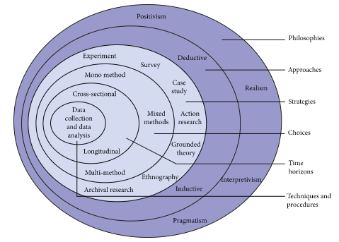
Figure 15: Research onion model
(Source: Alturki, 2021)
Further, Alturki (2021) stated that each step of the research onion model helps to depict the specific aspect of the study and thereby helps to demonstrate different paradigms, strategies and choices, which have to be selected by the researcher during conducting the study respectively. The following study considers the identification of the impacts of e-vehicles on business sustainability of the automobile industry in India and thereby, Saunders's research onion model would help to provide a better understanding of the subject matter by ensuring powerful and multidisciplinary application of the onion framework respectively.

3.2 Research design
According to Prudhomme and Lund (2022), the research design would help to provide a smooth flow of the research operation. It has been identified that the research design would help to consider a systematic framework of the research study regarding the stages of the research onion process and thereby help the researcher to make a concrete understanding regarding the subject matter respectively. Additionally, Elman (2022) opined that the research design would help to consider the key objectives of the study for providing the best solutions as the research outcome respectively. The three major research designs are- descriptive, exploratory and explanatory based on the type of methodological structure selection by the researcher. Prudhomme and Lund (2022) stated that the descriptive design would consider the primary methodological process while the explanatory and exploratory design would consider the secondary methodological process respectively.
Justification:
In this study, the researcher aims to identify the impact of the E-Vehicle in the sustainable business practice in the automobile industry in India and considering this, the researcher has selected the exploratory research design for making the study effective. Govindarajan et al. (2022) stated that the exploratory research design would help to explore the key variable and principle of the study, which will ultimately help the researcher address the key problem statement and objective respectively. According to this study, exploratory research design has helped the researcher to identify the variables such as the trend of E-Vehicle purchases among Indian consumers, its impact on the sustainable business practice of the automobile industry in India and so on, which has made the study effective and comprehensive.

3.3 Research philosophy
Žukauskas, Vveinhardt and Andriukaitienė (2017) stated that the research philosophy considers the key source, nature and knowledge of the subject matter of the research project. It has been identified that the research philosophy could help to provide a philosophical understanding of the study, which will help the researcher for making the study effective. GuhaThakurta (2016) stated that the research philosophy would help to address key beliefs regarding the overall methodological process in which the researcher could select the process of the data collection, analysis and interpretation process respectively. According to Ramsberg (2018), two main kinds of research philosophies could be developed in the study such as positivism, and interpretivism among which, positivism philosophy would help to consider the primary methodological process and interpretivism philosophy would help to address the secondary methodological process respectively.
Justification:
The following study tends to evaluate the impact of E-Vehicle on the sustainability in the business operation of the automobile industry in India and considering this, the researcher has selected the interpretivism philosophy, which would help to consider the key belief regarding the subject matter and core variables of the study. Additionally, Ramsberg (2018) stated that the interpretivism philosophy could help to provide understanding related to the key principle of the study and considering this study, the key principle is regarding the E-Vehicle on the sustainability in the business operation of the Indian automobile industry. Thus, with the help of interpretivism philosophy, the researcher has helped address the problem statement of the study.

3.4 Research approach
According to Chetty (2016), the research approach considers the systematic plan of action regarding which the steps related to the research study could be generated and thereby helps the researcher to provide an effective solution and outcome of the study. Additionally, it can be stated that the research approach could help to provide broader assumptions to the detailed methods of data collection, analysis and interpretation strategy for addressing the core problem of the study. As opined by Grover (2022), there are three main types of research approaches present such as deductive, inductive and abductive based on the methodological selection of the research. It has been identified that the inductive and abductive approach considers secondary research while the deductive approach considers the numerical facts of the study.
Justification:
Considering this study, the researcher has selected the abductive research approach, which would provide a better solution to the problem of the study. It has been identified that the abductive approach to the research study would help to consider the surprising facts, which will address the key facts, variables and findings respectively (Grover, 2022). In this aspect, the researcher has helped to utilise the abductive research approach, as it would help to address the problem regarding the E-Vehicle impact on the sustainable business operation in the Indian Automobile industry respectively. The deductive and inductive approach could provide the general to the specific or specific general aspect of the study, which would not provide any new information related to the subject matter and thus, the researcher has selected the abductive approach over the others.

3.5 Research Strategy
It has been investigated that the research strategy would help to consider the systematic process for providing the direction to the research for conducting the overall study. According to Walia (2022), the research strategy would help to maintain an effective schedule and framework regarding the data collection and analysis process and thereby make the study analytical. It has been further identified that the research strategy is of three types such as qualitative, quantitative and mixed strategy (Johannesson and Perjons, 2022). The quantitative strategy would help to collect the primary and numerical data and information regarding the study while the qualitative strategy would help to provide secondary information for the study respectively.
Justification:
In this study, the researcher tends to evaluate the impact of E-Vehicle on the sustainable business operation in the automobile industry in India and considering this, a qualitative strategy would help to consider the secondary information for the study. Walia (2020) stated that the qualitative strategy would help to provide the experience-based and non-numerical data to the study and considering this study, the non-numerical and secondary data and information have effectively provided the idea regarding the subject matter for making the study effective. Additionally, the numerical data could provide fake and misleading data and thus, the researcher has selected the qualitative strategy over the quantitative strategy.

3.6 Data collection method
When it comes to the conduction of any research project with a significant subject matter, it becomes vital for the researcher to have a clear idea regarding the processes utilised for acquiring vital information. It has been observed that academic research works are conducted with the aid of either the primary data collection method or the secondary data collection method. The former method leads a researcher into the path of acquiring valid and relevant information regarding any social phenomena from individuals or groups of people, influenced by the incident/event. In this case, the researcher has the option of gathering either quantitative or qualitative data. Quantitative data can be obtained by conducting surveys on people, who have been subjected to the influence of a social issue or any situation (Taherdoost, 2021).
However, the qualitative primary data is procured from the interviews of experienced individuals, who are not only influenced by the social phenomena but have wide knowledge about it as well. Contrary to this, the latter method guides a researcher to gather information related to the topic of the dissertation from the different sources of literature such as articles, journals and web pages available from various online platforms such as Google Scholar, Researchgate, Statista and others (Ruggiano and Perry, 2019). The secondary data collection relies only on qualitative data, and due to this aspect, the secondary method is considered a significant qualitative method for gathering authentic and ideal information for any research work.
Justification
In this research project, the researcher has attempted to conduct an extensive study on the impact of EVs on the business sustainability of the Indian automobile sectors. Based on this aspect, the researcher is in the need of selecting the most suitable method for collecting accurate and valid data from authentic sources. Hence, the researcher has selected the secondary data collection method for collecting qualitative information from different peer-reviewed articles, journals and other web sources, which are developed by other researchers with the agenda of elaborating on the influence of EVs on the business sustainability within Indian automobile industry (Ruggiano and Perry, 2019). The main benefit of the selection of the secondary method is the scope of flexibility that the researcher can have, while still having the ability to acquire high quality and authentic information (O’Reilly and Kiyimba, 2015). Moreover, secondary data can be advantageous for the researcher, as it enables the generation of new findings from the analysis of the existing information and the research can be cost-effective, which can be beneficial for the researcher (Valcheva, 2022).

3.7 Data analysis technique
For the sake of developing and completing a research project on timely and systematic manner, the researcher is required to identify the appropriate techniques for evaluating the information, which were collected based on the subject matter of a research project. When it comes to the process of analysing information collected for a research, frequency analysis, content analysis and thematic analysis are the three most prominent methods. Both frequency analysis and content analysis are used for analysing the information acquired using the primary method for collecting information. However, the thematic analysis is the ideal technique for evaluating the data obtained from varies literary materials such as web articles, reports and journals (Taherdoost, 2021).
Due to this reason, the researcher has considered the selection of the thematic analysis technique for the systematic evaluation of the information procured from different literary sources pertaining to EVs and their influences on business sustainability of the Indian automobile industry. In this case, the researcher had devised some themes based on the objectives formed in this research. The main benefit of thematic analysis is the flexibility, it lends to the researcher, for finding in-depth theoretical understanding (Ruggiano and Perry, 2019). Moreover, thematic analysis can be an effective technique for developing new knowledge from existing sources of literature.

3.8 Ethical consideration
According to Resnik (2020), the consideration of ethical practice in the research process would help to make the study effective and authentic as well. It has been identified that the importance of ethical consideration regarding the entire research project is regarding the practice of certain ethical norms for promoting the aims of the research, knowledge development, truth as well as avoidance of errors in the overall study respectively. Further, Chetty (2019) stated that the ethical consideration in the secondary research process is a vital aspect, as it would help to maximise the value of the publications, the authenticity of the data collection process, ensures the reliability of the study findings and thereby considers the transparency and integrity to the overall study respectively. Moreover, Bhandari (2022) stated that the secondary research process needs de-identification of the data before its utilisation in the following study. Additionally, the proper scrutiny of the chosen publication is further become one of the aspects of ethical consideration in the research process.
In this study, the researcher tends to evaluate the impact of E-Vehicle on sustainable business practice in the Indian automobile industry, which needs proper ethical consideration aspect to make the study effective. Considering this, the researcher has accredited the authors to the publications, which have been utilised in the study. The researcher has utilised the secondary articles, which are published in a public domain and could be accessed by everyone. This would ensure the General Data Protection Regulation (GDPR) regarding this study. Meanwhile, as the study practiced secondary methodological structure, the collection and processing of personal data of individuals has not been utilised, which need to maintain GDPR regarding the study as well. Additionally, the researcher has utilised the original and authentic data regarding the study, which could provide the future scope of the study. Moreover, the researcher has avoided the articles and journals, which are irrelevant to this study and could provide misleading information to the study respectively and thereby provide maintaining ethical consideration to the study.

3.9 Limitation of the chosen method
Although the researcher had relied on the research methods mentioned in this chapter; however, there are some limitations for the methods. The main limitation of the exploratory design and interpretivism philosophy is the aspect of subjective interpretation, which can at times result in biased findings (Voxco, 2021). Moreover, the use of abductive approach can be at time incoherent and it can be complex for the readers to understand. Furthermore, the use of secondary data collection and analysis can be a complex and difficult task for an inexperienced researcher, and often the findings generated with the aid of methods can be dated or not very relevant to the changing situations.

3.10 Research timeline
Task | Start Date | Duration
Starting of the research project | 15-Jun-22 | 2
Research aim, objectives and questions creation | 17-Jun-22 | 3
Development of dissertation structure | 18-Jun-22 | 4
Performing the literature review | 22-Jun-22 | 10
Selection of Methodological Structure | 1-Jul-22 | 4
Submission of research proposal | 7-Jul-22 | 20
Conduction of qualitative research | 25-Jul-22 | 15
Collection of the secondary data | 2-Aug-22 | 15
Analysis of the findings | 8-Aug-22 | 10
Deducing the findings | 28-Aug-22 | 10
Data interpretation | 8-Sep-22 | 10
Development of conclusion and recommendations | 29-Sep-22 | 7
Conceptualising self-reflection | 8-Oct-22 | 2
Submitting the final project | 31-Oct-22 | 1
Table 1: Research timeline

Figure 16: Gantt chart

Chapter 4: Findings and discussion

4.1 Findings

4.1.1 Increasing demand among consumers for E-Vehicles in India
Findings
The twilight of the traditionally gasoline fuelled and internal-combustion engines has become clear due to several reasons as they are pointed out. As per with Ewing (2022), the consumers are preferring E-Vehicles at an exponentially growing rate, from India to America, irrespective of the increasing prices, long waits for delivery as well as issues with finding proper parts and suffice charging infrastructures. As per the report of Financialexpress (2022), the carmakers have been facing too many issues due to the shortages of semiconductors that are more than essential to electric cars; however, the people still prefer E-Vehicles in spite of this major problem. The growing rates of E-Vehicles in preference to the traditionally fuelled new models of vehicles have not only raised the concern of the only traditionally fuelled vehicle company owners but even their stakeholders.
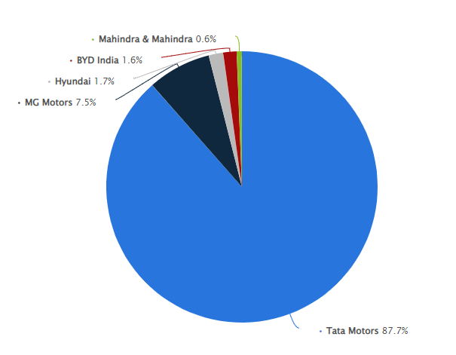
Figure 17: Company shares in Automobile sector of India by their percentage
(Source: Sun, 2022)
As per with Tiwari (2022), the shares of the new E-Vehicles have raised more than a double of what they had been only one year ago. Furthermore, studies even confirmed that companies such as Ford Motors, Volkswagen and Tesla could have delivered quite more than what they did, only if, they could produce their cars faster than they are doing (Kumar and Padmanaban, 2019). As mentioned in the Financialexpress (2022), the predicted shift towards a sustainable future by gradually replacing the traditional modes of transport with E-Vehicles is committed towards a completely net zero rate of emission by the year of 2070.
According to the aims set by the government as well as the E-Vehicles companies have attracted the customers’ attention more and set higher preferences for them. As deduced from Sun (2022), companies and specifically Tata have shown a tremendous growth in their total share in the national automobile market. According to Kumar and Chakrabarty (2020), Tata dominated the whole market with a share of more than 87 per cent in the passenger vehicles OEM. At the current market, more than a million E-Vehicles are being sold annually which are mostly in the urban areas, pointing out to the link between modern thinking and adoption of the E-Vehicles.
Analysis
As pointed out by Monika (2019), the E-Vehicles not only have high potential to boost the automobile sectors in India but also many other sectors that would contribute to the establishment and functioning of the various E-Vehicles services and running. Holding the position of being the largest automobile industry in the earth since 2019, the impact of the automobile business is one of the biggest factors that would determine the economy of India. As pointed out by Aswani, Bhadoria and Singh (2018), the automobile manufacturing companies are already pursuing numerous environmental initiatives, in India, including better eco-friendly designs, green supply chains, recyclable accessories and car parts, reverse logistics, green buildings, emission-free innovations and decomposable packing materials.
In the views of Tupe, Kishore and Johnvieira (2020), the critical analysis of the sustainability measures of the organisations, has found an observable gap between the companies' sayings about their sustainability approaches and the data from the various reports on their activities. In the views of RK and NithinDaniel (2019), India irrespective of its current inaccessibility to modern facilities required for running electric cars in the streets aims to be a 100 per cent e-mobility country by the year of 2030.
India is all set up to welcome the surge of E-Vehicles in a very close future, reading their public demands, the country is preparing and reinforcing itself to make the most out of this upcoming revolution. In the views of Shanmugavel and Micheal (2022), when all the other industries were severely suffering due to the impacts of the global pandemic, the year 2020 proved to be a remarkably successful year for the global E-Vehicles companies, with a growth of more than 40 per cent from that of 2019. In the year of 2021, the sales of the E-Vehicle companies have yet doubled themselves to 6.75 million. The popularity of the E-Vehicles in India is particularly due to their less maintenance factor, environmental friendliness and particularly its pocket-friendly nature than the ICEs.
As pointed out by Monika (2019), shifting to electric mobility services will contribute a lot to India to save about a Giga tonne of carbon dioxide production by the year of 2031. In the views of Tupe, Kishore and Johnvieira (2020), the most influential factor that makes these E-Vehicles so demanded also by the average middle-class people is that they do not require almost any fuel to run, they are completely safe for the environment and future generations, have better performance and no noise or other forms of undesirable emissions.

4.1.2 Sustainable business practice has become a major factor in the Indian automobile sector
Findings:
According to Luthra, Garg and Hlleem (2022), electric vehicles have gained popularity in the Indian market by adapting to recent trends such as zero tailpipe emissions vehicles as well as carbon neutral manufacturing, which demonstrates the growing importance of sustainability for the automobile sectors in India. As opined by Roukouni and Homem de Almeida (2020), the automobile industries in India have adopted sustainable practices by following the trends such as electro-mobility, autonomous driving and shared mobility services. Luthra, Garg and Hlleem (2022), stated that the Indian automobile sectors focus on the creation of new solutions to eliminate the harmful effects on society. As per Nayal, Pandey and Paul (2022), during the time of the Covid-19 pandemic, the automobile companies maintained sustainable growth by making alternations in the pricing strategies and by developing employee engagement. As opined by Abbas et al. (2019), Corporate Social Responsibility (CSR) plays a significant role in increasing the sales of a business by emphasising the environmental, ethical and philanthropic responsibilities of the organisations. According to Kumar et al. (2020), the Tata Motors Company of India has increased the number of electric cars by providing flexible solutions to mobility.
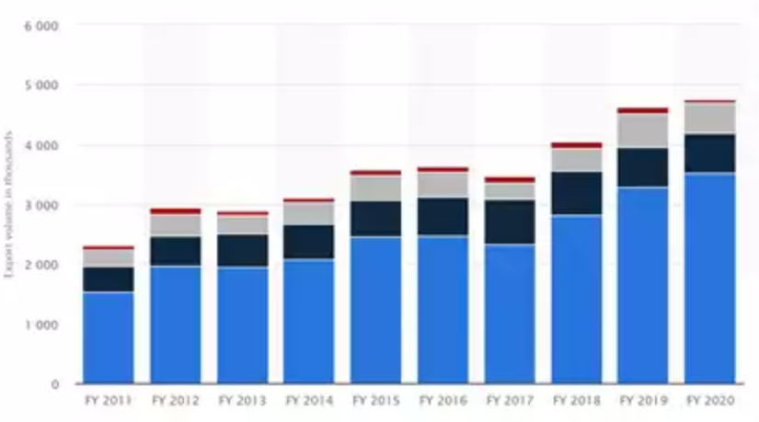
Figure 18: Growth of sustainable practices by the automobile sectors
(Source: Economictimes, 2022)
It has been observed that the Indian automobile sectors have made a great progress with the help of sustainability practices and with the growth of population in India, conventional sources of energy is not considered to be a sustainable option due to the rising price of the essential fuels (Economictimes, 2022). As per Goel et al. (2021), over the last three decades, about 0.52 million electronic vehicles had been registered in India and the country witnesses a robust growth of EVs in 2021 as it ensures the reduction of energy consumption. Luthra, Garg and Hlleem (2022), further stated that the developing countries like India, the manufacturers as well as the suppliers of the automobile industries find out solutions, which would be cost-effective and sustainable to integrate sustainability into the business models.
Analysis:
As per Kumar et al. (2020), the sustainable goals, practiced by the Indian automobile sectors have created awareness regarding the environment as well as sustainability issues within the society, which ensures growing interest among the customers in sustainable vehicles. Umar et al. (2021) have stated that the sustainable or green auto aims of manufacturing help in minimising the production waste as the environmental impact of the production of vehicles. Islami, Mustafa and Topuzovska (2020), the new pricing strategies have been effective in fulfilling the demand of the global customers and thereby enhancing the overall profitability of the business. According to Li et al. (2019), the development of employee engagement has been effective in securing the knowledge of sustainability and competence to enhance productivity and benefit the external stakeholders as well.
According to Umar et al. (2021), the inventions of innovative batteries ensure the increase o sustainability rate and considering this, the demand of the customers increase by using non-fossil energy sources. As opined by Tripathi et al. (2021), the automobile sectors are making efforts to avoid carbon emissions as well as waste generated from the manufacturing sectors and making innovations to the overall production processes of vehicles. Reyes-Muñoz and Guerrero-Ibáñez (2022) stated that the reduced production of energy is effective in deducting the operational costs and thereby enhances the brand image as well as less legal hassles. Shah et al. (2020) have stated that the use of electro-mobility avoids the emission of tonnes of greenhouse gases, which helps in the conflicts against the consequences of climatic changes. As opined by Reyes-Muñoz and Guerrero-Ibáñez (2022), the innovation of autonomous driving in India has helped to reduce road accidents and improve the interconnectivity of transport.

4.1.3 E-Vehicle practice increases the business sustainability in the automobile industry in India
Findings:
According to Munjal (2022), the main reason for introducing E-Vehicles is to reduce environmental pollution and maintain natural resources, like natural gas. As a natural gas resource, petrol has some limitations; only the E-vehicle will be very effective for saving resources of the environment. The use of E-vehicle will be very effective for the practices of future sustainability as it is cheaper than other resources of energy. To make the environment greener and increase sustainability, the automobile sector in India is launching e-vehicles, which are further very effective for the sustainability of the environment and the climate. Patel (2022) deducted that the global automobile sector is engaging with the massive production of E- vehicles and governments of different countries are using them as public transport. Swain (2021) deducted that it was identified that by 2025 the new model of electronic vehicles would require one-third of the vehicle industry, and all the automobile companies will stop the production of classic cars and entirely focus on the electronic vehicle. Mirwani (2021) said that with the increase in the interest in electronic cars, the Indian market of automobile products is launching electronic vehicles and planning for rising in the production of more than 40% of the market within a few years.
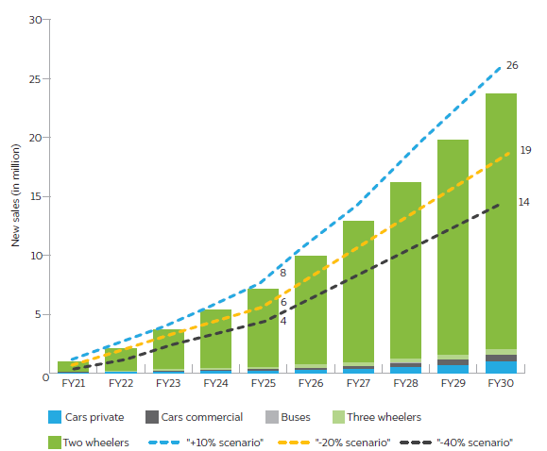
Figure 19: Transition of E-vehicles in India
(Source: Swain, 2021)
Malhotra (2019) reflected that people are interested in purchasing new technologies, looking for e-vehicles with adequate charging facilities, and planning to use renewable energies in different ways. As people are shifting their preferences for the E- vehicles, automobile companies are planning to enhance their performances. With advanced technology and better infrastructure, E-vehicle companies are further attracting customers, and for sustainable energy, Indian customers prefer that. Sun (2020) identified that the sales margin of E-vehicles has recently increased due to the high demand in the market. Common people are choosing e-vehicles for the zero noise and emission of all kinds of harmful gases. Sruthi (2021) identified that lately, the owners of transport businesses prefer E-vehicles, which further created enormous opportunities for automobile companies. A massive increase in the sales margin of two-wheeler E-vehicles was identified. Production increased as the government of India planned to use E- vehicles as public transport. Pandey (2020) has deducted that the business plans of the automobile companies additionally depend on the permission of the Indian government for the establishment of the new charging station. The charging station at the shopping mall will benefit the customers, and the government of Delhi is planning to launch an electronic vehicle plan and aims to establish more than 200 charging stations per year, which will be helpful for e-vehicle owners. However, there will be a considerable workforce need for the plan, which will increase the sustainability of the environment.
Analysis:
Nulkar (2020) identified that automobile companies plan to launch E- vehicles to sustain the environment and use renewable energies. As the government of India has announced using E-vehicles as public transport, the demand in the market has rapidly increased. People prefer E-vehicle for zero pollution; noise and using renewable energies will be very effective for environmental sustainability practices. Though the high cost of the parts is creating problems regarding using modern technologies, automobile companies are further planning to enhance their technologies, which will be user-friendly. Molere (2020) deducted that international companies are planning to close the production of traditional fuel-consumed cars and produce E- vehicles for environmental development. Though the charging facilities further create problems for E-vehicle owners, they are facing enormous difficulties. Hans (2020) said that with the increase in popularity of E-vehicles, some transport owners want to use that for commercial purposes. Due to the vast consciousness among common people, the sale of two-wheeler electronic vehicles has rapidly increased.
Deepak (2020) said that the automobile companies are waiting for government permission to establish charging stations and charging points near shopping malls and other places that will be very helpful for E-vehicle owners. Different states in India are further planning to launch a master plan for establishing a vast number of power stations within a year, which can increase the demand for e-vehicles among customers. Different projects for promoting E-vehicles will be beneficial in expanding the consciousness of people who want to use that. The automobile industry in India is further looking to increase the workforce for better production of E-vehicles. Shanmugavel (2022) identified that due to the massive recession in the market, those companies are facing huge problems regarding that. Most E-vehicle companies are further developing strategies for attracting customers. The government of India is further providing loans and subsidies to E-vehicles customers, which further increased the sales margin in recent times.

4.1.4 Challenges faced by E-Vehicle affect the business sustainability practice in the Indian automobile industry
Findings:
According to Kumar (2022), the high cost of electric vehicles has changed the automobile sector in India and minimised the revenue of organisations massively. Moreover, the high cost of batteries and poor charging stations has reduced the sales and popularity of EVs in India. In addition, the functions of the automobile companies have dynamically changed the image of business sustainability and reduced the ability to run their business in India. As per the opinion of Garg (2022), though the Indian EV market will reach a CAGR rate of around 42.38% by 2025, certain concerns hindered the performance of the organisations such as high cost, long-ranging charging stations, battery cost, service cost, changing consumer behaviour, the beta version of vehicles and lack of trained personnel. These challenges not only mitigated the business activities but also rapidly hindered the financial condition of the automobile companies in India.
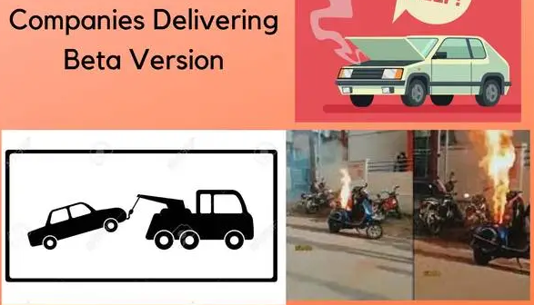
Figure 20: Beta version of batteries in the EVs
(Source: Kumar, 2022)
Tarei, Chand and Gupta (2021) mentioned that business sustainability depends on organisational awareness and their course of action. Hence, it can be said that due to poor infrastructure and lack of EV popularity the automobile companies in India are not functioning properly and that massively hindered the business sustainability. Kumar (2022) opined that the beta version of batteries is prone to blast the car including the batteries. Moreover, it can hinder human death very devastatingly. However, there is no human death news had been announced b any news agencies. Apart from this, several challenges such as range anxiety and poor infrastructure of EVs hindered the business sustainability of the automobile companies in India.

Figure 21: Challenges faced by Indian EV companies
(Source: Self-created)
Khan (2022) outlined that supply chain issues are a very critical barrier for Indian automobile companies and that has reduced their overall manufacturing goal massively. As Indian automobile companies depend on the imports of Lithium-ion batteries hence, they faced major challenges to produce cheap batteries for Indian EV consumers (Khan, 2022). Hence, it can be said that it becomes a major roadblock for organisations to operate their business sustainably.
Analysis:
From the above findings, it can be analysed that the high cost of the batteries, long-range charging stations, poor supply chain management, beta version of batteries, and poor experts are the major barriers for automobile companies. According to Khan (2022), the EV market in India is rapidly increasing but due to some internal and external obstacles, it could not reach the global level. Moreover, import of the batteries from foreign countries has cost around 60% and Indian automobile companies will spend around $65 billion per year to make transportation affordable and effective (Khan, 2022). Hence, it can be said that this upward trend of import of EV batteries from foreign countries has increased the cost of EVs in the Indian market.
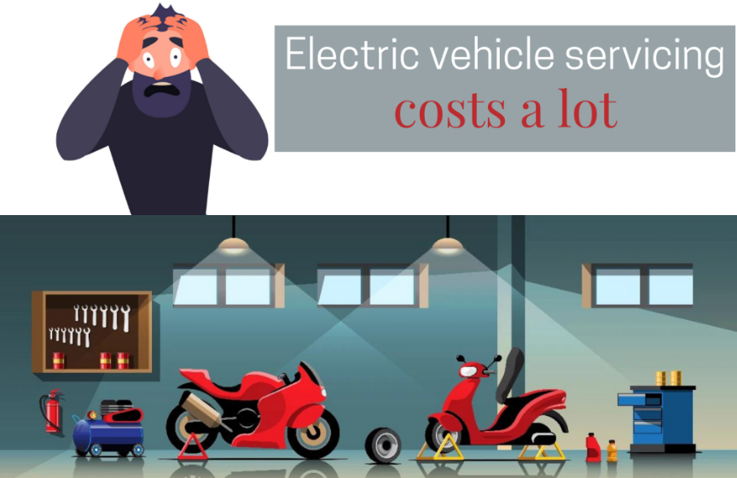
Figure 22: Service cost of EVs in India
(Source: Kumar, 2022)
Kumar (2022) depicted that EV costs in India are massively hindering the performance of automobile companies and the service cost of EVs are very increasing rapidly. Moreover, the performance of automobile companies is not properly effective to reach their goals effectively. Hence, it can be said that high service cost, high battery cost, poor internal control, poor infrastructure, long-range and reduced supply chain massively hindered the automobile sectors' business operation in the context of India.

4.2 Discussion
As opined by Chen et al. (2019), sustainable pricing strategies involved price settings, which aim to achieve a sustainable economy to reduce the impact on the planet. It is due to the ineffective pricing strategies by the Indian automobile sector that have reduced the profit margins and are unable to maintain positioning in the competitive market. According to Dey et al. (2019), the automobile sectors of India have faced challenges in setting up customer-based pricing strategies, which are initially achieved by implementing low or price strategies on products and services for a limited time. Chen et al. (2019) further stated that the high cost of batteries especially for electronic vehicles is often caused by the scarcity of raw materials, which results in an increase in the purchasing prices of the products by affecting business sales.
According to Li et al. (2019), Tata Motors, which is among the top-selling automobile companies in India, has witnessed the price rise of the battery cells by 20% for the surging costs of lithium, cobalt, and nickel that are used for the manufacturing of batteries. Dey et al. (2019) stated that India has only 1742 charging stations, which creates problems for the EVs buyers to charge at a short interval. The charging stations of India are not affordable combined with government subsidies and tax benefits to improve the customer's experience. According to Caulfield et al. (2022), India considers some effective strategies for mitigating the current gap that has been created between the densities of charging stations in urban as well as rural areas.
From the above findings and analysis, it can be discussed that the functions of the automobile companies are not effectively operating their activities to become major players in EV manufacturing in the context of India. Moreover, certain challenges such as the pandemic, carbon emission, poor supply chain, Lack of EV infrastructure, poor lithium-ion availability and other factors massively changed the image of the automobile companies and hindered their business sustainability. As per the opinion of Garg (2022), though the Indian EV market will reach a CAGR rate of around 42.38% by 2025, certain concerns hindered the performance of the organisations such as high cost, long-ranging charging stations, battery cost, service cost, changing consumer behaviour, the beta version of vehicles and lack of trained personnel. Hence, it can be said that these challenges must be mitigated through the proper allocation of funds and making better infrastructure for developing the EV market targeted sales.
As per the report by A Khan (2022), India's automobile sales in the domestic market nosedived to 17.51 million in 2021-22 compared with 2012-13 due to high fuel prices and poor financial services. Hence, it can be said that in order to meet the favourable goal, automobile industries must focus on sustainable strategies for future betterment. Along with this, high fuel prices massively hindered the consumers’ preferences and mitigated the sales of EVs in the Indian context. Moreover, import of the batteries from foreign countries has cost around 60% and Indian automobile companies will spend around $65 billion per year to make transportation affordable and effective (Khan, 2022). Hence, in order to meet the targeted goal, the companies must focus on their weaknesses and maintain the overall functions of the EV market in the context of India.
Recently due to the increase in the consciousness for the sustainability of the environment, the demand for the E-vehicle has rapidly increased. As the price of petrol and diesel and other natural gases are very high in the international market, people are looking for cheaper options, which have created a huge opportunity for them. Due to the practices of people for natural resources, they are looking for renewable energies, and E-vehicles created huge opportunities for them. Different countries are using E-vehicle for private and commercial purposes, and people prefer them for public transport. The sustainability of the business is the main motto of the companies, and they are further looking for a huge investment in this particular sector. As the Indian government is planning to use the E-vehicle as public transport, the automobile companies in India are further planning to increase g their production, which needs a huge amount of investment. The government of India is further developing their budget for technological development in the E-vehicle, and with a huge change in infrastructure, further helping the automobile sector to continue its sustainable practices.
Due to the zero pollution and noise, the demand for ER-vehicle has increased in recent years and massive consciousness among customers, further creating a vast opportunity for the automobile sector. People are shifting their preferences from traditional fuel cars to electronic vehicles, and automobile companies are further enhancing their performance as per the demand in the Indian market. The high price of the parts creates problems for the consumers, and the lack of presence of charging stations affected the performance of the automobile companies in India. They are looking for the initiative of the Indian government to establish a charging station every 3 km. Different states of India are further planning to promote e-vehicle among common people to increase their consciousness and use them as public transport, which further removes the pollution level from the environment.
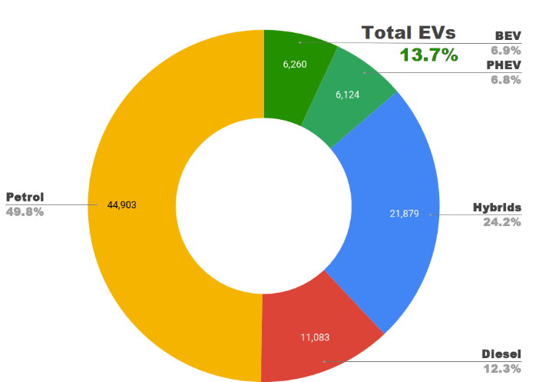
Figure 23: Increase in the demand for the electronic vehicle in India
(Source: Vijayakumar, 2021)
Vijayakumar (2021) identified that the initiative of the Indian government to use the E-vehicle as a public transport created enormous opportunities for the companies, and it was identified that the EV market will earn more than Rs.475 billion within 2025. Garg (2020) said that the massive penetration of the electronic vehicle market further helped the automobile sector to enhance their performances. The different projects of the Indian government for launching electronic vehicles can improve their performances by 15% by 2025. The aggressive activities of the promotional strategies of the automobile sector will create a huge opportunity, and the better infrastructure, they can easily remove the cost. The overdependence on the parts is creating problems for the companies. Bhardwaj (2019) identified that the planning for preparing the components and batteries in India further decreases the price margin for E-vehicle parts. The Indian government plans to incise the charging station within a few years, which can quickly increase the demand for the product among customers. Pachar (2020) said that the companies are launching one solution for charging all E-vehicles to mitigate the difficulties related to the setting. India further understands the problem of shortage of supply of power and plans to establish more power plants in different cities, villages and small towns. Gill (2022) concludes that with the identification of the resource of renewable energies, the Indian government is further developing the supply of power, which will be very effective for enhancing the performance of the Indian automobile sector through an increase in sales of E-vehicles.

Chapter 5: Conclusion and recommendation

5.1 Conclusion and Summary of the findings
Conclusion
The following study deals with the identification of the impact of E-Vehicle on the business sustainable practice in the automobile industry in India and considering this, the researcher has selected an effective dissertation structure for the study effectively. The researcher has divided the overall study into five systematic structures, which has effectively described the significance of the study as well. In the introductory chapter, an effective background of the study has been provided, which has helped to develop the problem statement, aim, objectives and research questions of the study for making it effective. Moreover, in the literature review section, several authentic journals and articles have been summarised, which has provided significant understanding regarding the subject matter.
Following the key perspective and significance of the study, the researcher has selected the secondary methodological structure, which has provided important information related to the subject matter respectively. Considering the secondary methodological structure, the researcher has selected the exploratory research design, interpretivism philosophy, abductive approach and qualitative strategy, which has helped the researcher to consider the data and information from the online authentic publications and thereby, ensures the thematic analysis process for processing the data respectively. With the help of effective implementation of the selected methodology, the researcher has effectively addressed the key objectives of the study, and thereby, resolved the problem statement as well.
The data analysis section has provided significant information regarding the increasing consumer demand among the consumer demand for E-Vehicles in the Indian market, which would help to understand the key factors for improving business sustainability in the automobile business sector. Additionally, the importance of sustainable business practice in the automobile sectors in India as well as the role of E-Vehicle regarding the improvement of sustainable business practices has described, which further addressed the key problem statement of the study respectively.
Summary of the findings
At the end of the study, it has been identified that the impact of E-Vehicle has increased the sustainable business practice in the automobile industry in India effectively. From the analysis of the findings, it has been discovered that the growth of the E-Vehicle preferences among the Indian citizen is gradually increasing and thus, the sustainable business practice has become the major factor in the automobile industry in India respectively. The findings have further depicted that the consumer's attraction to sustainable practices has become a major concern for the automobile industry in India. Considering this, the E-Vehicle implementation has enhanced the consumer attraction towards it, and thereby, helping the companies to ensure their sustainability in the Indian business market respectively.
Moreover, it has been identified that due to the impact of the pandemic, the business growth and financial stability in the Indian business sectors have become reduced, which influenced the industrial sectors such as automobile industries to focus on their business sustainability rather than profitability and other business goals. Furthermore, the study depicted that with the help of E-vehicle practice, eco-friendly approaches are presented to the consumers, which has helped the companies to develop a high consumer base as well as ensure high profit and revenue to improve their business sustainability effectively.
However, the study has shown several problems regarding the E-Vehicle implementation such as its high cost and battery cost. Additionally, technological advancement of the products is new to the Indian market, which might result in sustainable business practice issues as well. Furthermore, the supply chain disruption due to the impact of Covid-19 has resulted in the difficulties in battery importation of E-Vehicle, which would further generate difficulties for the automobile sectors in India and thereby need further modification for a better future.

5.2 Linking with objectives
The research objectives are very important for a dissertation as it helps in making the study more effective. The first objective of the study illustrates the importance of e-vehicles for the business sustainability practice of the automobile sector. It has been observed in the literature review section that electronic vehicles are eco-friendly compared to traditional transport and some of the positive effects have been further discussed in the study, which includes achieving future sustainability in the automobile sector. The second has been linked successfully in the literature review, by identifying the significance of E-vehicles in maintaining business sustainability and it has been observed that developing countries like India have made progress to reach sustainable goals by launching electronic vehicles in the market.
The third objective has also been linked successfully by analysing the major challenges faced by the E- vehicles in the automobile sectors of India and it has been observed that the pricing strategies of the e-vehicles are causing inconvenience for the customers. Furthermore, it has been analysed that India does not have an adequate number of charging stations for electronic vehicles to meet the demands of the customers. The fourth objective delves into the evaluations of suggestive measures for sustainable business development of E-vehicles. It has been investigated that there is a need to establish a developed charging infrastructure to change the perceptions of the customers in the perspective of reducing the consumption of fuel.

5.3 Future scope
According to Sruthi (2021), the future scope of the study has been considered an important element for the study, as it helps to prove the authenticity of the following study respectively. In this study, the researcher aims to develop the idea for the future of the automobile sector in India for launching the E-vehicle and the different barriers they are facing presently; the key findings of the study would help to generate the future scope of the study, respectively. It has been identified that the future scope of the study could be generated by the present research, presentation of the limitation and further justification and suggestive research. In this study, the main outcome stated that the impact of the increase in the conciseness among common people, the automobile companies further taking initiative for technological development and producing different parts of E-vehicles in India.
However, the study lacks a focused aspect and primary findings, and thus, the future study should focus on the limitation faced by this research respectively. Moreover, the following study has provided significant information regarding the increase in the demand for E-vehicle in India in recent years and the government further taking initiative for using the ER-vehicle for commercial purposes. Considering this, the study could be another important secondary resource for future study as well.

5.4 Research limitation
There are certain limitations faced by the researcher while proceeding with the study and adding effects to the research. The pandemic situation has created several barriers to pursuing this particular research, as it hampered the data-collection process from authentic sources. The research relied on secondary data sources and as a result, the secondary data sources have posed many complications to make it successful. Moreover, the pandemic situation has obstructed the identification of the real views of the authors of this research. The market for electronic vehicles has not expanded greatly in India and considering this, the research finds it difficult to collect authentic data regarding the market share of EVs. Apart from these, many libraries were closed and as a result, the research faced difficulties finding out appropriate ideologies that would have been relevant to this particular research topic. The secondary data caused hindrance in analysing the current data due to the cookies and restrictions caused by certain websites.

5.5 Recommendation
From the above results, the following recommendations could be outlined:
- Effective pricing:
After analysing all the obstacles regarding the EV market in India, the researcher recommended effective pricing strategies for developing EV sales and promoting environmental functions dynamically in the context of India. Through making effective pricing decisions the automobile companies such as Tata, Mahindra, and Hyundai can expand their sales massively and implement proper solutions for future business sustainability. Affordable pricing would beneficial for automobile companies, and with the aid of this factor, organisations can effectively build their outcome and sales volume for the future running of the business.
- Organisational strategy:
An organisational strategy is very crucial in modern times and it helps to develop the functions of the organisations. As automobile companies are becoming the major elements for EV production in India hence, the functions of organisations must be flexible and effective. Along with this, through organisational strategy, automobile companies can expand their sales and improve their business sustainability. Moreover, flexible decisions would help to boost the EV market in India and would strategically develop carbon footprint reduction. Hence, it can be said that through proper organisational strategy, automobile companies can be benefitted massively in the future.
- Import substitution:
As the Indian automobile companies are importing Lithium-ion batteries from foreign markets, hence, this becomes a major issue for increasing EV battery cost. In order to meet this challenge, automobile companies must take import substitution and find new ways to allot batteries for EVs in the context of India. Moreover, the production of cheap batteries in the context of Indian EVs would be beneficial for the companies and would expand the future product sales massively. Additionally, the production of cheap batteries would maximise India’s efficiency to become the top EV marketplace. Hence, it can be said that with the aid of proper allocation of business policies and import substitution, EV organisations would expand their business sustainability.
- Improving EV charging infrastructure:
As the EV companies in India are operating with a low charging infrastructure hence, the companies need to expand their number of charging stations. Moreover, the growing EV manufacturing unit in India significantly raises the number of charging stations. Along with this, an increasing number of charging stations would reduce the charging issue and would maximise the operation of automobile companies. Hence, it can be said that by increasing the production of EV charging stations, EV companies would reach their goals swiftly and maximise their business sustainability in the context of India.

Reflection
According to Adeani, Febriani and Syafryadin (2020), description is the major part of the Gibbs Reflective Cycle and it consists of the overall experience from the learning. Moreover, the study insists that service businesses reach a sustainable level by reducing barriers relating to EV production. In addition, I have come to know the challenges and barriers to this topic and have outlined the major challenges to improving their business actions and business performance. Moreover, I have reflected that the business sustainability in the automobile industry in the context of India is under the pressure due to several challenges such as low infrastructure, poor charging stations and high prices. Hence, it can be said that these challenges must be reduced for flexible business sustainability and it helped me to increase my knowledge dynamically. Along with this, it can be said that through effective support of sustainable practices, I would expand my future career dynamically and influence my professional integrity massively.
During the conduction of the study, I felt a little nervous, as this was my first attempt at doing this kind of project. Additionally, the overall project has been done by focussing on the automotive industry in India regarding the business sustainability practice of E-Vehicle implementation, there are a limited number of articles, and journals present on the internet, which has further influenced my nervousness regarding the study respectively. Moreover, the lack of research skills inside me has further triggered my overall condition significantly. However, my module teacher and my peers have provided me with moral support and increased enthusiasm inside me regarding the following research process respectively.
In this project, I have understood the importance of E-Vehicle in the automobile sector in India. I have identified the increasing trend of E-Vehicle practice in Indian automobile sectors, which has further increased the business sustainability respectively. In this aspect, I have effectively addressed the key variables of the study and linked them to the research objectives for making the study critical. Additionally, I have been able to provide a specific aim and problem statement in the study, which has made the study critical. It has been identified that the trend of E-Vehicle practice in the Indian automotive market is increasing; however, there are some challenging factors are present, which need further consideration for ensuring a systematic growth of the business sustainability respectively. Moreover, I have investigated that the consumer engagement regarding the E-Vehicle in the Automobile sectors in India is increasing, which would help to provide a better competitive advantage to the following industry and thereby sustain their business on a long-term basis. With these findings, I have become able to provide a better discussion and compare them with the literature review section of the study for making it effective.
As I have mentioned earlier, I have below research skills and team-building ability, which has created a certain kind of hindrance regarding the study. However, with the help of my peers and module teacher, I have become able to overcome this and make the study effective. However, I have certain key strong skills such as high communication skills, critical thinking ability and problem-solving capability, which have helped me to resolve the issues regarding the project implementation respectively. Thus, concerning my weaknesses, I need to participate in further projects and research, which will develop research skills and team-building skills inside me and thereby help me to develop future projects effectively.

References
Abbas, J., Mahmood, S., Ali, H., Ali Raza, M., Ali, G., Aman, J., Bano, S. and Nurunnabi, M., (2019). The effects of corporate social responsibility practices and environmental factors through a moderating role of social media marketing on sustainable performance of business firms. Sustainability, 11(12), p.3434. doi: 10.3390/su11123434.
Abdi, K., Mardani, A., Senin, A.A., Tupenaite, L., Naimaviciene, J., Kanapeckiene, L. and Kutut, V., (2018). The effect of knowledge management, organizational culture and organizational learning on innovation in automotive industry. Journal of Business Economics and Management, 19(1), pp.1-19, doi: 10.3846/jbem.2018.1477.
Adeani, I.S., Febriani, R.B. and Syafryadin, S., (2020). Using Gibbs’reflective Cycle In Making Reflections Of Literary Analysis. Indonesian EFL Journal, 6(2), pp.139-148.
Agrawal, H., Talwariya, A., Gill, A., Singh, A., Alyami, H., Alosaimi, W. and Ortega-Mansilla, A., (2022). A Fuzzy-Genetic-Based Integration of Renewable Energy Sources and E-Vehicles. Energies, 15(9), p.3300.
Alturki, R. (2021) "Research Onion for Smart IoT-Enabled Mobile Applications", Scientific Programming, 2021, pp. 1-9. doi: 10.1155/2021/4270998.
Arfeen, Z.A., Khairuddin, A.B., Munir, A., Azam, M.K., Faisal, M. and Arif, M.S.B., (2020). En route of electric vehicles with the vehicle to grid technique in distribution networks: Status and technological review. Energy Storage, 2(2), p.e115. doi: 10.1002/est2.115.
Aswani, G., Bhadoria, V.S. and Singh, J., (2018), October. Electric vehicles in india: Opportunities and challenges. In 2018 International Conference on Automation and Computational Engineering (ICACE) (pp. 65-71). IEEE.
Autocarpro (2022) EV sales in Q1 already 49% of entire FY2022, https://www.autocarpro.in. Available at: https://www.autocarpro.in/analysis-sales/%E2%80%8Bev-sales-in-india-cross-210-000-units-in-q1--charge-towards-new-record-in-fy2023-92164 (Accessed: 31 August 2022).
Banjarey, R., Jacob, I., Yadav, S., Yamujala, S., Agrawal, A.K. and Bhakar, R., (2021), December. Electric Vehicle Charging Policies in Indian states: Key Learnings from International Experiences. In 2021 9th IEEE International Conference on Power Systems (ICPS) (pp. 1-6). IEEE.
Bhandari, P. (2022) Ethical Considerations in Research | Types & Examples, Scribbr. Available at: https://www.scribbr.com/methodology/research-ethics/ (Accessed: 1 September 2022).
Bhardwaj, A. and Bhardwaj, T., (2019). Future prospects of electric vehicles in Indian market: marketing opportunities and challenges. International Journal of Management Research and Reviews, 9(3), pp.17-25.
Bindhu, V., (2020). An enhanced safety system for auto mode E-vehicles through mind wave feedback. Journal of Information Technology, 2(03), pp.144-150.
Business-standard (2022) Auto component industry to see 9-11% revenue from EV parts by 2027: Crisil, Business-standard.com. Available at: https://www.business-standard.com/article/automobile/auto-component-industry-to-see-9-11-revenue-from-ev-parts-by-2027-crisil-122072600850_1.html#:~:text=period%2C%20it%20said.-,EV%20components'%20share%20in%20the%20sector's%20overall%20revenue%20during%20last,crore%20last%20fiscal%2C%20it%20said. (Accessed: 31 August 2022).
Caulfield, B., Furszyfer, D., Stefaniec, A. and Foley, A., (2022). Measuring the equity impacts of government subsidies for electric vehicles. Energy, 248, p.123588. doi: 10.1016/j.energy.2022.123588.
Chaturvedi, B.K., Nautiyal, A., Kandpal, T.C. and Yaqoot, M., (2022). Projected transition to electric vehicles in India and its impact on stakeholders. Energy for Sustainable Development, 66, pp.189-200.
Chen, D., Ignatius, J., Sun, D., Zhan, S., Zhou, C., Marra, M. and Demirbag, M., 2019. Reverse logistics pricing strategy for a green supply chain: A view of customers' environmental awareness. International Journal of Production Economics, 217, pp.197-210. doi: 10.1016/j.ijpe.2018.08.031.
Chetty, P. (2016) Importance of research approach in a research, Knowledge Tank. Available at: https://www.projectguru.in/selecting-research-approach-business-studies/#:~:text=The%20research%20approach%20is%20a,the%20research%20problem%20being%20addressed. (Accessed: 31 August 2022).
Chetty, P. (2019) Importance of ethical considerations in a research, Knowledge Tank. Available at: https://www.projectguru.in/importance-ethical-considerations-research/ (Accessed: 1 September 2022).
Chhikara, R., Garg, R., Chhabra, S., Karnatak, U. and Agrawal, G., (2021). Factors affecting adoption of electric vehicles in India: An exploratory study. Transportation Research Part D: Transport and Environment, 100, p.103084.
Deb, S., Tammi, K., Kalita, K. and Mahanta, P., (2019). Charging station placement for electric vehicles: a case study of Guwahati city, India. IEEE Access, 7, pp.100270-100282.
Deepak, B.B.V.L., (2020). A Systematic Approach to Identify the Critical Parameters of Two-Wheeler E-Vehicles. In Innovative Product Design and Intelligent Manufacturing Systems (pp. 229-240). Springer, Singapore.
Dey, B.K., Sarkar, B., Sarkar, M. and Pareek, S., (2019). An integrated inventory model involving discrete setup cost reduction, variable safety factor, selling price dependent demand, and investment. RAIRO-Operations Research, 53(1), pp.39-57.doi: 10.1051/ro/2018009.
Dua, R., Hardman, S., Bhatt, Y. and Suneja, D., (2021). Enablers and disablers to plug-in electric vehicle adoption in India: Insights from a survey of experts. Energy Reports, 7, pp.3171-3188.
E-amrit (2022) Benefits Of Electric Vehicles, E-amrit.niti.gov.in. Available at: https://e-amrit.niti.gov.in/benefits-of-electric-vehicles#:~:text=Electric%20vehicles%20are%20more%20efficient,electric%20vehicles%20more%20eco%2Dfriendly. (Accessed: 31 August 2022).
Ecer, F., (2021). A consolidated MCDM framework for performance assessment of battery electric vehicles based on ranking strategies. Renewable and Sustainable Energy Reviews, 143, p.110916.
Economic Times (2020) Indian auto industry posts its worst performance till date: SIAM - ET Auto, ETAuto.com. Available at: https://auto.economictimes.indiatimes.com/news/industry/indian-auto-industry-posts-its-worst-performance-till-date-siam/76964083 (Accessed: 31 August 2022).
Economic Times (2021) The heat is on, no matter what, says IPCC - ET Auto, ETAuto.com. Available at: https://auto.economictimes.indiatimes.com/news/industry/the-heat-is-on-no-matter-what-says-ipcc/85243989 (Accessed: 31 August 2022).
Economictimes (2022) Opinion: Is the Indian auto industry big enough? - ET Auto, ETAuto.com. Available at: https://auto.economictimes.indiatimes.com/news/industry/opinion-is-the-indian-auto-industry-big-enough/79146351 (Accessed: 1 September 2022).
EdacUK (2022) Gibbs' Reflective Cycle, The University of Edinburgh. Available at: https://www.ed.ac.uk/reflection/reflectors-toolkit/reflecting-on-experience/gibbs-reflective-cycle (Accessed: 1 September 2022).
Elman, R.J., (2022). Still Searching for Understanding: The Importance of Diverse Research Designs, Methods, and Perspectives. American Journal of Speech-Language Pathology, pp.1-10.
Esther Krupa, M. and Udhaya, S., (2021). Sustainable business model-perception on electric vehicles among the users with reference to two-wheelers. Shodhsamita, 8(11), pp.16-35.
Ewing, J. (2022) U.S. Electric Car Sales Climb Sharply Despite Shortages, Nytimes.com. Available at: https://www.nytimes.com/2022/07/14/business/electric-car-sales.html (Accessed: 31 August 2022).
Financialexpress (2022) Role of electric vehicle industry in revival of the Indian economy in 2021 | The Financial Express, Financialexpress.com. Available at: https://www.financialexpress.com/auto/industry/electric-vehicle-industry-Indian-economy-revival-2021-budget-electric-bikes-electric-scooters-cars/2186914/ (Accessed: 31 August 2022).
Garg, A. (2022) Exclusive - Challenges faced by EVs to become the next big thing in India, Zee News. Available at: https://zeenews.india.com/electric-vehicles/exclusive-challenges-faced-by-electric-vehicles-to-become-the-next-big-thing-in-india-2443191.html (Accessed: 1 September 2022).
Garg, S. and Pachar, S., (2020). Future of Electric vehicles: Empirical study in relations to Potential Factors. Future, 29(03), pp.5843-5853.
Goel, P., Sharma, N., Mathiyazhagan, K. and Vimal, K.E.K., (2021). Government is trying but consumers are not buying: A barrier analysis for electric vehicle sales in India. Sustainable Production and Consumption, 28, pp.71-90. doi: 10.1016/j.spc.2021.03.029.
Goel, S., Sharma, R. and Rathore, A.K., (2021). A review on barrier and challenges of electric vehicle in India and vehicle to grid optimisation. Transportation engineering, 4, p.100057. doi: 10.1016/j.treng.2021.100057.
Googleusercontent (2022) Lh6.googleusercontent.com. Available at: https://lh6.googleusercontent.com/SvGgNIwmqIT0BbUnWLfnGsGsy9NZFYbuN3huYXbjTJGlOoYqFxYFvL8GfT6GgAGgRlyyzYkyCqc6XI454_B7CfFmztgDvpOEBSoxlyhGiCRjhoCv91XG0ylLCIPXcnhcYAYIgrpV (Accessed: 31 August 2022).
Govindarajan, A., Rao, P.V., Vaishnavi, B.V.S., Mulendema, P., Hadassah, V.N. and Rakesh, T., 2022. Is Cognitive and Literacy Interrelated-An Exploratory Study from Students' Perspective. Journal Of Algebraic Statistics, 13(3), pp.1925-1928.
Grover, V. (2022) Research Approach: An Overview, Researchgate. Available at: https://www.researchgate.net/publication/273352276_Research_Approach_An_Overview (Accessed: 31 August 2022).
GuhaThakurta, S. (2016) Understanding research philosophy, Knowledge Tank. Available at: https://www.projectguru.in/research-philosophy/ (Accessed: 31 August 2022).
Hans, M.R., Renapurkar, A.B. and Ghuge, K.K., (2020), September. Implementation of Fuzzy Logic for Modern E-Vehicles using Super Capacitors and Li-ion Battery. In 2020 International Conference on Smart Electronics and Communication (ICOSEC) (pp. 1128-1132). IEEE.
Islami, X., Mustafa, N. and Topuzovska Latkovikj, M., (2020). Linking Porter’s generic strategies to firm performance. Future Business Journal, 6(1), pp.1-15. doi: 10.1186/s43093-020-0009-1.
James, A.T., Kumar, G., Pundhir, A., Tiwari, S., Sharma, R. and James, J., (2022). Identification and evaluation of barriers in implementation of electric mobility in India. Research in Transportation Business & Management, 43, p.100757.
Jeon, W., Cho, S. and Lee, S., (2020). Estimating the impact of electric vehicle demand response programs in a grid with varying levels of renewable energy sources: Time-of-use tariff versus smart charging. Energies, 13(17), p.4365. doi: 10.3390/en13174365.
Jiang, C., Zhang, Y., Bu, M. and Liu, W., (2018). The effectiveness of government subsidies on manufacturing innovation: Evidence from the new energy vehicle industry in China. Sustainability, 10(6), p.1692. doi: 10.3390/su10061692.
Johannesson, P. and Perjons, E. (2022) "Research Strategies and Methods", An Introduction to Design Science, pp. 39-73. doi: 10.1007/978-3-319-10632-8_3.
Juyal, S., (2022). Electric Mobility and Electric Vehicles Management in India. In Infrastructure Planning and Management in India (pp. 159-172). Springer, Singapore.
Karmaker, A.K., Hossain, M.A., Manoj Kumar, N., Jagadeesan, V., Jayakumar, A. and Ray, B., (2020). Analysis of using biogas resources for electric vehicle charging in Bangladesh: A techno-economic-environmental perspective. Sustainability, 12(7), p.2579. doi: 10.3390/su12072579.
Kaur, K., Garg, A., Cui, X., Singh, S. and Panigrahi, B.K., (2021). Deep learning networks for capacity estimation for monitoring SOH of Li‐ion batteries for electric vehicles. International Journal of Energy Research, 45(2), pp.3113-3128.
Kaur, N., Sahdev, S.L. and Bhutani, R.S., (2021), February. Analyzing adoption of electric vehicles in India for sustainable growth through application of technology acceptance model. In 2021 International Conference on Innovative Practices in Technology and Management (ICIPTM) (pp. 255-260). IEEE.
Khan, D. (2022) Major roadblocks for India's electric vehicle market, mint. Available at: https://www.livemint.com/auto-news/major-roadblocks-for-india-s-electric-vehicle-market-11647771170663.html (Accessed: 1 September 2022).
Khan, I. (2022) Growth of Indian OEMs and challenges faced by them, Times of India. Available at: https://timesofindia.indiatimes.com/blogs/voices/growth-of-indian-oems-and-challenges-faced-by-them/ (Accessed: 1 September 2022).
Khan, N. (2022) India’s auto market at a decade low; 6 red signals, from high fuel prices to chip shortage, stall the road to recovery this year - ET Auto, ETAuto.com. Available at: https://auto.economictimes.indiatimes.com/news/industry/indias-auto-market-at-a-decade-low-6-red-signals-from-high-fuel-prices-to-chip-shortage-stall-the-road-to-recovery-this-year/91061638 (Accessed: 31 August 2022).
Kiesecker, J., Baruch-Mordo, S., Heiner, M., Negandhi, D., Oakleaf, J., Kennedy, C. and Chauhan, P.,( 2019). Renewable energy and land use in India: a vision to facilitate sustainable development. Sustainability, 12(1), p.281. doi: 10.3390/su12010281.
Kumar, H. (2022) Top 9 Problems with Electric Vehicles in India - 2022 » Evehicleshop, Evehicleshop. Available at: https://evehicleshop.in/problems-with-electric-vehicles-in-india-2o22updated/ (Accessed: 1 September 2022).
Kumar, P. and Chakrabarty, S., (2020). Total cost of ownership analysis of the impact of vehicle usage on the economic viability of electric vehicles in India. Transportation Research Record, 2674(11), pp.563-572.
Kumar, R. and Bangwal, D., (2022). An assessment of sustainable supply chain initiatives in Indian automobile industry using PPS method. Environment, Development and Sustainability, pp.1-27.
Kumar, R. and Padmanaban, S., (2019). Electric vehicles for India: overview and challenges. IEEE India Informatics, 14, p.139.
Kumar, R., Jha, A., Damodaran, A., Bangwal, D. and Dwivedi, A., (2020). Addressing the challenges to electric vehicle adoption via sharing economy: An Indian perspective. Management of Environmental Quality: An International Journal. Doi: 10.1108/MEQ-03-2020-0058.
Kumar, R., Jha, A., Damodaran, A., Bangwal, D. and Dwivedi, A., (2020). Addressing the challenges to electric vehicle adoption via sharing economy: An Indian perspective. Management of Environmental Quality: An International Journal. doi: 10.1108/MEQ-03-2020-0058.
Kumar, R., K. and Raman, A., (2021). Role of zero emission vehicles in sustainable transformation of the Indian automobile industry. Research in Transportation Economics, 90, p.101064.
Kurien, C., Srivastava, A.K. and Molere, E., (2020). Indirect carbon emissions and energy consumption model for electric vehicles: Indian scenario. Integrated Environmental Assessment and Management, 16(6), pp.998-1007.
Lamba.VS, N., (2022). Standards for electric vehicle charging stations in India: A review. Energy Storage, 4(1), p.e261.
Li, H., Sajjad, N., Wang, Q., Muhammad Ali, A., Khaqan, Z. and Amina, S., (2019). Influence of transformational leadership on employees’ innovative work behavior in sustainable organizations: Test of mediation and moderation processes. Sustainability, 11(6), p.1594. doi: 10.3390/su11061594.
Llopis-Albert, C., Rubio, F. and Valero, F., (2021). Impact of digital transformation on the automotive industry. Technological forecasting and social change, 162, p.120343.
Llopis-Albert, C., Rubio, F. and Valero, F., (2021). Impact of digital transformation on the automotive industry. Technological forecasting and social change, 162, p.120343. doi: 10.1016/j.techfore.2020.120343.
Luthra, S., Garg, D. and Hlleem, A. (2022) Researchgate. Available at: https://www.researchgate.net/publication/269923305_Sustainable_purchasing_in_Indian_automobile_industry_An_ISM_approach (Accessed: 1 September 2022).
Melnikovas, A., (2018). Towards an explicit research methodology: Adapting research onion model for futures studies. Journal of Futures Studies, 23(2), pp.29-44.
Mirwani, P.M. and Kavitha, N.L., (2021). Indian Electric Vehicles Market: The Way Ahead. Embracing change & Transformation: Vision 2025, p.1.
Mishra, S. (2021) A Deep-dive Into World EV Market: In India, only 8% of new car sales will be electric by 2030 against 28% globally, says Report - ET Auto, ETAuto.com. Available at: https://auto.economictimes.indiatimes.com/news/passenger-vehicle/cars/a-deep-dive-into-world-ev-market-in-india-only-8-of-new-car-sales-will-be-electric-by-2030-against-28-globally-says-report/82570153 (Accessed: 31 August 2022).
Mishra, S. and Malhotra, G., (2019). Is India ready for e-mobility? An exploratory study to understand e-vehicles purchase intention. Theoretical Economics Letters, 9(02), p.376.
Mishra, S., Verma, S., Chowdhury, S., Gaur, A., Mohapatra, S., Dwivedi, G. and Verma, P., (2021). A comprehensive review on developments in electric vehicle charging station infrastructure and present scenario of India. Sustainability, 13(4), p.2396.
Monika, M., (2019). A Study On Customer Perception Towards E-Vehicles In Bangalore. ISSN-2349-5162
Morankar, G., Bhanushali, P., Sharma, S. and Borase, D., (2020). Application of Hybrid E-Vehicles in Indian Scenario. International Journal of Digital Electronics, 6(2), pp.10-14.
Mordorintelligence (2022) India Electric Vehicle Market Size, Share, Analysis | 2022-27, Mordorintelligence.com. Available at: https://www.mordorintelligence.com/industry-reports/india-electric-vehicle-market (Accessed: 31 August 2022).
Munjal, N. (2022) India's electric vehicle transition: Impact on the auto industry, The Economic Times. Available at: https://economictimes.Indiatimes.com/industry/auto/two-wheelers-three-wheelers/Indias-electric-vehicle-transition-impact-on-the-auto-industry/articleshow/90666775.cms?from=mdr (Accessed: 31 August 2022).
Naumov, S., Keith, D.R. and Sterman, J.D., (2022). Accelerating vehicle fleet turnover to achieve sustainable mobility goals. Journal of Operations Management. doi: 10.1002/joom.1173.
Navalagund, N., Mahantshetti, S. and Nulkar, G., (2020). Factors influencing purchase intention towards E-vehicles among the Potential Indian consumers-A study on Karnataka region. Journal of the Social Sciences, 48(3), pp.1598-1616.
Nayal, P., Pandey, N. and Paul, J., (2022). Covid‐19 pandemic and consumer‐employee‐organization wellbeing: A dynamic capability theory approach. Journal of Consumer Affairs, 56(1), pp.359-390. doi: 10.1111/joca.12399.
O’Reilly, M. and Kiyimba, N., (2015). Advanced qualitative research: A guide to using theory. Sage. ISBN: 978-1-4462-7343-2.
Pandey, A.K. and Das, S., (2020). Exploring adoption of e-vehicles in India: an institutional perspective. Academy of Strategic Management Journal, 19(1), pp.1-10.
Pandey, M., Mohan, M. and Subha, D., (2021). A Study on Customer Perception Towards Purchase Intention of Electric Cars in India. Journal of Emerging Technologies and Innovative Research, 8(8), pp.552-569.
Patel, V., (2022). Intention to Purchase E-Vehicles: The Mediation Role of Consumption Values. Energy and Infrastructure Management in Post Covid-19 Era, p.371.
Patil, M. and Majumdar, B.B., (2022). An investigation on the key determinants influencing electric two-wheeler usage in urban Indian context. Research in Transportation Business & Management, 43, p.100693.
Patyal, V.S., Kumar, R. and Kushwah, S., (2021). Modelling barriers to the adoption of electric vehicles: An Indian perspective. Energy, 237, p.121554.
Pb, M.L., Rayudu Thunga, D.S. and Raju, D., (2021). The covid-19 in India-impacts on the economy and the automobile sector. Journal of Contemporary Issues in Business and Government, 27(3), pp.197-201, doi: 10.47750/cibg.2021.27.03.028.
Pelletier, S., Jabali, O., Mendoza, J.E. and Laporte, G., (2019). The electric bus fleet transition problem. Transportation Research Part C: Emerging Technologies, 109, pp.174-193. doi: 10.1016/j.trc.2019.10.012.
Pielecha, J., Skobiej, K. and Kurtyka, K., (2020). Exhaust emissions and energy consumption analysis of conventional, hybrid, and electric vehicles in real driving cycles. Energies, 13(23), p.6423. doi: 10.3390/en13236423.
Prasad, P.P.M., Kanagasabai, N. and Kumar, P.S., (2022). Design and Implementation of IOT based Innovative Charging Method For E-vehicles. Mathematical Statistician and Engineering Applications, 71(4), pp.622-632.
Prudhomme, G. and Lund, K. (2022) Benefits of a research methodology from organisational sciences for analysing design interactions, Researchgate. Available at: https://www.researchgate.net/publication/50857627_Benefits_of_a_research_methodology_from_organisational_sciences_for_analysing_design_interactions (Accessed: 31 August 2022).
Radhakrishnan, V. and Rose Varghese, R. (2022) Data | How many electric vehicles and charging stations are there in India?, Thehindu.com. Available at: https://www.thehindu.com/data/data-how-many-electric-vehicles-and-charging-stations-are-there-in-india/article65681302.ece (Accessed: 31 August 2022).
Ramsberg, N. (2018) Research methodology, Medium. Available at: https://medium.com/ma-leading-design/research-methodology-45871a6e4cc7 (Accessed: 31 August 2022).
Reinhardt, R., Christodoulou, I., Gassó-Domingo, S. and García, B.A., (2019). Towards sustainable business models for electric vehicle battery second use: A critical review. Journal of environmental management, 245, pp.432-446, doi: 10.1016/j.jenvman.2019.05.095.
Resnik, D. (2020) What Is Ethics in Research & Why Is It Important?, National Institute of Environmental Health Sciences. Available at: https://www.niehs.nih.gov/research/resources/bioethics/whatis/index.cfm#:~:text=There%20are%20several%20reasons%20why,the%20truth%20and%20minimize%20error. (Accessed: 1 September 2022).
Reyes-Muñoz, A. and Guerrero-Ibáñez, J., (2022). Vulnerable road users and connected autonomous vehicles interaction: a survey. Sensors, 22(12), p.4614. doi: 10.3390/s22124614.
Roukouni, A. and Homem de Almeida Correia, G., (2020). Evaluation methods for the impacts of shared mobility: Classification and critical review. Sustainability, 12(24), p.10504. doi: 10.3390/su122410504.
Ruggiano, N. and Perry, T.E., (2019). Conducting secondary analysis of qualitative data: Should we, can we, and how?. Qualitative Social Work, 18(1), pp.81-97.
Sahay, A., (2016). Peeling Saunder's research onion. Research Gate, Art, pp.1-5.
Salikhov, S. and Tulaganov, K., (2022). The Market And Policy Development Of Ev Industry On A Global Level And In Uzbekistan Review. Academic research in educational sciences, 3(4), pp.1245-1271.
Saunders, M.N., Lewis, P., Thornhill, A. and Bristow, A., (2015). Understanding research philosophy and approaches to theory development.
Secinaro, S., Brescia, V., Calandra, D. and Biancone, P., (2020). Employing bibliometric analysis to identify suitable business models for electric cars. Journal of cleaner production, 264, p.121503. doi: 10.1016/j.jclepro.2020.121503.
Shah, S.I.H., Nawaz, R., Ahmad, S. and Arshad, M., (2020). Sustainability assessment of modern urban transport and its role in emission reduction of greenhouse gases: A case study of lahore metro bus. Kuwait journal of science, 47(2).doi: 10.3390/su70912164.
Shanmugavel, N. and Micheal, M., (2022). Exploring the marketing related stimuli and personal innovativeness on the purchase intention of electric vehicles through Technology Acceptance Model. Cleaner Logistics and Supply Chain, 3, p.100029.RK, A. and NithinDaniel, M., (2019). Green initiatives and sustainable development in automotive industry. ISSN: 0374-8588
Shanmugavel, N. and Micheal, M., (2022). Exploring the marketing related stimuli and personal innovativeness on the purchase intention of electric vehicles through Technology Acceptance Model. Cleaner Logistics and Supply Chain, 3, p.100029.
Singh, V., Singh, V. and Vaibhav, S., (2021). Analysis of electric vehicle trends, development and policies in India. Case Studies on Transport Policy, 9(3), pp.1180-1197.
Sivamaran, V., Manoharan, H., Teekaraman, Y., Kuppusamy, R. and Radhakrishnan, A., (2022). Optimization Drive on a Flat Tire Vehicular System for Autonomous E-Vehicles Using Network Distribution Simulations. Journal of Advanced Transportation, 2022.
Sruthi, B. and Kumar, P.S.N., (2021). Highly Efficient ZVS-ZCS Bidirectional DC-DC Converter for E-Vehicles. International Journal of Research in Engineering, Science and Management, 4(6), pp.237-240.
Stoycheva, S., Marchese, D., Paul, C., Padoan, S., Juhmani, A.S. and Linkov, I., (2018). Multi-criteria decision analysis framework for sustainable manufacturing in automotive industry. Journal of Cleaner Production, 187, pp.257-272.
Sun, S. (2022) India: electric passenger vehicle market share by manufacturer 2022 | Statista, Statista. Available at: https://www.statista.com/statistics/1320437/India-electric-passenger-vehicle-market-share-by-manufacturer/ (Accessed: 31 August 2022).
Sun, S. (2022) India: electric vehicle sales by type 2022 | Statista, Statista. Available at: https://www.statista.com/statistics/1234761/india-electric-vehicle-sales-by-type/ (Accessed: 31 August 2022).
Sun, S. (2022) Topic: Automotive industry in India, Statista. Available at: https://www.statista.com/topics/3771/automotive-industry-in-india/#dossierKeyfigures (Accessed: 31 August 2022).
Swain, P.K. and Shendge, A., (2021), March. A Comparative Study on Detection of Combustion Vehicles and Electric Vehicles in New Era. In 2021 International Conference on Emerging Smart Computing and Informatics (ESCI) (pp. 148-152). IEEE.
Taherdoost, H., (2021). Data Collection Methods and Tools for Research; A Step-by-Step Guide to Choose Data Collection Technique for Academic and Business Research Projects. International Journal of Academic Research in Management (IJARM), 10(1), pp.10-38.
Tarei, P.K., Chand, P. and Gupta, H., (2021). Barriers to the adoption of electric vehicles: Evidence from India. Journal of Cleaner Production, 291, p.125847.
Tiwari, D., (2022). Barriers to Adoption of e-Vehicles in India: A Literature Review and Prospects for Sustainability. ECS Transactions, 107(1), p.10325.
Tripathi, V., Chattopadhyaya, S., Mukhopadhyay, A.K., Sharma, S., Singh, J., Pimenov, D.Y. and Giasin, K., (2021). An innovative agile model of smart lean–green approach for sustainability enhancement in Industry 4.0. Journal of Open Innovation: Technology, Market, and Complexity, 7(4), p.215. doi: 10.3390/joitmc7040215.
Tupe, O., Kishore, S. and Johnvieira, A., (2020). Consumer perception of electric vehicles in India. European Journal of Molecular & Clinical Medicine, 7(8), p.2020.
Umar, M., Khan, S.A.R., Muhammad Zia-ul-haq, H., Yusliza, M.Y. and Farooq, K., (2021). The role of emerging technologies in implementing green practices to achieve sustainable operations. The TQM Journal.doi: 10.1108/TQM-06-2021-0172.
Valcheva, S. (2022) Secondary Data: Advantages, Disadvantages, Sources, Types, Blog For Data-Driven Business. Available at: https://www.intellspot.com/secondary-data/ (Accessed: 31 August 2022).
Venugopal, D., Pranav, V.S., Lakshmi, B.S. and Vishnu, K., (2021), May. Lifetime Prediction of Lithium-Ion Battery Using Machine Learning For E-Vehicles. In Journal of Physics: Conference Series (Vol. 1916, No. 1, p. 012200). IOP Publishing.
Vidhi, R. and Shrivastava, P., (2018). A review of electric vehicle lifecycle emissions and policy recommendations to increase EV penetration in India. Energies, 11(3), p.483. doi: 10.3390/en11030483.
Vijayakumar, K., (2021), March. Solar Charging Infrastructure for E-vehicles-A Review. In 2021 International Conference on Advance Computing and Innovative Technologies in Engineering (ICACITE) (pp. 586-588). IEEE.
Virtaglobal (2022) The Global Electric Vehicle Market In 2022 – Virta, Virta.global. Available at: https://www.virta.global/en/global-electric-vehicle-market#:~:text=However%2C%20as%20time%20showed%2C%202020,from%202021%20to%206.75%20million. (Accessed: 31 August 2022).
Voxco (2021) Pros And Cons of Exploratory Research, Voxco.com. Available at: https://www.voxco.com/exploratory-research-pros-and-cons/ (Accessed: 1 September 2022).
Walia, A. (2022) How to formulate a research strategy?, Knowledge Tank. Available at: https://www.projectguru.in/how-to-formulate-a-research-strategy/#:~:text=A%20research%20strategy%20refers%20to,research%20systematically%20and%20on%20schedule. (Accessed: 31 August 2022).
Yankevich, N. and Yankevich, S., (2022). Electromobility Market: Perspectives and Risks. Global Economics Science, pp.162-186. doi: 10.37256/ges.3220221337.
Yosef, R., Kumbhojkar, S., Sharma, S. and Morelli, F., (2021). Electric vehicles minimize disturbance to mammals. European Journal of Wildlife Research, 67(4), pp.1-7.
Žukauskas, P., Vveinhardt, J. and Andriukaitienė, R. (2017) "Philosophy and Paradigm of Scientific Research", Management Culture and Corporate Social Responsibility. doi: 10.5772/intechopen.70628.

