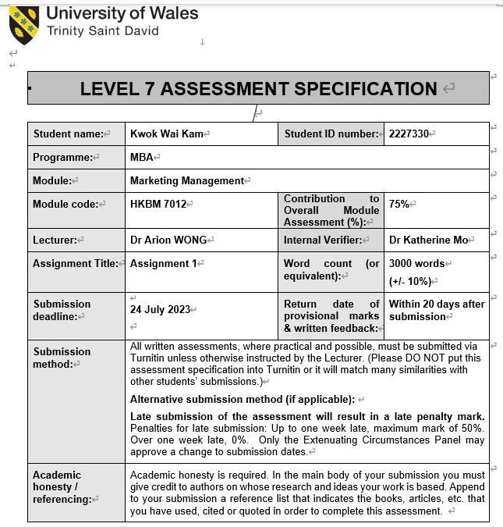

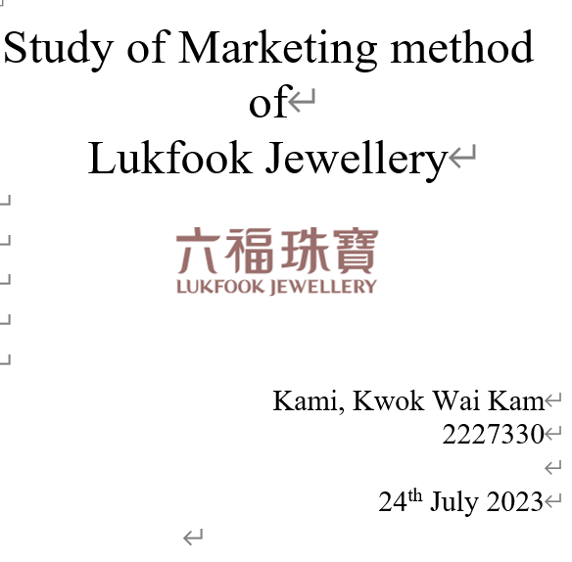

Executive Summary

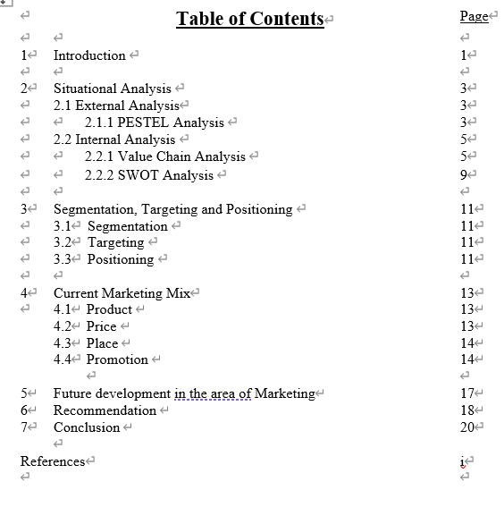
- Introduction
Jewellery is one of luxury goods in Hong Kong. As the “Brand of Hong Kong’ recognized worldwide and turned as shopping paradise, the brands are benefited from the Tourism, especially for the Frequent Induvial Travel after 2003. During the pandemic period in last 3 years, the revenue is deteriorated. (Luk Fook Holdings (International) Limited, 2019) When the economic is affected and the willingness of purchase of shopper goods will be affected.

Lukfook Jewellery (LKJ) is one of the renowned luxury brands in Hong Kong found in 1991 and listed as Luk Fook Holdings (International) Limited in 1997 (HKEX: 0059). (Luk Fook Holdings (International) Limited, 2022) LKJ has 3 kinds of business as licensing, retailing, and wholesaling and retailing is the major sources of the revenue. The branches located mainly in Eastern Asian countries over 2900 shops. It also had launched the professional institutions to foster the professionalism among the industries. China Gems Laboratory Limited providing services in authentication of diamonds, jadeite jade gemstones, and jewellery. Victoria Gemological Institute Limited engages in professional training in jewellery authentication. (Luk Fook Holdings (International) Limited, 2022)

With the reopening of the border, the spending of the tourists increase which stimulated the retail sales. As studied, the provisional estimate of the value of sales of jewellery, watches and clock, and precious gifts increased by 88.0% in the first quarter of 2023.(CCCCCCXXXXXXXXXXXXXX)

Gold and Platinum (gold) and Fixed price jewellery (jewellery) are the products that LKJ sells. As showed figure 1.1, the sales amount of gold products which in orange color is higher than jewellery which in pink color. It had been a lit higher than gold in 2020. However, the sales amount of the fixed price jewellery still below the gold even in the rebounded of economic in 2021 with the consumer vouchers. (XXXXX) In 2023, the sales amounts of jewellery in the decreasing trend to only sharing 37% of the total amount while the gold increased to 63%. The dot lines represent the tendency of the sales and assumed both will decrease in 2024 and continue to have lower sales amount of jewellery. This report will concentrate on jewellery part.

As studied the population projections till 2037, female population aged 35 to 54 have a steady grow and showed the population in 25 to 34 are abnormal. So, to continue in target in the segment who have more willingness to spend money, a continue marketing in targeting the segment is the choice.

Thus, this report will study in jewellery and to continue in target in the same segment.

- Situational Analysis
To understand the current situation of LKJ, general analysis on external and internal analysis should be used.

2.1 External Analysis
External environment is the factors that affecting the macro-economic factors that LKJ cannot control.

2.1.1 PESTLE Analysis
In this analysis, PEST analysis is used for understanding the strategic risk in the external environment factors in 4 aspects: Political, Economic, Social and Technological (Sammut‐Bonnici & Galea, 2014).

2.1.1.1 Political Factors
Since Covid-19 treat as common flu, all the anti-epidemic Measurement and social distancing measurements had been released. (Hong Kong’s Information Services Department, 2022, World Health Organization, 2023) The restrictions of travel had been lifted. (The Standard, 2023) After reopening of boarders amongst Hong Kong, Macau and Mainland, it is expected the flow in of the tourists and the trade moving forward along the path to normalcy. (xxx)

2.1.1.2 Economic Factors
During the covid-19, the world was locked down and the economic activities taking a hit. Revenue of Jewellery industry which belongs to the luxury industry is decrease (xxxx). As mentioned by Mr. Paul Chan, he hoped citizens should increase their spending because the household spending decreases even resume normal. (The Standard, 2023) Local spending of Hongkongers is decrease after travel restrictions of Hong Kong released and the citizens are urging in travel outside to relax for the 3-years locked. (NOW 新聞, 2023) These all might implied the economic situations will be worse in the coming future.

      - Social Factors
The long-lasting pandemic time, the business had already changed their business mode to survive. The consumer behavior also adopting the new changes. So, in post-covid era, the business needs to change the business mode to continue in their operations (Morgan, 2021, Fabius et al, 2020) The world is taking the adaptations in all aspects. In the new era, the spending mode of new generation is different from those in the baby boomers. (Deloitte, 2022) And people tend to have more tailor made services and more personalized services are in need. (CXXXX) They will choose the products can show their personalities. Jewellery is one of the fashions to match their outfits (XXXXXXXXX)

2.1.1.4 Technical Factors
The business and the customers adopted the new mode of business, online shopping is happened been the trend. (Fabius et al, 2020) Smartphone and social media is an essential of our lives. (Mekky, 2022, Wong, 2023) AI and Chatbox support are widely used in all business to reduce the cost of the operations. (XX)

  - Internal Analysis
For microenvironments, we will look into the internal environment. In this part, we use value chain analysis.

    - Value Chain Analysis
It can be used to set up the competitive strategies, understand the internal sources of the competitive advantage which establish the interrelationship between create value and activities to gain the profit (Porter, 1985) The model below shows the concept of how the primary and support activities added value.

Figure 2.1 The model of Value Chain Analysis
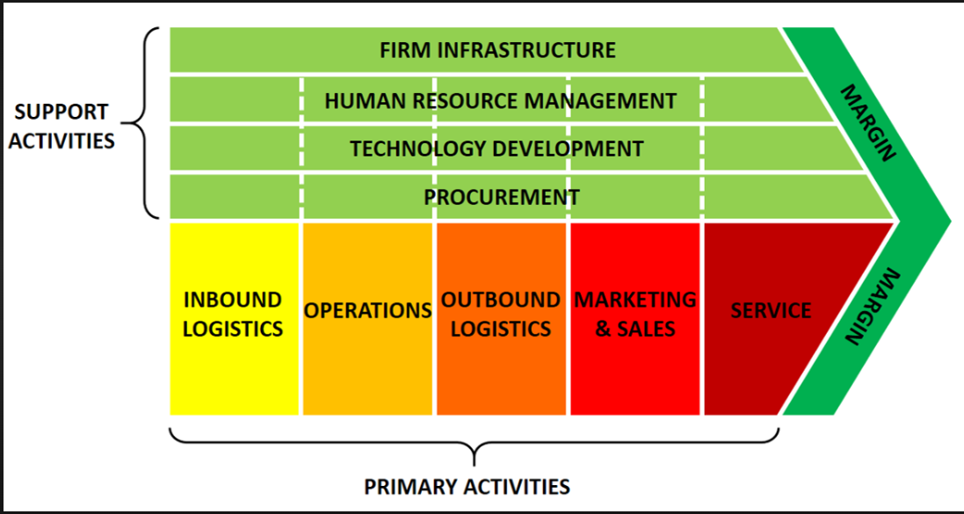
2.1.1.1 Analysis of the primary activities
The primary activities are the processes involved in raw materials, production, maintaining and supporting a good or service to add value and create competitive advantage.

2.1.1.1.1 Inbound logistic:

LKJ has its own sources of materials and makes sure a stable supply in a high quality. Apart from cooperate with Shanghai Gold Exchange and Shanghai Diamond Exchange, LKJ is also the sightholder of De Beers which allows with steady quality rough diamond supply. With the connections, LKJ can contact the suppliers directly. All jewellery passed the Kimberley Process Certification Scheme which proved the rough diamonds are not mined in war zones to lower the environmental and social risk. Value is added with the high-quality materials from suppliers to ensuring high-quality standards.

2.1.1.1.2 Operation:
LKJ has operational Control which allows the standardization of the products. And the large-scale jewellery processing plant in Guangzhou gained in the cost effectiveness and production efficiency which also awarded ISO 9001 to better quality. It is more efficient in production methods and allows professional development for skilled employees. Sales and Inventory System Access is also real-time in the company. It will reduce the costs borne by the customers and value-added.
2.1.1.1.3 Outbound logistic:
The central inventory department will control all the stock and to distribute the product to fulfill the orders of the stores. As there are mature delivery platform, LKJ also use SF express to send the products to customers within Hong Kong but the amount over HK$10,000, figurines, solid gold pieces and accessories cannot be sent. The goods would be delivered through other platform to fasten the delivery process.

2.1.1.1.4 Marketing and Sales:
LKJ has its own marketing and branding strategy, with the effective advertisements in public relation, sponsorship, and the advertising in social media arouse the interests of the customers, and to spotlight the specific needs of customers and to be superior to their competitors among the market. The details will be analyzed in the Section 4.

2.1.1.1.5 Service:
LKJ has provided the tailor-made and pre-sales consultation services to their customers (XXXXX) before the deal is made. By not only setting up the chatbot service for general customer enquiry. There is also after-sale service for the customers. For after sales services, they provide free maintenance services and advise for 1 year. Besides, LKJ deliver with the Beauty of Love with Six Heartfelt Services to high tier shopping experience.

Figure 2.2 showing the Autoreply chatbox in website
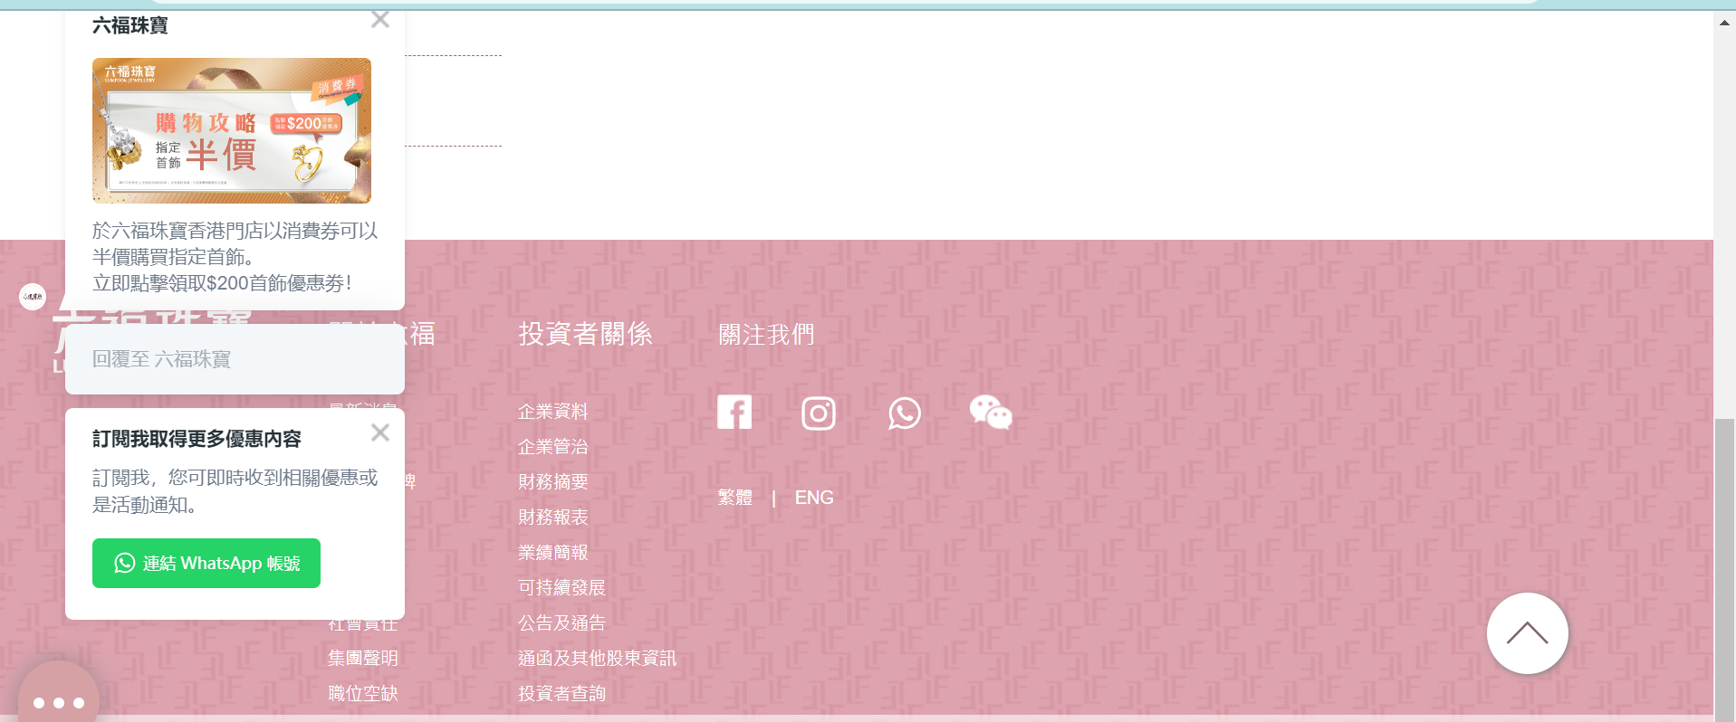
2.1.1.2 Analysis the secondary activities
Supporting activities are there to help improve the efficiency of the primary activities. By increasing efficiency, it benefits from support activities which typically show as overhead on a company.

2.1.1.2.1 Firm Infrastructure:
LKJ set up the management execution system with a clear organization structure and allows different department to perform the own uniqueness to support the operations of LKJ. Apart from the Board of Directors and top management in the decision-making process, there are accounting and finance, procurement, human resources departments etc. to support the organizations operate. Risk Management and Sustainability Committee and the Audit Committee are responsible for the monitor and control of the policy in right positions.

2.1.1.2.2 Human Resource Management:
LKJ had a range of system in recruitment, hiring, training, development, retention, and compensation of employees. LKJ has put a lot of effects to train up the skills of the staffs in basic and advanced courses during the join in of staffs. Besides, LKJ had its own institutions to train up the skills.

2.1.1.2.3 Technology development:
As LKJ develop in new products and new design to serve the new demand of customers. Technology can help enable feedback. LKJ uses several platforms where clients can ask questions, make suggestions, express opinions publicly and share experiences. As technology are matured now, the use of auto reply in chatbox and reply had also been used in LKJ.

2.1.1.2.4 Procurement:
Procurement is integrated into the supply chain throughout the company. LKJ sets extensive terms, requirements, and criteria for all its procurement transactions. This enables standardized materials to be negotiated with stable suppliers at reasonable prices, thereby gaining a competitive advantage.
To ensure that the raw materials meet the quality requirements, the comprehensive quality inspection is needed. Furthermore, LKJ had a relationship with the partner factories as Shanghai Gold Exchange, Shanghai Diamond Exchange and De Beers, one of the world’s largest diamond suppliers.

2.2.2 SWOT Analysis
SWOT analysis is used for studying a company’s internal environment. It divided in the factors that the ability of control from the company. Strengths and weaknesses can control by the company while opportunities and threats in external factors cannot. It is a summary to allows the company to understand the current environment before any business decisions. (Skye Schooley, 2023)
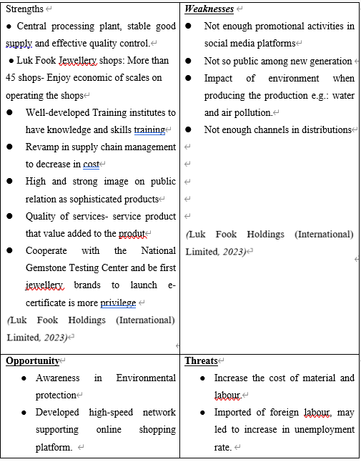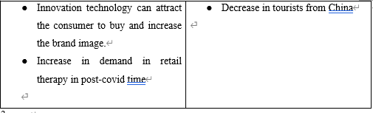
- Segmentation, Targeting and positioning.
STP marketing is a strategic approach that involves dividing a larger market into smaller segments and positioning a product or service to meet their needs and preferences, thereby helping to deliver the correct and relevant message to an engaged audience. (XXXX) LKJ targeted in the middle-to-high end market, and those who get those in wedding and generation Z market. (Lukfook XXXX)

3.1 Segmentation
Market segmentation is an actual process to identify the market segments by breaks the audience into smaller groups. This process separates a wide range of consumers who base into subgroups of consumers who have specified needs and wants (Camilleri,2018).

LKJ use demographic attributes to segment its customers. It defined the market segment by age, income and different family cycle. Currently LKJ using differentiated marketing in as offering different products, promotions, and customer experience to serve different markets.

3.2 Targeting
Targeting is the process that to determine the segments to target by evaluating how profitable different segments in the market that will offer the largest return and will be the most profitable. (XXXXXXXXXXXX)

LKJ targeted to several segments in different brands focus on different segments. The basic of the middle-to-high end class who are willing to spend a value price to have the products and services. The group who get marriage, and the new generations Z are also more willing to spend money. As studied, the segment of wedding segment is more eager to spend money as it said to be once in lifetime. (XXXXXXX). The next consumer group will be the generation Z who will have impact to the global economy and will have a steady growth in Hong Kong with around aged 30 to 35 segments shown in figure 1.2.

3.3 Positioning
Positioning involves creating a unique and compelling brand among the competitive market that makes it stand out among consumers in a target segment. (XXXXX)
LKJ shows the long-standing image of Miss Hong Kong, which is dignified, elegant, smart, and well-educated. This will shows the special icon or personality of this kind of women in the new era. Brave, Confident, Independent and strong while match in the feminine.

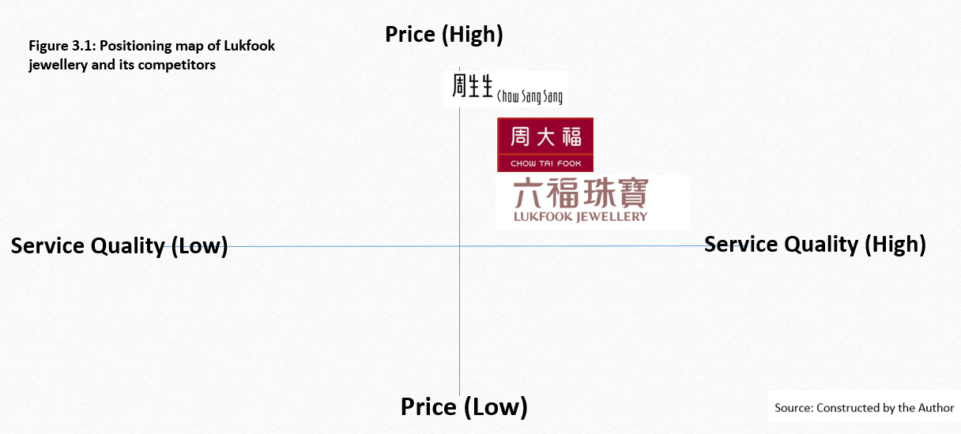

- Marketing Mix
The marketing mix refers to the set of actions, or tactics, that a company uses to promote its brand or product in the market. The 4Ps make up a typical marketing mix - Price, Product, Promotion and Place. However, nowadays, the marketing mix increasingly includes several other Ps like Packaging, Positioning, People and even Politics as vital mix elements. (Kolter, 1989）

4.1 Product
Product can be offered to the market for attention, acquisition, use or consumption to satisfy some want or need. It includes objects, services, people, places, organizations and ideas. (Kolter et al, 2020）

Jewellery is the specialty goods with limited distribution with high price to promote the brand uniqueness. LKJ is a very strong in branding that helps to identify with the differentiation with the competitors. It is found that there is distinctive name of each product line called individual branding. LKJ has 1 brand with 4 sub-brands in multi-brand strategy selling different targeting to different groups of customers. Service product is common nowadays. With providing the warranty, repair and maintenance and efficient handling of complaints and return, LKJ gives the strong confidences to reduce the risk of the purchase of customers. Besides, the jewellery products will be awarded with the certificate from the LKJ to prove its uniqueness with class which gives the quality perceptions in the mind of customers.

4.2 Price
This refers to the selling price of a product or service under consider market conditions. Price refers to the amount that can be sold to consumers after considering the pricing strategy and analyzing competitors. (Singh, 2012)

LKJ is unique in providing the professional and qualified jewellery with certificates in the market. (Luk Fook Holdings (International) Limited, 2022) And it is using the “Value-in-Use” Approach as LKJ understand differentiated worth as compared to competitors.

4.3 Place
The process of moving a product or service from a manufacturer to a consumer involves warehousing facilities, distribution channels, shipping methods, and inventory control management. Channels are designed to increase the availability of goods or services to potential customers.(CXXX)

There are self-operated shops at convenient locations allows accessibility. Licensing shops are also exits but the sales are not significant to Hong Kong sales. LKJ has partnered with HKTV MALL to sell the jewellery products online. And there are also products selling on the websites through the online ordering, delivery will be sent by delivery company.

4.4 Promotion
Promotion is an important part of marketing as it is used to communicate the value to customers and arouse the consumer awareness to do persuasively purchase on the product and thus create a lasting relationship with customers. (Novak, 2011) In this part, it is used to carry out the uniqeiness and the image passively to the receivers and it is pull strategy in the past. With aid of new technology, it becomes more active now.

In Advertising, LkJ using traditional advertising in TV, Transit advertising, Printed media in Newspaper and the Fairs and exhibitions of Jewellery and wedding every year hold by the Government.

While in Sale promotion part, LKJ hold promotional activities in the retail store to attract the consumer in special occasion, such as special Festivals, Valentine’s Day, Mothers’ Day. Promotions can potentially create a strong bond between brands and consumers.

There are key contribution in Personal selling. LKJ will provide sales staffs with training on jewelry knowledge and customer service skills, thereby enhancing the brand's positive image.

Public relations also played an important role in Lee Kwang-je. Since the late 1990s, LFJ has sponsored diamond crowns and precious jewelry for "Miss Hong Kong". Ms. Pauline Yeung, the co-founder of LFJ has been the iconic spokesperson since its establishment. She has served as a promotional ambassador for the brand. It became the hallmark of the competitions, as the winner would have a photo shooting for the advertisement right after the competitions finished. In addition, LFJ sponsors horse races events and marathons events to raise awareness among the middle class.

In conclusion, there are improvements in the 4Ps. LFJ has its Unique selling point of its special pre-longed image and the specialty resources and support with the suppliers in the certificate qualifications. The price also set as value-in-use to give the perceived value to the customers. It also keens in jewellery knowledge within the industry. It can success to develop in their position and gain the competitive advantage in the market. Nevertheless, the place and promotions would be improved. For the place part, there are direct online sale even on the website of LKJ, and there are no selling price even in the official websites. Besides, the official social media platform has little followers and with not frequent updates and no online live sales promotion which will reach the target of the new segment. (Kamp, 2023, Mekky, 2022),With the further recommendations will be discussed in section 6.
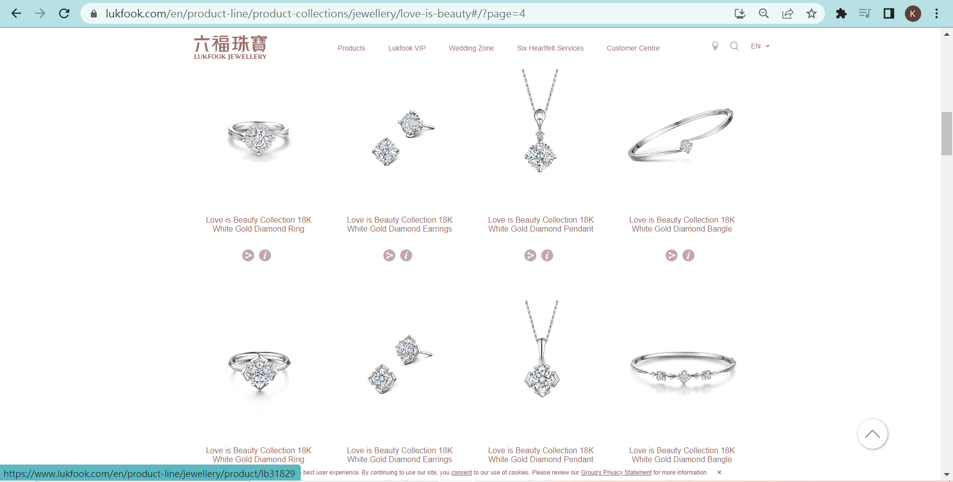
Figure 4.1 Picture showing no selling price on the official

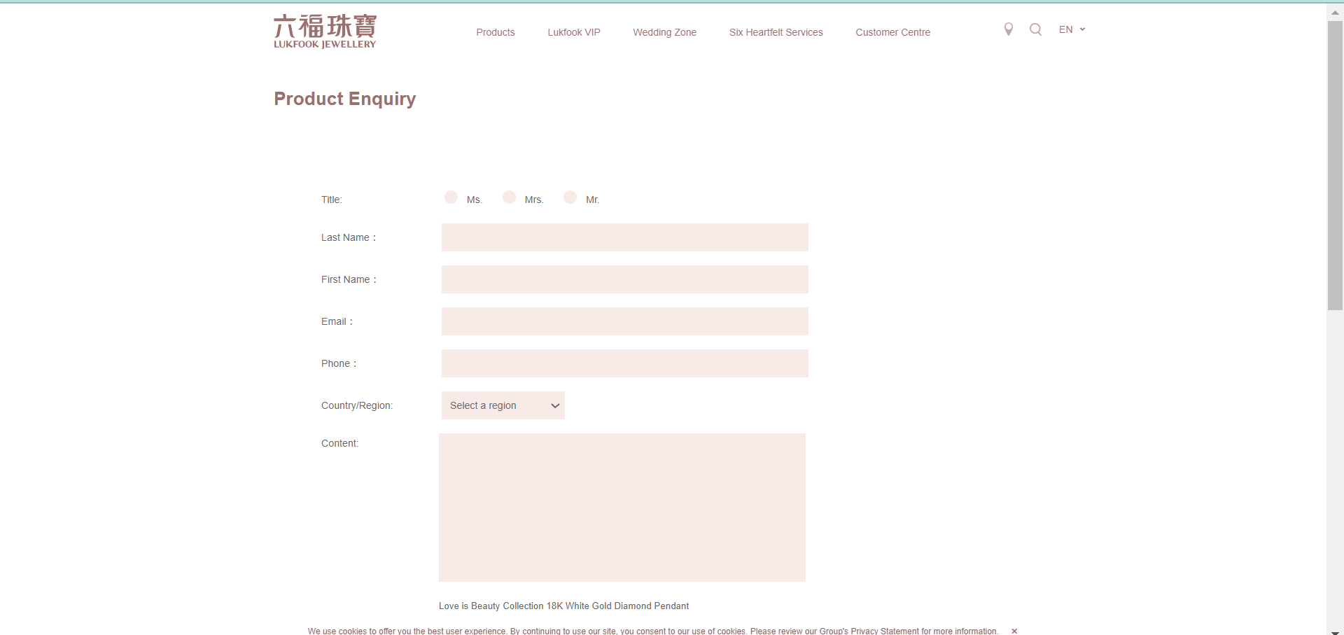
Figure 4.2 showing the page that when clicking in the product
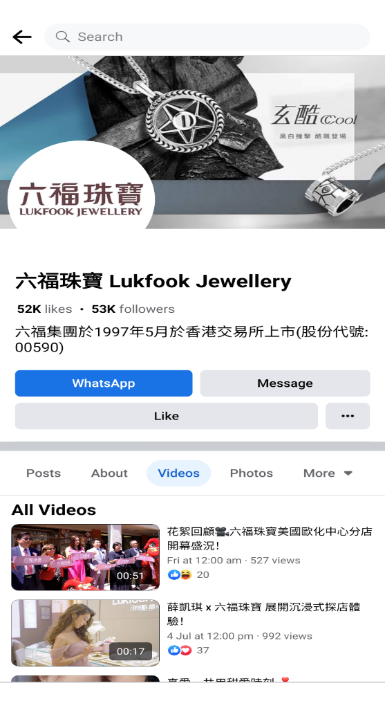 | 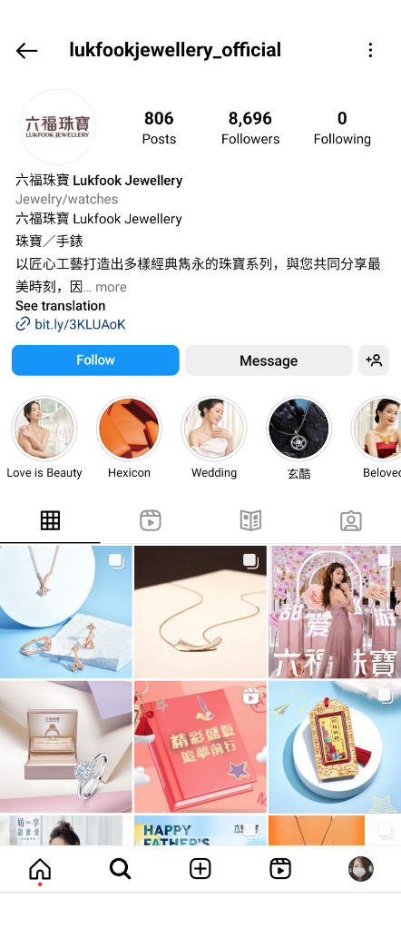
Figure 4.3 showing the social media platform with less followers and no online live sales promotion | Figure 4.4 showing the official Instagram with little followers with no frequent update

- Future development in the Area of Marketing

- Importance of using Brick and mortar
Covid-19 foster the development of online shopping during locked down while people will continue this kind of omni channel. (Dartnell, 2022, Mastercard Economics Institute, 2023) It is more important that the business keep using this kind of channels to increase the accessibility to the customers. Without the omni channels, there will decrease the competitiveness as the competitors also doing this. (Hall, 2022)

- Changed in business mode in post-covid time-Personalize services and retail therapy
People are tending to improve their wellbeing after the release of the social-distancing and there is increase trend in ‘retail therapy’ to taking care of the mental and spiritual side. During the shopping time, people willing to have a personalized services based on their needs. (Fabius et al., 2020, Mastercard Economics Institute, 2023)

- Jewellery is a fashion
As stated in HKTDC (2023), Jewelry is a fashion. Customers choose tailor-made jewellry to match the personality. Jewelry design is more and more influenced by clothing fashion. The population of consumers are buying accessories such as jewelry to express their fashion sense.

- Generation Y and Z will be the important consumer group
Gen Y and Gen Z consumers become important consumers to jewelry. This group will treat jewelry as must-have item everyday. Luxury brands are launching affordable collections for their selection who welcome by the new generation who is trend conscious. (Deloitte, 2022, HKTDC, 2023)

- Recommendation

- Use more up to date ways to do promote.eg. social media, while continue to use public advertising

- Strength in the tailor-made products services
- Better service to product

- Conclusion

Lkj is a recognized Hong Kong Brand and a iconic image to be soapicated. To target the new market of generation, to be young is the important to the market in the new and ever changing environment.
Reference
Deloitte (2022) Deloitte's Gen z and millennial survey reveals two generations striving for balance and advocating for change - press release, Deloitte. Available at: https://www.deloitte.com/global/en/about/press-room/deloittes-gen-z-and-millennial-survey-reveals-two-generations-striving-for-balance-and-advocating-for-change.html (Accessed: 27 March 2023).
Fabius, V. et al. (2020) How covid-19 is changing consumer behavior-now and forever, McKinsey & Company. Available at: https://www.mckinsey.com/industries/retail/our-insights/how-covid-19-is-changing-consumer-behavior-now-and-forever (Accessed: 3 May 2023).
Hong Kong’s Information Services Department (2022). Social distancing set to be eased Available at: https://www.news.gov.hk/eng/2022/03/20220321/20220321_124329_218.html (Accessed: 15 June 2023).
McKinsey & Company (2020) How COVID-19 has pushed companies over the technology tipping point-and transformed business forever Available at: https://www.mckinsey.com/capabilities/strategy-and-corporate-finance/our-insights/how-covid-19-has-pushed-companies-over-the-technology-tipping-point-and-transformed-business-forever (Accessed: 3 May 2023).
Mekky, M. (2022) Council post: How social media is changing the face of Pr, Forbes. Forbes Magazine. Available at: https://www.forbes.com/sites/forbesagencycouncil/2019/02/21/how-social-media-is-changing-the-face-of-pr/?sh=12c0ebcd724f (Accessed: 7 April 2023).
Neiman, H. (2021) Council post: What will the restaurant industry look like post-pandemic?, Forbes. Forbes Magazine. Available at: https://www.forbes.com/sites/forbescommunicationscouncil/2021/06/08/what-will-the-restaurant-industry-look-like-post-pandemic/?sh=6cae62281982 (Accessed: 3 May 2023).
NOW 新聞. (2023) 通關後港人多北上消費 深圳餐廳：五成顧客是港人, Now 新聞. Available at: https://news.now.com/home/local/player?newsId=522381 (Accessed: 26 June 2023).
The Standard (2023) Paul Chan urges residents to spend more to boost the economy, The Standard. Available at: https://www.thestandard.com.hk/breaking-news/section/4/205174/Paul-Chan-urges-residents-to-spend-more-to-boost-the-economy (Accessed: 23 June 2023).
Wong, Rebecca (2023) 小紅書=內地版Instagram？社交媒體行銷新玩法︰打造香港最美打卡勝地吸人流！「金魚街」如何變成網紅新寵？ 跨境營商戰略 | etnet經濟通Available at: http://www.etnet.com.hk/www/tc/lifestyle/digitalnewage/chinaecommerce/84271#%E5%B0%8F%E7%B4%85%E6%9B%B8=%E5%85%A7%E5%9C%B0%E7%89%88Instagram%EF%BC%9F%E7%A4%BE%E4%BA%A4%E5%AA%92%E9%AB%94%E8%A1%8C%E9%8A%B7%E6%96%B0%E7%8E%A9%E6%B3%95%EF%B8%B0%E6%89%93%E9%80%A0%E9%A6%99%E6%B8%AF%E6%9C%80%E7%BE%8E%E6%89%93%E5%8D%A1%E5%8B%9D%E5%9C%B0%E5%90%B8%E4%BA%BA%E6%B5%81%EF%BC%81%E3%80%8C%E9%87%91%E9%AD%9A%E8%A1%97%E3%80%8D%E5%A6%82%E4%BD%95%E8%AE%8A%E6%88%90%E7%B6%B2%E7%B4%85%E6%96%B0%E5%AF%B5%EF%BC%9F (Accessed: 3 June 2023).

The Standard (2023) John Lee welcomes the positive effects of the Golden Week Holidays, The Standard. Available at: https://www.thestandard.com.hk/breaking-news/section/4/203236/John-Lee-welcomes-the-positive-effects-of-the-Golden-Week-holidays (Accessed: 04 May 2023).
Dartnell, L. (2022) The COVID-19 changes that could last long-term, BBC Future. Available at: https://www.bbc.com/future/article/20200629-which-lockdown-changes-are-here-to-stay (Accessed: 03 May 2023).
RTHK HK (2023) pins hope on Golden Week to attract back tourists. Available at: https://news.rthk.hk/rthk/en/component/k2/1693565-20230325.htm (Accessed: 29 April 2023).

HKSAR (2020) Compulsory quarantine of certain persons arriving at Hong Kong Regulation and prevention and control of disease (Disclosure of Information) Regulation gazette, Press Releases. Available at: https://www.info.gov.hk/gia/general/202002/07/P2020020700674.htm?fontSize=1 (Accessed: 16 March 2023).
Kotler, P., Armstrong, G. M., Harris, L. C., He, H. (2020). Principles of Marketing. United Kingdom, Pearson Education Limited.

Mastercard Economics Institute (2023) Mastercard Economics Institute Shines spotlight on how covid impacted hong kong consumers’ spending trends, Mastercard Newsroom. Available at: https://www.mastercard.com/news/ap/en-hk/newsroom/press-releases/en-hk/2023/mastercard-economics-institute-shines-spotlight-on-how-covid-impacted-hong-kong-consumers-spending-trends/ (Accessed: 4 July 2023).
HKTDC (2023) Jewellery Industry in Hong Kong , HKTDC research. Available at: https://research.hktdc.com/en/article/MzEzOTU0Nzcx (Accessed: 24 June 2023).
Singh M. (2012), ‘Marketing Mix of 4P’S for Competitive Advantage’, IOSR Journal of Business and Management Available at: https://d1wqtxts1xzle7.cloudfront.net/28251386/G0364045-libre.pdf?1390873668=&response-content-disposition=inline%3B+filename%3DIOSR_JBM_www_iosrjournals_org.pdf&Expires=1688606494&Signature=OhYWKIA5Ek-HhAh21TjruhkxDr6nJZgvYe8NDqq1-o1VaB3c63Q8wWx57LjTc4BApH4xmFN5ogNw73jzVqUI9e0p8lCVGxoGHkrZEZe6BQbU3SQ~t2U4DUwk1vNHfjvsX1zZWwSXI2xuLA12L2Lu3RrZLNe6uT8m~FeXxR6tMq-p9ZPrbV~-S6hrz0co~h3V2YEyfiSboWCeuM5kAVeyrjYULS2FynrlwPF5tkDCup2R59Pav7bETm-rv2HYnw3P~oT1eaZtavi-b7IV7e2dSgBF5lMK3CN5PRAN6m17hMQYzUGE8qVYNhZGqmU~y18Xed04fGULv~7HoyvuXHedYQ__&Key-Pair-Id=APKAJLOHF5GGSLRBV4ZA (Accessed 5th July 2023)

Lockett, Asia R., (2018) Online Marketing Strategies for Increasing Sales Revenues of Small Retail Businesses
Hall, J. (2022) Council post: Social media marketing tips every business should be using, Forbes. Available at: https://www.forbes.com/sites/forbesagencycouncil/2021/10/29/social-media-marketing-tips-every-business-should-be-using/?sh=195cee6432c0 (Accessed: 07 June 2023).

Darmanwan D. and Grenier E. (2021) ‘Competitive Advantage and Service Marketing Mix’, Journal of Social Science Studies Vol. 1, No. 2, Available at https://ejournal.metromedia.education/index.php/jos3/article/view/9/15 (Accessed 5th July 2023)

Kemp, S. (2023) Digital 2023: Hong Kong - DataReportal – global digital insights, DataReportal. Available at: https://datareportal.com/reports/digital-2023-hong-kong (Accessed: 24 June 2023).
Hall, J. (2022)
Novak D. (2011), ‘PROMOTION AS INSTRUMENT OF MARKETING MIX’, I International Symposium Engineering Management And Competitiveness 2011, Available at https://citeseerx.ist.psu.edu/document?repid=rep1&type=pdf&doi=a7ba6691bb0e869bc2e880951a156f112ade9f4e (Accessed 5th July 2023)

