Project Management.
Project: wedding planning:
Of Happi Goga and Richard Kamsi.

By

Claire La Joie Pechangou Kounga: 1601353
Assignment 1
Molly Jack | SBUS5127

Table of content
Introduction
Smart objectives
Scope
Work breakdown structure
Wedding constraints
Wedding assumption
Risk identification
Project organisational structures
Project control mechanism
Project stakeholders’ analysis
Cost estimation
Gantt chart
Conclusion
References

Introduction
a project can be defined as task with the desire end. “project management is a formal discipline for managing a project”. Projects management has the aim of ensuring that the project is completed and that the end goals are achieve. (Newton, 2016)
The following report will describe the project about planning a proper wedding for Happi Goga and Kamsi Richard in six months. It is initiated in accordance to Kamsi Richard’s engagement by his parents. This report will emphasis in detail with regards to the project, on all stages of the project which are as follows: Stakeholder Analysis, SMART objectives and Goals, scope, Work Breakdown Structure, Risk Management, project constraints and assumptions, project organisational structure, project control mechanism.
Smart objectives
The wedding project objectives is to plan a memorable wedding in six months for Happi Goga and Kamsi Richard with all the requirement and all the constraint as stated by the groom’s parents who are the project sponsors funding the project. It purpose is to deliver a legal, unforgettable wedding experience, and allow all the persons taking part with sense of satisfaction and fun. With the constraints of six months, £10000, and with an invitation list of 200 attendee. However, the project can be managed within the time frame and budget given; notwithstanding, to maximise the guest, we might have to reduce the availability of some hospitalities at the reception.
Within six months (January 16 to June 16), the wedding project is to plan and implement the wedding of Happi Goga and Kamsi Richard. The project plan is to develop and summit it to the sponsors for them to approve. All the resources will be given by the project sponsors

Scope/major deliverables/proposed process
The wedding is taking place in six months, preferable in a reception hall with 200 people invited. The wedding budget is 10000 and it should be a legal and proper wedding ceremony.
The project deliverable includes; guest list, reception hall and decoration, wedding invitation, photography, videographer, catered dinner, cake, equipment rented, wedding day transportation, marriage contract and commissioner, wedding speech, ceremony program, wedding favours, wedding hotel night room, wedding gown, accessories, hair, makeup, groom dress, thank you card.
The project will not be responsible for the following deliverables; bridesmaid dresses, bachelorette party, date and venue, date and venue, the groomsmen and, honeymoon, gift for bridal party, bachelor party, wedding ring.
Work breakdown structure
work breakdown structure (WBS) may be defined as deliverables or tasks arranged in groups of project work part that can be presented in graphical way and split the total work level of a project and it an important project tool (Rev, 2003).

venue
- Check out different location
- Discuss budget for the venue
- Select venue according to couple demand
- Select decoration
Guest
- Do the guests list.
- design/select invitations.
- Print them
- Send invitations.
- Track RSVP’s.
- Finalize guest content

Photo
- Choose a photographer
- Photo rehearsal
- Photo selection
- Payment plan
Catering
- Caterer selection
- Reserve the caterer
- Menu selection
- Testing
- Cake selection
- Payment confirmation
flowers
- Florist selection arrangement
- Choosing bridal bouquet
- Coordinate delivery, venue setup
Entertainment
- Contact the DJ
- Music selection
- Setup music

Wedding constraints
- Wedding is in 6 months and 12 days from today
Restricted budget
- Venue holds 200 people
Wedding assumption
- Find someone who can consider our budget and rent us the hall on the date of our wedding
- Wedding ceremony at 2pm follow by the reception
- Packing accessibility do not need to pay
- My Uncle will be able (legally) to wed you
- All family and friends will come
- Parents will provide the money when need arise

Approach taken to identify risk

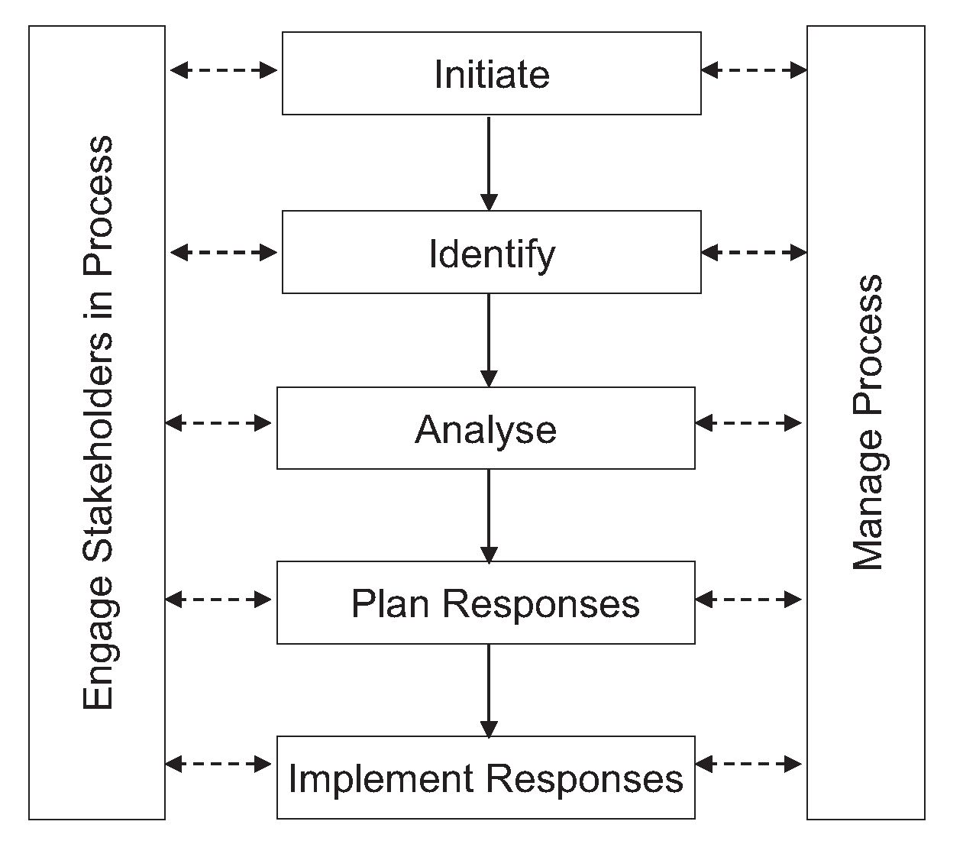
Risk management is all about managing and controlling risk of project success to a satisfactory level. It is concern with project success regarding cost, scope, schedule and even client fulfilment. “Project-risk management seeks to control project risk beyond the scope of your project plan and beyond your circle of control” (Lawrence P, Leach, 2004)

My wedding project could also meet some risks. We have different steps in analysing a project risk: identify the risk, prioritise it, Manage it. From the above deliverables, we have six major categories and each of them can further be break down;
- Accommodation/venue
- Food services
- Transportation
- Environmental conditions
- Miscellaneous
- Hire services
Risk analysis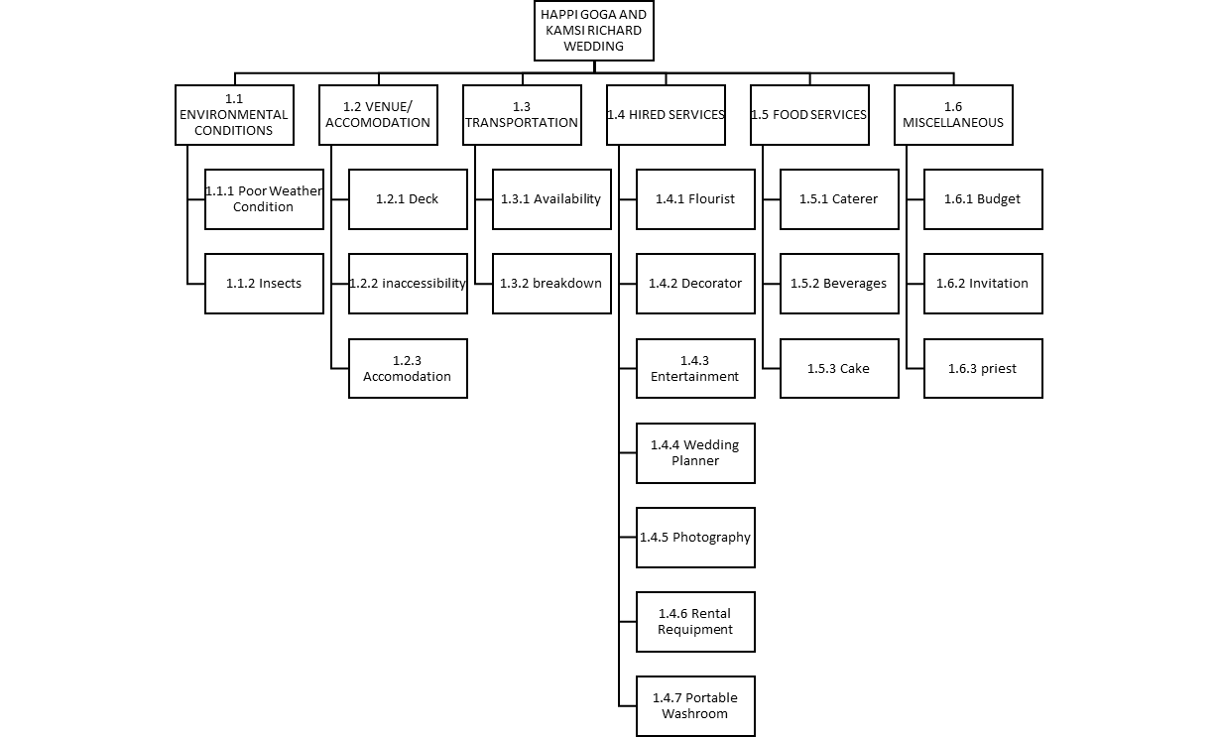
Identification of risk
Elevated level risks.
Risk categories | Risk name | Risk response
Venue/accommodation | Not enough space to accommodate all the guests making them unhappy | Active acceptance:
Food services | Broken bottles of liquor during delivering causing the guest to be thirsty | Active acceptance: take more precaution when transporting the drink and handle them correctly
Environmental condition | Dirty and stagnant water giving room to mosquitos/insects | Passive acceptance: nothing can really be done in this situation
Environmental condition | Very freezing weather causing the guest to be uncomfortable | Mitigation: ensure the hall has a good heating system or provide them with portable heaters
miscellaneous | Budget exceeding | Mitigation: put a cash bar on the wedding, advise the guests, and host a stag and doe
miscellaneous | Incorrect information on the invitation leading to guests’ confusion | Mitigation: take some time to check on all the invitation prior before giving them out
Hire services | Not good music selection causing the guests to be bore and unpleased | Mitigation: make sure your playlist is arranged ahead of time the DJ must consider the guests request

Project Organisation Structure and Roles and Responsibilities
The project team will be responsible for the deliverables by providing the breakdown of the budget allocations by doing some research on the cost of reservation, services, and the things needed for the wedding; giving the detail of booking choices which include ceremony and reception venue, cake arrangement, catering arrangement, wedding themes and decors, wedding choice of music, choice of photographer; arrangement for the wedding dresses, fitting and modifications; giving the detail schedules of task that will be carry out in a timely matter by week of the wedding. Analysing and developing these different choices is to make sure that it’s all align with the available budget; making sure that all the reservation, bookings, arrangement for services, equipment, products are made within the time frame. Also come up with a contingency plan if should any problem arise.

Related product, deliverables and resources proposed
The following are the project dependencies as they can influence the choices made by the groom and bride; the bride and grooms family, the bridal party and groomsmen.
List of resources proposed
- Wedding catered; The Flavour Kitchen, Caribbean Caterers London | Maroon Spice, Eagle Catering, Ebunolacafe Catering Services
- Wedding cake; Brighton cake company, Bespoke Cakes & Treats, Rosalind Miller Wedding Cakes, C, Emperor House, Dragonfly Pl, London SE4 2FL
- Wedding rental and decors; Theme Traders, Partyonestop Decoration,
- Wedding hotels; Cavendish Banqueting Colindale, Meridian Grand
- Hair and makeup; Makeup by Jodie - London Makeup Artist + Hairdresser, Afrotherapy Salon, Blackhairblackbeauty Natural hair and beauty services UK
- Wedding attires and gowns; Amanda Wakeley Bridal Shop, Caroline Castigliano, David's Bridal
- Wedding venues, ceremony and packages; Plaisterers' Hall, Oaks Farm Barn, Meridian Grand

Project Control Mechanisms
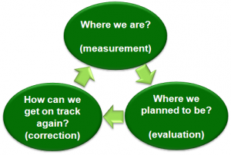

Projected customers
We have two main customers, the groom and the bride. The parents of the groom and the project sponsors, so it important that we meet their expectation. They are also involved in the wedding as they provide some input in the choices and make decision. Most importantly the deliverables and the cost associate to them
Customers requirement
The customers will be the one to determine whether the wedding was a success on how smoothly things were carryout and the objectives met. All the deliverables must be meets within the proposed timeline.
It means that, all the deliverables which are to be done before the wedding ceremony has to be carryout in advance with enough time before the wedding such as catered choice, transportation booked on time, cake testing arrangement, invitation printed and send out on time just to mention a few.
Moreover, it is critical that everything that is prepare and is going to take place on the wedding day should not be on hold or delay (transportation, all decorations, music in place, dinner tables set are all timely matter).
More so, our obligation is to stay within the budget, this means that we must not go over budget. Deliverables value and quality is to be maximise within the time and budget constraint. Need might arise for the groom and bride to cut down on their more expensive choices due to shorter time frame and budget constraints, some services may not be available for booking.
Customers need and attribute
The project is given out as a contract in other to ease the load from the customers. They went ahead to hire me as a project manager because they want to enjoy every festive moment of ceremony without having to deal with the detail of running this type of event.

Communication analysis
Communication planning is a plan put in place to ease communication between a project manager and its stakeholders according to their interest and power. The project manager talks with them differently
The idea behind it is to know how data will be calculated and describe the correspondence requirements for the project (Docs, 2017, p. 2).
This communications direction Plan is characterizing the following:
- type of data communicated—to align with the level of feature and organization
- what are the method uses to convey the data—in meetings, email, phone, web-based interface, to name a few.
- Who is responsible of presenting project data- the project board or the project manager?

 | Sponsor/FOB | Bride/groom/FOB | FOB | FOB | FOB | guests
How often | Once a month (for the three first months) | Three times a month for the first four months | weekly | Bi weekly | once | once
purpose | To review the budget and schedule | To go through the project and check if they are on schedule and discuss the next plan | Issue log | invoices | Project closure | The wedding date and place
How | Face to face meeting and via mail | Phone, mails, face to face meeting | Email memo | Hard copy | meeting | Mail or phone (if need be)

Stakeholders and their Involvement
Stakeholders are “any group or individuals who can affect or is affected by the achievement of the organisation objectives” (Management, 2016).
Looking at it from the project management angle, acknowledgment of the thought of project stakeholders suggests that the project must be managed not only from the customers point of view but from an over-all perspective of everybody and the organisation. Consequently, together ensures a long-term strength of the undertaking and its outputs, the project board needs to identify and deal with all collaborators recognised with the project (Perić et al, 2014, p. 2)
Wedding stakeholders
Parents of the groom (project sponsor) | They are responsible for funding the six months wedding project, setting the time frame, budget constraints, requirement of 200 guests list and the wedding legality
Groom and Bride and (customers) | They are responsible for approving choices, making decision and schedule proposed by the project manager
guest | They have no responsibilities in any part of the project, but their satisfaction means the both parents and couple are satisfied too. One of the gaols of the project is to entertain the guests at the wedding
Project team members | They work hand in hand with the project manager by implementing and coordinating tasks in the whole project, must importantly, assisting with findings and decision, if the project manager want them to do it. They also do some tasks during the planning stage and the wedding day (taking care of booking caterer, venue, transportation to state a few to ensure that everything goes efficiently on the wedding day

Project manager and authority level
Kounga Claire who is project manager has the authority to decide on the allocation of resources within the budget constraint, employ a project team, delegates responsibilities within the framework of the project, communicate with the bride and groom for the to agree to make sure that the project is successfully completed within the time (six months). The project manager is responsible maintaining control on the project stage by stage, monitoring the cost of resources allocated effectively, developing the project plan and monitoring the schedule to make sure all is being carryout on time.

Preliminary schedule (milestone chart)
The preliminary schedule is done and must be approved by the groom’s parents (project sponsor), the bride and the Groom. When they give their consent, resources will they be assign to different tasks that need to be carryout. The propose schedule is;
January 16, 2018-March 16,2018 | March 16,2018-May 16, 2018 | May 16, 2018- June 16, 2018
Wedding date | Send out invitation | Book appointment for makeup and hair
Ceremony location, reserve date and time | Order cake | Finalizing menu and cake
Reception location, date and time | Choose and Order wedding attire | Finalizing decors
Guests list for the ceremony and reception | Start or order decors | Finalizing guests list
Decide on the wedding decor and theme | Reserve transportation for wedding day | Finalizing wedding attire
Chose a wedding invitation | Reserve hotel for wedding night | Confirm all reservation
Chose and reserve a photographer, florist, caterer, music | Order party favours
Wedding dresses(review)
Thank you notes
Book priest
Ordered marriage licence

cost estimate/budget
activities | Estimated cost for each activity
Wedding design plan | 0
Date, time of wedding confirmation | 0
budgeted | £10000
Guests list | £0
Reception venue confirmation date | £1000
Book catering date and create menu | £0
Confirm food menu | £3000
Order cake | £200
Contact florist, make arrangement for setting up venue | £800
Call and reserve entertainment | £1000
Book a photographer | £500
Book a videographer | £300
Wedding outfit | £1000
Salon appointment for bride and groom | £500
Invitation | £350
Table card | £150
Officiate fee | £50
License | £100
Visit venue to confirm space | £100
Post or mail of couples on social media sites | £0
Church donation | £10
Transportation for the wedding day | £300
Order wedding gifts for guests | £458.50
Confirm and finalizing seats, arrangement at the reception | £0
Wedding day

£10000 is budgeted for the six months wedding project and the budget is estimated based on the guest count of 200 guests, which is funded by the project sponsor

Activity sequences
Activity sequences are distinctive and writing interrelated situations. Activities must be sequence exactly to aid later improving realistic and achievable schedule (Darby, 2012, p. 4).
project | task | Start date | End date | Days to finish
A | venue | 25th January | 10th February | 15days
B | Guests list | 10th February | 20th February | 10days
C | photos | 20th February | 1st march | 11days
D | catering | 1st march | 15th march | 16days
E | flowers | 15th march | 20th march | 6days
F | entertainment | 20th march | 1st April | 11days


GANTT CHART

conclusion
Notwithstanding, some cost like license fee can be fixed and other non-negotiable like the type of the venue, meanwhile some cost can be adjusted and reallocated. For instance, costs may be cut down on the stationary by going for modest cards and this saving can then be reallocate to menu by providing a more elaborated dinner for the guests.

Approved requirement
Accomodation and transportation: guests will cover their own expenses
Honeymoon: bride parents are offering ticket to Amsterdam

References
Darby, U., (2012). Project Time Management. Project management institute, p 4.1.
Docs, P.M., (2017). Communication Management plan. Project Management Docs, p.2.
Lawrence P. Leach, (2004). Critical Chain Project Management, second Edition, p.209.
Management, P. S., (2016). Project Management and Leadership. Project Stakeholder Management, p. 2.
Marko Perić, J. Đ. I. L., (2014). IMPORTANCE OF STAKEHOLDER MANAGEMENT IN TOURISM PROJECT: CASE STUDY OF THE ISTRA INSPIRIT PROJECT. TORISM AND HOSPITALITY INDUSTRY, p. 2.
Project Management for Wedding Planning. [Online] Available at: https://thebudgetsavvybride.com/project-management-wedding-planning-engineers-perspective/ [Accessed 18 December 2017].
Rev, E., 2003. Work Breakdown Structure. Project Management Practices, p. 3.
Richard Newton, 2016. Project Management Step by Step
Wedding project management. [Online] Available at: https://www.slideshare.net/alibhalli43/wedding-project-management-29953590 [Accessed 18 December 2017].

