University of Wales “Trinity Saint David”
International Hotel Management
Student: Mr Zoltan Mathe
Student ID:2110539
BMIH6006/8

Hotel Placement Research Project

An Analysis of The Leadership Management in the Hospitality Industry: A Case Study of Doubletree By Hilton Bristol North

Project Supervisor: Ka Po Chong

Executive summary
Doubletree By Hilton Bristol North is a part of the hospitality industry could have employees who are constantly changing and have inefficient operations. Also, there's the issue of ineffective leadership. In addition, the Doubletree by Hilton Bristol North has to solve these issues if it is going to improve productivity retention, morale, and productivity. Doubletree by Hilton Bristol North's leadership practices are scrutinized and new ways of looking at the practices are suggested through this research. The research shows the importance of motivating and inspiring employees in an extremely aggressive hospitality industry. In-depth analysis of leadership strategies employed in the workplace of Doubletree by Hilton Bristol North has been done through the research. Discovering strategies to improve leadership and providing clear direction to inspire and motivate employees. A comprehensive analysis of leadership methods will be given through this research.
It is the primary goal for this research to determine what currently the leadership practices for Doubletree by Hilton Bristol North influence employee satisfaction and loyalty. Study analysis, case study analysis, reflective writing as well as netnography are just a few research methods to be utilized in this study. The case study emphasizes the importance of creating guidelines for managing and leadership through examining the effect on methodology and leadership strategies on employee satisfaction and engagement. There are a few drawbacks regardless of its value. Two of the issues that are encountered when using the case study method are research biases and the difficulties of generalizing research results. Methods like triangulation or reflection can help us tackle these problems. Through research techniques like reflective writing as well as netnography precise information collection as well as analysis can be assured.
The study can be improved and give a more comprehensive analysis of possible leadership challenges for the hospitality industry with these methods. The many areas covered by the research are investment in employee development, technology-enabled openness to feedback and communication, and relationships in the workplace that are flexible, as well as employee control over turnover. This report will examine different ways in which Doubletree by Hilton Bristol North can be able to improve their morale of employees and employee retention. Also, productivity has improved. One of the topics one has been focusing on in the research in this area, which is the hospitality industry, is the need to deal with issues like high staff turnover, ineffective management practices, and a lack of efficiency in operations.
To increase the efficiency of its staff and operations, Doubletree by Hilton Bristol North may use innovative leadership strategies, like the use of technology for applications and flexible recruitment methods. The ability of employees to buy into training programmes and a culture that is rich in input and has a clear line of communication are essential to a moral and productive workforce. Offering workers more flexibility through technological solutions is one of the suggestions, as is investing in leadership development programmes and making training programmes the top priority. With these tips, Doubletree by Hilton Bristol North may improve operational efficiency, encourage an environment of cooperation, and lower employee turnover. Their future success is dependent on their performance in the highly competitive hospitality industry.

1. Introduction

1.1 Introduction to the research
It is crucial to maintain employee motivation throughout the growth of the company in order to remain at the forefront of the fiercely competitive hospitality industry. A solid leadership team is essential as learning the art of creative leadership through learning to motivate and inspire employees. The leadership methods employed for Doubletree by Hilton Bristol North are the subject of the research. Doubletree by Hilton Bristol North, with its headquarters in Bristol, UK, is an established firm when it comes to customer service. Doubletree by Hilton Bristol North is known for its dedication to quality. A neutral research organisation will conduct a thorough analysis of Doubletree by Hilton Bristol North's current leadership methods in a bid to boost levels of morale and retention.

1.2 Rationale
In order to determine potential structural weaknesses within the company that impact employee satisfaction and loyalty, the study explores the complexity of the current leadership structure. Knowing how employees in the hospitality industry can improve productivity and morale is the principal goal of this study. The aim of the research is to pinpoint the most effective methods of leadership. Apart from Doubletree by Hilton Bristol North and similar organisations, managers from the hospitality industry and other industries that employ contemporary leadership and management methods could gain from studying the research's findings and suggestions. Three goals are being addressed through the research.

1.3 Objectives
Objectives for this research are given below:
- To understanding how Doubletree by Hilton Bristol North's current leadership practices impact employee satisfaction and loyalty to the company.
- To study and research the most efficient leadership strategies that can boost productivity and create a happy workplace.
- To provide Doubletree by Hilton Bristol North with concrete solutions to boost their motivation and enthusiasm.
2. Literature review

2.1 Introduction
The agility to successfully traverse the intricacies of the hospitality industry is defined by its diversity in its fast development, its constancy in change, and its reliance on competent leadership. In the hospitality industry, leadership and management essentially include inspiring and enabling people from all backgrounds to provide exceptional client experiences in an effective and efficient manner. On the other hand, a comprehensive examination of the many components of industry leadership is necessary to resolve some concerns and disputes.

2.2 Traditional Hierarchical Structures: Implications and Challenges
The traditional hierarchical framework serves as the foundation for many cafes, hotels, and other businesses in the hospitality industry. Actually, the industry is defined by leadership models where the highest layers of management have all the decision-making authority (Jones et al., 2019). While this might enhance decision-making and service standards, it could also stifle creativity and prevent people from expressing their own views. Those lower on the organisational chart may lack the self-confidence and commitment to see a project through to completion and the company's long-term objectives. There is a traditional hierarchical model of leadership best illustrated by those in the hospitality industry. It can provide some help; however, it limits employee freedom and flexibility, which is a disadvantage (Avolio et al., 2019). Involving the followers in the decision-making process and keeping the lines of communication open, new forms of collaboration leadership are emerging that create an environment that encourages cooperation and ingenuity. Because of its dependency on traditional, well-established power structures, the concept of collaborative leadership could be difficult to apply within hierarchical environments (Kim and Escobar, 2021).

2.3 Distributed Leadership: Empowerment and Collaboration
There is an increasing amount of evidence within the hospitality industry that suggests distributed leadership techniques are beneficial. The hospitality industry recognizes it as a case study that exemplifies distributed leadership. It is evident that the hospitality industry is beginning to realise the benefits that come from distributed leadership techniques (Quintana-García et al., 2018). But they're not the sole option. Teams greatly benefit from distributed leadership models since they facilitate collaboration throughout the process of decision-making and problem-solving (XIA, 2022). However, employees can share their knowledge in any way they choose. Since this model places an emphasis on personal accountability, employees are more committed to their job and give everything they have (Hassanien and Dale, 2019). The need to overhaul the company's culture and make changes to leadership behaviour are two possible barriers to distributing the effectiveness of leadership.

2.4 Transactional vs. Transformational Leadership: Impact on Employee Retention
To win the trust of the team, honesty and open leadership are essential. The most important thing is to set specific goals and then recognise and reward the achievement. It may result in immediate effects, but it will not have an impact that lasts for long or inspire them to continue engaging. Leaders who employ transformational leadership motivate and guide their teams to achieve success through clear goals, requiring excellence from their employees, and offering opportunities for development (Dimitrios et al., 2018). Setting up transformational leadership qualities that include efficient communication and fostering confidence isn't easy for those who work in areas with high turnover, for example, the hospitality industry. The difficulty of keeping staff on the job and the high turnover rate within the hospitality industry are well known (Huertas-Valdivia et al., 2018). Another important point is that upper management generally employs transactional leadership methods that place emphasis on incentives over outcomes. While there could be immediate benefits, the openness of leadership generally isn't an issue. In fact, the effects of stress and burnout can get worse over time because of this issue (Park and Min, 2020). The principal goal of transformational leadership is to boost employee satisfaction and engagement through the use of various methods of reward and positive reinforcement.

2.5 Servant Leadership: Cultivating a Positive Work Environment
People who excel at servant leadership are humble and compassionate. To help their colleagues, they employ whatever methods are needed. In the end, hospitality is about meeting the demands of guests (Mistry et al., 2021). A culture that is respectful of people and offers them the chance to improve their lives as people and as employees’ results from the leadership approach that is defined in servant leadership. In the high-pressure, fast-paced hospitality industry the concept of servant leadership won't suffice. The team's leadership are expected to adhere to the guidelines. Although there are numerous benefits of having a system in place, individuals may be feeling down or anxious due to it (Holston-Okae and Mushi, 2018). It is true that the hospitality industry is one of the industries that is beginning to accept the concept of a system that is built on servant leadership's well-defined rules and guidelines. One of the fundamental tenets in servant leadership is putting the needs of others over ones own or placing the own interests first.

2.6 Digital Leadership: Navigating Technological Advancements
The rapid advancement of technologies is leading to radical changes in leadership strategies and methods of management employed for the hospitality industry. Managers are able to adapt to the new digital environment, improve operational efficiency, and offer superior customer service with the aid of data analytics and automation (Khuong and Linh, 2020). Digital leadership success is contingent on three aspects being able to respond to the changing trends in technology in the future, anticipate and profit from technological advances within the industry and maximize the application of technical expertise. Modern technology can be applied to the limitations. There are no limits in terms of data security (Upneja and Kwortnik, 2020). Cybersecurity incidents like this one are rising in recent years. The organizational structures need to be strengthened for frontline staff.

2.7 Conclusion
The capacity of a business to adjust to the changing sector of leadership management is contingent on its knowledge of various leadership methods and the results that they generate. Companies operating in the hospitality industry have to be mindful of this (Yam et al., 2018). While the traditional hierarchical system of leadership makes employees feel secure, they do not do anything to make them less likely to take part. The types of leadership that have a higher chance to help create productive workplaces and increase the efficiency of the business in general. Dispersed leadership, transformational leadership, and servant leadership are just a couple of examples of these types employed at work. They focus on cooperation, employee engagement, and growth, as opposed to these models.
3. Methods

3.1 Introduction
Through extensive academic study, this research aims to understand the managerial and leadership methods used in the hospitality sector. The most important tools and methods used for this research include netnography and reflective writing, in addition to the case study methodology. In addition to outlining the supplementary research methodologies, this page provides a summary of the case study methodology, including its benefits, drawbacks, and procedures.

3.2 Case Study Methodology
Researcher will be using a case study methodology to understand different variety of events that can occur in these aspects and contexts (Collis and Hussey, 2014). For carefully examining different leadership techniques that are used by this hospitality company, this case study method will be applied.

3.3 Benefits of Case Study Methodology
This case study approach are having different advantages, such as the availability of data that can be provided on the context-dependent complexity of management and leadership. This method will help the research to shed light on the aspects of leadership techniques with their effect on the employee happiness and retention with the support of exhaustive analysis on the Doubletree's past performance (Saunders et al., 2012). This research can help users learn a lot about the topic by looking at different angles by considering different issues. In turn, it can help in finding patterns and commonalities which is enabled by case studies methods.

3.4 Limitations of Case Study Methodology
Before using the case study technique, researcher must be sure this research understands its limits. Because it isn't always easy to adapt the results of one case study to other situations, a generalizability issue arises. One main drawback of this method is the bias of researcher and assumptions which can influence the interpretation of this data (Cottrell, 2014). Even after having different obstacles, the study will rely on case study as it can boost the credibility of research findings by integrating data from different viewpoints and sources.

3.5 Techniques of Case Study Methodology
The case study methodology employs a wide range of techniques for data collection and analysis. It entails physically seeing leadership in action, interviewing important chain members, including hotel personnel and management, and reviewing pertinent organisational papers (Collis and Hussey, 2014). This research aims to get a better understanding of the Doubletree's management and leadership by integrating several sources of information.

3.6 Additional Methods
This research makes use of analytical tools, reflective writing, netnography, and case study methodology to improve overall data gathering and analysis, in addition to data collection and analysis methodologies. The researcher may improve their awareness and reflexivity by writing critically about their own experiences and observations (Cottrell, 2014). But netnography—the study of the web and its connections—may shed light on modern hospitality leadership.

3.7 Conclusion
Utilising case study methodology, reflective writing, and netnography methodologies, this research delves into leadership and management difficulties within the hospitality industry. Reflective writing and netnography both enrich and expand the breadth of study by integrating different points of view and facts from different sources. The case study follows a specific methodology (Cottrell, 2014). Rather, it clarifies some criteria of research topic on Doubletree. Improving leadership techniques in the hospitality industry to boost morale and commitment among workers. The goal of doing this research is to find practical data by combining several complementary approaches and technologies.
4. Case study
Turnover Management and Impact on Operations
Retention issues with staff can account for 60 to 80 percent of Doubletree by Hilton Bristol North's turnover. Large turnover could impact the bottom line, as the cost of recruitment and training could slow down operations and result in less efficient services (Benhadda and Chibili, 2019). In providing a secure and comfortable workplace, and incentives to be competitive in compensation and the chance for internal promotions, the hospitality industry can aid in a less stressful scenario.
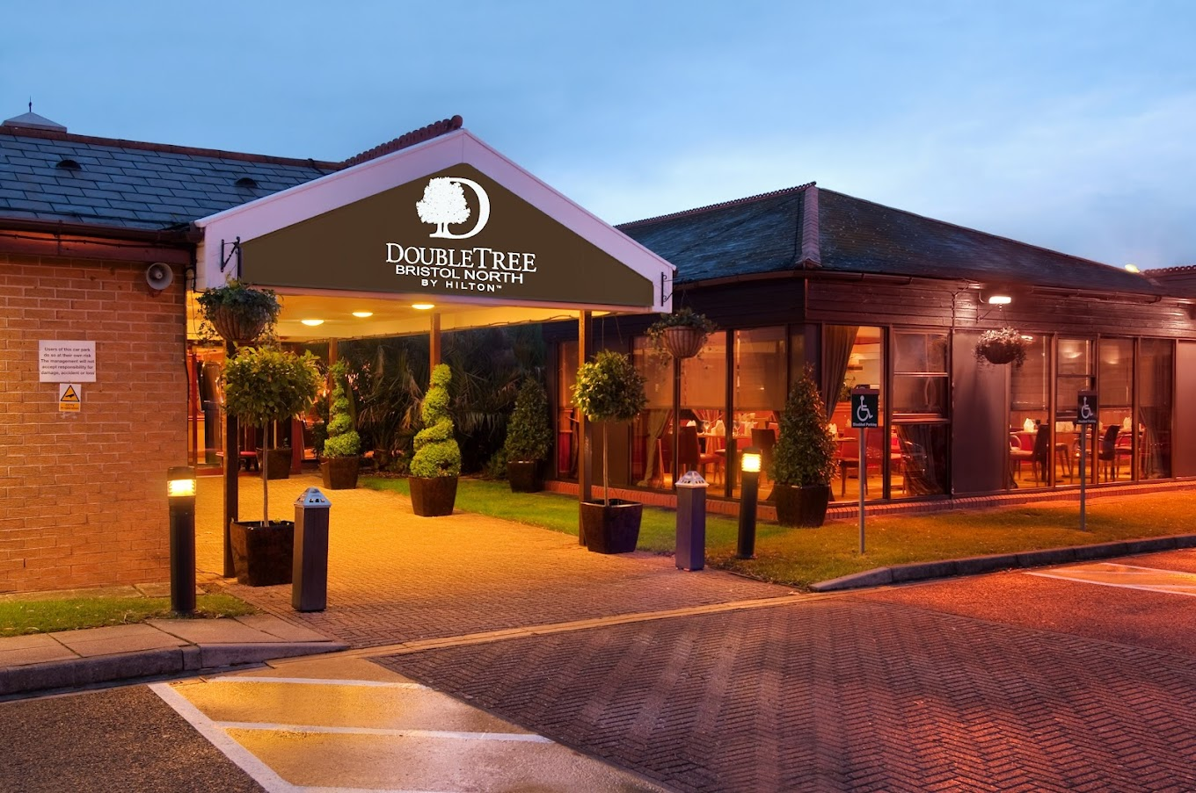
Image: Doubletree by Hilton Bristol North (Source: Hilton)

Staffing Dynamics and Flexibility
The efficient management of its various divisions is possible because the hotel has an array of employees totaling around 200. Because of the fast-paced characteristics of the hospitality industry, it is essential that the hotel employ a flexible method of recruiting to keep pace with the constantly changing expectations of its clients (Jung and Yoon, 2018). The schedule can be altered to accommodate seasonal employees or those with multitasking abilities when there is high demand. This is why services are available throughout the entire year.
Single-Location Operation within a Larger Chain
While it has Doubletree by Hilton Bristol North branding and support from Hilton, Doubletree by Hilton Bristol North is really its own company. Everyone is familiar with Hilton. Through the use of a globally recognised hospitality business's marketing strategies and operational best practices, loyalty programmes, and other benefits, Doubletree by Hilton Bristol North has a chance to grow in popularity and competitiveness (Gui et al., 2021). Hotel chains could be able to bring together their expertise and experience to meet the needs of guests efficiently and devise innovative ways to solve problems.
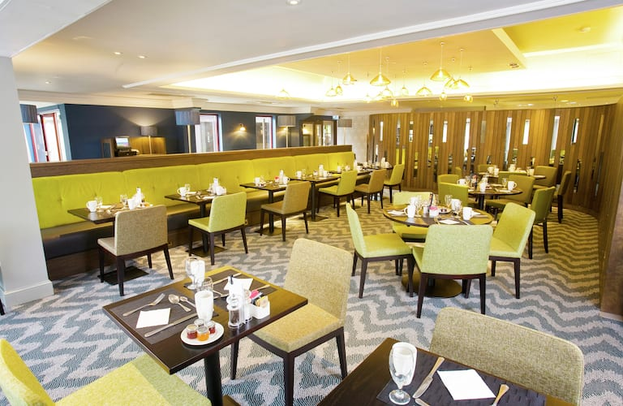
Image: Dining facilities of Doubletree by Hilton Bristol North (Source: Hilton)

Market Positioning and Competitive Advantage
Famous for its warm and welcoming staff, modern amenities, and modern style The Doubletree by Hilton Bristol North is among the most luxurious accommodations in Bristol. With its ideal position and stellar image, it is able to cater to a variety of guests, from those travelling for business to those on vacation (Judge and Piccolo, 2024). If the hotel wants to thrive in this competitive industry and retain its leadership position, the hotel must keep track of industry developments and shifts in customer behavior. This will allow it to keep its position as a market leader by continually improving its services.
Guest Satisfaction and Reputation Management
A high proportion of satisfied guests could mean this hotel is determined to go further and more to meet the demands of its clients. The Doubletree by Hilton Bristol North has earned the hotel an excellent reputation due to the many favorable reviews posted by past guests. Many guests return to the hotel due to a variety of reasons, such as its location in a convenient area, the helpful staff, and spacious rooms (Groenewald, 2024). The hotel is at its position at the very top of hospitality industry due of its quick responses to online comments and suggestions. This is a sign of how serious it is about customer satisfaction as well as the speed at the manner in which it resolves issues.
Community Engagement and Corporate Social Responsibility
Corporate social responsibility and development of the community is a key concern for this hotel Doubletree by Hilton Bristol North. The hotel plays its part by helping local projects as well as charities. Through the promotion of local tourist attractions and donating to charity and building relationships with small-scale enterprises, Doubletree by Hilton Bristol North builds trust with tourists and locals alike in Bristol (Cismaru and Iunius, 2019). Apart from increasing the image of the hotel, these events also aid in the development of the local community sustainably.
Market Performance and Growth Strategies
Doubletree by Hilton Bristol North consistently beats its competition in effectiveness, efficiency, and occupancy rates, even when the industry is extremely competitive. This is due to its effective marketing strategy, reasonable pricing, and continuous infrastructure maintenance and improvement (Şimşek, 2024). Hotel owners may discover opportunities to expand, diversify, or target marketing through the exploration of new markets. The hotel can maintain its position in the market by gradually increasing its revenue. By paying close attention to trends in the market and the preferences of customers, the hotel can keep abreast of the changing hospitality industry and its constantly changing trends (Bayighomog and Arasli, 2022). Due to this, the hotel can alter its strategies to reflect current trends.
SWOT analysis
Strengths: There are many reasons why, for a variety of reasons, the Doubletree by Hilton Bristol North is a popular preferred hotel for those travelling through the Bristol region. Anyone looking for a luxurious hotel with friendly staff will find it appealing, as it is part of the well-known Hilton portfolio, which is known for its extraordinary quality and reliability (Halim et al., 2022). It is also distinct from other Bristol hotels that cater to the most customers with discerning tastes because of their top-quality facilities and services. The consistently high number of favourable reviews that the hotel has is proof of its commitment to providing top-quality service. The hotel's dedication to offering outstanding service is also evident in this (Peng et al., 2023). The hotel's central position in the middle of Bristol makes it an ideal option for both business travellers and those who want to benefit from Bristol's numerous public transport options and the lively environment.
Strengths  - Extraordinary quality and reliability  - Top-quality facilities and services  - Offering outstanding service  - Central position in the middle of Bristol  - Benefit from Bristol's numerous public transport options and the lively environment | Weaknesses  - The turnover of staff is high  - Making adjustments to staff numbers and operations  - Single-location structure  - Lack of larger systems and economies of scale.
Opportunities  - Marketing, operations, and guest services.  - Unlimited opportunities for promotion and recommendations.  - Sustainability guidelines, green certifications, and other eco-friendly programs. | Threats  - Unintentional to make decisions.  - Sustaining earnings and market share.  - Offering additional services which can compromise quality.

Table 1: Analysis of SWOT factors (Source: Self)
Weaknesses: Additionally, Doubletree by Hilton Bristol North is proud of its commitment to the community and aims to establish trust and an excellent reputation as a responsible business through partnerships and other initiatives. There are many serious issues at the hotel, making running and maintaining it difficult (Segovia-Pérez et al., 2019). The turnover of staff is high (anything between 60% and around 80%), which decreases efficiency in operations and raises the cost of hiring and training. Making adjustments to staff numbers and operations to accommodate seasonal shifts in demand is vital (Lub et al., 2019). Additionally, the company's single-location structure prevents it from using up resources and does not allow it to take advantage of synergies that are available to larger systems and economies of scale.
Threats: Relying too heavily on the Hilton name could also render the hotel unintentional to make decisions on its own and be flexible. The hotel industry is highly competitive, and keeping ahead of the pack requires continuous innovation in order to sustain earnings and market share (Rengel Jara et al., 2019). There are plenty of opportunities for Doubletree by Hilton Bristol North to build on its weaknesses and increase its strengths (Kapur, 2020). A greater position in Bristol and adjacent areas is something organizations are attempting to achieve. Offering additional services, like fitness centres and event spaces, can aid us in connecting with more people and generate more income in the long term.
Opportunities: The customer experience, efficiency, and personalisation could all make a leap ahead when applied to marketing, operations, and guest services. When organisations join forces with local establishments, places of interest, or event organisers, they provide unlimited opportunities for promotion and recommendations (Albashiti et al., 2021). Consumers who are concerned are more likely to work with businesses whose corporate social responsibility (CSR) objectives are aligned with their sustainability guidelines, green certifications, and other eco-friendly programs. Risks to the bottom line of hotels include, but are not limited to, competition, shifting consumer preferences, changes in regulations, new trends, and international events that may cause a ripple effect (Konovalova et al., 2018). In order to maintain its status as the most prestigious Bristol hospitality accommodation, Doubletree by Hilton Bristol North has done so by capitalising on its strengths while minimising its flaws.
PEST analysis
Political Factors: Bristol has simple and reliable laws that regulate the hospitality industry and make it a great place to establish a business. This is due to the peace in social and political aspects within the Bristol region. The bottom line of a hotel's business and the number of visitors could benefit from government-sponsored initiatives aimed at boosting the tourist industry and the economy (Majid et al., 2019). The regulations governing licencing and employment, and taxes, are all subject to change. This means that compliance requirements and operational expenses must be reviewed and revised regularly to ensure performance (Busulwa et al., 2022).
Economic Factors: In direct response to Bristol's flourishing economy and the constant increase in GDP, the city's tourism industry is growing, which ensures that there is always a steady flow of guests in the area of resorts. When people are eager to spend money on things like accommodation and transportation, it is a sign that the economy in Bristol is doing very well (Walker, 2021). This is why the premium hospitality services provided by Doubletree by Hilton Bristol North are highly sought-after. In addition, occupancy and income are dependent on macroeconomic factors like interest and inflation rates that affect the way that consumers spend their money (Book et al., 2019). In the most likely scenario, organisations' earnings are being affected by issues such as inflation and growing operational expenses due to inadequate financial management.
Political | Bristol has simple and reliable laws  The bottom line of a hotel's business  The regulations governing licencing and employment
Economic | Bristol's flourishing economy and the constant increase in GDP  Accommodation and transportation  Occupancy and income
Social | The lively and diverse living style  The demand for specific services or amenities  Strategies updated and revised
Technological | The development of technology  Operations, guest services, and marketing  Smart rooms, mobile check-in and check-out capabilities

Table 2: Analysis of PEST factors (Source: Self)
Social Factors: Through leveraging changes in society like the increasing awareness of travel and health, hotels are able to stand apart and draw a wide variety of customers. Lively and diverse living styles that visitors often enjoy in Bristol is because of the city's large and diverse populace (Ghani et al., 2022). The requirements for these specific services and amenities are now affected by the changes in the demographic such as the ageing population and the growing millennial generation's preference. So, it will be necessary to have strategies updated and managed because it will be helping to keep up with the altering demands of travellers (Pai et al., 2020).
Technological Factors: The development of technology within the hospitality industry is vital, as it allows for more effective and innovative methods. Doubletree by Hilton Bristol North is a technology-driven business across all aspects, which include operations, guest services, and marketing (Ali et al., 2020). This creates the most enjoyable guest experience and more efficient operations with cost savings and a competitive advantage. Smart rooms, mobile check-in and check-out capabilities, and tools for data analysis are just a few examples of technology that could increase efficiency and make life easier (Heimerl et al., 2020). Technology isn't without its flaws. Privacy and security issues, and the constant need to invest in infrastructure and employee education to maximise the benefits of new technology, are all possible consequences.
Competitors’ analysis (Price vs Quality)
Hotel guests looking for prices that are comparable to or greater than Doubletree typically select The Marriott Hotel Bristol City Centre. Like Doubletree, guests at The Hotel Marriott Bristol City Centre can count on excellent amenities and a warm welcome throughout their stay (Schwepker Jr and Dimitriou, 2021). The guests can immediately get involved in various activities and then depart. This hotel, the Radisson Blu Hotel Bristol, is an excellent choice to consider if organizations are searching for an establishment that has five stars. The Radisson Blu Hotel, located in Bristol, is a good choice for Doubletree due to its similar prices (Arici et al., 2021). The guests of the Radisson Blu Hotel Bristol will enjoy modern furnishings and premium amenities.
It is in competition with Doubletree in both its quality and the service it provides visitors. Although it is more expensive than rivals like Doubletree, some still view the Bristol Harbour Hotel & Spa as being on the more expensive end of the spectrum (Nazarian et al., 2022). Customers who are looking to invest in special experiences will appreciate the historic splendour and luxurious amenities provided through Bristol Harbour Hotel & Spa. It is located in Bristol Harbour and is the Hotel and Spa. This hotel is situated on Bristol Harbour. Mercure Bristol Grand Hotel is an ideal alternative to Doubletree for those with less of a budget due to the lower cost. While it doesn't have the luxury Doubletree amenities The Mercure Bristol Grand Hotel aims to offer top-quality service and comfortable, affordable rooms (Sarangal et al., 2020).

Figure 1: Top 3 competitors of Doubletree (Source: Self)
While compared with other hotels on Bristol region, Doubletree is providing the moderate pricing for luxury amenities. There are three other hotels in Bristol that are relatively priced such as Radisson Blu Hotel Bristol, Bristol Harbour Hotel, and Marriott Hotel Bristol City Centre. They are also responsible for providing similar levels of service and high-end amenities (Guillet et al., 2019). Even after that, the Bristol Harbour Hotel & Spa have been providing a greater level of luxury where Doubletree might be what customers are searching for if they're looking for a blend of comfort and luxury during their stay.

5. Theme Exploration
Employee Turnover Management
In the hospitality industry, primary issue which is creating problem is the high employee turnover rate. This could result in increased costs and lower efficiency of operations. With an employee turnover rate that can reach up to 80 percent, it is evident that it is necessary to take action to reduce the rate at Doubletree by Hilton Bristol North (Estiri et al., 2018). Controlling employee turnover effectively requires an integrated strategy that considers the entire leadership and organisational context. The initial and most crucial step is to evaluate the leadership strategies employed (Wang and Xie, 2020). Reviewing their management philosophy, communication techniques, and relationship-building techniques are all necessary for managers to improve their leadership skills. One method to reduce employee turnover is to employ transformational leadership methods to create more committed and engaged team (Baum, 2019). Leaders need to continue working to create a diverse and inclusive society in which everyone is able to thrive.
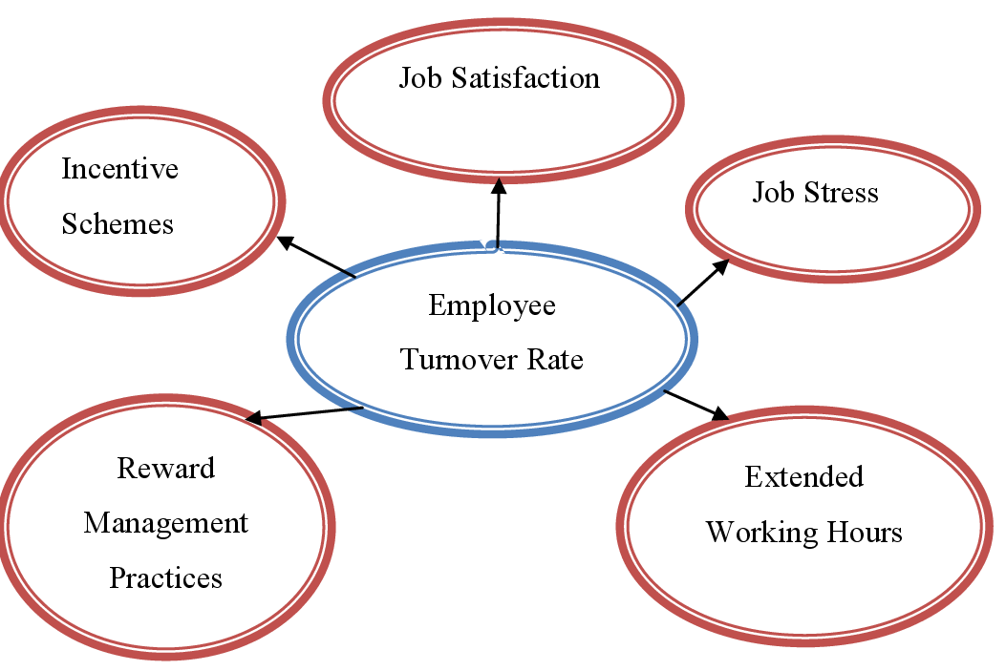
Figure 2: Employee Turnover Management (Gupta, 2019)
In creating an environment where employees are valued and appreciated Business leaders can reduce employee turnover and improve satisfaction. The ability to attract and retain best talent are the essential element to running the success of a company (Gupta, 2019). Offering attractive pay, incentive programs and compensation plans is vital to success within the competitive hospitality industry when attempting to attract the best talent. Compensation plans that offer a range of benefits, such as health insurance and retirement savings plans and premium pay, are elements of these (Hayes et al., 2021). If customers are reassured that a company is concerned about their wellbeing, they are more likely to stick with the firm. In order to help employees achieve the right balance between work and family is a matter of flexibility in their work schedules and program choices.
Flexible Staffing Dynamics
The current hospitality industry relies on employees who are able to adjust to ever-changing demands for staff all through the year. This is why Doubletree by Hilton Bristol North Doubletree by Hilton Bristol North has also decided to change its recruitment methods to meet the changing needs of its clients and to ensure that the company is running smoothly (Dashper, 2020). Companies can take advantage of the fluctuation and ebb of demands throughout the entire year by boosting their workforce through seasonal recruitment. This is vital to ensure that a workforce is able to adapt (Rabiul and Yean, 2021). Hoteliers can make better use of their resources and maintain the highest standard of service by decreasing staff numbers during times of slowness and by hiring part-time or even temporary employees during peak seasons.
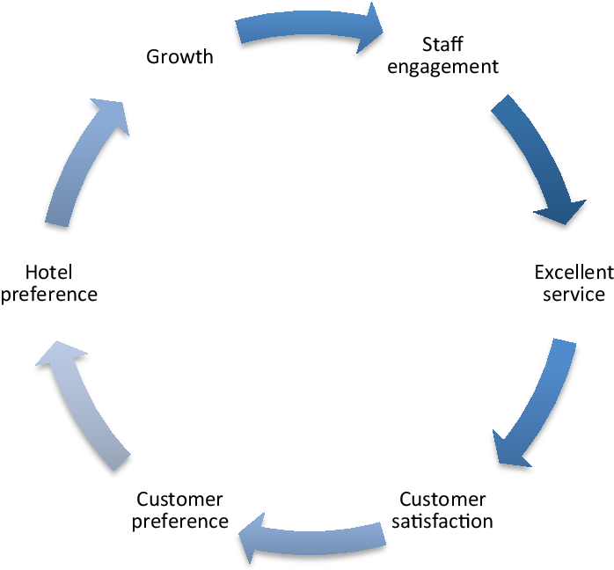
Figure 3: Flexible Staffing Dynamics (Rabiul and Yean, 2021)
If individuals are in the process of recruiting, Doubletree at Hilton Bristol North may provide temporary workers, such as retirees or students, the chance to be part of an organization, gain knowledge of different perspectives, and to be flexible (Sisson et al., 2023). Multitasking staff is vital to creating a flexible workforce. If hotel managers train their employees to multitask successfully and adapt to changing demands without lowering the standards of service, People who can manage multiple tasks and smoothly switch between jobs or departments can ensure the highest levels of staffing and reduce disruptions to operations as a result of changes in demand (Hight et al., 2019). Technology such as the automated scheduling programme can allow human resource management to be more flexible.
Investment in Employee Development
Businesses must invest in their employees' development to boost productivity, happiness, and retention. Opportunities for advancement in the workplace and continuous training are essential in building loyalty and commitment among employees, as acknowledged by Doubletree by Hilton Bristol North (He et al., 2019). Instructing employees in the skills, knowledge, and capabilities required to perform their job effectively will be the initial step to making investments in professional growth. In training courses, participants acquire the necessary skills to meet client expectations and leave an impression (Shukla et al., 2023). Onboarding programmes and opportunities to continue professional development could be beneficial for new and existing employees.
Employee satisfaction, productivity, and trust could be improved when companies provide opportunities for training. The opportunities for growth in the workplace are vital to retaining top performers and ensuring that they trust the future of the business (Elkhwesky et al., 2022). Programmes for mentoring as well as succession planning plans and the chance for workers to improve their skills are only some of the ways employers can support their employees to be genuine in their work. To foster an environment where employees are encouraged to meet their goals, employers must acknowledge their appreciation for their employees' achievements and motivate them to do their best (Hoang et al., 2021). The investment a company makes in the professional development of its employees extends beyond technical education. Another factor is the promotion of leadership and personal growth. Skills like collaboration, problem solving, and communication aren't enough to create an impact in industry.
Utilization of Technology
Improved human resource management technology could positively impact various sectors, such as those in the hospitality industry. This results in a significant increase in the efficiency of operations as well as a reduction in administrative burden and a dramatic increase in employee output (Huertas-Valdivia et al., 2022). This is because The Doubletree by Hilton Bristol North is cognizant of the transformational capabilities of technology with regard to the management of employees and overall productivity. Automatic scheduling can be described as the primary technology solution for improved workflow management. Overall, these factors are solely based on several aspects such as the level of experience and knowledge, the quantity of labour available, and the expected level of demand expected (Shum et al., 2018). Different aspects of automated scheduling can be employed here with the sophisticated algorithms as data analytics can help to determine the optimal timing for workers to complete all the tasks.
Open Communication and Feedback
Employees in the hospitality industry will need to be given with an atmosphere that's open to feedback, communication, and suggestions to improve morale, engagement, and retention efforts. Open communication with the process of giving constructive feedback are considered as two most important aspects that Doubletree by Hilton Bristol North recognises. Overall, these are essential for the creation of a culture which promotes employee satisfaction and importance (Huertas-Valdivia et al., 2019). The availability of a channel for communication within the company is crucial to ensuring that employees feel respected and well-informed. It is crucial that the leadership of the company keep everyone informed about the current status of the company's goals, the company's performance goals, expectations for employees, and any changes to procedures or policies (Zia et al., 2022). Employers who keep their employees up-to-date and incorporate management into their decision-making processes demonstrate they're committed to transparency and that they wish their employees to feel accountable and to have a sense of control over their work.
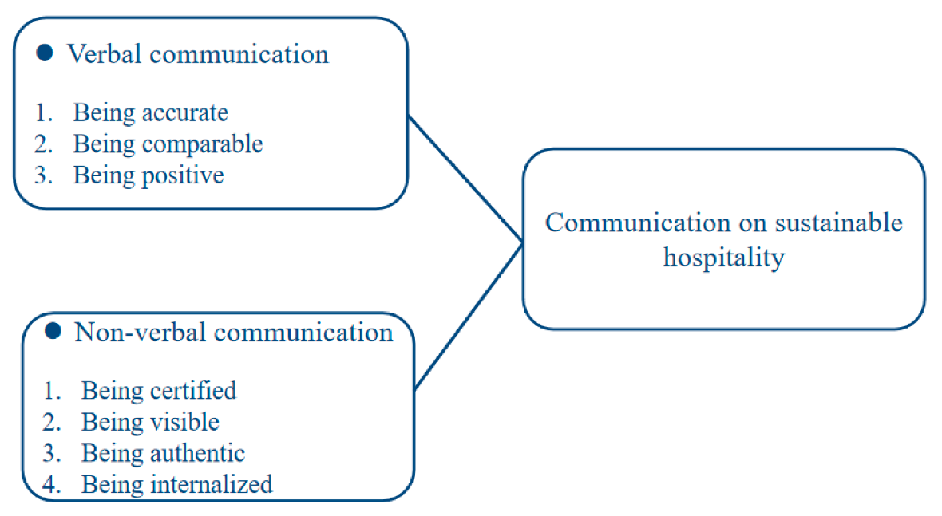
Figure 4: Communication on sustainable hospitality (Zia et al., 2022)
In order to have the concerns or complaints taken care of and for changes to be implemented quickly, it is essential to give management and staff the opportunity to talk about issues. Town hall meetings, and focus groups and regularly scheduled one-on-one sessions between employees and management, are among the ideal venues for deep discussions and the exchange of constructive feedback (Arasli et al., 2020). If employers listen to and address employee issues and concerns promptly and in an open way, it shows they are committed to their employees' wellbeing and engagement. Employers can gain insight into the perspectives of their employees, their moods, and the potential for improvement through formal feedback techniques like employee surveys or suggestion boxes, and reviews of performance (Karatepe et al., 2020). Managers could use feedback analysis to determine patterns, establish priorities, and implement targeted changes in order to resolve the root of the issues. They display that they appreciate employee input and are committed to continuous growth by asking for and responding to suggestions (Remington and Kitterlin-Lynch, 2018). A sense of gratitude and gratitude could boost productivity and morale at work.
Assessment of Existing Leadership Practices
When leaders invest in their employees' personal and professional advancement, they're assisting the team to achieve its goals. As per research and analysis that the shift rate for Doubletree located at Hilton Bristol North is rather high, with a range of sixty percent to 80 percent. The decrease in productivity and a rise of efficiency is triggered by the high staff turnover (Wood et al., 2021). This can increase the cost of training and recruiting new employees. Enhancing employee happiness and retention demands the examination of the current leadership procedures. A key element of any assessment is to ensure that employees feel secure and at ease working. To ensure their employees feel valued, loved and valued, managers must evaluate the leadership manner, culture of the organization communications style, as well as processes (Chon and Zoltan, 2019). Through fostering a positive workplace atmosphere, leadership may assist in keeping employee happiness and motivation. Furthermore, it is expected that every employee are proficient. It is vital to keep exceptional employees by offering lucrative plans that are attractive and offer prospects for advancement (Gui et al., 2020). Pay plans should be based on reality fair, equitable, and conforming to industry standards if managers wish to impress their employees. Giving employees’ opportunities to improve their skills and establishing clear pathways to progress could increase their satisfaction and engagement in their job.
Identification of Cutting-Edge Leadership Techniques
Giving employees more flexibility in their schedules is a fantastic way to increase productivity and retention. Because the hotel employs around 200 employees, this hotel Doubletree by Hilton Bristol North can swiftly adapt to changes in market conditions and fluctuations in guest count (Bavik, 2020). Innovative recruitment strategies including posting ads for seasonal employees or multitaskers, can boost the ability to change and improve the efficiency of operations (Hassi, 2019). Employing flexible staffing solutions hoteliers can boost their workforce's capacity in peak times while reducing costs for labor during off-peak hours. Many people believe that modern technology offers the greatest opportunity for ingenuity leadership to manage the operations in a manner that improves efficiency and morale. It is possible to consider scheduling software that takes into consideration the availability of workers, their skills and demand estimates to optimize shifts. Along with the reduction of administrative duties, it also boosts the morale of employees and increases productivity (Alexakis and Jiang, 2019). Tools for communication built on technology enhance collaboration and sharing of information through greater coordination and linking.
Proposing Practical Measures
Employees who make use of Doubletree by Hilton Bristol North's numerous training opportunities will be well-equipped to perform their jobs effectively and grow in their careers. Thinking about a bonus scheme or other type of incentive for internal promotion can help retain employees to the end of the road and increase the chances of the business achieving its goals (Hassi, 2019). Motivation and retention of employees can be as simple as requiring workers to participate in educational programs and setting up rewards at workplace. Software for scheduling that is automated can be a prime illustration of how technology-based solutions could improve the management of labour while reducing administration costs. Utilizing computerized schedulers, hotels may enhance productivity as well as reduce conflicts with scheduling and make more efficient use of their employees (Alexakis and Jiang, 2019).
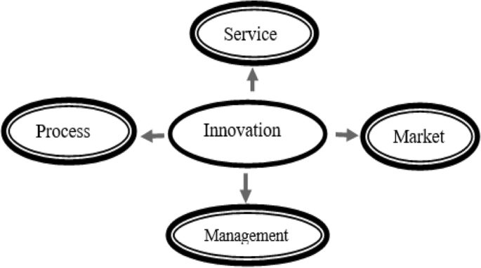
Figure 5: Proposing Practical Measures (Alexakis and Jiang, 2019)
The creation of a space in which workers and managers are at ease sharing their thoughts and receiving constructive feedback is crucial to increasing the morale and happiness of employees. In a supportive and inclusive workplace, employees will feel more valued and respected when they are given the opportunity to express their opinions through events such as town hall meetings, suggestion programs and frequently scheduled feedback session (Huertas-Valdivia et al., 2019). To tackle issues related to employee turnover and increase efficiency of operations, it's essential to evaluate the current leadership approach, assess the approach currently employed and create an action plan. It is expected that the Doubletree by Hilton Bristol North hotel will benefit from a culture that encourages creativity and collaboration in the process.

6. Conclusions and Recommendations

6.1 Conclusion
Insufficient management practices and inefficiencies are only among the many major issues that the hospitality industry is faced with and overcome, as the Doubletree Company's long history has demonstrated. A solution to these issues can be found by utilizing the most up-to-date methods as well as a thorough analysis of the most recent leadership strategies. Through focusing on the most current leadership strategies, Doubletree By Hilton Bristol North can achieve its objective of creating an inviting and warm workplace to its workers. Managers should evaluate the effectiveness and effectiveness of the effectiveness of their leadership and communication techniques to ensure a secure and welcoming workplace that is welcoming to all employees. One way to keep top talent and reducing turnover is to offer opportunities for professional development. Giving opportunities to grow professionally through education, mentorship and other initiatives are essential for increasing employee satisfaction and engagement.
To efficiently manage human resources and ensure efficient operation Modern leadership strategies emphasize the use of technology and advancements in working schedules. The employees in hotels utilize scheduling software to automate their tasks, and other solutions that use technology to assist in scheduling and enhance collaboration and communication, in order to offer customers the highest quality service and satisfy their ever-changing needs. To attract and retain the top employees, every business requires a plan. Promotions are a chance to recognize employees who continuously exceed expectations that, which increases morale and motivates others to follow suit. Furthermore to this, a positive and inviting workplace will be generated by the company's constant insistence on honesty, openness along with constructive feedback.

6.2 Recommendations
One of the most well-known services offered by Doubletree by Hilton Bristol North includes leadership programmes that help supervisors learn the art of directing and motivating their employees. The effectiveness of leadership could be improved, and a more business-friendly environment can be created through an education programme in conflict management, employee engagement, and efficient communication. The ability of the hotel to react quickly to shifts in demand is dependent on the use of its resources and its ability to consider different options for staffing (Huertas-Valdivia et al., 2019). The process of recruiting seasonal employees and offering them opportunities to cross-train is essential for organisations to be able to adjust to the changes in mobility of people. Software that automates scheduling and other types of online communications can help in managing the activities of workers and improve efficiency. The aspects to which any team's members can utilise different tools that are available to them is considered as the key factor effectiveness of the team (Wood et al., 2021). The Human Resources team at Doubletree by Hilton Bristol North will need to be insistent while they are having programmes which are including mentorship, training, and opportunities for development.
The morale of the workplace and its productivity can be enhanced by creating an environment that promotes the openness of dialogue as well as constructive critique. Town meetings and suggestion programmes are two of the most common methods for feedback that hotels could employ to encourage more discussion and assist staff in resolving problems. The metrics of satisfaction with staff and turnover rates are essential to determining the effectiveness of an initiative (Huertas-Valdivia et al., 2019). Performance evaluations and feedback from employees will help make decisions about how to manage labour in order to ensure constant improvement. When these plans are put into practice, Doubletree by Hilton Bristol North will be able to improve its efficiency in operations and create an environment that encourages creativity and collaboration, as well as address the challenges posed by the high turnover of staff (Hassi, 2019). By investing in efficient leadership and staffing methods and flexible technology solutions and programmes to assist employees in enhancing their professional abilities, the hotel can improve its sustainability and ensure long-term achievement for this hospitality industry.

7. Reflection
I gained a thorough understanding within the hospitality industry specifically regarding staff management, leadership dynamics, and strategies to engage employees in their job while working at the Doubletree by Hilton Bristol North. In looking at the industry in its entirety I could discern the potential and difficulties when I considered how crucial it is to have effective leadership and a fresh method to address issues while ensuring the efficiency of operations and a huge amount of employee shifts. As an executive for the Doubletree by Hilton Bristol North, the most pressing issue was the same. This issue affects all aspects of all of the hospitality industry and impacts morale, business continuity, and the overall satisfaction of customers. The high turnover rate at employees at the Doubletree located at Hilton Bristol North has serious implications, so having a long-term solution to the issue is critical.

References
Albashiti, B., Hamid, Z., and Aboramadan, M. (2021). Fire in the belly: the impact of despotic leadership on employees work-related outcomes in the hospitality setting. International Journal of Contemporary Hospitality Management, 33(10), 3564-3584.
Alexakis, G., and Jiang, L. (2019). Industry competencies and the optimal hospitality management curriculum: An empirical study. Journal of Hospitality and Tourism Education, 31(4), 210-220.
Ali, M., Usman, M., Pham, N. T., Agyemang-Mintah, P., and Akhtar, N. (2020). Being ignored at work: Understanding how and when spiritual leadership curbs workplace ostracism in the hospitality industry. International Journal of Hospitality Management, 91, 102696.
Altin, M., Koseoglu, M. A., Yu, X., and Riasi, A. (2018). Performance measurement and management research in the hospitality and tourism industry. International Journal of Contemporary Hospitality Management, 30(2), 1172-1189.
Arasli, H., Altinay, L., and Arici, H. E. (2020). Seasonal employee leadership in the hospitality industry: a scale development. International Journal of Contemporary Hospitality Management, 32(6), 2195-2215.
Arici, H. E., Arici, N. C., Köseoglu, M. A., and King, B. E. M. (2021). Leadership research in the root of hospitality scholarship: 1960–2020. International Journal of Hospitality Management, 99, 103063.
Avolio, B. J., Bass, B. M., and Jung, D. I. (2019). Re-Examining the Components of Transformational and Transactional Leadership Using the Multifactor Leadership Questionnaire. Journal of Occupational and Organizational Psychology, 72(4), 441-462.
Baum, T. (2019). Does the hospitality industry need or deserve talent?. International Journal of Contemporary Hospitality Management, 31(10), 3823-3837.
Bavik, A. (2020). A systematic review of the servant leadership literature in management and hospitality. International journal of contemporary Hospitality Management, 32(1), 347-382.
Bayighomog, S. W., and Arasli, H. (2022). Reviving employees’ essence of hospitality through spiritual wellbeing, spiritual leadership, and emotional intelligence. Tourism Management, 89, 104406.
Benhadda, L., and Chibili, M. N. (2019). Managing Change in the Hospitality Industry. In Modern Hotel Operations Management (pp. 508-565). Routledge.
Book, L., Gatling, A., and Kim, J. (2019). The effects of leadership satisfaction on employee engagement, loyalty, and retention in the hospitality industry. Journal of Human Resources in Hospitality and Tourism, 18(3), 368-393.
Busulwa, R., Pickering, M., and Mao, I. (2022). Digital transformation and hospitality management competencies: Toward an integrative framework. International Journal of Hospitality Management, 102, 103132.
Chon, K. K. S., and Zoltan, J. (2019). Role of servant leadership in contemporary hospitality. International Journal of Contemporary Hospitality Management, 31(8), 3371-3394.
Ciftci, D. O., and Erkanli, H. (2020). Mediating Role of the Positive Psychological Capital on the Relation between the Authentic Leadership Style and Employees' Work Engagement: An Applied Study on Hospitality Industry. Business and Economics Research Journal, 11(2).
Cismaru, L., and Iunius, R. (2019). Bridging the generational gap in the hospitality industry: reverse mentoring—an innovative talent management practice for present and future generations of employees. Sustainability, 12(1), 263.
Collis, J and Hussey, R (2014). Business Research, A Practical Guide for Undergraduate and Post Graduate Students, Palgrave, London,
Cottrell, S. (2014). Dissertations and project reports: A a step by step guide. New York: Pallgrave.
Dashper, K. (2020). Mentoring for gender equality: Supporting female leaders in the hospitality industry. International Journal of Hospitality Management, 88, 102397.
Dimitrios, B., Ioannis, R., Efstathios, V., Christos, A., Dimitrios, T., and Labros, S. (2018). Successful and efficient knowledge management in the Greek hospitality industry: Change the perspective. Academic Journal of Interdisciplinary Studies, 7(1), 185-191.
Elkhwesky, Z., Salem, I. E., Ramkissoon, H., and Castañeda-García, J. A. (2022). A systematic and critical review of leadership styles in contemporary hospitality: a roadmap and a call for future research. International Journal of Contemporary Hospitality Management, 34(5), 1925-1958.
Estiri, M., Amiri, N. S., Khajeheian, D., and Rayej, H. (2018). Leader-member exchange and organizational citizenship behavior in hospitality industry: a study on effect of gender. Eurasian Business Review, 8, 267-284.
Ghani, B., Zada, M., Memon, K. R., Ullah, R., Khattak, A., Han, H., ... and Araya-Castillo, L. (2022). Challenges and strategies for employee retention in the hospitality industry: A review. Sustainability, 14(5), 2885.
Groenewald, E. (2024). Assessing the Role of Leadership in Shaping EDI Policies and Initiatives in Hospitality Industries: A Systematic Review and Meta-analysis Review. International Multidisciplinary Journal of Research for Innovation, Sustainability, and Excellence (IMJRISE), 1(1), 13-19.
Gui, C., Luo, A., Zhang, P., and Deng, A. (2020). A meta-analysis of transformational leadership in hospitality research. International Journal of Contemporary Hospitality Management, 32(6), 2137-2154.
Gui, C., Zhang, P., Zou, R., and Ouyang, X. (2021). Servant leadership in hospitality: A meta-analytic review. Journal of Hospitality Marketing and Management, 30(4), 438-458.
Guillet, B. D., Pavesi, A., Hsu, C. H., and Weber, K. (2019). Is there such a thing as feminine leadership? Being a leader and not a man in the hospitality industry. International Journal of Contemporary Hospitality Management, 31(7), 2970-2993.
Gupta, V. (2019). Talent management dimensions and their relationship with retention of Generation-Y employees in the hospitality industry. International Journal of Contemporary Hospitality Management, 31(10), 4150-4169.
Halim, V., Rahayu, P., and Asshofi, I. (2022). The Impact of Leadership Training on Employee Performance in the Hospitality Industry. In UNCLLE (Undergraduate Conference on Language, Literature, and Culture) (Vol. 2, No. 01, pp. 570-577).
Hassanien, A., and Dale, C. (2019). Hospitality business development. Routledge.
Hassi, A. (2019). Empowering leadership and management innovation in the hospitality industry context: The mediating role of climate for creativity. International Journal of Contemporary Hospitality Management, 31(4), 1785-1800.
Hayes, D. K., Hayes, J. D., and Hayes, P. A. (2021). Revenue management for the hospitality industry. John Wiley and Sons.
He, J., Morrison, A. M., and Zhang, H. (2019). Improving millennial employee well-being and task performance in the hospitality industry: The interactive effects of HRM and responsible leadership. Sustainability, 11(16), 4410.
Heimerl, P., Haid, M., Benedikt, L., and Scholl-Grissemann, U. (2020). Factors influencing job satisfaction in hospitality industry. SAGE open, 10(4), 2158244020982998.
Hight, S. K., Gajjar, T., and Okumus, F. (2019). Managers from “Hell” in the hospitality industry: How do hospitality employees profile bad managers?. International Journal of Hospitality Management, 77, 97-107.
Hilton (2024). Doubletree Bristol North. Available at: https://www.hilton.com/en/hotels/bstbrdi-doubletree-bristol-north/. [Accessed on: 18th March, 2024].
Hoang, G., Wilson-Evered, E., Lockstone-Binney, L., and Luu, T. T. (2021). Empowering leadership in hospitality and tourism management: a systematic literature review. International Journal of Contemporary Hospitality Management, 33(12), 4182-4214.
Holston-Okae, B. L., and Mushi, R. J. (2018). Employee turnover in the hospitality industry using Herzberg’s two-factor motivation-hygiene theory. International Journal of Academic Research in Business and Social Sciences, 8(1), 218-248.
Huertas-Valdivia, I., Gallego-Burín, A. R., and Lloréns-Montes, F. J. (2019). Effects of different leadership styles on hospitality workers. Tourism management, 71, 402-420.
Huertas-Valdivia, I., González-Torres, T., and Nájera-Sánchez, J. J. (2022). Contemporary leadership in hospitality: a review and research agenda. International Journal of Contemporary Hospitality Management, 34(6), 2399-2422.
Huertas-Valdivia, I., Llorens-Montes, F. J., and Ruiz-Moreno, A. (2018). Achieving engagement among hospitality employees: A serial mediation model. International Journal of Contemporary Hospitality Management, 30(1), 217-241.
Jones, P., Hillier, D., and Comfort, D. (2019). Sustainability in the Hospitality Industry: Some Personal Reflections on Corporate Challenges and Research Agendas. International Journal of Contemporary Hospitality Management, 28(1), 36-67.
Judge, T. A., and Piccolo, R. F. (2024). Transformational and Transactional Leadership: A Meta-Analytic Test of Their Relative Validity. Journal of Applied Psychology, 89(5), 755-768.
Jung, H. S., and Yoon, H. H. (2018). Improving frontline service employees' innovative behavior using conflict management in the hospitality industry: The mediating role of engagement. Tourism Management, 69, 498-507.
Kapur, R. (2020). Hospitality Management.
Karatepe, O. M., Aboramadan, M., and Dahleez, K. A. (2020). Does climate for creativity mediate the impact of servant leadership on management innovation and innovative behavior in the hotel industry?. International Journal of Contemporary Hospitality Management, 32(8), 2497-2517.
Khuong, M., and Linh, U. (2020). Influence of work-related stress on employee motivation, job satisfaction and employee loyalty in hospitality industry. Management Science Letters, 10(14), 3279-3290.
Kim, S. S., and Escobar, Q. M. (2021). Transformational Leadership and Front-Line Service Employee’s Job Performance: The Mediating Role of Work Engagement. International Journal of Hospitality Management, 45, 7-14.
Konovalova, E. E., Yudina, E. V., Bushueva, I. V., Uhina, T. V., and Lebedev, K. A. E. (2018). Forming approaches to strategic management and development of tourism and hospitality industry in the regions. Journal of environmental management and tourism, 9(2), 241-247.
Lub, X., Breuker, H., and Tomaszewski, L. (2019). Competencies and leadership. In Hospitality Experience (pp. 250-270). Routledge.
Majid, A., Yasir, M., Yousaf, Z., and Qudratullah, H. (2019). Role of network capability, structural flexibility and management commitment in defining strategic performance in hospitality industry. International Journal of Contemporary Hospitality Management, 31(8), 3077-3096.
Mistry, T. G., Okumus, F., and Orlowski, M. (2021). Employee perceptions of diversity management in the hospitality industry. International Hospitality Review, 37(2), 265-285.
Nazarian, A., Zaeri, E., Foroudi, P., Afrouzi, A. R., and Atkinson, P. (2022). Cultural perceptions of ethical leadership and its effect on intention to leave in the independent hotel industry. International Journal of Contemporary Hospitality Management, 34(1), 430-455.
Pai, A., Manjunath, M., Kowshik, C. S., Ayedee, N., Malarout, N., and Naik, N. (2020). Soft skills as a key competency for the future leaders of the hospitality industry. PalArch's Journal of Archaeology of Egypt/Egyptology, 17(9), 4341-4355.
Park, J., and Min, H. K. (2020). Turnover intention in the hospitality industry: A meta-analysis. International Journal of Hospitality Management, 90, 102599.
Peng, M. Y. P., Liang, Z., Fatima, I., Wang, Q., and Rasheed, M. I. (2023). The nexus between empowering leadership, job engagement and employee creativity: role of creative self-efficacy in the hospitality industry. Kybernetes.
Quintana-García, C., Marchante-Lara, M., and Benavides-Chicón, C. G. (2018). Social responsibility and total quality in the hospitality industry: does gender matter?. Journal of Sustainable Tourism, 26(5), 722-739.
Rabiul, M. K., and Yean, T. F. (2021). Leadership styles, motivating language, and work engagement: An empirical investigation of the hotel industry. International Journal of Hospitality Management, 92, 102712.
Remington, J., and Kitterlin-Lynch, M. (2018). Still pounding on the glass ceiling: A study of female leaders in hospitality, travel, and tourism management. Journal of Human Resources in Hospitality and Tourism, 17(1), 22-37.
Rengel Jara, E. V., Babb, J. W., and Flohr, T. M. (2019). Status and scope of project management in the hospitality industry. International Hospitality Review, 33(2), 142-149.
Sarangal, R. K., Sharma, P., and Manhas, P. S. (2020). Organizational commitment, talent management and performance in hospitality industry. Journal of Tourism, Hospitality and Culinary Arts, 12(3), 65-83.
Saunders, M., Lewis, P. and Thornhill, A. (2012). Research Methods for Business Students, FT/Prentice Hall: Harlow.
Schwepker Jr, C. H., and Dimitriou, C. K. (2021). Using ethical leadership to reduce job stress and improve performance quality in the hospitality industry. International Journal of Hospitality Management, 94, 102860.
Segovia-Pérez, M., Figueroa-Domecq, C., Fuentes-Moraleda, L., and Muñoz-Mazón, A. (2019). Incorporating a gender approach in the hospitality industry: Female executives’ perceptions. International Journal of Hospitality Management, 76, 184-193.
Shehawy, Y. M. (2022). Current workplace issues and behaviours in tourism and hospitality: moderating role of empowering leadership. Current Issues in Tourism, 25(10), 1627-1648.
Shukla, B., Sufi, T., Joshi, M., and Sujatha, R. (2023). Leadership challenges for Indian hospitality industry during COVID-19 pandemic. Journal of Hospitality and Tourism Insights, 6(4), 1502-1520.
Shum, C., Gatling, A., and Shoemaker, S. (2018). A model of hospitality leadership competency for frontline and director-level managers: which competencies matter more?. International Journal of Hospitality Management, 74, 57-66.
Şimşek, T. (2024). Strategic Leadership and Crisis Management in the Hospitality Industry. In Human Relations Management in Tourism (pp. 29-56). IGI Global.
Sisson, A. D., and Roberts, K. R. (2023). Leadership skills with classroom instruction integration in hospitality management higher education. Journal of Teaching in Travel and Tourism, 23(2), 208-228.
Upneja, A., and Kwortnik, R. J. (2020). The Importance of Leadership Style: A Survey of Frontline Hotel Employees. International Journal of Hospitality Management, 51, 88-99.
Walker, J. R. (2021). Introduction to hospitality. Pearson.
Wang, Z., and Xie, Y. (2020). Authentic leadership and employees’ emotional labour in the hospitality industry. International Journal of Contemporary Hospitality Management.
Wood, B. P., Eid, R., and Agag, G. (2021). A multilevel investigation of the link between ethical leadership behaviour and employees green behaviour in the hospitality industry. International Journal of Hospitality Management, 97, 102993.
XIA, S. (2022). Leadership styles and their impact on employee engagement in the UK hospitality industry organizations (Doctoral dissertation, SIAM UNIVERSITY).
Xu, S., Stienmetz, J., and Ashton, M. (2020). How will service robots redefine leadership in hotel management? A Delphi approach. International Journal of Contemporary Hospitality Management, 32(6), 2217-2237.
Yam, L., Raybould, M., and Gordon, R. (2018). Employment stability and retention in the hospitality industry: Exploring the role of job embeddedness. Journal of Human Resources in Hospitality and Tourism, 17(4), 445-464.
Zia, M. Q., Naveed, M., Bashir, M. A., and Iqbal, A. (2022). The influence of servant leadership on employees' outcomes via job embeddedness in hospitality industry. Journal of Hospitality and Tourism Insights, 5(3), 612-628.

