

Student name: Nida Jamil
Student ID:2516924
Module name: Introduction to Health and Social Care
Module code: (LCHS4003_LON)
Lecturer name: Mark Kane

Content page

Residential care home……………………………………………..............3
Community antenatal midwifery services...........................................4
References..............................................................................................6

History
Dementia residential care home
- 1906 —A doctor named Alois Alzheimer was the first to identify Alzheimer's, the most common type of dementia . (Alzheimer, 1907, cited in Burns and Iliffe, 2009).
- 1948 — UK National Assistance Act meant the state started taking responsibility for vulnerable people, including those with dementia (National Assistance Act, 1948).
- 1970s–80s — Dementia began to be more widely recognised; dedicated care homes started to develop
- 2009 — UK National Dementia Strategy launched, pushing for better, specialist dementia care (Department of Health,2009).
- Today — Dementia care homes are highly regulated, person-centred, and designed specifically around dementia needs

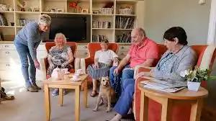 (B&M Care Group,2003)https://www.bmcare.co.uk/our-care/early-onset-dementia-care/

Current functioning
- Morning: Staff assist residents with hygiene, dressing, and eating breakfast
- Some residents in later stages need help feeding themselves.
- Family Involvement: Relatives and friends can visit, sometimes participate in activities..
- Afternoon: Activities such as music, simple gardening, and memory games are provided; tea and snacks are served
- Medication is given by trained staff at scheduled times((Skills for Care, 2022).
- Tailored Support such as Care plans based on individual needs.
- Evening: Residents relax with TV or quiet activities before a supported bedtime routine.
- They focus on early diagnosis, personalized care planning, and intensive support for patients and carers, aimed at reducing crisis hospital visits and supporting independent living (INTs–Benfleet Primary Care, 21,Feb 2025).


Being forgetful is not unusual, unless it means something serious like dementia (Tenzin Chodon published on Jun 24, 2023 16:00 IST)

Challenges
Staffing and training
Emotional and behavioural demands
One challenge faced by dementia care homes is the shortage of staff and the need for specialist training. Many carers come unprepared with only basic training and lack the skills to understand dementia-related behaviour. Communication difficulties between carers and residents can also cause stress, especially during personal care tasks like bathing and feeding (Skills for Care, 2022).
A second challenge is the emotional strain placed on carers. Some residents can change their mood instantly, becoming aggressive and agitated. Without proper dementia training, carers may struggle to manage demanding or suspicious behaviour, which can lead to increased stress for both the resident and the carer — and over time, this can cause burnout. (NMC, 2019).
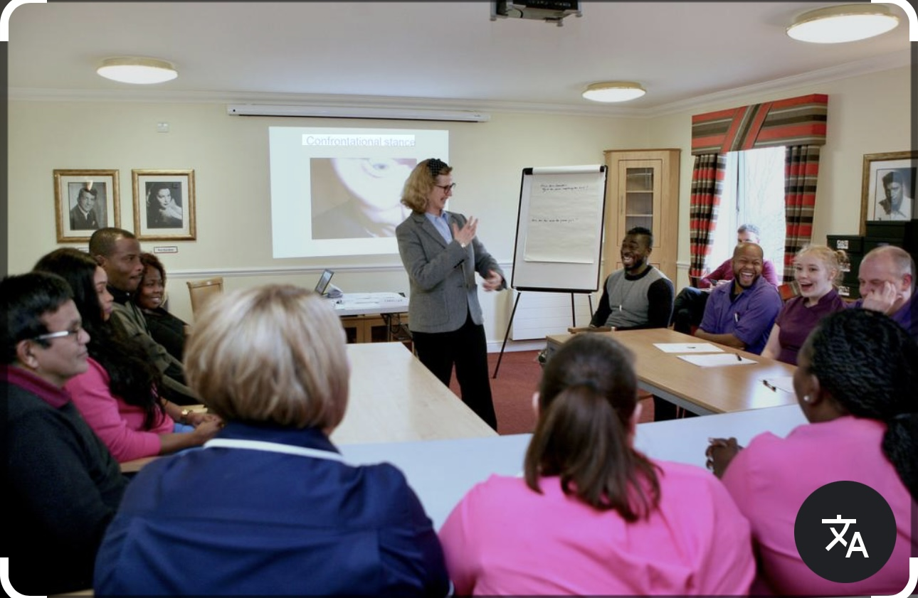
Training session for people with dementia on how to managing distressing their behaviour. To improve support methods for resident with dementia (Alzheimers.org.uk ,no date)

According to Nurseline Healthcare, this image is used to indicate a lack of staff available, this can be always a challenges in the carehome.
A residential care home focussing on Dementia.
“A dementia residential care home is a place where people with memory loss and communication difficulties receive personal care (Alzheimer's Society, 2023). People with dementia can become confused and may wander, putting them at risk of getting hurt, so “care homes are designed with secure environments to keep residents safe (CQC, 2022). Staff — including dementia support workers, nurses, senior carers, wellbeing coaches, and healthcare professionals — assist with daily routines. Activities such as music listening and simple gardening are also used to support brain function and emotional wellbeing.” Dementia is caused by different disease its not only happens to the older people.

Residential Care home
Nida Jamil, Health and Social Care, 2516924@student.uwtsd.ac.uk

Community Antenatal Midwifery Services
This essay is focus on Community antenatal midwifery services which provide care and support to pregnant women in local settings to ensure that antenatal care can be started in a variety of straightforward ways, depending on women's needs and circumstances. This essay will explain the origin of community antenatal midwifery services, how the service functions today, and its significance in enhancing the quality of life of service users. Community antenatal midwifery services play a significant role in enhancing the quality of life of service users, helping to keep pregnant women and their babies safe. Without community antenatal care, women may be at greater risk of infection and life-threatening complications. Having a named midwife means a woman sees the same person at every appointment, which helps her feel comfortable and safe. When a woman feels comfortable with her midwife, she is more likely to share how she is feeling and ask for the help she needs

“Community antenatal midwifery services have a long history that dates back to before 1900, when women in the community assisted pregnant women during birth, surrounded by myth and cultural tradition. In 1902, the Midwives Act made midwifery a regulated profession (Midwives Act, 1902)." So meaning unqualified women could no longer call themselves midwives. In 1948, the NHS was founded, making antenatal care free for all women. “In 1993, the Changing Childbirth report further transformed the service by placing women's choice at the centre of maternity care, including the right to choose where to give birth and have a named midwife (Midwives Act, 1902)”. However, in 1970, a government report recommended that all births should take place in hospital, as this was considered safer for both mother and baby, allowing health professionals to provide immediate medical support if complications arose (National Institute for Health and Care Excellence, 2021). This shift meant that community midwifery became less central for a period, as care moved away from the home and into clinical settings." Advances in technology, such as ultrasound scanning, mean that midwives are now able to detect potential problems with the baby or mother early, even while the baby is still in the womb. “Early detection means that healthcare professionals can intervene quickly, reducing the risk of harm to both the mother and the baby”(Nursing and Midwifery Council, 2018).

Today, community antenatal midwifery services offer a range of care throughout pregnancy, including regular appointments to monitor the baby's heartbeat, growth, and the mother's blood pressure and sugar levels. After birth, midwives also carry out home visits to check that the mother is not suffering from postpartum complications and that the baby is healthy, including screening for jaundice. However, not all women have equal access to these services, as care can vary depending on location, language barriers, and cultural differences. For women who do not speak English as a first language, accessing antenatal care can be challenging because they may not be able to express their symptoms or ask for the care they need. If a woman cannot clearly communicate her symptoms, there is a risk that healthcare professionals may give incorrect treatment, which could harm both the mother and the baby. To address this, community antenatal services could provide culturally trained staff who is able to communicate effectively with women from different backgrounds, ensuring they receive the correct care and treatment."
In conclusion, community antenatal midwifery services have come a long way from informal community women in the 1900s to a regulated, NHS-funded profession. Today the service provides essential care during and after pregnancy, though access can vary. The service remains vital in protecting the physical and emotional wellbeing of pregnant women and their babies.

References
Alzheimer's disease (1906): Alzheimer, A. (1907) 'Über eine eigenartige Erkrankung der Hirnrinde', Allgemeine Zeitschrift für Psychiatrie, 64, pp. 146–148.

Care Quality Commission (2022) Registering as a care home. Available at: https://www.cqc.org.uk (Accessed: 22,03,2026).

General dementia information: Alzheimer's Society (2023) What is dementia? Available at: https://www.alzheimers.org.uk (Accessed: [12,03,2026]).
National Institute for Health and Care Excellence (2021) Antenatal care. Available at: https://www.nice.org.uk (Accessed: 23 March 2025).

National Institute for Health and Care Excellence (2018) Dementia: assessment, management and support. Available at: https://www.nice.org.uk (Accessed: 22,03,2026).

Skills for Care (2022) The state of the adult social care sector and workforce in England. Available at: https://www.skillsforcare.org.uk (Accessed: 22,03,2026).

Nursing and Midwifery Council (2018) The Code: Professional standards of practice and behaviour for nurses, midwives and nursing associates. London: NMC.

Nursing and Midwifery Council (2019) The Code. Available at: https://www.nmc.org.uk (Accessed: 22,03,2026).

UK National Assistance Act (1948): Great Britain (1948) National Assistance Act 1948. London: HMSO.

UK National Dementia Strategy (2009): Department of Health (2009) Living well with dementia: A National Dementia Strategy. London: Department of Health. Available at: https://www.gov.uk (Accessed: 12,03,2026).

