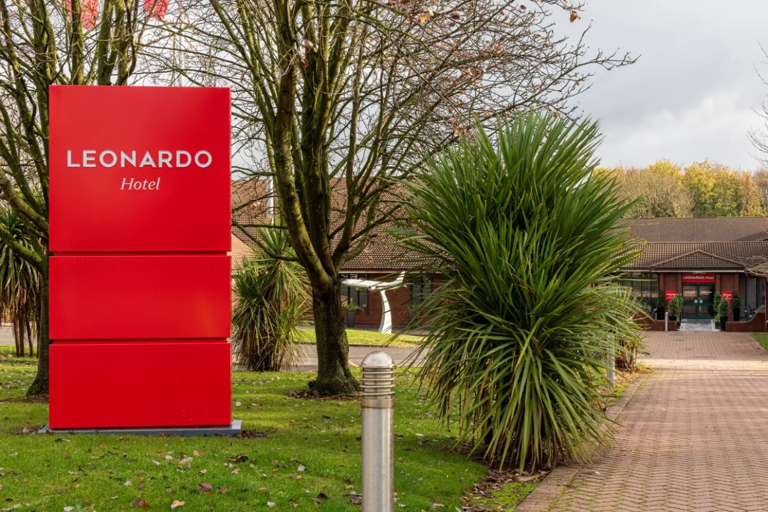
Augusta Roxana Toth (2226559)
word count:1823

May 20, 2025
BMIH6003
Hotel Placement – Managing Guest Service
Operations
LEVEL 6 Module Lead: LIsa Bassler

During my placement at Leonardo Hotel East Midlands Airport, I had the opportunity to work in the Housekeeping Department, which gave me a first-hand understanding of how crucial this area is to the overall guest experience. Housekeeping is much more than just cleaning rooms, it’s about maintaining high hygiene standards, presentation, and comfort throughout the hotel (GoAudits, 2025). From preparing guest rooms to managing laundry services and assisting with lost and found items, I quickly learned how much goes on behind the scenes to keep everything running smoothly. I also saw how closely the housekeeping team works with other departments, especially the front desk, to ensure rooms are ready on time, particularly during busy check-in and check-out periods. This experience helped me appreciate the vital role housekeeping plays in meeting brand expectations and contributing to overall guest satisfaction.

While working at Leonardo Hotel East Midlands Airport, I was part of the housekeeping team, which included room attendants, supervisors, and a department manager. The team worked together to look after 164 guest rooms (Leonardo Hotel, 2025) , meeting rooms, and all the public areas in the hotel.
During my time there, I set myself three main learning goals:
- First, I wanted to understand how the housekeeping department runs day to day, like how tasks are given out, how rooms are checked, and how shifts are organised (E360, 2024).
- Second, I wanted to get better at managing my time and paying attention to detail, especially while helping to clean and prepare rooms to the hotel’s standards (Indeed, 2025).
- Lastly, I wanted to improve my communication and teamwork by working with other departments like maintenance and reception to make sure guests were happy and any problems were sorted quickly.

As a Housekeeping Assistant, I got to do real tasks like cleaning rooms, changing beds, and restocking supplies. I also had the chance to watch how the supervisors led the team, solved problems, and kept everything running smoothly. This helped me understand how important leadership and teamwork are in a busy hotel environment.

Section 1: Role Reflection

Looking back on my experience at Leonardo Hotel East Midlands Airport, I noticed that good delegation from supervisors really helped the team stay on track and meet deadlines. However, I also saw that when communication wasn’t clear, it sometimes led to delays and unhappy guests. One example was when a family requested an extra cot for their baby. The supervisor, unfortunately, misunderstood the room number and arranged for an extra bed to be placed in a different room. When the family arrived and found no cot in their room, they were understandably upset. The team had to act quickly to fix the mistake, but the initial error affected the guests' first impression.
Another situation involved a guest who asked the reception team to arrange a small surprise for someone’s birthday. However, due to poor coordination and a mix-up with dates, the surprise was delivered to the wrong room. As a result, the intended guest didn’t receive anything on their special day, which caused disappointment.
These experiences made me realise just how crucial clear communication is between departments and how even small mistakes can have a big impact on guest satisfaction. It also showed me the value of double-checking information and confirming guest requests carefully. I’ve learned that while problems can happen, how the team responds and how well they communicate can make all the difference in resolving the issue professionally.
To improve, I want to focus on developing my communication skills. I plan to attend workshops and practice speaking more clearly and confidently. I also want to learn more about problem-solving by shadowing supervisors and thinking about how they handle different challenges. Taking on more responsibility during shifts will also help me prepare for future roles in hospitality.

While working in the Housekeeping Department, I saw how important leadership, teamwork, and following rules are to keeping the hotel running smoothly. I also saw how the workplace culture and quality of service really affect both staff performance and guest satisfaction. These observations have motivated me to keep learning and growing in this field (Herrity, 2025).

Section 2: Management Performance & Guest Service Analysis
- Management Styles and Staff Motivation

From my first day at Leonardo Hotel East Midlands Airport, I started to notice how different management styles affected the team. Our regular housekeeping supervisor used a mix of democratic and transformational leadership. During the morning briefings, she always asked for our feedback and created a friendly atmosphere where we felt comfortable speaking up. This reminded me of what I learned in the Management & Organisational Behaviour module, how involving staff in decision-making can help increase motivation and improve team performance (Las de Bruin, 2020).

One example was when a room attendant suggested a quicker way to organise the cleaning trolley to save time on busy days. The supervisor listened and gave it a try. It helped us work faster, and it made the team feel like our ideas were valued and taken seriously.

However, I also experienced a different style during a weekend shift with a temporary manager. He gave strict instructions without asking for any input or feedback. The atmosphere became tense, and most of the team stayed quiet. I noticed that we were less motivated and worked more slowly than usual. This showed me how important leadership style is not just for getting the job done, but for keeping morale high and making sure the team works well together.

- Health & Safety Compliance
Health and safety were a key focus during my placement in the Housekeeping Department at Leonardo Hotel East Midlands Airport. Before I started, I received training on how to use cleaning chemicals safely and how to lift and carry heavy items correctly. The training followed COSHH (Control of Substances Hazardous to Health Regulations 2002) guidelines, and it made me feel more confident doing my daily tasks. All chemicals were clearly labelled and stored in locked cupboards. We were also given gloves and masks when using stronger cleaning agents, which is standard practice in the industry (Morrison, 2023).

Manual handling was another important part of the training. I had to lift heavy laundry bags and move furniture during deep cleans, so I always used safe lifting techniques to avoid injury.
One situation that made me aware of the health risks involved was when we had a guest with asthma and breathing difficulties staying in the hotel. We were told to avoid using strong-smelling cleaning chemicals near their room. Instead, we used milder products and made sure the room was well-ventilated. This showed me how important it is to think about the specific needs of guests and how using certain products can affect someone’s health. It made me realise that health and safety isn’t just about staff, it’s also about protecting the well-being of our guests (Parkinson-Ramsbottom, 2025).

3. Marketing and Guest Experience

Even though housekeeping isn’t directly linked to marketing, it plays a big role in the guest experience, which is a form of indirect marketing. At Leonardo Hotel, the team understood the importance of small touches that create a memorable stay. For example, if we noticed a guest was celebrating a special occasion, like a birthday or anniversary, the supervisor might ask us to leave a handwritten note or arrange towels into a heart shape on the bed. These small gestures often led to positive reviews and return visits, which ties into what I learned in the Hospitality & Guest Services module (Wider et al., 2024).

We were also encouraged to report any issues we spotted in the rooms, like broken lights or missing amenities, so they could be fixed before guests arrived. This helped maintain the hotel's standards and prevent complaints. The cleanliness and appearance of rooms are one of the first things guests notice, and I realised that housekeeping staff play a huge role in brand image and guest satisfaction.

Section 3: Three-Step Guest Service Improvement Plan

1. Real-Time Room Status Updates
One improvement would be connecting the housekeeping team’s mobile devices directly to the Opera PMS system. This would let staff update room status straight after cleaning or inspection, so the front desk can see which rooms are ready in real time. I noticed that delays sometimes happened because the reception didn’t know if a room was clean yet. This kind of update would help avoid those situations, especially during busy check-in times.
A clear example of why this is important happened when a guest arrived from the airport after 3:00 p.m., clearly tired and expecting to check in right away. However, the system still showed their room as dirty, even though it had already been cleaned. An hour later, the status still hadn’t been updated, and the guest became upset and stressed. The duty manager eventually took them to the room and confirmed it was actually ready. Because of the delay and confusion, the hotel had to offer them dinner vouchers as compensation. This situation could have been avoided with real-time updates, saving both time and guest frustration.

2. Better Shift Scheduling
Another improvement is adjusting housekeeping shifts, so more staff are working during the busiest hours, mainly between 11:00 a.m. and 3:00 p.m., when guests are checking out and rooms need to be cleaned quickly. During my placement, I saw that not having enough staff during these peak hours caused delays and stress. Changing the schedule would make things more efficient and also help staff manage their workload better.

3. Daily Briefings with Priorities
Finally, having short daily meetings before each shift would help the team stay organised. These briefings should cover which rooms are top priority like VIP guests or early check-ins, and any special requests. During my placement, I saw that sometimes rooms for VIPs weren’t cleaned first, which led to complaints. A quick daily update would make sure everyone knows what needs to be done first.

My time in the Housekeeping Department at Leonardo Hotel East Midlands Airport was a valuable and eye-opening experience. I learned how important time management, teamwork, and attention to detail are in delivering high-quality service to guests. I also saw how much leadership style and communication can influence staff motivation and the overall atmosphere within the team.

This placement helped me connect what I’ve learned in class to real situations. I improved my technical skills, learned to meet the hotel’s cleanliness standards, and grew more confident in my role. At the same time, I became more aware of the areas I still need to work on, especially improving my communication and assertiveness, which I aim to develop through future training and experience.

Overall, working in housekeeping gave me a solid foundation for my future in hospitality. It showed me how every task, no matter how small, plays a role in shaping the guest experience and the hotel's reputation. I’ll take these lessons with me as I continue to grow in this industry.

References
- Go Audits (2025) How to Optimize Housekeeping Management in the Hotel Industry (Tips, Tricks & Checklists). Available at: https://goaudits.com/blog/hotel-housekeeping-management/ (Accessed 20 May 2025).
- Leonardo Hotel (2025) Leonardo Hotel East Midlands Airport. Available at: https://www.leonardohotels.co.uk/east-midlands/leonardo-hotel-east-midlands-airport/ (Accessed 20 May 2025).
- E360 (2024) Hotel Housekeeping Duties and Responsibilities: Essential Guide. Available at: https://e360hospitality.com/hotel-operations/hotel-housekeeping-comprehensive-guide/ (Accessed 20 May 2025).
- Indeed (2025) 45 Time Management Performance Review Phrases To Use. Available at: https://www.indeed.com/career-advice/career-development/performance-review-time-management/ (Accessed 20 May 2025).
- Petty, L. (2023) What is the Importance of Effective Communication in the Hospitality Industry? Available at: https://www.highspeedtraining.co.uk/hub/communication-in-the-hospitality-industry/ (Accessed 21 May 2025).
- Herrity, J. (2025). 10 Strategies to Effectively Promote Your Professional Growth. Available at: https://www.indeed.com/career-advice/career-development/professional-growth/ (Accessed 20 May 2025).
- Lars de Bruin (2020) Hersey and Blanchard Situational Leadership Model: Adapting the Leadership Style to the Follower. Available at: https://www.business-to-you.com/hersey-blanchard-situational-leadership-model/ (Accessed 21 May 2025).
- Morrisson, S. (2023) Employees Responsibilities for COSHH – A Complete Guide. Available at: https://humanfocus.co.uk/blog/employees-responsibilities-for-coshh-a-complete-guide/ (Accessed 21 May 2025).
- Parkinson-Ramsbottom, H. (2025) Guide to COSHH regulations in the UK for employers. Available at: https://www.brighthr.com/articles/health-and-safety/coshh/ (Accessed 21 May 2025).
- Bouke, J. (2016) The six signature traits of inclusive leadership. Available at: https://www2.deloitte.com/us/en/insights/topics/talent/six-signature-traits-of-inclusive-leadership.html/ (Accessed 21 May 2025).
- Wider, W., Foong Ping Tan, Yen Ping Tan, Lin, J., Muhammad Ashraf Fauzi, Ling Shing Wong, Cloyd, J. and Syed (2024) Service quality (SERVQUAL) model in private higher education institutions: A bibliometric analysis of past, present, and future prospects. Social Sciences & Humanities Open, 9, pp.100805–100805. Available at: https://www.sciencedirect.com/science/article/pii/S2590291124000020/ (Accessed 21 May 2025).
- Kandampully, J., Zhang, T. and Bilgihan, A. (2015) Customer loyalty: A review and future directions with a special focus on the hospitality industry. Available at: https://www.researchgate.net/publication/275333939_Customer_loyalty_A_review_and_future_directions_with_a_special_focus_on_the_hospitality_industry/ (Accessed 21 May 2025).
- Lacalle, E. (2024) What are PMS integrations and why are they important? Available at: https://www.mews.com/en/blog/pms-integration/ (Accessed 21 May 2025).

