Machine Learning Model
Artificial Intelligence and Machine Learning (ACCA6011)
Jonathan Wilcox (2206641)

Abstract
This study applies supervised and unsupervised machine learning techniques to predict player engagement and uncover behavioural patterns using the Predict Online Gaming Behaviour dataset, which includes demographic, behavioural, and progression-related features for 40,034 players. Two supervised models—Decision Tree and Support Vector Machine (SVM)—were developed to classify players into High, Medium, and Low engagement levels, with a focus on identifying Low-engagement players at risk of churn. After hyperparameter and threshold tuning, the SVM achieved the strongest performance, correctly identifying 90% of Low-engagement players and demonstrating a high AUC-ROC score for separating Low from Not-Low users. Unsupervised methods, including K-Means and Agglomerative Clustering, revealed three meaningful behavioural groups characterised by session duration and purchasing activity. These insights provide a deeper understanding of player behaviour that complements the predictive models. Overall, combining supervised prediction with behavioural segmentation offers a practical framework for early churn detection, targeted retention strategies, and data-driven game design decisions.

Table of Contents
Abstract 1
List of Figures 3
Abbreviations 5
1. Introduction 6
2. Literature Review 7
3. Problem Statement 10
4. Methodology 11
4.1 Data Preprocessing 11
4.2 Supervised Machine Learning Models 12
4.2.1 Support Vector Machine (SVM) 12
4.2.2 Decision Trees 13
4.3 Evaluation Metrics 14
4.4 Hyperparameter Tuning 15
4.5 Unsupervised Learning 16
5. Results and Discussion 17
5.1 Data Investigation 17
5.2 Supervised Model Performance 18
5.3 Unsupervised Clustering Results 22
5.4 Supervised vs Unsupervised Learning 25
6. Business Recommendations 27
7. Conclusion 28
References 29

List of Figures
Figure 1. Split Data into train and test 23
Figure 2. SVM Model, with train and test outputs 23
Figure 3. Decision Tree model, with train and test outputs 23
Figure 4. Function to display confusion matrix and classification report 23
Figure 5. Hyperparameter Tuning on SVG model 23
Figure 6. Elbow plot to identify suitable number of clusters for algorithm 23
Figure 7. Correlation Analysis Between Numerical Features 23
Figure 8. SVM Classification Report and Confusion Matrix 23
Figure 9. ROC Curve for the Tuned SVM Model 23
Figure 10. SVM Model Test Results After Threshold Tuning 23
Figure 11. Decision Tree Train Data Results 23
Figure 12. Decision Tree Classification Report and Confusion Matrix 23
Figure 13. ROC Curve for the Tuned Decision Tree Model 23
Figure 14. Elbow Method Showing 3 Clusters are Optimal 23
Figure 15. Silhouette Score Confirming 3 Clusters are Optimal 23
Figure 16. Grouped Bar Chart of Cluster Behaviours (K-Means) 23
Figure 17. Grouped Bar Chart of Cluster Behaviours (Agglomerative Clustering) 23

Abbreviations
Abbreviation | Full Term
ML | Machine Learning
SVM | Support Vector Machine
K-Means | K-Means Clustering
AHC | Agglomerative Hierarchical Clustering
RBF | Radial Basis Function
AUC-ROC | Area Under the Receiver Operating Characteristic Curve

1. Introduction
Player engagement is a crucial factor in the success of online games, directly impacting retention and long-term profits. This study uses the Predict Online Gaming Behaviour dataset, which contains demographic player behaviour metrics and an engagement label for each player. The data is used to predict player engagement and for behavioural analysis.
The aim of this project is to apply both supervised and unsupervised machine learning methods to help understand the player base and player engagement. Two supervised models are used: Decision Trees and Support Vector Machines (SVMs). These models are designed to categorise players into High, Medium, and Low engagement levels, with a focus on identifying Low-engagement players who may be at risk of leaving. Hyperparameter tuning and evaluation metrics are used to assess and improve model performance.
Unsupervised methods, including K-Means and Agglomerative Clustering, are then applied to find behavioural groups/clusters within the player base. These clusters provide insight into different player types and can inform targeted retention techniques, marketing strategies, and adjustments to game design.
By comparing the outputs of both supervised and unsupervised approaches, the study gives recommendations that help the business improve engagement.

2. Literature Review
Machine learning involves the creation of algorithms capable of recognising patterns and making predictions, enabling automatic analysis within a data-driven environment [1]. Within game analytics, these techniques have become increasingly important for identifying behavioural patterns that support business decision-making, such as detecting players at risk of leaving or personalising the player experience based on their past behaviours. These techniques can also enhance customer satisfaction and contribute to long-term retention. Recent research examining gamer behaviour shows that machine learning can significantly enhance a business's ability to understand and adapt to player behaviour, ultimately improving retention and long-term game profits [2].
Supervised learning is a type of machine learning where a model learns from labelled data, identifying how features within the dataset relate to the correct output, allowing it to make future predictions [3]. This makes supervised methods particularly suited for prediction tasks such as predicting engagement classification in games. Common supervised learning methods include Decision Trees, which split data into branches based on simple decision rules, Support Vector Machines (SVMs), which find the boundaries between classes and often perform well on non-linear data and Linear Models, which provide quick and effective predictions by assuming a linear relationship between features and the target variable [4], [5].
In gaming analysis, supervised learning has been demonstrated to be highly effective for behavioural prediction. Runge et al. used a SVM model to predict player churn in mobile games. They demonstrated that SVM models achieved significantly higher accuracy than logistic regression and decision tree approaches, particularly in identifying players at risk of leaving [6]. This study shows that supervised algorithms, such as SVMs, can detect patterns earlier, allowing organisations to intervene early and apply retention strategies to retain their player base.
Pedersen et al used a Decision Tree model to predict player preferences in a platform game. The paper showed how Decision Trees could successfully predict which game levels players preferred and were most likely to enjoy based on behavioural features such as movement patterns, completion time, and interaction style [7]. This study highlights the value of Decision Trees in game design, revealing that models can provide deep insight into player preferences and help game developers produce game content for different types of players.
Unsupervised learning refers to machine learning methods that interpret unlabelled data to discover hidden patterns, structures, or groupings within the dataset [8]. Unlike supervised learning, where models learn from labelled examples, unsupervised algorithms explore the data to identify relationships between features. This makes unsupervised learning especially suitable for gaming datasets, which often contain a wide range of behavioural features that can reveal meaningful player behavioural patterns.
A commonly used unsupervised learning model is K-Means Clustering, which groups players into classes by minimising the distance between individuals and the cluster's central point (centroid) [9]. Drachen et al. applied K-Means to analyse the behaviour of approximately 70,000 players in a video game and identified distinct playstyle clusters such as "Completionists," "Speed runners," and "casual". The study demonstrated that K-Means can reveal behavioural groups that are not visible through traditional analysis and can provide valuable insights into how different types of players interact with a game [10].
Another commonly used method is Agglomerative Hierarchical Clustering (AHC). This algorithm builds clusters step-by-step by repeatedly merging the closest data points [11]. In relation to a gaming dataset, this method can help reveal how players interact with one another, producing a hierarchy of player features. Unsupervised methods can help game developers and businesses understand the patterns of their player base, enabling them to personalise game design and targeted marketing campaigns.
Supervised and unsupervised learning offer different but complementary strengths for game analytics. Supervised methods are used when labelled data is available, allowing models to learn player behaviours and known outcomes, for example, engagement levels. Unsupervised models can explore unlabelled data to uncover groupings and hidden patterns within the player base, providing a deeper understanding of underlying player behaviour. Using both techniques together enables analysts to predict future outcomes of a player base and also identify behavioural patterns that could impact player engagement.
Evaluation metrics play a crucial role in determining the effectiveness of machine learning models. Making accurate predictions is especially important in this study, as incorrect outputs could lead to poor business decisions and a potential loss of players. Metrics such as accuracy, precision, recall, and F1-score help assess how well supervised learning models are performing [12]. While all metrics have significance, recall is especially important in this study because identifying low-engagement players is essential for the business. Failing to detect these individuals may result in players becoming inactive, leading to reduced engagement and financial loss. For unsupervised learning, metrics such as the Silhouette Score and inertia help evaluate how well-separated and cohesive behavioural clusters are. These measures ensure that the clusters reflect meaningful behavioural differences rather than random groupings, enabling more reliable insights into player behaviour.
The insights gained from the reviewed literature inform the aims and methodology of this study, where the main objective is to apply supervised and unsupervised machine learning techniques to predict engagement levels and uncover behavioural patterns within the player dataset.

3. Problem Statement
Understanding and predicting player engagement is crucial for a gaming company, as maintaining an active player base has a direct impact on profit. Research shows that increased engagement leads to higher retention and sustained income in games [2]. In this project, player engagement is categorised into three levels: High, Medium, and Low, making this a multiclass classification problem. Accurately identifying Low-engagement players is particularly important, as they are the group most likely to become inactive, resulting in financial loss.
The dataset includes demographic features and behavioural variables such as playtime, session frequency, achievements, and purchase activity, all of which contribute to predicting engagement. The primary challenge is correctly identifying Low-engagement players, with a priority on achieving high recall to ensure that at-risk users are detected early. Recall is particularly important in this study because it measures how many of the actual low-engagement players the model successfully identifies, reducing the risk of losing players without intervention.
Alongside predicting engagement levels, the project also aims to understand behavioural patterns within the player base. Revealing underlying trends will help the business make marketing decisions and apply interventions to help retention. Previous research has demonstrated that clustering is effective in identifying player types and enhancing tailored experiences [14].
Overall, this project aims to address the issue of player disengagement by developing models that accurately predict engagement levels and identify behavioural patterns using a combination of supervised and unsupervised learning methods.

4. Methodology
This section outlines the methodology used in the study, including data preprocessing, supervised modelling, hyperparameter tuning, model evaluation, and unsupervised clustering.

4.1 Data Preprocessing
Machine learning models require a clean and well-prepared dataset to work efficiently. The original dataset contained multiple feature types, including numerical and categorical variables and a target variable (EngagementLevel).
The PlayerID feature is a unique identifier and does not help machine learning algorithms, so it was removed. An initial exploratory analysis was then conducted to understand the dataset's structure and identify any potential issues that could impact model performance. This included examining feature distributions, checking for outliers, and confirming that all variables were in the correct formats. No missing values were identified, and no errors were found within the dataset. A correlation analysis was also conducted to explore relationships between numerical features; however, no strong correlations were identified that required transformation.
Categorical variables were encoded into numerical features to ensure compatibility with machine learning algorithms, which require numerical inputs. Numerical variables were standardised using z-score scaling to ensure that all features contributed equally to the algorithms; this is particularly important for algorithms such as K-Means and SVMs that are sensitive to feature size [15].
Following the data preparation steps, the dataset was split into training and testing sets to help with model evaluation. A 70%–30% split was used, allocating 70% of the data for training and 30% for testing, a commonly used split with machine learning algorithms [16].
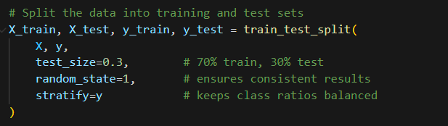
Figure 1. Split Data into train and test

4.2 Supervised Machine Learning Models
Two supervised models were implemented: a Decision Tree and a Support Vector Machine (SVM).

4.2.1 Support Vector Machine (SVM)
A Support Vector Machine (SVM) is a supervised learning model used for classification by finding the best boundary that separates different classes [17]. An SVM model with three kernels: linear, polynomial, and Radial Basis Function (RBF) was initially tested to determine which configuration worked best with the dataset. Kernel selection is a crucial step because different kernels capture distinct types of relationships within the data. The linear kernel is effective when the data can be separated with a straight line; the polynomial kernel can detect more curved relationships. The RBF kernel is well-suited for complex datasets and can model a wide range of non-linear patterns
[17]. After testing all three, the RBF kernel showed the best performance and was selected for further tuning to optimise the results.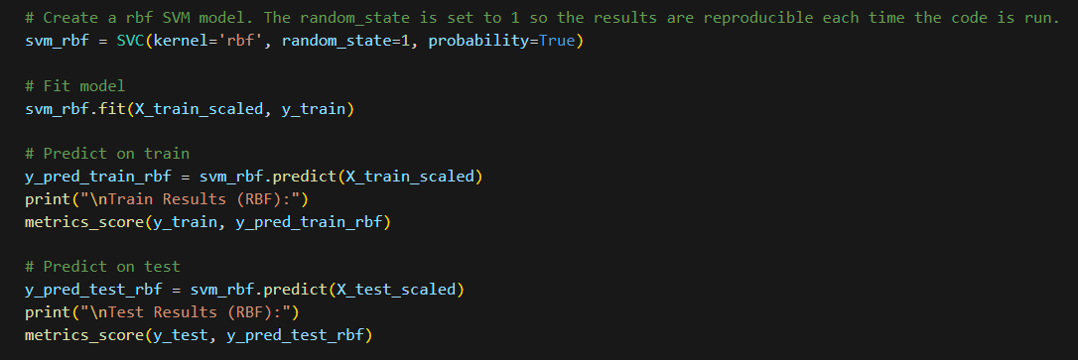
Figure 2. SVM Model, with train and test outputs

4.2.2 Decision Trees
A Decision Tree is a supervised learning model that makes predictions by asking a series of simple yes/no questions based on the input features. Decision Trees work by splitting the data into smaller groups based on the most valuable features, forming a tree-like structure where each final branch represents a prediction [18]. One advantage is interpretability, as the tree provides a clear picture of how the model makes decisions. However, Decision Trees can easily overfit, especially if the tree becomes too deep or the data is noisy [19]. To avoid overfitting, the Decision Tree was tuned to reduce this issue and provide a good comparison model to the SVM.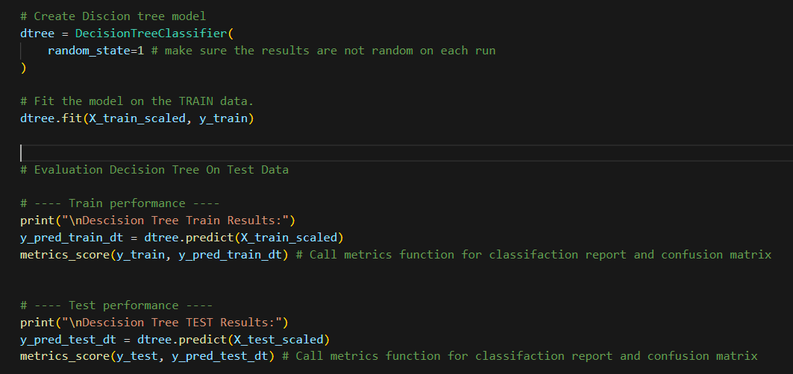
Figure 3. Decision Tree model, with train and test outputs

4.3 Evaluation Metrics
Accurate evaluation is essential to test how the models are performing, as the results determine how useful the predictions are for business decision-making. A number of evaluation metrics were used to assess each model performance. A confusion matrix and classification report were used to display the results. Accuracy gives an overall measure of correct predictions, while precision and recall show how well the model identifies each class. Recall is particularly important in this study because the business must detect low-engagement players early, missing them could result in reduced activity or player loss. The report has a strong focus on recall when comparing model performance. Incorrectly identifying a highly engaged player as low has far less impact than misclassifying a low-engagement player as highly engaged. The F1-score provides a combined measurement of both precision and recall.
Also a ROC Curve (AUC-ROC) was used to evaluate how well the model separates Low from Not-Low engagement players. These metrics together provide a strong assessment of the model’s overall performance.
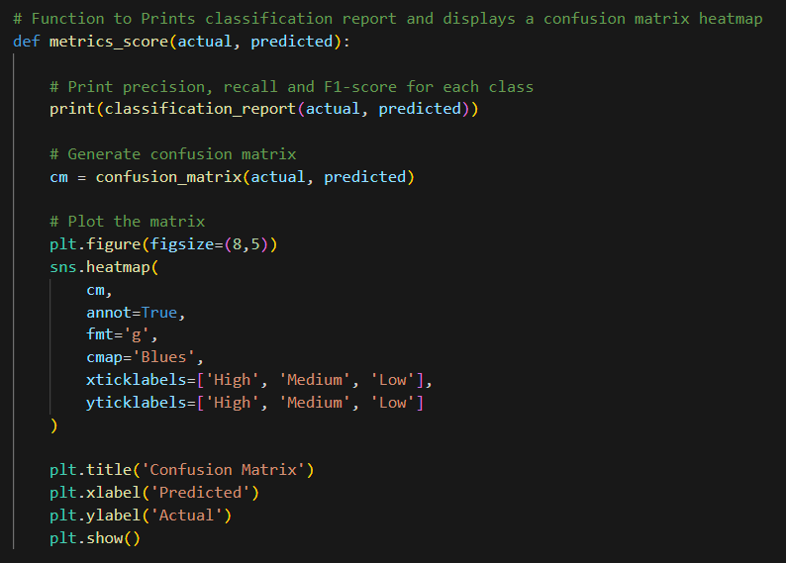
Figure 4. Function to display confusion matrix and classification report

4.4 Hyperparameter Tuning
Hyperparameter tuning was performed to improve model performance by finding the best parameter settings. This was done using Grid Search, which attempts multiple combinations of hyperparameters and selects the configuration that produces the best results [20]. For the SVM, parameters such as C and gamma were tested across multiple combinations. For the Decision Tree, parameters such as max_depth and min_samples_split were altered to reduce overfitting and improve performance. Overall, tuning helped both models produce better predictions, especially in terms of recall.
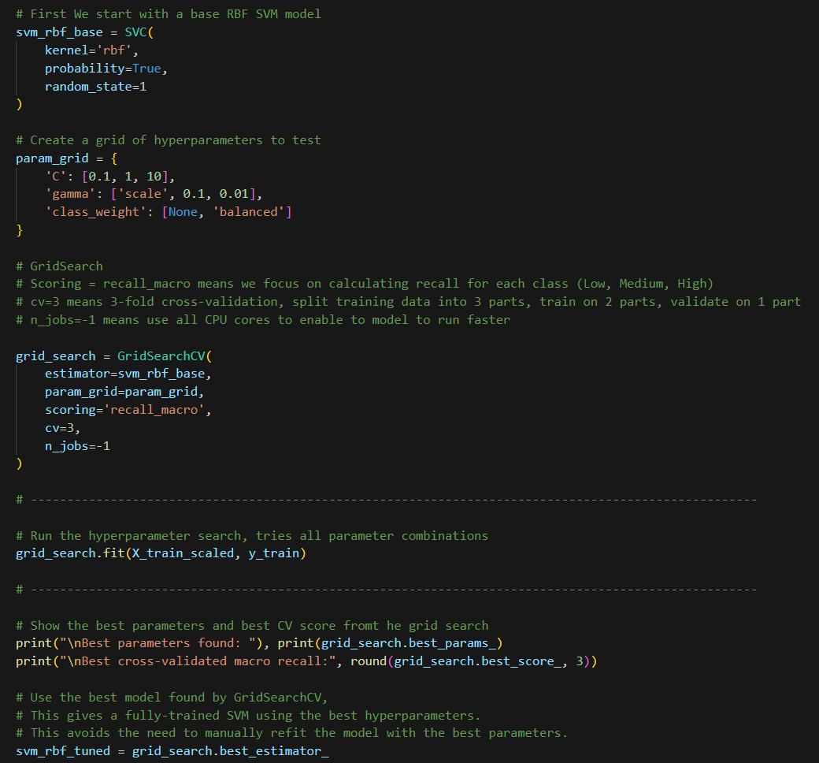
Figure 5. Hyperparameter Tuning on SVG model

4.5 Unsupervised Learning
Unsupervised learning was used to explore behavioural patterns within the data. Two methods were applied: K-Means and Agglomerative Clustering. K-Means groups players based on similarity, using distances to cluster centroids. The elbow method and silhouette scores were used to indicate the number of suitable clusters. Agglomerative Clustering was also used for comparison. It starts by treating each player as their own group and then joins the closest groups step by step. These unsupervised methods provided a more in-depth understanding of how players interact with the game, complementing the supervised models by revealing patterns within the player base.
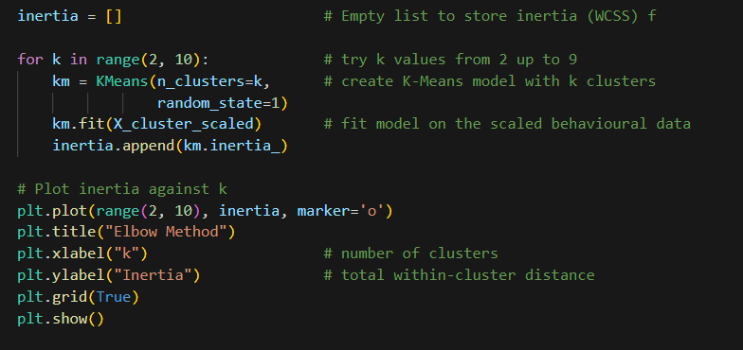
Figure 6. Elbow plot to identify suitable number of clusters for algorithm

5. Results and Discussion
This section presents the results of the supervised and unsupervised models and explains their importance for business decision-making. Because one of the main goals is to identify players at risk of disengagement, recall for the Low-engagement class is a key metric, as missing these players is likely to result on financial loss and a smaller player base.

5.1 Data Investigation
Initial data investigation revealed that the dataset was whole, with no missing values across the 40,034 records. Numerical and categorical features were clearly defined, and irrelevant fields such as player number were removed before analysis. Behavioural features such as session duration, weekly activity, and player progression showed clear differences between engagement groups, while demographic features for example gender, location and difficulty had little influence on engagement.
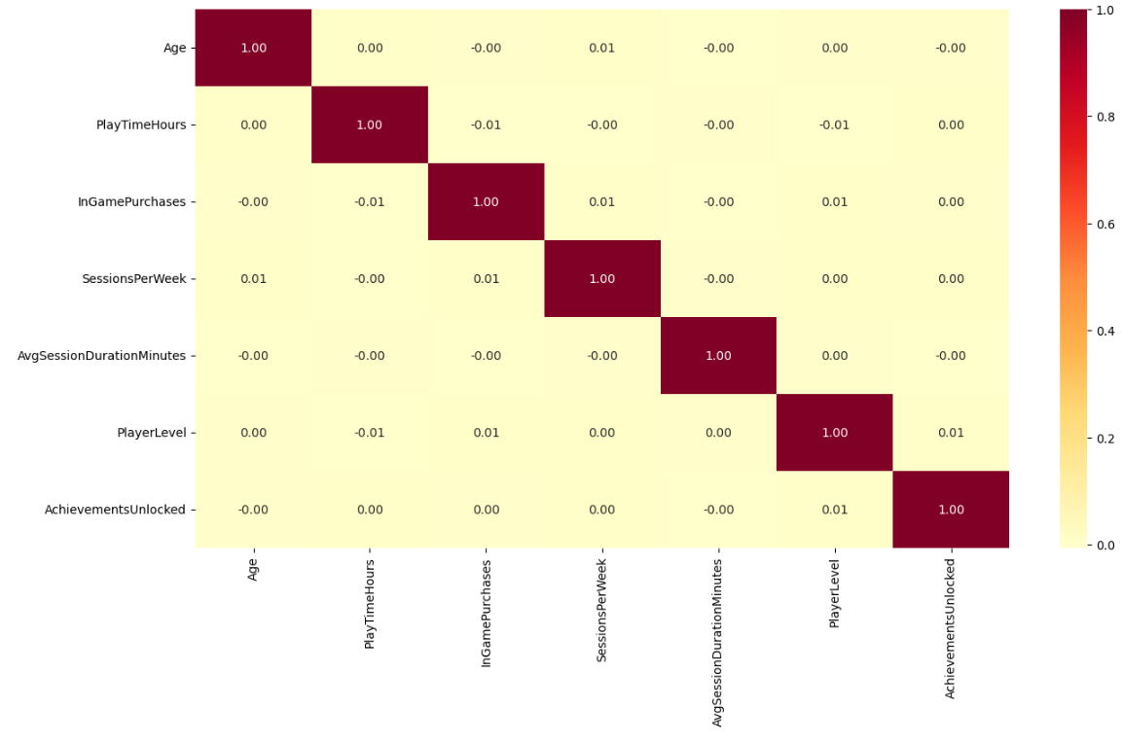
Figure 7. Correlation analysis between numerical features
Correlation analysis also showed no strong relationships between numerical features, suggesting that engagement is mainly influence by behaviour features. These findings helped identify which features were most important for the modelling.

5.2 Supervised Model Performance
Both supervised models, SVM and Decision Tree were evaluated using Accuracy, Precision, Recall, F1-score, and AUC-ROC. Each model produced strong results, the SVM model was slightly better than the Decision Tree, particularly when predicting the Low-engagement class.

The SVM showed higher Recall for Low-engagement players, which is the most important metric for this project. The untuned SVM achieved a Recall of 0.85 for the Low-engagement class, meaning it correctly identified 85% of at-risk players. After hyperparameter tuning, this improved to 0.89, indicating that the tuned model correctly detected 89% of actual Low-engagement players.

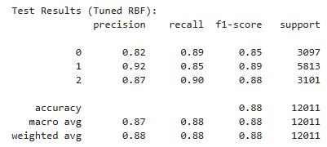

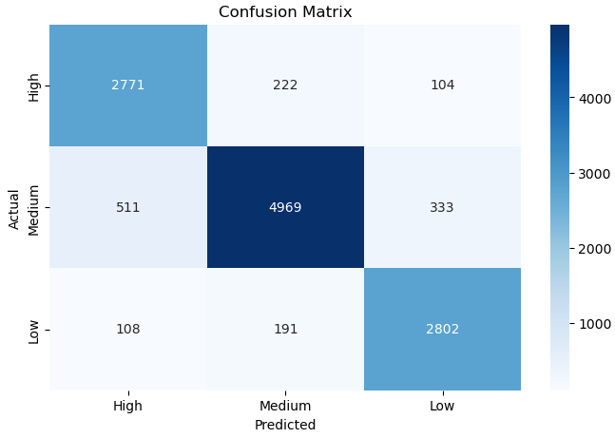
Figure 8. SVM Classification Report and Confusion Matrix

Although overall Accuracy decreased slightly after tuning, the model still achieved a strong test Accuracy of 0.88, showing good generalisation to unseen data. Training and test performance were also similar, confirming that the model is not overfitting. The tuned SVM achieved an AUC-ROC score of 0.94, showing a strong ability to distinguish between Low and Not-Low engagement players.

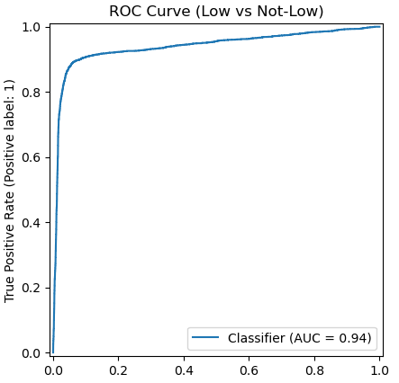

Figure 9. ROC curve for the tuned SVM model

In addition to hyperparameter tuning, adjusting the decision threshold further improved the SVM’s performance when predicting Low from Not Low engaged players. After threshold tuning, the model accomplished a Low-class Recall of 0.90 on the test data, meaning it successfully identified 90% of players at risk of disengaging.

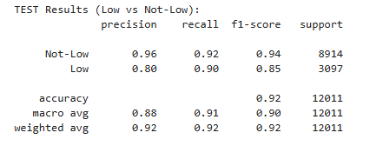
Figure 10. SVM model test results after threshold tuning

The Not-Low class also remained highly accurate, and overall test Accuracy increased to 0.92. These improvements demonstrate that threshold tuning played an important role in improving the model’s ability to detect low-engagement players.

In comparison, the Decision Tree initially delivered extremely high performance on the training data, achieving 100% Precision, Recall, and Accuracy for all classes. While this initially appeared impressive, this was a strong indication of overfitting, meaning the model memorised the training data rather than learning patterns. This issue was confirmed by the significantly lower performance on the test set, where Accuracy dropped to 0.83, with Recall values of 0.80 for Low, 0.85 for Medium, and 0.81 for High engagement players. These results show that the model struggled to generalise to unseen data.

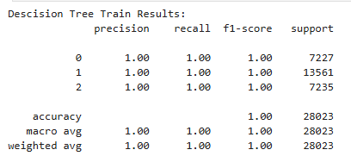
Figure 11. Decision Tree train data results

After parameter tuning. For example max_depth and min_samples_split, the Decision Tree showed much better generalisation. The tuned model achieved a test Accuracy of 0.91, with an improved Recall of 0.89 for the Low-engagement class and improvements across all categories.

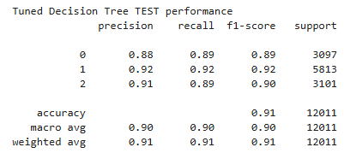

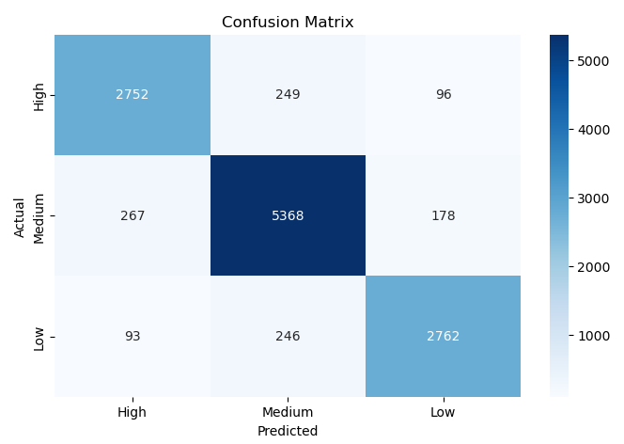
Figure 12. Decision Tree Classification Report and Confusion Matrix

A ROC curve with an AUC score of 0.93 further showed that the tuned Decision Tree is highly effective at separating Low from Not-Low players.
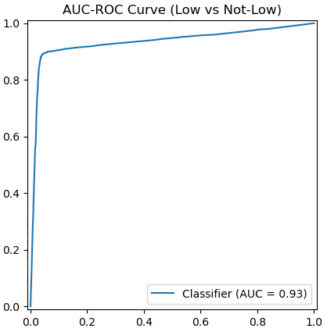

Figure 13. ROC Curve for the Tuned Decision Tree Model

Hyperparameter tuning played an important role for both models, and the use of grid search / Threshold tunning helped improve generalisation, increase recall for the Low-engagement class, and improved accuracy on the test data compared to base models.
Although the tuned Decision Tree achieved better Accuracy and trained faster than the SVM, the SVM proved to be the more reliable model. Its higher recall for Low-engagement players, stronger generalisation to unseen data, and slightly superior AUC-ROC score make it the best choice for identifying at-risk players in this project and for helping business decision-making.

5.3 Unsupervised Clustering Results
The unsupervised analysis provided additional insight into player behaviour outside the labelled engagement classes. K-Means clustering was used to discover natural behavioural patterns within the player base. Before fitting the model, the elbow method and silhouette score were applied to determine an appropriate number of clusters.
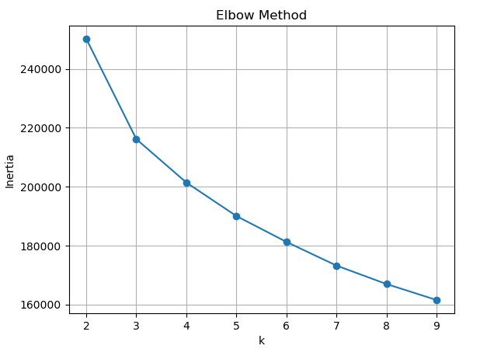
Figure 14. Elbow Method Showing 3 Clusters are Optimal
The elbow plot showed a clear point at k = 3, where the reduction in inertia began to level off, indicating that additional clusters would not significantly improve separation.
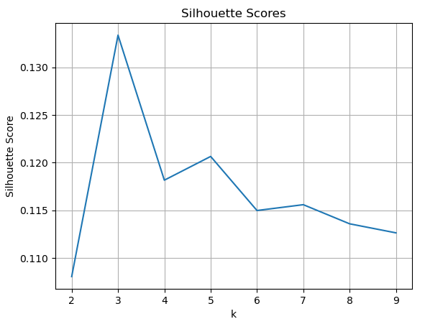
Figure 15. Silhouette Score Confirming 3 Clusters are Optimal
The silhouette score also reached its strongest value at k = 3, indicating that the data naturally forms three defined groups.
Once the final model was fitted, the results were analysed using a horizontal grouped bar chart that compared average behavioural features across the three clusters.
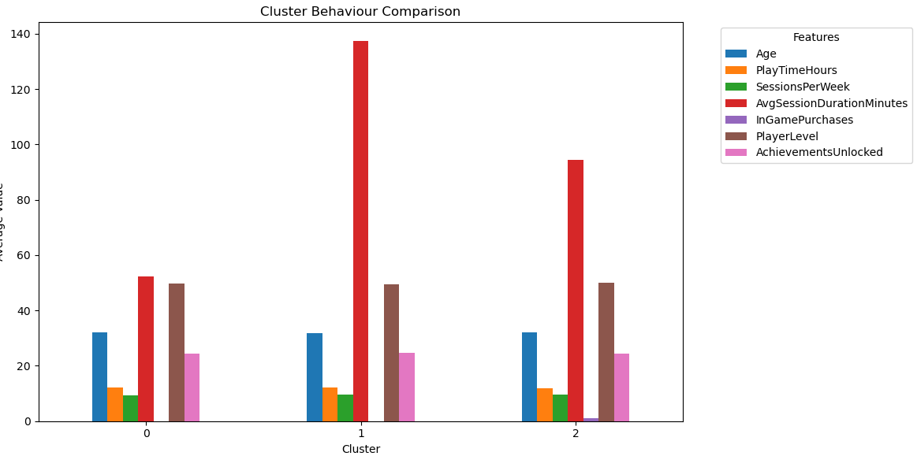
Figure 16. Grouped Bar Chart of Cluster Behaviours (K-Means)
The chart shows that most features Age, SessionsPerWeek, PlayerLevel, AchievementsUnlocked, and PlayTimeHours are very similar across all clusters. This indicates that these variables do not strongly influence how the model separates players. Only two features show noticeable variation: Average Session Duration and InGamePurchases. Based on this analysis, the cluster can be defined as:
Cluster 0: Short Session Casual Players
Players in Cluster 0 play the shortest sessions and do not make in-game purchases. Their behaviour is stable but low intensity, suggesting they are casual gamers who engage with the game briefly.
Cluster 1 – Long Session Immersive Players
Cluster 1 players stay in the game for significantly longer sessions than any other group. Although all other behaviours remain similar to the other clusters, their long session duration suggests deeper engagement, this group also does not make purchases.
Cluster 2 – Medium Session Players with Purchases
Cluster 2 has moderate session lengths but is the only cluster where purchases occur. These players do not have the highest activity levels but do bring additional income with in game purchases.
Overall, the clusters highlight three distinct behavioural patterns manly influenced by session duration and purchasing behaviour. These findings offer the business a useful information for tailoring content, promotions, or retention strategies for different types of player clusters.
To validate the findings from K-Means, Agglomerative Clustering was tested using the same number of clusters. The model produced three groups with similar behavioural patterns to K-Means, supporting the earlier conclusion that session duration and purchase activity are the main factors separating player clusters.
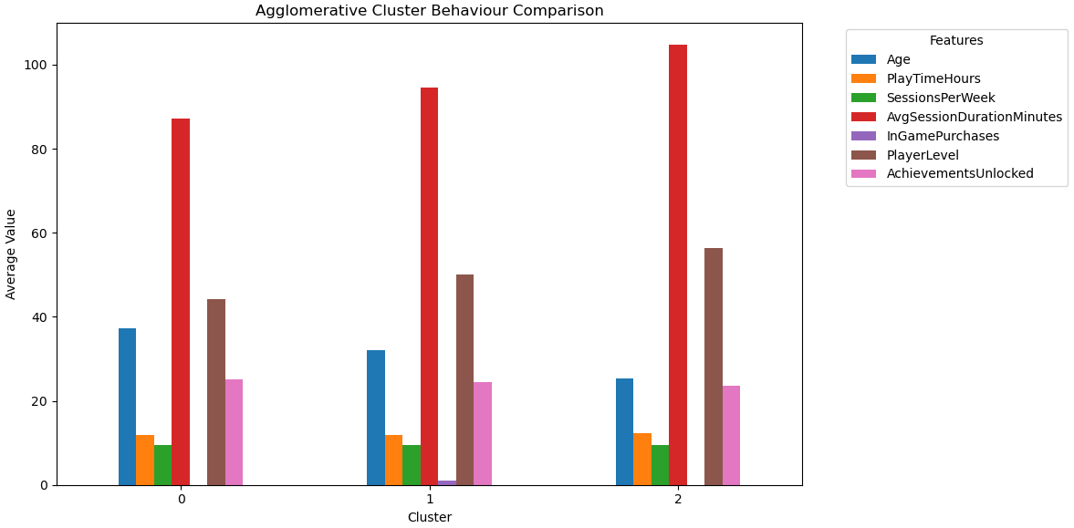
Figure 17. Grouped Bar Chart of Cluster Behaviours (Agglomerative Clustering)
However, unlike K-Means, this model also showed Age as another factor. Cluster 0 showed noticeably older players on average, while cluster 2 consisted of younger players. Other than this small difference, both clustering methods identified very similar behavioural groups.

5.4 Supervised vs Unsupervised Learning
Supervised and unsupervised learning each offer different advantages and limitations when analysing player engagement and behavioral patterns. Using both approaches together provides a more complete view of how players behave and how likely they are to stop playing.
Supervised learning, as identified by the SVM and Decision Tree models, is very effective for predicting player engagement levels when labelled data is available. Its main strength is the ability to identify at-risk players, with the SVM model performing exceptionally well. This makes supervised models helpful in determining where early intervention is needed to help with retention strategies. However, supervised learning is limited by its reliance on labelled data, meaning prediction quality depends on how accurately engagement levels are defined.
Unsupervised learning does not require labelled data and instead reveals behavioral patterns within the players. K-Means and Agglomerative Clustering both identified meaningful clusters, primarily around session duration, purchase activity, and age, providing insight into different user types, such as casual players, long-session players, and purchasers. This is useful for marketing, game content design, and personalised retention strategies. However, unsupervised learning has limitations; it cannot predict engagement level or the risk of players leaving. Additionally, cluster interpretation can be highly subjective, particularly when feature differences are minimal.
For player engagement, supervised learning is best for this prediction and will enable the business to identify which players may be at risk of leaving. Unsupervised learning is best for identifying segmentation, helping the company understand how behaviours vary across the player base. When combined, the two approaches complement each other, helping the business with decision-making.

6. Business Recommendations
By integrating predictive analytics with behavioural segmentation, the business can make better-informed decisions, improve retention strategies, and create a more personalised experience for players.
The unsupervised SVM model should be used to identify players who are at risk of low engagement. The business can then apply retention techniques such as targeted item promotions, difficulty adjustments, and personalised in-game events to help encourage these players and reduce churn. The model can also highlight highly engaged users, who are ideal candidates for upselling opportunities such as premium items or exclusive content.
Unsupervised learning techniques, such as K-Means and Agglomerative Clustering, should be used to segment the player base into meaningful behavioural groups. These clusters help the business understand why players behave the way they do and how each group prefers to interact with the game. For example, casual short-session players may benefit from simplified gameplay and early rewards, while long-session immersive players could be targeted with richer content and more challenging tasks. Players with purchasing patterns may respond well to personalised store offers, bundles, and loyalty programmes.
Combining these methods will allow the business to target groups more accurately. For example, a high-spending player identified as at risk may require more urgent or personalised attention.
Future development could analyse how the players' behaviour changes over time over the lifecycle of a game. This could inform future game design by understanding what motivates people. Additionally, more models could be tested to increase accuracy or identify different clusters within the data.

7. Conclusion
This study showed that combining supervised and unsupervised machine learning techniques can enhance the understanding of an online gaming player base and help inform business decision-making.
The SVM and Decision Tree models both performed well at predicting engagement levels, with the tuned SVM providing the most reliable results for identifying Low-engagement players. Its high recall and high AUC-ROC score make it well-suited for detecting at-risk players who may require intervention.
Unsupervised clustering added an additional insight by revealing three main behavioural groups based on session duration and purchase activity. Short-session casual players, long-session immersive players, and medium-session purchasers. These clusters can help the business tailor game content, promotions, and retention strategies. This will be even more useful when combined with supervised learning predictions.
Overall, combining predictive modelling with behavioural clustering offers a useful tool for reducing player churn, improving retention, and implementing targeted marketing and game design decisions. Future work could expand on this project by analysing trends over time and testing additional models to improve accuracy and identify further player clusters.

References
[1] W. Koehrsen, “What is Machine Learning? How I Explain the Concept to a Newcomer,” Medium [Online]. Available: https://medium.com/data-science/what-is-machine-learning-how-i-explain-the-concept-to-a-newcomer-d96f35a5c4f3. [Accessed: 20/11//2025].
[2] Melhart, D., Liapis, A., & Yannakakis, G. N. (2021). Towards General Models of Player Experience: A Study Within Genres. IEEE Conference on Computational Intelligence and Games, 01–08. https://doi.org/10.1109/CoG52621.2021.9618902
[3] IBM, “Supervised Learning,” IBM Think [Online]. Available: https://www.ibm.com/think/topics/supervised-learning. [Accessed: 20/11//2025].
[4] 1 Scikit-learn, “Supervised Learning Algorithms” scikit-learn [Online]. Available: https://scikit-learn.org/stable/supervised_learning.html[Accessed: 20/11//2025].
[5] Moez R, “Supervised Machine Learning” Data Camp [Online]. Available: https://www.datacamp.com/blog/supervised-machine-learning [Accessed: 22/11//2025].
[6] J. Runge, P. Gao, F. Garcin, and B. Faltings, “Churn prediction for high-value players in casual social games,” in Proc. IEEE Conf. Computational Intelligence and Games (CIG), Dortmund, Germany, 2014, pp. 1–8, doi: 10.1109/CIG.2014.6932875.
[7] C. Pedersen, J. Togelius and G. N. Yannakakis, "Modeling player experience in Super Mario Bros," 2009 IEEE Symposium on Computational Intelligence and Games, Milan, Italy, 2009, pp. 132-139, doi: 10.1109/CIG.2009.5286482.
[8] Géron, A. (2023). Hands-on machine learning with Scikit-Learn, Keras and TensorFlow : concepts, tools, and techniques to build intelligent systems (Third edition.). O’Reilly Media, Inc.
[9] Windland V, “What is k-means clustering?”,, IBM [Online]. Available: https://www.ibm.com/think/topics/k-means-clustering [Accessed: 23/11//2025].
[10] Drachen, A., Sifa, R., Bauckhage, C., & Thurau, C. (2012). Guns, swords and data: Clustering of player behavior in computer games in the wild. 2012 IEEE Conference on Computational Intelligence and Games (CIG), 163–170. https://doi.org/10.1109/CIG.2012.6374152
[11] babu p, “Agglomerative Hierarchical Clustering (AHC)”,, Medium [Online]. Available: https://medium.com/@prasanth32888/agglomerative-hierarchical-clustering-ahc-e9e7a48cb042 [Accessed: 23/11//2025].
[12] kashyap p, “Understanding Precision, Recall, and F1 Score Metrics”,, Medium [Online]. Available: https://medium.com/@piyushkashyap045/understanding-precision-recall-and-f1-score-metrics-ea219b908093 [Accessed: 23/11//2025].
[13] Óskarsdóttir, M., Gísladóttir, K. E., Stefánsson, R., Aleman, D., & Sarraute, C. (2022). Social networks for enhanced player churn prediction in mobile free-to-play games. Applied Network Science, 7(1), Article 82. https://doi.org/10.1007/s41109-022-00524-5
[14] M. H. Schiller, M. Schedl, A. Flexer, and S. G. Schulz, “Inside the Group: Investigating Social Structures in Player Groups and Their Influence on Activity,”IEEE Transactions on Games, vol. 11, no. 4, pp. 416 - 425, Dec. 2019, doi: 10.1109/TG.2018.2858024.
[15] Bobbitt Z, “Z-Score Normalization: Definition & Examples”, Statology [Online]. Available: https://www.statology.org/z-score-normalization/ [Accessed: 19/11//2025].
[16] Raschka, S. (2018). Model Evaluation, Model Selection, and Algorithm Selection in Machine Learning. https://doi.org/10.48550/arxiv.1811.12808
[17] “Support Vector Machine (SVM) Algorithm”, Geeks for geeks. [Online]. Available: https://www.geeksforgeeks.org/machine-learning/support-vector-machine-algorithm/ [Accessed: 25/11//2025].
[18] Kavlakokoglu, E, “What is a decision tree?”, IBM [Online]. Available: https://www.ibm.com/think/topics/decision-trees [Accessed: 28/11//2025].
[19] Bhaskar, N, “Overfitting in Decision Tree Models: Understanding and Overcoming the Pitfalls”, Medium [Online]. Available: https://www.ibm.com/think/topics/decision-trees [Accessed: 29/11//2025].

[20] Gianluca, M, “Hyperparameter tuning. Grid search and random search”, Medium [Online]. Available: https://www.yourdatateacher.com/2021/05/19/hyperparameter-tuning-grid-search-and-random-search/ [Accessed: 30/11//2025].

