Introduction
Prior to this chapter, a literature review was conducted which provided the researcher with an insight in to existing literature and data concerning the contributory factors associated with Road Traffic Collisions. This current chapter will, namely Methodology, will focus on achieving one of the four objectives listed as part of the research project:
- To identify the most suitable and feasible research methods to successfully gather and analyse information to best understand the contributory factors associated with Road Traffic Collisions.
Gratton and Jones (2009) state that the term research refers to a systematic process conducted with the aim of discovering and enhancing knowledge in a particular subject matter. Denicolo (2013) argues that the definition of ‘research’ is not specific and varies amongst different researchers.
Bryman (2016) outlines that there are two main methods of research, those being primary and secondary. Primary research refers to when the research involves the collection of original data relating to that specific project or research topic (Gratton and Jones, 2010). Primary research can be obtained through dissemination of surveys, conducting interviews, focus groups and observing individuals. Secondary research differs from primary based upon the fact that the information obtained already exists either in a published book, article, or journal. Fitchburg State University (2020) state that secondary research is commonly used when the researcher is reviewing a topic whereby that researcher reviews all existing literature and studies to formulate their findings. Both primary and secondary research will be conducted throughout the research project to provide findings to the questions proposed in the literature review.
Research Onion
Saunders et al (2009) developed the ‘Research Onion’ which enables researchers to adopt a systematic approach to conducting research and provides guidance as to how such research should be completed. Figure 1 outlines the researcher’s approach and decisions regarding the research methods chosen.
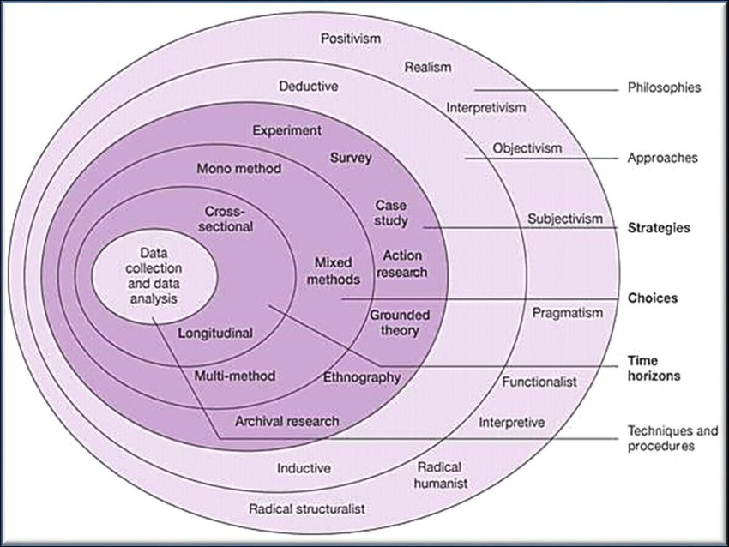
Figure 1., Research Onion (Saunders et al, 2009)
The research onion is divided into three categories:
- The first two outer rings consist of the research philosophy and research approach.
- The dark pink sections refer to the research design outlining the potential choices, strategies, and time horizon.
- The core of the onion refers to the data collection and analysis (Saunders et al, 2019)
Research Philosophy
The outer layer of the research onion concerns Research Philosophies. Saunders et al (2019) refers to the term research philosophy as the approach in which the researcher adopts to conduct their research i.e., the style or type of their research including any assumptions the researcher may hold about the subject matter.
Burrel and Morgan (2016) argue that commonly a researcher will make numerous assumptions whilst conducting their research on their chosen topic. There are three philosophies that are of significance when conducting research, those being Epistemology, Ontology and Axiology. Crow and Semmens (2006) refer to Epistemology as a form of philosophy which seeks to examine knowledge, focusing on what the knowledge is, where it came from and identifies if true knowledge can be sought.
This piece of work will seek to benefit from Epistemological Philosophy which Bryman (2009) states is a theory of knowledge. There are six philosophical stances that are associated with the three philosophies which are outlined in the first layer of Saunders’ research onion, those being Interpretivism, Positivism, Pragmatism, Realism, Constructivism and Objectivism. An interpretivism approach will be adopted, Interpretivism assists in gaining understanding of a matter and provides solutions and/or explanations as to why something happens (Bryman, 2016.) Consideration was provided to adopting a Realism and Positivism approach however, Interpretivism suited the research project in terms of the aims and objectives.
Research Approach
There are namely two significant research approaches as noted by Saunders et al (2016) those being Inductive and Deductive methods. Bryman (2014) states that a Deductive approach to research is the view of the relationship between theory and social research. In simpler terms, during a Deductive method a theory is identified, data is collected and analysed to produce findings to negate or confirm the theory. Figure 2 outlines the process of a Deductive approach.
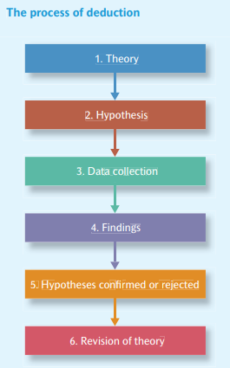
Fig., 2 Deductive Research Process (Bryman, 2016)
An inductive theory is the opposite of a Deductive one, the researcher reviews and analyses the findings and seeks to identify and collate information as to why that theory has occurred.
It is decided that a Deductive approach will be adopted to assist with the completion of the dissertation. A Deductive approach will enable information and statistics to be gathered and to be critically analysed to produce answers to the questions surrounding the contributory factors associated with Road Traffic Collisions.
Research Strategy and Choice
Numerous methodological strategies are in place for the researcher to obtain and gather information, the methods adopted are dependent upon several factors, namely the type of research, the questions, and the availability of resources (Ponto, 2015). The researcher has created a survey via Microsoft Forms which has been disseminated on social media, enabling a wide variety of responses. In addition, the survey has been sent to individuals within the workplace, those individuals being staff members of South Wales Police. An advantage of creating a survey is that the results will provide Quantitative and Qualitive data surrounding road user’s awareness of motoring laws and their understanding as to what they believe the main contributory factors are associated with Road Traffic Collisions. However, a disadvantage to this method is that the process of analysing and displaying the results will be time consuming, however, this method is free and by utilising social media and the workplace a high number of participants can be achieved, improving the credibility and reliability of the findings.
As touched upon above, this study will use both Qualitive and Quantitative research and data, commonly known as mixed-method research. Creswell (2014) explains that it is effective to use a mixed method approach as such approach can assist with understanding the research title efficiently. Quantitative and Qualitive research will be of benefit to the study in terms of analysing individuals’ responses on the survey and depicting them into percentages, furthermore, Quantitative research is an essential foundation of this study as statistics are the foreground of understanding the contributory factors associated with Road Traffic Collisions.
Time Horizon
Time Horizon refers to the ‘Longitudinal and Cross-Sectional’ element of the onion. During a Longitudinal study researchers focus on examining the same persons over a certain period to identify any correlations or trends. Cross-sectional studies differ in the respect that researchers gather information from participants in one instance of time, an example of this being a survey (Setia, 2016).
An advantage to adopting a Longitudinal study is that it enables the researcher to follow their findings real time and identify any new trends or correlations, however, this process can be truly time consuming and costly. This study will utilise the Cross-Sectional method as it is the most appropriate method to use in terms of collecting data. A Cross-Sectional study will enable the researcher to obtain a large quantity of data from various individuals and one benefit being that it is cost effective and not as time consuming as the other proposed method.

Techniques
- Data Collection
There are several factors that will impact the way in which data is collected, those being COVID-19 restrictions and the number of individuals expected to complete the survey. As previously mentioned, the survey has been completed using Microsoft Forms which is a user friendly and easily accessible document. The hyperlink to the survey has been disseminated on social media and to work colleagues.
- Data Analysis
It is anticipated that the survey will receive between 50-100 participants so that a large quantity of data can be obtained and analysed. The data obtained will consist of Qualitive and Quantitative data, such data will be analysed and displayed using percentages and graphs to identify any trends and/or correlations.
Survey Design
A survey, commonly known as a research tool, consists of several questions formed on the intention of gaining and recording information from participants (Gillham, 2008). The survey consisted of 14 questions, 12 of those closed multi-choice questions and two open questions. A variation of multiple-choice, open, and closed questions was utilised to keep the participant engaged and not appear tedious as Creswell (2014) states. In addition to this, it is beneficial to vary the questions to receive differing responses, allowing a deeper and thorough analysis.
Sample
When research is conducted it is vital to sample a small minority of the population as the wider population is too large to compare findings (Ghauri et al, 2020). As noted above, the aim of the research is to receive between 50-100 respondents because Quantitative research predominantly requires a larger number of respondents for an effective analysis to take place. The suggested sample size is sufficient for this study and will provide the researcher with primary data for analysis.
Reliability and Credibility
The reliability of data is deemed sufficient when the data is consistently obtained through the same research method whereas validity of data refers to the data obtained being valid, accurate and agreed upon academically (Saunders et al., 2007). The validity and reliability of the primary data that will be obtained during this study will be carefully selected by the researcher due to the sampling of the survey. Saunders (2015) states that surveys are deemed to be a valid method for the collection of data as surveys enable the respondent to detail their views and responses to tailored questions.
Ethical Considerations
This study will not require the participants to divulge any personal information that would aid in identifying their identity. Participants are made aware of aim of the survey and their involvement is voluntary. The information collated from the survey will be anonymised, therefore there are no ethical concerns regarding the way in which data is collected.
Limitations
A research project will always have certain limitations which are out of the researcher’s control. This research project will be limited to 10,000 words so it is imperative that the research conducted is significant and the findings are relevant with the aim of achieving the aims and objectives. COVID-19 has the potential to limit the secondary research which will be obtained in the respect that local and national lockdowns had a significant impact on motoring traffic, effecting the annual Road Traffic statistics, making identifying recent trends troublesome.
Conclusion
The Methodology chapter of this project has explained in depth the methods that will be used to efficiently answer the Research question. The chapter leading on from this will aim to produce the findings of the research through analysis.

Bryman, A. (2014). Social Research Methods. 4th ed. Oxford: Oxford University Press.
Bryman, A. (2016). Social Research Methods. 5th ed. Oxford: Oxford University Press.
Creswell, J. (2014) A Concise Introduction to Mixed Methods Research. 3rd edn. London: SAGE Publications.
Crow, I. and Semmens, N. (2008) Researching Criminology, Mcgraw-Hill (Open University Press)
Crowder, M. (2017) Statistical Analysis of Reliability Data. London: CRC Press.
Denicolo, P. (2013) Achieving Impact in Research. London: SAGE Publishers.
Fitchburg State University., (2020) Educational research (Sargent & Hirsch). (2020, March 20). Home – Research Help at Fitchburg State University. https://fitchburgstate.libguides.com/educ9300 [Accessed 1st March 2022)
Ghauri, P., Grønhaug, K. and Strange, R. (2020) Research Methods in Business Studies. Cambridge University Press.
Gillham, B. (2008) Developing a Questionnaire: Real World Research. 2nd edn. London: Bloomsbury Publishing
Gratton, C. & Jones, I. (2009) Research Methods for Sports Studies, 2nd edition, London: Routledge
Gratton, C., & Jones, I. (2010). Research methods for sports studies (2nd ed.). Taylor & Francis. https://repository.stkipgetsempena.ac.id/bitstream/575/1/Research_Methods_for_Sports_Studies.pdf [Accessed 1st March 2022]
Ponto, J., 2015. Understanding and Evaluating Survey Research. [online] 1(1). Available at: <https://www.ncbi.nlm.nih.gov/pmc/articles/PMC4601897/> [Accessed 2 March 2022].
Saunders, M. (2015) Using questionnaire surveys for within-organisation HRD research: In Handbook of research methods on human resource development. London: Edward Elgar Publishing
Saunders, M., Lewis, P. and Thornhill, A. (2009) Research methods for business students. England: Pearson Education Limited.
Saunders, M., Lewis, P. and Thornhill, A. (2016) Research methods for business students. 7th edn. Nueva York: Pearson Education.
Setia, M. (2016) ‘Methodology Series Module 3: Cross-Sectional Studies’, Indian Journal of Dermatology, 61(3), pp. 261–264.

