Research Method & Planning

3.1 - Introduction
Within this chapter it will document how the system of research works and explain how the research has been undertaken. The topic chosen seeks to research the effects policing can have onto officers wellbeing. The purpose of this chapter is to explore the challenges police officers face, including the impact on their mental and physical health whilst coping with the ever-increasing stressors as policing being labelled as one of the most stressful occupations (Polfed, 2019). Within this chapter, it will also discuss the chosen research methods considerations and limitations. This will be conducted through primary research which is described as new data collected by the researcher themselves, in turn provides raw data derived from direct questions. Primary research includes the use of surveys, interviews / experiments and observational methods (Bouchrika, 2025). This differs to the secondary research used within the literature review, as this research is data collected from others, this includes statistics and literature that is used to support beliefs and analyse gaps in literature (Bouchrika, 2025). To collect data researchers can use quantitative and qualitive research. Qualitive research uses open questions in order to obtain comprehensive answers allowing the researcher to analyse experiences (Lakshman, 2000). Alternatively, quantitative research uses closed questions and numeric data (Lakshman, 2000).

3.2 – Research Onion
Saunders, Lewis and Thornhill (2009) designed a model named the ‘research onion’ in order to break down the process of deciding the research method choice, through layers and segments.
This tool has been vastly utilised in various forms of research methodologies (Melnikovas, 2018).

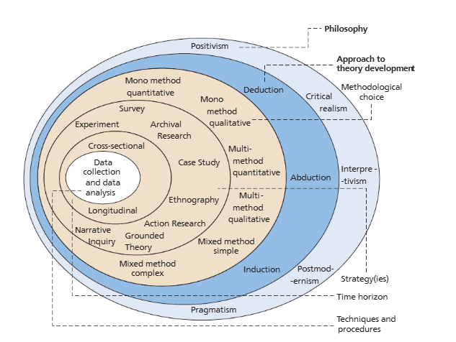
Each layer of the ‘research onion’ can be categorised into the following segments: philosophy of research, approaches, strategy, choices and time horizon. The aim is to follow these layers to then core of the ‘research onion’ which relates to techniques and procedures allowing the collection of data and the analysis of it. A visual depiction of the ‘research onion’ and its various stages that can be used when designing a research methodology is shown below.
Figure 1: The Research Onion (Saunders, Lewis and Thornhill, 2009)

3.3 – Philosophy of Research
Philosophy of research moulds the understanding of seeking research whilst utilising knowledge and views to best decided which research method is most applicable (Priest, 2006). Within the illustration of the ‘research onion’ it shows that inside the Philosophy segment that there is five philosophies – Positivism, Critical realism, Interpretivism, Postmodernism and Pragmatism.

Each of these philosophies provide a role when assessing which research method will be best suited. With positivism and realism relating to the use of quantitative research this is due to the concept of using objective data and observations (Khanna, 2019). In opposition, to positivism and realism philosophies the use of interpretivism differs due to its use relying on the researcher to be ‘subjective’ by gathering their own interpretation by their individual values, beliefs and experiences (Nickerson, 2024). This researcher will use an interpretivist approach, in order to utilise qualitative research with the objective of collecting ‘rich data’, for example the researcher also conducting interviews with the participants (Barrett and Twycross, 2018). Postmodernism and pragmatism relates to using a variety of methods allowing the combination of positivism and interpretivism to develop a understanding of the full topic and this can be done through qualitative or quantitative research (Saunders, Lewis and Thornhill, 2009).

3.4 - Research Strategy, Approach and Choices
There are two approaches a researcher may follow to undertake their project, with those being deductive and inductive. Inductive approach to research relies on a researcher collecting data and looking at pre-existing theories and how they can be developed (Kumar and Ujire, 2024). Alternatively, a deductive approach seeks to test existing theories that are in place whilst using data that has been collected by the researcher (Kumar and Ujire, 2024). The deductive approach will be sued during this project to add to existing theories and knowledge demonstrated in the literature review.

This study seeks to understand how a person’s wellbeing may be affected in the Police organisation how it can be minimised. During analysis of data, it seeks out existing staff within various areas of the police organisation and their personalised unique experiences, allowing the contrast and comparison to be shown between individuals within the organisation.

In order to gather data, the researcher will utilise the survey method with a mono-method research approach. This is due to the approach allowing the collection of both quantitative and qualitive data, with the survey producing both numerical data that can be statistically analysed and open-ended answers providing personal experiences and opinions (Onwuegbuzie and Leech, 2005). To disseminate the survey to people within policing they will be digitally invited via a secure internal forum that all people with the policing organisation can access. The survey will be conducted online to allow a wider range of responses to be obtained in a shorter period of time whilst also the researcher benefiting from the online surveys automatically correlating data. The survey will consist of both closed and open questions to allow depth of data within the results when they are analysed. Some closed questions will have multiple choice answers to allow for quantitative analysis. There will also be open ended questions inside the survey to collect opinions and the experiences of the participants subsequently allowing qualitive analysis. Within the appendix section there will be a blank unanswered copy of the survey.

3.5 – Time Horizon
This layer is made up of either a cross sectional or longitudinal timeline approach. Cross section research is the collection of data at a single time and this approach will be used as data will be gathered over a short period of time (Rindfleisch, A. et al, 2008). However, a longitudinal approach is the repeated collection over data over a period of time, which has been considered as a less appropriate method choice for this topic (Rindfleisch, A. et al, 2008).

3.6 - Data Collection & Analysis
The digital survey method chosen will produce qualitative results through the format of graphs and charts. The sample sized is aimed at 50 responses to gather a range of data to contrast. The participants responses will be analysed through the comparison of responders department, length of service and gender whilst also comparing their experiences, this allows the analysis of both quantitative and qualitative data.

3.7 - Limitations & Potential problems
A limitation of the chose research method is that the survey approach limits the richness of data, as most questions are closed and are traditionally a shorter process that a qualitative approach such as interviews. As this survey is aimed at frontline police officers, this researcher may find responses are limited due to officers duty commitments. This research will explore contingencies such as emailing line mangers and using a variety of internal platforms to distribute the survey. Further to this a limitation is the stigma of mental health(REF). Officers are likely to complete this survey during their tour of duty, and as it is a sensitive topic, they may find it difficult to be open and honest about their personal experiences.

3.8 – Conclusion
This chapter has explored the research method choices through the research onion tool to seek the most appropriate methodology for this topic. It has analysed the use of surveys and how this will be used to examine the data collected within the following chapter.

Word Count – 1218

Reference List
Barrett, D. and Twycross, A. (2018) “Data collection in qualitative research,” Evidence-based nursing, 21(3), pp. 63–64. Available at: https://doi.org/10.1136/eb-2018-102939.

Bell, S. and Eski, Y. (2016) “‘Break a Leg—It’s all in the mind’: Police Officers’ Attitudes towards Colleagues with Mental Health Issues,” Policing A Journal of Policy and Practice, 10(2), pp. 95–101. Available at: https://doi.org/10.1093/police/pav041.

Bouchrika, I. (2025) Primary Research vs Secondary Research for 2025: Definitions, Differences, and Examples, Research.com. Available at: https://research.com/research/primary-research-vs-secondary-research (Accessed: November 19, 2025).

Khanna, P. (2019) “Positivism and Realism,” in Handbook of Research Methods in Health Social Sciences. Singapore: Springer Singapore, pp. 151–168.

Kumar, S. and Ujire, D.K. (2024). Inductive and deductive approaches to qualitative research. International Journal of Multidisciplinary Educational Research, 13(1), pp.58-63. Available at: http://ijmer.in.doi./2024/13.1.69 (Accessed: November 19, 2025).

Lakshman, M. et al. (2000) “Quantitative vs qualitative research methods,” Indian journal of pediatrics, 67(5), pp. 369–377. Available at: https://doi.org/10.1007/BF02820690.

Melnikovas, A (2018). Towards an Explicit Research Methodology: Adapting Research Onion Model for Futures Studies. Journal of futures Studies, 23(2). Available at: https://doi:10.6531/JFS.201812_23(2).0003

Nickerson, C. (2023) Interpretivism paradigm & research philosophy, Simply Psychology. Available at: https://www.simplypsychology.org/interpretivism-paradigm.html (Accessed: November 19, 2025).

Onwuegbuzie, A.J. and Leech, N.L. (2005) “On becoming a pragmatic researcher: The importance of combining quantitative and qualitative research methodologies,” International journal of social research methodology, 8(5), pp. 375–387. Available at: https://doi.org/10.1080/13645570500402447.

Polfed (2019) Government must face facts - extreme stress in policing is real, Polfed.org. Available at: https://polfed.org/news/latest-news/2019/government-must-face-facts-extreme-stress-in-policing-is-real/ (Accessed: November 27, 2025).

Priest, G. (2006). What is philosophy? Philosophy, 81(2), pp.189-207

Rindfleisch, A. et al (2008) Cross-Sectional versus Longitudinal Survey Research: Concepts, Findings, and Guidelines, Sage Journals. Available at: https://doi.org/10.1509/jmkr.45.3.26.

Saunders, M., Lewis, P. and Thornhill, A. (2009). Research methods for business students. Pearson education.

