Activity – Establishing Research Paradigm
Guidelines :
- Please form a group of 2 students
- Select a theme – Food, Online shopping, Transportation and Generation Z.
- Based upon your selected theme, You will be given 3 piece literature.
- Try to think of a research topic based upon the given literature.

Practical – Research Paradigm
Whether we are aware of it or not, we all operate on a belief system. Sometimes we are able to articulate this, but most of the time it is hidden to us. When we operate on a hidden belief system, we are not aware of our prejudices. As researchers, it is vital that we know where we stand before we embark on our research. Being aware of our belief system (paradigm) is part of our education and the gold standard, Doctor of Philosophy, is an illustration of this.
Understanding our own belief systems also emancipates us as we begin to see the underlying beliefs and possible prejudices in others' work. We can challenge the views of our own subject groups, who might be operating in a manner imposed on them by others through time. Being aware of our belief system makes us conscious beings and enables us to confidently challenge the standard positions of our discipline.

ACTIVITY : What's the paradigm for your research?
Question 1: Describe your own research topic or one you might choose to research and explain how you might go about researching it. Once you have done that, see if you can identify the paradigm you use. What methodology could you use?
Your research topic:

Form qualitative research result: got information of relationship
From the quantitative research result：many factors impact The visitor's experience of food
Local food traditional culture development tourism sustainability (society economic environment performance)
Food related (Type of food service environment emotion quality )
Food ——Satisfaction
Topic：
The visitor's experience of traditional food impact the sustainable of tourism sustainability.
Your paradigm:

Functionalism paradigm ：
More objectivism，
The world is considered as social order (ontology) and hence seek to study patterns of ordered events or behaviors. The best way to study such a world is using objective approach (epistemology) that is independent of the person conducting the observation or interpretation, such as by using standardized data collection tools like surveys, then they are adopting a paradigm of functionalism.

Your epistemology:
It emphasizes objectivity and detachment. To analysis a social phenomenon by a objective way. Food related variables such as (Type of food service environment emotion quality).Collect data by survey or second and data to measure and analyze social phenomena in a way that is not influenced by the researcher’s personal biases or subjective interpretations.

Your ontology:
Reality is related to social phenomenon. Food has special function in society and develop of economic, which impact the sustainable development of tourism in a positive way.

Your choice of methodology
Survey sustainable tourism
Variables relationship
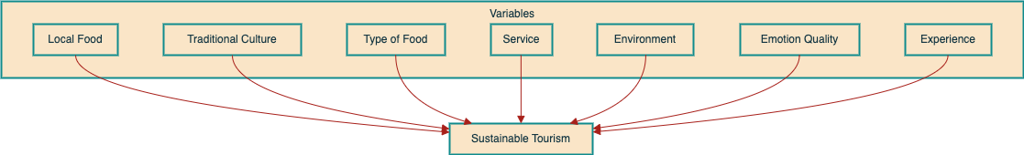
Question 2:
If you put your research into a different paradigm, how might you then carry out your research?

Whichever paradigm we are working within, our approach will be systematic. This separates haphazard learning from research. We will collect data in many guises (facts, figures, experimental findings, opinions, artefacts etc) and then interpret this in relation to current body of knowledge and/or our own opinion in order to contribute to that knowledge community.
In order to clarify this it may be worth looking at the 'knowledge hierarchy', sometimes referred to as the DIKW (Data, Information, Knowledge, Wisdom). There is some debate as to the origins of DIKW, so if you want to follow this up, consult an article by Nikhil Sharma (2005). There are claims the DIKW was derived from the T.S. Eliot poem 'The Rock' (1934) where this hierarchy was first mentioned.

Where is the Life we have lost in living?
Where is the wisdom we have lost in knowledge?
Where is the knowledge we have lost in information?

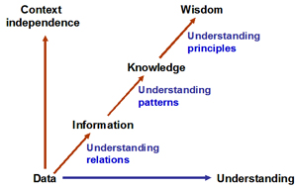
Source: Gene Bellinger (2004) Systems Thinking, Knowledge Management - Emerging Perspectives.
D = Data is the facts you will work with and they are without context.
I = Information comprises these facts with some context and perspective allowing you to see the relations between data.
K = Knowledge comprises information and where you start to see patterns in those relations and begin to understand those patterns. Patterns give you predictability and repeatability (validity and reliability).
W = Wisdom comprises knowledge and occurs when you understand why these patterns are occurring. When the pattern is understood at this level you have high predictive and reliability powers. At this point you can determine the founding principles for the patterns.
Your work therefore needs to move through to at least the 'knowledge' level of this model. Can you see how to do that? Look at the following 'walk-through' of the knowledge hierarchy (DIKW).
- Your hypothesis or research question will enable you to devise a research paradigm which identifies the data you need and how to collect it. [data]
- Through the work of others and your own findings you can contextualise your data through analysis and start to make sense of it by identifying relations within the data in a given context. [information]
- From your analysis you may start to see patterns of recurring behaviour which you now begin to understand. You may be able to answer what is happening in a given context. Here you need to apply some critical analysis that enables you to contextualise and interpret your findings. As a Masters student you may stop your research at this point. [knowledge]
- From the knowledge gained and possibly some follow up studies in addition to the work of others, you may be able to understand why these patterns of behaviour are occurring and develop/support/refute a theoretical model as an explanation. [wisdom]

ACTIVITY : Identify the paradigm for the DIKW model
Identify the paradigm behind the approach taken by DIKW. Does it fit with your research? Could you modify it to align with your paradigm?
Your answer:

-

