University of Wales Trinity Saint David
Undertaking a Green Belt Project
Thomas Rosser
2214462
Apprenticeship in Mechanical and Manufacturing Engineering (BEng)
29th of April 2024
Six Sigma Green Belt – ACMA5005



1. Introduction 4
2. Define 5
2.1 The Process 5
2.2 Problem Statement 6
2.3 Voice of the Customer/Critical to Quality 6
2.4 Project Scope 7
2.5 Process Map 9
3. Measure 11
3.1 Measurement system analysis 11
3.1.1 Objective 11
3.1.2 Method 11
3.1.3 Plan 11
3.1.4 Data Collection: 12
4. Analyse 13
4.1 Measurement system analysis (Continued) 13
4.1.1 Variability Guage R&R Analysis. 13
4.1.3 Line and Bias Number 14
5. Improve 16
5.1 Improvement possibilities. 16
5.2 FMEA 17
5.3 Cost Benefit Analysis for the Keyence IM8000 17
5.4 Keyence IM8000 Validation 18
6. Control 20
6.1 Operating Procedure 20
6.2 Daily Checks 20
6.3 Calibration 20
7. Conclusion 20
8. References 21
9. Appendices 22

Table of Figures
Fig 1 - Renishaw Manufacturing Site 3
Fig 2 - Hawk Vision System 5
Fig 3 - Coupon Diagram 5
Fig 4 - Process Map 10
Fig 5 - Data Collection Document 12
Fig 6 - Gage R&R Results 14
Fig 7 - Gage Linearity and Bias Report 15
Fig 8 - IM8000 (Keyence.co.uk, 2024) 16
Fig 9 - Comparison of measurement variation. 18
Fig 10 – IM8000 Gage R&R Report 19
Fig 11 - Keyence IM8000 Probability 19

Table of Tables
Table 1 - Decision Matrix 16
Table 2 - FMEA 17

Introduction
In today's constantly evolving manufacturing world, achieving high standards of operations and continuous improvement is critical for organisations looking to stay at a competitive advantage (Kumar, 2023). Six Sigma, a proven method for process improvement and optimisation, provides a methodical approach to recognising and eliminating flaws, reducing variability, and increasing overall efficiency.
This assignment focuses on using Six Sigma's DMAIC (Define, Measure, Analyse, Improve, and Control) structure to improve a measurement process within a manufacturing company (Pyzdek, 2003). The manufacturing company in question is Renishaw, an engineering technology group founded in 1972 and based in Gloucester. 39 years on and Renishaw opened their lead manufacturing site in Miskin South Wales (Figure 1), which now employs over 650 employees (Renishaw plc, 2020).
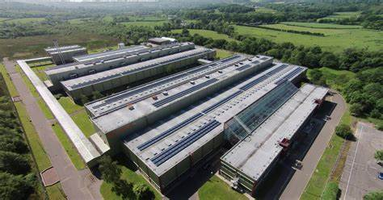
Fig 1 - Renishaw Manufacturing Site
Within Renishaws manufacturing site there are multiple disciples of Engineering such as electronics, machining and assembly. This Six Sigma report will follow a process that is based within in the Encoder Products Division which consists of two main product lines, optical encoders and scale. FSP2 (Flexible Scale Product) is a product within the scale department, It is a stainless steel ribbon with a laser ablated set of lines ranging with pitches from 20µm to 40 µm. FSP2 is then paired with an optical encoder which gives a numerical value through a visual display to the user.
This project is being done to improve the process of checking the dimensions of coupons (Test parts before production) within the FSP2 process. With improving this, the cost of quality will be reduced and the process will be more efficient all contributing towards the overall time and cost of the manufacturing process.

Define

2.1 The Process
A Part of FSP2’s manufacturing process is ablation. This is a reel-to-reel process where stainless steel ribbon is moved along a granite bench and a pneumatic controlled carriage ablates a set of lines upon the scale. This process can take upwards of four hours, so to make sure the scale being made is within specification a 100mm test part called a coupon is ablated and tested using a manual vision scope (Figure 2).
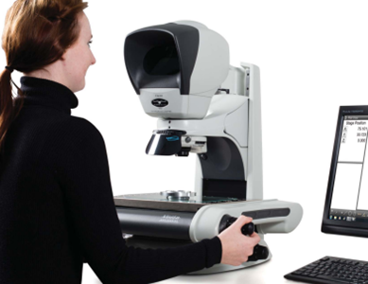
Fig 2 - Hawk Vision System
The coupon is ablated in the same conditions but then cut off the reel of material and checked using a manual vision scope. The operators places the coupon on the bed of the Vision Scope and uses the manual X,Y and Z movements to focus and make measurement points on the coupon. The Operator makes 4 measurements, these are: The Top Margin (1), Line Length (2), Bottom Margin (3) and the Yaw of the line (4) (Figure 3). After measuring the operator then inputs the measurements into a software which lets them know if the coupon has passed or failed.
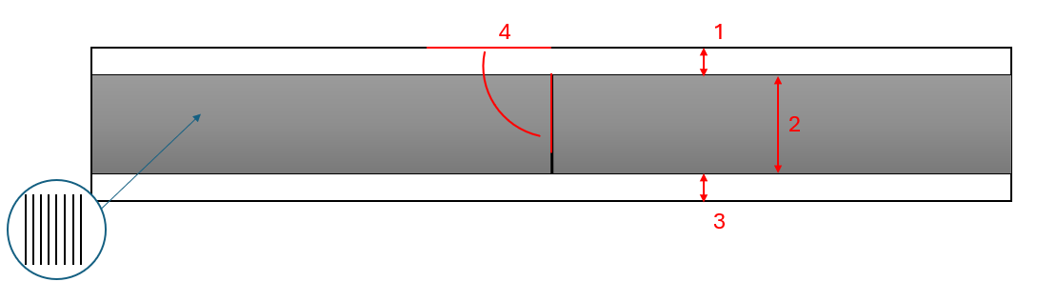
Fig 3 - Coupon Diagram

2.2 Problem Statement
This aim of this problem statement is to clearly define the main issues with the current process and assist in creating a focus for future work in the project. The current process for checking the dimensions of the coupon works and does not need much attention in terms of repairs/maintenance. However, the machine does have its flaws which effects the processes efficiency, cost of quality and technical advancements. These flaws are:
Slow operating speeds: Manual measurement increases processing time, with operators given 20 minutes, reducing cost-effectiveness.
Inconsistent Performance: Human error in manual processes results in fluctuations in accuracy, allowing flawed parts through inspection and increasing scrap costs.
Inadequate Capacity: The outdated system lacks scalability for anticipated demand growth, which may impede future production.
Productivity Impact: Process inefficiencies cause delays, wasting valuable production time and lowering overall productivity.
Risk of Obsolescence: Relying on obsolete equipment increases the risk of production halt due to a lack of parts and services.
Addressing the shortcomings of the current vision system is critical for maintaining a competitive advantage, improving operational performance, and future-proofing operations. By investing in a new vision system that can deliver faster operating speeds, consistent performance, and scalability to meet future demand, efficiencies can be improved, and scrap cost reduced to drive long-term growth and maintain a competitive market position.

2.3 Voice of the Customer/Critical to Quality
To understand the voice of the customer and what is critical to quality, a meeting was held with the stakeholders of the project. The minutes from the meeting outlined three critical points that needed to be met for customer satisfaction and to meet quality means. The first one of these is the ease of use of the new system, this is to reduce resistance to the change and to enable a quick application of the new system. The second point raised by the stakeholders is that the machine must be reliable and repeatable, all the coupons must be measured correctly and stopped if the coupon has failed its checks. The third point that was made clear by the shareholders is that the new system should be cost effective, the systems capital cost should be earnt back in a reasonable time.

2.4 Project Scope
A project scope was created as it defines the boundaries, objectives and constraints of the project ensuring that everyone involved understands the core principles of the project and does not get distracted from the end goal.
1. Project Overview:
The project's goal is to implement an improved vision system into FSP2 within the time and budget constraints. The new vision system must perform better than the original with an improved efficiency, accuracy, and reliability. The project will involve the selection, implementation commissioning of the vision system, along with training for users and ongoing support.
2. Objectives:
Increase operational efficiency.
Reduce measurement errors.
Ability to deal with increase of production.
Reduce/remove manual inspection efforts and errors.
Able to integrate with existing systems.
3. Scope Items:
Research and selection of an appropriate vision system.
Testing and validation of the vision system's performance.
Training for operators and maintenance staff.
Ongoing support and maintenance.
Documentation of processes, procedures, and user manuals.
4. Deliverables:
Detailed project plan outlining tasks, timelines, and responsibilities.
Selection criteria and justification for the chosen vision system.
Integrated vision system with documented testing results.
Training materials and sessions for users.
Maintenance/Calibration plan.
Documentation including maintenance and user manuals.
5. Exclusions:
Purchase of hardware components that are not directly related to the vision system.
Significant infrastructure changes unrelated to vision system integration.
Training for unrelated systems or processes.
6. Assumptions:
The availability of necessary resources such as personnel, budget, and equipment.
Stakeholder cooperation in data access, testing, and validation.
There will be minimal disruption to ongoing operations during implementation.
7. Constraints:
Budget constraints may influence the choice of the vision system and customisation efforts.
Time constraints for implementation in order to reduce downtime and disruptions to operations.
8. Risks:
Installation and commissioning pose technical challenges.
Operators show resistance to change.
System delivery could be delayed.
9. Stakeholders:
Project Sponsor – Chris Long (Group Technical Manager)
Project Manager – Jamie Lewis (Technical Manager)
Engineering/Maintenance – Thomas Rosser (Process improvement Technician)
IT Department – Dan Acres (Software Development Engineer)
End Users – FSP2 Production – Karen Powell (Senior Production Supervisor)
10. Timeline
Define the issues with the current vision system and allocate stakeholder – September 2023
Measuer the current vision system using production products – November 2023
Analyse the measurement data and suggest improvement to current system – December 2023
Find an improved system and purchase it thorough the stakeholders – February – 2024
Create standard working procedures and maintenance plans for the new system – March 2024
11. Budget
A sum of money is to be requested from the project sponsor with a document breaking down the cost of equipment/labour and how long it will take for the overall cost to be earnt back and start making a positive effect.
12. Approval:
This project will need to undergo two phases of approval. The first is for the budget as stated above and the second is the overall validation and commissioning of the new system. A document must be signed and approved by all shareholders to enable the system to be rolled out into production.
This project scope describes the objectives, deliverables, assumptions, constraints, risks, stakeholders, timeline, budget, and approval process for implementing an enhanced vision system. It ensures that everyone involved has a clear understanding of the project's boundaries and expectations.

2.5 Process Map
Below is a process map of implementing an improved vision system (Figure 4).
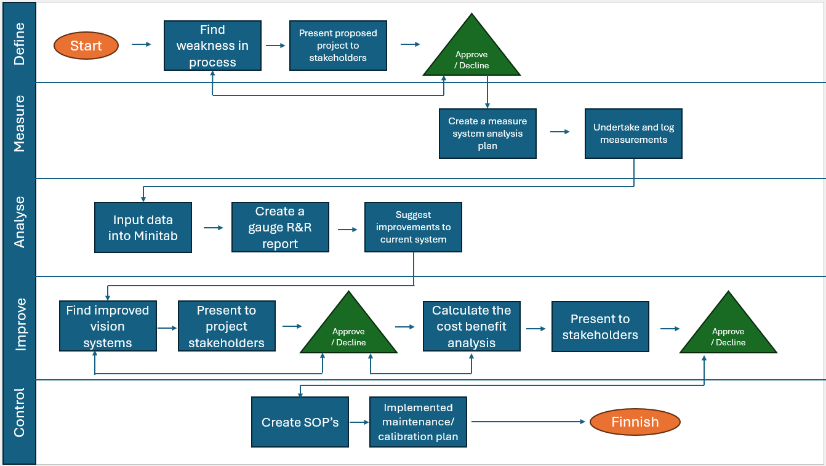
Fig 4 - Process Map

Measure

3.1 Measurement system analysis

3.1.1 Objective
The primary purpose of this Measurement System Analysis (MSA) is to thoroughly assess the reliability, precision, and accuracy of the current vision system. By completing a thorough evaluation, the MSA should help identify any potential sources of variation in the measurement system and recommend areas for improvement.

3.1.2 Method
This analysis consists of a Gauge R&R (Repeatability and Reproducibility) study, which is a well-known method for evaluating measurement system capabilities. This method will help to determine the current vision system's repeatability (consistency of measurements by the same operator) and reproducibility (consistency of measurements taken by different operators) and if it is acceptable for use.

3.1.3 Plan
To conduct the Gauge R&R study, the procedure will be as follows:
- Choose a sample of five parts that have ablated as a coupon and reflect the standard of proper use.
- Identify three operators who are familiar with the vision system and capable of taking accurate measurements.
- Each operator will fully measure five parts, five times. These parts will all be measured for Top margin, Line length, Bottom margin, and Yaw. Resulting in each part having sixty measurements.
- The measurements will be taken under typical operating conditions to ensure that they are representative of real-world scenarios and consider any environmental factors that may affect measurement accuracy.

3.1.4 Data Collection:
The operators chosen are Gavin, Paul and Tom. These operators were chosen as they are fully competent in the use of the vision system and understand how it works. Five samples were ablated normal operating conditions and labelled as such, 1, 2,3 etc. The coupons where them placed in protective sleeving to avoid damage or loss. Over the course of the week Gavin, Paul and tom conducted their five tests on their five coupons, making note of their results a made-up document (Figure 6). The vision system is placed in a temperature-controlled room, and it has no windows so lighting stays at a constant throughout the day. The data from these measurements can be found in the appendix of this document.

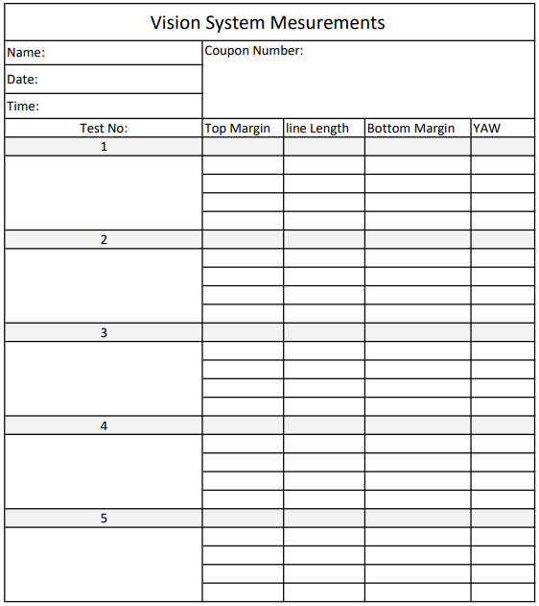
Fig 5 - Data Collection Document

Analyse

4.1 Measurement system analysis (Continued)
During this phase of DMAIC, the measurements taken are inputted into a software called MINITAB, with this software the measurements can be statistically analysed through terms such as validity, Guage R&R and linearity Bias. Due to the Yaw being the most crucial measurement, the study analysis is follow as suit. Through this analysis it will assist in pinpointing issues with the current system and help recommended improvements to the new.

4.1.1 Variability Guage R&R Analysis.
Shown in Figure 6, the gauge R&R report provides a clear visual representation of all aspects of the measurement system. From this report there are two main data sets, these are repeatability and reproducibility.
“Repeatability focuses on the precision of measurements obtained under the same conditions” (Nicoletti, 2021). In this instance, repeatability is the measure of how precise the five results the operators measure on the same part. The calculated percentage of study variation for the repeatability is 41.14%. This level of poor repeatability could be caused by focusing and image stability when undergoing the tests.
Reproducibility examines the consistency of measurements made by different operators using the same system (Nicoletti, 2021). With reference to the measurements taken on this analysis, repeatability is the consistency of the measurements from operator to operator on the same part. The calculated percentage of study variation for the reproducibility is 19%. This level of poor repeatability could possibly be caused by how the operators used the system in different ways, but due to the system being a manual system this is expected.
The total Study variation of this system is 45.72%. The guidelines from the AIAG when completing a gauge R&R state that a measurement system with a Overall Study variation over 30% is not acceptable and should be improved (Standards, 2024).
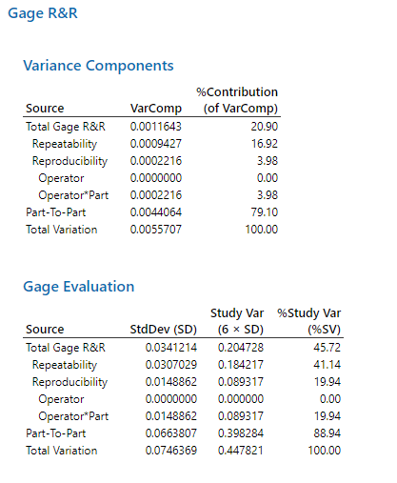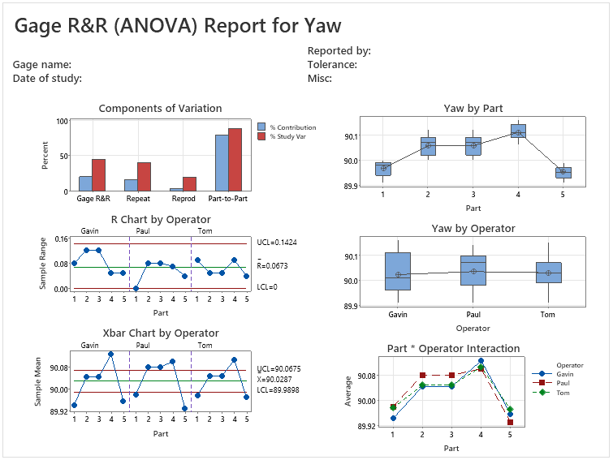
Fig 6 - Gage R&R Results

4.1.3 Line and Bias Number
“Linearity and bias are important metrics in a Gauge R&R report because they assess measurement system's accuracy and consistency” (Burdick, Borror and Montgomery, 2005). The Gage bias number in this report shows an average amount of deviation the measurement is from its true value; in this case It is 0.026mm. This means that if a parts true YAW is 91, it will be measured on average as 91.026. This may not seem a large amount, however when the tight tolerances are applied it could result in passing a failed part.
“The gage linearity assesses whether the measurements systems response is proportional to changes in the measured values” (Burdick, Borror and Montgomery, 2005). In terms of linearity the higher the percentage the better. The linearity percentage for this vision system is 42.5% which is an overall poor result. This poor linearity result can be caused by factors such as difference in machine use and machine capability.
The Gage linearity and Bias report for the yaw can be found below in Figure 7.
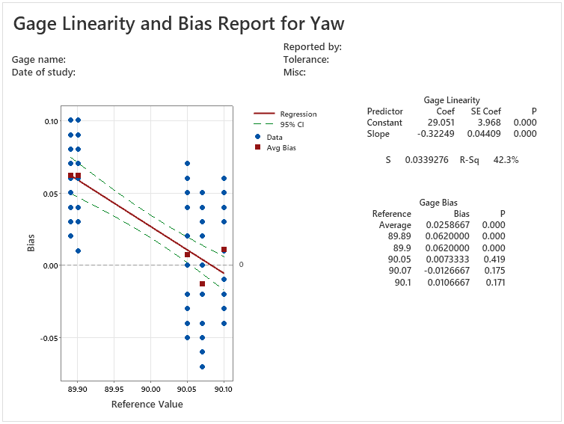
Fig 7 - Gage Linearity and Bias Report

To summarise, a poor Gauge R&R result from a manual vision scope study indicates significant variability and inconsistency within the measurement system. Addressing the factors that contribute to poor repeatability and reproducibility is critical for increasing measurement reliability and consistency, as well as ensuring decision-making accuracy.
Due to the use of the system being the main factor of the poor gage R&R result, it may be suggested to look at automated vision system to eliminate this variability and increase the overall repeatability and reproducibility.

Improve

5.1 Improvement possibilities.
After thorough market research, three main products stood out from the rest. These were the ‘Keyence IM8000’ , ‘Mitotoyo 359’ and the ‘Vision pro’ . Each had their strengths and weaknesses as can be shown in the decision matrix below (Table 1)
Table 1 - Decision Matrix
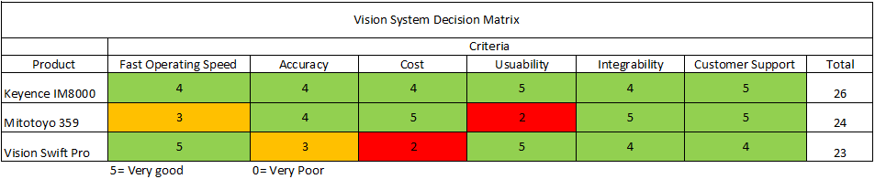
This decision matrix was then presented to the stakeholders and each individual strength and weakness was explained in detail. The stake holders concluded that the highest scoring product which was the Keyence IM800 (Figure 8) was the best vision system to move forward with. The three key advantages of the Keyence IM800 are:
- Automated measurement, eliminating manual error.
- Simple Programme editor software, reduced training/implementation time.
- Available to but direct with an included training package.
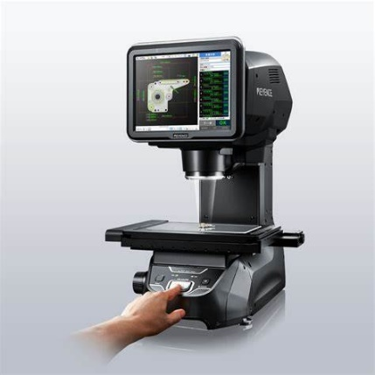
Fig 8 - IM8000 (Keyence.co.uk, 2024)

5.2 FMEA
A failure mode element analysis (FMEA) (Table 2) was created for the Keyence IM800 to put the risks of purchasing this product and what can be done to reduce these risks in a visual format. This FMEA was then presented to the stakeholders to gather their views and address their possible concerns on the new vision system. This FMEA is also in the appendix for a more clear image.
Table 2 - FMEA
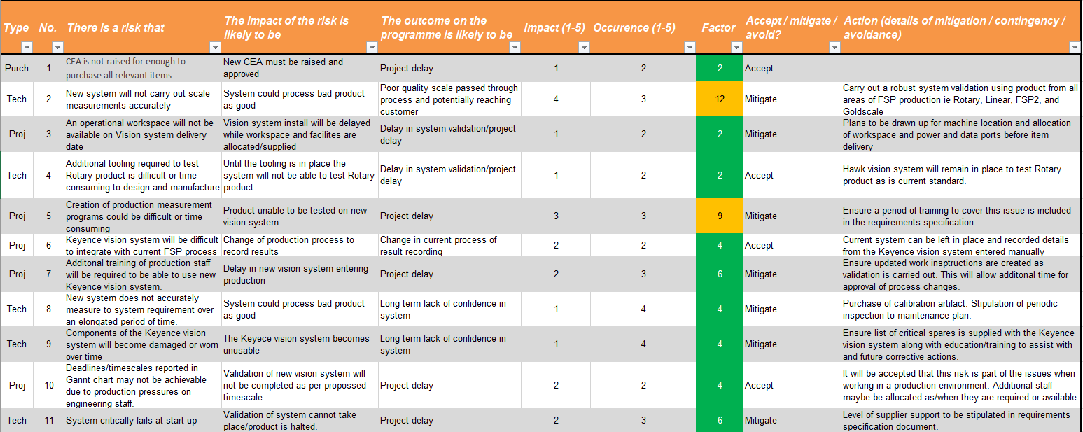

5.3 Cost Benefit Analysis for the Keyence IM8000
For a large purchase to be made within Renishaw a Cost analysis must be presented to the project sponsor, the project sponsor then approves or denies the request. Below Is a breakdown of the cost of the implementation of the new system and its savings and how long it will take to cover the initial costs.
The new Keyence IM8000 costs £45,000
The labour time committed to the implementation is £5,000.
This is a total cost of £50,000.
The Keyence IM8000 will reduce scrap costs (Based on 2022-2023 data) by incorrectly measured coupons by £8,500.
Due to the new system being operated, the labour time (Based on 2022-2023 data) saved per annum is £33,040.
To cover the initial cost of this project it will take 18months. After this there will be a cost saving of £41,500 per annum.
Considering these numbers the project sponsor approved the cost of the new project.

5.4 Keyence IM8000 Validation
For a new process to be implemented it must first be validated, in this case, the Keyence IM8000 validation must be put in report format and submitted to the stakeholders for approval. Due to it being an improved process and not a new one, the validation document will be mainly comparative on how to the new measurement system is better than the old, as well as assessing it repeatability and reproducibility.
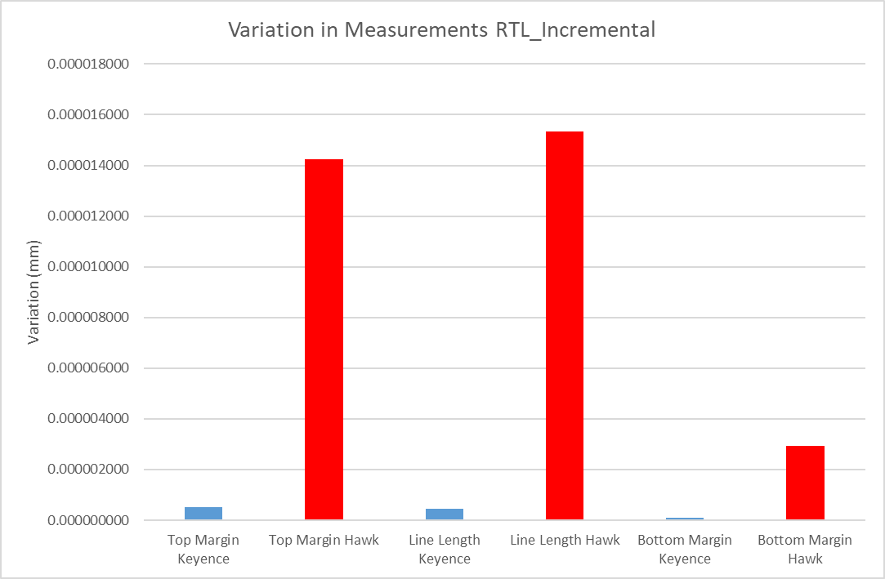
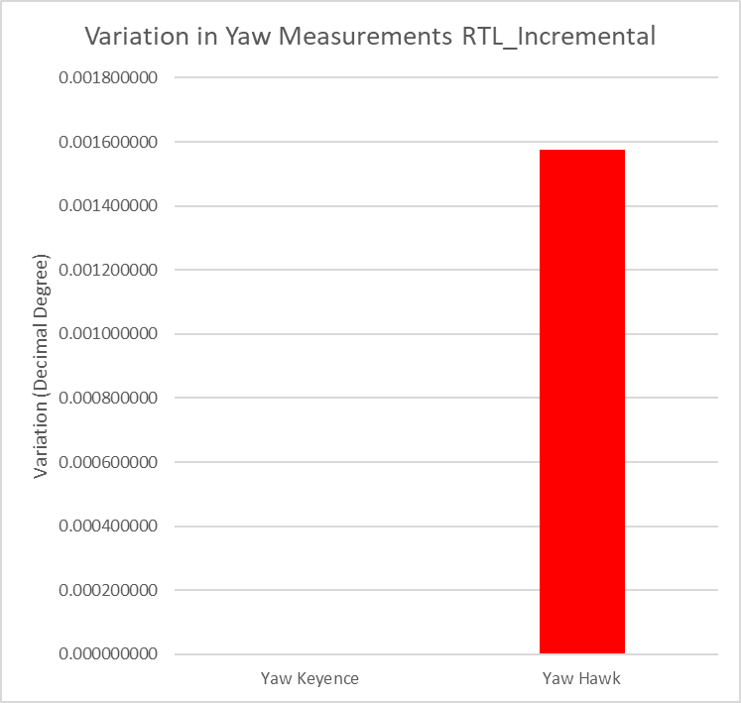
The comparative data within the report is as shown below in Figures 13, 14 and 15.
Fig 9 - Comparison of measurement variation.

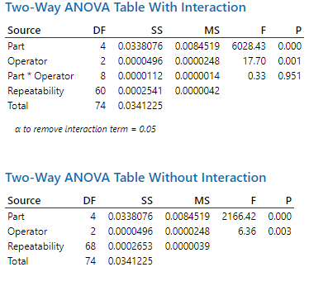
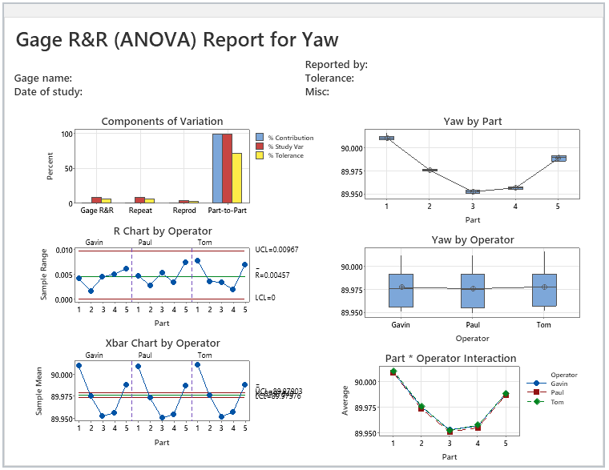
Fig 10 – IM8000 Gage R&R Report

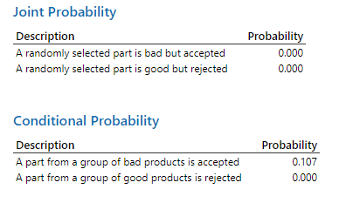
Fig 11 - Keyence IM8000 Probability

As can be seen in these results the new Keyence IM8000 vision scope is a significant improvement with a Variance number of almost zero, a probability of a bad part passing being 0.1 and an overall Guage R&R study variation of 0.83% which the AIAG deems more than acceptable. With these results the validation of the machine was signed off by the stakeholders.

Control

6.1 Operating Procedure
To ensure the new vision system is operated correctly, a standard operating procedure will be introduced. Within Renishaw these are called Work Instructions (WI’s). Wi’s are a detailed, step by step walkthrough of how the process is operated, what PPE needs to be worn and who is trained to work on the specific process. These Wi’s are then kept in a visible folder near the process.

6.2 Daily Checks
Before using the new vision system, daily checks are to be put in place. These checks will be done in the form of masters, which will be measured under a specific programme and tested against tighter tolerances than production to ensure the vision system is still working within specification.
Two brown masters will be made. These will be ablated incorrectly, one with incorrect margins and the other with an incorrect Yaw, when these are then then tested on the vision system the should fail the test. A Gold master will then be made to the best it can be. A programme will then be made for this master but with tighter tolerances than production.

6.3 Calibration
When purchasing the new vision system, a calibration artefact was bought. It consists of high precision patterns that are tested by a programme designed by Keyence. The results from this programme then display a PDF document with how every aspect of the vision system is preforming to its specification such as light intensity, focus ability and YX movement. From this Keyence can be contacted to arrange maintenance/spares if needed.

Conclusion
In conclusion, the use of Six Sigma's DMAIC methodology has resulted in significant improvements to FSP2's coupon measurement process: increasing operational efficiency, accuracy, and reliability by eliminating inefficiencies and implementing the automated Keyence IM8000 vision system. The new system's effectiveness was validated using rigorous analysis and stakeholder collaboration, paving the way for long-term improvements. With clear standard operating procedures and ongoing maintenance protocols in place, the process is well-positioned to maintain these gains and drive future success. This project exemplifies DMAIC's ability to drive continuous improvement and maintain competitive manufacturing.

References
Burdick, R.K., Borror, C.M. and Montgomery, D.C. (2005). Design and Analysis of Gauge R&R Studies. SIAM.
Kumar, P. (2023). What is Six Sigma: A Complete Overview. [online] Simplilearn.com. Available at: https://www.simplilearn.com/what-is-six-sigma-a-complete-overview-article.
M. Bradley (2024). Vision Measuring Systems QUICK SCOPE QS-L Digital Microscope. [online] Available at: https://www.mitutoyo.com/webfoo/wp-content/uploads/mit_qsl_brochure_web.pdf [Accessed 26 Apr. 2024].
MacDonald (2023). Vision Engineering Swift Pro - BC MacDonald. [online] Available at: https://bcmac.com/product/vision-engineering-swift-pro/ [Accessed 26 Apr. 2024].
Nicoletti, B. (2021). Lean Six Sigma and digitize procurement. International Journal of Lean Six Sigma, 4(2), pp.184–203.
Pyzdek, T. (2003). The Six Sigma project planner : a step-by-step guide to leading a Six Sigma project through DMAIC. New York: Mcgraw-Hill.
Renishaw plc (2020). Renishaw: About Renishaw. [online] Renishaw. Available at: https://www.renishaw.com/en/about-renishaw--6432.
Standards, E. (2024). New AIAG & VDA FMEA Handbook - Failure Mode and Effects Analysis. [online] https://www.en-standard.eu. Available at: https://www.en-standard.eu/new-aiag-vda-fmea-handbook-failure-mode-and-effects-analysis/?msclkid=924004c1bf3d1fcc1fe562ea65a81675 [Accessed 26 Apr. 2024].
visioninc_admin (2020). Hawk Duo high precision measuring microscope - Vision Engineering. [online] Visioneng.com. Available at: https://www.visioneng.com/products/non-contact-measurement/hawk-duo/ [Accessed 26 Apr. 2024].
www.keyence.co.uk. (2024). KEYENCE (UK) Ltd. [online] Available at: https://www.keyence.co.uk/.

Appendices
FMEA:
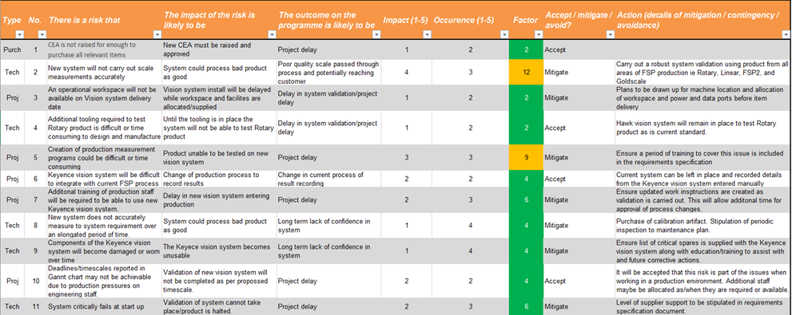

Original Vision Scope Measurements
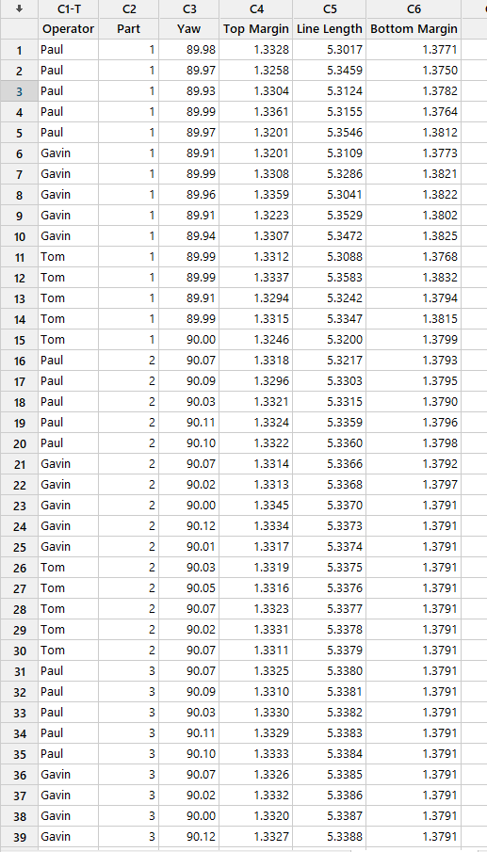
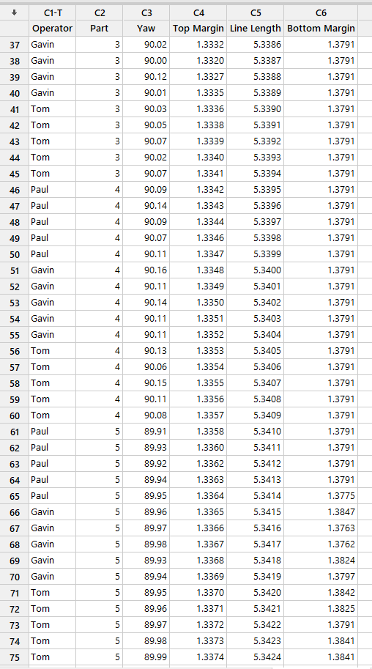

New Vision System measurements:


