Module number: ECEY5005
Student number: 2200885
Word count: 4135

Awe and Wonder – Science, Mathematics and the Outdoors

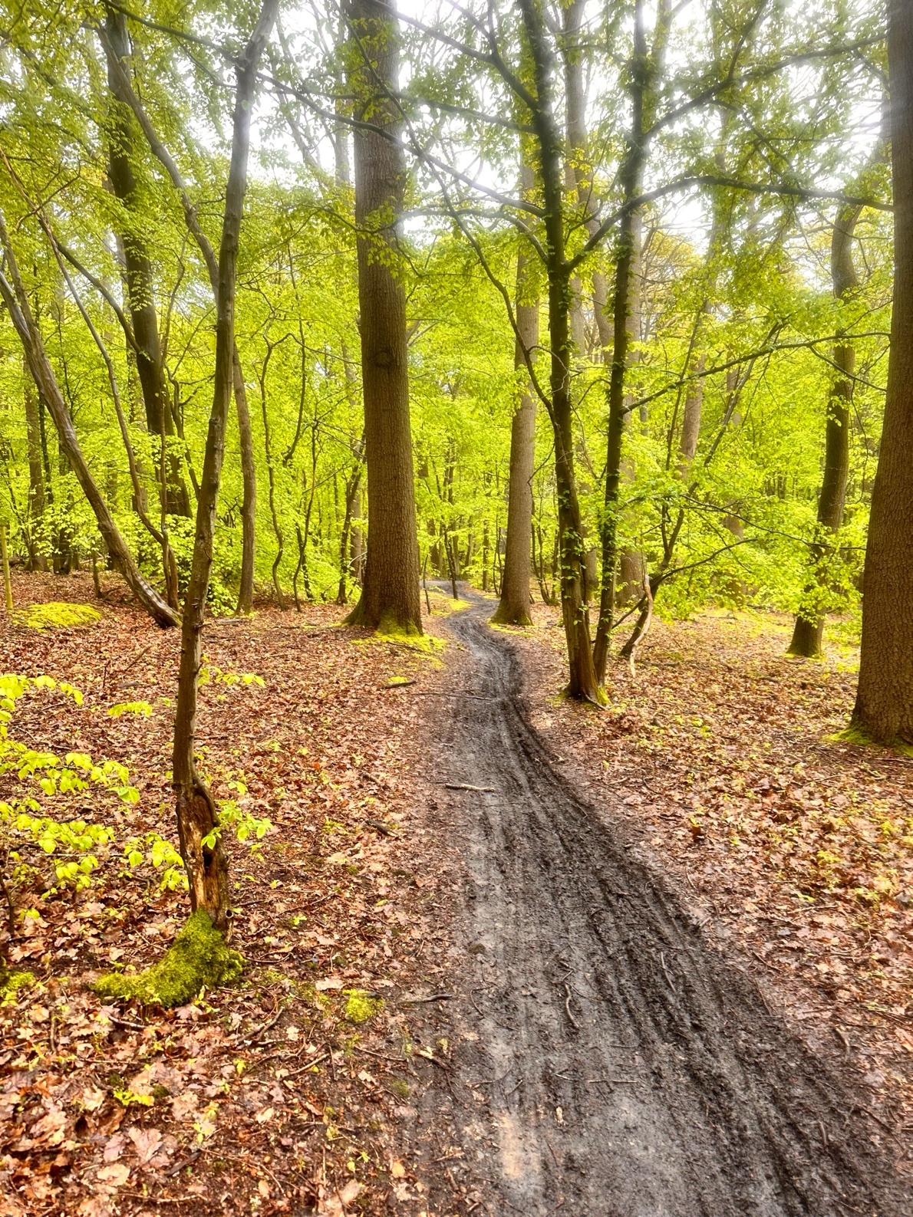
Part one- Woodland Area ( )
Part two- Guidance: Learning Story
The trip to the woodland area took place on the 22^{nd of} April, those attending include an early year's class of twenty students aged four to five additionally with four members of staff including myself. Previously that week it was discussed with the children that we would be visiting a natural environment, and they were encouraged to investigate as well as experiment within this area. Before leaving the setting, the children were counted and equipped with appropriate footwear and clothing such as wellies and wet gear. Ensuring this would greater the interaction between the children and nature. Upon arrival the children were motivated to explore the natural features at the site taking into consideration the variety of resources provided for them. Such resources included magnifying glasses, baskets, art supplies, string, pegs, pieces of cloth and cardboard along with numerous pots, pans, utensils and a bottle of water. I believed the children would utilise the site by making dens or by producing artwork from the materials provided.
Firstly, I observed a little girl and boy excitedly begin exploring the ground with magnifying glasses. They sat beside one another and started picking the leaves up of the ground examining them under the magnifying glasses. The little girl asked me, “why are some leaves green and some orange?”, I replied with “why do you think the leaves are different?”. The little boy answered my question with “I think the leaves are different colours because they are from different trees”, we began a discussion about different trees how they are different shapes, colours and how some grow berry’s. We then went on to considering how the weather may have an effect on the leaves, “sometimes the wind pushes the leaves off the tress” the little girl explained, adding to this discussion I said “when is it windy? Is it windy, when the sun is out?”. This guided our discussion to Seasons, “no, it is windy when my mummy says I have to wear my scarf and when its sunny I have to wear my suncream” the little boy clarified. I furthered our conversation, “so sometimes the weather changes, why do you think that is?”, both children began describing different weathers to me, how it can sometimes be hot and sometimes cold. The little girl then stated that “the weather is always cold when Santa comes” to which the little boy replied, “that is when it is Winter”. I then asked “but what is winter” to which he was unsure about, after further discussion we concluded that there are four seasons, that bring different weather conditions that affect the leaves and plants in different ways. The children then went on to collect the different leaves, gathering them into the baskets. The little boy said, “I will collect the green leaves and you can collect the orange ones”, both children appeared to investigate varies areas of the site where they were able to collect more leaves counting as they gathered. Through open discussions the children were encouraged to expand their knowledge of the environment, building upon the idea of Seasons, as well as the elements. The children were able to take note of a variety of colours, textures and shape when examining the leaves under the magnifying glasses. In addition to, their capacity to differentiate the leaves, gathering them into different baskets based on colour whilst exploring cardinal numbers. This links to the Curriculum for Wales (2020) progression steps, which describes a child’s ability to explore the environment, make observations in addition to their capacity to communicate ideas. Together with, the children being able to recognise plants as things that grow suggesting the relationship of all living things indicating the concept of life cycles.
Next, I was in a position to take note of a few children participating in mud and water play with the use of pots, pans and utensils. I watched as they began digging through the muddy path and placing the mud inside the pots, scooping and stirring whilst having conversations between one another about what they were doing. Some children explored the idea of making potions with the mud, the others discussed creating food. The children who decided to create potions, began pouring the bottled water into a pot. Following this, the children began exploring the site collecting flowers and leaves to further the creation of their potion. Afterwards, they began placing them into the water the children watched the flowers and leaves float. One child picked up the pot and started moving it from left to right, whilst watching the ripples form in the water “the flowers are swimming fast” they said. Then, lifted the pot up and down “that makes a bigger splash”. The child was free to investigate how water moves and how objects react when placed in water. In addition to, taking note of reflections, weight and balance. Following this, I noticed two children talking through their mud play “If I push the spoon into the mud harder, I can get more chocolate for my cake” the little girl said. When a little boy suggested “if we use our hands, we can get more mud”. They then began, using their hands to dig through the mud assembling a moulded shape. “Good, my chocolate cake is finished” the little girl said whilst staring at her creation, along with her muddy hands. I then observed, the little girl walk over to a long sheet of paper placed on the ground where she started printing her muddy hands onto the paper. “Wow” she said whilst calling over her friend still sat with their invention. I watched, as they ran back and forth between the mud path and the paper. After a while, the little boy started to walk along the paper leaving a trail of his footprints. Fascinated by the patterns he was able to create, he then decided to then use crayons to draw around his hands. I witnessed, the pair take turns drawing around each others' hands and feet. The children were able to take charge of their own learning expanding their knowledge based on what interested them as well as what they already had explored. Taking into consideration, the Curriculum for Wales (2020) ideas of progression, which indicate a child’s potential of making decisions based upon the concept of their creative expression. This suggests, using their existing knowledge of materials and products which can impact the process of design. Additionally, children’s means to predict and understand forces and their effects as part of their scientific exploration, along with identifying patterns.
Lastly, a pair of children began enthusiastically gathering the resources provided for them including the pieces of cloth, cardboard as well as, the baskets, string and pegs. Whilst doing so they were discussing what they were building, a den that one little girl suggested could be a bakery. However, a little boy expressed that he wanted it to be a hide out from animals. “Elephants will be too big, to fit in our den” he said, “Puppies can fit because they are small” the little girl explained. I watched as the children worked together balancing the pieces of cardboard on top of one another, the little girl then came to me asking me to assist them with their den. “Can you help us please, we are too small to reach the trees” she said, “what would you like me to do with the trees?”. The little girl directed me to tie the pieces of cloth to the trees using the string, I helped her do so however she enjoyed tying the knots. I watched her as she measured the string, holding it against the tree “I need a longer piece of string for this tree” she said and then tied it into a knot. After a few minutes, the children had tied the cloth to the trees and placed the baskets on top of one another in front of the cloth creating a square shape. The little boy then explained “we need more sticks for our den” he then began exploring the site, assembling a collection. When he brought the sticks back to their creation, the children started digging into the ground with their hands. They shaped holes which they placed the sticks in, the little girl struggled pushing one of the sticks into the ground. I observed her as she balanced on top of one of the baskets, she stood upon it and wiggled the stick into the hole. “I need to use both my hands to push the stick into the ground” she explained, “it is very satisfying watching the stick
wiggle because it's moving the mud around” the little boy voiced as he watched. The children finished placing all the sticks into the ground, following this the children used the pegs to attach the pieces of cardboard to the sticks. Once the pair had finished the construction of their den, they discussed how they could decorate it using natural materials like flowers or leaves additionally with art supplies. Continuing their discussion, they debated where the door and windows could be, then the pair persuaded their imaginative play. Some time later, the little girl expressed her interest to take their den apart to rebuild it. The children took their time disassembling their den when they began rebuilding it, some of their peers came to join. Relating to the Curriculum for Wales (2020) progression steps which suggest children’s faculties to design as well as communicating whilst designing. Also, a child’s skill to safely operate tools, materials and equipment to construct and destruct. Through den building, children are further encouraged to use mathematical language like shorter than, longer than and wider than. Together with, the child being able to explore number counting with an understanding of the value based on their hands on experience.
Part three- Risk & Benefit Assessment
Location/Activity: | Assessor: | Date: | Review Date:
Trip to a Woodland Area | Charleigh Steel | 20th April | 31st May

Experience exploring outdoor space in photograph. | How will children BENEFIT from this space? | Possible Hazards | Who is at risk? | Precautions in place to reduce the risk of injury. | Overall risk RATING:  L/M/H
Uneven ground | Children are encouraged to explore a variety of sites motivating the development of the vestibular senses. | Young children are at risk of an injury or accident when exploring on uneven grounds. | Young children and possibly adults. | Providing the children with knowledge of the uneven grounds. This enables the children to be aware and careful. | Risk is medium after precautions.
Weather conditions. | Children are able to experience all elements when exploring outside. Through such elements, children can gain an understanding of the seasons along with how their body works as temperatures change. | When investigating the outdoors a series of weather conditions can be expected including:  Hot weather suggesting a risk of sun burn or sun stroke.  Cold weather indicates a risk of sickness or hypothermia. | Both children and adults. | Ensuring that all those participating in outdoor activity are equipped with appropriate clothing and footwear. Advocating wet gear, wellies or sun cream and hats. | After the appropriate precautions the overall risk is low.
Animal waste and litter. | It is significant that children are encouraged to freely participate in nature, through independent investigation. Within nature children are in a position to learn how to keep themselves safe additionally with the environment. | Litter can include needles as well as being dirty and unhygienic, along with animal waste. A possible hazard surrounding this, is that young children may touch or eat such items. | Young children. | When visiting pubic areas with young children, golden rules are key such as if they see any thing unusual not to touch it but to notify an adult. Accompanying rules as a precaution is that the children are supervised the duration of activity. | Following precautions risk is a low rating.
Members of the public. | Children should be encouraged to participate in the woodland site, which can include members of the public. Children should note that not engaging with the public is of importance, this offers the means of boundaries. | Children wish to interact with strangers however their intentions may not be appropriate. | Young children exploring unsupervised. | When visiting areas open to the public precautions such as high vises along with, children being aware of where they are aloud to explore within boundaries. It is important to ensure that the monitoring from adults is great taking into account adult to child ratio. | Precautions shape overall risk to a medium.
Muddy Play | Muddy play can offer varies benefits for children considering investigating the senses. Inspecting senses like touch or smell through muddy play, children become aware of their surroundings building a connection with the natural environment. Along with, establishing an adventurous spirit inspiring a child’s artistic development. | When inspecting natural ingredients like mud children may wish to explore with senses such as taste. This can result in an illness or sickness, due to bacteria. Children can also slip on the mud which can led to injury. | Children interested in muddy play. | Effective guidelines like golden rules assembling children to be aware not to taste the mud, additonally with supervision. Children should also feel a sense of independence when exploring, enabling their ability to form resilience if they do slip on the mud. | After such safety measures risk rating should be regarded as low.
Water Play | Children can develop both fine and gross motor skills.  Additonally with, children are encouraged to pursue their creative expression.  Through such play children can explore how water works. The use of elements like wind, children can experiment with balance suggesting sinking and floating. | When engaging in water play children may wish to drink the water, which could lead to illness as it is unhygienic and dirty. The children might additionally, get wet leading to further illness like a cold. | Young children engaging with water play. | Children who are inspired by experimenting with water, should be supplied with wet gear. Furthermore, those supervising should encourage the children yet, assure that they are familiar with golden rules like not drinking the water they play with. | Such precautions establish the basis of risk as a low status.
Den building | When children partake in den building, they are able to explore balance along with their motor skills. Den building is a way for a child to express themselves accounting for their imagination and creativity. | It is important to consider the resources used when communicating the risks involved. For example, when using the string the children may feel comfortable to place it around their neck, which may cause injury. Additionally, the children may hit their fingers when placing sticks into the ground. | Children partaking in den building activity. | Offering the children independence when den building is key however it significant that they are aware of the risks associated with such resources. Suggesting the use of rules and appropriate monitoring. | When children are aware of these risks and how to safely den build, the overall risk such be considered low.

Part four- The Role of the Adult
According to Golubović-Ilić and Mikarić (2023) the significance of nature on children’s development is key. As stated, children are able to develop motor skills as well as build a positive physical and mental well being. Interactions with the natural environment enables children to grasp an ecological awareness in addition to an effective attitude toward the world as a whole. Further described, forest pedagogy specifies that outdoor learning should be considered important within the curriculum, along within the perspectives of early years key workers. This concept is supported by the Froebel Trust (no date) when expressed that through real life experiences in nature, children are able to gain a deep understanding of the interrelationship of all living things including themselves. By means of the outdoors children are encouraged to meet higher levels of thinking, feeling, imagining and creating. Froebel’s theory outlined the significance of freedom accommodated with guidence within the early years. Advocating that educators should facilitate and guide children in nature, rather than instruct shaping a child led approach.
Indicated by Mclnnes (2023) et al. high-quality early years education is fundamental to enabiling young children to grow and lean to their full potential. To create such an environment, early years key workers should aid a child’s learning and development. Practitioners must merge theory within practice, adding the why and how across all areas of the curriculum. This notion is supported by Evans and Saracho (2022) when describing Piaget’s theory, which highlighted young children as ‘little scientists’. Piaget expressed that through experiments as well as trail and error throughout the early years, stimulates a child’s ability to understand and view the world. Additionally, this can foster a child’s wellbeing along with, the development of their cognitive ability. Aiding this concept is the role of the adult in providing stimulating experiences for children along with, creating an environment that children are able to engage with independently. Sargent (2019) states that outdoor provision is just as significant as a learning tool, as inside a classroom. It is demonstrated that the natural environments, offer children active hands-on learning experiences that can promote the development of both communication and language skills. Additionally promote the practice of fine and gross motor skills, fundamentally fostering playful activity that encourages emotional and social skills. Further highlighted, within the early years it is significant that children are able to gain first hand experiences of scientific phenomena. This can only be achieved through personal exploration, where children are able to develop an interest in gaining a deep understanding of how the world works. Practitioners should offer children the freedom to achieve this, prompting child- led investigations of nature as well as understanding where their role is needed. This idea indicates Nicholson’s theory (1971) which describes science in action, with the use of loose parts. Nicholson suggested that young children should be encouraged to explore variables of the world, interacting and playing with such components that can inspire experiments, discovery and inventiveness. Children should be motivated to explore such things that have no apparent purpose, which assists open ended play where children can explore new concepts comprehending their own perspectives. Suggested by Flannigan and Dietze (2017) the natural environment offers a great opportunity for children to explore loose parts. Through the use of loose parts children are able to exhibit a range of social behaviours, considering both verbal and non-verbal positive behaviours. Loose parts in an outdoor environment motivates numerous types of risk taking through children’s play. England (2019) states that the role of early years practitioners when considering loose parts, is to educate themselves gaining an understanding of the learning that takes place during this type of play. Key workers building connections with the children in their care, shapes this understanding of when such learning takes place. Loose parts play is built upon a child’s freedom to discover and invent independently in all forms. Considering this the role of professionals is to only allow such child-led learning.
As demonstrated by Boulton and Thomas (2022) children are able to construct their knowledge and understanding throughout outdoor learning environments, considering the use of schemas. Practitioners building an understanding of each individual child’s schemas, can facilitate practice within the early years. The affordance of resources within the outdoors as well indoors considering the use of loose parts can nurture young children’s schematic development. Boulton and Thomas (2022) further suggested that the natural environment affords greater use of the senses. Outdoors movement is substantial and creativity is extensive, enabling the use of loose parts in ways unique to that individual child. This view is advocated by McDermott (2020) stating that schemas in young children appear as patterns in action or patterns of play. Children engage in schemas to determine their mental capacity, supporting their understanding of the world. Key workers have the responsibility to observe and identify their purpose in understanding a child’s learning through their actions. This greater expands their role in further supporting the child’s learning and development, based upon that child’s interests and dis-interests. Aziz and Said (2016) says that the natural environment offers high affordance for children in their schematic development, along with their holistic. Outdoor play creates meaningful connections between nature and the individual child, indicating that the natural environment can address a child’s preferences. The foundations for relationships to form between the outdoors and children are based upon the role of the practitioner. Key workers should gain an in-depth understanding of such realtionships of children’s play considering their schemas through the concept of affordances. Affordances in children’s play considerers the attributes of their environment, this suggests the significance that the possibilities of action can provide children. White (2022) expresses that outdoor environments have the potential to be empowering teachers, when used as a means to consider the holistic dvelopment of the child. This concept is assisted by Taber (2017) indicating that scaffolding young children’s learning can be very widespread, often supporting beyond classroom structured activities. The term scaffold is associated with the views of Vygotsky, the theory of Vygotsky considers the individual learner's current level of development. Practitioners that scaffold create open-ended opportunities providing resources to support and encourage a child led approach to an individuals own learning. Effective teaching should be considered in the terms of facilitating a child’s intended learning, based on their own interests, likes and dislikes. The natural environment creates such opportunities for children, as stated by White (2022).
From the viewpoint of Oberle et al. (2021) outdoor learning of young children provides great physical, cognitive, socio-emotional and academic benefits. However, as stated from an educators' perspective achieving forest pedagogy can be challenging. Taking into account, key workers confidence within the outdoors considering both when handling risks and preparing for risks. Along with, structured factors suggesting funding, resources and setting’s policies or schedules. Sociocultural characteristics can also be regarded as influences on outdoor learning in respect of culture, beliefs and the family backgrounds of the child. Further highlighted by Oberle et al. (2021) environmental features such as weather or hazards, might also negatively impact the idea of outdoor teaching. Dijk-Wesselius (2020) assists such concepts, stating that practitioners often feel restricted in facilitating outdoor learning relating to curriculum requirements, lack in time or resources. However, further added re-designing school yards into green school yards creates an easy to access resource, accomplishing outdoor learning in the grounds of the setting. Despite the idea of green school yards, outdoor learning as a whole remains underrated as a tool within educational practices. Key workers express feeling insecure within the field of outdoor learning, due to a lack in knowledge and experience. According to Payler and Georgeson (2013) early years professionals should be provided with numerous opportunities, training and experience to work inter-professionally. Interpreting multi-agency working into the early years considering specific contexts, key workers are able to gain both competence and confidence. This suggests settings have a responsibility to provide their professionals with tailored training to individual contexts, for example using nature as a learning resource for children. Howells and Meehan (2017) agreed with this concept when stated, that professionals have a lack in confidence throughout all aspects of outdoor learning, considering providing physical activity for children. Further indicated that the development of resources, can encourage the foundation of confidence as educators along with, meeting the standards of the curriculum. As well as, strengthening the delivery of such learning opportunities for children.
Suggested by Wien, Guyevskey and Berdoussis (2011) when considering forest pedagogy practitioners must educate themselves, of how to effectively work with such documentation inspired by Reggio Emilia. Key workers recognising pedagogical documentation as a concept that describes the movement of a child’s understanding. This notion provides professionals as well as careers with the knowledge, to grasp the idea that learning can be dynamic. Advocating visible documentation such as photographs or videos, creating a true representation of a child’s learning experience. Aiding this view, Tan and Yang (2022) says that pedagogical documentation is an in-depth qualitative research approach. Further highlighting, such documentation of children’s outdoor learning as visible whilst expressing both the child’s and practitioners' perspectives.
To conclude, key workers have the responsibility to scaffold young children throughout their mathematic and scientific exploration, with the use of the outdoors. This often suggests, facilitating rather than guiding encouraging child-led exploration. Taking into account the Curriculum for Wales (2020) associated with the idea of loose parts as well as individuality, in the view of schemas. Practitioners have the capacity to examine the risks along with the benefits linked with the natural environment. Suggesting professionals gain an in-depth understanding on such concepts, regarding the ideas of Froebel, Piaget, Vygotsky and Reggio Emilia.

