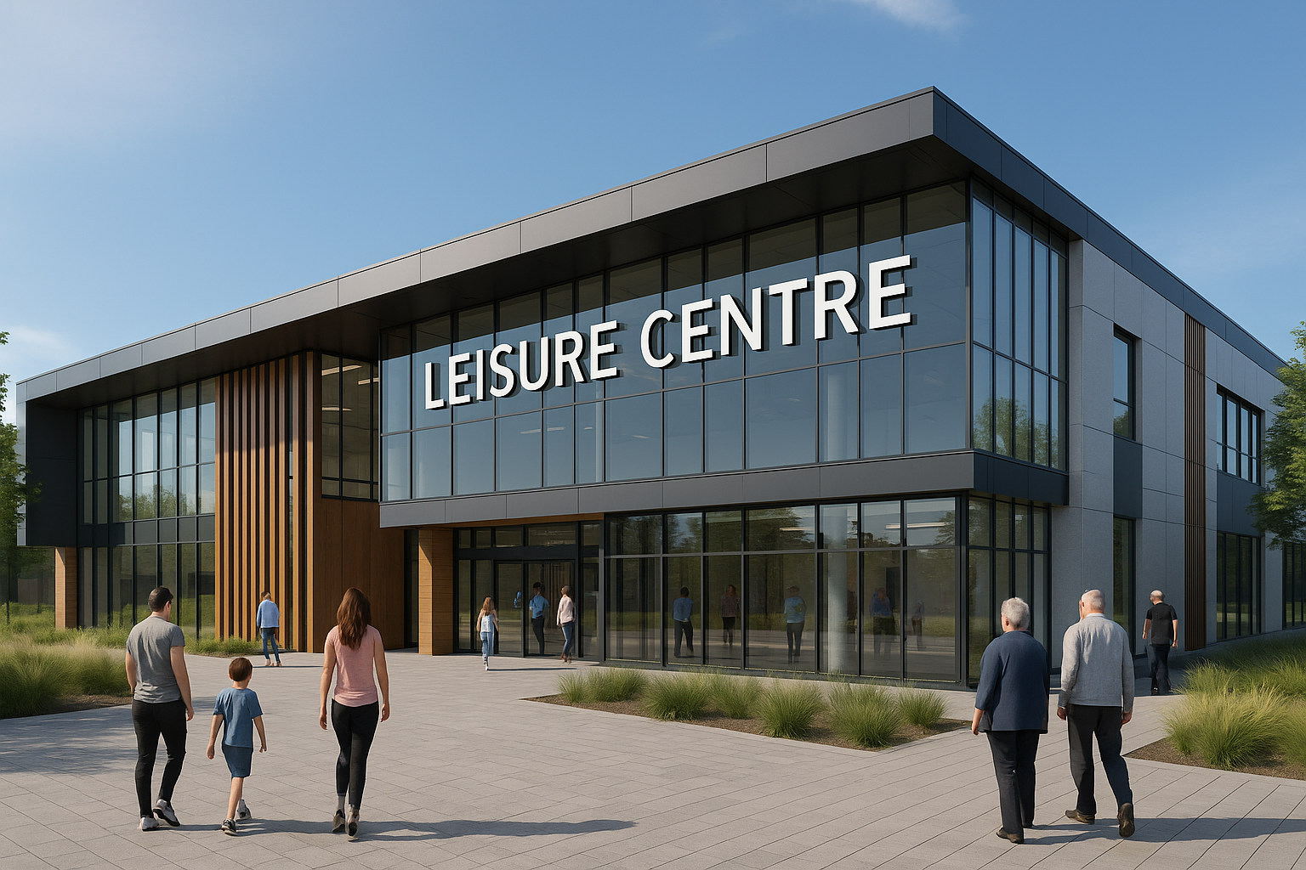
  - UWTSD BIRMINGHAM

Stakeholder Engagement

Adrian Mihai Neacsu 2312529

Name: Adrian Mihai Neacsu
Student number: 2312529
Module Code: LCBB4013
Module Title: Stakeholder Engagement
Assignment Title: Component 1:Coursework-Portfolio (4 elements)

University of Wales Trinity Saint David, Birmingham

Table of Contents
Introduction 3
Application to include Stakeholder Engagement Strategies 5
Power, Influence, and Interest Table 5
Stakeholder Map and Justification 6
Communication Plan and Consultation Strategy 7
SMART Objectives for the Communication Plan 8
Risks and Areas of Concern in the Communication Plan 9
Ethical Considerations in Stakeholders Consultation, Participation and Feedback 10
Methods of Consultation 10
Ethical Considerations in Consultation 11
Diversity, Equity and Inclusion (DEI) 12
Collecting and Reviewing Feedback 12
Conclusion and Reflection 13
REFERENCES 14

Leisure Centre Marston Green
Stakeholder Management Strategy
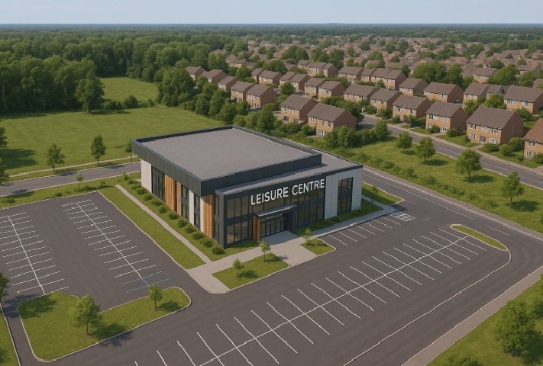

Introduction
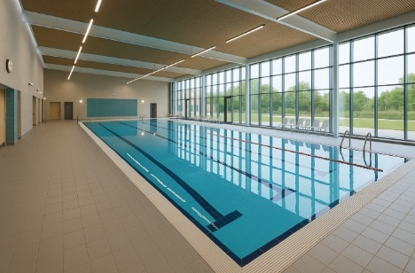

The proposed development of a new Leisure Centre represents a vital local infrastructure project designed to enhance health, well-being, and social inclusion within the community. More than just a recreational facility, a leisure centre acts as a hub where individuals and families can access fitness, education, and social opportunities (Sport England, 2023; National Standards for Community Engagement, 2016). It plays a pivotal role in addressing challenges such as rising obesity levels, mental health concerns, and limited access to safe, affordable recreational spaces (World Health Organisation, 2018). The planned facilities are expected to include a swimming pool, sports hall, fitness suite, wellness rooms, and flexible community spaces, all of which align with national and international agendas promoting healthier and more active lifestyles (Sport England, 2020).

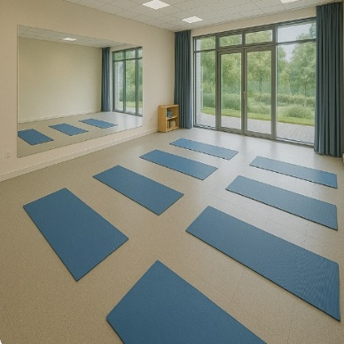


The relevance of this project extends beyond individual well-being. According to the Department for Digital, Culture, Media & Sport (2021), investment in leisure infrastructure strengthens community resilience, reduces inequalities, and contributes to social cohesion. By integrating inclusive design and sustainable planning, the project will also contribute to the United Nations’ Sustainable Development Goals, particularly those related to good health, reduced inequalities, and sustainable cities (United Nations, 2015). Furthermore, the project aligns with the NHS Long Term Plan, which emphasises the importance of preventative health measures and local partnerships to ease pressure on health services (NHS, 2019).
A wide range of stakeholders will directly benefit from the proposed Leisure Centre. The following are those considered to have significant power and interest in the proposed Leisure Centre:
• Local government will see improved delivery of policy objectives relating to public health, youth engagement, and sustainable community development (DCMS, 2021).
• Residents and families will gain access to safe, affordable facilities that encourage regular exercise and social interaction, thereby improving quality of life (World Health Organization, 2022; Public Health England, 2021).
• Schools and educational institutions will benefit from dedicated spaces for physical education and extracurricular programmes, supporting the physical and social development of young people (Department for Education, 2023; Sport England, 2023).
• Sports clubs and associations will have access to modern facilities for training, tournaments, and community outreach, strengthening local sporting culture (Sport England, 2020).
• Healthcare providers will be able to utilise the facilities for preventative health campaigns, rehabilitation, and wellbeing initiatives, supporting long-term health outcomes (NHS, 2019).
• Local businesses stand to benefit from increased footfall and economic activity, with opportunities for partnerships, contracts, and service provision (Tarry, 2018).
• Youth and community groups will gain accessible spaces to deliver programmes, workshops, and social activities, helping to promote inclusion, reduce isolation, and support young people’s development (NCVO, 2020).
• Environmental groups will benefit from the opportunity to influence sustainable design choices, ensuring the leisure centre supports eco-friendly practices and aligns with wider climate goals (United Nations, 2015).
In summary, the new Leisure Centre is a strategically significant project that supports multiple dimensions of community life. By combining inclusive stakeholder engagement with robust planning and sustainable development practices, it will deliver lasting social, health, and economic value (Bowen, Newenham-Kahindi and Herremans, 2010).

Application to include Stakeholder Engagement Strategies

Power, Influence, and Interest Table
To organise the stakeholder analysis, I have applied the power-influence-interest framework. This framework enables categorising stakeholders into high, medium, or low positions, depending on the extent of their authority, their ability to shape decisions, and their level of interest in the project outcomes. The table below sets out how each of the eight identified stakeholders has been positioned.
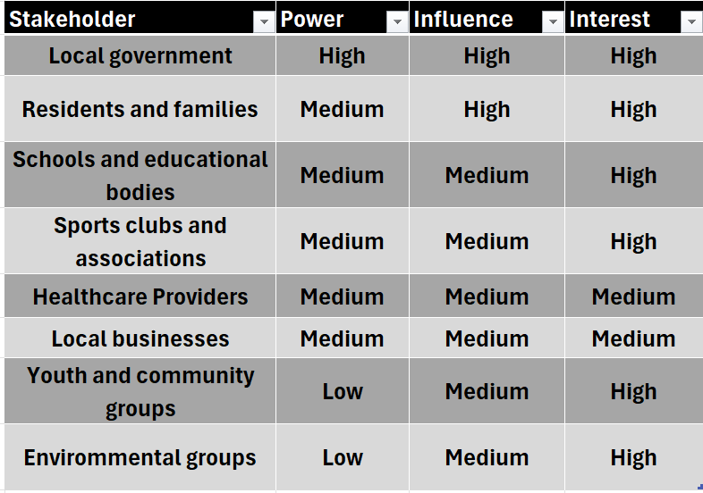

Local government sits in the high–high quadrant because it controls planning approvals, budgets, and long-term strategic direction (DCMS, 2021). Residents and families hold significant influence through support or opposition, making their engagement vital for legitimacy. Schools, sports clubs, and healthcare providers show high interest in service delivery but generally medium levels of power. Local businesses benefit economically and may lobby, yet their influence remains moderate (Tarry, 2018). Youth and community groups often lack formal authority but exert influence by mobilising participation and voicing community concerns (NCVO, 2020). Environmental groups hold medium power due to regulatory frameworks and growing sustainability expectations (United Nations, 2015).
While this framework offers clarity, research suggests that it must not be viewed as perfect. Stakeholder positions are dynamic and can shift as projects evolve (Bryson, 2011). For instance, residents’ influence may rise sharply if organised opposition develops. Similarly, environmental groups can escalate their power by leveraging planning law or media attention. The tool also simplifies complex relationships, potentially overlooking hidden interests or unequal power dynamics (Doyle, 2017). Over-reliance risks marginalising vulnerable groups, such as young people, whose voices remain essential for inclusivity (National Standards for Community Engagement, 2016).
Therefore, we should treat the matrix as a starting point, complemented by ongoing communication, feedback, and flexibility. By combining structured mapping with dialogue and reflection, stakeholder engagement can remain responsive and inclusive (Keyton, 2017).

Stakeholder Map and Justification
The power–influence–interest table provided an initial overview of how stakeholders relate to the proposed leisure centre project. To extend this analysis, a stakeholder map has been developed using the power–interest matrix. This visual tool places stakeholders into quadrants according to their relative power and level of interest, supporting clearer prioritisation of engagement strategies (Bryson, 2011; Johnson, Scholes and Whittington, 2017; Bowen, Newenham-Kahindi and Herremans, 2010).
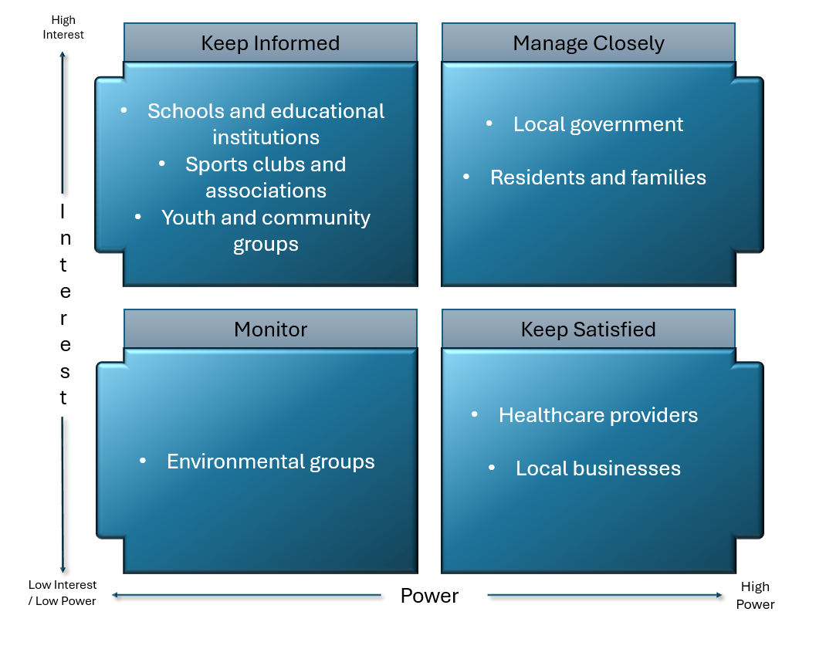

- High Power, High Interest – Manage Closely
Local government holds the greatest authority as the approving and funding body, while also being highly interested in achieving policy outcomes linked to public health and community development (DCMS, 2021). Residents and families, though individually limited in formal authority, collectively exert strong influence by shaping local opinion and directly benefiting from the project. Both groups must be managed closely, with active communication and opportunities for consultation.
- High Power, Low Interest – Keep Satisfied
Healthcare providers hold institutional power and credibility in shaping health agendas, but have only a moderate interest, as the leisure centre is not central to their operations (NHS, 2019). Local businesses also fall into this quadrant. They may wield economic influence through contracts, partnerships, or lobbying, yet their main concern is commercial benefit rather than social outcomes (Tarry, 2018). These stakeholders should be kept satisfied to ensure continued support without requiring intensive engagement.
- Low Power, High Interest – Keep Informed
Schools and educational institutions are highly interested in using the facilities for physical education and extracurricular activities, but have limited decision-making authority (Sport England, 2020). Sports clubs and associations are similarly reliant on access to modern facilities, yet cannot strongly influence outcomes. Youth and community groups also show high interest as potential users and programme organisers, but limited formal power (NCVO, 2020). All of these groups should be kept informed and regularly consulted to maintain their support.
- Low Power, Low Interest – Monitor
Environmental groups have an interest in ensuring sustainable and eco-friendly design. Their power is typically moderate, though it may rise if planning regulations or public campaigns are activated (United Nations, 2015). At this stage, they require monitoring and proportionate engagement depending on emerging concerns.

Communication Plan and Consultation Strategy
An effective communication plan ensures that stakeholders remain informed, engaged, and aligned with the objectives of the proposed leisure centre project. Clear communication builds trust, manages expectations, and empowers participation (Keyton, 2017; Cornelissen, 2020). The use of two-way channels is particularly important, as consultation is not only about transmitting information but also about receiving feedback, consistent with Schramm’s interactive model of communication (Schramm, 1954). The plan below sets out who will be engaged, what information will be shared, when communication should occur, and the most appropriate medium.

SMART Objectives for the Communication Plan
To ensure that the communication and consultation strategy is effective, objectives should follow the SMART framework — Specific, Measurable, Achievable, Relevant, and Time-bound. This provides clarity and accountability in engaging stakeholders (Bryson, 2011; Johnson, Scholes and Whittington, 2017).
- Specific: Hold two community meetings per quarter with residents and families to provide updates and collect concerns (National Standards for Community Engagement, 2016).
- Measurable: Achieve a minimum response rate of 60% from local schools and sports clubs to consultation surveys within three months (Department for Digital, Culture, Media and Sport, 2021).
- Achievable: Deliver consultation activities within the project’s allocated engagement budget, using existing venues such as community halls and schools (HM Treasury, 2022).
- Relevant: Ensure communication activities directly support project goals of transparency, trust, and inclusion by engaging groups with high interest and influence (Mendelow, 1991).
- Time-bound: Complete the initial consultation phase, including surveys, workshops, and feedback reports, within the first 12 months of the project timeline (Project Management Institute, 2021).
By embedding SMART objectives into the communication plan, the project team can monitor progress, evaluate effectiveness, and adjust strategies where required. This structured approach ensures that consultation is not symbolic but measurable, inclusive, and aligned with stakeholder expectations. (Doran, 1981; Bryson, 2011; Johnson, Scholes and Whittington, 2017).

Risks and Areas of Concern in the Communication Plan
Although the communication plan for the proposed leisure centre project sets out clear approaches for engaging different stakeholders, there are several areas where risks may arise if not managed carefully.
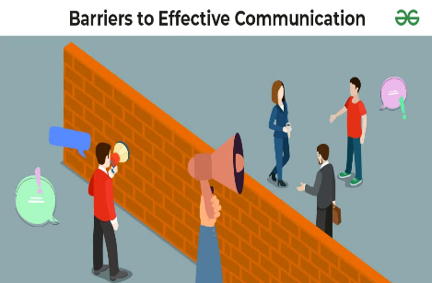
Communication barriers present a significant challenge. Stakeholders differ in their access to and familiarity with communication channels. For instance, older residents may not use digital platforms, while younger groups may prefer online engagement. If the plan relies too heavily on one medium, some groups could be excluded, leading to dissatisfaction and reduced legitimacy. Using a combination of traditional and digital methods helps overcome this barrier (National Standards for Community Engagement, 2016).

Information overload and clarity are other concerns. Government bodies require detailed reports, but residents and community groups may disengage if updates are overly technical or lengthy. Tailoring the level of detail to the audience ensures clarity and avoids confusion (Keyton, 2017).
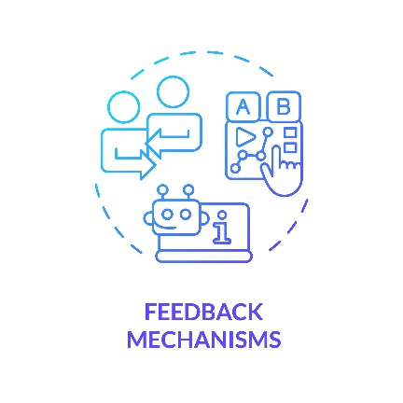
A further risk is insufficient feedback mechanisms. If communication is only one-directional, stakeholders may perceive the process as tokenistic. According to Schramm’s model, communication is incomplete without feedback (Schramm, 1954). Similarly, the IAP2 Spectrum highlights that genuine participation requires opportunities to consult, involve, and collaborate (IAP2, 2018). Structured workshops, surveys, and forums should therefore be prioritised.

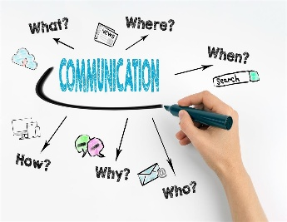
The timing of communication also requires attention. Providing updates only after decisions have been taken undermines trust. Early engagement at key milestones ensures that stakeholders feel included in shaping outcomes (Bryson, 2011).

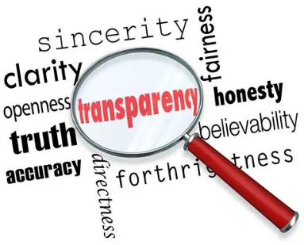
Finally, trust and transparency must be safeguarded. If communication highlights only benefits while ignoring risks, such as construction disruption, credibility may be lost. Transparent and balanced messaging is essential for maintaining confidence (Cornelissen, 2020).
In summary, the communication plan must pay close attention to inclusivity, clarity, feedback, timing, and transparency. Addressing these risks will strengthen stakeholder relationships and support the project’s long-term success.

Ethical Considerations in Stakeholders Consultation, Participation and Feedback
Following the development of the stakeholder quadrant, it is important to recognise that the map provides only an initial snapshot based on logical assumptions and theoretical guidance. Stakeholder positions are not fixed and must be tested in practice. Consultation, therefore, plays a critical role in validating whether stakeholders have been placed accurately and in shaping effective engagement strategies. By drawing on a range of consultation methods, this process will ensure that the stakeholder analysis is evidence-based rather than assumption-driven, and that the voices of all groups are incorporated into the project planning (Bryson, 2011; Johnson, Scholes and Whittington, 2017).
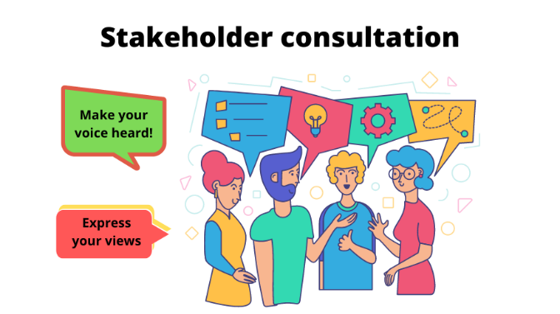
Methods of Consultation
The consultation will employ a mixed-methods approach to ensure inclusivity and reliability. This reflects principles from the National Standards for Community Engagement (2016), which stress the importance of using multiple techniques to avoid exclusion. Four complementary methods will be applied:
- Public meetings will be held in accessible venues such as community halls to provide residents and families with opportunities to raise concerns and receive updates. These meetings support transparency and inclusivity, aligning with the National Standards for Community Engagement principle of openness and participation (National Standards for Community Engagement, 2016) and the UNICEF Minimum Quality Standards for Community Engagement guidance on accessibility and two-way communication (UNICEF, 2020). Ensuring venues are inclusive also meets the accessibility duties set out under the Equality Act 2010 (Equality and Human Rights Commission, 2022).
- Online surveys will be distributed to schools, sports clubs, and families to capture broad participation and provide quantifiable data on key priorities such as affordability, accessibility, and programme demand. Surveys are particularly effective for reaching stakeholders who may be unable to attend meetings due to time constraints, supporting inclusive and evidence-based engagement practices (Department for Digital, Culture, Media and Sport, 2021; Blackadder, n.d.; UNICEF, 2020).
- Workshops will be organised for youth and community groups. These will adopt interactive formats (such as group discussions and role-play exercises) to make participation accessible and meaningful. This aligns with communication theories that highlight the importance of dialogue and participation in effective engagement (Schramm, 1954; Keyton, 2017).
- Secondary data analysis will involve reviewing policy and strategic documents, including Sport England’s Uniting the Movement (2020) and the NHS Long Term Plan (2019). This ensures alignment with wider agendas around health, wellbeing, and active communities, and provides an external evidence base to balance community input.
By using multiple approaches, the consultation will reduce reliance on a single data source and provide a balanced picture of stakeholder views. This “triangulated” design will ensure that the quadrant positions can be confirmed or adjusted with greater confidence (Flick, 2018).

Ethical Considerations in Consultation
Consultation must be underpinned by ethical safeguards to maintain fairness, transparency, and trust. Three areas are particularly significant:
- Informed consent and confidentiality: All participants will be provided with clear information on the purpose of the consultation, how their contributions will be used, and their right to withdraw. Surveys will be anonymised to protect privacy, which is essential for encouraging honest responses (National Standards for Community Engagement, 2016).
- Avoiding bias: A common risk in consultation is that powerful stakeholders dominate the process while marginalised voices are overlooked. To counter this, deliberate outreach will target groups such as young people, minority communities, and the elderly, ensuring their contributions carry equal weight (Bryson, 2011). Using varied consultation methods also reduces the risk of bias, since reliance on a single tool (e.g. surveys) may exclude certain groups.
- Transparency: Stakeholders will be informed about how their input will be considered and how it might influence project decisions. This is essential to prevent perceptions of tokenism and to demonstrate that consultation is genuinely participatory (Doyle, 2017).
Addressing these ethical dimensions will help to build legitimacy for the project and reduce risks of mistrust or disengagement.
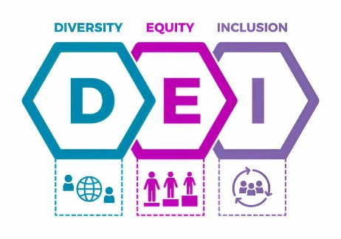
Diversity, Equity and Inclusion (DEI)
DEI principles will be embedded in all aspects of consultation to ensure that it represents the full range of community needs.
- Diversity will be promoted by actively inviting participation from a wide spectrum of stakeholders, including local government, residents, schools, businesses, healthcare providers, sports clubs, and voluntary groups. This reflects guidance from community engagement literature, which stresses that diversity is essential for legitimacy (Bowen, Newenham-Kahindi and Herremans, 2010).
- Equity will be achieved by addressing barriers to participation. This may include providing translation services, offering childcare support at public meetings, or designing surveys in plain language. Such measures ensure that consultation is not limited to the most resourced or articulate stakeholders (Cornelissen, 2020).
- Inclusion will be prioritised during interactive events such as workshops, where facilitation techniques will be used to encourage participation from quieter voices. This ensures that all contributions are valued equally, not just those from dominant or confident groups (Keyton, 2017).
Applying DEI principles will not only reduce the risk of exclusion but will also ensure that the project reflects the diverse needs of the community (Cheshire 2025; Hivebrite 2024).

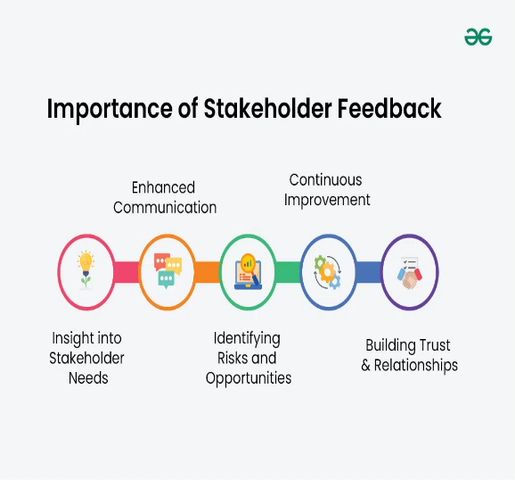
Collecting and Reviewing Feedback
Collecting and reviewing feedback is critical for demonstrating that consultation is meaningful rather than symbolic.
- Survey responses will be analysed statistically to identify trends in stakeholder priorities. For example, the percentage of respondents prioritising affordable membership will help to guide decisions on pricing structures.
- Workshop and meeting data will be coded thematically to capture recurring concerns and suggestions. Themes such as sustainability, accessibility, and disruption management will be highlighted for integration into planning.
- Systematic review: Feedback will be analysed carefully to ensure minority perspectives are not overlooked. Less common responses may highlight risks or opportunities that the majority ignore.
While triangulation (combining multiple evidence sources) could have enhanced the credibility of these findings, it was not fully applied here because the analysis is based on hypothetical stakeholder data. In a live project, triangulation through surveys, interviews, and document analysis would provide stronger validation and reduce bias (Flick, 2018; Bryson, 2011).
- Closing the feedback loop: Stakeholders will be kept informed about how their input has shaped decisions through newsletters, local newspapers, social media, and public forums. A “you said, we did” approach will be adopted to demonstrate accountability and transparency (Schramm, 1954).
Consultation is essential for validating stakeholder analysis, ensuring ethical practice, and embedding inclusivity in the planning of the leisure centre. By using multiple methods (meetings, surveys, workshops, and policy review), the process will capture a broad range of voices and reduce bias. Ethical safeguards, including informed consent, confidentiality, and transparency, will maintain fairness and legitimacy, while embedding DEI principles will ensure that participation is representative and equitable (UNICEF, 2020; National Standards for Community Engagement, 2016; Equality and Human Rights Commission, 2022). Finally, systematic collection, review, and communication of feedback will demonstrate accountability and strengthen stakeholder trust. Together, these measures will ensure that the consultation strategy not only tests the stakeholder quadrant but also builds a project that reflects the genuine needs and priorities of the community.

Conclusion and Reflection
Reflecting on this project, I have realised how vital effective stakeholder engagement is for ensuring both success and sustainability. The model shown in the figure helped me structure my thinking. I began by recalling the past, reviewing examples of local projects that failed due to poor communication and limited community involvement. This highlighted mistakes that I was determined not to repeat. Next, by examining the present, I analysed the current needs of Marston Green, including gaps in leisure and wellbeing provision, which confirmed the relevance of this project. From there, I worked on creating future scenarios, imagining how the leisure centre could promote health, inclusion, and community cohesion. This process allowed me to identify common ground between stakeholders: families, schools, sports clubs, and local government and to build a shared vision of accessible and sustainable facilities. Finally, this led to an action plan where consultation, ethical safeguards, and DEI principles became central to my engagement strategy.
As a student, I have learned that stakeholder engagement is not only about managing power and interest, but also about building trust and transparency. Done effectively, it ensures that projects deliver long-term value and reflect the needs of the whole community.
Throughout this module, I have gained a strong understanding of stakeholder engagement and how it supports ethical, inclusive, and effective community projects. In Week 1, I learned the foundations of stakeholder theory and how engagement builds legitimacy and trust between organisations and communities. Week 2 introduced reflective writing and models such as Gibbs’ (1988) and Kolb’s (1984), helping me see how self-evaluation improves learning and professional practice. In Week 3, I explored how to research community needs through surveys, focus groups, and mapping to ensure projects are evidence-based and relevant. Week 4 developed my planning skills by applying SMART objectives, stakeholder mapping, and risk management to design feasible and transparent projects. In Week 5, I understood how quality standards such as inclusion, fairness, and accountability strengthen engagement credibility. Week 6 focused on communication, where models by Berlo and Schramm highlighted how feedback and clarity reduce barriers and build trust. Although I was unable to attend Weeks 7 to 9 in person, I studied the materials online. In Week 8, I learned about creative problem-solving techniques such as mind mapping and the Plus-Minus-Interesting (PMI) approach (Doyle, 2017), which encourage innovation and collaboration. Finally, Week 9 taught me the value of impact assessment and evaluation, using both qualitative and quantitative methods to measure change and demonstrate accountability. Overall, this module has shown me that effective stakeholder engagement depends on inclusion, transparency, communication, and continuous reflection. Studying the final weeks independently helped me take responsibility for my learning, and I now feel more confident in designing ethical, participatory, and outcome-focused community engagement projects.

REFERENCES

- Blackadder, A. (n.d.) 7 creative ways to increase community engagement on social media. Available at: https://www.hughesandco.ca/blog/7-creative-ways-to-increase-community-engagement-on-social-media (Accessed: 13 November 2025).
- Bowen, F., Newenham-Kahindi, A. and Herremans, I. (2010) ‘When suits meet roots: The antecedents and consequences of community engagement strategy’, Journal of Business Ethics, 95(2), pp. 297–318.
- Bryson, J.M. (2011) Strategic Planning for Public and Nonprofit Organizations. 4th edn. San Francisco: Jossey-Bass.
- Cheshire, B. (2025) ‘Ensuring diversity, equity and inclusion in community engagement activities’, Delib Newsroom, 9 October. Available at: https://newsroom.delib.net/diversity-equity-and-inclusion-in-community-engagement-activities/ (Accessed: 13 November 2025).
- Cornelissen, J. (2020) Corporate Communication: A Guide to Theory and Practice. 6th edn. London: Sage.
- Department for Digital, Culture, Media and Sport (2021a) Community Life Survey 2020/21. London: DCMS. Available at: https://www.gov.uk/government/statistics/community-life-survey-202021 (Accessed: 13 November 2025).
- Department for Digital, Culture, Media and Sport (2021b) National Leisure Recovery Fund: Final Report. London: DCMS.
- Department for Digital, Culture, Media and Sport (2021c) UK Government Sport and Physical Activity Strategy. London: DCMS.
- Doran, G.T. (1981) ‘There’s a S.M.A.R.T. way to write management’s goals and objectives’, Management Review, 70(11), pp. 35–36.
- Doyle, A. (2017) ‘Adaptive challenges require adaptive leaders’, Performance Improvement, 56(9), pp. 18–26.
- Equality and Human Rights Commission (2022) Equality Act 2010: Guidance. London: EHRC. Available at: https://www.equalityhumanrights.com/en/advice-and-guidance/equality-act-guidance (Accessed: 13 November 2025).
- Flick, U. (2018) An Introduction to Qualitative Research. 6th edn. London: Sage.
- Hivebrite (2024) ‘The crucial role of DEI in community building’, Hivebrite Guides. Available at: https://hivebrite.io/downloads/dei-community-building/ (Accessed: 13 November 2025).
- HM Treasury (2022) The Green Book: Central Government Guidance on Appraisal and Evaluation. London: HM Treasury. Available at: https://www.gov.uk/government/publications/the-green-book-appraisal-and-evaluation-in-central-governent (Accessed: 13 November 2025).
- International Association for Public Participation (IAP2) (2018) IAP2 Spectrum of Public Participation. Denver: IAP2.
- Johnson, G., Scholes, K. and Whittington, R. (2017) Exploring Strategy: Text and Cases. 11th edn. Harlow: Pearson.
- Keyton, J. (2017) Communication in Organizations. 2nd edn. New York: Routledge.
- Mendelow, A. L. (1991) ‘Environmental scanning: The impact of the stakeholder concept’, in Proceedings of the Second International Conference on Information Systems. Cambridge, MA: Harvard Business School, pp. 407–418.
- National Council for Voluntary Organisations (NCVO) (2020) The Road Ahead 2020: The future of the voluntary sector. London: NCVO. Available at: https://www.ncvo.org.uk (Accessed: 26 September 2025).
- National Health Service (NHS) (2019) The NHS Long Term Plan. London: NHS England.
- National Standards for Community Engagement (2016) National Standards for Community Engagement. Available at: http://www.voicescotland.org.uk/media/resources/NSfCE%20online_October.pdf (Accessed: 13 November 2025).
- Project Management Institute (2021) A Guide to the Project Management Body of Knowledge (PMBOK Guide). 7th edn. Newtown Square, PA: Project Management Institute.
- Schramm, W. (1954) How Communication Works. Urbana: University of Illinois Press.
- Sport England (2020) Uniting the Movement: A 10-Year Vision for an Active Nation. London: Sport England.
- Sport England (2023) Why invest in facilities? Available at: https://www.sportengland.org/facilities-and-planning (Accessed: 13 November 2025).
- Tarry, J. (2018) ‘Making a positive contribution to the local communities we serve’, Tesco PLC Blog. Available at: https://www.tescoplc.com/blog/making-a-positive-contribution-to-the-local-communities-we-serve/ (Accessed: 21 September 2025).
- United Nations (2015) Transforming Our World: The 2030 Agenda for Sustainable Development. New York: United Nations.
- UNICEF (2020) Minimum quality standards and indicators in community engagement. Available at: https://www.unicef.org/mena/reports/community-engagement-standards (Accessed: 13 November 2025).
- World Health Organization (WHO) (2018) Global Action Plan on Physical Activity 2018–2030: More Active People for a Healthier World. Geneva: WHO.

