Experimental data analysis
Data Analysis & visualisation
joseph williams
2020
Table of Contents
1. Introduction 2
2. The data (Description) 2
3. Hypotheses 5
3.1. Alternative Hypothesis 5
3.1. Null Hypothesis 5
4. Hypotheses Testing 6
4.1. t-Test 0.05 6
4.2. t-Test 0.01 7
4.3. t-Test 0.10 8
5. Investigating the outliers 9
6. Discussion 10
7. Conclusion 10

1. Introduction

This report covers an experiment to test whether a company should keep their website or if they should switch to the newly updated website. In the report, the data provided by the experiment is described and analyzed and necessary statistics are taken to show the results of the experiment overall.
A set of testable hypotheses are created to justify why the new website has a larger amount of sales when compared to the old website. These hypotheses are then tested to significance levels of 0.05, 0.01 and 0.10 and the result of these tests is displayed, and the correct hypothesis is shown.
Further in the report, any outliers that are found within the dataset are investigated and tested to find out whether they need to be removed or if they can be kept. Finally, any other potential factors that could have affected the experiment are discussed and a way to control these factors is given for each possible factor. A conclusion closes out the report summarizing the results and giving a final verdict.

2. The data (Description)
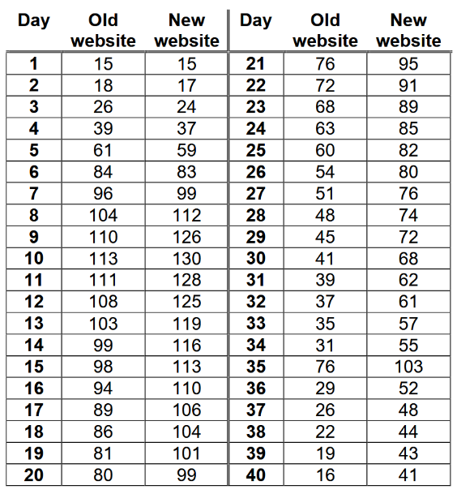

This data is showing the number of sales made per day on both the old website and the new website over the span of 40 days. During this test period, the company offers a 15% discount on orders that are made on the website in order to encourage people to visit their website. From an initial view of this data, you can see that over time, the new website is consistently higher, however, in the first few days, the old website starts off with more purchases made but quickly loses this advantage.

From this graph, it is clear the new website is producing more sales when compared with the old website. Like in the initial view, the new website starts out slow but spikes rapidly until it eventually overtakes the old website completely on day 7, this could be because of more users discovering the new website or could even be old website users making the switch to the new website for a better experience. Before day 7, the old website is in the lead. At day 34 you can see clearly that both websites experienced the same surge in sales which lasted until day 35 however, day 36 both websites had the same reduction in sales.

This graph shows the average of both websites over the span of the 40-day test. The graph shows that most sales came from the new website and had an increase of 16.95. By using this basic data, the company should make the switch to the new website and replace the old website. The graph in its basic form allows the user to look at the entire picture, which is both good and bad, however, it gives a non-bias view of how both websites operate over a selected amount of time (40 days).
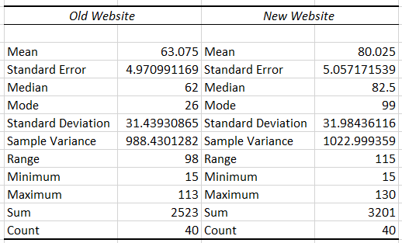

The descriptive statistics shown in the table above do well to summarize the datasets of the old and new website, the statistics cover a wide range of things such as the sample variance and the standard deviation. As well as this, it covers basic, but necessary things such as mean, median, mode etc.... By presenting the data in this way, it displays the data in an easier way which allows a better interpretation of the data.

3. Hypotheses

3.1. Alternative Hypothesis

The company’s new website offers modern payment methods which would allow more people to purchase items they are looking for using methods such as apple pay, PayPal etc.… this would lead to more sales on the new website.

3.1. Null Hypothesis

The null hypothesis would be that both websites offer the same payment methods which would result in a similar amount of sales between both websites.

4. Hypotheses Testing

To test the hypotheses, testing is necessary which is why within this experiment the chosen testing method was the t-Test: Two-Sample Assuming Unequal Variances. This t-Test will help prove or disprove the hypothesis by using the t-critical which means that there is less than a % probability that the difference in the mean occurred by chance. This test is used to find out whether the mean of the two samples differ to a statically significant degree, because of this, the t-Test is one of the most commonly used statistical tests.

4.1. t-Test 0.05

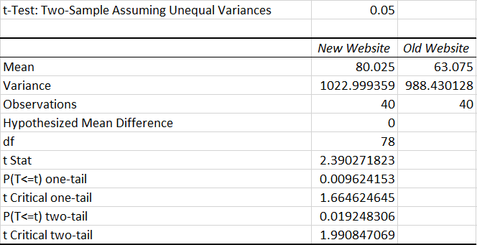

In this t-Test the level of significance is set at 0.05 (5%) which means that for this test, it is considered as (alpha) which is the probability of getting a type 1 error and also means that there is a less than 5% probability that the difference in means occurred by chance. Within the test, the variance and the observations were used to calculate the t Stat which ended up being 2.39. Because the t Stat is higher than the t Critical, the null hypothesis is rejected, and the alternative hypothesis is accepted which proves that the chosen hypothesis is right when using the above dataset.

4.2. t-Test 0.01

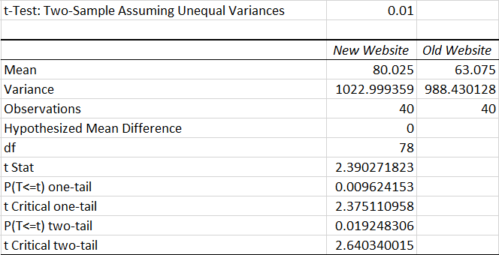

In this t-Test the level of significance is set at 0.01 (1%) which means that for this test, it is considered as (alpha) which is the probability of getting a type 1 error and also means that there is a less than 1% probability that the difference in means occurred by chance. Within the test, the variance and the observations were used to calculate the t Stat which ended up being 2.39 just like the previous t-Test 0.05. Because the t Stat is lower than the t Critical (2.64 in this example), this means that the null hypothesis is correct, and the alternative hypothesis is rejected.

4.3. t-Test 0.10

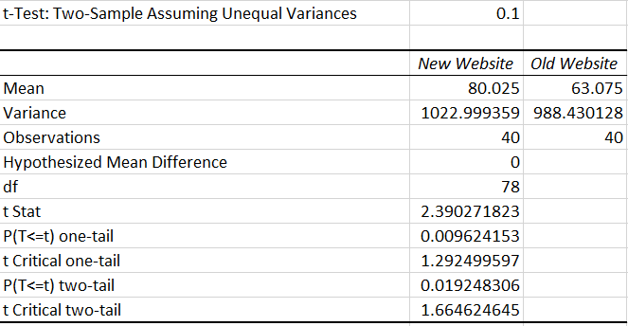

In this t-Test the level of significance is set at 0.10 (10%) which means that for this test, it is considered as (alpha) which is the probability of getting a type 1 error and also means that there is a less than 10% probability that the difference in means occurred by chance. Within the test, the variance and the observations were used to calculate the t Stat which ended up being 2.39 which is the same as the previous tests. Because the t Stat is higher than the t Critical which worked out as 1.66 in this example, the null hypothesis is rejected, and the alternative hypothesis is accepted which proves that the chosen hypothesis is right when using the above dataset.

5. Investigating the outliers

An outlier of data is when a specific point of data is in an abnormal distance from all the other values from a random sample datasheet. Failing to remove an outlier can distort results by dragging the mean which gives an unreliable result which would then result in any conclusion using this dataset being flawed. To remove any outliers, you first would need to discover what the normal observations of data are.

In this dataset for the number of sales on the old and new website there seems to be an obvious outlier that occurs at day 35 where both websites experience a surge in the number of sales. This data outlier could have been caused by a popular product being released at that specific date which would have resulted in the spike of number of sales as seen in the graph. Another possible explanation of this outlier could be that the website was advertised by multiple platforms e.g. Radio, TV, Newspaper etc… This would also result in a surge of sales as seen in the graph.

To test whether this outlier influences the results of the data, all three of the tests were re-done however, day 35 was removed from the data. The result of this was that it barely changed anything. The differences between these values were as follows:

0.05 | 40 days | 39 days | 0.01 | 40 days | 39 days | 0.1 | 40 days | 39 days
t Stat | 2.39 | 2.30 | t Stat | 2.39 | 2.30 | t Stat | 2.39 | 2.30
t Critical | 1.99 | 1.99 | t Critical | 2.64 | 2.64 | t Critical | 1.66 | 1.66

From looking at these test results, it’s clear to see that removing the outlier doesn’t influence the final data and that removing the outlier is unnecessary as it doesn’t distort the data. Another reason why the outlier wouldn’t need to be removed is that it has effects on both the old website and the new website almost equally. For the new website, day 35 say an increase of 48 sales whereas the old website saw an increase of 45 sales this means that removing this data wouldn’t change anything.

6. Discussion

Many factors could have affected the results that weren’t considered in the experimental setup some of these could include any additional discounts that could have been offered on one of the websites or on specific items which would mean that the website with additional discount would generate a higher number of sales which would make the data flawed which would result in the experiment being a fail.
A second factor that could cause data distortion that wasn’t covered in the initial experimental setup would be if either of the websites experienced any downtime e.g. the website hosting went down for several hours which would end up reducing sales and making the results of the experiment unfair and flawed, to control this, both of the websites should be hosted by the same provider so that if one of the websites were to go down then the other would also go down. This would ensure a fair testing area for the experiment as neither of the websites would benefit from the other going offline.
Another factor could be that the old website wasn’t updated and so only sold remaining stock for what was on sale before the implementation of the new website. To control this factor, the experiment makes sure that both websites receive the same updates at the same time which will offer equal offerings to both customers of the new website and the old website, this would result in a fair set of results when the experiment has concluded.
All of these factors could logically prove why one website was statistically better than the other so, to control these factors, the experiment would need to be under constant review to ensure that both websites were given equal offerings to maintain fair testing and ensure any concluded results are fair and accurate.

7. Conclusion

The results of the tests show that the alternative hypothesis stating that the company’s new website could offer more modern payment methods compared to the older website which would increase the number of sales on the new website due to people being able to use easy to use payment methods such as apple pay etc... is correct and results in the new website having a larger number of sales compared to the old website. The hypothesis shows that the new website is the better choice and that the company should replace their old website with this new one as sales are improved.

