Assignment Title: Assignment 1: Innovation & Research

2424748@student.uwtsd.ac.uk
University of wales trinity saint david
Modulo: Changemakers: Creativity and Value Creation
Modulo Code:ACCA5033
Lecturer Name : Dr. Faham Ahmad
Student Name : Tania Crespo
Student Number:2424748

Table of Contents
Introduction 2
Task _1: Mind Map – Changemaker Project 2
Task_2 Aim, Objectives, and Research Area 8
Task_3 :Types of Quantitative and Qualitative Analysis 12
References: 15
Appendices 17
Appendix A FocusFlow Mind Map 18
Appendix B – Evidence of Search Strategy 19

Introduction

FocusFlow is a user-centred digital support system created to help individuals with ADHD. It is designed to address key challenges such as difficulties with time management, starting tasks, and regulating emotions, all of which can have a significant impact on productivity and everyday functioning. The FocusFlow Ecosystem extends beyond a basic application by providing a comprehensive digital solution supported by structured services. It integrates technological tools with practical support strategies to build a more inclusive and flexible productivity environment tailored to neurodivergent users. This project aims to develop an adaptable and effective approach that brings together innovation, technological advancement, and multidisciplinary perspectives to create social, educational, and economic value. The ecosystem model acknowledges that ADHD-related challenges are not limited to digital contexts. For this reason, it combines digital tools with structured support systems to enhance long-term productivity, consistency, and overall wellbeing.

Task _1: Mind Map – Changemaker Project
The main objective of this mind map is to develop a solution that supports individuals with ADHD. It highlights key challenges such as difficulties with time management, task completion , and emotional regulation. The mind map integrates principles from creativity, human-centred design, and value creation to propose a digital ecosystem that promotes inclusion . The project demonstrates changemaker principles by using technology and long-term solutions to address a real-world problem [1].
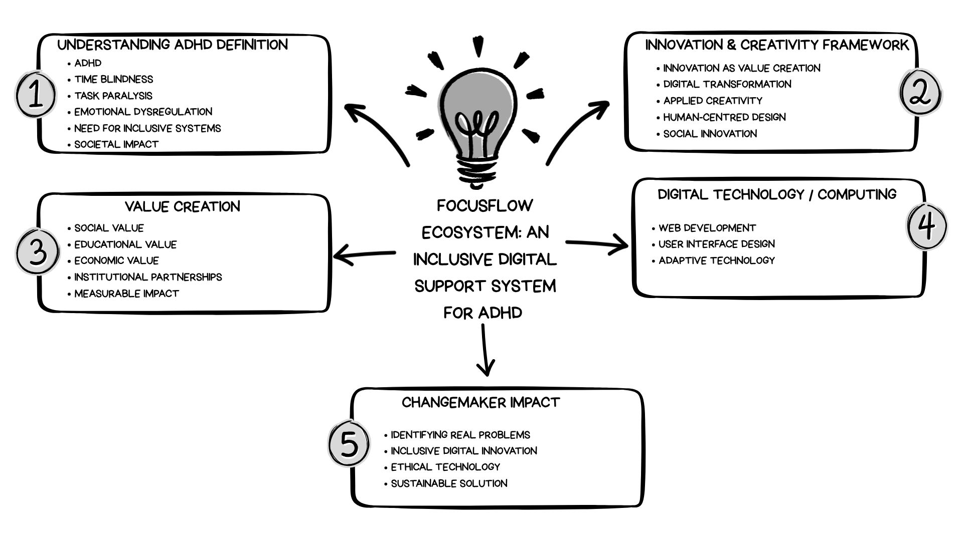
Figure: 1 Mind Map
The FocusFlow project used Canva to create the mind map. It addresses key area including ADHD-related challenges, creativity, value creation, and the proposed FocusFlow system.

My Mind Map Explanations
Understanding ADHD Definition:
- ADHD is a recognized neurodevelopmental condition that affects attention regulation, executive functioning, and emotional control [1]. These cognitive differences influence academic performance and productivity outcomes.
- Time Blindness: Individuals may struggle to perceive and manage time accurately, leading to missed deadlines and inconsistent task completion.
- Task Paralysis: Large or complex assignments may create cognitive overload, reducing motivation and delaying task initiation.
- Emotional Dysregulation: Increased sensitivity to stress may affect confidence, concentration, and emotional stability in learning environments.
- Need for Inclusive Systems: ADHD highlights the importance of inclusive productivity systems.
- Societal Impact: These challenges emphasise the need for innovative solutions such as the FocusFlow Ecosystem to improve inclusion, productivity, and wellbeing.

Innovation & Creativity Framework
- Innovation as Value Creation: Creativity in this project is solution focused. addressing a real-world problem through technological design[2] .
- Digital Transformation: Digital transformation involves rethinking traditional productivity tools by designing a technology-based system adapted to neurodivergent users.
- Applied Creativity: This project is solution-focused, addressing a real-world problem through technological design.
- Human-Centred Design: Design decisions are based on user needs.
- Social Innovation: Technology is used to improve wellbeing, inclusion, and quality of life.

Value Creation
- Social Value: The FocusFlow Ecosystem reduces anxiety and promotes independence(Drucker, 1985).
- Educational Value: Enhances independence, improves task completion, and builds confidence through adaptive support structures. The application of computing skills such as web development and supports the development of this system.
- Economic Value: The ecosystem may operate through a freemium model and institutional partnerships, creating sustainable revenue opportunities.
- Institutional Partnerships: Collaboration with universities and workplaces can support the implementation of inclusive productivity systems.
- Measurable Impact: Potential outcomes are greater efficiency and regularity. This can help you feel less anxious and better control emotions, which can help you complete tasks more quickly.

My Creative Solution – FocusFlow Ecosystem.
- Purpose: The FocusFlow Ecosystem is a structured and scalable digital support system designed specifically for individuals with ADHD. It combines a core digital application with complementary support tools to create inclusive and adaptive productivity solutions. This ecosystem approach addresses structural gaps in traditional productivity systems by prioritising neurodivergent cognitive models.
- Core Component – Smart ADHD App: It includes features such as intelligent task segmentation, time visualization using a colour-coded system, scheduled focus markers, and emotional state tracking. These tools are designed to support users in managing daily pressure, encouraging task initiation, and strengthening consistency in work routines.
- Visual Time System: incorporates colour-coded progress bars and visual indicators within the application interface to represent time in an accessible and understandable way. This supports individuals who experience time blindness in digital environments.
- Parent Support Resource: Offers practical and evidence-informed strategies that help families create structured and emotionally supportive home environments. This strengthens long-term behavioural consistency beyond educational settings.
- Visual Time Device: A complementary physical timer designed to provide tangible, real-world visual time cues. This device supports individuals who respond more effectively to concrete and highly visible time indicators outside digital screens
- Educational Toolkit: Provides structured guidance for teachers and educational professionals to ensure classroom strategies align with digital support tools. This promotes consistency between technological and academic environments
- Hyperfocus Timer: Introduces structured 15–45-minute focus sessions designed to balance concentration and prevent burnout. Encourages sustainable productivity rhythms.
- Emotional Check-In: Tracks mood patterns and suggests adaptive coping strategies. Supports emotional regulation and self-awareness.
- Gamification Rewards: Uses positive reinforcement mechanisms to increase motivation, engagement and task completion consistency.

Changemaker Impact
- Identifying Real Problems: A changemaker recognises unmet societal needs. This project addresses ADHD-related productivity challenges through technological innovation.
- Inclusive Digital Innovation: FocusFlow adapts productivity tools to neurodivergent users, promoting accessibility and inclusion rather than traditional one-size-fits-all systems.
- Ethical Technology: The design respects privacy, promotes wellbeing and avoids harmful productivity pressure.
- Sustainable Solution: The system is flexible and scalable, with opportunities for strategic partnerships that can enhance its long-term social impact.

Digital Technology / Computing:
- Web Development: Enables the creation of the FocusFlow digital platform, allowing users to access tools that support task management and productivity.
- User Interface Design: Ensures the system is simple, accessible, and easy to use, helping individuals with ADHD interact with the platform effectively.
- Adaptive Technology: Allows the system to adjust to different cognitive needs, providing flexible and personalised support for users with ADHD.

Task_2 Aim, Objectives, and Research Area
The project is about computers and virtual imaginative thinking, and it aims to make technology easier for those with attention-deficit hyperactivity disorder (ADHD).
The National Health Service (2023) [3]. says that ADHD is a brain development disorder that changes the way individuals think, plan, and control their feelings. The above-mentioned challenges greatly affect your study habits, time management, and academic performance.
Proper care of psychological well-being in an equal manner is becoming more and more important around the world. The World Health Organization (2023) [4] states that systems that are simple to use, reduce inequality in society, and improve health are extremely significant. Even though technology is always getting better, many methods of productivity are still developed using neurotypical cognitive models. This may make such systems more difficult for neurodivergent individuals to use effectively.
Personal experiences of ADHD-associated learning difficulties in a family setting have also influenced this effort. As a parent of a child with ADHD, I have seen personally how challenges with organization, time management, and emotional control impact learning opportunities.
This understanding makes the research more relevant in real-world contexts life and fits with problem-focused creativity, which uses what you know to develop technological solution that benefit those around you. This particular area of subject matter has been extremely significant considering that it is linked to research on how technology is changing. It adopts the rules associated with developing adaptive technology, adapting in a way to benefit people, and making digital systems that can help individual with diverse cognitive abilities identify actual-life issues. The project applies innovation, creative thinking that puts people first, and new social technologies to make a digital help tool that can grow and incorporates software and planned innovations in technology.

Q1. Aim and Objectives
Aim
The aim of this project is to design and critically evaluate a human-centred digital productivity system (FocusFlow) that supports individuals with ADHD by promoting inclusive, ethical, and sustainable value through technological innovation.
Objectives
- To critically examine the cognitive and productivity issues linked to ADHD in academic and professional settings.
- To review the current state of research on value generation, innovation, and digital transformation in inclusive systems of technology.
- To create a theoretical framework for the FocusFlow ecosystem, which involves a main productivity program along with additional organized support instruments like graphical time systems and learning resources.
- To evaluate how the proposed ecosystem contributes to social inclusion, educational performance, and long-term wellbeing.
- To assess ethical considerations, accessibility principles, and sustainability within inclusive digital innovation.
- To explore the scalability and potential integration of hardware and educational components within the broader FocusFlow system.

The theory of innovations says that creativity is the procedure of transforming knowledge into useful outcomes. These goals fit with this concept. The ecosystem model additionally demonstrates how innovative disruption works, as different system design helps groups that do not receive enough support [5].

2 . Research Philosophy
Pragmatic thinking is the best philosophical approach for this subject. The philosophy of pragmatism promotes practical, solution-oriented research that addresses real-world issues instead of just focusing on abstract concepts from theory. It is stated that pragmatic thinking enables investigators to combine many approaches and points of view to produce practical and politically relevant findings [6]. Pragmatism is particularly appropriate in innovation-driven research where solutions must demonstrate measurable practical impact rather than purely theoretical insight. This project does not aim solely to conceptually analyse ADHD but also to design a functional and scalable digital support system. The integration of lived experience strengthens the applied dimension of research while maintaining academic rigor. Pragmatism, therefore, supports the alignment of theory, technological design, and measurable innovation outcomes [7].
3. Search Tools and Research Strategy
To preserve academic credibility and methodical precision, numerous study tools and information sources were carefully used.
- Google Scholar was used to find peer-reviewed research from multiple disciplines related to ADHD, creativity, and technology, which is accessible to all individuals.
- The Scopus platform gave those interested in computers and technological advances access to exceptionally important journal articles.
- It is searching for psychologically understood ADHD and neural developmental papers in PubMed, a medical journal.
- IEEE Xplore provides the opportunity to explore technical studies on the development of electronic structures and engineering solutions.
Keywords included: ADHD productivity technology, Digital innovation AND inclusion, Human-centred design in education, Neurodiversity AND digital tools, Value creation in digital systems. Boolean operators (AND, OR) and quotation marks were applied to refine search accuracy. Filters were used to prioritise peer-reviewed and recent publications, strengthening reliability and relevance. This structured research strategy ensures that the proposed ecosystem is grounded in evidence-based innovation practices and aligns with systematic academic research standards.

4 . Justification of Research Approach:
The way of study chosen combines theoretical models with practical applications. Google Scholar, Scopus, PubMed, and IEEE Xplore are all academic databases which make sure you can go to reliable sources. Using standard keywords and logical operators makes searches better and useful. Multidisciplinary sources help create a useful digital system, which shows a practical approach that focuses on real-world results.
Task_3 :Types of Quantitative and Qualitative Analysis
Introduction
Research methods can be divided into quantitative and qualitative methods. Quantitative analysis focuses on numerical data and statistical measurement, while qualitative analysis explores meanings, behaviours, and experiences. Both approaches are essential in creativity-focused research, as they provide different perspectives when evaluating technological systems such as the FocusFlow Ecosystem [8].
Quantitative Analysis
Quantitative research involves the collection and analysis of numerical data to identify patterns and relationships.[9]. Descriptive statistics summarise data using measures such as mean and standard deviation. For example, it can measure task completion rates before and after using FocusFlow. Inferential statistics allow results to be applied to a wider population using methods such as hypothesis testing.[10]. Correlation analysis examines relationships between variables, such as the link between visual time tools and productivity. Experimental methods can also be used by comparing a group using FocusFlow with a control group to measure effectiveness.
Qualitative Analysis
The qualitative method focuses on understanding people's experiences, behaviours, and perceptions. Thematic analysis identifies patterns in user feedback, such as emotional regulation and stress management. Content analysis categorises responses from surveys or discussions into meaningful groups. Case studies provide detailed insights into how user behaviours develop over time. Narrative analysis explores personal experiences, which is particularly relevant in ADHD-related research. These methods provide deeper insights that complement quantitative findings[10].

Application to the FocusFlow Ecosystem
A combination of methods strategy uses both quantitative and qualitative data, which makes research more reliable. Quantitative information can tell you how efficient you are and how well you manage your time, while qualitative evidence can tell you how happy and mentally healthy you are. This integrated method gives us greater knowledge of how the FocusFlow Ecosystem relates to the general public [[11].
Validity, Reliability, Generalisability and Ethical Considerations
To ensure research quality and credibility, key principles must be considered.
- Validity: This is concerning if the research in fact measures what it says it is going to do. This project will utilise data gathering technologies to evaluate productivity, time management, and emotional control in patients with ADHD.
- Reliability: relates to the consistency of results. This will be achieved through structured and standardised methods such as surveys and repeated testing.
- Generalisability: focuses on if the outcomes can be used by more people. The FocusFlow Ecosystem is meant to work in many various areas, not only schools. It can also be implemented in homes and places of employment as well.
- Ethical considerations are essential due to the involvement of neurodivergent individuals. The study will ensure:
- Informed consent
- Data privacy and confidentiality (GDPR)
- Protection from psychological harm
- Respect for neurodiversity
These principles ensure the research is conducted responsibly and meets academic standards.

Data Collection Methods and Pilot Study
To support the development of the FocusFlow Ecosystem, a combination of data collection methods will be used.
Primary data collection methods include:
Surveys: Structured questionnaires using Likert scales to measure productivity, focus levels, and emotional wellbeing
Interviews: Semi-structured interviews to explore user experiences and behavioural changes
System Data Analysis: Monitoring user interaction data such as task completion rates and time usage
A pilot study will be performed to see if the proposed system works. A small group of people (around 5 to 10) will use a conceptual or preliminary version of the FocusFlow system for a brief period of time.
The pilot study aims to:
- Identify usability issues
- Evaluate user engagement
- Collect feedback for system improvement
Participants will complete a short questionnaire and provide feedback based on their experience.

References:
[1] World Health Organization, Working for a brighter, healthier future: how WHO improves health and promotes well-being for the world’s adolescents, World Health Organization, 2024.
[2] J. J. Ashman, L. Santo, Z. J. Peters, T. Okeyode, and D. Gidali, "Visits to Health Centers by Adults With Attention-Deficit/Hyperactivity Disorder: United States, 2023," in NCHS Data Briefs [Internet], National Center for Health Statistics (US), 2025,
[3] J. Creswell, Research design: Qualitative, quantitative, and mixed methods, Sage Publications, 2003.
[4] C. Christensen, "The Innovator’s Dilemma: When the technologies cause great firms to fail. Harvard Business School Press," 1997,
[5] P. Drucker, "Entrepreneurship and innovation: Practice and principles," 1985,
[6] A. Tashakkori and C. Teddlie,Sage handbook of mixed methods in social & behavioral research, SAGE publications, 2021.
[7] A. Bryman, Social research methods, Oxford university press, 2016.
[8] L. Cohen, L. Manion and K. Morrison,Research methods in education, Routledge, 2002.
[9] M. Saunders, P. Lewis and A. Thornhill,Research methods for business students, Pearson education, 2009.
[10] J. Creswell, Research design: Qualitative, quantitative and mixed methods, Sage Publications., 2003.

Appendices

The following appendices provide supplementary supporting information relevant to the development of the FocusFlow Ecosystem project. These materials offer additional evidence of the research and creative development process.

Appendix A FocusFlow Mind Map

Appendix B – Evidence of Search Strategy

PubMed
Google Schola


IEEE Xplore
Scopus platform

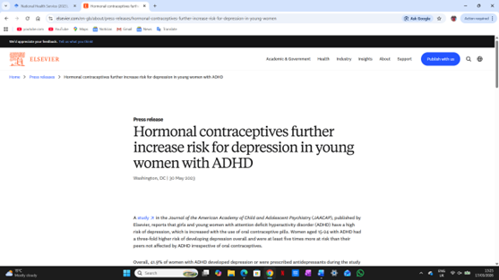
This appendix provides an overview of the search strategy used to identify relevant academic sources for the FocusFlow project.
Keywords Used
- ADHD productivity technology
- Digital innovation AND inclusion
- Human-centred design in education
- Neurodiversity AND digital tools
- Value creation in digital systems
Search Strategy
Boolean operators such as AND and OR, as well as quotation marks, were applied to refine search accuracy and improve the relevance of results.
Filters were used to prioritise peer-reviewed sources and recent publications, ensuring the reliability and academic quality of the selected literature
Research Approach
This methodical research process assists in creating the FocusFlow ecosystem by making certain that a project is built on scientifically proven innovation procedures and follows the rules of methodical scholarly research.

