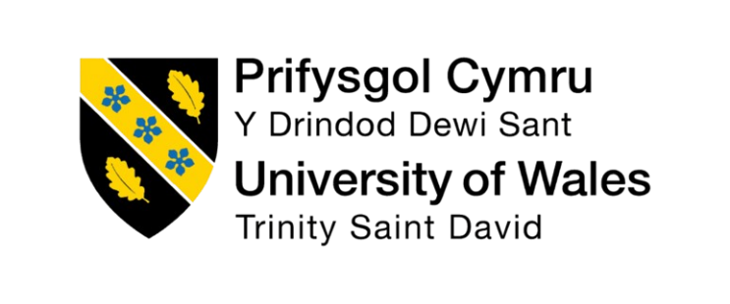

Programme Name: Master in Business Administration in International Business

Module Title: INTERNATIONAL MARKETING: PRINCIPLES AND PRACTICES
Module Code: LCMB7026

Report Title: Comparative Analysis of Starbucks’ International Marketing Strategies in the India and United Kingdom

Name: Rohan Adodariya
ID: 2434156

Lecturer Name: Taonga Kaonga Sobere-Snithers
Submission Date: 14 nov 2025

Word Count: 5036

Table of Contents
Introduction 3
Brand overview 3
Comparison of the socio-cultural context of the UK and India 4
Comparison of Brand’s STP strategies in the UK and India 6
Comparison of Marketing Mix Strategies in the UK and India 11
Evaluation of the performance of marketing strategies 15
Evaluation of marketing ethics practice 16
Recommendation & Conclusion 16
Reference List 18
Appendices 23
Appendix 1: Starbucks’ Products 23
Appendix 2: Marketing Strategy 23
Appendix 3: Growth of Starbucks 24
Appendix 4: Growth of Starbucks in the UK 24
Appendix 5: Marketing Strategy for India 25
Appendix 6: Business Evaluation 25
Appendix 7: Competitors of Starbucks in India 26
Appendix 8: Competitors of Starbucks in the UK 26
Appendix 9: FY24 Income Statement 27
Appendix 10: Target Consumers 27

Introduction
Starbucks originated in Seattle, USA, in 1971, and is recognised as one of the predominant coffeehouse chains globally for its speciality coffee blends, authentic café experience and powerful brand identity internationally. Operating in over 80 markets, Starbucks modifies its marketing and operating strategies to reflect local cultural, economic, and consumer behaviour patterns (Starbucks, 2025). This report analyses the marketing strategies that Starbucks implements within two different markets, the United Kingdom and India. The two markets demonstrate different degrees of coffee culture maturity, consumer behaviours, economic systems, and cultural expectations. Starbucks entered the UK in 1998, following its acquisition of the Seattle Coffee Company, to operate in a highly developed and competitive coffee environment (Starbucks, 2024). In comparison, its entry into India took place in 2012 with a joint venture with “Tata Global Beverages”, conveying a need for an experienced local partner. In addition, the Indian market is dominated by tea culture and distinctive use habits.
This report reviews Starbucks’ marketing strategies in two diverse markets, the United Kingdom and India, comparing Starbucks’ “macro-environmental influences”, “segmentation-targeting-positioning (STP)” strategies, and the marketing mix within both markets, evaluating performance, ethical considerations, and global marketing suggestions for the future, including viable improvements to its operations.

Brand overview
Starbucks launched in the UK market in 1998, following the acquisition of Seattle Coffee Company, and has since established itself as one of the leading players in the British coffee shop market, competing with the likes of “Costa Coffee” and “Caffè Nero”. Users were changing their habits to support on-the-go consumption, and there was an increase in demand for convenient, high-quality coffee (Starbucks, 2024). The Starbucks approach to the UK was built upon dense store expansion, convenience, premium positioning, and, now, with a growing consideration of sustainability initiatives for more socially aware users. Currently, the UK is one of Starbucks’ most developed international markets with over 1,200 stores in high streets, train stations, airports, and university campuses. Starbucks entered the Indian market in a joint venture with Tata Global Beverages in 2012, operating under the title “Tata Starbucks Limited” (Starbucks, 2024). This granted Starbucks instant access to local knowledge and supply chain capabilities, along with local cultural insight.
The beverage culture in India has primarily been tea-driven for many decades; however, with a changing demographic, including rapid urbanisation, a growing middle class and aspirational consumption, coffee culture has become increasingly interesting to local consumers. Starbucks capitalised on the trend by positioning itself as a premium lifestyle destination for young consumers, specifically urban professionals and millennials interested in modern café environments. The company successfully grew its store footprint, now exceeding more than 390 stores in metropolitan areas, by actively innovating local menu items to suit local tastes, designing stores inspired by Indian culture, and creating an experience with high-quality service (Tata Starbucks, 2024). The Starbucks concept in both the UK and India parallels their overall global agenda, whereby the brand emphasises quality, a quality customer experience, and quality brand consistency, all while adapting products depending on regional taste and preferences.

Comparison of the socio-cultural context of the UK and India
The socio-cultural context in the UK and India is markedly different and will influence Starbucks’ marketing and consumer engagement strategies.
Socio-culture in the UK
The socio-cultural environment within the United Kingdom shows a developed and mature coffee culture, which has developed over the last twenty years to become deeply embedded into lifestyles and routines to function both as a social and functional need. Whilst historically tea has been the nation's beverage, coffee is clearly an everyday requirement for consumers in the UK, and consumers in the UK often adopt fast-paced lifestyles that often assume coffee consumption will occur within them as a first-world consumption practice (Gosalvitr et al., 2023). This obvious trait of UK culture corresponds to urban lifestyles, which revolve around efficiency and speed of consumption. As a result, a coffee shop like Starbucks is not just a leisure destination, but a place for commuters, professionals, and students to situate themselves. The coffee culture in the UK is very much ingrained into society, with a high consumption level and an inclination towards speedy service and takeaway forms of coffee (Mintel, 2023). Consumers are also increasingly concerned with aspects such as ethical sourcing, sustainability, and product quality.
An alternative feature of consumer culture in the UK is the growing concern for ethical, sustainable and socially responsible consumption. Consumers in the UK are conscious of environmental matters, and want to embrace brands that are authentically committed to sustainability, fair-trade and transparency within their corporate practices (Moesviara, 2022). The ethical cultural tendency affects purchasing decisions, resulting in quite a number of brands moving towards recyclable packaging, carbon-neutral projects and transparency within their supply chains. Consumers in the UK embrace customisation and choice, and this trend towards personalisation with beverages and plant-based alternatives all fall sensibly in line with Starbucks' global product strategy and offer the UK consumer the option for dietary choice (Ozieranski et al., 2023). Digital adoption is also prominent in the UK, with consumer engagement in online ordering systems, loyalty apps, and food delivery platforms. All of these socio-cultural aspects help shape the UK into a modern, competitive, and ethical coffee market.
Socio-Cultural Context of India
The socio-cultural context of India presents a stark contrast to the UK. Beverage consumption has traditionally been dominated by tea and continues to be central to households, communities, and social companionship in India. Tea is extremely symbolic in Indian culture in terms of hospitality and warmth, and sociability. Despite this deep-rooted tradition, the rapid urbanisation and increases in individual disposable income levels, combined with increasing exposure to global culture, have resulted in a growing acceptance of coffee as a lifestyle beverage (Statista, 2024). The shifting of a primarily tea-drinking society towards coffee is particularly evident amongst India's urban youth, young professionals, and students who increasingly view coffee shops as modern social environments.
In India, beverage culture has historically been dominated by tea, but urbanisation and growth of the middle-class youth have created a burgeoning coffee culture. Starbucks targets affective millennials and young professionals reaching for aspirational lifestyles and experiences, which are then shared with their social circles (DPIIT, 2024). A defining aspect of India's social and cultural context is aspirational consumption patterns. Indian consumers view international brands such as Starbucks as markers of status, modernity, and global awareness. The act of going to Starbucks often entails lifestyle identity, social belonging, and personal success. This cultural stance puts consumers in the frame of mind to invest in the experience and prestige of the brand as part of the cost of doing so. In addition, India's demographic profile—its massively youthful population—also factors in fairly importantly, too (FSSAI, 2023). Younger people tend to be more engaged with global food trends, open to the cafe experience, and interested in being in places that are comfortable and visually appealing for working, studying, or being social.
Cultural preferences also shape product expectations—as Indian consumers exhibit a strong interest in local flavour and food diverse range of regional cuisines. Café patrons in India, unlike coffee patrons in Western non-immigrant markets, expect food in addition to the beverages and want to see products that rely on familiar spices and ingredients and bring forth tastes from regional cuisines (Robichaud and Yu, 2022). Likewise, the norms of hospitality in India would expect friendly and attentive service, and personalised engagement, which in turn shapes consumer expectations and experiences regarding service. For this reason, it is not surprising that Starbucks in India is often geared toward a more local engagement and experience with consumers through the ambience of the store.
Impact of Significant Socio-Cultural Differences on Starbucks
The differences in socio-cultural contexts in each country impact Starbucks' marketing strategies. The UK is a mature, convenience-oriented, and ethically conscious market that consumes coffee routinely and functionally. The growing Indian market is aspirational, younger-focused, and emerging, where coffee culture does not exist yet, and consumption is influenced by lifestyle aspirations and cultural preferences (Wang et al., 2024). Starbucks requires differentiation in product strategy, promotional activity, store format, and customer engagement, as it pertains to customer expectations and brand relevance in both markets.

Comparison of Brand’s STP strategies in the UK and India
Market Segmentation
UK
Demographic Segmentation
Starbucks demographically segments UK consumers primarily by age, occupation and lifestyle stage. Young adults and university students comprise a key portion of footfall, looking to use Starbucks spaces for group study, social meet-ups and casual work. In the UK, Starbucks segments their markets into urban professionals, students, and ethically minded consumers who are interested in premium, sustainably sourced coffee (BBC News, 2023). Working professionals aged 25-50 comprise another key demographic group, driven by daily routines, commuting patterns and workplace culture. These consumers are looking for quality coffee, while also looking for speed, efficiency and convenience. In addition, middle-income households are also regular Starbucks consumers as part of everyday life, which is lured by the brand’s consistency and familiarity.
Geographic Segmentation
In terms of geographic segmentation, Starbucks’ presence in the UK is primarily concentrated in urban areas, within densely populated areas. Larger cities such as London, Manchester, Birmingham, and Edinburgh demonstrate several Starbucks outlets in small geographic areas to maximise local availability. Starbucks stores are also located adjacent to foot traffic areas such as major train stations, airports, business districts and university campuses (Financial Times, 2024). This geographic segmentation is purposeful to meet the UK culture of commuting and pickle consumption.
Psychographic Segmentation
Psychographic segmentation is crucial in the elaboration of Starbucks' UK strategy. Many British consumers value sustainability, ethics, and eco-conscious consumption. Starbucks appeals to those interests through responsible sourcing of coffee, recyclable cups, and waste reduction strategies. Another psychographic segment consists of consumers who value customisation of their beverages and healthy alternatives, such as plant-based milk and low-calorie options (Salini and Simamora, 2024). These consumer preferences are fundamentally compatible with Starbucks' global menu and customisation.
Behavioral Segmentation
From a behavioural perspective, Starbucks' UK customers are established coffee consumers who habitually purchase coffee as part of their daily lives. They regularly buy their coffee from Starbucks to build up points through the loyalty program, demonstrating their loyalty to Starbucks. Another behavioural segment consists of digital-first consumers who rely on mobile ordering and/or delivery services (The Guardian, 2023). These behaviours were encouraged through the Starbucks Rewards app, promotions through digital media, and partnerships with delivery services.
India
Demographic Segmentation
India's demographics are quite different. Starbucks targets younger consumers, particularly millennials and Gen Z, who have been exposed to global brands and are likely to have more disposable income and are enthusiastic consumers of Western café culture. The segmentation considers a collection of urban demographic groups (Mishra et al., 2025). Young professionals – those in IT, banking, consulting, and the creative industries – have become a major source of Starbucks clientele because they appreciate Starbucks for meetings or work sessions. Upper middle-class families are another key demographic for Starbucks; they typically enter cafés as a social and leisure occasion.
Geographic Segmentation
Starbucks’ geographic segmentation in India is largely focused on metropolitan cities; a model consisting of large cities with Mumbai, Delhi, Bangalore, Chennai, Hyderabad, and Kolkata at the forefront, all of which have the most earning potential, are cosmopolitan, and have a greater readiness to adopt and accept global lifestyle trends. Starbucks has recently begun to expand into Tier-2 cities, where younger consumers are increasingly participating in a café culture of sorts (The Economic Times, 2024). Starbucks stores are typically located in malls, a business district, or an upscale neighbourhood to reach consumers who are capable of spending a higher disposable income.
Psychographic Segmentation
Psychographic segmentation plays the most prominent role in Starbucks’ strategy in India. Indian consumers are often more positive about international brands than local brands, and consumers often view international brands as aspirational and symbolic of a modern lifestyle. Therefore, Starbucks appeals to consumers who are seeking to elevate their social experience, premium service, and a pleasant environment for social media sharing. In this psychographic segment, some individuals also view Starbucks as a representation of prestige and sophistication, and an opportunity to engage with global culture (Mint, 2024). The brand targeting this segment is broader and also targets consumers who appreciate local flavour fused with international flavour and menu innovation, which is reflected in items like Masala Chai, filter coffee, and Indian inspired food items.
Behavioural Segmentation
Behavioural segmentation in India identifies customers who are primarily driven by ambience and experience rather than coffee consumption. Many Indian customers visit Starbucks for social occasions, studying, group work, or leisurely time, and many customers appear to spend longer periods of time inside stores compared to UK consumers (Pandey et al., 2021). In mixed or in moderation, Indian customers also behave by appreciating novelty and variety with food pairing, and thus, the food menu is more characteristically influential on their purchasing behaviour. This segment's frequency of visit is lower due to more disposable income in comparison to the UK. However, the average spend for a day visit is higher due to Starbucks charging more for the premium experience.
Targeting
UK
Starbucks employs a broad target strategy in the UK market, targeting multiple segments of consumers. Starbucks occupies a unique position in the UK coffee culture, and meeting the expectations of various demographics in a premium market is made far easier by the well-established acceptance of premium products in British coffee culture (AWC, 2024). The broadest demographic of the Starbucks consumer includes commuters, students, workers, families, and ethical consumers. The targeting strategy emphasises convenience, reflected in its high density of store presence and applications of technology with its “Starbucks Rewards app”.
One significant target market for Starbucks in the UK includes customers looking for convenience and speed while enjoying their premium beverage. These customers may order ahead of time with the Starbucks mobile app or use a drive-thru to get their coffee while on their commute to work, using Starbucks technology and mobile payment capabilities to enhance their experiences (Mintel, 2023). As a consequence of raised awareness about environmental sustainability and personal health, Starbucks also appeals to consumers who search for plant-based alternatives, whose products offer ethically sourced options, and a less of carbon impact. Consumers closely respect Starbucks' campaigns articulating their ethical and sustainability communications. Another major target market for Starbucks exists, specifically to habitual coffee drinkers in the UK who purchase coffee from the store anywhere from daily to multiple times a week (Ferreira et al., 2021). Starbucks appeals to habitual coffee drinkers by offering rewards programs, promotions that support subscriptions, and consistency in product and experience quality.
India
In India, Starbucks utilises more of a niche targeting strategy that caters to affluent millennials and young professionals who see the brand as related to lifestyle aspiration on a global scale. Starbucks utilises a niche, premium targeting strategy within India. This strategy targets urban consumers who have financial resources (disposable income) to pay premium prices and value Starbucks as a social and global status identifier. Members of the affluent segment are attracted to high-quality service, contemporary and attractive store designs, and an international image (Manojkumar et al., 2021). India has one of the largest populations of youth (ages 18 to 34) in the world, and Starbucks also engages in targeting millennials and Gen Z consumers who are frequently searching for socially appealing locations to meet friends and study, or use their laptops to work. This group tends to be highly attracted to global brands, digital marketing, and beautiful cafés spaces (interiors) around developing consumption occasions.
The next small segment within this target group is young professionals who work in the corporate sector. They tend to use Starbucks locations for meetings, creating collaborative ideas, and/or working individually. The younger professional group also tends to share traits with the upper-class group (high income, age) in that they prefer to use Starbucks for convenience (or re-purposed time) and cost, and a potential social experience (space, comfort, premium coffee). Many Indian consumers may choose to visit Starbucks simply as a convenience (cardio consumption) or a premium outdoor lifestyle experience (Melliyanti et al., 2023). Starbucks markets this group by developing spacious interior design schemes that can accommodate multiple customers (and preferably adults) meeting for social justice, free wifi, and cultural orientation, which have indicators of people as "ambient type" coffee shop. Starbucks develops destination-type coffee shops vs. speciality coffee quickly consuming coffee shops.
Positioning
UK
In the UK, Starbucks occupies the premium pricing segment of the brand value continuum, as prices indicate quality rather than exclusivity, allowing Starbucks to capture a more extensive socio-demographic market. Sustainability is an essential dimension of Starbucks' UK brand position, as sustainability is a key brand element that showcases the Starbucks brand as supporting ethically sourced coffee, recyclable packaging, and reduced waste initiatives (Zhang, 2023). This positioning connects with UK consumer values and builds trust with the coffee shop brand. Starbucks also positions itself within the coffee segments of brands that understand the UK consumers' fast lifestyle, in that the Starbucks brand demonstrates conveniences for the consumer through mobile ordering, quick service, drive-thru stores, and app-based benefits that represent knowledge and sophistication around digital technology (Carter et al., 2023). The positioning strategy emphasises the premium aspect of the product, while also emphasising accountability and a consistently high-quality experience relative to developing sustainable agricultural practices worldwide.
India
Starbucks is an upscale and aspirational brand across India. Starbucks' international identity is largely responsible for shaping consumers' perceptions of the brand, making it a representation of contemporary living and sophistication. While Starbucks remains an alluring, global brand, it appeals to Indian consumers by using local flavours, co-creating with Tata, and designing stores that include local elements of the Indian culture. This global-local hybrid position strengthens emotional connection to the brand among consumers. Starbucks emphasises itself as a destination for socialising, celebrating, and leisure activities (Kuek et al., 2024). Indian consumers often utilise Starbucks for relaxation, a place to take pictures, and extended periods of time, which reinforces its value to the experience. Starbucks' positioning strategy in the Indian market builds on cultural fusion: offering global products and providing products that reflect regional flavours, including a partnership with Tata.

Comparison of Marketing Mix Strategies in the UK and India
Product Strategy
UK
The UK Starbucks embodies almost the entire global assortment of coffee beverages in its product strategy—they offer cappuccinos, lattes, espresso, macchiatos, and cold brews, to name just a few. This product range is a reflection of the established nature of the UK coffee market and the expectations of British consumers that they will receive high-quality and highly standardised coffee products (Sadri and Aprianingsih, 2025). The United Kingdom has extensive experience with international coffee culture. The brand also provides a wide array of bakery items—pastries, muffins, cookies, and breakfast sandwiches—all designed to cater to the busy British lifestyle, preferring a grab-and-go option. Additionally, the UK product strategy features a strong emphasis on plant-based alternatives; they have vegan food options, and also offer dairy-free milk substitutes like oat milk, coconut milk, and almond milk, which aligns with consumer concerns around health and ethical consumption (Kim and Park, 2021). Seasonal beverage offerings like the Pumpkin Spice Latte, or drinks offered exclusively during the holiday season, also generate product interest and serve as drivers of repeat visits.
India
In India, though, Starbucks’ product strategy is much more local. They still incorporate a number of the global favourite offerings, such as cappuccinos and caramel macchiatos, while tailoring the menu to integrate many Indian-inspired food offerings, such as the “Chicken Kathi Roll” and “Tandoori Paneer Sandwich”, and made-in-India beverage offerings like the “Masala Chai Latte” and “Elaichi Mawa Croissant”. Indian-style filter coffee fits regional preferences in India, especially for South Indian customers, who value filter coffee as part of their culture. Starbucks also prioritises vegetarian food choices because of the significant vegetarian population in India (Siwu et al., 2023). Many stores feature menu variations based on geographic confinement to include regional ingredients, spices, and traditional food preparation techniques for Indian customers. This level of localisation contributes to Starbucks's branding and keeps the company from being a completely foreign brand experience, but more of a foreign, global brand with respectful local sensibilities that contribute to customers accepting the brand.
Pricing Strategy
UK
Starbucks implements a pricing strategy that involves premium pricing in the UK, which is in line with the global position of the brand. Nonetheless, prices are still competitive with companies like “Costa Coffee”, “Caffè Nero”, and “Pret A Manger”. British customers are accustomed to paying higher prices for coffee due to high-quality coffee offerings, ethical sourcing claims, and added value, all indicative of the Starbucks offer (Liu, 2022). The pricing structure is consistent with the relatively high disposable income of consumers in the UK and the individual's willingness to pay for convenience or consistency of product and brand.
India
In India, Starbucks also uses a premium pricing strategy, but in reality, the pricing construct between Starbucks and local cafés is much wider than in the UK. Many local coffee chains and independent cafés sell beverages at a much lower price point. Consequently, Starbucks is an inherently premium, aspirational brand. This works well with the conceptualisation of the Starbucks brand as a symbol of luxury and modernity. In reality, however, this high pricing construct limits access to middle-income earners, especially in “Tier-2 and Tier-3” cities (The Economic Times, 2024). Nevertheless, Starbucks manages to attract wealthy individuals, and the rising urban middle class, who are willing to pay for a better quality, ambience, and brand prestige. The use of premium pricing works to reinforce exclusivity and fulfils the aspirational expectations of many consumers.
Place Strategy
UK
Starbucks has a very extensive distribution strategy in the UK with over 1,200 stores that are mainly located in metropolitan areas, transport hubs, primary shopping districts, and university campuses. The place strategy is focused on being accessible, convenient, and visible. Many UK stores have drive-thru locations to target commuters and suburbanites (Helmold, 2022). Starbucks also expands its place beyond its own store locations by providing ready-to-drink bottled beverages that consumers can buy from grocery and retail stores, and offering delivery options through services like Uber Eats to raise brand awareness and reach busy consumers.
India
Starbucks’ place strategy in India is much more concentrated as it has approximately 390 stores, situated mostly within metropolitan areas, including Mumbai, Delhi, Bengaluru, and Hyderabad. Expansion in India is slower and far more selective than in the UK, largely because of high real estate costs, the social and economic diversity, and different appetites for what a cafe is and does throughout the country. The majority of Starbucks stores in India focus on affluent neighbourhoods, often in premium malls or business districts for high-income consumers (Bao, 2022). Starbucks has begun the process of expanding into Tier-2 cities in India, but this is minor compared to the UK strategy. The brand is positioned more towards premium distribution and visibility, rather than mass accessibility.
People Strategy
UK
Starbucks’ workforce strategy prioritises professionalism, efficiency, and friendliness when it comes to customer service delivery in the UK environment. Baristas are trained to perform well in a high-volume, high-traffic modality, to prepare speciality drinks, and prepare food items with confidence, speed, and consistency (Wang, 2025). As with most other businesses in the UK, staff professionals perform with consideration to customers' needs for efficiency, order accuracy, and an acknowledgement of their presence and communication in the exchange.
India
Starbucks' workforce strategy emphasises warmth, hospitality, and customer engagement when serving consumers in India. Many Indian consumers value conversing with front-line staff and appreciate a warm interaction and service, so staff frequently take more time engaging with consumers when delivering service, explaining menu items, and recommending food or beverages (Lee et al., 2022). The Starbucks Company's expectation of service also reflects well beyond service efficiency; it aligns with the cultural value(s) of warmth, hospitality, and friendliness in the service norm in India. Starbucks also recruits its workforce based on regional language skills, as the diversity of linguistic options offers its uniqueness in India as well.
Process Strategy
UK
In the UK, Starbucks' process strategy is aimed mainly at efficiency. Services such as mobile ordering, contactless payments, and takeout orders all support the fast pace of the current consumer environment. The stores are built to manage the greatest possible customer volume, especially during busy segments of the day (Rizk, 2021). The process is engineered for the fastest overall time spent as customers go about their drinks and potential food purchases.
India
In India, Starbucks is more focused on the customer experience in-store and the duration of time guests stay. Customers typically have longer stops at the café, so they designed their services to allow for larger casual dining, plentiful leisure seating, and additional customer engagement (Elumilade et al., 2022). Although customers can mobile order, based on the display of customer behaviours, most guests consider an over-the-counter experience more affinity, and for further customer engagement, enjoyment versus traditional service, afforded higher levels of engagement as well.
Physical Evidence
UK
The physical evidence of Starbucks in the United Kingdom showcases a stylish, modern, clean, minimalistic aesthetic with anticipated branding. The design elements prioritise a functional seating arrangement catering to those working or studying inside the café (Bukhari et al., 2025). The use of sustainable packaging is also consistent with the brand globally, where familiar branding clues or symbols provide instant recognition to the outside world.
India
Likewise, Starbucks India incorporates local aesthetics, including traditional artwork sourced locally, traditional repeating patterns, and handcrafted design elements, into the stores. The stores are designed to have larger open and dramatic ceilings to attract Indian consumers, who value overall ambience and experience (Nair et al., 2021). The physical evidence and positioning of the product also encourage value in relationships with friends and family, as the experience becomes less transactional and more social and connection-centred.

Evaluation of the performance of marketing strategies
Starbucks' marketing tactics have resulted in strong brand visibility, significant market penetration, and continued growth in the UK and India, albeit with differences in consumer behaviour and market maturity. The company has approximately 9% market share in the branded coffee shop market in the UK, with stable revenue recovery and progress in the post-COVID pandemic (AWC, 2024). It has outperformed most other chains and independent cafes, aided in part by strategic digitalisation, such as the Starbucks Rewards loyalty programme, which tailors discounts for customers and encourages retention through mobile ordering and convenient services.
Starbucks in India, through its joint venture Tata Starbucks, has seen astounding growth with record sales and 43% year-on-year growth in FY2024. The success of Starbucks in India is attributed to menu localisations, urban store ambience, and aspirational branding targeting the area's emerging middle/systematic upper-middle-class consumers (Tata, 2024). For example, their Chicken Kathi Rolls, Elaichi Mawa Croissants, and various cold regional beverages achieve cultural relevance, while the Starbucks brand, with its premium cafe experience, allows itself to be incorporated into lifestyle. By rapidly expanding in major metropolitan areas and selectively entering Tier-2 towns, Starbucks has reinforced its success in the market and confirmed the strength of its philosophy to adapt its international marketing efforts.

Evaluation of marketing ethics practice
Starbucks’ internationally related responsibility (CSR) as a company focuses on environmental responsibility, sustainability, and labour practices. Starbucks has publicised their commitment to ethical sourcing through its “Coffee and Farmer Equity (C.A.F.E.)” program and also invests in community development in both regions. Nonetheless, some ethical challenges and criticisms associated with Starbucks have contexts that depend on geographical location.
In the UK, the brand has faced scrutiny for possible greenwashing when its marketing communications are perceived as overstating environmental achievements in an effort to brand the company as environmentally responsible. In a second incident, Starbucks has received backlash over tax avoidance and tax structuring, which reflects poorly on its image and raises doubt about corporate integrity (BBC, 2023). The company has reported significant strides in transparency and improvement in its plans to report on its sustainability efforts, but these reputational matters highlight areas where ethical governance should be stronger.
In India, ethical marketing for Starbucks is directly linked to the company’s strategic alliance with Tata, which gives Starbucks local legitimacy within India’s borders - and denotes that Starbucks is in alignment with national priorities in the areas of supporting farmers who grow coffee, local sourcing, and supporting engagement with communities. However, Starbucks’ premium pricing strategy poses ethical concerns, particularly in a price-sensitive market, where it limits access to lower- and middle-income consumers, making access less inclusive (Lombardi et al., 2021). For the most part, Starbucks maintains an ethically sound approach, though the brand would proactively help rebuild its reputation by repeatedly demonstrating its commitment to sustainability and avoiding communications that exaggerate environmental achievements.

Recommendation & Conclusion
To enhance its global brand image, Starbucks should continue its strategy of emphasising digital transformation, sustainability, and partnerships that are consistent with local cultural and economic realities. In the UK, Starbucks has the potential to increase its ethical image by further shifting into more environmentally-friendly operations, such as moving to recycled and compostable packaging and continuing its carbon-neutral coffee operations, as a way to respond to some of the previous criticisms, while also speaking to UK consumers who are becoming more environmentally conscious.
In India, Starbucks should consider transforming its pricing strategy to the rapidly growing middle class in a more meaningful way, especially with respect to Tier-2 cities. A valuable way to increase affordability while keeping its premium brand image would be for Starbucks to offer mid-range product lines or value-based options (Euromonitor, 2024). Compounding this idea could be providing store alternatives, such as express stores, that could increase affordability and reach into some communities.
In both markets, Starbucks can develop trust with consumers by providing more transparency in marketing communications, particularly around sustainability claims, sourcing, and initiatives to support communities. The more consistent, verifiable, and culturally-contexed the communication is, the stronger of ethical consumption experiences and long-term loyalty to the brand. Ultimately, Starbucks' ability to balance a global brand identity with local adaptations, ethical credibility, and inclusive market strategies will determine if the firm maintains its competitive advantage in international markets.

Reference List
Allegra World Coffee Portal. (2024). Project Café UK 2024 Report. Allegra Strategies Ltd.
AWS (2024). Allegra World Coffee Portal / World Coffee Portal – Project Café UK 2024: Available at: https://www.worldcoffeeportal.com/content/files/2025/04/Project-Caf-UK-2024-Infographic.pdf (Accessed: 11 November 2025)
Bao, D. (2022). Case Study on Anti-tax Avoidance under Reservation Pricing Arrangements--With the Starbucks Company Case Analysis. Frontiers, 3(10).
BBC News (2023). Starbucks in the UK: tax, green claims and corporate responsibility—news coverage. Available at: https://www.bbc.co.uk/ — I couldn’t locate the exact article free-to-read.
BBC. (2023). Starbucks faces criticism over UK tax and green claims. [Online] Available at: https://www.bbc.com/ (Accessed: 11 November 2025)
Bukhari, M. Z., Ali, A., Audi, M., and Irfan, M. (2025). External Variables Affecting the Transfer Pricing Decisions: Arm’s Length Basis and Transfer Pricing. Advance Journal of Econometrics and Finance, 3(3), 1-20.
Carter, D. B., Warren, R., and Steinhoff, A. (2023). The anatomy of tragedy: Starbucks as a politics of displacement. Accounting, Auditing and Accountability Journal, 36(1), 146-176.
Elumilade, O. O., Ogundeji, I. A., Achumie, G. O., Omokhoa, H. E., and Omowole, B. M. (2022). Optimizing corporate tax strategies and transfer pricing policies to improve financial efficiency and compliance. Journal of Advance Multidisciplinary Research, 1(2), 28-38.
Euromonitor. (2024). Starbucks Corporation: Company Profile. Euromonitor International.
Ferreira, J., Ferreira, C., and Bos, E. (2021). Spaces of consumption, connection, and community: Exploring the role of the coffee shop in urban lives. Geoforum, 119, 21-29.
Financial Times (2024). Global coffee chains eye UK recovery and inflation headwinds. Available at: https://www.ft.com/content/b337fb7b-0813-4ec4-82b9-24e4dc119987
Gosalvitr, P., Cuéllar-Franca, R. M., Smith, R., and Azapagic, A. (2023). An environmental and economic sustainability assessment of coffee production in the UK. Chemical Engineering Journal, 465, 142793.
Helmold, M. (2022). Pricing Strategies and Discount Policy. In Performance Excellence in Marketing, Sales and Pricing: Leveraging Change, Lean and Innovation Management (pp. 133-146). Cham: Springer International Publishing.
Kim, J. E., and Park, E. S. (2021). The spatial design marketing strategy of global franchises that take into consideration the characteristics of modern consumers—a study involving the global coffee companies of starbucks and blue bottle. Land, 10(7), 716.
Kuek, T. Y., Yusof, R., Roslan, S. R. B., Vats, I., Singhal, J., Chaudhary, K., and Kee, D. M. H. (2024). How does Starbucks develop brand loyalty among its customers in Asia?: Insights from Malaysia, Indonesia, and India. Advances in Global Economics and Business Journal, 5(2), 95-106.
Lee, W. S., Jung, J., and Moon, J. (2022). Exploring the antecedents and consequences of the coffee quality of Starbucks: a case study. British Food Journal, 124(4), 1066-1080.
Liu, J. (2022, December). The Secret of Starbucks’ Success in the Chinese Coffee Market: Pricing and Marketing Strategies Analysis. In 2022 2nd International Conference on Financial Management and Economic Transition (FMET 2022) (pp. 571-577). Atlantis Press.
Lombardi, C. V., Chidiac, N. T., and Record, B. C. (2021). Starbucks coffee corporation’s marketing response to the COVID-19 pandemic. Innovative Marketing, 17(2), 177.
Manojkumar, S. S., Vasavada, M., and Sharma, M. S. (2021). Influence of sensory branding on consumer buying behavior: An empirical evidence with reference to coffee outlets of India. International Journal of Management (IJM), 12(3), 654-668.
Melliyanti, S. N., Afandi, F. A., Giriwono, P. E., and Herawati, D. (2023). A meta analysis: the effects of types, roasting degrees and origins on antioxidant properties of coffee. International Journal of Food Science and Technology, 58(6), 2857-2865.
Mint (HT Media) (2024). Tata Starbucks’ localisation, pricing and growth strategy in India. Available at: https://www.livemint.com/companies/news/indias-tata-faces-pressure-in-starbucks-joint-venture-as-consumers-cut-back-11734349210671.html (Accessed: 11 November 2025)
Mintel (2023). Mintel– Coffee Shops – UK – 2023: Available at: https://store.mintel.com/report/coffee-uk-2023 (Accessed: 11 November 2025)
Mintel. (2023). UK Coffee Shop Market Report. Mintel Group Ltd.
Mishra, P., Sheth, N., and Daftardar, S. (2025). A STUDY ON MARKETING STRATEGIES AND ITS RELATION WITH CONSUMER LOYALTY: A CASE OF AMBIENCE MARKETING BY STARBUCKS BUSINESS UNIT. Cuestiones de Fisioterapia, 54(3), 1238-1249.
Moesviara, A. D. (2022). Fair Trade Certification Practices In The Export Process of Indonesian Coffee Commodities To The UK Market In Terms Of The Technical Barriers To Trade (TBT) Agreement. Transnational Business Law Journal, 3(2), 142-157.
Nair, R. K., Sinha, R., Crasto, S. G., Kian, K. W., Kee, D. M. H., Abdullah, S. A. B., ... and Ganatra11, V. (2021). The effect of Starbucks marketing campaigns on consumer buying behaviour. Asia Pacific Journal of Management and Education, 4(1), 72-81.
Ozieranski, P., Saito, H., Rickard, E., Mulinari, S., and Ozaki, A. (2023). International comparison of pharmaceutical industry payment disclosures in the UK and Japan: implications for self-regulation, public regulation, and transparency. Globalization and Health, 19(1), 14.
Pandey, R., Ganatra, V., Jamnik, S., Goel, P., Goyal, P., Xuan, C. L., ... and Zen, L. J. (2021). An empirical study on customer satisfaction, perception, and brand image in Starbucks Coffee in India, Asia. International Journal of Tourism and Hospitality in Asia Pasific, 4(1), 53-63.
Pratomo, F. R., and Pujiarti, P. (2024). The Influence of Service Quality, Product Quality, Price and Promotion on the Purchase Decision of Starbucks Coffee in Tangerang. eCo-Sync: Economy Synchronization, 1(2), 131-136.
Rizk, A. (2021). The UK and European Tax Anti-Avoidance Solutions for MNEs (Google, Facebook, Starbucks etc.) Are they effective?. Available at SSRN 4073224.
Robichaud, Z., and Yu, H. (2022). Do young consumers care about ethical consumption? Modelling Gen Z's purchase intention towards fair trade coffee. British Food Journal, 124(9), 2740-2760.
Sadri, I., and Aprianingsih, A. (2025). Strategic Marketing Approaches Leveraging the 7P Marketing Mix Framework to Overcome Sales Challenges and Enhance Purchase Intention for IELTS Programs at Athena English Course. Journal of Research in Social Science and Humanities, 5(1), 120-125.
Salini, S. S., and Simamora, V. (2024). Product Development and Positioning Strategies for Seaclues Local Coffee. Jurnal Indonesia Sosial Teknologi, 5(10).
Siwu, G., Tumbuan, W. J., and Rumokoy, L. J. (2023). The influence of green marketing mix and green brand awareness towards consumer purchase intention at Starbucks Coffee Manado. Jurnal EMBA: Jurnal Riset Ekonomi, Manajemen, Bisnis dan Akuntansi, 11(4), 1609-1619.
Starbucks (2024). Global Environmental and Social Impact Report 2024/2025 (PDF). Available at: https://about.starbucks.com/uploads/2025/05/Starbucks-Fiscal-2024-Global-Impact-Report.pdf (Accessed: 11 November 2025)
Starbucks (2025). Our Company. Available at: https://www.starbucks.com/about-us/ (Accessed: 11 November 2025)
Starbucks Corporation (2024). Starbucks Corporation – Annual Report 2024 (PDF). Available at: https://s203.q4cdn.com/326826266/files/doc_financials/2024/ar/Starbucks-Fiscal-2024-Annual-Report.pdf (Accessed: 11 November 2025)
Starbucks. (2024). Starbucks Annual Report 2024. Starbucks Corporation. [Online] Available at: https://www.starbucks.com/ (Accessed: 29 October 2025)
Statista. (2024). Coffee Consumption Trends in India 2024. Statista Research Department.
Tata Consumer Products. (2024). Annual Report 2023–2024. Tata Consumer Products Ltd.
Tata Starbucks Private Limited (2024). FY 24 performance summary (2024). Available at: https://entrackr.com/2024/09/starbucks-india-posts-rs-1218-cr-revenue-in-fy24-losses-surge-3-2x/ (Accessed: 11 November 2025)
The Economic Times (2024). Tata Starbucks posts record FY24 sales; expansion into Tier-2 cities. Available at: https://m.economictimes.com/industry/cons-products/food/starbucks-india-losses-surge-65-in-fy25-sales-grow-5/articleshow/121398481.cms (Accessed: 11 November 2025)
The Guardian (2023). UK coffee shop competition intensifies as chains expand post-pandemic. Available at: https://www.theguardian.com/business/2023/jan/19/wake-up-and-buy-the-coffee-inflation-raises-cost-of-a-takeaway-cup – while not exactly your titled headline, it covers the market shifts for UK coffee chains.
Wang, J. (2025). Starbuck Marketing Project. Finance and Economics, 1(2).
Wang, M. J., Opoku, E. K., and Tham, A. (2024). Exploring Gen-Z consumers’ preference for specialty coffee in the socio-cultural context of Taiwan. Young Consumers, 25(3), 368-382.
Zhang, X. (2023). Starbucks’ Global Journey: Internationalization, Challenges, and Brand Positioning. Journal of World Economy, 2(3), 45-47.

Appendices

Appendix 1: Starbucks’ Products
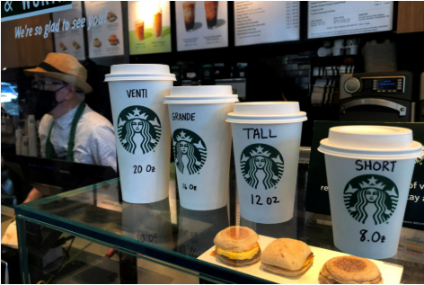

Appendix 2: Marketing Strategy
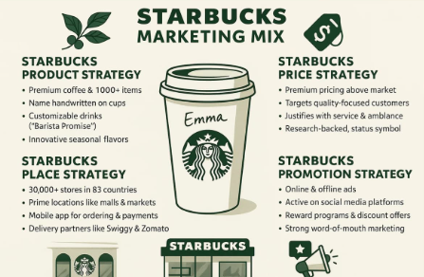

Appendix 3: Growth of Starbucks
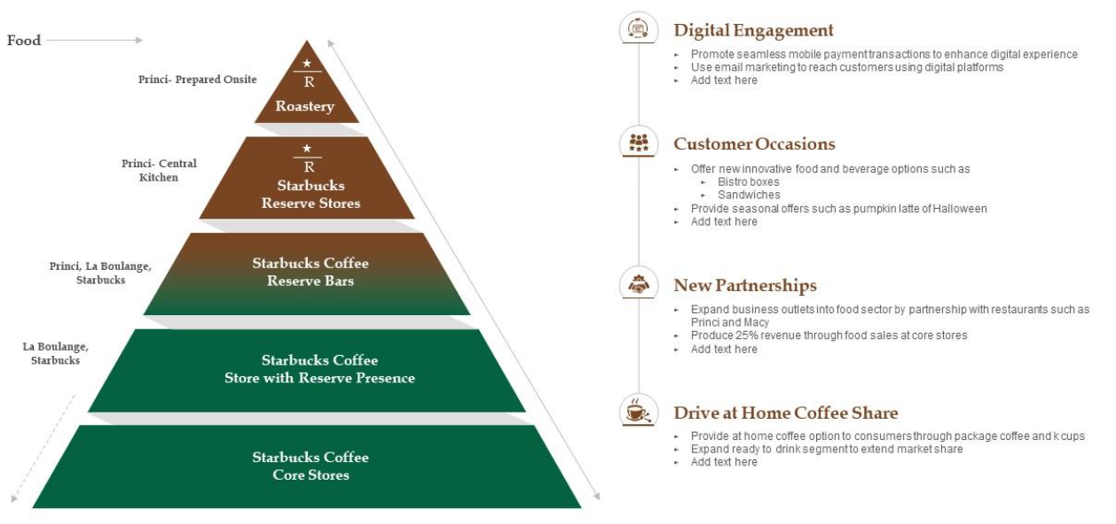

Appendix 4: Growth of Starbucks in the UK
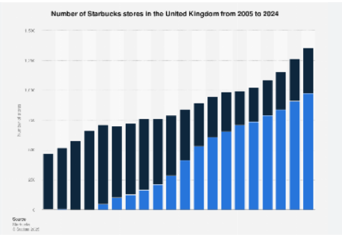

Appendix 5: Marketing Strategy for India
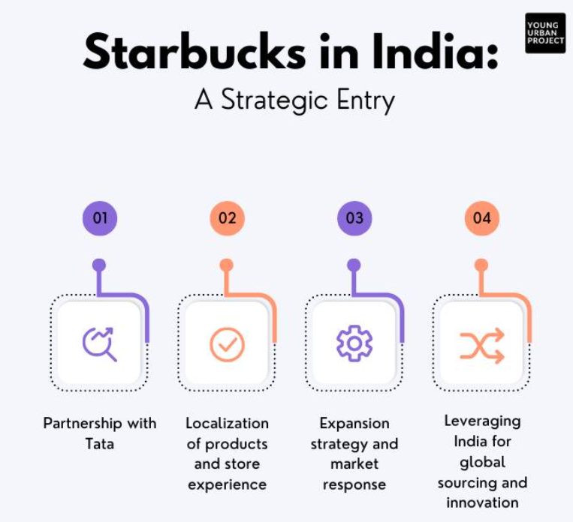

Appendix 6: Business Evaluation
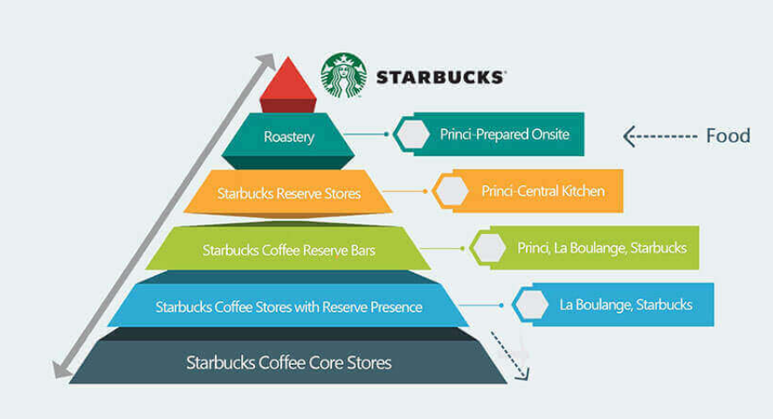

Appendix 7: Competitors of Starbucks in India
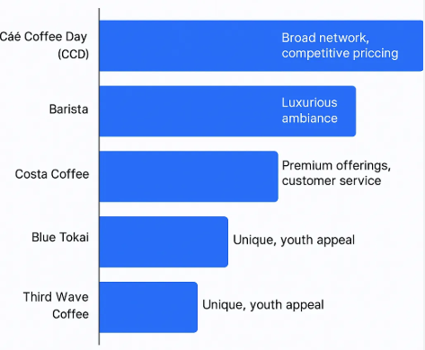

Appendix 8: Competitors of Starbucks in the UK
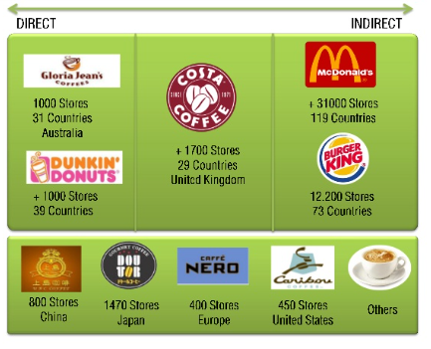

Appendix 9: FY24 Income Statement
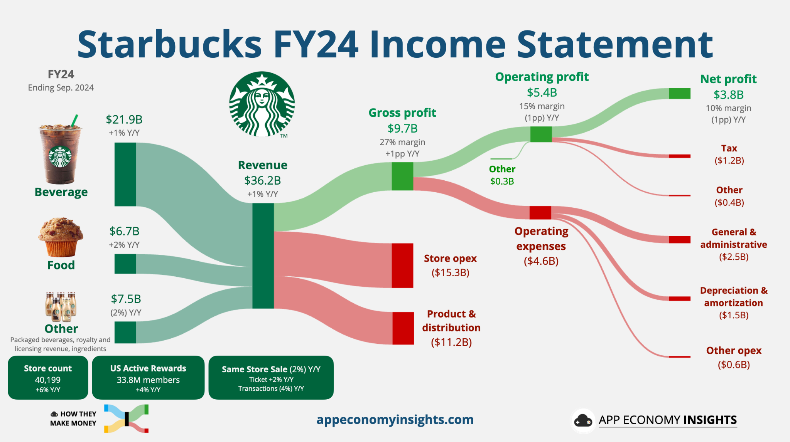

Appendix 10: Target Consumers


