Health Assessment Report

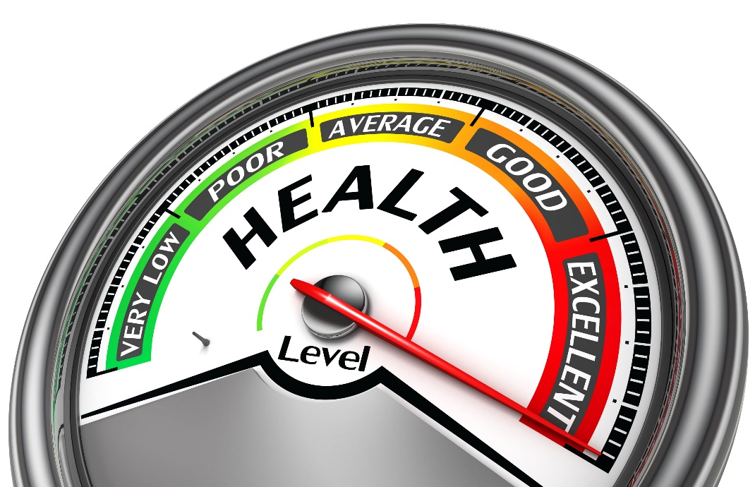

Name: Natalie Tully
Student Number: 2025743
Lecturer: Rachael Rivers
Module Code: BMPH5003- BIRM
Module: Introduction to physiology

Contents
Introduction 3
Diet 4
The effects of type 2 diabetes have on the body 5
Activity 5
Lifestyles choices 6
Counselling 7
Smoking and alcohol 8
Being more active and involved in his community 8
Working less hours and getting more sleep 8
Conclusion 8
References 10

Introduction
Within this health report, will be clarifying the health issues and concerns around Bobs health and wellbeing. Understanding the impacts of his lifestyle has had on his body. This case study will also Identify the elements of the physiology normal and abnormal conditions. By gathering data and information on Bobs lifestyle will help get a better understanding of the factors to help guide and support Bob to maintain a better lifestyle, with recommendations from professional organisations. By using factors in the table below to build a health plan guidance to determine Bobs health needs.
Key points of health questionnaire | Additional information
Age | 52
Occupation | Truck driver
Smoking status | Smokes cigarette/ more than 40 per week
Height / weight | 5.9 /15 stone
Blood pressure | High blood pressure

Overall view of Bobs main factors to take in consideration with mental, emotional, and physical state of mind due to traumas that can impact his choices, health, and lifestyle.
- Loneliness – no family, Brother, mother, and father passed away 10 years ago
- One daughter and two grandchildren – limited communication or visits due to the distance of area.
- Divorced from his wife 5 years – impacts being on the road working long hours (evenings and weekends).
- Smoking cigarettes – for 32 years, impacts on health.
- Eating takeaways – due to factors being on the road and the impact of not being in the family home
- High sugar drinks – to help with his low energy and struggles to sleep.
The factors will include diet, physical activity, and lifestyle choices.

Diet
Bob is a Black male at the age of 52 years old, who weighs 15 stone and is on the road most of the time. Due to these concerning factors, Bob eats take away food and snacks on the go which results in a poor diet and consumes high sugar drinks including coca cola. According to the NHS website Bob BMI is 31.1 which results suggests his obese (NHS, 2018). Bob is also in the high-risk category of developing serious health conditions like type 2 diabetes and high cholesterol. It is very highly likely that bob has type 2 diabetes as the NHS states common symptoms is tiredness and excessive thirst (NHS, 2020). According to NHS Bobs average calories intake to a maintain healthy weight is around 2,500kcal (NHS, 2021). Recommendations that are supported by the NHS guidelines are to eat a wide range of foods, including 5 a day requirement of fruits and vegetables (NHS Choices, 2020). Bob needs to reduce intakes of his sugar and salt, while considering his portion control when getting his foods on the go. As Bob is a truck driver he eats on the go, states in NHS eat well 5 a day fruits and vegetables are contained in readymade foods which also counts towards his 5 a day requirement (NHS, 2022). Keeping hydrated is also extremely important for his diet, according to Eatwell guide 6 to 8 cups a day, including water, lower fat milk, sugar-free drinks including tea and coffee all count. Limit on fruit juice and smoothies to total of 150ml a day (NHS, 2019). Also avoiding cigarettes and alcohol to maintain daily sugar levels within recommended by blood glucose level guidelines, table below shows NICE recommended targets below (Diabetes UK, 2019).

Target Levels  by Type | Upon waking | Before meals  (pre prandial) | At least 90 minutes after meals  (post prandial)
Non-diabetic* |  | 4.0 to 5.9 mmol/L | under 7.8 mmol/L
Type 2 diabetes |  | 4 to 7 mmol/L | under 8.5 mmol/L
Type 1 diabetes | 5 to 7 mmol/L | 4 to 7 mmol/L | 5 to 9 mmol/L
Children w/ type 1 diabetes | 4 to 7 mmol/L | 4 to 7 mmol/L | 5 to 9 mmol/L

The effects of type 2 diabetes have on the body.
Diabetes is profoundly serious health condition which can harm and damaged the body over an extended period which is in addition to its symptoms (Diabetes.co.uk, 2019). Diabetic complications are a frequent phrase used to describe the long-term harm (Diabetes.co.uk, 2019). These factors, such as high blood pressure, excessive cholesterol, and an inability to manage.
Any areas of the body can be impacted by diabetes since it affects our blood vessels and nerves
Diabetes can affect many of the body including, eyes (diabetic retinopathy), coronary heart disease (can cause stroke due to high blood pressure), kidneys, nerves and the skin (Diabetes.co.uk, 2019).

Activity
Bobs main employment is a truck driver, his on the road quite often including evenings and weekends. This impacts his health and wellbeing, as diet and exercise go hand in hand, due to Bob feeling of symptoms of tiredness and lack of energy could result in many health condition which is already impacts Bobs life. In the case study of Bob there is no evidence of any form of exercise, the importance of regular exercise will help Bob with health conditions as well as his mental health. According to better health that states that regular exercise can boost your mood and help with your concentration levels (Better Health Channel, 2012). The benefits to regular exercise are, brain's levels of chemicals like serotonin, stress hormones, and endorphins alter and helps you sleep better. (Better Health Channel, 2012). NHS guidelines for older adults should do some type of activity everyday to help improve Bobs health and reduce the risk of heart disease and stroke (NHS, 2022).
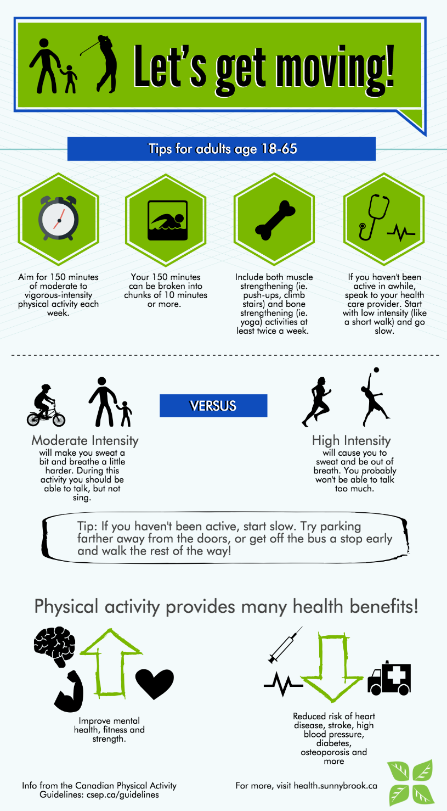

Lifestyles choices
After viewing Bobs case study there are many factors that could have led to Bob choosing unhealthy lifestyle. The past trauma of losing his parents and his brother at the age of 42, with no family to talk to when things got hard in his relationship, must have put more pressure on their marriage, which in turn ended with divorced which all so impacted his relationship with daughter and his grandchildren. This can assume that his mental health is not in a good place and not dealing with the concerning issues, instead put his self into working overload. This could isolate Bob from his daughter, grandchildren, and the world. Bob needs to consider counselling to get his life back on track. To maintain a positive relationship with his daughter.

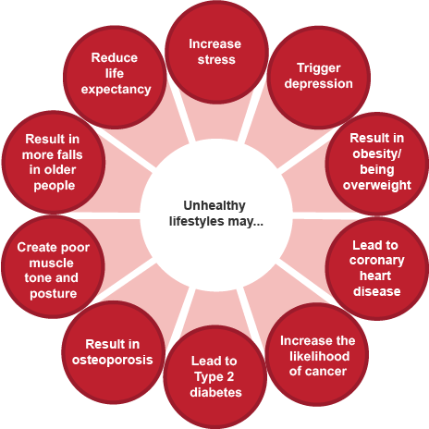(BBC Bitesize, n.d.)

If Bob can face his feelings and consider how he got into an unhealthy lifestyle, with guidance and recommendations which could support Bob through his journey.
1. Counselling
2. Reducing Smoking and alcohol intake
3. Being more active to reduce stress levels, weight loss, energy increase and improve sleep.
4. Build relationships and friendship groups
5. Work less hours
6. Introduce family meals on days off with daughter and grandkids

Counselling
Bob could have some psychological issues due to different impacts of events that has occurred in his life. Which Bob has not dealt with, which is having a negative impact on his life and him moving forward. Specially the loss of his both parents and his brother. According to studies on men finding it harder dealing with the loss of both parents and has a negative impact on their lives, not to underestimate the impact on adult wellbeing which lasting an extended period (Marks, Jun and Song, 2007).

Smoking and alcohol
Bob has been smoking for 32 years, which would have made an impact on his health and his body over the years. Smoking more than 40 per week Bob would be high risk to lung cancer, respiratory disease, and cardiovascular disease (GOV.UK, n.d.).
According to estimates around smoking, in 2019 4.7% of the population had low life satisfaction, 3.7% had low self-worth, 8.3% had low happiness, and 20.7% had excessive anxiety (GOV.UK, n.d.).
Bob will find it harder to completely stop smoking but with support and trying to use nicotine replacement therapy (NRT) hopefully Bob understands the impact of smoking has had on his health and will try to cut down and hopefully stop one day.
Bob states that he does not drink alcohol often but has a bottle of whisky every time his at home, this also suggest and backs up the theory of Bob being alone and bored when his not working, quoted by Bob “it passes time and I enjoy it”

Being more active and involved in his community
The benefits for Bob to try and fit in some exercise in his daily routine is paramount for his overall health and wellbeing. Due to him being obese, high cholesterol and has high calories intake. The guidelines suggest that an adult should aim to exercise 4 to 5 days a week, do strengthening activities at least 2 days a week (NHS, 2021).
If Bob goes for a local walk every day before work or after work or even on his breaks to stretch his legs and could join a gym which will help him meet new people in his community to build new relationships.

Working less hours and getting more sleep
Bob spends many hours on the road due to having no family or commitments, long evenings and weekends, this impacts on his relationship with his daughter and his mental health.
Within the case study Bob has difficulty sleeping, which could result in his long hours and not resting enough as well as poor diet. According to the EU rules in which truck drivers are guided by, should rest every day for at least 11 hours or 9 hours rest 3 times between 2 weekly rest periods (GOV.UK, n.d.). According to drivers require on HGV drivers it states having a sedentary work increases your chance of developing significant disorders including high blood pressure, poor heart health, and weight problems. It might be particularly difficult to maintain one's physical and emotional health when there are not enough HGV drivers (Driver Require, n.d.).

Conclusion
This health assessment report has investigated the risk factors that potentially could cause substantial amount of harm on Bobs health and wellbeing including issues with his mental health. This outlines the importance of considering all the health risk and recommendations by professionals to improve Bobs overall lifestyle and health.
If Bob followers the advice given by professionals to maintain a healthy life, he can lower his BMI, lower is cholesterol and high blood pressure. Bob needs to understand the seriousness of his unhealthy lifestyle, how its impact his life? Bob is Black male at the age 52, not getting any younger which makes him in the higher risk bracket.
By reviewing this report with Bob its aim is to inform and educate Bob to make changes in his life to have a higher life expectancy due to living a healthy lifestyle.

References
BBC Bitesize. (n.d.). Negative lifestyle choices – the implications - Health and wellbeing - WJEC - GCSE Physical Education Revision - WJEC. [online] Available at: https://www.bbc.co.uk/bitesize/guides/z3shycw/revision/3#:~:text=They%20include%3A%201%20not%20doing%20enough%20physical%20activity (Accessed 10 November 2022).
Better Health Channel (2012). Exercise and mental health. [online] Vic.gov.au. Available at: https://www.betterhealth.vic.gov.au/health/healthyliving/exercise-and-mental-health (Accessed 11 November 2022).
Diabetes.co.uk. (2019). How Does Diabetes Affect The Body - Effects of Diabetes. [online] Available at: https://www.diabetes.co.uk/how-does-diabetes-affect-the-body.html (Accessed 12 November 2022).
Diabetes UK (2019). Normal and Diabetic Blood Sugar Level Ranges - Blood Sugar Levels for Diabetes. [online] Diabetes.co.uk. Available at: https://www.diabetes.co.uk/diabetes_care/blood-sugar-level-ranges.html (Accessed 11 November 2022).
Driver Require. (n.d.). 5 Health & Wellness Tips That HGV Drivers Should Know. (online) Available at: https://driverrequire.co.uk/news/item/health-wellness-tips-for-hgv-drivers (Accessed 10 November 2022).
GOV.UK. (n.d.). Drivers’ hours. [online] Available at: https://www.gov.uk/drivers-hours/eu-rules (Accessed 13 November 2022)
GOV.UK. (n.d.). Smoking and tobacco: applying All Our Health. [online] Available at: https://www.gov.uk/government/publications/smoking-and-tobacco-applying-all-our-health/smoking-and-tobacco-applying-all-our-health#harm-to-health-caused-by-smoking (Accessed 17 November 2022).
GOV.UK. (n.d.). Smoking prevalence in adults commentary: current smokers aged over 18 years by wellbeing group and region. [online] Available at: https://www.gov.uk/government/publications/smoking-prevalence-in-adults-current-smokers-aged-over-18-years-by-wellbeing-group-and-region/smoking-prevalence-in-adults-commentary-current-smokers-aged-over-18-years-by-wellbeing-group-and-region (Accessed 16 November 2022).
Marks, N.F., Jun, H. and Song, J. (2007). Death of Parents and Adult Psychological and Physical Well-Being: A Prospective U.S. National Study. Journal of family issues, [online] 28(12), pp.1611–1638. doi:10.1177/0192513X07302728.
NHS (2022). 5 A Day portion sizes. [online] nhs.uk. Available at: https://www.nhs.uk/live-well/eat-well/5-a-day/portion-sizes/ (Accessed 15 November 2022).

NHS (2018). BMI Healthy Weight Calculator. [online] NHS. Available at: https://www.nhs.uk/live-well/healthy-weight/bmi-calculator/ (Accessed 15 November 2022)
NHS Choices (2020). Food and keeping active - Type 2 diabetes. [online] NHS. Available at: https://www.nhs.uk/conditions/type-2-diabetes/food-and-keeping-active/ (Accessed 16 November 2022)
NHS (2021). Physical Activity Guidelines for Adults Aged 19 to 64. [online] nhs.uk. Available at: https://www.nhs.uk/live-well/exercise/exercise-guidelines/physical-activity-guidelines-for-adults-aged-19-to-64/( Accessed 17 November 2022).
NHS (2022). Physical activity guidelines for older adults. [online] nhs.uk. Available at: https://www.nhs.uk/live-well/exercise/exercise-guidelines/physical-activity-guidelines-older-adults/ (Accessed 14 November 2022)
NHS (2021). Understanding Calories. [online] nhs.uk. Available at: https://www.nhs.uk/live-well/healthy-weight/managing-your-weight/understanding-calories/ (Accessed 12 November 2022)
NHS (2020). What is type 2 diabetes? [online] NHS. Available at: https://www.nhs.uk/conditions/type-2-diabetes/ (Accessed 13 November 2022)

NHS (2019). The eatwell guide. [online] nhs.uk. Available at: https://www.nhs.uk/live-well/eat-well/food-guidelines-and-food-labels/the-eatwell-guide/ (Accessed 23 November 2022).

‌

‌

‌

‌
‌

‌
‌
‌
‌
‌

‌

‌

