Computer Architecture
Assessment Report



Student Name: Borislav Dimitrov
Student ID: 1921770
Course: BCs Cloud Computing UWTSD 2019-2022
Table of Contents
Scenario 1 “Low-cost Desktop PC” 3
I. Short overview 3
II. Motherboard 3
III. CPU 5
IV. Graphic Card 6
V. RAM 7
VI. HDD 8
VII. Power Supply 9
VIII. Computer Case 10
IX. Monitor 11
X. Mouse and Keyboard 12
XI. Cables and peripheries 12
Scenario 2 “High-End Desktop PC” 15
I. Short overview 15
II. Motherboard 15
III. CPU 17
IV. CPU FAN 18
V. Graphic Card 19
VI. RAM 20
VII. HDD 21
VIII. Power Supply 22
VI. Computer Case 23
X. Monitor 24
XI. Card Reader 25
NAS Drive 26
Appendix 28
Total Cost of Built 1 28
Total Cost of Built 2 29
Total Cost of NAS Drive 30
References 31

Scenario 1 “Low-cost Desktop PC”

I. Short overview

In this case scenario ‘Cheap but efficient’ is the main thought. We will appreciate the value of the low-class items, giving a prove that they are still efficient for the given scenario.
Building a Desktop that will serve basic needs like checking email, skype video calls, office components and YouTube possible HD videos will require at least 2 core processor followed by at least 4GB of DDR3 RAM, to secure the smoothest experience, without any lag or overheating.

II. Motherboard

Affordable and desent option for this project, will be small size factor motherboard. Appropriate choice will be Gigabyte GA-J1800N-D2H Mini ATX, compact design (170x170mm) and entirely fanless. Quiet and small, ideal for the case. All needed ports for the scenario are on site (GIGABYTE Technology LTD, 2014)

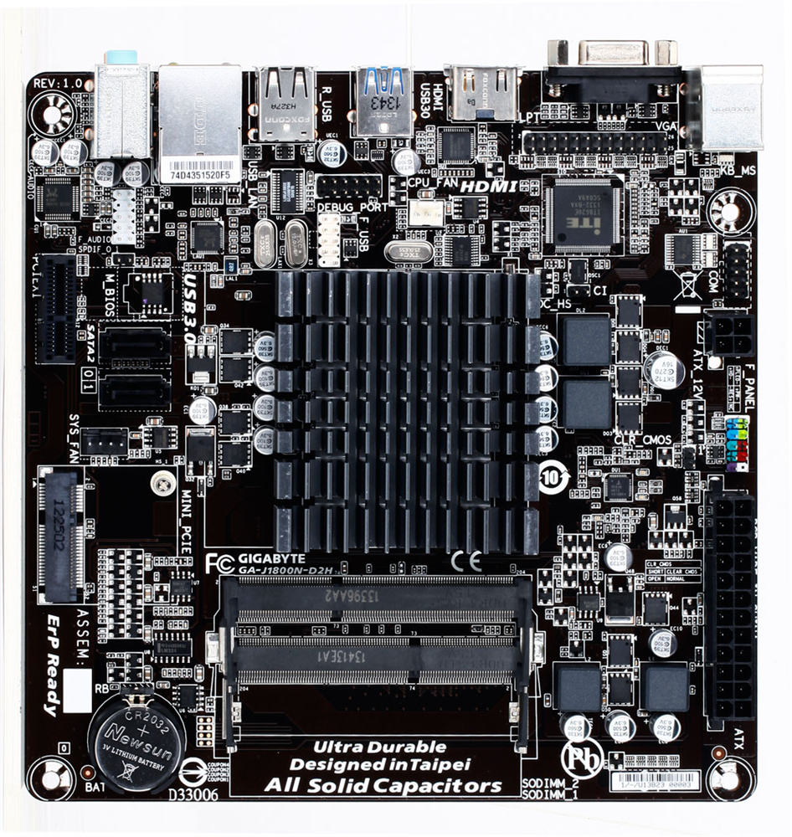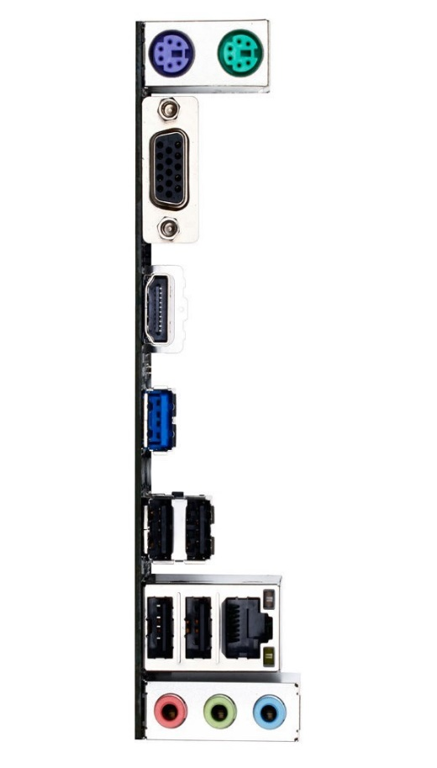
Fig1:MBGA-J1800N-D2H (GIGABYTE Technology LTD, 2014) Fig2:J1800N-D2HPorts (GIGABYTE Technology LTD, 2014)

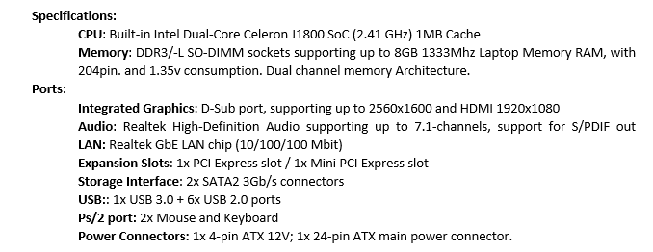
Fig1A:J1800N-D2HSpecifications (GIGABYTE Technology LTD, 2014)

III. CPU

The motherboard is equipped with building 64-bit Intel Celeron J1800 (2.41GHz – 2.58Ghz) Dual-Core SoC processor , which is the perfect fit for our project. The supported memory type is DDR3L 1333MHz up to 8GB, same as the mother board. After comparing the built-in processor with respectively the highest available option for socket FCBGA1170 which is Intel Pentium J2900 (2.41GHz – 2.66GHz) 2MB L2 Chase, Pentium J2900 shows 50% more efficiency in Multi-core operations, but still not that big difference in high-end performance (Intel Corporation, 2013).
Specifications: Number of cores: 2 Base Frequency: 2.41GHz Cache: 1MB-L2-Cache Number of Threads: 2 Max Frequency: 2.58GHz TDP: 10W Memory Types: DDR3L-1333 Lithography: 22nm
Fig3A:Specifications(Intel Corporation, 2013)

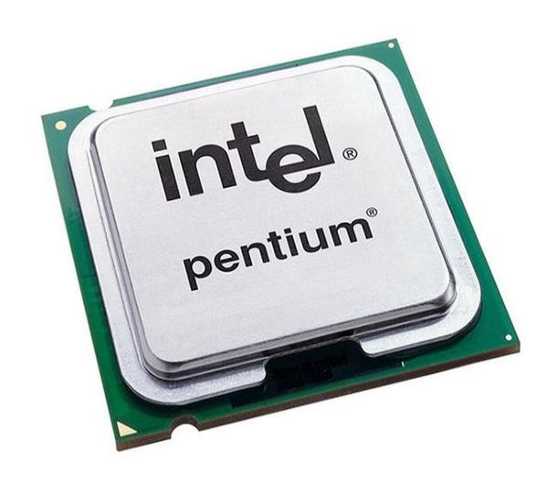
Fig3:INTELJ1800 (Intel Corporation, 2013)

IV. Graphic Card

In this case, we are completely satisfied with our Built-in Intel HD Graphics for Z3700 Series, which will bring satisfying experience true out YouTube HD video’s, Skype Video Call’s, Microsoft Office Essentials. Intel delivers a performance that keeps up with all those basic user tasks, plus dedicated H.264 encoder which provides clear HD video playback (Intel Corporation, 2013).
Specifications:
Base-Frequency: 688MHz Displays supported: 2
Turbo-Frequency: 792MHZ DirectX: 11 / Intel Quick-Sync Video

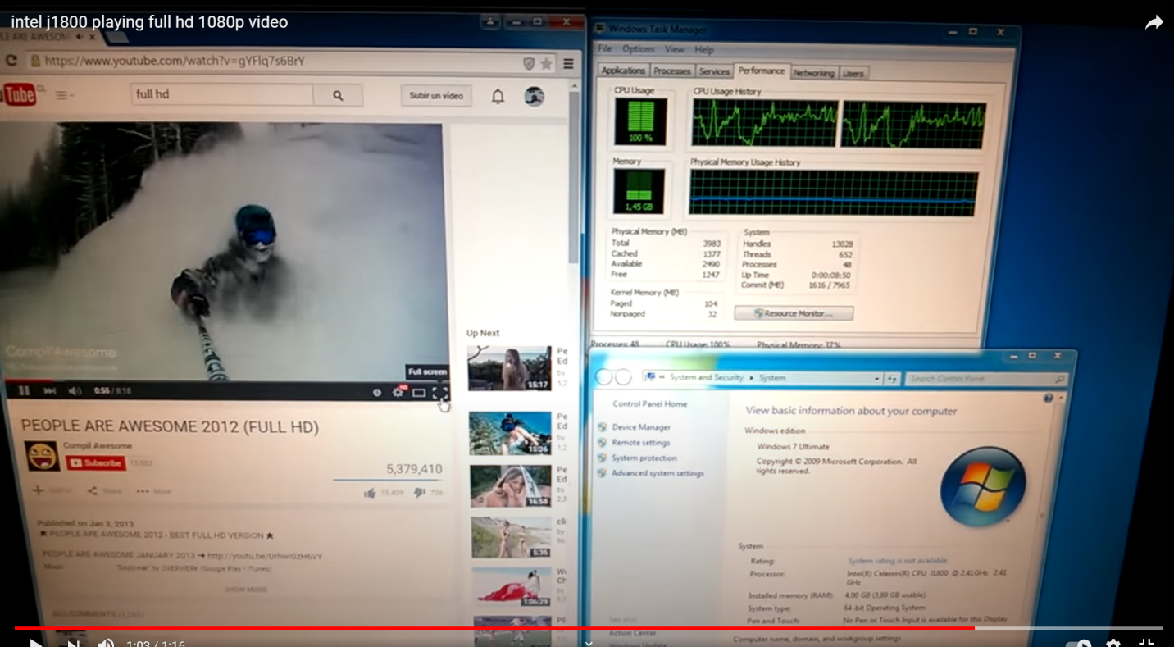
Fig4:Intel-playing-Full-HD-1080p (Mehr, 2015)

V. RAM

The maximum capacity of the Motherboard is 8GB. In this case 4GB of DDR3-L will be plenty. However, in about 2/3 years, an update should be considered, by just adding another brick of 4GB of RAM.
Socket DDR3/-L SO-DIMM is considered as a laptop memory socket, with low voltage of 1.35v! Perfect fit will be the Corsair Value Select 4GB DDR3L 1333Mhz SODIMM Memory Module 1.35 Volts:

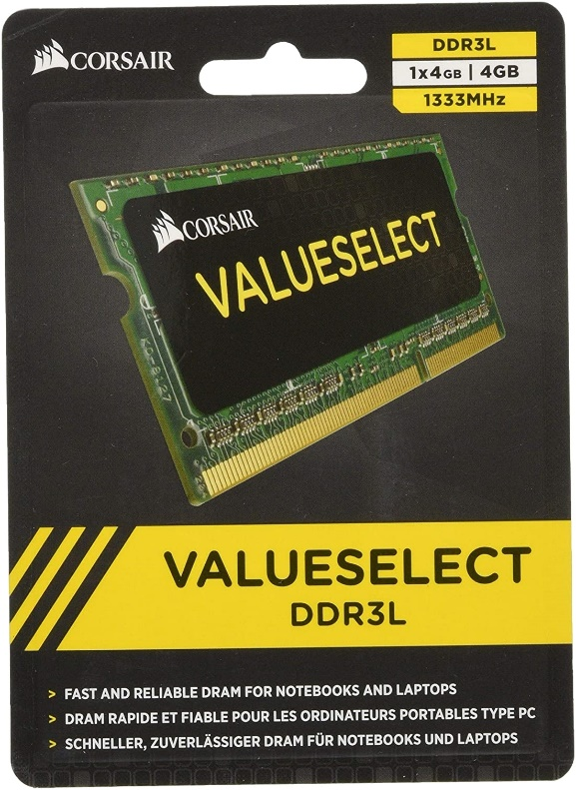

Fig5:CORSAIRPackage (Amazon Co, 2013) Fig6:CORSAIR (Corsair Co, 2013)

VI. HDD

For everyday computing, Western Digital is appropriate chouse for high standards of quality and reliability. 500GB WD Blue Mobile Hard Drive 2.5inches will be the drive for this project. Speed of 5400rpm, 6Gb/s plus 8MB cache is good enough for the scenario. 500GB will be plenty for Microsoft Office Documents, pictures, music, etc. Hard Drive interface is Serial ATA (SATA) equivalent to the motherboard requirements (Western Digital , 2013).

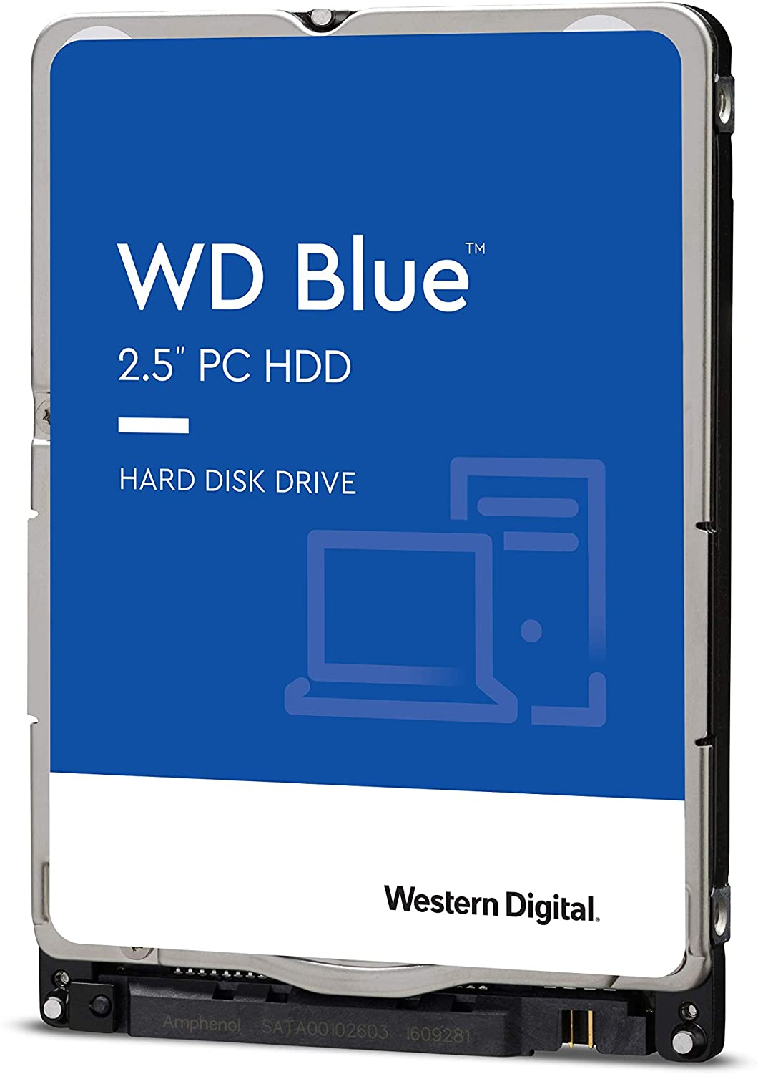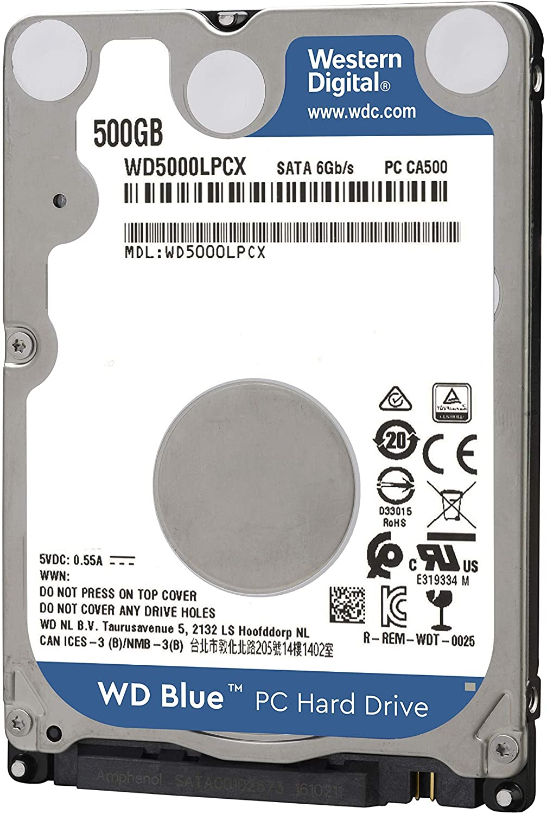

Fig7:WD2.5HDD (Western Digital , 2013) Fig8:WD500GB (Western Digital , 2013)

VII. Power Supply

In this section, a delicate approach is required, to consolidate the current level of progress. Our build is fanless, and it is going to be that way. The use of “Cyncronix PicoPSU-90 is cool and soundless 90W 12V DC-DC ATX mini-ITX” world’s tiniest 12V power supply unit, for small PC’s! Supplying motherboard build with 20 or 24pin ATX connector (Amazon, 2019).


Fig9: (Amazon, 2019) Fig10: (Amazon, 2019)

To supply PicoPsu-90 with 12V of power, the need of LightingWill Power Adapter, 100-240V AC to 12V DC 10Amp 120Watt Wall Plug” is required. 120cm long power cord with a male DC 5.5x2.1mm jack end (Amazon, 2019).

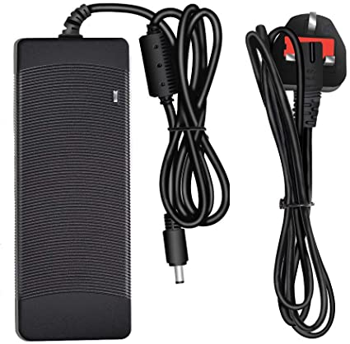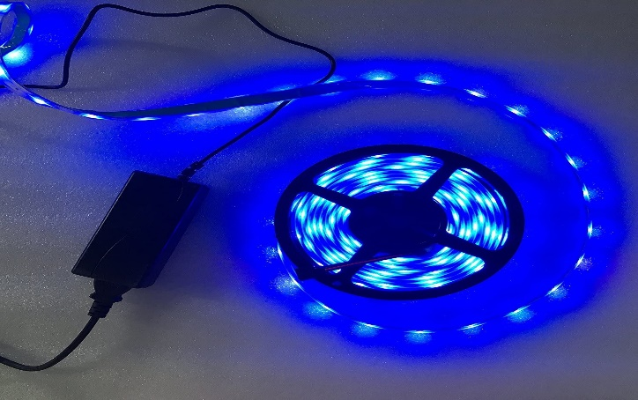
Fig11:LightingWill (Amazon, 2019) Fig12: (Amazon, 2019)

VIII. Computer Case

Mini G60S can fit-in Mini-ITX 170x170cm motherboards. Supports 1x 3.5inch or 2 x 2.5inch hard drive (Amazon Co, 2020).

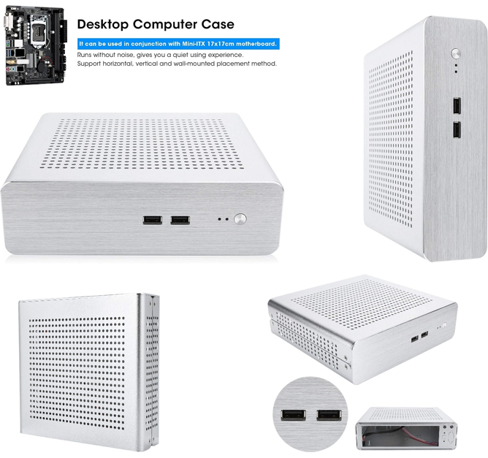

Fig13:Case (Amazon Co, 2020)

IX. Monitor

24’ HD Monitor should be big enough for the given scenario. Philips 243V7QJABF IPS 1080 1920x1080 HD Monitor, with Built-in Speakers. For a budget project this IPS panel produces briliant colours and offers view from a wide angles. Vesa wall mount availabe. 60Hz Refresh Rate (Philips corporation, 2017).

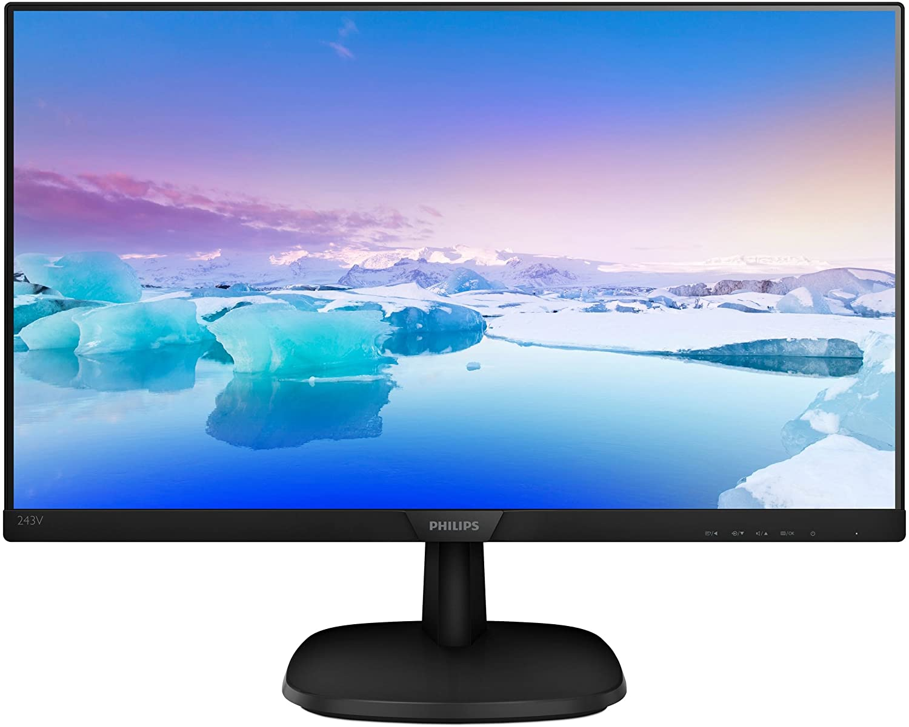

Fig14:PhilipsMonitor (Philips corporation, 2017)

X. Mouse and Keyboard

Only requirement for this section is full-size keyboard. Logitech K120 Wired USB Plug-and-Play, Full-Size, Spill Resistant UK Layout – Black. Plus Logitech wired USB plug-and-play mouse, 1000 DPI Optical Tracking 1.5 Volts.
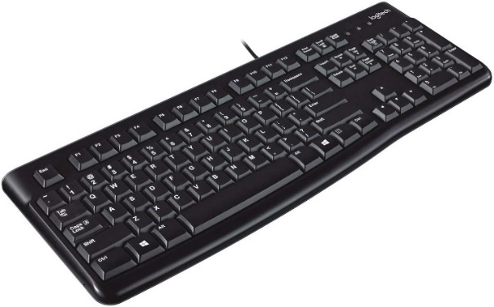
Fig15:K120 (Logitech Co, 2010) Fig16:M90 (Amazon, 2010)

XI. Cables and peripheries

In the package of the Philips HD Monitor, we have only VGA cable, but we need HDMI, which will be “Amazon Basics HDMI 2.0 Cable.”, This cable will transfer audio from the motherboard to the built-in speakers of the Monitor. (Amazon Co, 2015)
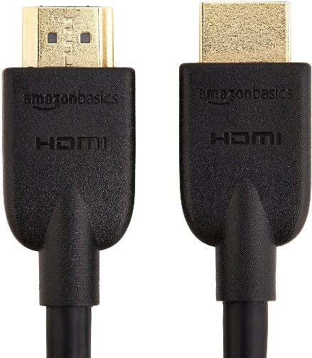
Fig17: (Amazon Co, 2015)

DEEPFOX Dual 2.5 SSD/HDD to 3.5 Inch Internal HDD will provide the SATA connection between HDD 2.5 and PicoPSU-90 power supply, and will leave an option for future update, by just adding another 2.5 HDD to the system (Amazon Co, 2019).
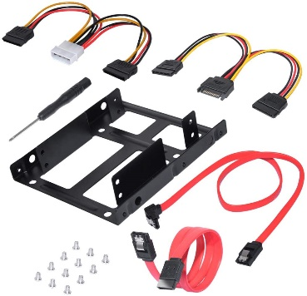
Fig18: (Amazon Co, 2019)

LAN port is available, but just in case “Mini AC1200 PCIe Wi-Fi Network card” will providing 2.4Gh/5G Wi-Fi connection if required (Amazon Co, 2020).

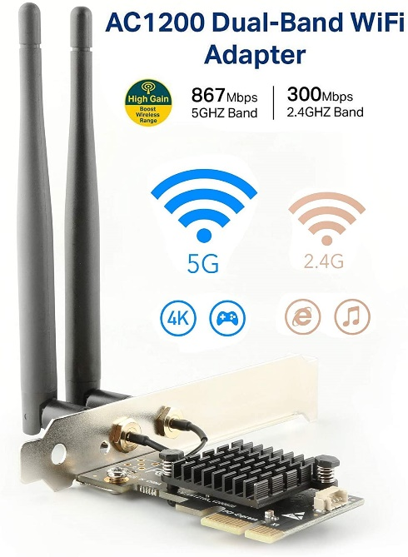
Fig19: (Amazon Co, 2020)

The subject will need web camera to be able to make video calls. Our pick is “LarmTek Full HD1080p” affordable and has a microphone. Privacy Shutter is an accessory that covers the eye when needed (Amazon Co, 2019).
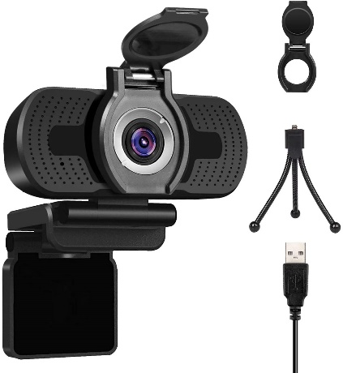
Fig20: (Amazon Co, 2019)

Scenario 2 “High-End Desktop PC”

I. Short overview

In this case scenario ‘speed and productivity’ is the main thought. A budget of 2500 pounds will be spent, for machine that serve the purpose of 4K Video Editing, where not only the CPU, but also the GPU acceleration will be consumed. This energy consuming build will require a stable Power Supply as well. Powerful and heavy Programs like Adobe Premiere PRO will be used, which require at least Intel 7th Gen CPU or AMD Ryzen 3000Series followed by 32GB of ram plus SSD Drive for smoothest 4k media rendering (Adobe, 2019).

II. Motherboard

“Gigabyte Aorus B550 ELITE AX V2” is suitable and sustainable board for our high-end machine. Supports 2020 processors plus DDR4 ram followed by 3x PCI express x16slots and SPDIF port (as shown on Fig:21 and Fig22) (Gigabyte, 2020).

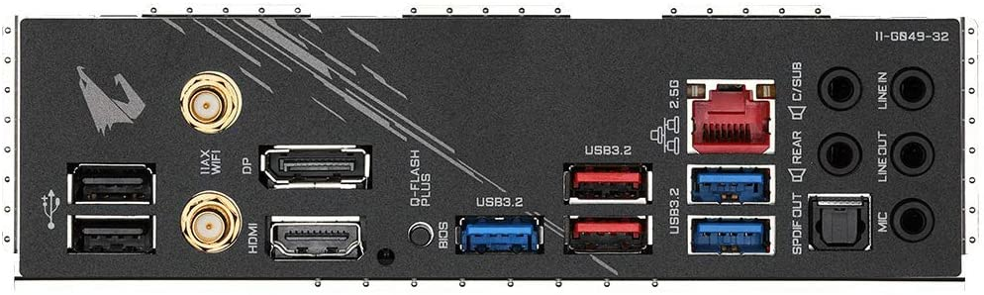
Fig21:BackPanel (Gigabyte, 2020)
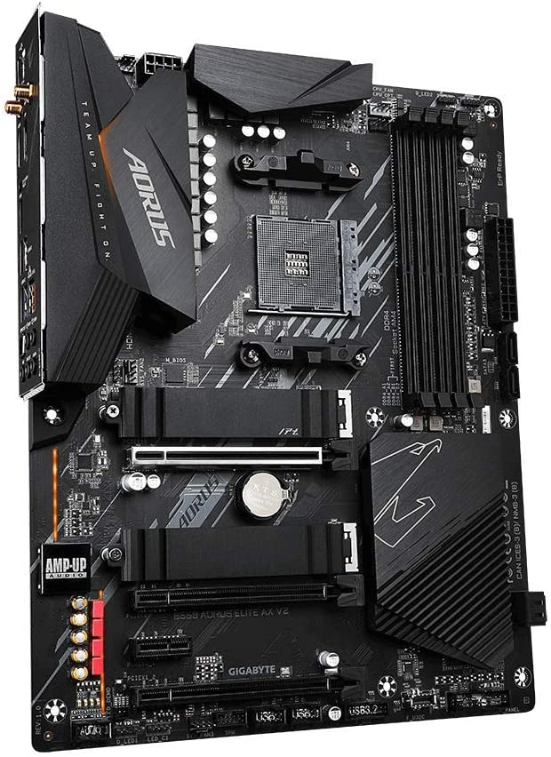

Fig22:AorusB550ELITE (Gigabyte, 2020)

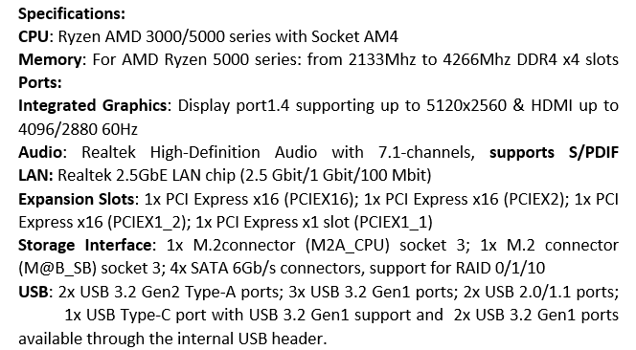
Fig22A:AorusSpecifications (Gigabyte, 2020)

III. CPU

Extreme processing for gamers, streamers and creator is the moto of AMD Ryzen 9 3900XT Desktop Processor. With 12 physical cores and 24 # of Threads, the 3-rd Gen AMD Ryzen offer no-compromise performance. The first processor with PCIe 4.0 delivering double the graphics and storage bandwidth. Leading edge 7-nanometer technology for cool, quit, efficient operation (AMD Corporation, 2020).
Technical Specifications:
Cores/Threads: 12/24 L3 Cache: 63MB
Max Boost: Up to 4.7GHz PCIe Version: 4.0
System Memory Type: DDR4 up to 3200MHZ Socket: AM4
Unlocked for Overclocking: Yes, with Precision Boost Overdrive TDP: 105W

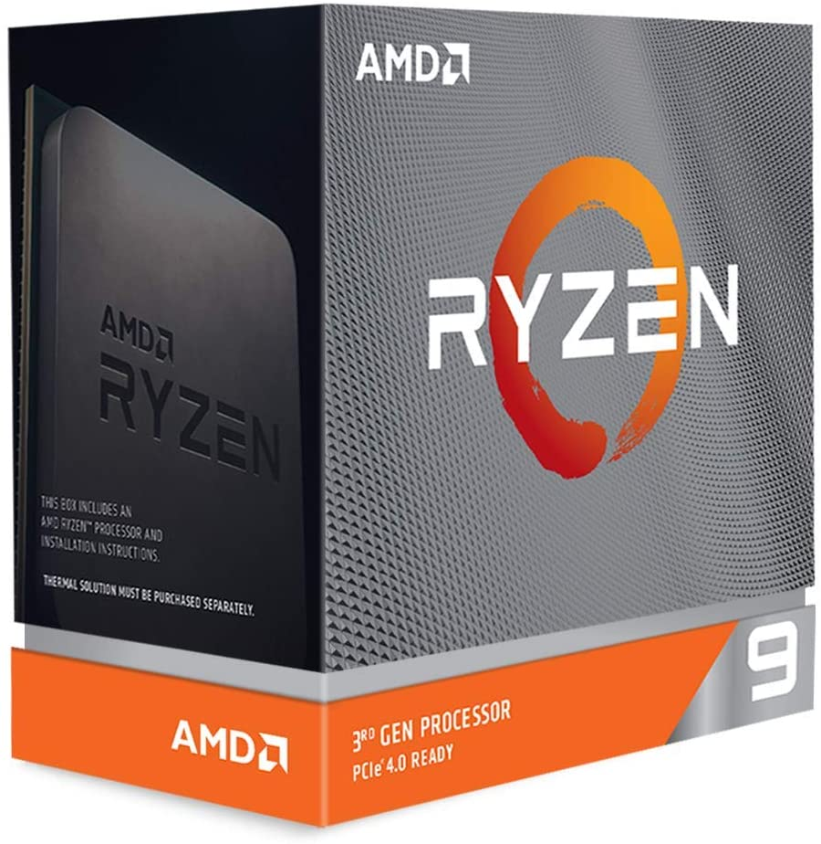

Fig23:Ryzen3900XT (AMD Corporation, 2020) Fig24:AMDPackage (AMD Corporation, 2020)

IV. CPU FAN

For Ryzen 3rd generation, AMD strongly recommend use of liquid coolers. Kraken Z Series is a 2 fan 500 -1800 RPM liquid CPU Fan. Compatible with socket AM4. Pump motor speed between 800 – 2,800 RPM working with 12V DC, 0.3A (NZXT, 2020).

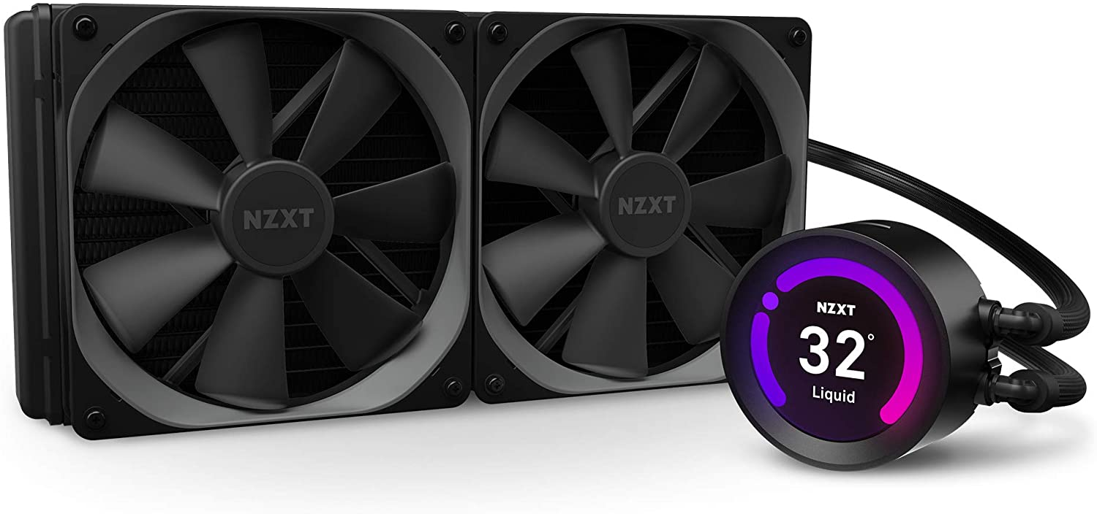
Fig25:KrakenFen (NZXT, 2020)

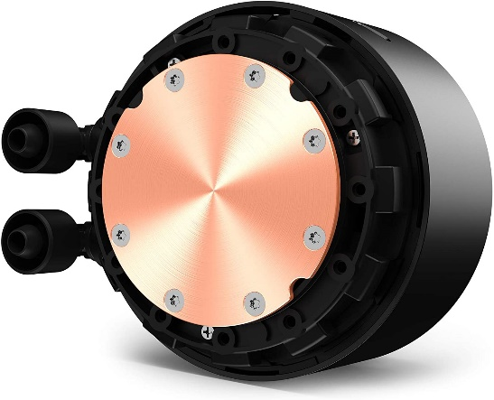
Fig26:Kraken (NZXT, 2020) Fig27:ThermanPaste (Amazon, 2020)

When assembling the Fan over the CPU, the use of thermal paste is esential and a must. ARCTIC MX-4 (4 Grams) will do a great job.

V. Graphic Card

GeForce RTX 2060 Super EVO is powered by the Turing GPU architecture, which brings 60% more powerful performance of previous generation cards. Two powerful axial-tech fans are in charge, for the boosted 1695MHz clock rate GPU, to stay cool and on demand for fast 4k Video rendering (ASUS Co, 2019).
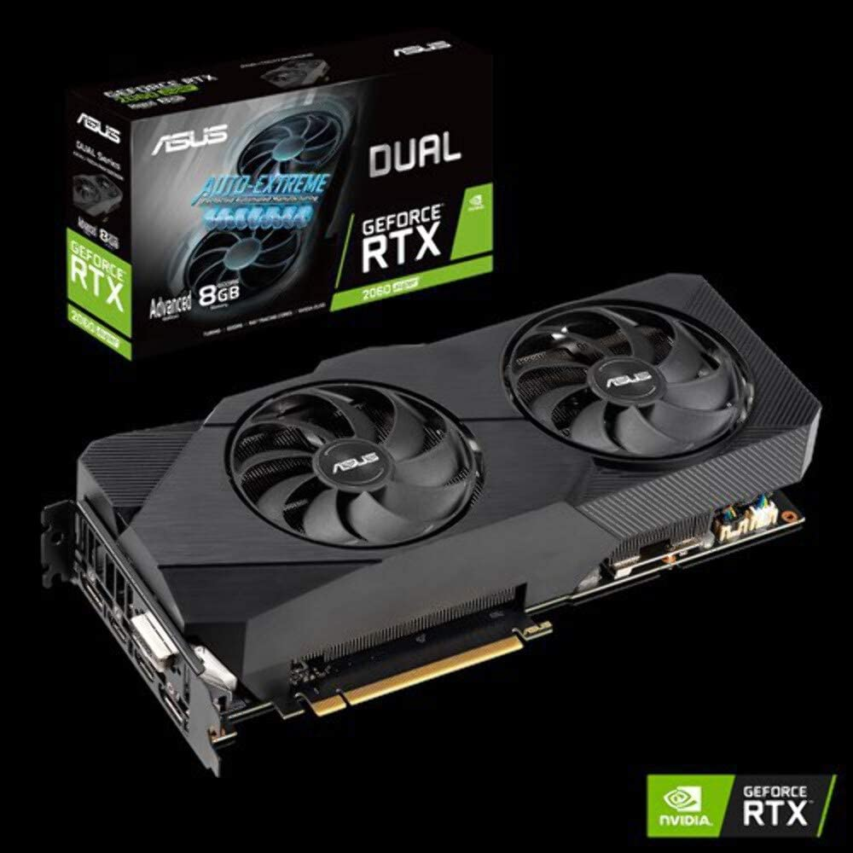
Fig28:RTX2060 (ASUS Co, 2019)
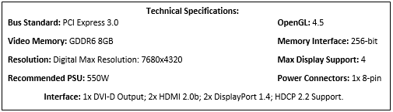
Fig28A:RTX2060Specifications(ASUS Co, 2019)

VI. RAM

2x Kingston HyperX HX432C16FB4K2/32 kit of two. Which means 4x 64-bit DDR4 16GB 3200MHz CL16 288-Pin SDRAM. Each of them supports Intel Extreme Memory Profiles (XMP) 2.0, which brings the highest speeds. Total storage of 64GB is a good investment in the future. Factory Timing Parameters for our case will be XMP Profile 2 which is DDR4-3200 CL 16-20-20 1.35V (Kingston, 2020).

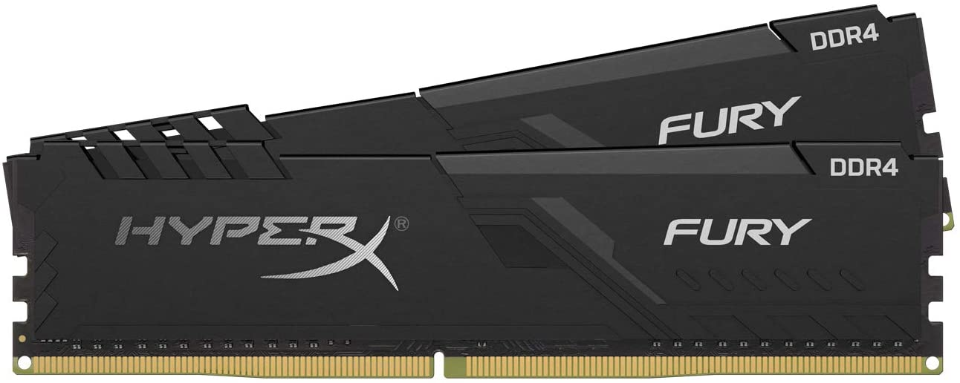
Fig29:HyperX (Kingston, 2020)

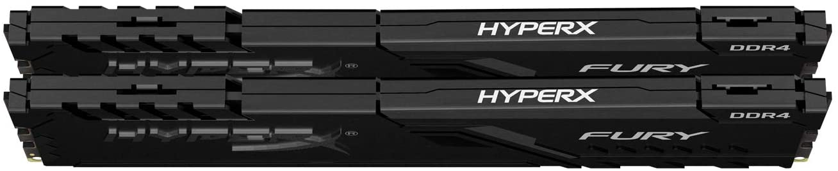

Fig29A:HyperX2 (Kingston, 2020)

VII. HDD

Inside the use case, the additional storage needs to be, NAS drive with 8TB for start. But no information was given for the internal storage, so we are going to assume that 1TB of WD Black SN850 NVMe SSD will do the job. With up to 7000Mb/s read and 5300Mb/s write speeds provided by supreme PCIe Gen4 technology, transferring 4k content will be fast and smoot experience (Wester Digital, 2019).
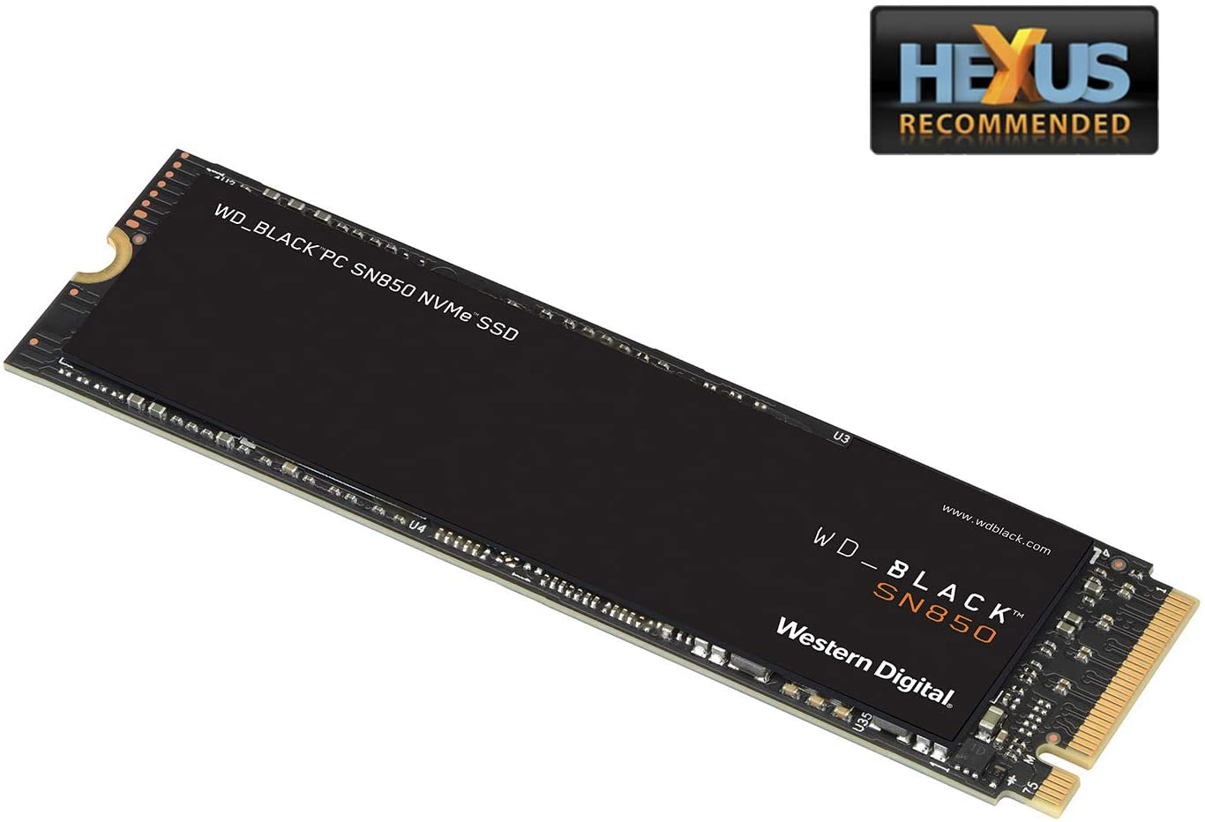
Fig30:WD1TB (Wester Digital, 2019)

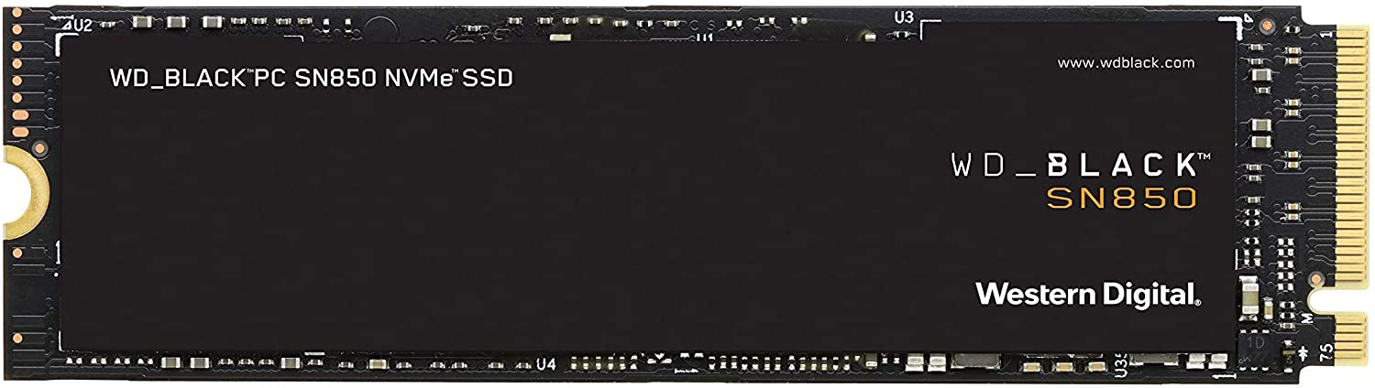
Fig30A:WDBlack (Wester Digital, 2019)

VIII. Power Supply

Powerful and sustainable supply recommended by Gigabyte is Aorus P850W 80+. Model GP-AP850GM is a Intel Form Factor ATX 12V with Active PFC. Output Capacity is 850W, ATX/MB 20+4 pin, 2xCPU/EPS 4+4 Pin, 6xPCI-e 6+2 pin, SATA x6+4 Pin (Gigabyte, 2019).

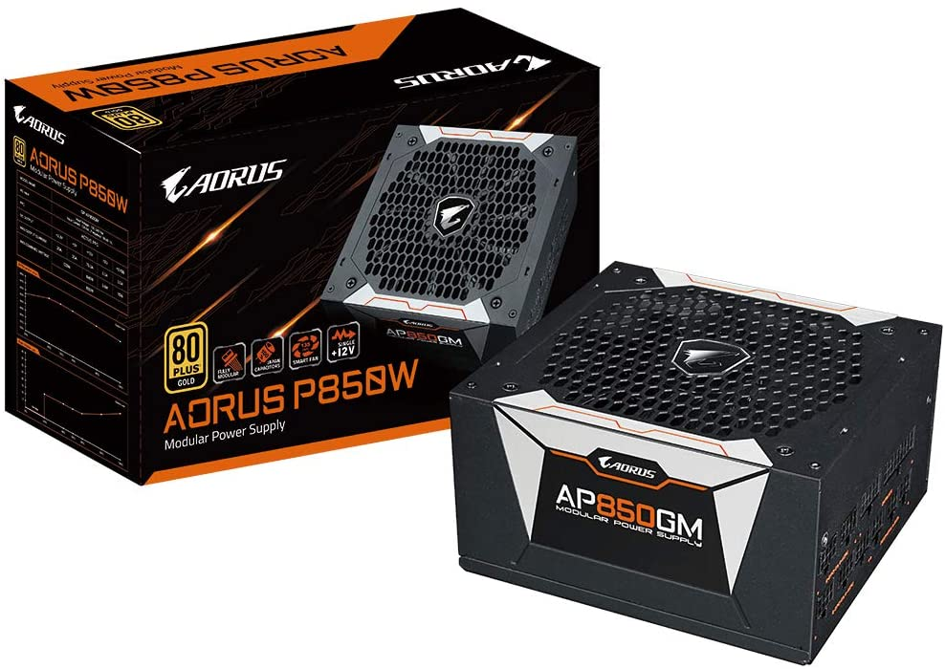

Fig31:P80WPowerSupply (Gigabyte, 2019)

VI. Computer Case

Ionz KZ20 is a PC Computer mid tower case from TEMPERED GLASS. Upper top is removable for max air flow. Available ports on the from: USB2.0/3.0 plus HD Audio front panel.

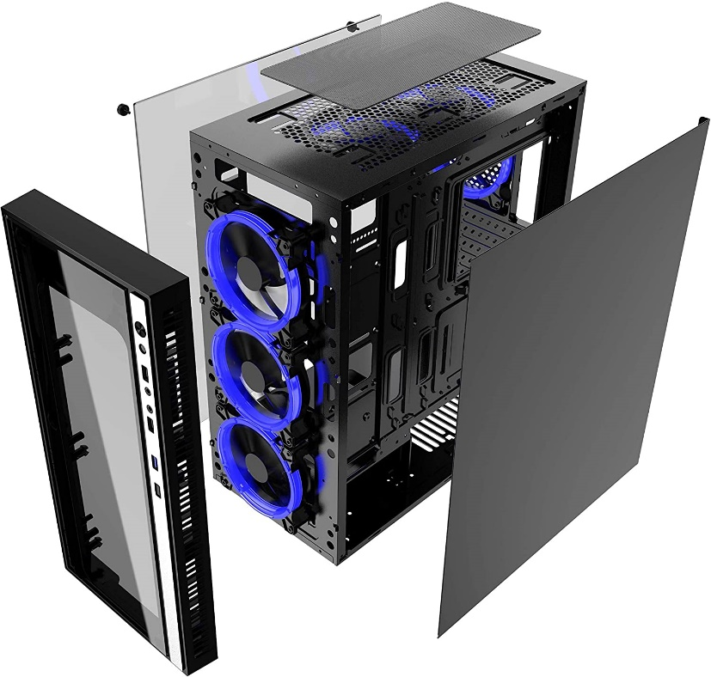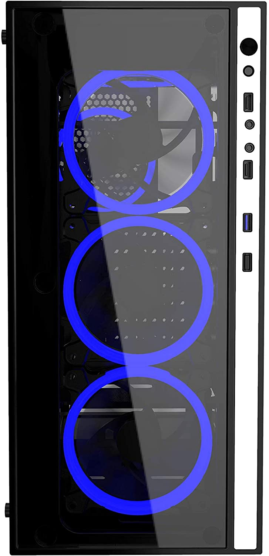

Fig32:Case (Amazon, 2020) Fig32A:CaseFront (Amazon, 2020)

X. Monitor

A true specialist knows that 32-inch width screen is not enough (Fig34-Fig35). Here comes an important part in this scenario. Samsung LC49J890DKUXEN Curved 49’ Ultra-Wide LED Monitor. Rapid 144Hz Refresh rate minimizes image lag and motion blur for smoother experience of 4k video content. DisplayPort Cable inside the box (Samsung corp, 2018).

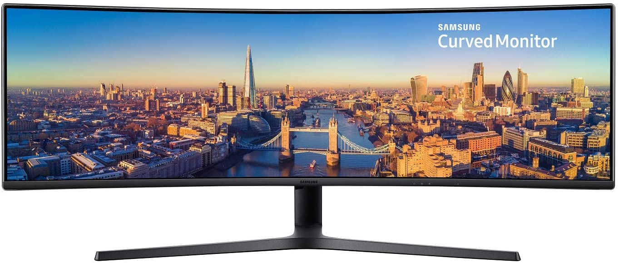
Fig33:Samsung49UWLED (Amazon, 2018)
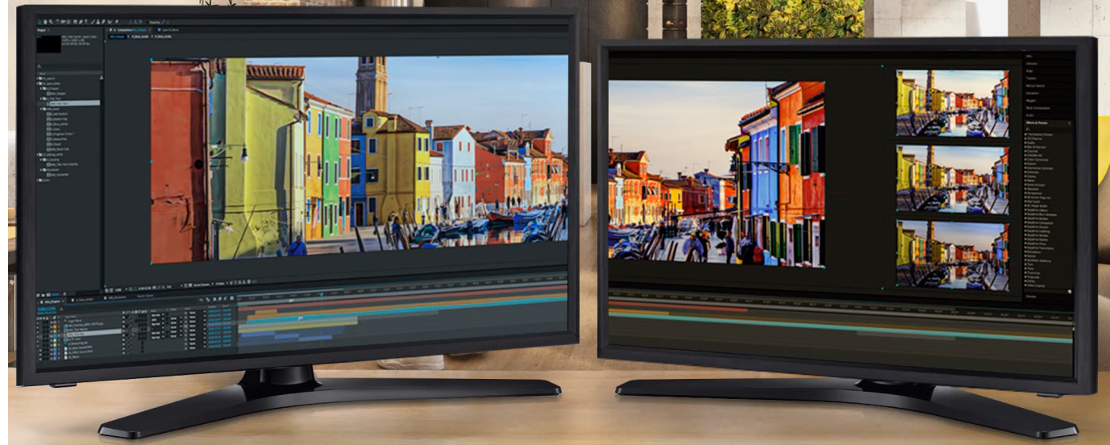
Fig34:Example1 (Amazon, 2018)
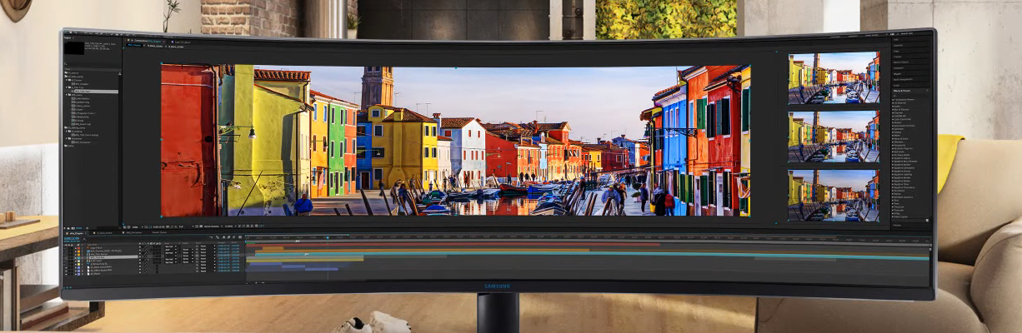
Fig35:Example2 (Amazon, 2018)

XI. Card Reader

ZEDELA provides 7 in 1 USB 3.0 SD Card Hub Adapter that can read various types of memory cards. Up to 5Gb/s through USB 3.0 port. SD/ Micro SD/ CF and MS/M2 slots.

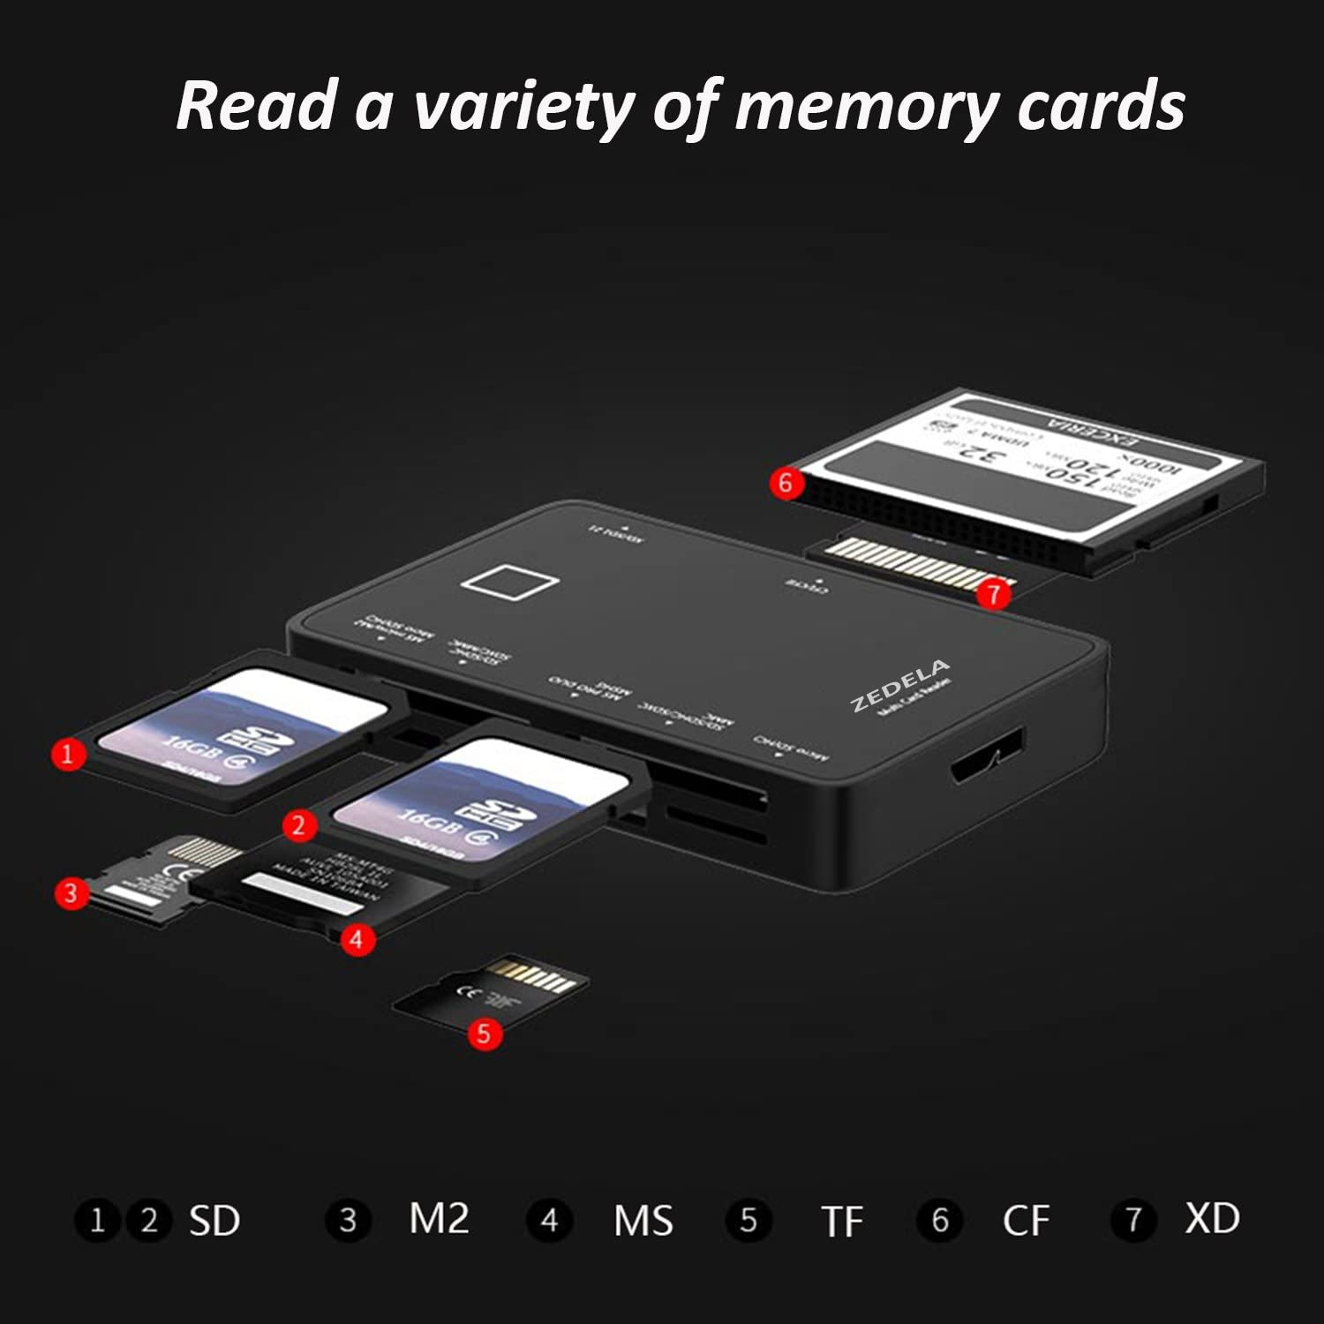
Fig36:Reader (Amazon, 2017)

NAS Drive

QNAP UX-800U-RP 8 Bay 2U Rack RAID Expansion Enclosure for Turbo NAS offers flexible RAID config with the QTS Storage Manager. Max capacity 64TB, SATA 6Gb/s Interface type. Easily add additional drive capacity to a Turbo NAS by using RAID5 configuration, allowing to add additional 8TB Drives to the storage without losing any data in the process (Qnap, 2014). USB3.0-TypeB.

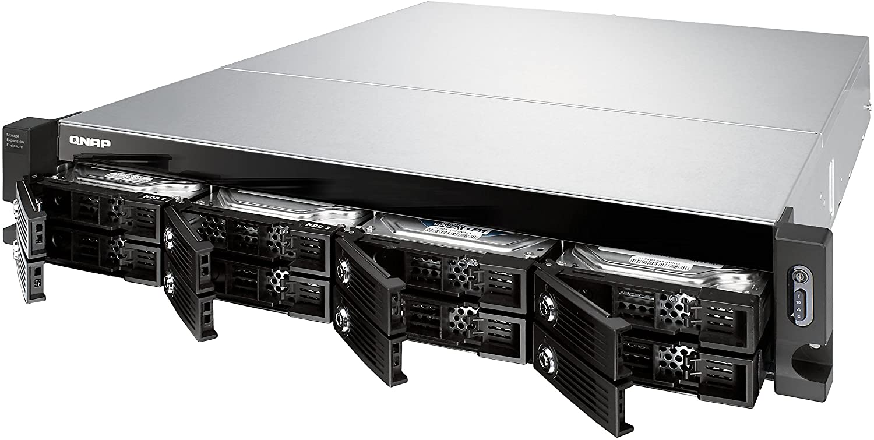

Fig37:QNAPUX800URP (Qnap, 2014)

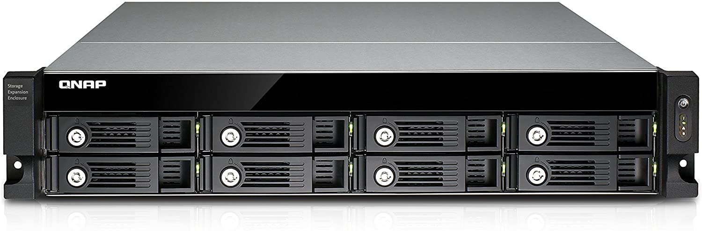

Fig38:QNAPFront (Qnap, 2014)

Sustainable Hard drive for this case will be WD Red-PRO WD8003FFBX 8TB 3.5 Inch NAS Internal 7200RPM Drive. Getting speed up to SATA 6.0Gb/s.

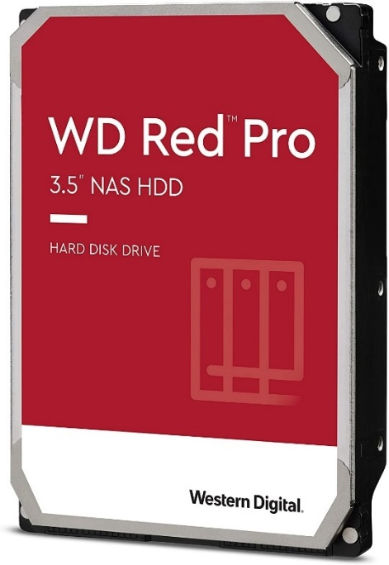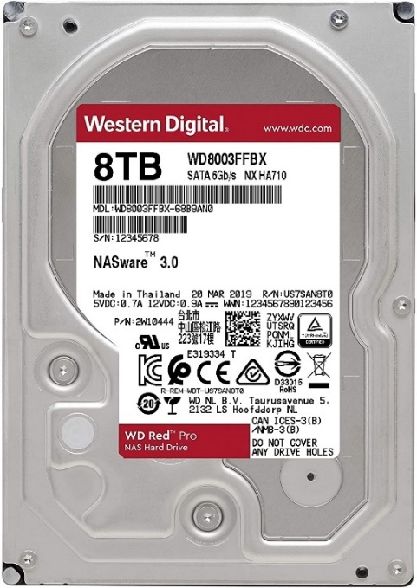
Fig39:NASPro (Amazon, 2018) Fig40:NASPro8TB (Amazon, 2018)

USB 3.0 Type-B SuperSpeed(SS) up to 5Gbit/s cabel required for conection between NAS and Built 2.
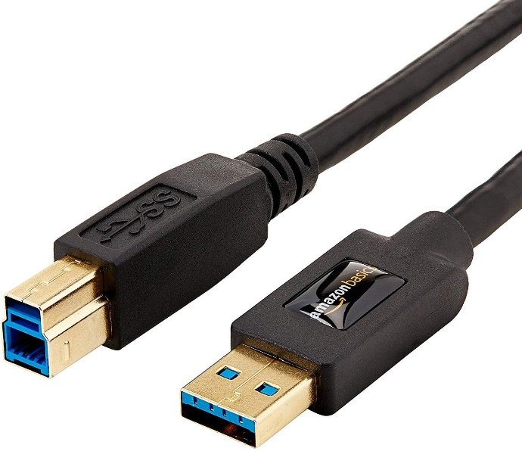
Fig41:TypeB (Amazon, 2014)

Appendix

Total Cost of Built 1
Shopping List from www.amazon.co.uk
Articular Name | Price:£ | Image
Gigabyte GA-J1800N-D2H | £59.23 | 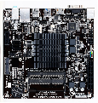 (Fig1)
Corsair  Value Select 4GB | £17.66 |  (Fig6)
500GB WD Blue | £38.95 |  (Fig8)
PicoPSU-90 | £27.83 |  (Fig10)
Lighting Will Power Adapter | £23.98 | 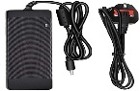 (Fig11)
G60S Case | £44.19 | 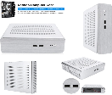 (Fig13)
Philips 243V7QJABF | £94.98 | 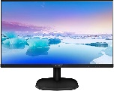(Fig14)
Wi-Fi AC1200 PCIe card | £15.29 | (Fig19)
Logitech M90 | £8.00 | (Fig16)
Logitech K120 | £10.00 | 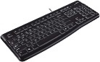(Fig15)
Amazon Basics HDMI 3m. | £5.79 | 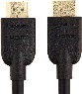(Fig17)
DEEPFOX SATA Connection | £5.79 | 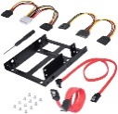(Fig18)
LarmTek Webcam | £19.44 | 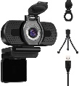(Fig20)
TOTAL: | £371.13

Total Cost of Built 2

Shopping List from www.amazon.com
Gigabyte-Aorus-B550-ELITE | £199.22 | 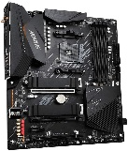(Fig22)
AMD-Ryzen-9-3900XT | 433.95£ | 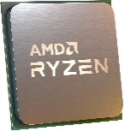(Fig23)
Kingston-HyperX | £114.62 | 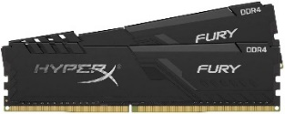(Fig29)
WD-Black-SN850 | £461.47 | 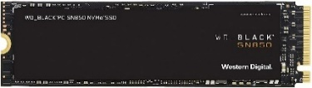(Fig30A)
GeForce-RTX-2060-Super-EVO | £459.99 | 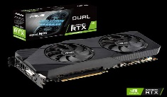(Fig28)
Aorus-GP-AP850GM | £148.07 | 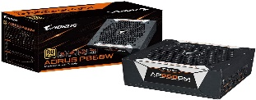(Fig31)
Ionz-KZ20 | £37.95 | (Fig32)
Samsung-Ultra-Wide-LED-Monitor | £799.97 | 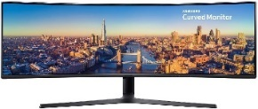(Fig33)
Kraken-Z63 | £121.47 | 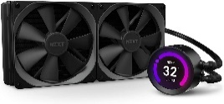(Fig25)
ZEDELA-7+1 | £13.99 | 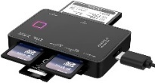(Fig36)
Thermal-Paste | £5.37 | (Fig27)
TOTAL: | £2,649.23

Total Cost of NAS Drive

Shopping List from www.amazon.com
QNAP-UX-800U-RP | £958.81 | 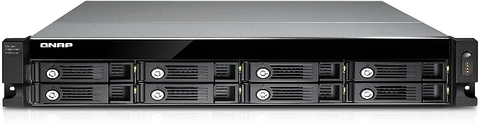 (Fig38)
WD-Red-Pro-8TB | £229.66 | 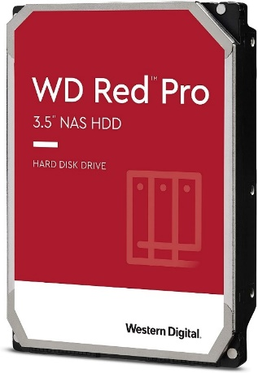  (Fig39)
USB3.0-Type-B(3.0m) | £8.49 | 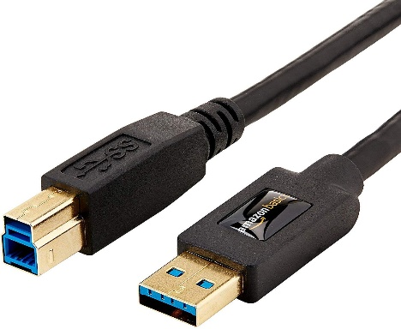  (Fig41)
TOTAL: | £1,196.96

References
Adobe, 2019. Premiere Pro system requirements. [Online]
Available at: https://helpx.adobe.com/in/premiere-pro/user-guide.html/in/premiere-pro/system-requirements.ug.html
[Accessed 20 11 2020].
Amazon Co, 2013. Corsair Store. [Online]
Available at: https://www.amazon.co.uk/Corsair-CMSO4GX3M1C1333C9-1333Mhz-Mainstream-Notebook/dp/B00F96KNGQ/ref=sr_1_8?dchild=1&keywords=ddr3l+1333mhz+sodimm&qid=1607528171&s=computers&sr=1-8
[Accessed 16 11 2020].
Amazon Co, 2015. Amazon basics. [Online]
Available at: https://www.amazon.co.uk/gp/product/B014I8T0YQ/ref=crt_ewc_img_dp_21?ie=UTF8&psc=1&smid=A3P5ROKL5A1OLE
[Accessed 16 11 2020].
Amazon Co, 2019. Brand: Deepfox. [Online]
Available at: https://www.amazon.co.uk/gp/product/B07R65F913/ref=crt_ewc_img_dp_20?ie=UTF8&psc=1&smid=A20ZEIJKW3UQT5
[Accessed 26 11 2020].
Amazon Co, 2019. LarmTek Store. [Online]
Available at: https://www.amazon.co.uk/gp/product/B07WVNYML1/ref=crt_ewc_img_huc_1?ie=UTF8&psc=1&smid=A592QXHV8VIIB
[Accessed 16 11 2020].
Amazon Co, 2020. Brand Dilwe. [Online]
Available at: https://www.amazon.co.uk/gp/product/B08MWJK5TX/ref=crt_ewc_title_dp_2?ie=UTF8&smid=A2KREUBK79VF64&th=1
[Accessed 16 11 2020].
Amazon Co, 2020. Ziyituod Store. [Online]
Available at: https://www.amazon.co.uk/gp/product/B08LYHLWQF/ref=crt_ewc_title_huc_11?ie=UTF8&psc=1&smid=A32IGEZ3DX93HZ
[Accessed 16 11 2020].
Amazon, 2010. Logitech store. [Online]
Available at: https://www.amazon.co.uk/Logitech-910-001794-M90-Optical-Mouse/dp/B003AUZKYI
[Accessed 16 11 2020].
Amazon, 2014. Amazon Basics. [Online]
Available at: https://www.amazon.co.uk/AmazonBasics-USB-3-0-Cable-Feet-Black/dp/B00I83XF76/ref=psdc_1338421031_t2_B00NH144GK
[Accessed 25 11 2020].
Amazon, 2017. Brand zedela. [Online]
Available at: https://www.amazon.co.uk/gp/product/B06ZXV6Y8J/ref=crt_ewc_img_dp_7?ie=UTF8&smid=A1DCZH27EK8ALU&th=1
[Accessed 20 11 2020].
Amazon, 2018. Samsung store. [Online]
Available at: https://www.amazon.co.uk/gp/product/B07C7YNLBW/ref=crt_ewc_img_dp_2?ie=UTF8&psc=1&smid=A3P5ROKL5A1OLE
[Accessed 20 11 2020].
Amazon, 2018. Western Digital Store. [Online]
Available at: https://www.amazon.co.uk/gp/product/B07D3N95GS/ref=ox_sc_saved_image_10?smid=A3P5ROKL5A1OLE&psc=1
[Accessed 20 11 2020].
Amazon, 2019. LightingWill. [Online]
Available at: https://www.amazon.co.uk/gp/product/B07XJ1MMHZ/ref=crt_ewc_img_huc_1?ie=UTF8&psc=1&smid=A38ZM5SGXW39ZT
[Accessed 20 11 2020].
Amazon, 2019. PicoPSU90. [Online]
Available at: https://www.amazon.co.uk/PicoPSU-90-Cyncronix-90W-DC-DC-mini-ITX/dp/B00316RGD4
[Accessed 20 11 2020].
Amazon, 2020. Ionz KZ20. [Online]
Available at: https://www.amazon.co.uk/gp/product/B08M3NFC38/ref=crt_ewc_img_dp_6?ie=UTF8&psc=1&smid=A3NKYWL4DC22AS
[Accessed 20 11 2020].
Amazon, 2020. Thermal Compounder. [Online]
Available at: https://www.amazon.co.uk/gp/product/B07L9BDY3T/ref=crt_ewc_title_dp_1?ie=UTF8&psc=1&smid=A3P5ROKL5A1OLE
[Accessed 20 11 2020].
AMD Corporation, 2020. AMD Ryzen 3900XT. [Online]
Available at: https://www.amd.com/en/products/cpu/amd-ryzen-9-3900xt
[Accessed 20 11 2020].
ASUS Co, 2019. Asus Nvidia GeForce. [Online]
Available at: https://www.asus.com/uk/Graphics-Cards/DUAL-RTX2060S-A8G-EVO/specifications/
[Accessed 09 June 2020].
Corsair Co, 2013. Corsair. [Online]
Available at: https://www.corsair.com/uk/en/Categories/Products/Memory/Corsair-Memory-%E2%80%94-4GB-%281x4GB%29-1333MHz-CL9-DDR3L-SODIMM-Memory/p/CMSO4GX3M1C1333C9#tab-faqs
[Accessed 16 11 2020].
GIGABYTE Technology LTD, 2014. GA-J1800N-D2H (rev. 1.x). [Online]
Available at: https://www.gigabyte.com/Motherboard/GA-J1800N-D2H-rev-1x#ov
[Accessed 15 11 2020].
Gigabyte, 2019. Aorus P850. [Online]
Available at: https://www.gigabyte.com/Power-Supply/GP-AP850GM/sp#sp
[Accessed 20 11 2020].
Gigabyte, 2020. B550 Aorus Elite AX v2. [Online]
Available at: https://www.gigabyte.com/Motherboard/B550-AORUS-ELITE-AX-V2-rev-10#kf
[Accessed 20 11 2020].
Intel Corporation, 2013. Intel Celeron Processor J1800. [Online]
Available at: https://ark.intel.com/content/www/us/en/ark/products/78866/intel-celeron-processor-j1800-1m-cache-up-to-2-58-ghz.html
[Accessed 16 11 2020].
Kingston, 2020. Memory Module Specifications. [Online]
Available at: https://www.kingston.com/dataSheets/HX432C16FB4K2_32.pdf
[Accessed 20 11 2020].
Logitech Co, 2010. Logitech store. [Online]
Available at: https://www.logitech.com/en-gb/product/k120
[Accessed 16 11 2020].
Mehr, R., 2015. Intel j1800 playing full jd 1080p. [Online]
Available at: https://www.youtube.com/watch?v=s7x5L88eJCE&ab_channel=RicardoMehr
[Accessed 16 11 16].
NZXT, 2020. Kraken z63. [Online]
Available at: https://www.nzxt.com/products/kraken-z63
[Accessed 08 11 2020].
Philips corporation, 2017. Philips Web Site. [Online]
Available at: https://www.philips.co.uk/c-p/243V7QJABF_00/full-hd-lcd-monitor
[Accessed 16 11 2020].
Qnap, 2014. Qnap Store. [Online]
Available at: https://www.qnap.com/en-uk/product/ux-800u-rp/specs/hardware
[Accessed 20 11 2020].
Samsung corp, 2018. Samsung Store. [Online]
Available at: https://www.samsung.com/uk/monitors/business/curved-monitor-with-329-super-ultra-wide-screen-49-inch-lc49j890dkuxen/
[Accessed 20 11 2020].
Wester Digital, 2019. WD Store. [Online]
Available at: https://shop.westerndigital.com/en-ie/products/internal-drives/wd-black-sn850-nvme-ssd#WDS500G1X0E-00AFY0
[Accessed 20 11 2020].
Western Digital , 2013. Western Digital Store. [Online]
Available at: https://shop.westerndigital.com/en-gb/products/internal-drives/wd-blue-mobile-sata-hdd#WD5000LPCX
[Accessed 16 11 2020].

