

Computer Architecture
Giuseppe Costanza | Bsc Cloud Computing | 13/11/2020
Contents
Scenario 1 1
Scenario 2 9
References 17

Scenario 1
In this first scenario, we will produce a computer for daily use.
As the first thing, we will start with choosing a processor or “CPU”, in this case, we don’t need a very powerful CPU, because it will make just normal operations, a good CPU, in this case, will be an “Intel Core i3-10100”.
I always prefer an Intel as a processor, the only bad thing about them is that usually they are consuming too much power compare to the others, but in this case, this processor is good, is not that powerful, and is not consuming that much.
This processor is the last generation CPU, comes out with 4 core with a processor base frequency at 3.60 GHz with a functionality Turbo that arrives till 4.30 GHz, integrated graphics, and integrated sound.
The price for this Cpu is 100£ (Intel, 2020)
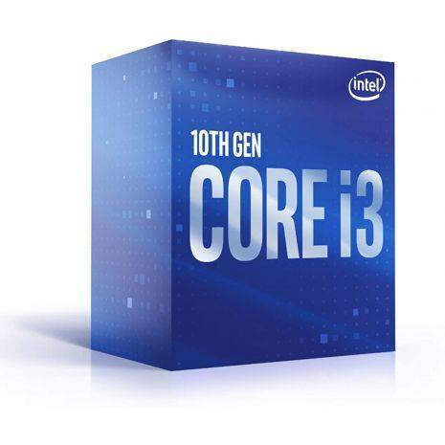
After that we have chosen the CPU, we need a cooler for our processor to prevent it from burning, we chose an ALPINE 12 from Artic company. The price for this component is around £ 5

Now is the time for the Mainboard, concerning the CPU we need to use a Compatible mainboard, and for me, the best one, in this case, will be the “ASUS Prime H410M-A Intel Socket 1200 Motherboard”.
The manufacture of this Mainboard is Intel, as our processor. We choose this because is from the same manufactured and engineered to unleash the full potential of 10th Gen Intel® Core™ processors, so the Pc will work efficiently and we will not have a problem at all.
This mainboard come out with a space slot for one processor, and that is perfect for as, 2 slots for the memory, maximum RAM supported till 64 Gb, supported the type of storage HDD AND SSD, and 4 USB ports
The price of this mainboard is less than the CPU and is around 65 £.
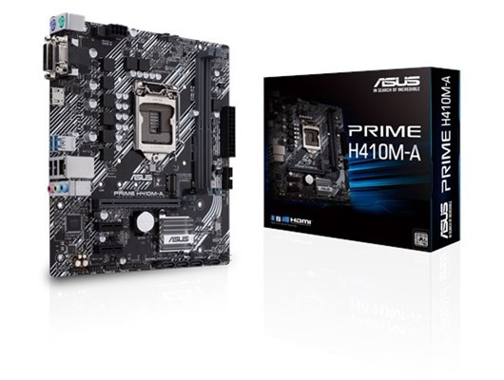

Instead, to buy and use a Video Card we will use the integrated graphics that come with the CPU, which is an Intel® UHD Graphics 630 by doing this we will save on our budget, and at the same time, we would have a performing computer for our daily operations.

As a RAM instead I chose an 8 Gb bank that will be more than good, as a supplier I preferred the Crucial because compared to Corsair they are cheaper and they also have good components, precisely the bench I have chosen is a “Crucial 8GB DDR4-2400 UDIMM”. The price for this component is around 20 £.
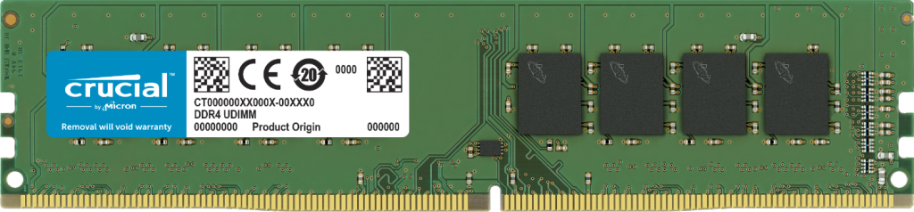
After choosing let's say the main components and now to think about the fixed memory, not needing so much memory I opted for a 250 Gb SSD, the difference compared to a hard disk is that SSD are much faster at the data processing level and today the price is almost the same.
The component is manufactured by western digital and the product name is “250GB Western Digital Blue 3D NAND M.2 (WDS250G2B0B)”.
The price of it is 30 £. (WesternDigital.Store, 2020)
We choose this product unlike others because the 3D NAND SATA SSD has a capacity of up to 2 TB and optimized reliability, then it also has up to 25% lower active power consumption than previous generations of WD Blue SSDs
After this we need a power supply to power the computer, in this case, I chose "SYSTEM POWER B9 300W (bulk)" which we say is one of the cheapest power supplies in the market but that do their job, also is come out with the power cable for connecting it to the socket.

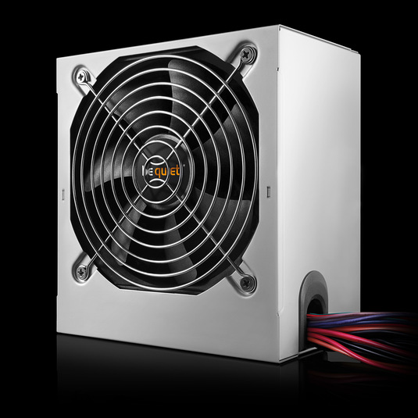
The price for this component is around 15£.
Now that we have all the internal components, it is time to think about our structure that will contain everything, that is the case. I chose a “ Case A-Dis (ELITE U8 OC) 2x USB 3.0 Front (BxHxT: 175x375x405mm)” very cheap since the work we are going to do with our computer does not require any special support for cooling.
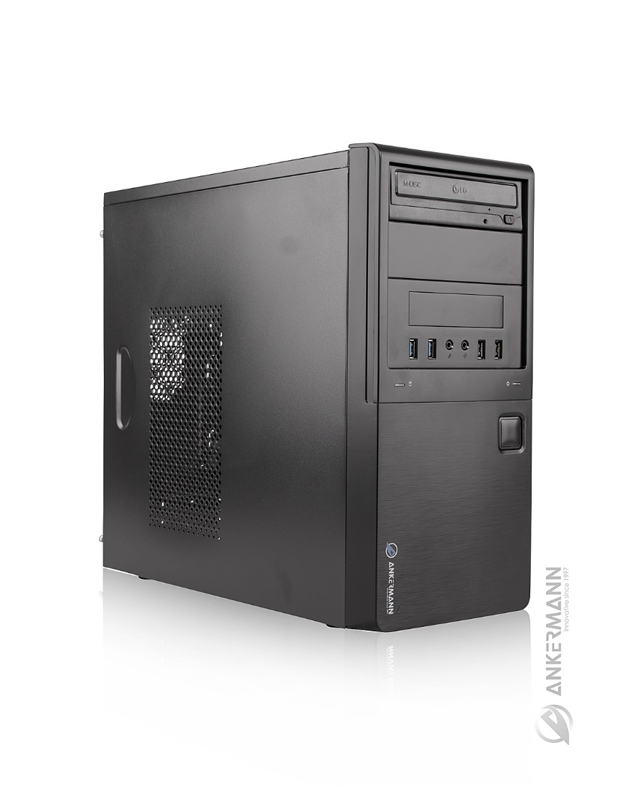
The price of this case is 10£.
Now that our computer is ready and time to think about external peripherals, we will first get a monitor. Given the visual needs of our customer, I evaluated a display of the “ASUS VA249HE 24 ”. So we will have a 24 "screen that will help our client to see the images better and besides the screen has an eye care function.
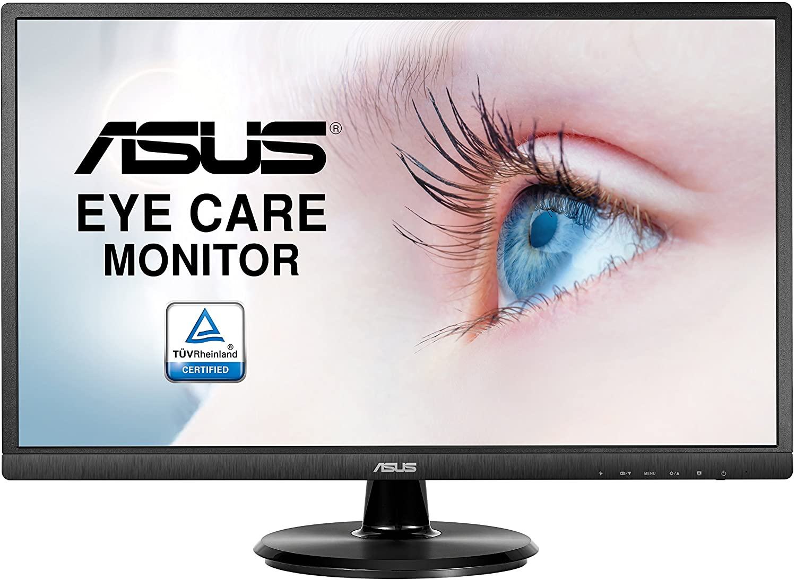
The price of this monitor is around 60 £.
Instead, as an external writing device, I chose a Logitech keyboard with precision “DESKTOP MK120 model”, given the customer's request I chose a keyboard with large keys to facilitate their pressing, the keyboard uses a connection via USB cable. Together with the keyboard, they will also give us a mouse.
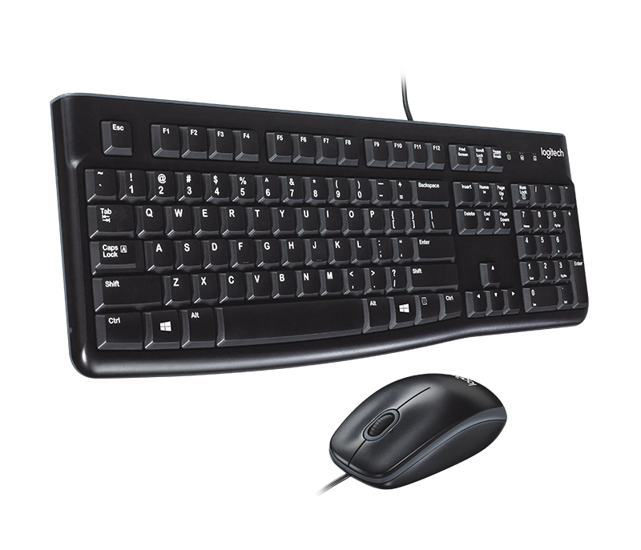
The price for this keyboard is 10£
Lastly, we need a Wi-Fi peripheral, since it is not integrated with the motherboard we have chosen, as a peripheral, I have chosen a “TP-LINK TL-WN822N “wireless card for price and quality.

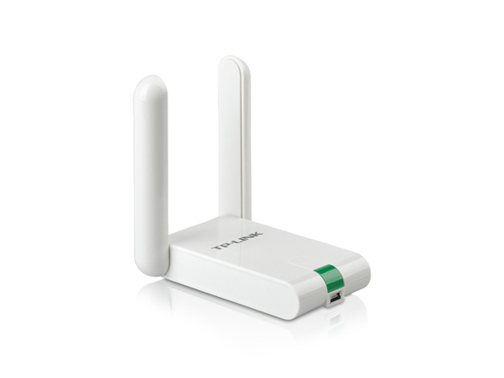
The price for this wireless card is 10£.
So we assembled our computer. The total price is £ 330 and we will have a lower-middle-class computer, to have the opportunity to perform all our daily operations, view streaming videos, and use programs to make video calls.

Scenario 2
In this scenario, we will project a computer for a self-employed, for editing 4k video and using heavy software.
First of all, we will choose the CPU that will have to be powerful enough since it will process very heavy data, and we will choose a CPU with an integrated GPU to help our video card when it is under stress and vice versa.
The CPU that is chosen is the “Intel® Core™ i9-10850K Processor” we chose this because is a 10th generation intel core processor with 10 cores, processor base frequency 3,60 GHz which reaches up to 5.20 GHz in Max Turbo, Cache 20 Mb, Bus speed 8GT/s. It’s a very good CPU like all the Intel products.
The price of this CPU is around 430 £. (INTEL, 2020)
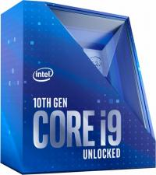
After we have chosen our CPU, we will choose our cooler since we do not want to have any nasty surprises after spending all this money, I chose an air cooler, specifically a "be quiet! Pure Rock 2 Silver (BK006)".
The price for this component is only £ 30
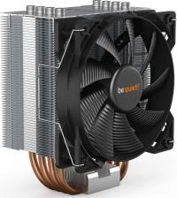
Now It is time that we have a look for the mainboard, we chose an "MSI MPG Z490M GAMING EDGE WIFI LGA 1200 Micro ATX Intel Z490 (7C79-006R)".
We choose this mainboard because:
- Total control of the fans through software for cooling our components.
- Latest generation Wi-Fi already integrated
- Supports RAID 0, RAID 1, RAID 5, and RAID 10 for SATA storage devices
- Supports S / PDIF output for support of our surround system.

The price for this component is around 190 £ (Msi, 2020)
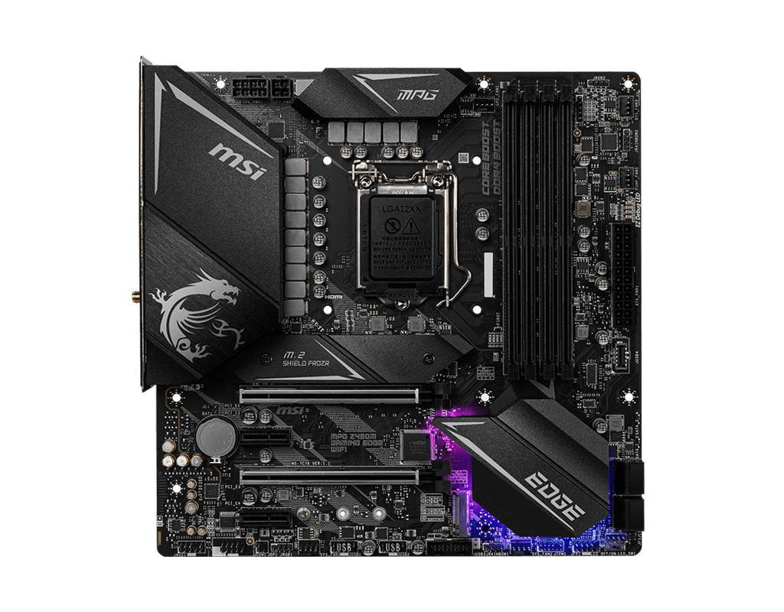
After this, It is up to the graphics card, since we are going to process videos in 4k and therefore at a high resolution, we need a powerful video card that goes to work together with our CPU when it ends up under stress.
For this, we chose the "MSI Radeon RX 5700 XT GAMING X (V381-032R)"
We choose this because:
- Memory Speed 14 Gbps
- Memory 8GB GDDR6
- 256-bit Memory Bus
- Core Clocks Up to 1980 MHz
The price of this mainboard is 500 £. (MSI, 2020)
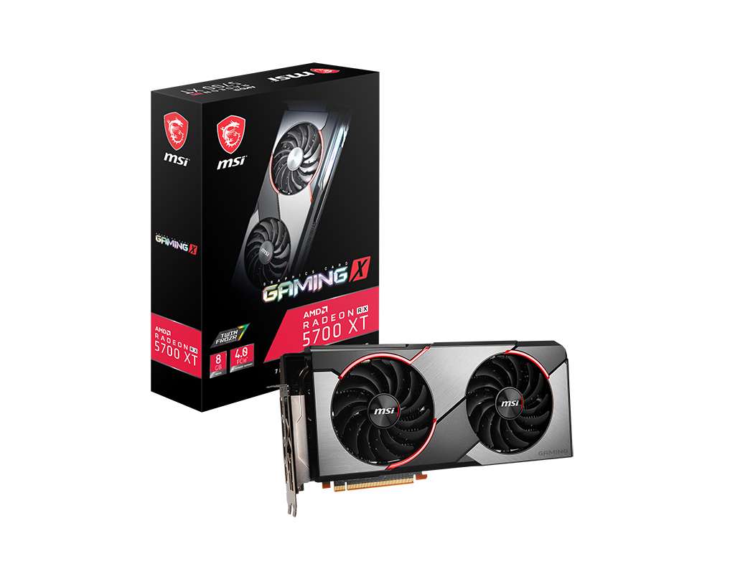
As System memory instead we decided to choose two 16 Gb banquets so in total 32 Gb of RAM since we need to process heavy data quickly we need a good amount of RAM.
we chose the “32GB Corsair Vengeance LPX Kit DDR4 2.666MHz (CMK32GX4M2A2666C16)”, which will be perfect for our configuration.
The price for this component is around: 100£.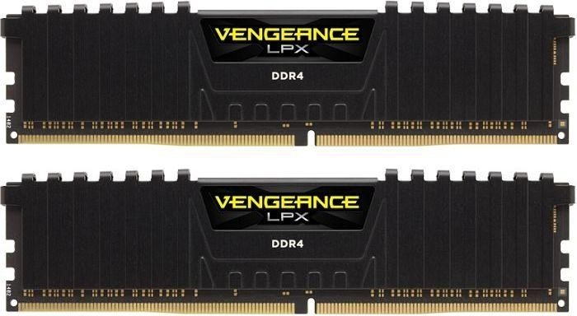
As internal memory we have chosen an SSD, which makes the transfer and processing of data fast, we have chosen 1 Tb as the size of our memory since even if we are going to use external memory support, we must also have a good memory capacity internal for all to function properly.
The product I chose is "1TB Western Digital Blue 3D NAND M.2 (WDS100T2B0B)" and the price for this component is around £ 100.
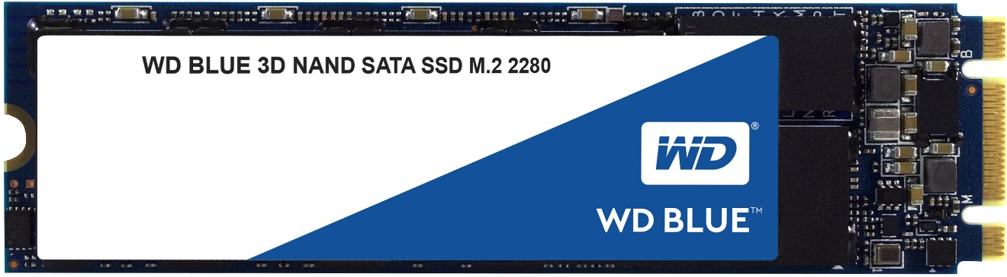
As a power supply, I chose a 600W power supply with a frequency of 50 Hz which will be perfect for powering our PC.
The chosen product is the following "600W be quiet! System Power 9 (BN247)"
We can find this power supply for just £ 50.
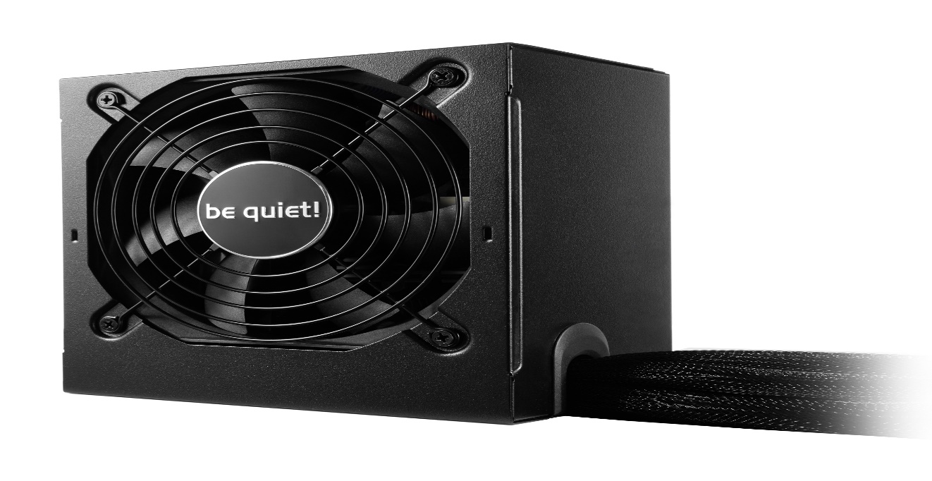
Given the advanced configuration of this computer, I decided to choose a case that silences the noises produced by the hardware, and also nice to see with external configurable LEDs.
The case I chose is "Wild Rabbit Black Rabbit Green LED Light".
The price is 25 £.
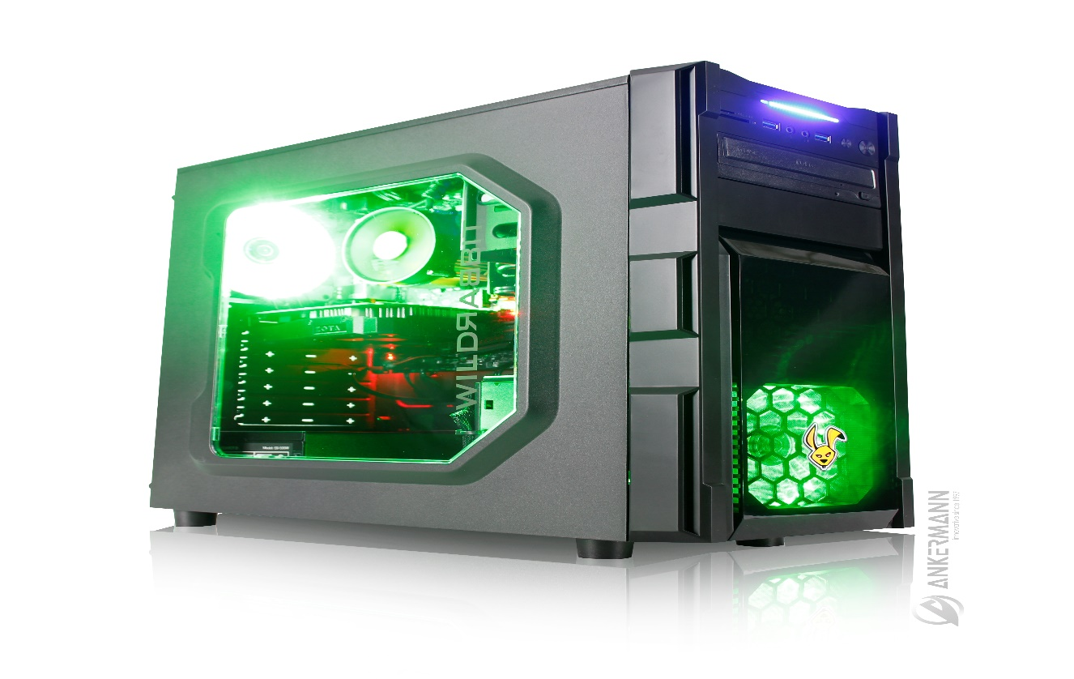
After that we chose all hardware for the input is time to think about the output, since we are going to process high-resolution videos and right that our monitor is too. So we chose a full HD monitor from Samsung, the model is "Samsung U28E590D 28-Inch LCD / LED Monitor - Black"
We can find it for around £ 100.
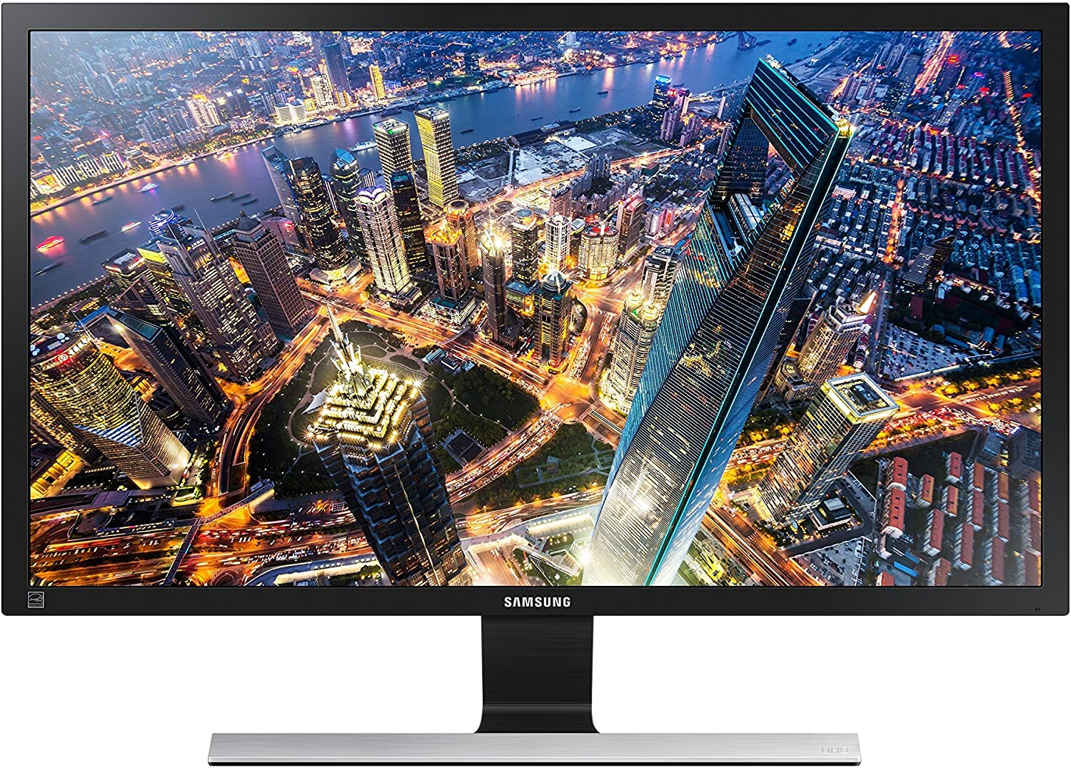

Given our conditions, we would need a NAS storage drive to expand our memory whenever we need it. For starters I will choose the NAS Drive, I chose the “Synology DS920 + 8TB 4 Bay Desktop NAS Solution” model with an 8GB drive. The price for our NAS drive plus hard disk is around £ 900 (Synology, 2020)
So we assembled our computer. The total price is £ 2430 and we will have a high-class computer.

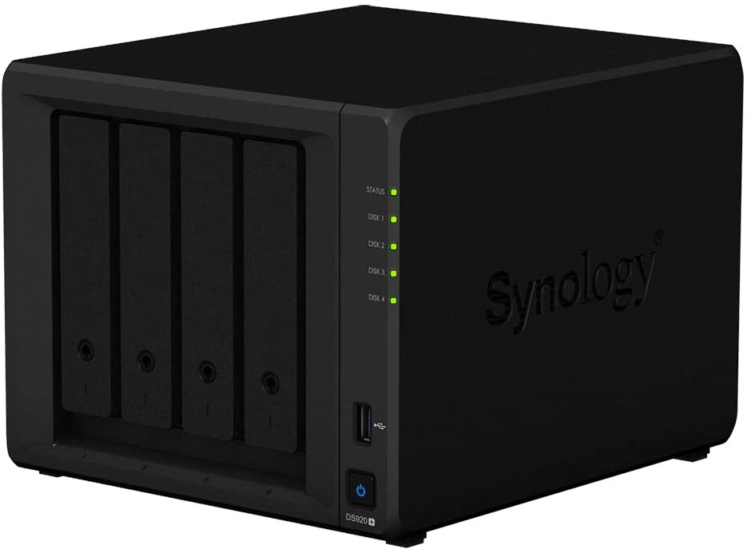
Since for now in our NAS we have only one hard disk there is no need to use any Raid technology, but in the future we should expand our hard disk up to 56 TB, to do this I will evaluate the best technology to use in the future.
RAID is an acronym that stands for Redundant Array of Inexpensive Disk.
There are different types of RAID, based on the type of hard drive we own and our needs for performance, security, and total storage capacity.
The first type is RAID 0 is the only one that does not provide effective redundancy. In RAID 0 two or more disks operate to create a single logical volume (for example, two 8 TB disks create a single 16 TB volume) this solution has the advantage that reading and writing occur simultaneously on the two disks but has the disadvantage that when one hard drive is damaged, the other can also be compromised.
The second type, also very common, is RAID 1 (also called mirroring): this can offer real redundancy because data is read and written equally between the two disks, which are always and at all times identical.
By connecting two or more hard drives in RAID 1, we will always get a single logical volume, but the total capacity will be only that of the smaller physical disk so this technology will be very expensive in terms of price. This technology is very good in terms of security and to manage two hard drives, we could use this type when we have two hard drives in our NAS but by the time they are 3 this technology will no longer be valid.
The third type is RAID 5, a smarter system that splits data and parity across all disks. This system is now very popular in medium-small and medium-large generic systems because it offers security, redundancy and an acceptable speed, which grows as the number of disks grows but to be used at least 3 hard disks must be available. capacity. That said in the future when we have more than two hard drives we will use RAID 5 technology and when they will be 2 we will use RAID 1 technology instead.
Since I've talked extensively about the RAID systems we can use for our NAS, it seems fair to me to talk about how the NAS works.
NAS stands for Network Attached Storage and represents a type of computer that can connect to the local network and by using one or more hard drives, allows you to share files between various devices.
The NAS can be configured in two ways on our PC.
The first is via the USB connection and the second is via the network connection.
After configuring our NAS we can access it directly through our PC if connected with the USB cable, or even remotely from another device that is a smartphone or a PC via a normal web browser by entering the web page we can log in and enter and use our file.
The speed of the NAS depends on two factors both from the CPU it mounts because as I said before they are computers, so the more powerful the processor will be the faster it will process data and therefore whether it is about writing data to the disk, or that sharing data online the speed depends on the processor. The model I chose has a speed of over 225 MB / s for both reading and writing. The second factor is the internet connection since if we want to access a movie for example that we have on our NAS from our mobile we must have a very good connection on our NAS that is at least higher than 10 Mbps to have fluid streaming of the file.

References
Asus. 2020. Asus. [Online] 2020. https://www.asus.com/Motherboards-Components/Motherboards/PRIME/PRIME-H410M-A/.
Digital, Western. 2020. [Online] 2020. https://shop.westerndigital.com/products/internal-drives/wd-blue-sata-ssd#WDS250G2B0A.
Intel. 2020. Intel. [Online] 2020. https://ark.intel.com/content/www/us/en/ark/products/199283/intel-core-i3-10100-processor-6m-cache-up-to-4-30-ghz.html.
INTEL. 2020. Intel. Ark.Intel. [Online] 2020. https://ark.intel.com/content/www/us/en/ark/products/205904/intel-core-i9-10850k-processor-20m-cache-up-to-5-20-ghz.html.
Msi. 2020. Msi. [Online] 2020. https://www.msi.com/Motherboard/MPG-Z490M-GAMING-EDGE-WIFI.
MSI. 2020. Msi. [Online] 2020. https://www.msi.com/Graphics-Card/Radeon-RX-5700-XT-GAMING-X.
Synology. 2020. Synology. [Online] 2020. https://www.synology.com/en-us/products/DS920+.
WesternDigital.Store. 2020. Wester Digital. [Online] December 2020. https://shop.westerndigital.com/en-gb/products/internal-drives/wd-blue-3d-nand-sata-ssd#WDS250G2B0A.

