DS 1 – My Digital Life

Screenshot 1
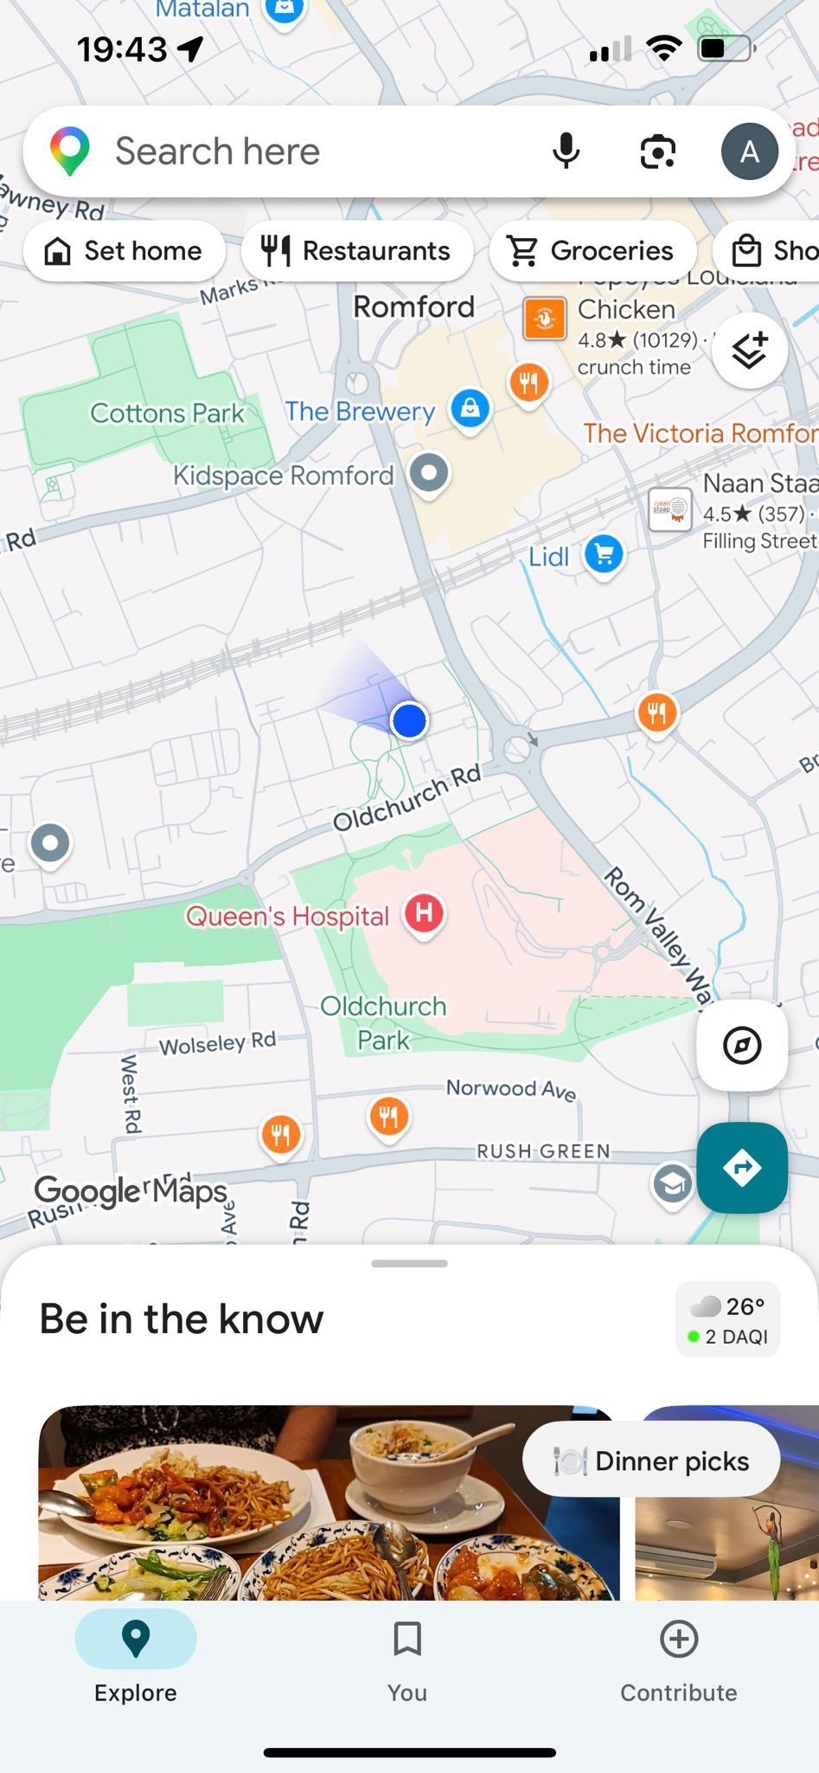
This screenshot shows Google Maps, which I use to navigate, find places and plan journeys.

Screenshot 2
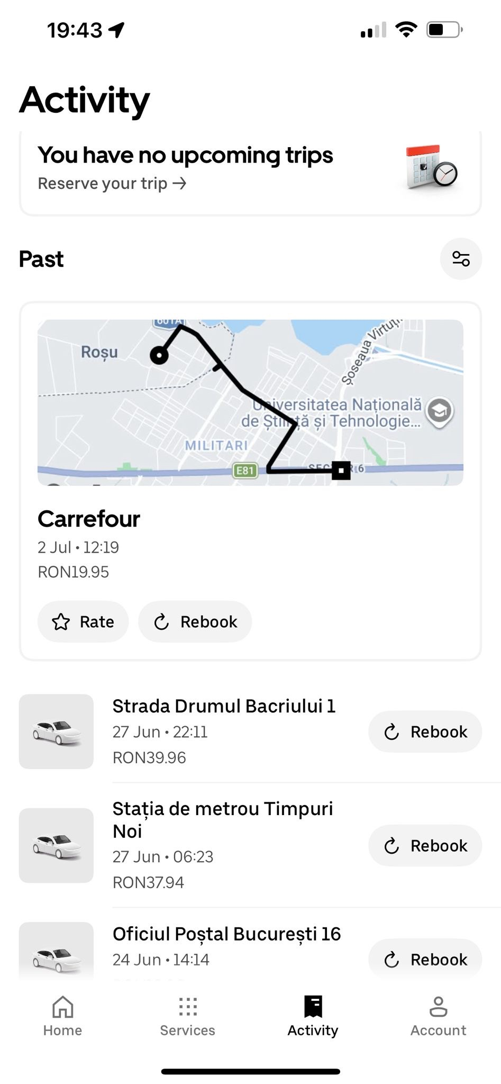
This screenshot shows my ride history. I use transport apps to travel and manage my journeys.

Screenshot 3
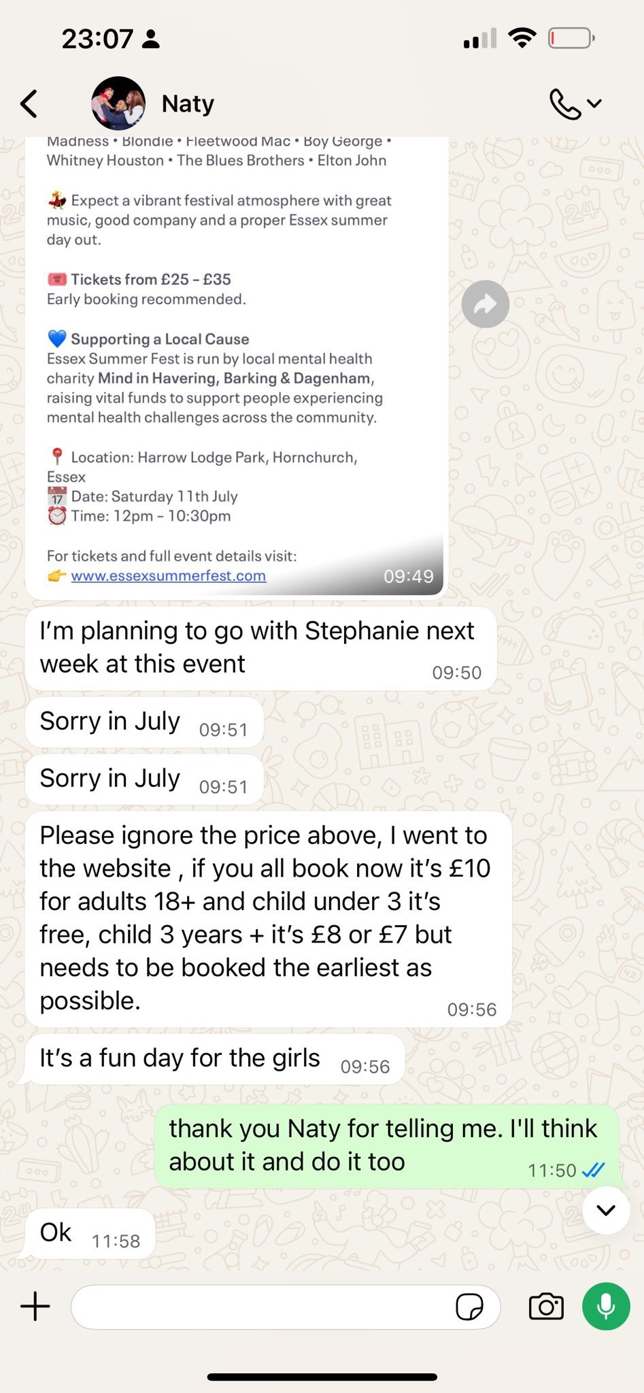
This screenshot shows a WhatsApp conversation. I use messaging apps to communicate with friends and family.

Screenshot 4
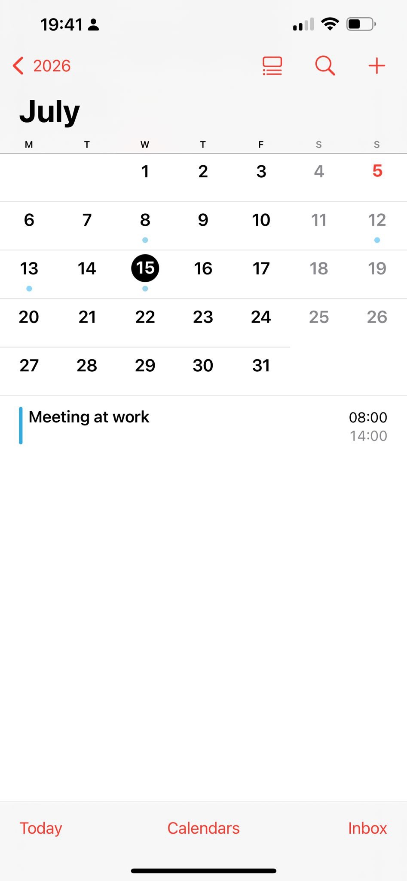
This screenshot shows my digital calendar. I use it to organise meetings and remember important events.

My Short Reflection
I use digital tools every day for work, communication and travel. Google Maps helps me find locations and plan routes. Messaging apps help me stay in touch with family and friends. I also use digital calendars to organise my schedule and remember important meetings. I feel confident using most digital applications, but I would like to improve my digital skills even more. Digital technology makes my daily life easier and more efficient. I hope this module will help me become more confident and productive when using digital tools.

