Change Makers recycling and organizing

Contents
Introduction 3
Selecting the idea 3
2-minute elevator pitch 4
Research in to how bad does E waste damage the planet? 4
Writing a survey 5
The results of the survey. 8
Bibliography 13

Introduction
My plan for this project is to find new ways to help our course recycle and re-use equipment from both the sound and light department so we don’t end up throwing away usable equipment that can be fixed using parts from another identified “broken” fixture, alongside taking ownership of the spaces we are given so people are less intimidated with recycling and reusing if the environment there in is workable. To do this I will talk with individuals that work closely with the equipment to get their honest thoughts on what they feel can be done to improve the places we work in along with recycling parts so as what we have can last longer.

Selecting the idea
There are many different things I could have chosen for this project from dealing with how people that suffer from things like dyslexia find it hard to push them self forward to achieve their goal of landing the job they want, to how people use different coping mechanisms for deadlines and how that can affect them both positively and negatively.
I started by writing all the ideas I wanted to look at in a mind map and went through the pros and cons of each idea, to make sure I was not rushing myself I would sit down after having dinner and look at one idea and focus my time looking at the pros and the cones and if it would lead to an outcome and if that outcome would be useful for future students.
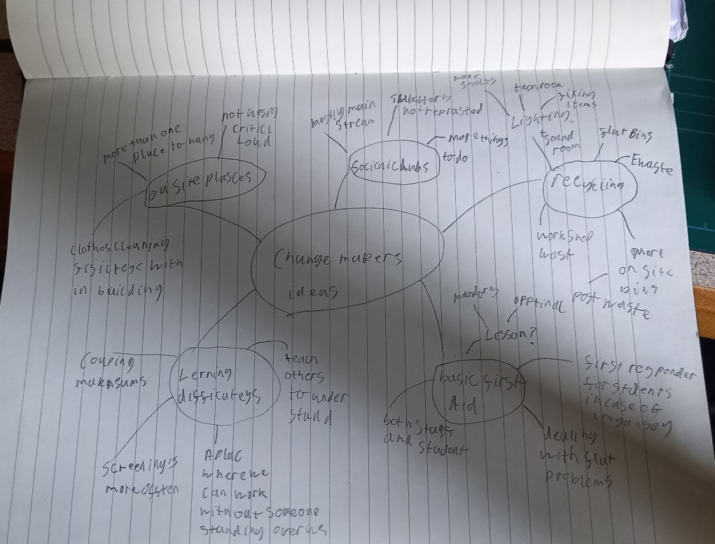

But after seeing and hearing how Libby’s idea has had a change in a space we use every day has inspired me, Libby was in the workshop most of the time and I tend to spend most of my time in the light and sound tec cupboards but every time I walk in there I am greeted by a sea of mess and half of the time people don’t know what’s not working and what is. I intend to find new ways for us to store items and start thinking about not throwing away items if there are parts that can be saved and used elsewhere.

2-minute elevator pitch
As part of the development of the idea we were each asked to make a 2-minute elevator pitch to Stacy and Paul, the idea being that if they could grasp what our idea was in a short amount of time, we would then be given the green light to continue and develop the idea Further.
Below is what I intend to say during the pitch I will place the pitch on cue cards but I will try not to rely on them.
Good morning, I would like to enact a change with in our department one that means we waist less and recycle more and take back some space that we all can use, be honest how many times have you through away a piece of tech that you own just because something in it has stopped working and replaced it with something ells, I will put my hand up I have, and we have the same mentality when it comes to our lighting and sound equipment when something stops working it gets marked as broken placed on the floor and it sits there till we all get tired tripping over it.
But just because it is marked as broken does not mean everything in it is broken take a car for example when your car has a fault or breaks down you don’t through the car away and get a new one no you take to a garage and they fix the fault or replaces the faulty part, there is still usable parts in that car the same way there are usable parts in that broken fixture that we can reuse, why not take that fixture apart and hold on to the parts that still work and start a store of replacement bits that can be used when a fixture is marked as broke.
If we start thinking, how do we start reusing rather than throw away we as the new breed of theatre technicians will have a new skill to fall on that being able to repair and reuse equipment so that we can reduces the damage to our planet by not throwing something out that can be reused in a different way and save who ever we are working with some cash.

At the end of the pitch, I got to one minute and fifty seconds so a few seconds short of the hole two minutes but Stacy and Paul agreed and liked the idea and they support getting more storage for equipment, so I was given the green light to develop the idea father, but to get a better idea of how bad electronic goods damage the planet when not recycled I needed to do some research.

Research in to how bad does E waste damage the planet?
The answer to this question is not a good one, even if the item is recycled correctly there is still a hole heap of problems, but if an item is taken straight to land fill that is even worse.
There are specific rules laid out when it comes to dismantling an electrical good so that most of the materials within that can be recycled like plastic, steel, aluminium and glass, but even this can have problems. As the process to retrieve the recyclable materials requires more time and effort, so people might think to just send it to a land fill but that is worse as it damages the planet in a way that most would not think about, allowing the item to just rot in a land fill means harmful toxic liquids and gases can leach in the to soil, air and water damaging the eco system and in some cases country’s find it easier to burn items witch again is not good as this leads to more fossil fuels to be burnt to keep up with the demand to get rid of the electrical goods and the environment is effect by this method with increased changes of acid rain, more smog and the toxic gasses being released in to the air.
We also have an ethical dilemma to look at as from 2021 it was estimated that each person would contribute seven point six kilograms of electrical goods waste and most of our electrical good’s waste gets shipped off to developing countries where its then dismantled by hand in un healthy circumstances. Then what ever is left that can’t be recycled it is sent to land fill where whatever is left leaches chemicals or wastes away over years poising the earth, water and air.
And that’s just when it comes to modern day living when you turn your attention to the creative arts, we waste far more than the average person just in creating prototypes before even getting in to the theatre. After the performances or film is finished it thrown away, things that could be reused just placed in to a skip and off to land fill both scenic pieces and tech pieces, there are some that are trying to deal with this impact for example some lighting and sound company’s now use electric vans to move equipment around and also have started changing the bulbs on the inside of older fixtures to more energy efficient LEDs. We also have the National theatre and their Theatre Green Book published in May 2021 which gives theatres new guid lines and good practises for a greener theatre spaces

This is way I try to reuse as much as I can and how I am aiming to get people to start reusing and fixing items as sometimes only one thing is broken in the item not the whole thing but to do that, we need people to organise and clean the spaces there in so it does not get out of hand and we have a place we can all benefit from and start to fix and repair not replaces and through away.

Writing a survey
As part of my looking into dealing with organising and recycling for the lighting and sound tech rooms with in the university I needed to get a general idea on what people’s stances where when it comes to recycling electrical goods and organisation. This also gave me a changes to see if there were any ways that others recycled and organise that would befit our department and the future years that come after us.
This was the first time I had ever put a survey together so I needed to look into what makes a good survey lay out, along with taking what had been mentioned in the lectures with John about writing and laying out a survey.

What was surprising and something that I don’t think we think about when it comes to using a survey to get results is the different ways, we can go about lunching our survey and how each method may get different responses.
For example, we could launch our survey on social media asking people if they could spear a few minutes to answer questions, and although this could get a large response it’s not necessarily going to be our target audiences as am looking at something specific that effects our department and industry. Along with people don’t often fill out survey’s if there not interested or after some time they get bored if there are too many questions. We can give them an incentive to do the survey but then are we just getting people that want the reward and are not answering truthfully.
Another option is to get a focus group so select people and ask them if they would answer some questions, this way I can select my target audience, the only thing though is people may not have time to talk faces to faces.
Going with the idea of a focus group we can ask the public but this might get a large or a small response along with not really getting my target audience.

From this I have decided to great an online survey that I will email out to people so they can fill in at their own time, this allows me to send it to my target audience along with allowing them time to answer the questions at their own paise.
The next thing I need to think about is the lay out of my questions and making sure there not biased in favour of what am trying to achieve.
Laying the questions out in the right order can not only make the survey easier for people to understand and answer but also it allows me to come up with questions that can produces a response to a question feather on down the line. I need to make sure the questions do not revoke a response that supports my view on the subject matter instead I should allow the results to support my argument or provide me with insight witch I can then use to show my results and how people go about dealing with the subject matter.
One thing that jumped out at me during John’s lecture was the idea of which was best posing to people in a survey that being open ended questions and close ended questions. The idea being people are more likely to answers questions if they are closed ended questions, so questions with a yes, no, maybe answer or is measurable so on a scale of one to ten one being bad and ten being good, that sort of thing. Yes, you are able to get a sold measurable response to your survey doing it this way but you’re missing that personal input that can change the direction you’re going in or give your insight or an idea so adding open ended questions, questions in which the person wrights their own response can not only help me when it comes to collecting the dater but also help the person filling out the survey as it can help them form a result to a question that I pose later on.
Something ells that appeared during my research was keeping a balanced set of answers to a question and letting some of the questions being optional, this is interesting and I can also see why they say that as if the answers are complicated people will less likely do the survey so in a way you have to simplify the answer for the reader without insulting them. I also liked how it says let some of the questions be optional meaning that people can skip a question if they don’t want to answer it or can’t think of an answer, so for my survey am going to make all my questions optional so any question can be skipped one as I don’t want to force the person who is taking the survey to feel daunted by the questions and I would like to see if any questions are skipped so in the future if I have to run a survey again what sort of questions where skipped and who I can adjust them or what to avoid.
After researching the best way of presenting my survey and how to lay it out I then needed to come up with the questions, in total I ended up with nine questions with a mix of open ended and closed ended questions. A copy of the questions can be found below.

Servery questions.

- Do you recycle.
Yes, all the time.
Yes, when I can
Sometimes not all the time.
Not as much as I should.
Not at all.

- Do you recycle electrical goods.
Yes, all the time
Yes, if I can
Sometimes not all the time
Not as much as I should
Not at all.

- Do you keep a space you’re working in organised? Like an office, a storage room or workshop.
Yes, I know where things are
Yes, but sometimes I places things where I know they are
Sometimes but I keep things that are needed in the moment near me
No, I place things down if I don’t need them
No things tend to go everywhere

- In your own words what would stop you from keeping a space you walked in too organised?

- If the room was organised, would you be more likely to recycle what was in there?

Yes.
Sometimes
No

- If there were marked areas for things that are broken, can be recycled and usable, would that make you want to keep the spaces organised and recycle?

Yes
Yes, as long as some cheeked after wards
Sometimes
No, as am not sure where things should go
No, I would leave it to someone ells

- What is one thing that helps you recycle more?

- What is one thing that helps you keep a space organised?

- If the two ways you stated in the last questions where implemented would you keep a workspace organised and recycle more?

Yes.
Sometimes.
No.

The results of the survey.

After leaving my survey for a two-week period the results are in and it’s a mixture of somethings I was expecting and others I was not.
Question one of do you recycle
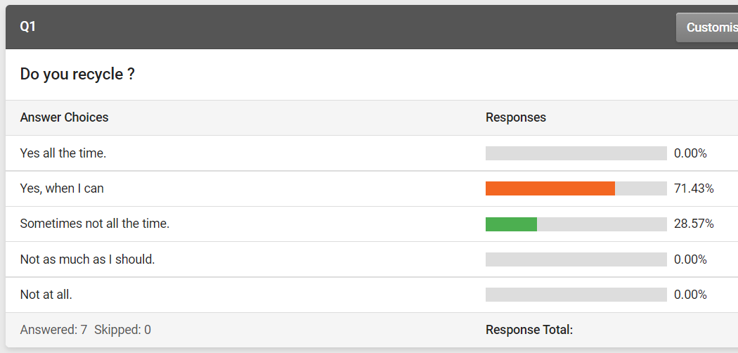

Most of the answers are in the positive that tells me that most do recycle all items on a hole with only 28.57% that do recycle but not as much as they should.

Question two on recycling electrical goods, this is where I am both not surprised and somewhat surprised, as I was expecting more people to say they don’t but 42.86% of people do recycle electrical goods when they can. This shows me that no one answered yes, all the time means that when it comes to electrical goods people are not aware that they can all be recycled.
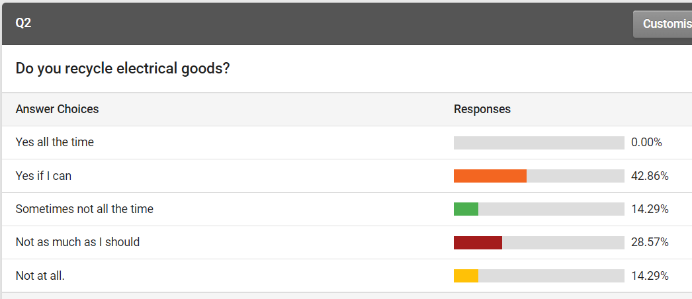

Question three about organisation in a working area, as my target audience for this survey is designers and maker’s 71.43% answered that they keep it organised but keep what they need to hand from watching people from both first, second and third year over the last project I can see how this leads to the room they are working in falling in to chaos along with 14.29% of people being honest and saying if they don’t need it, it gets put down.

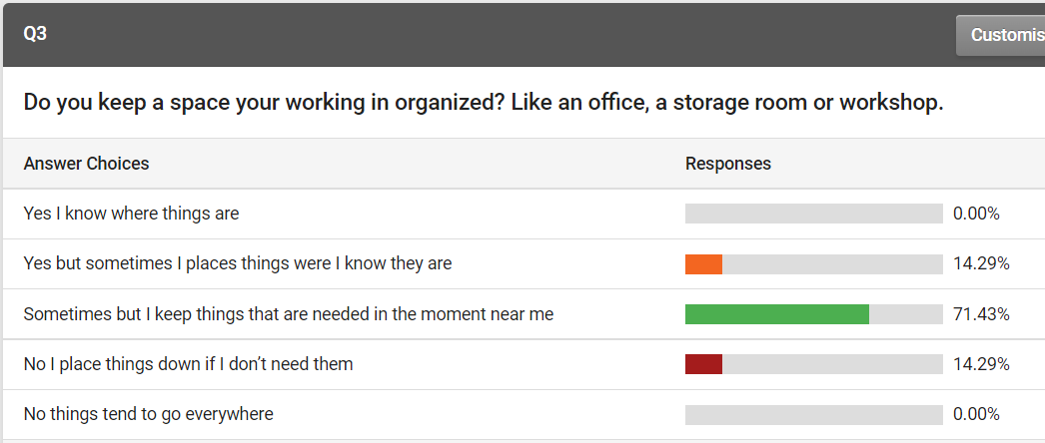

Question four our first open ended question about what would stop someone from keeping a spaces organized, from this I can see that the most seem to say about things not having a proper places to go or if there trying to finish something fast. What was interesting to me was ID207456935 saying watching others treat the space poorly indicating to me that sometimes that people that would keep a workspace tidy don’t stick to what they would do if they see other treating the spaces poorly.

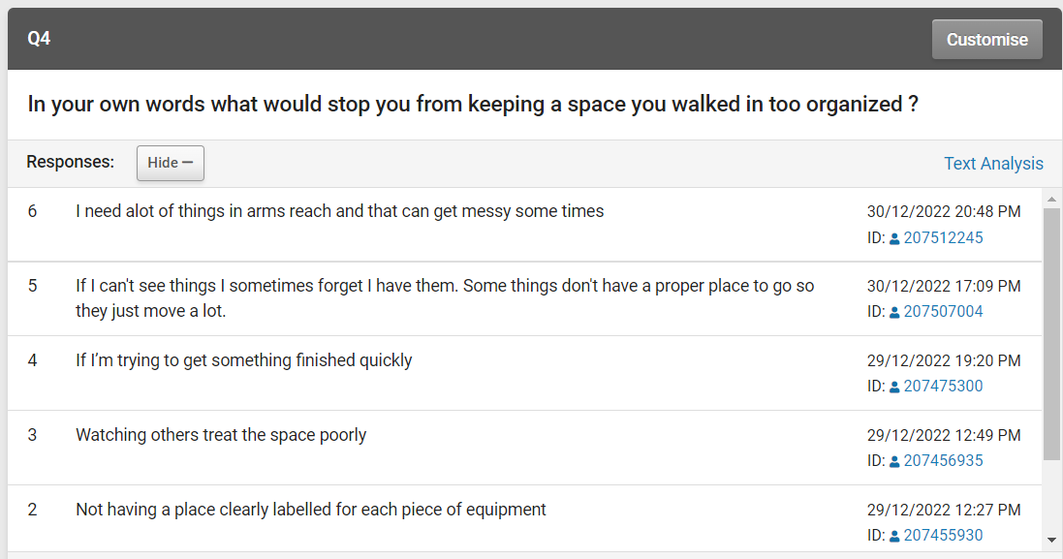

Question five now starting to dive into how organisation and recycling go hand in hand and if others would follow suit. Most would recycle if the spaces were organised what was surprising is 28.57% of people would only recycle some of the time if the room was organised.

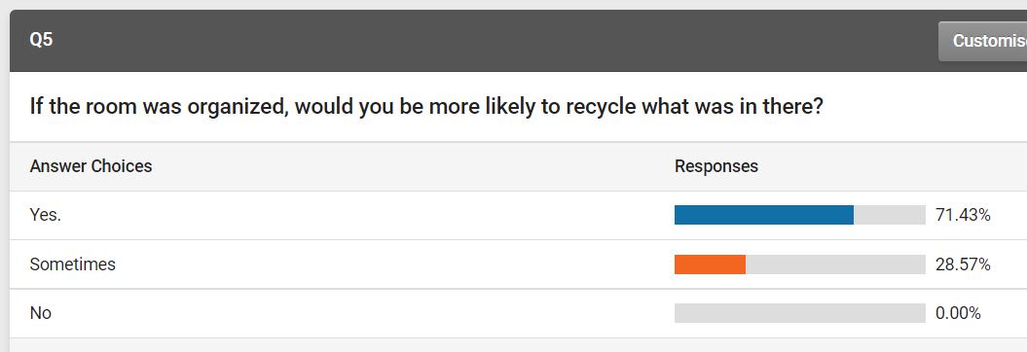

Question six talking about if there was organized spaces would people keep a spaces organized and recycle more the majority say yes but there is 28.57% that would but as long as someone checked afterwards or during.
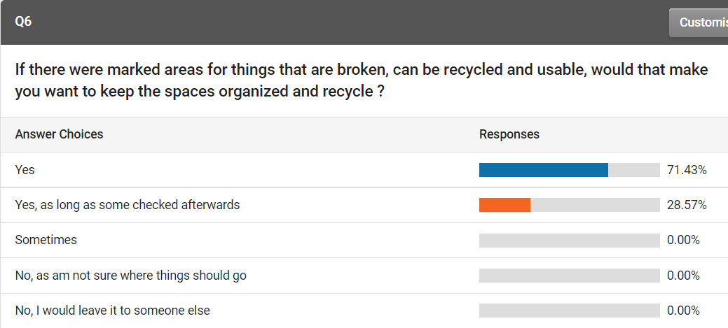

Question seven asking what would help them recycle more, the majority of answers were having clearly labelled bins but ID207454607 said clear guidelines of what is recyclable this jumped out at me as at times there are things that am unsure if they can be recyclable let alone when it comes to electrical goods.
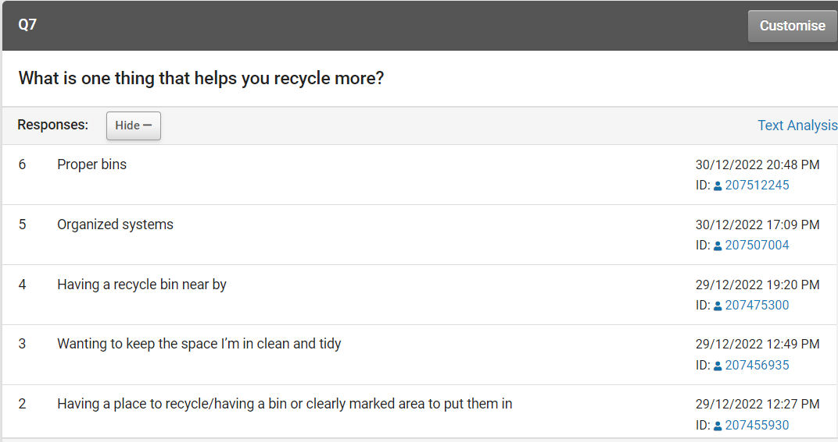

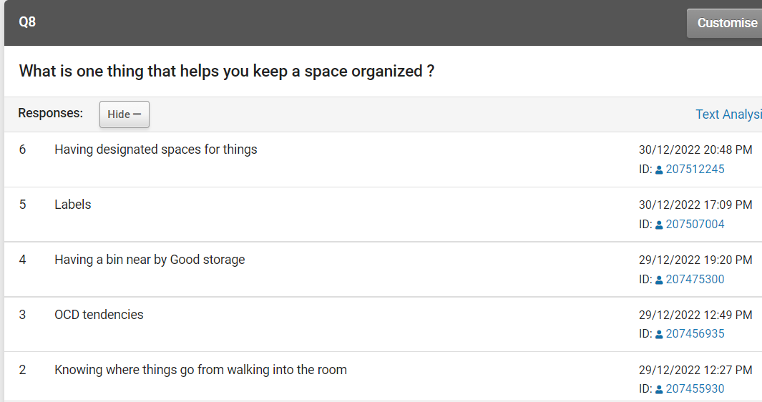
Question eight looking at what would help people keep a spaced organized, the majority seem to talk about having clearly marked spaces and clear marked bins nearby.

Question nine using the prevue’s two questions to inform their answer with this one saying if the ways they mentioned was implemented would they keep a spaces organized and recycle more, 71.43% said yes and 28.57% said sometimes that was interesting to me that some said sometimes I thought it would be a 100% yes to this question.

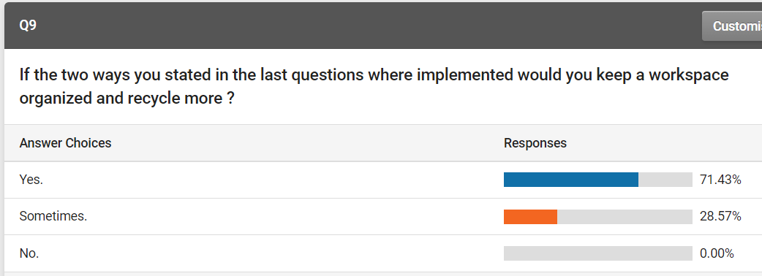

The results of the survey where very interesting as there was some answers to questions, I was not expecting like some people answering sometimes to certain questions along with if the ways they mentioned was implemented they still would only sometimes keep a space organized and recycle more. When it comes to recycling its interesting to see that people already try to recycle electrical goods yet people want clear labels so they know what can be recycled and how the way they would keep a space organised is by clear labels. If I could I would trial run a labelling system and then see if people seem happier and more willing to recycle and keep a work space organised.

With the information I have gathered I will know go and create a PowerPoint personation to show my findings back to a select panel, from this I hope that we are all able to see that people are willing to recycle and organises if people are given the right tools to help them weather that is guid lines on recycling or labelled areas.

Bibliography
Momentive. (1999-2023). Best practices for writing good survey and poll questions. Retrieved from Survey Monkey : https://www.surveymonkey.co.uk/mp/writing-survey-questions/ (Accessed on 16/11/2022)
SmartSurvey. (2022). Survey Software. Retrieved from SmartSurvey: https://www.smartsurvey.co.uk/survey-software (Accessed on 18/11/2022)
substrakt. (No Date Given). Sustainability. Retrieved from Nationl Theatre: https://www.nationaltheatre.org.uk/about-us/sustainability/ (Accessed on 17/11/2022)
Boeckelman, C. (2020, January 3rd). How to Distribute Surveys to Get Quality Responses. Retrieved from GetFeedBack : https://www.getfeedback.com/resources/online-surveys/distribute-online-surveys-get-quality-responses/ (Accessed on 16/11/2022)
Committee, M. o. (November , November 26th). How do we solve our electronic waste problem? Retrieved from House of Commons Committees: https://houseofcommons.shorthandstories.com/environmental-audit-e-waste/index.html (Accessed on 18/11/2022)
Donnay, M. (2021). Wasted: Material Use in the Theatre. Retrieved from Six by Eight Press: https://sixbyeightpress.com/wasted/ (Accessed on 17/11/2022)
Envirotech . (2021, November 18th). Which Are the Most Polluting Industries? Retrieved from Envirotech : https://www.envirotech-online.com/news/air-monitoring/6/breaking-news/which-are-the-most-polluting-industries/56791 (Accessed on 17/11/2022)
Geneva Environment Network. (2020, January 16th ). The Growing Environmental Risks of E-Waste. Retrieved from Geneva Environment Network: https://www.genevaenvironmentnetwork.org/resources/updates/the-growing-environmental-risks-of-e-waste/ (Accessed on 09/11/2022)
Jury, L. (20/3/2019). Making theatre eco-friendly and zero-waste. Retrieved from southdevonplayers: https://www.southdevonplayers.com/blog-creating-theatre/making-theatre-eco-friendly-and-zero-waste (Accessed on 17/11/2022)
Lubell, I. (2018 , April 27th). 5 Shocking Environmental Effects of E-Waste. Retrieved from Mayer Alloys Corporation: https://info.mayeralloys.com/ewaste-blog/5-shocking-environmental-effects-of-e-waste (Accessed on 09/11/2022)
Malouchou, R. P. (2020, January 9th). Reduce, Reuse, Recycle: How Movie Theaters Are Cutting Down on Waste. Retrieved from Boxofficepro: https://www.boxofficepro.com/reduce-reuse-recycle-how-movie-theaters-are-cutting-down-on-waste/ (Accessed on 17/11/2022)
Mavrokefalidis, D. (2021, February 26th). Government considers e-waste obligation for online retailers. Retrieved from Energy Live News : https://www.energylivenews.com/2021/02/26/embargoed-friday-00-01-mps-urge-government-to-set-out-e-waste-obligation-for-online-retailers/ (Accessed on 18/11/2022)
Pew Research Center. (2022). Writing Survey Questions. Retrieved from 2023 Pew Research Center: https://www.pewresearch.org/our-methods/u-s-surveys/writing-survey-questions/ (Accessed on the 16/11/2022)
Poet, J. (2019, September 26th). Home » Blog » Negative impacts of household appliances. Retrieved from Healthy Life Essex: https://healthylifeessex.co.uk/2019/09/negative-impacts-household-appliances/ (Accessed on 09/11/2022)
Qualtrics. (2022). How your survey distribution methods can impact your research results. Retrieved from Qualtics.xm: https://www.qualtrics.com/uk/experience-management/research/survey-distributinon-methods/ (Accessed on 16/11/2022)
Ratnam, K. M. (2020, January 27th). Could contemporary art be less wasteful? Retrieved from Apollo : https://www.apollo-magazine.com/contemporary-art-waste-kate-mcmillan-niru-ratnam/ (Accessed on 17/11/2022)
Reconomy. (02.10.2020). Managing waste in the film industry. Retrieved from Recycling Magazine : https://www.recycling-magazine.com/2020/10/02/managing-waste-in-the-film-industry/ (Accessed on 16/11/2022)

